ACSL
American Computer Science League
2015 - 2016

All-Star Contest

Short Round Solutions
- Boolean Algebra
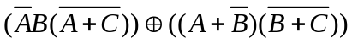 = 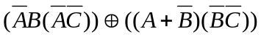
= 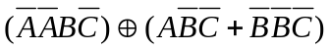=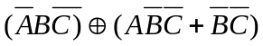
= 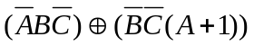=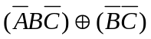
= 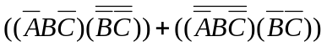=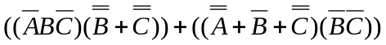
= =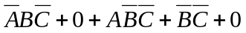
=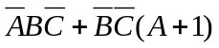 = 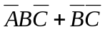=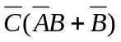
If =1, then 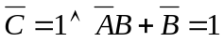
So 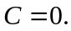 If 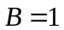, then 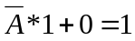. 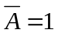. 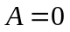 (0, 1, 0)
If 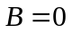, then 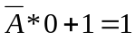. 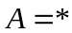 (*, 0, 0)

- (C) (0, 1, 0) (1, 0 0)
(0, 0, 0)

2. Bit String Flicking
Let X = abcde
LHS = (LCIRC-2(RSHIFT-1 X)) OR (RCIRC-1 (LSHIFT-2 X))
= (LCIRC-2(RSHIFT-1 abcde)) OR (RCIRC-1 (LSHIFT-2 abcde))
= (LCIRC-2 0abcd) OR (RCIRC-1 cde00)
= bcd0a OR 0cde0 = bcdea
RHS = NOT X AND (LSHIFT-1(RCIRC-2 01011))
= NOT abcde AND (LSHIFT-1 11010)
= ABCDE AND 10100 = A0C00
LHS = RHS → bcdea = A0C00 → A = b, c = 0, d = C, e = 0, a = 0
So a = 0, b = 1, c = 0, d = 1, e = 0 → 01010

2. (B) 01010

3. Recursive Functions
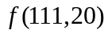 = 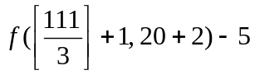 = 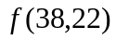 - 5 = 64 – 5 = 59
=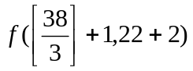 - 5 = 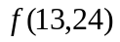 - 5 = 69 – 5 = 64
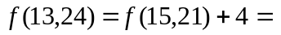65 + 4 = 69
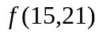=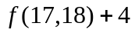= 61 + 4 = 65
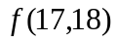= 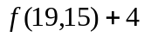= 57 + 4 = 61
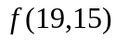= 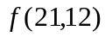+ 4= 53 + 4 = 57
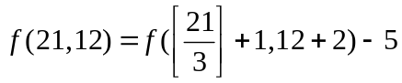= 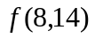- 5 = 58 – 5 = 53
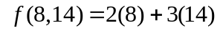= 58

= ( 5 5 %) 6 # 1 #
= (10 6 # ) 1 # = -4 1 # = 5

3. (C) 58

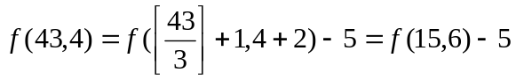= 20 – 5 = 15
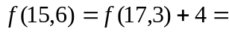16 + 4 = 20
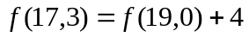= 12 + 4 = 16
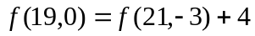= 8 + 4 = 12
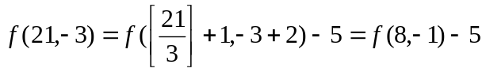=13 – 5 = 8
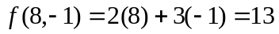
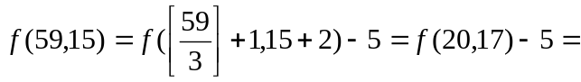 63 – 5 = 58
= 59 + 4 = 63
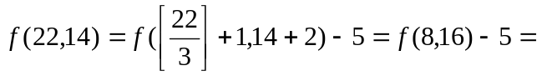64 – 5 = 59
Therefore = 58

4. Digital Electronics
The digital circuit is represented by the following Boolean
expression: ( 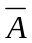  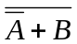 ) ( 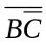 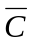 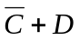) 

 |  |  |  |  |  |  |  |  | 
0 | 0 | 0 | 0 | 1 | 0 | 1 | 1 | 1 | 0 | 1 | 0
0 | 0 | 0 | 1 | 1 | 0 | 1 | 1 | 1 | 0 | 1 | 0
0 | 0 | 1 | 0 | 1 | 0 | 0 | 1 | 0 | 0 | 1 | 0
0 | 0 | 1 | 1 | 1 | 0 | 0 | 1 | 1 | 0 | 0 | 0
0 | 1 | 0 | 0 | 1 | 0 | 1 | 0 | 1 | 0 | 0 | 1
0 | 1 | 0 | 1 | 1 | 0 | 1 | 0 | 1 | 0 | 0 | 0
0 | 1 | 1 | 0 | 1 | 0 | 0 | 1 | 0 | 0 | 1 | 0
0 | 1 | 1 | 1 | 1 | 0 | 0 | 1 | 1 | 0 | 0 | 0
1 | 0 | 0 | 0 | 0 | 1 | 1 | 1 | 1 | 0 | 1 | 0
1 | 0 | 0 | 1 | 0 | 1 | 1 | 1 | 1 | 0 | 1 | 0
1 | 0 | 1 | 0 | 0 | 1 | 0 | 1 | 0 | 0 | 1 | 0
1 | 0 | 1 | 1 | 0 | 1 | 0 | 1 | 1 | 0 | 0 | 0
1 | 1 | 0 | 0 | 0 | 0 | 1 | 0 | 1 | 0 | 0 | 1
1 | 1 | 0 | 1 | 0 | 0 | 1 | 0 | 1 | 0 | 0 | 0
1 | 1 | 1 | 0 | 0 | 0 | 0 | 1 | 0 | 0 | 1 | 0
1 | 1 | 1 | 1 | 0 | 0 | 0 | 1 | 1 | 0 | 0 | 0

4. (B) 2

5. (E) None of the above

5. Prefix-Infix-Postfix
diff / 8 2 diff + 2 1 – 4 3 ↑ 2 3 * 2 3
= diff (/ 8 2) diff( + 2 1) (– 4 3)( ↑ 2 3)( * 2 3)
= diff (8/2) diff (2+1)(4 – 3)(2³)(2*3)
= diff 4( diff 3 1 8) 6 = diff 4 (max(|3 – 1|, |1 – 8|, |3 – 8|) 6
= diff 4 7 6 = max(|4 – 7|, |7 – 6|, |4 – 6|) = max(3, 1, 2) = 3

6. Computer Number Systems
Consider 101 in each position: 101xx, x101x, and xx1010. There
are 4 possible values for each (thus 12 in total). However 10101 will
appear twice, once as part of 101xx and a second time as part of
xx101.

6. (C) 11

7. (B) 12

7. What Does This Program Do?
This program manipulates the letters in the alphabet.
The “i” loop puts one letter in each cell of a$.
The “j” loop replaces each third letter with the one before and after it.
The “k” loop replaces the cells which are multiples of 4 or one more
than a multiple of 3 with a new string.
The “b” loop removes the string if the string is 2 characters and the
cell number is even.
The “d” loop removes strings shorter than 4.

- Data Structures
The resulting heap:

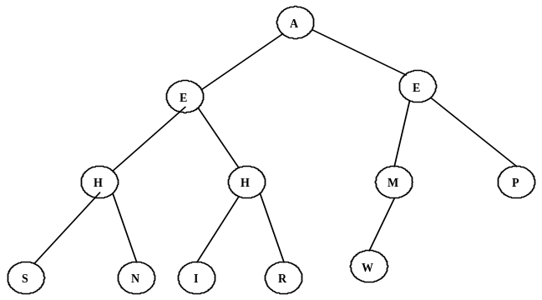
8. (D) H, H, M, P

- Graph Theory
The directed graph is a dag (directed acyclic graph), that is
a directed graph with no cycles. The paths are ABCF, ABDCF, ADCF, AF, BCF, BDCF, CF, DCF, EF, EBCF, EDCF, and EBDCF. There are no cycles.

9. (A) 0

- LISP
(REVERSE (CONS (CAR (CDR ‘(a b (c d) (e f g))))
(REVERSE (CAR ‘((a b c) (d e) f))))))
= (REVERSE (CONS (CAR ‘( b (c d) (e f g)))
(REVERSE ‘(a b c))))
= (REVERSE (CONS ‘b ‘(c b a)))
= (REVERSE ‘(b c b a)) = (a b c b)

10. (D) (a b c b)

- FSA and Regular Expressions
a ( a* U b )* b ( b* U a )* = a((a*)*b*)*b((b*)*a*)*
= a(a*b*)*b(b*a*)

11. (B) a(a*b*)*b(b*a*)

- Assembly Language

This program counts the number of integers from
1 to 100, inclusive, that are divisible by 3 using the
divisibility rule for 3 (If the sum of the digits is
divisible by 3 then the number is divisible by 3.).

The BASIC program for this is:
10 N = 1
20 A = 101
30 B = 0
40 IF N – A = 0 THEN 170
50 T = INT(N/10)
60 P = 10 * T
70 D = N – P
80 S = D + T
90 Y = INT(S/3)
100 X = Y * 3 – S
110 IF X = 0 THEN 140
120 N= N + 1
130 GOTO 40
140 B = B + 1
150 N = N + 1
160 GOTO 40
170 PRINT B
180 END

12. (C) 33

