ACSL
American Computer Science League
2015 - 2016

Contest #1

Intermediate Division

1. Recursive Functions
Find (6) given:
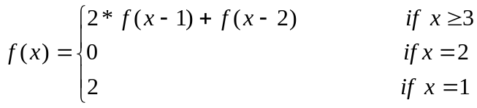

- Recursive Functions
Find 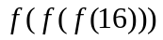 given:
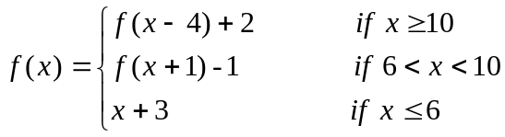

3. Computer Number Systems
Which expression evaluates with the most 1’s when the answer is
expressed in binary?
A) 25₈ + 1C₁₆ B) A0₁₆ – 100110₂ C) B8₁₆ + 127₁₀ D) 111₈ + 1000₂

b1

4. Computer Number Systems
What is the mean (average) of the following numbers expressed in
octal?
101010₂ 132₈ 33₁₆ 1010100₂ 44₁₆

- What Does This Program Do?
What is printed when this program is run?
a = 16: b = 2: c = 4: d = 0: e = 5
if a < b then a = a + b else a = a - b
if a * d < c * e then a = a + d else c = c + e
if b ^ d = 1 then d = d + 1 else b = b + 1
if int(a / c) = a / c then a = a / c else a = a - c
if (a < e) or (b >= d) then a = e else b = d
if (b >= c) and (d <= e) then c = b - c else d = a - e
print a ^ d + b * e / a – c * (a / e + b ^ b)
end

