ACSL
American Computer Science League
2015 - 2106

Contest #3

Intermediate Division

1.
- Graph Theory
Given the following adjacency
matrix, how many lines between
vertices are bidirectional, i.e.
arrowhead at both ends?

0 | 1 | 1 | 0 | 1 | 0
1 | 0 | 1 | 1 | 0 | 1
1 | 1 | 0 | 0 | 1 | 1
0 | 1 | 1 | 0 | 0 | 0
1 | 1 | 0 | 0 | 0 | 1
0 | 0 | 0 | 1 | 0 | 0

- Graph Theory
Which directed pair(s) of vertices do not have paths of length 3?
2.
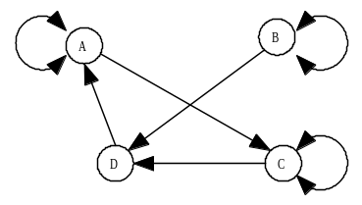

3.
- Boolean Algebra
Which ordered triple(s) make the following Boolean expression TRUE?
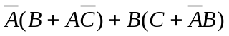

- Boolean Algebra

4.

How many ordered triples make the following Boolean expression TRUE?

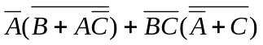

- What Does This Program Do?
Given array A below, what is printed when this program is run?
s = 0
for i = 1 to 4
for j = 1 to 4:a(i,j)=a(i,j)-a(j,i): next j
next i
for i = 1 to 4
for j = 1 to 4
if a(i,j)>= 10 then a(i,j)=a(i,j)-10
if a(i,j)/2=int(a(i,j)/2) then a(i,j)=a(i,j)/2
if abs(a(i,j)) < 5 then a(i,j) = 0
next j
next i
for i = 1 to 4
for j = 1 to 4
if a(i,j)=0 then s = s + 1
next j
next i
print s: end

5.

2 | 6 | 0 | -1
-3 | 4 | -2 | 3
0 | 3 | -1 | -4
8 | 2 | -3 | 0
A(1,2) = 6

