ACSL
American Computer Science League
2015 - 2016

Contest #3

Intermediate Division Solutions

- Graph Theory
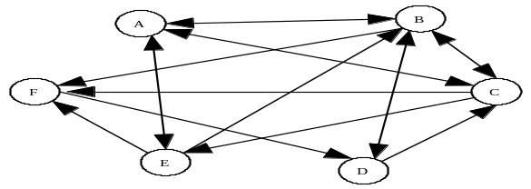

1. 5

- Graph Theory

2. AB, CB
and DB

d
d

1 | 0 | 1 | 0 | 3 |  | 2 | 0 | 3 | 2
0 | 1 | 0 | 1 |  |  | 2 | 1 | 1 | 1
0 | 0 | 1 | 1 |  | = | 2 | 0 | 2 | 1
1 | 0 | 0 | 0 |  |  | 1 | 0 | 2 | 1

Cubing an adjacency matrix produces all paths of length 3.
B does not have a path of length 3 from A, C and D.
3. (1, 1, 1)
(0, 1, 1)
(0, 1, 0)
- Boolean Algebra
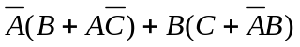 = 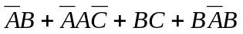
= 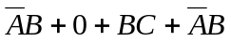 = 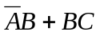 = 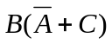
If 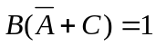, then 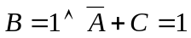
If 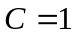, then 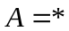. If 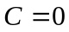, then 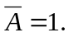 So 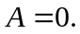

- Boolean Algebra
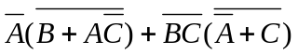 = 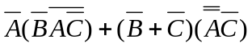
= 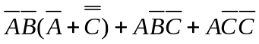 = 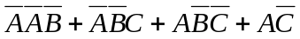
= 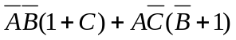= 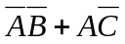
If 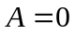, then 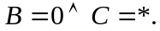 If 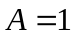, then 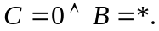 Thus 4 triples.

4. 4
- What Does This Program Do?
This program changes all the values in the original table and counts how many are 0. The final values are:

5. 11
0 | 9 | 0 | -9
-6 | 0 | -5 | 0
0 | 0 | 0 | 0
7 | 0 | 0 | 0

