ACSL
American Computer Science League
2015 - 2016

Contest #4

Intermediate Division

1.
- Data Structures
Find the depth of the binary search tree for
NEWHAMPSHIRE

2.
- Data Structures
What would the next popped element be in the following stack?

PUSH(C), PUSH(O), POP(X), PUSH(N), PUSH(C), POP(X),
PUSH(O), PUSH(R), POP(X), POP(X), PUSH(D), PUSH(N),
POP(X), PUSH(H),POP(X), POP(X)

- Digital Electronics. How many ordered triples make the circuit FALSE?
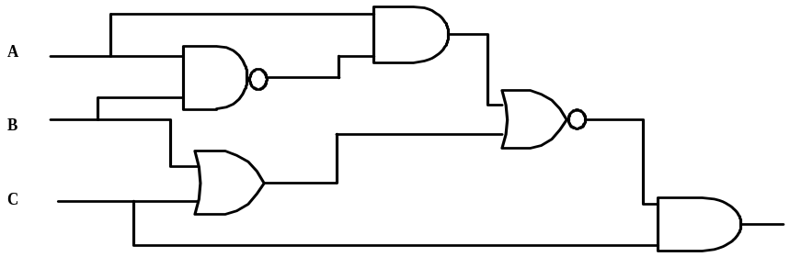

3.

- Digital Electronics Simplify the Boolean expression represented by the
circuit below.

4.
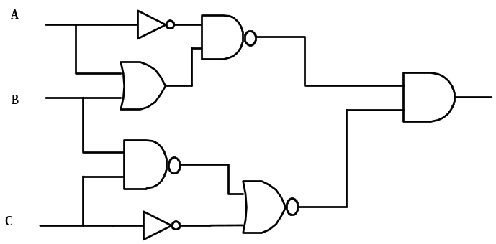

- LISP
Simplify the following LISP expression:

(CDR(CAR(CDR(CDR ‘(a (b c) (d a (b c)) (a b))))))

5.

