ACSL
American Computer Science League
2015-2016

Contest #4

Intermediate Division Solutions
- Data Structures
1. 4

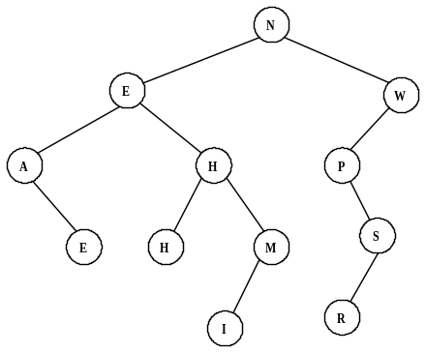

The binary search tree is shown on the right. The depth of the tree
is 4.

2. N
- Data Structures
The stack is constructed as follows:
C, CO, C, CN, CNC, CN, CNO, CNOR, CNO, CN, CND, CNDN,
CND, CNDH, CND, CN. The next popped item is N since stacks are LIFO.

3. 8
- Digital Electronics
The circuit translates to: 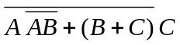
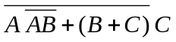 = 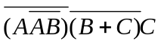= 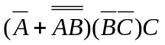
= 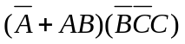 = 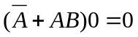
All the ordered triples make the circuit FALSE.

4. 
- Digital Electronics
The circuit translates to: 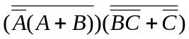
=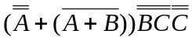=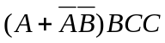
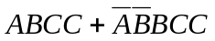=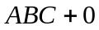=

5. LISP
(CDR(CAR(CDR(CDR ‘(a (b c) (d a (b c)) (a b))))))
= (CDR(CAR(CDR ‘((b c) (d a (b c)) (a b)))))
= (CDR(CAR ‘((d a (b c)) (a b))))
= (CDR ‘(d a (b c)))
= (a (b c))

5. (a (b c))

