ACSL
American Computer Science League
2015 - 2016

Contest #3

Junior Division
1. Graph Theory

Draw the directed graph containing the following vertices and edges. Vertices: {A, B, C, D}
Edges: {AC, AB, BC, CD, BD, BA, CA, DB}

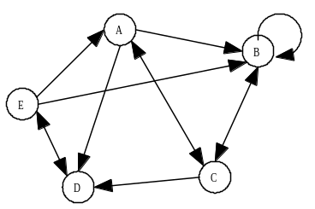

- Graph Theory

Write the adjacency matrix for
the directed graph.

3. Boolean Algebra

How many ordered pairs make the following Boolean expression TRUE?

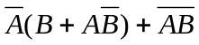

- Boolean Algebra
Simplify the following Boolean algebra expression:

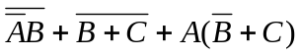

- What Does This Program Do?
Given array A below, how many elements of array A are less than or
equal to 10 after the program is run?

FOR I = 1 TO 4
FOR J = 1 TO 4
IF A(I,J)/4 = INT(A(I,J)/4) THEN A(I,J)=A(I,J)/4 ELSE A(I,J)=A(J,I)
IF A(I,J)>=20 THEN A(I,J)=A(I,J)-20 ELSE A(I,J)= A(J,I)
IF A(I,J)/2 = INT(A(I,J)/2) THEN A(I,J)=A(I,J)/2
ELSE A(I,J)=A(I,J)+A(J,I)
NEXT J
NEXT I
END

xxxxxxxxxxxxxxxxxxxx
12 | 2 | 54 | 3
11 | 60 | 44 | 24
1 | 98 | 64 | 65
10 | 20 | 38 | 4

Note: A(1,1) = 12

