ACSL
American Computer Science League
2015 - 2016

Contest #3

Junior Division Solutions

- Graph Theory

As shown
1.
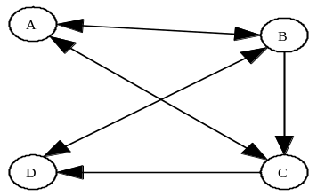

Adding the second row results in 11 paths

- Graph Theory

0 | 1 | 1 | 1 | 0
0 | 1 | 1 | 0 | 0
1 | 1 | 0 | 1 | 0
0 | 0 | 0 | 0 | 1
1 | 1 | 0 | 1 | 0

2. As shown

=

3. Boolean Algebra
3. 3

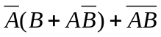 = 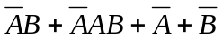 = 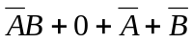
= 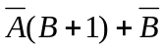 = 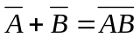
If 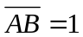, then 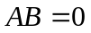. So 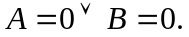 Therefore 3 ordered pairs
make the expression TRUE. (0,1), (1,0), (0,0)

4. Boolean Algebra
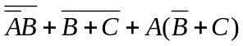 = 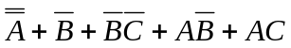
= 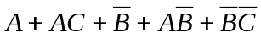
= 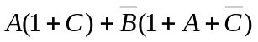
= 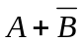

- 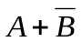

- What Does This Program Do?
This program checks for entries in the table that are divisible by 4 and 2 and greater than or equal to 20. Entries in A are adjusted accordingly. The final table is below. There are 5 entries less than or equal to 10.

5. 11

6 | 22 | 2 | 5
1 | 30 | 49 | 10
1 | 78 | 8 | 9
10 | 5 | 18 | 2

