ACSL
American Computer Science League
2015 - 2016

Contest #4

Junior Division
- Data Structures
How many nodes have only one child in the binary search tree for
NASHUAHIGHSCHOOL

- Data Structures
Given an initially empty queue and the following sequence of operations, what would be the next POPPED element? PUSH(N), PUSH(A), PUSH(T), POP(X), POP(X), PUSH(H), PUSH(A), POP(X), PUSH(N), POP(X), POP(X), PUSH(H), PUSH(A), POP(X), PUSH(L), POP(X) PUSH(E), POP(X)

3. Digital Electronics
Simplify the Boolean
expression represented by
this circuit using the fewest
numbers of parentheses,

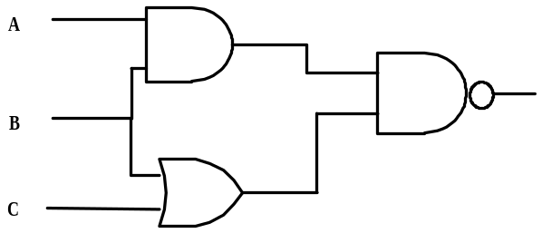

4. Digital Electronics

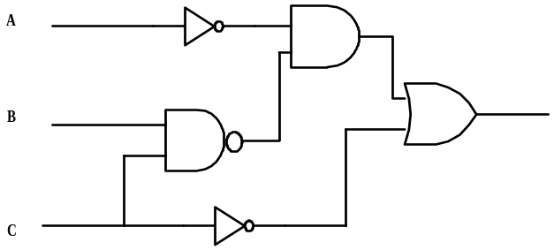

How many ordered triples make the circuit FALSE?

5. What Does this Program Do?
What is printed when this program is run?
A$ = "OLDMANINTHEMOUNTAIN"
B$="": C$="": D$="": E$="": F$="": G$=""
for I = 1 to len(A$)
if mid$(A$,I,1)<"N" then B$ = B$ + mid$(A$,I,1) else C$ = C$ + mid$(A$,I,1)
next I
for I = 1 to len(B$)-1
if mid$(B$,I,1)<mid$(B$,I+1,1) then D$=D$+mid$(B$,I,1) else
E$=E$+mid$(B$,I,1)
next I
for I = 1 to len(D$)
if mid$(D$,I,1) <> "A" and mid$(D$,I,1)<>"E" then F$=F$+mid$(D$,I,1)
next I
for I = 1 to len(F$)
if mid$(F$,I,1) >= "H" then G$=G$+mid$(F$,I,1)
next I
print len(G$)
end

3 | 2 | 4 | 5 | 1
0 | 1 | 3 | 2 | 6
1 | 2 | 1 | 3 | 4

