ACSL
American Computer Science League
2015 - 2016

Contest #4

Junior Division Solutions

- Data Structures
1. 5

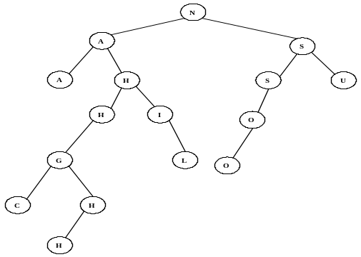

The binary tree formed is shown on the right. The
nodes with only one child
are: H, I, H, S, and O.

- Data Structures
The queue is constructed using FIFO as follows: N, NA, NAT, AT, T, TH, THA, HA, HAN, AN, N, NH, NHA, HA, HAL, AL, ALE, LE. The next element POPPED would be L. .

2. L

3. Digital Electronics
The circuit translates to the Boolean expression: 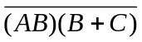
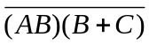=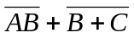= 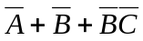= 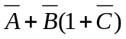= 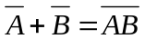

3. 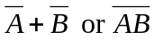

4. Digital Electronics
The circuit translates to: 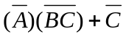.
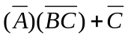=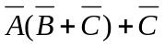= 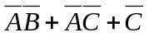= 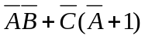=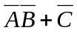
If 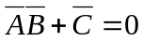, then 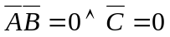.

The ordered triples (1,1,1), (1,0,1) and (0,1,1) make the circuit FALSE.

4. 3

3 | 2 | 4 | 5 | 1
0 | 1 | 3 | 2 | 6
1 | 2 | 1 | 3 | 4

5. What Does this Program Do?
The first loop looks for letters before N and puts them in B$. Those N’s or letters after N are placed in C$. The result is B$ = “LDMAIHEMAI” and C$ = “ONNTOUNTN”. The next loop compares 2 letters at a time in B$ and places a letter in D$ if the first is alphabetically before the second letter else it is put in E$. The result is D$ = “DAEA” and E$ = “LMIHM”. The next loop drops A’s and E’s in D$. The result is F$ = “D”. The last loop places the characters in G$ that are alphabetically after G. The length of G$ is 0. There are no letters left from A$ just like the actual Old Man InThe Mountain in NH that crumbled away.

5. MIGCUCOAUTAI
5. 0

