ACSL

AMERICAN COMPUTER SCIENCE LEAGUE

2017 – 2018 PROGRAMS

ALL-STAR CONTEST
SENIOR 5 DIVISION

Dear student:

Attached is the programming problem set for your division. The programs can be completed in any order. When completed save the code to your flash drive. Please put your school name and division on the flash drive tag. About one hour after you start programming, proctors will be available to score your results. Your team captain and the proctor will both sign below each scoring section and the bottom of the score sheet to indicate that the scoring is accurate.

You must change the file name that accesses the data in your program prior to having your program scored. As an example: the code in Program #5 must be changed from as5-sample.txt to as5-test.txt.

Your outputs must stay on the screen long enough for the proctor to check them. If they scroll quickly up and off the screen they will not be scored. Your program will only be RUN once with the test data. If data is entered incorrectly, the program may be started again, but the data must be started from test input #1 again.

The only materials allowed are your authorized number of computers, pencil/pens and paper. Other electronic devices of all types and manuals can’t be used in your test room. Students using devices or manuals will cause their team to be disqualified. Students are not allowed to connect to the internet during the contest. Previously written student code is not allowed to be on your computer or among your materials.

All appeals to the programming problems must be given to the contest director prior to 1:30 PM. The appeal must be in writing. It must include a complete description of your solution. It must contain your name, school name and division.

Our current plan is to make a series of announcements to alert you that 30 minutes, 15 minutes, 5 minutes and 1 minute remain in the contest. At the end of the contest, students should move away from the computers and wait for proctors to score any remaining unscored programs. If a program is tested after the end of the contest, it will have an execution time limit of 10 minutes. Programs tested prior to 12:30 PM must be completed by 12:40 PM.

At the end of the contest the proctor will collect your team score sheet and your labeled flash drive. Please put your school name and division on the flash drive tag. Save your programs using the program names provided at the top of each program sheet on the flash drive. The flash drive will be used to re-score programs that are appealed. If the flash drive is not returned you can’t appeal.

Below is the listing of the programs for your division. The order and point values are not indications of the level of difficulty.
5. LOOK AND SAY 10 pts
6. SUBPATTERN COVERAGE 10 pts
7. GRIDIMETER 10 pts
8. COMPRESSED TREES 10 pts
9. HEXGRID PATH 10 pts
10. SLIDING PUZZLE 10 pts

Good Luck!

5. Look and Say
PROBLEM: From Wikipedia: In mathematics, the look-and-say sequence is the sequence of integers beginning as follows:
1, 11, 21, 1211, 111221, 312211, 13112221, 1113213211,
To generate a member of the sequence from the previous member, read off the digits of the previous member, counting the number of digits in groups of the same digit. For example the second through sixth terms are formed as follows:
- 1 is read off as "one 1" or 11.
- 11 is read off as "two 1s" or 21.
- 21 is read off as "one 2, then one 1" or 1211.
- 1211 is read off as "one 1, one 2, then two 1s" or 111221.
- 111221 is read off as "three 1s, two 2s, then one 1" or 312211.

INPUT: There will be 10 lines of input. Each line will contain 3 integers: m, n, and p.

OUTPUT: For each line of input, find the term and print the string of digits starting with the digit and continuing through the digit.

FILES ON THE FLASH DRIVES ARE NAMED: as5-sample.txt and as5-test.txt

SAMPLE INPUT SAMPLE OUTPUT

2 2 0 1. 1
3 1 1 2. 21
4 2 2 3. 211
5 4 2 4. 221
6 1 2 5. 312
7 2 4 6. 31122
8 4 4 7. 32132
9 7 3 8. 1113
10 10 5 9. 231131
11 15 6 10. 1321132
6. Subpattern Coverage

PROBLEM: Given a 2-dimensional array, find the smallest TL subarray that can exactly tile the original array. A TL subarray is part of the array that starts in the Top Left corner of the original array.
For example, consider the 12 x 8 array below:
1 | 1 | 1 | 1 | 1 | 1 | 1 | 1
1 | 0 | 1 | 0 | 1 | 0 | 1 | 0
0 | 1 | 0 | 1 | 0 | 1 | 0 | 1
0 | 0 | 0 | 0 | 0 | 0 | 0 | 0
1 | 1 | 1 | 1 | 1 | 1 | 1 | 1
1 | 0 | 1 | 0 | 1 | 0 | 1 | 0
0 | 1 | 0 | 1 | 0 | 1 | 0 | 1
0 | 0 | 0 | 0 | 0 | 0 | 0 | 0
1 | 1 | 1 | 1 | 1 | 1 | 1 | 1
1 | 0 | 1 | 0 | 1 | 0 | 1 | 0
0 | 1 | 0 | 1 | 0 | 1 | 0 | 1
0 | 0 | 0 | 0 | 0 | 0 | 0 | 0

The smallest TL subarray that can exactly tile the original is the 4 x 2 array that is shaded above. When it tiles the array, it appears 12 times: 4 times on each of the 3 rows. By smallest, we refer to the number of elements in the array.
Here are some other TL subarrays and the reason why they don’t tile the original:
This TL subarray tiles the first two rows only. | This TL subarray doesn’t even tile the first row! | This isn’t a valid TL subarray of the array above.
  1 | 1
  1 | 0
  1 | 1 | 1
  0 | 1 | 1 | 0
  0 | 0 | 0 | 0
INPUT: There will be 10 lines of input. Each line will contain an array of 0s and1s. The format of each line is the integer R, followed by the integer C, followed by R hex strings that, when each hex digit is converted to 4 binary digits, will fill the R rows of the array from top to bottom and left to right.
If the conversion produces more digits than needed, delete the unneeded trailing digits. For example, if there are 5 columns A7 would convert to binary as 10100111 and the 5 columns would be filled with 10100.
OUTPUT: For each line of input, find the smallest TL subarray that exactly tiles the input array. Print the size of the TL subarray as two numbers: the number of rows followed by the number of columns. We guarantee that there is a unique answer to each input array. If there is no TL subarray smaller than the input array that can tile the input array, then print the size of the input array.

6. Subpattern Coverage

FILES ON THE FLASH DRIVES ARE NAMED: as6-sample.txt and as6-test.txt

SAMPLE INPUT SAMPLE OUTPUT

8 8 FF AA 55 00 FF AA 55 00 1. 4 2
4 4 F F F F 2. 1 1
4 4 1 1 1 1 3. 1 4
3 4 A A A 4. 1 2
4 8 CC AA CC AA 5. 2 4
4 6 22 B1 22 B1 6. 2 6
6 4 3 A F 3 A F 7. 3 4
6 6 B1 D2 21 B1 D2 21 8. 3 6
6 8 AA AA AA AA AA AA 9. 1 2
5 5 00 00 00 00 00 10. 1 1
7. Gridimeter
PROBLEM: Given a rectilinear simple polygon (RSP), find its gridimeter. An RSP is a simple polygon (i.e. edges only intersect at endpoints and edges only meet at right angles). Here are four examples:

The RSP’s gridimeter is similar to the concept of a perimeter, but reports the number of grid intersection points that make up the perimeter when the polygon is superimposed on a grid. In the diagram below, the figure at the left has a gridimeter of 10, and in the figure at right, it’s 24.
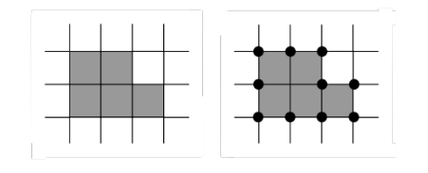 | 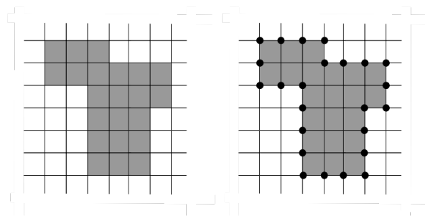
You will be given a RSP, and you need to report its gridimeter value. The RSP will be given as a 2-dimensional array whose cells contain the number of sides of that cell that are used to form the sides of a simple polygon. Below are the arrays for the two diagrams above:
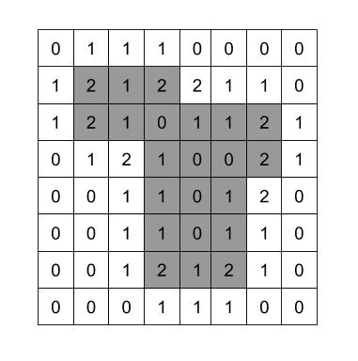
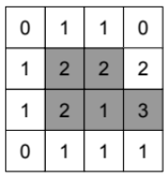

Each row of the array will be represented by a base 16 number. That number must be converted to base 10. The digits of the base 10 number are than placed right justified into the cells of that row. If there are too few digits, leading zeros are added.
In the 4 x 4 grid on the left, the top row is decimal 110 and would be given as 6E base 16. A leading zero is needed. The second row is decimal 1222 or 4C6 base 16. The third row is 1213 or 4BD base 16. The bottom row is decimal 111 or 6F base 16. Again, a leading 0 is needed.
7. Gridimeter
In the 8 x 8 grid on the right, the top row contains right justified 1110000 base 10 which is 10EFF0 base 16. A leading 0 was inserted to make it fit. The second row contains 12122110 base 10 which is B8F7FE base 16. No leading 0 is needed.
INPUT: There will be 10 lines of input, each representing a rectilinear simple polygon. Each line will have 2 integers, r and c, giving the number of rows and columns in the grid. Those numbers will be followed by r base-16 numbers; these numbers when converted to base 10, encode the rows, from the top to the bottom.

OUTPUT: For each line of input, print the gridimeter value of the RSP.

FILES ON THE FLASH DRIVES ARE NAMED: as7-sample.txt and as7-test.txt

SAMPLE INPUT SAMPLE OUTPUT
1. 8
2. 10
3. 6
4. 4
5. 10
6. 10
7. 10
8. 10
9. 14
10. 16

4 4 6E 4C5 4C5 6E

6 3 A 83 79 79 83 A

3 4 6E 533 6E

3 3 A 8D A

4 4 6E 4C6 4BD 6F

4 5 456 33A5 4CF A

4 5 456 3341 8AD 6E

4 3 83 79 79 83

6 5 2F59 2B03 2EEB 8AD 6E 0
5 5 2F59 2B03 2B67 3413 3F2

8. Compressed Trees

PROBLEM: Given a character string, calculate a compressed representation, create its binary tree representation and determine the path of a given letter. Use the procedure below to calculate the compressed representation.

- Calculate the frequency of each letter and build a frequency list. Each term of the list is the frequency of the letter followed by the letter. The frequency list is kept in ascending order based on frequency and in alphabetical order within each frequency. See the list below.
- Add the first 2 frequencies in the list and attach the letters keeping all of them in alphabetical order. If 2EK and 3AT are the first 2 frequencies, then they are combined to form 5AEKT.
- Delete these two terms from the list.
- Add the new frequency term to the list using the rules above. 2EH below was inserted between 2AD and 2O so as to keep the list in frequency order and alphabetical order within that frequency.
- Repeat from Step 2 until there is just one frequency in the list.
EXAMPLE: Consider the string HELLOAWORLD. The initial frequency list has
8 terms:

1A 1D 1E 1H 1R 1W 2O 3L

The algorithm works as follows:
Delete 1A and 1D, and insert 2AD into the list: 1E 1H 1R 1W 2AD 2O 3L
Delete 1E and 1H, and insert 2EH into the list: 1R 1W 2AD 2EH 2O 3L
Delete 1R and 1W, and insert 2RWinto the list: 2AD 2EH 2O 2RW 3L
Delete 2AD and 2EH, and insert 4ADEH into the list: 2O 2RW 3L 4ADEH
Delete 2O and 2RW, and insert 4ORW into the list: 3L 4ADEH 4ORW
Delete 3L and 4ADEH, and insert 7ADEHL into the list: 4ORW 7ADEHL
Delete 4ORW and 7ADEHL, and insert 11ADEHLORW into the list: 11ADEHLORW

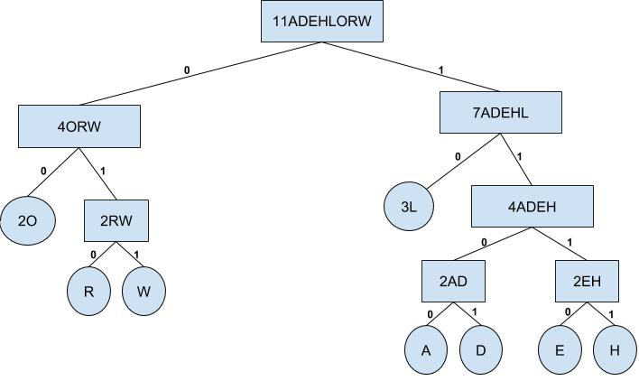

The above binary tree can be constructed from the procedure above. Working backwards the root of the tree is the compression factor 11ADEHLORW. It was formed by 4ORW and 7ADEHL. 7ADEHL was formed by 3L and 4ADEH. All of the other branches are placed in a similar manner from the procedure above keeping the left-right order in which they were combined. Then each letter can be represented by a unique set of bits by following the paths of the tree from the top. Note that the path to the left child is always labeled 0 and the path to the right child is always labeled 1. W = 011, O = 00 and E = 1110.

INPUT: There will be 10 lines of input. Each line will contain a character string and one character from that string.

OUTPUT: Print the compressed binary representation of the one character given on each input line.

FILES ON THE FLASH DRIVES ARE NAMED: as8-sample.txt and as8-test.txt

SAMPLE INPUT SAMPLE OUTPUT

HELLOAWORLD W 1. 011
ABCDEFHHHLLLNNN D 2. 1011
ABCDGGGKKKKK G 3. 10
LYAAEEGGPPP L 4. 010
ABCDEFHHLLL A 5. 1100
ABCCDDEEFFF C 6. 111
AABBBCCCCDDDDDEEEEEEFFFFFFF B 7. 1111
ABCCGGGHHHKKKKK B 8. 1001
ABFFFGGGGCCCCC C 9. 0
XAABBCCCDDDKKKKLLLL L 10. 01

9. Hexgrid Path Generator
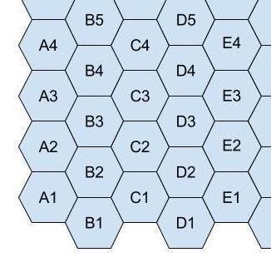
PROBLEM: Consider the grid of hexagons shown at the right. The grid extends upward infinitely and to the right for 26 columns.
One can move from cell to cell across the borders of the cells. For example, one of the paths of length 5 from B2 to D1 is B2-C2-D3-D2-E1-D1.
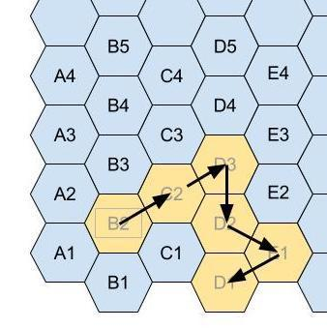
In this program, you will be given a starting and ending location. You need to report the number of different paths of a specified length between the two locations. No path can use the same cell more than once.
For example, there are 4 paths of length 3 starting at D5 and ending at E4. The paths are: D5-D6-E5-E4, D5-E5-F5-E4, D5-D4-E3-E4, D5-C4-D4-E4.
INPUT: There will be 10 lines of input. Each line will contain two strings (starting and ending cells), and the length of the path. The strings will be fewer than 5 characters long, and the path length will not exceed 16.

OUTPUT: For each line of input, print the number of different paths between the starting and ending cell of the specified length. A path may not go below Row 1, to the left of Column A, or to the right of Column Z, and may not contain any duplicate cells.

FILES ON THE FLASH DRIVES ARE NAMED: as9-sample.txt and as9-test.txt

SAMPLE INPUT
D5 E4 3
E4 D5 3
D5 E4 4
D5 E4 5
D5 E3 6
D1 B2 2
B2 D3 3
E1 D3 2
F6 H5 3
A1 K5 12

SAMPLE OUTPUT

- 4
- 4
- 10
- 30
- 140
- 1
- 6
- 2
- 6
- 8867

10. Sliding Puzzle

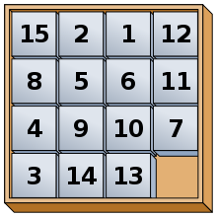
PROBLEM: The “Fifteen Puzzle” is a sliding puzzle that consists of a frame of numbered square tiles in random order with one empty space. The object of the puzzle is to place the tiles in order by making sliding moves that use the empty space.
In this problem, you’ll use an N-by-N grid. The grid will start with one cell empty (we’ll tell you which one) and the other cells will be filled with tiles numbered 1 through N² - 1 starting in the upper left corner. Adjacent tiles can move to the empty space. The diagram at the left below shows the number of each cell in a 4-by-4 grid. The second diagram shows an initial configuration of the puzzle with the cell 7 empty. The third diagram shows moving the 14 tile up (which also causes the 10 tile to move up). The fourth diagram shows moving the 13 tile to the right. The last diagram shows moving the 2 down (which causes the 6 and 9 to also move down). Cell 2 is now empty.

1 | 2 | 3 | 4 |  | 1 | 2 | 3 | 4 |  | 1 | 2 | 3 | 4 |  | 1 | 2 | 3 | 4 |  | 1 |  | 3 | 4
5 | 6 | 7 | 8 |  | 5 | 6 |  | 7 |  | 5 | 6 | 10 | 7 |  | 5 | 6 | 10 | 7 |  | 5 | 2 | 10 | 7
9 | 10 | 11 | 12 |  | 8 | 9 | 10 | 11 |  | 8 | 9 | 14 | 11 |  | 8 | 9 | 14 | 11 |  | 8 | 6 | 14 | 11
13 | 14 | 15 | 16 |  | 12 | 13 | 14 | 15 |  | 12 | 13 |  | 15 |  | 12 |  | 13 | 15 |  | 12 | 9 | 13 | 15

INPUT: There will be 10 lines of input. Each line will contain the size of the grid, the initial location of the empty space, and then a list of tiles that are moved. The example above would be 4, 7, 14, 13, 2 meaning it’s a 4-by-4 grid, cell 7 is initially empty, and then tiles 14, 13, and 2 are moved in that order.

OUTPUT: For each input line, print the final location of the empty space.

FILES ON THE FLASH DRIVES ARE NAMED: as10-sample.txt and as10-test.txt
SAMPLE OUTPUT

- 2
- 10
- 4
- 6
- 7
6. 7
7. 13
8. 4
9. 11
10. 2

SAMPLE INPUT
4 7 14 13 2
4 7 14 13 2 6
5 1 5 15 18 3
3 5 2 3 5 4 2
3 5 2 3 5 4 2 5 8 6
3 7 1 3 8 4
4 5 12 14 3 1 13
4 9 1 4 8 1 12 14 4 2 8
5 21 6 8 18 11 19 4 1 6
3 9 6 5 2 1 4 4 3 6 8 3

