ETRS-SCU
Diagnostic Specification
Version V2.0
SV51-03/04/H/B1 Project
 | Name/Signature |  | Dept Code |  | Date
Author | gubeibei |  |  |  | 2019/12/26
Check
Approved

Revision
Version | Description | Date | Modified by
1.0 | Initial version | 2018/07/02 | gubeibei
1.1 | 增加4.4节，自动泊车的配置字  6.11.5自学习的控制命令是BDFE[纠错] | 2018/08/01 | gubeibei
1.2 | 修改8.3小节，BDF2 和BDF3 占1个字节 ，BDF5和BDF7的信号描述 [纠错] | 2018/11/23 | gubeibei
1.3 | 修改8.2章节，增加3个报文超时的DTC码 | 2019/03/01 | gubeibei
1.4 | 修改6.11.5自学习的肯定响应报文byte5信号的描述  修改了4.4配置字的信号描述  修改8.2,增加两个故障码 | 2019/04/15 | gubeibei
1.5 | 增加6.11.6执行机构的盲控例程  SV51-03/04/H/B1共用此版本规范  修改4.4节配置字  增加了6.11.5适用的项目  增加了6.11.6 章节  修改了8.2 DTC 码  修改了8.4 | 2019/07/03 | Gubeibei
1.6 | 修改了6.11.5，增加了自学习的流程图 | 2019/07/19 | gubeibei
1.7 | 修改了4.4节配置字  修改了6.11.5，增加了自学习的流程图 | 2019/07/23 | gubeibei
1.8 | 修改了6.11.5,自学习的流程修改 | 2019/08/23 | gubeibei
1.9 | 修改6.4章节，删除28 02的子功能。修改8.3章节，全局快照增加时间。 | 2019/09/29 | gubeibei
2.0 | 修改8.2故障码对应的快照描述;  修改8.4 局部快照增加一个； | 2019/12/26 | gubeibei

Contents
1 Introduction 7
1.1 Scope 7
1.2 Confidentiality. 7
1.3 Purpose 7
1.4 Conventions 7
1.5 Related Documents 7
1.6 List of Abbreviations 8
2 ECU Addressing 10
2.1 ECU Addressing 10
3 Network layer and Application requirements 11
3.1 Network Layer Requirements 11
3.2 Application Layer Timing Requirements 11
4 Supported Identifiers 12
4.1 Bitmapped Identifiers 13
4.2 Non Bitmapped Identifiers 14
4.3 Logistic Data 17
4.3.1 PIF-Pointer to current block (F110) 18
4.3.1 PIF - Specific blocks (F111~F11F) 18
4.3.2 EcuBootSwRefNumber(F183) 19
4.3.3 EcuPartNumber(F187) 19
4.3.4 SystemSupplierID (F18A) 20
4.3.5 VIN (F190) 20
4.3.6 EcuHardwareNumber (F191) 20
4.3.7 SupplierEcuHwRefNumber (F192) 20
4.3.1 SupplierEcuSwRefNumber (F194) 21
4.3.2 EcuApplicationSoftwareNumber (F1A0) 21
4.3.3 EcuCalibrationSoftwareNumber (F1A1) 22
4.3.4 VehicleFreatureInformation(F1A8) 22
4.3.5 EcuManufactureDate (F18B) 23
4.3.1 ECU NET Reference Number (F1A2) 23
4.4 Configuration Data 24
5 Negative response 25
5.1 Negative Response code list 25
5.2 Positive and Negative Response Flow 25
6 Supported Diagnostic Services 27
6.1 Diagnostic SessionControl ($10) service 27
6.1.1 Description 27
6.1.2 Request message 27
6.1.3 Positive response message 29
6.1.4 Negative response codes 29
6.1.5 Implementation Rules 30
6.2 ECUReset ($11) service 30
6.2.1 Description 30
6.2.2 Request message 30
6.2.3 Positive response message 30
6.2.4 Negative response codes 31
6.2.5 Implementation Rules 31
6.3 SecurityAccess ($27) service 31
6.3.1 Description 31
6.3.2 Request message 32
6.3.3 Positive response message 33
6.3.4 Negative response codes 33
6.3.5 Implementation Rules 34
6.4 CommunicationControl ($28) service 34
6.4.1 Description 34
6.4.2 Request message 34
6.4.3 Positive response message 35
6.4.4 Negative response codes 35
6.4.5 Implementation Rules 36
6.5 TesterPresent ($3E) service 36
6.5.1 Description 36
6.5.2 Request message 36
6.5.3 Positive response message 36
6.5.4 Negative response codes 36
6.5.5 Implementation Rules 36
6.6 ControlDTCSetting ($85) service 37
6.6.1 Description 37
6.6.2 Request message 37
6.6.3 Positive response message 37
6.6.4 Negative response codes 37
6.6.5 Implementation Rules 38
6.7 ReadDataByIdentifier ($22) service 38
6.7.1 Description 38
6.7.2 Request message 39
6.7.3 Positive response message 39
6.7.4 Negative response codes 39
6.7.5 Implementation Rules 40
6.8 WriteDataByIdentifier ($2E) service 40
6.8.1 Description 40
6.8.2 Request message 40
6.8.3 Positive response message 40
6.8.4 Negative response codes 40
6.8.5 Implementation Rules 41
6.9 ClearDiagnosticInformation ($14) service 41
6.9.1 Description 41
6.9.2 Request message 41
6.9.3 Positive response message 42
6.9.4 Negative response codes 42
6.9.5 Implementation Rules 42
6.10 ReadDTCInformation ($19) service 42
6.10.1 Description 42
6.10.2 Request message 42
6.10.3 Positive response message 45
6.10.4 Negative response codes 47
6.10.5 Implementation Rules 47
6.11 RoutineControl ($31) service 47
6.11.1 Description 47
6.11.2 Request message 47
6.11.3 Positive response message 49
6.11.4 Negative response codes 49
6.11.5 Actuator selflearning control rouinte 50
6.11.6 Actuator blind control rouinte 53
6.11.7 Implementation Rules 54
6.12 RequestDownload ($34) service 54
6.12.1 Description 54
6.12.2 Request message 54
6.12.3 Positive response message 55
6.12.4 Negative response codes 56
6.12.5 Implementation Rules 57
6.13 TransferData ($36) service 57
6.13.1 Description 57
6.13.2 Request message 57
6.13.3 Positive response message 58
6.13.4 Negative response codes 58
6.13.5 Implementation Rules 59
6.14 RequestTransferExit ($37) service 59
6.14.1 Description 59
6.14.2 Request message 59
6.14.3 Positive response message 60
6.14.4 Negative response codes 60
6.14.5 Implementation Rules 61
6.15 Other services 61
7 Sequence of flash programming 62
7.1 General requirements 62
7.1.1 Data transfer mechanism 62
7.1.2 Functional requirement 62
7.1.3 ECU Hardware design requirement 62
7.1.4 Erase and programming routines requirement 62
7.1.5 Logistic data identifier 62
7.1.6 Flash file format requirement 62
7.2 Communication requirements 62
7.2.1 CAN ID requirements 62
7.2.2 Frame padding requirements 62
7.2.3 Network layer timing requirements 63
7.2.4 Flow control mechanism requirements 63
7.3 Safty-related requirements 63
7.3.1 Pre-condition for programming 63
7.3.3 Input/output port initialization 63
7.3.4 Fault tolerance mechanism 64
7.3.5 Programming counter 64
7.3.6 Detection of the data correctness during programming 64
7.3.7 Programming integrity check 64
7.3.8 Programming dependency check 64
7.3.9 Software validation 64
7.4 Session management 65
7.6 Diagnostic service requirements 66
7.7 Programming process 67
8 Fault Detection 69
8.1 General Condition 69
8.2 Supported DTC 69
8.3 Supported Global Snapshot Data 70
8.4 Supported Local Snapshot Data 72
8.5 Supported Extended Data 73

Introduction

Scope
This document covers only CVTC SV51-03 ETRS-SCU project.

Confidentiality.
The information in this specification is in strict confidence and should only be divulged on a need to know basis.

Purpose
This document details the diagnostic routines, identifiers and DTCs that are specific to the SCU.
This specification is to be used in conjunction with the ECU general diagnostic specification, referred to document 8.

Conventions
All values relating to messages are in hexadecimal unless stated otherwise.

Related Documents
No | Reference | Title
1 | ISO 11898–1 | Road Vehicles – Interchange of Digital Information CAN for High Speed Communications
2 | ISO 15765–1 | Road Vehicles – Diagnostic on Controller Area Networks (CAN)  Part 1 Physical Layer
3 | ISO 15765–2 | Road Vehicles – Diagnostic on Controller Area Networks (CAN)  Part 2 Data Link Layer
4 | ISO 15765–3 | Road Vehicles – Diagnostic on Controller Area Networks (CAN)  Part 3 Application Layer
5 | ISO 15765–4 | Road Vehicles – Diagnostic on Controller Area Networks (CAN)  Part 4 Requirement for emission-related system
6 | ISO 15031–6 | Communication between vehicle and external equipment for emissions-related diagnostics — Part 6: Diagnostic trouble code definitions
7 | ISO 14229-1 | Unified Diagnostic Services
8 | CVTC 27033-2013 | Technical Requirement for ECU Diagnostic Development
9 | CVTC 27032-2013 | Technical requirement for ECU programming

Table 1-1: Reference Documents

List of Abbreviations
Abbreviations | Description
DTC | Diagnostic Trouble Code
I/O | Input/Output
OBD | On-Board Diagnostics
HEX | Hexadecimal
RAM | Random Access Memory
ROM | Read Only Memory
EEPROM | Electrically Erasable Programmable Read Only Memory
SID | Service Identifier
PHYS | Physically Addressing Mode
FUNC | Functionally Addressing Mode
NRC | Negative Response Code
CS | Checksum Byte
Cvt | Convention
LID | Local Identifier
PID | Parameter Identifier
ID | Identifier
PIF | Programming Information Field
BCD | Binary-Coded Decimal
DID | Data identifier
RID | Routine identifier
CRC | Cyclic redundancy check
DSC | Diagnostic session control
PEF | Programming entry flag
SCS | Software compatibility status
SIS | Software Integrity status
SVF | Software valid flag
CAN | Controller Area Network
BCM | Body Control Management
EMS | Engine Management System
TCU | Transmission Control Unit
IPK | Instrument Park
TPMS | Tire Pressure Management System
ESP | Electronic Stability Program
ABS | Antilock Braking System
TCCU | Transfer Case Control Unit
SRS | Supplemental Restraint System
SAS | Steering Angle Sensor
HVAC | Heating Ventilation and Air Conditioning
AFS | Adaptive Front-lighting System
Info | Infomation
TBOX | Telematics Box
LDW | Lane Departure Warning
BSD | Blind Spot Detect
GW | Gateway
EPS | Electronic Power Steering
EPB | Electronic Parking Brake
ADAS | Advanced Driver AssistantSystem
SCM | Seat Control Module

Table 1-2: Abbreviations

ECU Addressing

ECU Addressing
The ECU Addresses supported by the ECU are:
CAN ID | Description
736 | Physically Addressed Diagnostic Request
7B6 | Physically Address ECU Response
7DF | Functional Addressed Request

Table 2-3: ECU Addresses
The ECU must respond with a physically addressed response regardless of if the request was functionally or physically addressed.

Network layer and Application requirements

Network Layer Requirements
The parameter set described below should be supported: Please refer to reference documents for definitions.
Parameter | SAIC Motor Enhanced Diagnostics
Parameter | Application |  | Bootloader
Parameter | Time out | Performance value | Time out | Performance value
N_As | 25ms | — | 25ms | —
N_Ar | 25ms | — | 25ms | —
N_Bs | 150ms | — | 25ms | —
N_Br | — | (N_Br+N_Ar)＜70ms | — | (N_Br+N_Ar)＜2ms
N_Cs | — | (N_Cs+N_As) ＜70ms | — | (N_Cs+N_As) ＜2ms
N_Cr | 150ms | — | 25ms | —
Blocksize (BS) | 8 |  | 8
STmin | 20 |  | 0

Table 3-1: Network Parameters

Application Layer Timing Requirements
The parameter set described below should be supported: Please refer to reference documents for definitions.
Parameters | Description | Min. | Max.
P2_{CAN_Server} | Performance requirement for the server to start with the response message after the reception of a request message. | 0 | 50ms
P2*_{CAN_Server} | Performance requirement for the server to start with the response message after the transmission of a negative response message with response code 0x78 (enhanced response timing). | 0 | 5000ms
S3_{Server} | Time for the server to keep a diagnostic session other than the defaultSession active while not receiving any diagnostic request message. | N/A | 5000ms

Table 3-2: Application Parameters

Supported Identifiers
This section defines the identifiers (IDs) that are to be supported for the service ReadDataByIdentifier (SID 22), WriteDataByIdentifier (SID 2E) and IOControlByIdentifier (SID 2F).
Identifiers may be used to read and specify ECU status and I/O states as well as internal constants or variables.
The Services in which each identifier is supported is specified in the Columns title “Accessed Via”.
The Services are identified by their hexadecimal SID (Service Identifier), as per ISO 14229. The security access level require to access the identifier is specified by a numeric value.

Value | Security Access Level
0 | No Security Access Required
1 | Extended Security Level
2 | Programming Security Level
3 | Immobilization Security Level

Table 4-4: Identifier Access Levels

Bitmapped Identifiers

ID No | Signal/ Variable name | Accessed via |  |  | Byte | Bit | Supported in |  |  | Bit Description | 0 | 1
ID No | Signal/ Variable name | 22 | 2E | 2F | Byte | Bit | Application | Bootloader |  | Bit Description | 0 | 1
BDE0 | 档位判断的信号 | ✓0 | × | × | 1 | 0 | √0 |  | × | GSM Unlock | 未按Unlock | 按Unclock
 |  |  |  |  |  | 1 |  |  | × | GSM Park 按键 | 未按 | 按
 |  |  |  |  |  | 2 |  |  | × | GSM告警 | 无 | 有
 |  |  |  |  |  | 3 |  |  | × | 主驾车门 | 未关 | 关
 |  |  |  |  |  | 4 |  |  | × | 主驾安全带 | 未系 | 系
 |  |  |  |  |  | 5 |  |  | × | 车速方向 | 前进或静止 | 后退
 |  |  |  |  |  | 6 |  |  | × | KL15状态 | OFF | ON
 |  |  |  |  |  | 7 |  |  | × | 刹车 | 未踩 | 踩
BDE1 | 告警拒绝提示信息 | ✓0 | × | × | 1 | 0 | √0 |  | × | 换挡拒绝因未按Unlock | 未请求 | 请求
 |  |  |  |  |  | 1 |  |  | × | 换挡拒绝因未踩刹车 | 未请求 | 请求
 |  |  |  |  |  | 2 |  |  | × | 换挡拒绝因车速 | 未请求 | 请求
 |  |  |  |  |  | 3 |  |  | × | 换挡拒绝因转速 | 未请求 | 请求
 |  |  |  |  |  | 4 |  |  | × | SCU一般故障 | 未请求 | 请求
 |  |  |  |  |  | 5 |  |  | × | SCU严重故障 | 未请求 | 请求
 |  |  |  |  |  | 6 |  |  | × | SCU自动泊车工作模式 | 否 | 是
 |  |  |  |  |  | 7 |  |  | × | EPB驻车请求 | 未请求 | 请求
Table 4-5: Bitmapped Identifier table

Non Bitmapped Identifiers
ID No | Short Name(or Signal / variable Name) | Accessed via |  |  | Bytes | Data type | Supported in |  | Description | Scaling | Offset | Min | Max | Unit
ID No | Short Name(or Signal / variable Name) | 22 | 2E | 2F | Bytes | Data type | Application | Bootloader
BDF0 | 执行器传感器1物理位置 | ✓0 | × | × | 2 | unsigned | √0 | × | 执行器传感器1物理位置 | 1/128 | 0 | 0 | 100 | %
BDF1 | 执行器传感器2物理位置 | ✓0 | × | × | 2 | unsigned | √0 | × | 执行器传感器2物理位置 | 1/128 | 0 | 0 | 100 | %
BDF2 | 执行器传感器1供电电源 | ✓0 | × | × | 1 | unsigned | √0 | × | 执行器传感器1供电电源 | 1/10 | 0 | 0 | 25 | V
BDF3 | 执行器传感器2供电电源 | ✓0 | × | × | 1 | unsigned | √0 | × | 执行器传感器2供电电源 | 1/10 | 0 | 0 | 25 | V
BDF4 | 当前档位 | ✓0 | × | × | 1 | unsigned | √0 | × | 0：P  1：R  2：N  3：D  4-15：ERROR | 1 | 0 | 0 | 15
BDF5 | GSM换挡杆位置信息 | ✓0 | × | × | 1 | unsigned | √0 | × | 0x0: A+2  0x1:A+1  0x2:A0  0x3:A-1  0x4:A-2  0x5:M+1  0x6:S  0x7:M-1  0x8:Invalid | 1 | 0 | 0 | 8
BDF6 | 执行机构档位信号 | ✓0 | × | × | 1 | unsigned | √0 | × | 0x0：Reserve  0x1：Position Detected Park  0x2：Position Detected Reverse  0x3：Position Detected Neutral  0x4：Position Detected Drive  0x5：Position Detected Between P&R  0x6：Position Detected Between R&N  0x7：Position Detected Between N&D  0x8：Position Detected Out of Bounds  0x9：Position Detected Release | 1 | 0 | 0 | 15
BDF7 | SCU请求档位 | ✓0 | × | × | 1 | unsigned | √0 | × | 0x0:P  0x1:R  0x2:N  0x3:D  0x4:S  0x5:M  0x6:M-  0x7:M+  0x8-0xF:ERROR | 1 | 0 | 0 | 15
BDF8 | 接收的车速 | ✓0 | × | × | 2 | unsigned |  |  | 车速值 | 0.015625 | 0 | 0 | 512 | Km/h
BDF9 | 接收的转速 | ✓0 | × | × | 2 | unsigned |  |  | 转速 | 0.25 | 0 | 0 | 16383 | Rpm

Table 4-6: Non Bitmapped Identifier table

Logistic Data
ID | Name | Writing Privilege | Updated by programming | Description | Data Type
F110 | PIF_PointerToCurrentBlock | √2 | N | PIF-Pointer to current block | Mixed  (16 bytes)
F111  ~  F11F | PIF - Specific blocks^{b} | × | N | PIF - Specific blocks | Mixed  (16 bytes)
F183 | EcuBootSwRefNumber | × | N | ECU Bootloader Software Reference Number | ASCII  (10 bytes)
F187 | EcuPartNumber | √2 | N | ECU Part Number | Mixed  (1 ASCII+5 BCD)
F18A | SystemSupplierID | × | N | System Supplier Identifier | Mixed  (1 ASCII+5 BCD)
F190 | VIN | √1 | N | VIN | ASCII  (17 bytes)
F191 | EcuHardwareNumber | × | N | ECU Hardware Number | Mixed  (1 ASCII+5 BCD)
F192 | SupplierEcuHwRefNumber | × | N | Supplier ECU Hardware Reference Number | ASCII  (10 bytes)
F194 | SupplierEcuSwRefNumber | × | N | Supplier ECU Software Reference Number | ASCII  (10 bytes)
F1A0 | EcuApplicationSoftwareNumber | × | Y | ECU Application Software Number | Mixed  (1 ASCII+5 BCD)
F1A1 | EcuCalibrationSoftwareNumber | × | Y | ECU Calibration Software Number | Mixed  (1 ASCII+5 BCD)
F1A2 | EcuNetReferenceNumber | × | Y | ECU NET Reference Number | Mixed  (1 ASCII+5 BCD)
F1A8 | VehicleFreatureInformation | √1 | N | Vehicle Feature Information | HEX  (20 bytes)
F18B | EcuManufactureDate | × | N | ECU Manufacture Date | BCD  (3 BCD)
Attention:
a “√”means the identifier(s) can be written viaWriteDataBy(Local)Identifier service; The number after it means required security level, “1” represents extended security level and “2” represent programming security level. “×”means the identifier(s) cannot be written via WriteDataBy(Local)Identifier service.
b If the corresponding ROM memory size is limit, and calibration files can’t be filled, this function (F111~F11F) shall not be realized.

Table 4-7: Logistic Identifier table

PIF-Pointer to current block (F110)
WriteDataByIdentifier service (0x2E) is not required for F111 to F11F as data is written via F110, and ECU determines location. The format is defined as follows.
ECU Part Number, 5 bytes, 1 ASCII +4BCD format;
Tester Reference Number, 6 bytes, HEX format;
Odometer Reading, 3 bytes, HEX format;
Reserved Status, 2 bytes, HEX format.
The example in Ref.8 is as follows.
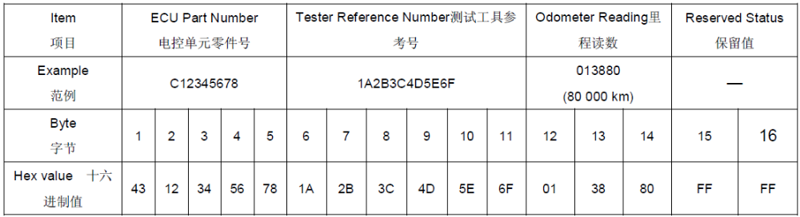
Because of the ECU’s EEPROM space limit, this ECU supports F110, and supports F111~F11F.

PIF - Specific blocks (F111~F11F)
F111 - F11F are the blocks used to store the PIF fields. To write a PIF field, F110 is used. If this is the first block then the data will be stored at F111. If another field is written (also with F110), then F112 should be populated and so on. Reading F110 shall always return that last PIF that was written. If all available blocks are populated, then F112 shall be overwritten, then F113 and so on. PIF write process is shown in as follows:
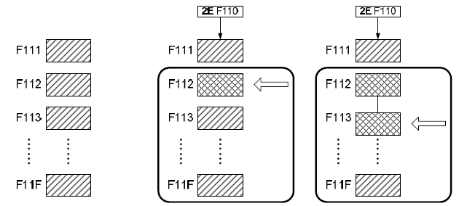
When the F115 is filled and then sid-2E(F110) is excuted, the F11F will filled with F114 and F111 will filled with origin F110, and F110 will be set by 2E(F110) service.

EcuBootSwRefNumber(F183)
Byte No | Description | Length | EnCoding
1~7 | Reserved | 8Byte | ASCII
8 | B | 1Byte | ASCII
9 | Developing: DOT  SOP: NULL | 1Byte | ASCII
10 | Developing: A、B、C、D……  SOP: NULL | 1Byte | ASCII

EcuPartNumber(F187)
The ECU part number is a part number that uniquely identifies the collection of software and hardware. This identifier shall be updated via WriteDataBy(Local)Identifier service by the tester after programming is performed that results in a software module changing.
The format is defined as follows. ECU Part Number, 6 bytes, 1 ASCII +5 BCD format. The first 5 bytes is the ECU part number in BOM. The last BCD is beginning at 00. The example in Ref.8 is as follows.
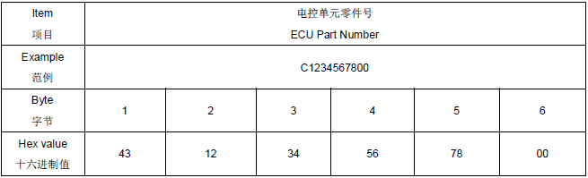

SystemSupplierID (F18A)
This identifier is used to identify the supplier. This identifier shall be written to during the ECU manufacturing process and shall not be able to be modified during the vehicle life. The content could be defined by ECU DRE and shall be documented in Component Diagnostic Specification.
As described in the Ref.8 Table A-1, The supplier ID’s size is 6 bytes .

VIN (F190)
The VIN shall be written when an ECU is first fitted to a vehicle, either manufacturing or in service as a replacement part. Once written, the data shall not be able to be overwritten. The format is defined as follows.
VIN, 17 bytes, ASCII format
The example in Ref.8 is as follows.
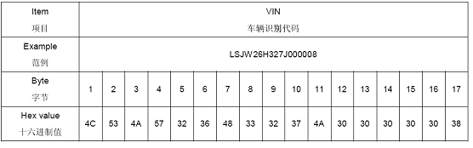

EcuHardwareNumber (F191)
This identifier shall be written to during the ECU manufacturing process and shall not be able to be modified during the vehicle life. The format is defined as follows.
ECU Hardware Number, 6 byte, 1 ASCII +5 BCD format. The first 5 bytes is the ECU hardware number in BOM. The last BCD is beginning at 00.
The example in Ref.8 is as follows.
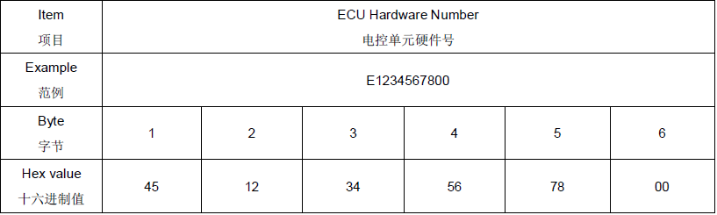

SupplierEcuHwRefNumber (F192)
This identifier is the hardware reference of the ECU supplier. This identifier shall be written to during the ECU manufacturing process and shall not be able to be modified during the vehicle life.
The content could be defined by supplier and shall be documented in Component Diagnostic Specification.
Byte No | Description | Length | EnCoding（ASCII）
1 | Supplier ECU Hardware Number High Byte | 1 Byte | 0xB
2 |  | 1 Byte | 0x1
3 |  | 1 Byte | 0x4
4 | Hardware version High byte | 1 Byte | 0x00-0xFF
5 | Hardware version Low byte | 1 Byte | 0x00-0xFF
6 | 1:Hardware 2:Software | 1 Byte | 1
7 |  | 1 Byte | 0xFF(default)
8 |  | 1 Byte | 0xFF (default)
9 |  | 1 Byte | 0xFF (default)
10 | Supplier ECU Hardware Low Byte | 1 Byte | 0xFF(default)

SupplierEcuSwRefNumber (F194)
This identifier is the application software reference of the ECU supplier. This identifier shall be updates automatically during the programming process and the supplier ECU software reference number shall be embedded in the ECU application software file.
The content could be defined by supplier and shall be documented in Component Diagnostic Specification.
Byte No | Description | Length | EnCoding
1 | Supplier ECU Software High Byte | 1 Byte | 0xB
2 |  | 1 Byte | 0x1
3 |  | 1 Byte | 0x4
4 | Software version High byte | 1 Byte | 0x00-0xFF
5 | Software version Low byte | 1 Byte | 0x00-0xFF
6 | 1:Hardware 2:Software | 1 Byte | 2
7 |  | 1 Byte | 0xFF (default)
8 |  | 1 Byte | 0xFF (default)
9 |  | 1 Byte | 0xFF (default)
10 | Supplier ECU Software Low Byte | 1 Byte | 0xFF (default)

EcuApplicationSoftwareNumber (F1A0)
This identifier shall be updated automatically during the programming process and the ECU application software number shall be embedded in the ECU application software file.
The format is defined as follows.
ECU Application Software Number, 6 bytes, 1 ASCII +5 BCD format. The first 5 bytes is the ECU application software number in BOM. The last BCD is beginning at 00.
The example in Ref.8 is as follows.
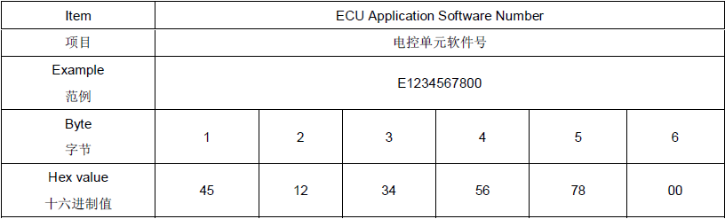

EcuCalibrationSoftwareNumber (F1A1)
This identifier shall be updated automatically during the programming process and the ECU calibration software number shall be embedded in the ECU calibration software file.
The format is defined as follows.
ECU Calibration Software Number, 6 bytes, 1 ASCII +5 BCD format. The first 5 bytes is the ECU calibration software number in BOM. The last BCD is beginning at 00.
The example in Ref.8 is as follows.
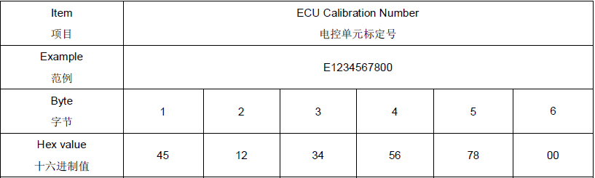

VehicleFreatureInformation(F1A8)
The identifier shall be written to during the vehicle manufacturing process and the maintenance process during the vehicle life.
The format is defined as follows.
Vehicle Feature Information, 20 bytes, HEX format.
The example in Ref.8 is as follows.
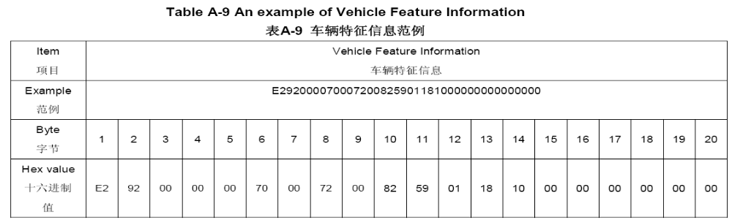

EcuManufactureDate (F18B)
This identifier is the manufacture date of ECU. This identifier shall be written to during the ECU manufacturing process and shall not be able to be modified during the vehicle life.
The format is defined as follows.
ECU Manufacture Date, 3 bytes, BCD format.
The example in Ref.8 is as follows.
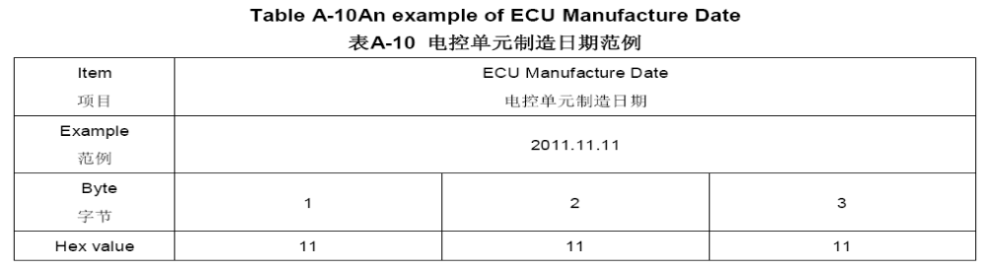

ECU NET Reference Number (F1A2)
This identifier shall be updated automatically during the programming process and the ECU NCF reference number shall be embedded in the ECU application software file.
The format is defined as follows.
ECU NET Reference Number, 6 bytes, 1 ASCII +5 BCD format. The first 5 bytes is the ECU NET reference number in BOM. The last BCD is beginning at 00.
An example is shown in Ref.8.

Configuration Data
ID No | ID name | Accessed via |  |  | Byte | Bit | Supported in |  | Vaule | Bit Description | UC String
ID No | ID name | 22 | 2E | 2F | Byte | Bit | Application | Bootloader | Vaule | Bit Description | UC String
C001 | 车身结构 | 0 | 1 | × | 1 | 0-7 | √1 | × | 0x00 | Minivan | 410J
 |  |  |  |  |  |  |  |  | 0x01 | Crossover | 410K
C001 | 车型系列细分 | 0 | 1 | × | 2 | 0-7 | √1 | × | 0x00 | 经典版 | 450H
 |  |  |  |  |  |  |  |  | 0x01 | 舒适版 | 450J
 |  |  |  |  |  |  |  |  | 0x02 | 豪华版 | 450K
 |  |  |  |  |  |  |  |  | 0x03 | 精英版 | 450L
 |  |  |  |  |  |  |  |  | 0x04 | 智驾版 | 450N
C001 | 变速箱型号 | 0 | 1 | × | 3 | 0-7 | √1 | × | 0x00 | 上汽齿6MT | E00G
 |  |  |  |  |  |  |  |  | 0x01 | 单级减速器 | E00L
 |  |  |  |  |  |  |  |  | 0x02 | 上汽齿DCT | E00S
 |  |  |  |  |  |  |  |  | 0x03 | 上汽齿eM18 | E00T
C001 | 遥控召唤 | 0 | 1 | × | 4 | 0-7 | √1 | × | 0x00 | 带遥控召唤（IECU+ADAS） | U09A
 |  |  |  |  |  |  |  |  | 0x01 | 带遥控记忆泊车（ADAS） | U09B
 |  |  |  |  |  |  |  |  | 0x02 | 无遥控召唤功能 | U09X
C002 | 自动泊车系统 | 0 | 1 | × | 1 | 0-7 | √1 | × | 0x00 | 自动泊车辅助系统 | U13A
 |  |  |  |  |  |  |  |  | 0x01 | 无自动泊车辅助系统 | U13x

Negative response

Negative Response code list
Each diagnostic service specifies applicable negative response codes but the diagnostic service implementation in the ECU may also utilize additional and applicable negative response codes specified in Table 5-1
Table 5-8 Negative response codes
HEX | ResponseCode
10 | generalReject
11 | serviceNotSupport
12 | subFunctionNotSupported
13 | incorrectMessageLength
14 | responseTooLong
21 | busyRepeatRequest
22 | conditionsNotCorrect
24 | requestSequenceError
26 | failurePreventsExecutionOfRequestedAction
31 | requestOutOfRange
33 | securityAccessDenied
35 | invalidKey
36 | exceedNumberOfAttempts
37 | requiredTimeDelayNotExpired
72 | generalProgrammingFailure
78 | requestCorrectlyReceived-ResponsePending
7E | subFunctionNotSupportedInActiveSession
7F | serviceNotSupportedInActiveSession
83 | enginelsRunning
84 | engineIsNotRunning
90 | shifterLeverNotInPark
92 | voltageTooHigh
93 | voltageTooLow

Positive and Negative Response Flow

Figure 5-1 Response Message Flow

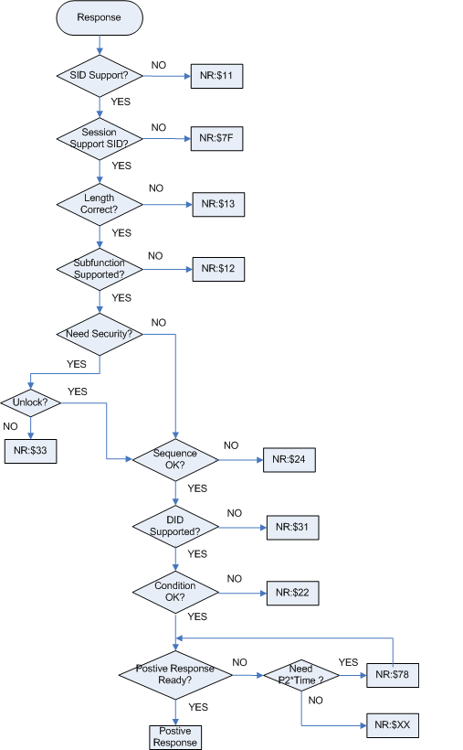

Supported Diagnostic Services
Diagnostic Service Name | REQ SID  (Hex) | Supported
Diagnostic Service Name | REQ SID  (Hex) | Default |  | Extended |  | Programming
Diagnostic Service Name | REQ SID  (Hex) | PHYS | FUNC | PHYS | FUNC | PHYS | FUNC
DiagnosticSessionControl | 10ª | √0 | √0 | √0 | √0 | √0 | √0
EcuReset | 11 | √0 | √0 | √1 | √0 | √2 | √0
SecurityAccess | 27 | × | × | √0 | × | √0 | ×
CommunicationControl | 28ª | × | × | √0 | √0 | × | ×
TesterPresent | 3Eª | √0 | √0 | √0 | √0 | √0 | √0
ControlDTCSetting | 85ª | × | × | √0 | √0 | × | ×
ReadDataByIdentifier | 22 | √0 | √0 | √0 | √0 | √0 | √0
WriteDataByIdentifier | 2E | × | × | √1/√3 | × | √2 | ×
ClearDiagnosticInformation | 14 | √0 | √0 | √0 | √0 | × | ×
ReadDTCInformation | 19 | √0 | √0 | √0 | √0 | × | ×
RoutineControl | 31 | × | × | √1/√3 | × | √2 | ×
RequestDownload | 34 | × | × | × | × | √2 | ×
TransferData | 36 | × | × | × | × | √2 | ×
RequestTransferExit | 37 | × | × | × | × | √2 | ×
√0: Without security access
√1: With security access level 1
√2: With security access level 2
√3: With security access level 3
×: Not supported
2) a：Support Sub-function SuppressPosRspMsgIndicationBit
Attention: The content of the table which is different with the SVXX specification spec.( Ref.8) is red font, and have been accepted by customer.

Diagnostic SessionControl ($10) service

Description
The DiagnosticSessionControl service is used to transfer the active session between all the supported diagnostic sessions of an ECU. A diagnostic session enables a specific set of diagnostic services and functionality in an ECU. Some diagnostic services are restricted to be used in a specific session.

Request message
Table 6-9 Request message
Data Byte | Parameter name | Cvt | Hex Value
1 | Request Service Id | M | 10
2 | sub-function = [  diagnosticSessionType ] | M | 01,02,03
The sub-function parameter diagnosticSessionType is used by the DiagnosticSessionControl service to activate the specific diagnostic session in the ECU.

Table 6-10 Definition of diagnosticSessionType
Hex (bit 6-0) | Description | Cvt
01 | defaultSession  This diagnostic session shall always be started when an ECU power up or  reset. | M
02 | programmingSession  This diagnostic session enables all diagnostic services required to support  the memory programming of an ECU. | M
03 | extendedDiagnosticSession  This diagnostic session enables all diagnostic services restricted to be used  in the defaultSession | M
a If an ECU with a resident Bootloader has received a DiagnosticSessionControl ($10) service with sessionType equal to programmingSession, the ECU shall enter the programming session in Bootloader within 500 ms. If an ECU runs in Bootloader when it receives the DiagnosticSessionControl ($10) service with sessionType equal to defaultSession or a session layer timeout occurs, and valid application software is present for both cases, then the ECU shall restart the application software. If an ECU without Bootloader has received a DiagnosticSessionControl ($10) service with sessionType equal to programmingSession, the ECU shall get into the Quiet Mode (the ECU will inhibit logging DTCs, stop normal network communication and network management communication in the quiet mode) within 100 ms and maintain this state until it leaves the programming session. The programming session shall only be left via an ECUReset ($11) service requested by a tester, a DiagnosticSessionControl ($10) service with sessionType equal to defaultSession, or the session layer timing parameter S3server timeout in the ECU.
The following Figure shows diagnostic session mode control transition.
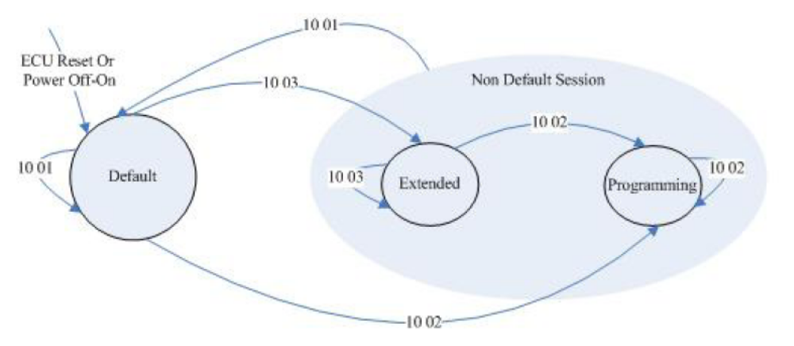

Positive response message
Table 6-11 Request message
Data Byte | Parameter name | Cvt | Hex Value
1 | Response Service Id | M | 50
2 | Sub-Function Parameter : Diagnostic Session Type | M | 01,02,03
3  4  5  6 | sessionParameterRecord[ ] = [  P2CAN_Server_max(high byte)  P2CAN_Server_max(low byte)  P2*CAN_Server_max(high byte)  P2*CAN_Server_max(low byte) ] | M  M  M  M | 00-FF  00-FF  00-FF  00-FF
The parameter sessionParameterRecord in Table 6-4 is defined for this service.

Table 6-12 Definition of sessionParameterRecord
Paramete | # of bytes | Resolution | Min. Val. | Max. Val.
P2CAN_Server_max | 2 | 1ms | 0ms | 65535ms
P2*CAN_Server_max | 2 | 10ms | 0ms | 655350ms

Negative response codes
Table 6-13 Negative response codes
Hex value | Description | Cvt
13 | incorrectMessageLength  The length of the message is wrong. | M
12 | subFunctionNotSupported  Send if the sub-function parameter in the request message is not supported | M
22 | conditionsNotCorrect  This code shall be returned if the criteria for the DiagnosticSessionControl request are not met. | M
7E | subFunctionNotSupportedInActiveSession  Attention: Add this NRC, which is used when request jump from Programming Session to Extend Session. | M
78 | requestCorrectlyReceived-ResponsePending | U

Implementation Rules
ECU can get into Programming session only when the vehicle speed is 0 kmph.

ECUReset ($11) service

Description
The ECUReset service is used to request an ECU to effectively perform a reset operation based on the content of the resetType parameter value. The ECUReset positive response message shall be sent before the reset is executed in the ECU. The ECU reset operation shall be executed.

Request message
Table 6-14 Request message

Data Byte | Parameter name | Cvt | Hex Value
1 | Request Service Id | M | 11
2 | sub-function = [  resetType] | M | 01,02,03
The sub-function parameter resetType is used by ECUReset service to describe how the ECU will perform the reset operation.
Table 6-15 Definition of resetType
Hex value | Description | Cvt
01 | hardReset | M
02 | KL15Reset | U
03 | softReset | U

Positive response message
Table 6-16 Positive response message of ECUReset
Data Byte | Parameter name | Cvt | Hex Value
1 | Response Service Id | M | 51
2 | sub-function = [resetType] | M | 01,02,03

Negative response codes
Table 6-17 Negative response codes
Hex value | Description | Cvt
7F | serviceNotSupportedInActiveSession  This code shall be returned because the ECU does not support the requested service in the session currently active. | M
13 | incorrectMessageLength  The length of the message is wrong. | M
12 | subFunctionNotSupported  Send if the sub-function parameter in the request message is not supported | M
33 | securityAccessDenied  This code shall be sent if the requested reset is secured and the server is not in an unlocked state. | M
22 | conditionsNotCorrect  This code shall be returned if the criteria for the ECUReset request are not met. | M
78 | requestCorrectlyReceived-ResponsePending

Implementation Rules
ECU can execute reset only when the vehicle speed is 0 kmph.

SecurityAccess ($27) service

Description
Supplier will implement CVTC security access algorithm which CVTC provides.
The SecurityAccess service is used to provide a means to access data or diagnostic services which have restricted access for security, emission or safety reasons. The security concept uses a seed and key algorithm. The seed and key are each 32 bits numbers (4 bytes).
ECU shall activate the delay mechanism under these two situations (refer to Annex D).
a) Two false access attempts has been reached;
b) When ECU is powered up/reset and a previously performed SecurityAccess service hasfailed due to a single false access attempt.
If the delay timer is less than 10 s, a negative respond to a SecurityAccess “requestSeed” message shall send to the tester. Once ECU is unlocked successfully with a valid key, the delay mechanism shall be inactivated.

Request message
The format of the SecurityAccess request service used to get the “Seed” from the ECU is shown in Table.
Table 6-18 Request message of SecurityAccess – requestSeed
Data Byte | Parameter name | Cvt | Hex Value
1 | Request Service Id | M | 27
2 | sub-function = [  securityAccessType = requestSeed ] | M | 01,05,09
The format of the SecurityAccess request service used to send the “Key” to the ECU is shown in Table.
Table 6-19 Request message of SecurityAccess – sendKey
Data Byte | Parameter name | Cvt | Hex Value
1 | Request Service Id | M | 27
2 | sub-function = [  securityAccessType = requestSeed] | M | 02,06,0A
3  4  5  6 | securityKey = [  key#1 (byte 1)  key#2 (byte 2)  key#3 (byte 3)  key#4 (byte 4) ] | M  M  M  M | 00-FF  00-FF  00-FF  00-FF
The sub-function parameter securityAccessType indicates to the ECU the step in progress for this ECU. If an ECU supports different levels of security, each level shall be identified by the requestSeed value, which has a fixed relationship to the sendKey value. These parameters defined as valid for the request message of this service are indicated in Table.
Security Level | requestSeed | sendKey | Applicable session | CVT
Extended security level | 01 | 02 | ExtendedDiagnosticSession | M
Programming security level | 05 | 06 | ProgrammingSession | Cª
Immobilizer security level | 09 | 0A | ExtendedDiagnosticSession | C^{b}
a Programming security level is applicable for ECU programming and shall only be supported in Bootloader.
b Immobilizer security level is applicable only for ECUs related immobilizer.

Positive response message
Table 6-20 Positive response message definition – requestSeed
Data Byte | Parameter name | Cvt | Hex Value
1 | Response Service Id | M | 67
2 | sub-function = [  securityAccessType=requestSeed ] | M | 01,05
3  4  5  6 | securitySeed = [  seed#1 (byte 1)  seed#2 (byte 2)  seed#3 (byte 3)  seed#4 (byte 4) ] | M  M  M  M | 00-FF  00-FF  00-FF  00-FF
The values of the parameter seed are not defined in this standard except for two values as below.
a) Value 0x00000000 indicates to the tester that the ECU is unlocked;
b) If the ECU memory has been erased, value 0xFFFFFFFF may occur and shall not be used as a seed.
Table 6-21 Positive response message definition – requestSeed
Data Byte | Parameter name | Cvt | Hex Value
1 | Response Service Id | M | 67
2 | sub-function = [  securityAccessType= sendKey] | M | 02,06

Negative response codes
Table 6-22 Negative response codes
Hex value | Description | Cvt
7F | serviceNotSupportedInActiveSession  This code shall be returned because the ECU does not support the requested service in the session currently active. | M
13 | incorrectMessageLength  The length of the message is wrong. If the request message length of theSecurityAccess – sendKey service is wrong, the negative response code 0x35 shall be returned. | M
12 | subFunctionNotSupported  Send if the sub-function parameter in the request message is not supported | M
24 | requestSequenceError  Send if the “sendKey” sub-function is received without first receiving a “requestSeed” request message. | M
22 | conditionsNotCorrect  This code shall be returned if the criteria for the request SecurityAccess are not met. | M
35 | invalidKey  Send if an expected “sendKey” sub-function value is received and the value of the key does not match the ECU’s internally calculated key. | M
36 | exceedNumberOfAttempts  Send if the delay timer is active due to exceeding the maximum number of allowed false access attempts. | M
37 | requiredTimeDelayNotExpired  Send if the delay timer is active and a request is transmitted. | M
78 | requestCorrectlyReceived-ResponsePending

Implementation Rules
No special implementation rules.

CommunicationControl ($28) service

Description
This service is used to switch on/off the transmission and/or the reception of certain messages of an ECU.

Request message
Table 6-23 Request message

Data Byte | Parameter name | Cvt | Hex Value
1 | Request Service Id | M | 28
2 | sub-function = [  controlType ] | M | 00,01,03
3 | communicationType | M | 01,02,03
The parameters defined for this service are listed below.
Table 6-24 Definition of controlType
Hex (bit 6-0) | Description | Cvt
00 | enableRxAndTx | M
01 | EnableRxAnd disableTx | C
03 | disableRxAndTx | M
Table 6-25 Definition of communicationType
Hex (bit 6-0) | Description | Cvt
01 | normalCommunicationMessage | M
02 | networkManagementCommunicationMessages | Cª
03 | networkManagementCommunicationMessages and normalCommunicationMessages | Cª
a If an ECU implements network management function, it shall support this communication type for CommunicationControl service.

Positive response message
Table 6-26 Positive response message
Data Byte | Parameter name | Cvt | Hex Value
1 | Response Service Id | M | 68
2 | sub-function = [  controlType] | M | 00,01,03

Negative response codes
Table 6-27 Negative response codes
Hex value | Description | Cvt
7F | serviceNotSupportedInActiveSession  This code shall be returned because the ECU does not support the requested service in the session currently active. | M
13 | incorrectMessageLength  The length of the message is wrong. | M
12 | subFunctionNotSupported  Send if the sub-function parameter in the request message is not supported | M
31 | requestOutOfRange  The ECU shall use this response code if it detects an error in the communicationType parameter | M
22 | conditionsNotCorrect  This code shall be returned when the ECU is in a critical normal mode activity and therefore cannot disable/enable the requested communication type. | M
78 | requestCorrectlyReceived-ResponsePending | U

Implementation Rules
ECU can execute this service only when the vehicle speed is 0 kmph.

TesterPresent ($3E) service

Description
This service is used to indicate to an ECU the tester is present. It shall be transmitted periodically to reset the S3server timer and maintain the currently active diagnostic session other than the defaultSession.

Request message
Table 6-28 Request message
Data Byte | Parameter name | Cvt | Hex Value
1 | Request Service Id | M | 3E
2 | sub-function = [  zeroSubFunction  ] | M | 00/80ª
a zeroSubFunction supports suppressPosRspMsgIndicationBit.

Positive response message
Table 6-29 Positive Response message
Data Byte | Parameter name | Cvt | Hex Value
1 | Response Service Id | M | 7E
2 | sub-function = [  zeroSubFunction  ] | M | 00

Negative response codes
Table 6-30 Negative response codes
Hex value | Description | Cvt
13 | incorrectMessageLength  The length of the message is wrong. | M
12 | subFunctionNotSupported  Send if the sub-function parameter in the request message is not supported | M
78 | requestCorrectlyReceived-ResponsePending | U

Implementation Rules
No special implementation rules.

ControlDTCSetting ($85) service

Description
This service is used to stop or resume the setting of diagnostic trouble codes (DTCs) in an ECU.
The update of the DTC status information shall continue once a ControlDTCSetting request is performed with sub-function set to “on” or a session layer timeout occurs (ECU transitions to defaultSession) or a successful ECUReset is performed.
If a ClearDiagnosticInformation ($14) service is sent by the tester, the ControlDTCSetting shall not prohibit resetting the ECU’s DTC memory.

Request message
Table 6-31 Request message
Data Byte | Parameter name | Cvt | Hex Value
1 | Request Service Id | M | 85
2 | sub-function = [  DTCSettingType  ] | M | 01,02
Table 6-32 Definition of DTCSettingType
Hex (bit 6-0)  十六进制值（位6-0） | Description | Cvt
01 | on  The ECU shall resume the setting | M
02 | off  The ECU shall stop the setting of diagnostic trouble codes. | M

Positive response message
Table 6-33 Positive response message
Data Byte | Parameter name | Cvt | Hex Value
1 | Response Service Id | M | C5
2 | sub-function = [  DTCSettingType  ] | M | 01,02

Negative response codes
Table 6-34 Negative response codes
Hex value | Description | Cvt
7F | serviceNotSupportedInActiveSession  This code shall be returned because the ECU does not support the requested service in the session currently active. | M
13 | incorrectMessageLength  The length of the message is wrong. | M
12 | subFunctionNotSupported  Send if the sub-function parameter in the request message is not supported | M
31 | requestOutOfRange  The server shall use this response code if it detects an error in the DTCSettingControlOptionRecord.  The ECU shall use this response code if it detects an error in the communicationType parameter | M
22 | conditionsNotCorrect  This code shall be returned when the ECU is in a critical normal mode activity and therefore cannot disable/enable the DTC setting. | M
78 | requestCorrectlyReceived-ResponsePending | U

Implementation Rules
No special implementation rules.

ReadDataByIdentifier ($22) service

Description
This service is used by the tester to read data record values from the ECU identified by one or more data identifiers. The data records may include analogue input and output signals, digital input and output signals, internal data and system status information if supported by the ECU.
The request message shall always include one (1) data identifier. The length of the positive response message is related to the size of data referenced by the dataIdentifier parameter value.
Upon receiving a ReadDataByIdentifier request, the ECU is responsible for knowing the address location and the block length corresponding to the requested data identifier, and transmits its value to the tester.

Request message
Table 6-35 Request message
Data Byte | Parameter name | Cvt | Hex Value
1 | Request Service Id | M | 22
2  3 | dataIdentifier[ ] = [  byte #1  byte #2 ] | M  M | - FF  00-FF

Positive response message
Table 6-36 Positive response message
Data Byte | Parameter name | Cvt | Hex Value
1 | Response Service Id | M | 62
2  3 | dataIdentifier[ ] = [  byte #1  byte #2 ] | M  M | 00-FF  00-FF
4  :  (k-1)+4 | dataRecord[ ] = [  data #1  :  data #k ] | M  ：  U | 00-FF  :  00-FF

Negative response codes
Table 6-37 Negative response codes
Hex value | Description | Cvt
13 | incorrectMessageLength  The length of the message is wrong. | M
31 | requestOutOfRange  The ECU shall use this response code if it detects an error in the communicationType parameter | M
22 | conditionsNotCorrect  This code shall be returned if the criteria for the ReadDataByIdentifier request are not met. | M
78 | requestCorrectlyReceived-ResponsePending | U

Implementation Rules
No special implementation rules.

WriteDataByIdentifier ($2E) service

Description
The WriteDataByIdentifier service allows the tester to write information into the ECU at an internal location specified by the provided data identifier. ECU shall send the positive response after the data has been written into the non-volatile memory.

Request message
Table 6-38 Request message
Data Byte | Parameter name | Cvt | Hex Value
1 | Request Service Id | M | 2E
2  3 | dataIdentifier[ ] = [  byte #1  byte #2 ] | M  M | 00-FF  00-FF
4  :  (k-1)+4 | dataRecord[ ] = [  data #1  :  data #k ] | M  :  U | 00-FF  :  00-FF

Positive response message
Table 6-39 Positive response message
Data Byte | Parameter name | Cvt | Hex Value
1 | Response Service Id | M | 6E
2  3 | dataIdentifier[ ] = [  byte #1  byte #2 ] | M  M | 00-FF  00-FF

Negative response codes
Table 6-40 Negative response codes
Hex value | Description | Cvt
7F | serviceNotSupportedInActiveSession  This code shall be returned because the ECU does not support the requested service in the session currently active. | M
13 | incorrectMessageLength  The length of the message is wrong. | M
33 | securityAccessDenied  This code shall be sent if the dataIdentifier, which references a specific address, is secured and the ECU is not in an unlocked state. | M
31 | requestOutOfRange  The code shall be sent if:  a) the dataIdentifier in the request message is not supported in the ECU or the dataIdentifier is supported for read only purpose;  b) any data transmitted in the request message after the dataIdentifier is invalid (if applicable to the ECU). | M
22 | conditionsNotCorrect  This response code shall be sent if the operating conditions of the ECU to perform the required action are not met.  Attention: this code will be used when a DID (which supports 2E service) reading from NVM fails. | M
72 | generalProgrammingFailure  This response code shall be sent if the ECU detects an error when writing to a memory location. | M
78 | requestCorrectlyReceived-ResponsePending | U

Implementation Rules
ECU should work in the normal voltage range..

ClearDiagnosticInformation ($14) service

Description
The ClearDiagnosticInformation service is used by the tester to clear diagnostic information in one or multiple ECUs’ memory. The information associated the specific DTC include the DTC, the DTC status, global snapshot, local snapshot, extended data, etc.

Request message
Table 6-41 Request message
Data Byte | Parameter name | Cvt | Hex Value
1 | Request Service Id | M | 14
2  3  4 | groupOfDTC = [  groupOfDTCHighByte  groupOfDTCMiddleByte  groupOfDTCLowByte ] | M  M  M | 00-FF  00-FF  00-FF
The following data parameter is defined for this service.
Table 6-42 Definition of groupOfDTC
Hex (bit 6-0)  十六进制值（位6-0） | Description | Cvt
FFFFFF | all groups (all DTCs) | M

Positive response message
Table 6-43 Positive response message
Data Byte | Parameter name | Cvt | Hex Value
1 | Response Service Id | M | 54

Negative response codes
Table 6-44 Negative response codes
Hex value | Description | Cvt
13 | incorrectMessageLength  The length of the message is wrong. | M
31 | requestOutOfRange  This response code shall be sent if the specified groupOfDTC parameter is not supported. | M
22 | conditionsNotCorrect  This code shall be returned if internal conditions within the ECU prevent the clearing of DTC related information stored in the ECU. | M
78 | requestCorrectlyReceived-ResponsePending | U

Implementation Rules
ECU should work in the normal voltage range.

ReadDTCInformation ($19) service

Description
This service allows a tester to read the status of ECU-resident DTC information from any ECU or group of ECUs within a vehicle.

Request message
Table 6-45 Request message of ReadDTCInformation –reportNumberOfDTCByStatusMask,reportDTCByStatusMask
Data Byte | Parameter name | Cvt | Hex Value
1 | Request Service Id | M | 19
2 | sub-function = [  reportNumberOfDTCByStatusMask  reportDTCByStatusMask ] | M  M | 01  02
3 | DTCStatusMaskª | M | 00-FF
a The definition of DTCStatusMask is the same as the definition of DTC Status byte. The bits are supported by SCU is defined in Table 6-38.

Table 6-46 Supported Bits of DTCStatusMask
Bit Num | Bit Description | Supported
0 | testFailed | √
1 | testFailedThisOperationCycle | √
2 | pendingDTC | √
3 | confirmedDTC | √
4 | testNotCompletedSinceLastClear | √
5 | testFailedSinceLastClear | √
6 | testNotCompletedThisOperationCycle | √
7 | warningIndicatorRequested | ×

Table 6-47 Request message of ReadDTCInformation–reportDTCSnapshotRecordByDTCNumber
Data Byte | Parameter name | Cvt | Hex Value
1 | Request Service Id | M | 19
2 | sub-function = [  reportDTCSnapshotRecordByDTCNumber] | M | 04
3  4  5 | DTCMaskRecord[ ] = [DTCHighByte  DTCLowByte  DTCFailureTypeByte ] | M | 00-FF  00-FF  00-FF
6 | DTCSnapshotRecordNumber | M  U | 01,FF  00,02
Table 6-48 Request message of ReadDTCInformation–reportDTCExtendedDataRecordByDTCNumber
Data Byte | Parameter name | Cvt | Hex Value
1 | Request Service Id | M | 19
2 | sub-function = [  reportDTCSnapshotRecordByDTCNumber] | M | 06
3  4  5 | DTCMaskRecord[ ] = [DTCHighByte  DTCLowByte  DTCFailureTypeByte ] | M | 00-FF  00-FF  00-FF
6 | DTCExtendedDataRecordNumber | M | 01
Table 6-49 Request message of ReadDTCInformation – reportSupportedDTC
Data Byte | Parameter name | Cvt | Hex Value
1 | Request Service Id | M | 19
2 | sub-function = [  reportSupportedDTC] | M | 0A
The sub-function parameter defined for the ReadDTCInformation service is specified in Table.
Table 6-50 Definition of sub-function of ReadDTCInformation service
Hex (bit 7-0) | Description | Cvt
01 | reportNumberOfDTCByStatusMask  This parameter specifies that the ECU shall transmit to the tester the number of  DTCs matching a tester-defined status mask. | M
02 | reportDTCByStatusMask  This parameter specifies that the ECU shall transmit to the tester a list of DTCs  and corresponding statuses matching a tester-defined status mask. | M
04 | reportDTCSnapshotRecordByDTCNumber  This parameter specifies that the ECU shall transmit to the tester the DTCSnapshot record(s) associated with a tester-defined DTC number and DTC snapshot record number. | M
06 | reportDTCExtendedDataRecordByDTCNumber  This parameter specifies that the ECU shall transmit to the tester the DTCExtendedData record(s) associated with a tester defined DTC number and DTCExtendedData record number | U
0A | reportSupportedDTC  This parameter specifies that the ECU shall transmit to the tester a list of all DTCs  and corresponding statuses supported within the ECU. | M
The following data parameters are defined for this service.
Table 6-51 Definition of DTCSnapshotRecordNumber
Hex (bit 7-0) | Description | Cvt
00 | The DTCSnapshot data record number 0x00 shall be the equivalent data record as specified in ISO 15031-5:2006 service 0x02 frame number 0x00 | Cª
01 | The DTCSnapshot data record number 0x01 is the global snapshot specified in 8.3. | M
02 | The DTCSnapshot data record number 0x02 is the local snapshot which is defined by the user, depending on dynamic usage. | U
FF | A value of 0xFF requests the ECU to report all stored DTCSnapshot data records at once. | M
a Only for emission-related ECUs (OBD-compliant ECUs).

Positive response message
Table 6-52 Positive response message
Data Byte | Parameter name | Cvt | Hex Value
1 | Response Service Id | M | 59
2 | sub-function = [  reportNumberOfDTCByStatusMask ] | M | 01
3 | DTCStatusAvailabilityMask | M | 49
4 | DTCFormatIdentifier = [  ISO14229-1DTCFormat ] | M | 01
5  6 | DTCCount[ ] = [  DTCCountHighByte  DTCCountLowByte ] | M | 00-FF  00-FF
Table 6-53 Positive response message definition –reportDTCByStatusMask,reportSupportedDTCs
Data Byte | Parameter name | Cvt | Hex Value
1 | Response Service Id | M | 59
2 | sub-function = [  reportDTCByStatusMask  reportSupportedDTCs ] | M | 02  0A
3 | DTCStatusAvailabilityMask | M | 49
4  5  6  7  8  9  10  11  :  4(k+1)-4  4(k+1)-3  4(k+1)-2  4(k+1)-1 | DTCAndStatusRecord[ ] = [  DTCHighByte#1  DTCLowByte#1  DTCFailureTypeByte#  statusOfDTC#1 a  DTCHighByte#2  DTCLowByte#2  DTCFailureTypeByte#  statusOfDTC#2  :  DTCHighByte#k  DTCLowByte#k  DTCFailureTypeByte#  statusOfDTC#k ] | C  C  C  C  C  C  C  C  :  C  C  C  C | 00-FF  00-FF  00-FF  00-FF  00-FF  00-FF  00-FF  00-FF  :  00-FF  00-FF  00-FF  00-FF
a The definition of statusOfDTC is specified in Table 6-37, the same hereinafter.

Table 6-54 Positive response message definition –reportDTCSnapshotRecordByDTCNumber
Data Byte | Parameter name | Cvt | Hex Value
1 | Response Service Id | M | 59
2 | sub-function = [  reportDTCSnapshotRecordByDTCNumber] | M | 04
3  4  5  6 | DTCAndStatusRecord[ ] = [  DTCHighByte  DTCLowByte  DTCFailureTypeByte  statusOfDTC ] | C  C  C  C | 00-FF  00-FF  00-FF  00-FF
7 | DTCSnapshotRecordNumber #1 | C | 01
8 | DTCSnapshotRecordNumberOfIdentifiers #1 | C | 00-FF
9  10  11  ：  (p-1)+11  ：  r-(m-1)-2  r-(m-1)-1  r-(m-1)  ：  r | DTCSnapshotRecord[ ] #1 = [  dataIdentifier#1 byte#1  dataIdentifier#1 byte#2  snapshotData#1 byte#1  ：  snapshotData#1 byte#p  ：  dataIdentifier#w byte#1  dataIdentifier#w byte#2  snapshotData#w byte#1  ：  snapshotData#w byte#m  ] | C  C  C  C  C  C  C  C | 00-FF  00-FF  00-FF  00-FF  00-FF  00-FF  00-FF  00-FF
: | : | : | :
t | DTCSnapshotRecordNumber #x | C | 00-FF
t+1 | DTCSnapshotRecordNumberOfIdentifiers #x | C | 00-FF
t+2  t+3  t+4  ：  (p-1)+(t+4)  ：  n-(u-1)-2  n-(u-1)-1  n-(u-1)  ：  n | DTCSnapshotRecord[ ] #x = [  dataIdentifier#1 byte#1  dataIdentifier#1 byte#2  snapshotData#1 byte#1  ：  snapshotData#1 byte#p  ：  dataIdentifier#w byte#1  dataIdentifier#w byte#2  snapshotData#w byte#1  ：  snapshotData#w byte#u  ] | C  C  C  C  C  C  C  C | 00-FF  00-FF  00-FF  00-FF  00-FF  00-FF  00-FF  00-FF

Table 6-55 Positive response message definition –reportDTCExtendDataRecordByDTCNumber
Data Byte | Parameter name | Cvt | Hex Value
1 | Response Service Id | M | 59
2 | sub-function = [  ReportDTCExtendedDataRecordByDTCNumber] | M | 06
3  4  5  6 | DTCAndStatusRecord[ ] = [  DTCHighByte  DTCLowByte  DTCFailureTypeByte  statusOfDTC ] | C  C  C  C | 00-FF  00-FF  00-FF  00-FF
7 | DTCExtendedDataRecordNumber #1 | C | 01
8  ：  (p-1)+8 | DTCExtendedDataRecord[ ] = [  extendedData#1 byte#1  ：  extendedData#1 byte#p  ] | C  ：  C | 00-FF  ：  00-FF

Negative response codes
Table 6-56 Negative response codes
Hex value | Description | Cvt
13 | incorrectMessageLength  The length of the message is wrong. | M
12 | subFunctionNotSupported  Send if the sub-function parameter in the request message is not supported. | M
31 | requestOutOfRange  This response code is returned if:  a) the tester specified a DTCMaskRecord that was not recognized by the ECU;  b) the tester specified an invalid DTCSnapshotRecordNumber / DTCExtendedDataRecordNumber. | M
78 | requestCorrectlyReceived-ResponsePending | U

Implementation Rules
No special implementation rules.

RoutineControl ($31) service

Description
The RoutineControl service is used by the tester to start a routine, stop a routine, and request routine results. A routine is referenced by a two-byte routine identifier.

Request message
Table 6-57 Request message
Data Byte | Parameter name | Cvt | Hex Value
1 | Request Service Id | M | 31
2 | sub-function = [  routineControlType ] | M | 01,02,03
3  4 | routineIdentifier[ ] = [  byte#1 (MSB)  byte#2 (LSB) ] | M | 00-FF  00-FF
5  :  (m-1)+5 | routineControlOptionRecord[ ] = [  routineControlOption#1  :  routineControlOption#m ] | U  :  U | 00-FF  :  00-FF
The sub-function parameter defined for the RoutineControl service is specified inTable.
Table 6-58 Definition of routineControlType
Hex  十六进制值 | Description | Cvt
01 | startRoutine  This parameter specifies that the ECU shall start the routine specified by the routineIdentifier. The condition must be satisfied to start the routine shall be documented in the Component Diagnostic Specification | M

Table 6-59 routineIdentifier defination
routineIdentifier | Description | RoutingControlOptionRecord | RoutingStatusRecord | Comment
routineIdentifier | Description | (In Request) | (In Pos. Response) | Comment
DFFF | checkProgrammingIntegrity | NA | #1:  softwareIntegrityStatusª | only Bootloader Supports
FF00 | Erase Memory | #1: 44;  #2: memoryAddress byte#1(MSB);  #3: memoryAddress byte#2;  #4: memoryAddress byte#3;  #5: memoryAddress byte#4(LSB);  #6: memorySize byte#1(MSB);  #7: memorySize byte#2;  #8: memorySize byte#3;  #9: memorySize byte#4(LSB); | NA | only Bootloader Supports
FF01 | Check Programming Dependencies | NA | #1:  softwareIntegrityStatus^{b} | only Bootloader Supports
a:The Value is the same as Ref.8 Table E-4 Definition of softwareIntegrityStatus
b:The Value is Ref.8 Table E-9 Definition of softwareCompatibilityStatus

Positive response message
Table 6-60 Positive response message

Data Byte | Parameter name | Cvt | Hex Value
1 | Response Service Id | M | 71
2 | routineControlType | M | 01,03
3  4 | routineIdentifier[ ] = [  byte#1 (MSB)  byte#2 (LSB) ] | M  M | 00-FF  00-FF
5  :  (m-1)+5 | routineStatusRecord[ ] = [  routineStatusRecord #1  :  routineStatusRecord #m ] | M  ：  M | 00-FF  :  00-FF

Negative response codes
Table 6-61 Negative response codes
Hex value | Description | Cvt
7F | serviceNotSupportedInActiveSession  This code shall be returned because the ECU does not support the requested service in the session currently active. | M
13 | incorrectMessageLength  The length of the message is wrong. | M
12 | subFunctionNotSupported  Send if the sub-function parameter in the request message is not supported | M
33 | securityAccessDenied  This code shall be returned if a tester sends a request with a valid secure dataIdentifier and the ECU’s security feature is currently active. | M
24 | requestSequenceError  This code shall be returned if the “stopRoutine” or “requestRoutineResults” sub-function is received without first receiving a “startRoutine” for the requested routineIdentifier. | M
31 | requestOutOfRange  This code shall be returned if:  a) the ECU does not support the requested routineIdentifier;  b) the user optional routineControlOptionRecord contains invalid data for the requested routineIdentifier. | M
22 | conditionsNotCorrect  This code shall be returned if the criteria for the request are not met. | M
72 | generalProgrammingFailure  This return code shall be sent if the ECU detects an error when performing a routine, which accesses ECU internal memory. | M
78 | requestCorrectlyReceived-ResponsePending | U

Actuator selflearning control rouinte
This control routine is for SV51-03/04/H project;
For SV51-03/H project .self-learning need check tcu internal IMS singal of TCU_1F5 CAN message;

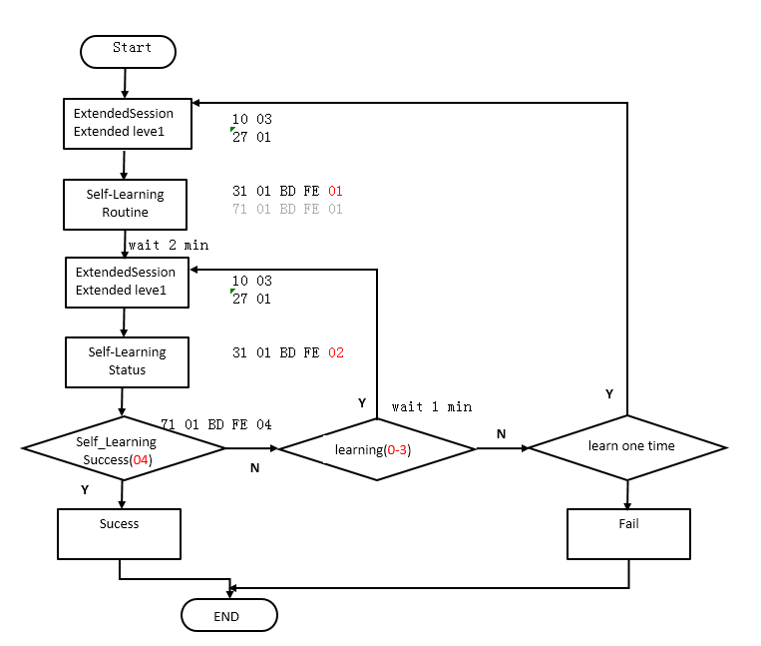
自学习流程图

Routine Identifier | Description | Security Access
BDFE | 请求执行器自学习 | Lever 1（Extended）
请求执行机构自学习的请求报文
Data Byte | Parameter name | Hex Value
1 | Request Service Id | 31
2 | sub-function = [  routineControlType ] | 01
3  4 | routineIdentifier[ ] = [  byte#1 (MSB)  byte#2 (LSB) ] | BD  FE
5 | routineControlOptionRecord[ ] = [  routineControlOption#1  ]  0x0 =start;  0x1 =restart;(不管SCU 是否有自学习数据，建议都发此值，0x01) | 0x0-0x1

请求执行机构自学习的的肯定响应报文
Data Byte | Parameter name | Hex Value
1 | Response Service Id | 71
2 | routineControlType | 01
3  4 | routineIdentifier[ ] = [  byte#1 (MSB)  byte#2 (LSB) ] | BD  FE
5 | routineStatusRecord[ ] = [  routineStatusRecord #1  ]  0x1 =start self_learning | 0x1

请求执行机构自学习的状态
Data Byte | Parameter name | Hex Value
1 | Request Service Id | 31
2 | sub-function = [  routineControlType ] | 01
3  4 | routineIdentifier[ ] = [  byte#1 (MSB)  byte#2 (LSB) ] | BD  FE
5 | routineControlOptionRecord[ ] = [  routineControlOption#1  ]  0x2 =status; | 0x2

请求执行机构自学习状态的的肯定响应报文
Data Byte | Parameter name | Hex Value
1 | Response Service Id | 71
2 | routineControlType | 01
3  4 | routineIdentifier[ ] = [  byte#1 (MSB)  byte#2 (LSB) ] | BD  FE
5 | routineStatusRecord[ ] = [  routineStatusRecord #1  ]  0x0 =lrn_init  0x1 =lrn_dead  0x2 =lrn_swing  0x3 =lrn_check_ims  0x4 = completed  0x5 = timeout error  0x6 = Dead learn error  0x7 = swing learn error  0x8 =check ims error | 0x0-0x3(正在自学习)  0x4 (自学习完成)  0x5-0x8(自学习失败)

Actuator blind control rouinte
This control routine is for SV51-03/04/H project;

Routine Identifier | Description | Security Access
BDFD | 执行机构的盲控 | Lever 1（Extended）
请求执行机构盲控的请求报文
Data Byte | Parameter name | Hex Value
1 | Request Service Id | 31
2 | sub-function = [  routineControlType ] | 01
3  4 | routineIdentifier[ ] = [  byte#1 (MSB)  byte#2 (LSB) ] | BD  FD
5 | routineControlOptionRecord[ ] = [  routineControlOption#1  ]  0x0 =blind control to P;  0x1 = blind control to D; | 0x0-0x1

请求执行机构自学习的的肯定响应报文
Data Byte | Parameter name | Hex Value
1 | Response Service Id | 71
2 | routineControlType | 01
3  4 | routineIdentifier[ ] = [  byte#1 (MSB)  byte#2 (LSB) ] | BD  FD
5 | routineStatusRecord[ ] = [  routineStatusRecord #1  ]  0x0 = resvered  0x1= P limit position  0x2 = D limit position  0x3 = unkown fault | 0x0-0x3

Implementation Rules

RequestDownload ($34) service

Description
This service is used by the tester to initiate a data transfer from the tester to ECU (download). After ECU has received a valid RequestDownload request message, it shall erase the memory of the requested range, and take all necessary actions to receive data before it sends a positive response message.

Request message

Table 6-62 Request message of RequestDownload
Data Byte | Parameter name | Cvt | Hex Value
1 | Request Service Id | M | 34
2 | sub-function = [  dataFormatIdentifier] | M | 00
3 | addressAndLengthFormatIdentifier | M | 44
4  :  7 | memoryAddress[ ] = [  byte #1  :  byte #4 ] | M  :  M | 00-FF  :  00-FF
8  :  11 | memorySize[ ] = [  byte #1  :  byte #4 ] | M  :  M | 00-FF  :  00-FF

Table 6-63 Definition of dataFormatIdentifier
Hex | Description | Cvt
00 ª | The value 0x00 specifies that no compressionMethod nor encryptingMethod is  used. | M
a Values other than 0x00 are not used by SAIC Motor at present.

Table 6-64 Definition of addressAndLengthFormatIdentifier
Bit | Hex (bit 6-0) | Description | Cvt
7-4 | 4 | The length of the memorySize parameter is 4 bytes. | M
3-0 | 4 | The length of the memoryAddress parameter is 4 bytes. | M

Table 6-65 Definition of memoryAddress
Parameter | Description | Cvt
memoryAddress (4  bytes) | The memoryAddress parameter is the starting address of ECU memory from which data is to be written. Byte1 in the memoryAddress parameter is always the most significant byte of the address and the last byte (byte 4) of the memoryAddress parameter is always the least significant byte of the memoryAddress parameter. | M

Table 6-66 Definition of memorySize
Parameter | Description | Cvt
memorySize  (4 bytes) | The memorySize parameter specifies the number of bytes to be write starting  at the address specified by memoryAddress in the ECU’s memory. | M

Positive response message
Table 6-67 Positive response message

Data Byte | Parameter name | Cvt | Hex Value
1 | Response Service Id | M | 74
2 | lengthFormatIdentifier | M | 20
3 | maxNumberOfBlockLength[ ] = [  byte #1  byte #2 ] | M  M | 00-FF  00-FF

Table 6-68 Definition of lengthFormatIdentifier
Bit | Hex (bit 6-0) | Description | Cvt
7-4 | 2 | The length of the maxNumberOfBlockLength parameter is 2 bytes. | M
3-0 | 0 | Reserved, to be set to zero(0). | M

Table 6-69 Definition of maxNumberOfBlockLength
Parameter | Description | Cvt
maxNumberOfBlock  Length(2 bytes) | This parameter is used by the RequestDownload positive response message to inform the tester how many data bytes (maxNumberOfBlockLength) shall be included in each TransferData request message from the tester. This length reflects the complete message length, including the service identifier and the data parameters present in the TransferData request message. This parameter allows the tester to adapt the length of the TransferData request message to satisfy the receive buffer size of the ECU before it starts transferring data to the ECU. | M

Negative response codes
Table 6-70 Negative response codes
Hex value | Description | Cvt
7F | serviceNotSupportedInActiveSession  This code shall be returned because the ECU does not support the requested service in the session currently active. | M
13 | incorrectMessageLength  The length of the message is wrong. | M
33 | securityAccessDenied  This code shall be returned if a tester sends a request with a valid secure dataIdentifier and the ECU’s security feature is currently active. | M
31 | requestOutOfRange  This code shall be returned if:  a) the requested dataIdentifier value is not supported by the ECU;  b) the value of inputOutputControlParameter is invalid;  c) the applicable controlState is invalid. | M
22 | conditionsNotCorrect  This code shall be returned if the criteria for the request are not met. | M
70 | uploadDownloadNotAccepted  This response code indicates that an attempt to download to a ECU’s memory cannot be accomplished due to fault conditions. | M
78 | requestCorrectlyReceived-ResponsePending | U

Implementation Rules
No special implementation rules.

TransferData ($36) service

Description
The TransferData service is used by the tester to transfer data from the tester to the ECU (download).
The TransferData service request includes a blockSequenceCounter to allow for improved error handling in case a TransferData service fails during a sequence of multiple TransferData requests.

Request message
Table 6-71 Request message of TransferData
Data Byte | Parameter name | Cvt | Hex Value
1 | Request Service Id | M | 36
2 | sub-function = [  blockSequenceCounter] | M | 00-FF
3  :  3+(m-1) | transferRequestParameterRecord[] = [  transferRequestParameter#1  :  transferRequestParameter#m ] | C  :  C | 00-FF  :  00-FF

Table 6-72 Request message data parameter definition
Parameter | Description | Cvt
blockSequenceCounter | The blockSequenceCounter parameter value starts at 0x01 with the first  TransferData request that follows the RequestDownload service. Its  value is incremented by one (1) for each subsequent TransferData  request. At the value of 0xFF, the blockSequenceCounter rolls over and  starts at 0x00 with the next TransferData request message. | M
transferRequestParameter  Record | The transferRequestParamterRecord includes the data to betransferred. | C

Positive response message
Table 6-73 Positive response message
Data Byte | Parameter name | Cvt | Hex Value
1 | Response Service Id | M | 76
2 | blockSequenceCounter | M | 00-FF

Negative response codes
Table 6-74 Negative response codes
Hex value | Description | Cvt
7F | serviceNotSupportedInActiveSession  This code shall be returned because the ECU does not support the requested service in the session currently active. | M
13 | incorrectMessageLength  The length of the message is wrong. | M
24 | requestSequenceError  The ECU shall use this response code:  a) if the RequestDownload service is not active when a request for this service is received;  b) if the RequestDownload service is active, but the ECU has already received all data as determined by the memorySize parameter in the active RequestDownload service. | M
73 | wrongBlockSequenceCounter  This return code shall be sent if the ECU detects an error in the sequence of the blockSequenceCounter.  The repetition of a TransferData request message with a blockSequenceCounter equal to the one included in the previous TransferData request message shall be  accepted by the ECU. | M
71 | transferDataSuspended  This return code shall be sent if:  a) the response code indicates that a data transfer operation was halted due to a fault;  b) the download module length does not meet the requirements of the memorySize parameter sent in the request message of the RequestDownload service. | M
92/93 | voltageTooHigh / voltageTooLow  This return code shall be sent, as applicable, if the voltage measured at the primary power pin of the ECU is out of the acceptable range for downloading data  into the ECU’s permanent memory (e.g. Flash Memory). | M
72 | generalProgrammingFailure  This return code shall be sent if the ECU detects an error when performing a routine, which accesses ECU internal memory. | M
78 | requestCorrectlyReceived-ResponsePending | U

Implementation Rules
No special implementation rules.

RequestTransferExit ($37) service

Description
This service is used by the tester to terminate a data transfer between the tester and the ECU (download). ECU shall check the integrity of this module when it receives the RequestTransferExit request message.

Request message
Table 6-75 Request message of RequestTransferExit
Data Byte | Parameter name | Cvt | Hex Value
1 | Request Service Id | M | 37
2 | CRCType  00 The CRC value of the data block is not required to be returned in the positive response message.  01 The CRC32 Value of the data block is required to be returned in the positive response message. | M | 00  01

Positive response message
Table 6-76 Positive response message

Data Byte | Parameter name | Cvt | Hex Value
1 | Response Service Id | M | 77
2 | CRCType | M | 00  01
3  4  5  6 | blockCRCValue[]=[  CRC Byte #1  CRC Byte #2  CRC Byte #3  CRC Byte #4  ] | Cª | 00-FF  00-FF  00-FF  00-FF
a The blockCRCValue parameter is present in case of CRCType equals to 0x01 in the request message.

Negative response codes
Table 6-77 Negative response codes
Hex value | Description | Cvt
7F | serviceNotSupportedInActiveSession  This code shall be returned because the ECU does not support the requested service in the session currently active. | M
13 | incorrectMessageLength  The length of the message is wrong. | M
24 | requestSequenceError  The ECU shall use this response code:  a) if the RequestDownload service is not active when a request for this service is received;  b) if the RequestDownload service is active, but the ECU has already received all data as determined by the memorySize parameter in the active RequestDownload service. | M
78 | requestCorrectlyReceived-ResponsePending | U

Implementation Rules
.

Other services
.

Sequence of flash programming

General requirements
All ECUs that support programming of the application software, the calibration data shall contain bootloader. Bootloader is responsible for programming the ECU, and for validating the application software and the calibration data. When the application software or the calibration data is missing or an update to these is required, ECU needs to be programmed to recovery function.

Data transfer mechanism
Any data transfer between the tester and ECU shall follow ISO 15765-2 and ISO 14229-1 via CAN bus. Any other solution is not considered. The upload of data transfer shall not be supported by an ECU in any case.

Functional requirement
The application software and the calibration data shall be programmable independently of one another. Updating the bootloader shall be prohibited.

ECU Hardware design requirement
ECU hardware shall be designed to make the supply voltage of MCU and/or the external memory chip available for bootloader check.

Erase and programming routines requirement
Memory erase and programming routines shall be embeded in the bootloader code and stored in an encrypted form. These routines shall be decrypted and relocated to RAM for execution.

Logistic data identifier
Bootloader should support the logistic DID defined in 4.3. When reading a DID, make sure the same content read from bootloader and application.

Flash file format requirement
The flash file shall be released to SAIC Motor in the Motorola S-record format (*.s19) or Intel Hex format (*.hex).
A description document, in which the start address, the size and the type (e.g. the application software, the calibration data, etc.) of each data block in the flash file is described, shall be released with the flash file.

Communication requirements

CAN ID requirements
Bootloader shall use the permanent CAN ID which is identical to the CAN ID used for enhanced diagnostic in the programmable ECU.

Frame padding requirements
The Data Length Code of all diagnostic requests and responses message shall always be eight (8) bytes. In the case of a diagnostic message that does not occupy all eight bytes, the remaining data bytes shall be padded with a HEX value of 0x00. The ECU shall always ignore a diagnostic frame of which the data length code in the CAN header control field is not fixed to eight bytes.

Network layer timing requirements
Table 7-78 specifies the network layer timing parameters to be used by the ECU's for programming software based on the definitions in ISO 15765-2:2004.
Table 7-1 Network Layer Time-Out and Performance Requirement Values
Parameters | Timerout value | Performance requirementValue
N_As | 25ms | ----
N_Ar | 25ms | ----
N_Bs | 25ms | ----
N_Br | ---- | (N_Br+N_Ar)<2ms
N_Cs | ---- | (N_Cs+N_As)<2ms
N_Cr | 25ms | ----

Flow control mechanism requirements
Flow control mechanism requirement values see table 7-2
Table 7-79 Flow Control Mechanism Requirement Values
Parameters | Application mode | BootLoader Mode
BS | 8 | 8
STmin | 20 | 0

Safty-related requirements

Pre-condition for programming
ECU shall ensure the state is safe to transit from application to bootloader. If the programming pre-conditions are not fulfilled (e.g. engine is running, shifter lever is not in the park or neutral position, etc.), the programming attempt must be rejected.
The condition to refresh ECU’s application software condition is : vehicle speed must be 0 kmph.
    - Access authorization
All programmable ECUs shall employ a seed and key security feature, accessible via the SecurityAccess ($27) service, to protect the programmed ECU from inadvertent erasure or unauthorized programming.
NOTE: The security access mechanism for ECU programming refers to Part 6 of this standard.

Input/output port initialization
ECU I/O ports shall be set to a safe state by bootloader to prevent the ECU and the vehicle from risk. If the conditions permit, I/O ports shall be set to the minimize system power consumption state.

Fault tolerance mechanism
Bootloader shall be stored in a permanent memory location. Bootloader shall be protected against inadvertent erasure and shall be always present, such that in the absence of the application software or the application data, ECU can communicate effectively to allow programming. ECU shall be able to recover and be reprogrammed if any of the following error conditions occur during the programming process.
- loss of supplied power connection;
- loss of the ground connection;
- disruption of CAN communication;
- exceed the voltage available range.

Programming counter
For each programmable ECU, there shall be a programming counter stored in the non-volatile memory. The programming counter returns the number of already performed programming events. And it shall be set to zero (0) when ECU is manufactured. The programming counter is incremented by one (1), once the memory erase is executed. The ECU maximum programmable times shall be approved by the diagnostic engineer and documented in Component Diagnostic Specification.
NOTE: The programming counter shall only be incremented by one (1) during each programming event.

Detection of the data correctness during programming

The method is that ECU calculates the CRC32 value of each data block and returns the CRC32 value to the tester in the RequestTransferExit positive response message. The tester shall check the correctness of the data in the transfer process according this CRC32 value. If the CRC32 value is wrong, the programming process shall be terminated right now by the tester.

Programming integrity check
ECU shall check the integrity of the data downloaded into memory. ECU shall update the SIS parameter according to the check result. The method used to check integrity is determined by the supplier and shall be approved by the diagnostic engineer.

Programming dependency check
ECU shall check programming dependency by verifying the compatibility between the application software and the bootloader, between the application data and the application software. And ECU shall update the SCS parameter according to the check result. If the SIS parameter is an incorrect result, the SVS shall always be an incorrect result. The method used to check compatibility is determined by the supplier and shall be approved by the diagnostic engineer.

Software validation
ECU shall update the SVF when it exits the programming session. If the results of both the programming integrity check and the programming dependency check are correct, the currentsoftware status of ECU is valid and the SVF shall be set to TRUE (0x01). Bootloader shall only allow the application software to run if the SVF is TRUE.

Session management
ECU shall enter the programming session in Bootloader within 500 ms when it receives the request message DSC=2.
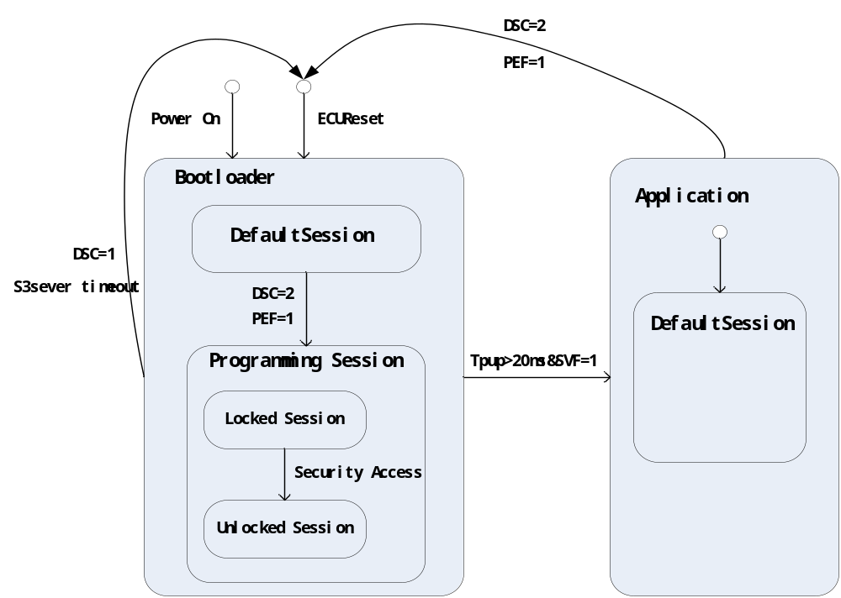
Figure 7-1 Session Management
The transition between the application software and the bootloader shall follow the process below.
- When ECU running in the application software received the service $10 request message with the sub-function equals to 0x02, it shall set PEF to TRUE (1) and store the PEF value into the non-volatile memory.
- ECU resets.
- ECU starts in the default session of bootloader and checks if the application requested a transition into programming session previously by checking the value of PEF. (The PEF check shall be conducted within Tpup 20 ms.)

- If true, ECU enters the programming session, and then clears PEF.

- If false, ECU maintains running in the default session of the bootloader. Only if Tpup exceeds 20 ms and SVF is true, ECU transits from the bootloader to the application.

  - Memory distribution
A typical case for the memory distribution is that the memory of an ECU is divided into three partitions. The first partition is the application software. The second partition is the network configuration data. The third partition is the calibration data. The fourth partition is the bootloader. The bootloader must lie in a protected memory area. Both the application software and the bootloader shall contain their own software module for the communication and the diagnostic services. The ECU memory distribution information shall be documented in Component Diagnostic Specification.

Diagnostic service requirements
The diagnostic services defined in part 6 of this standard have to be supported by the ECU bootloader in order to fulfil the requirements for performing memory programming.

Programming process
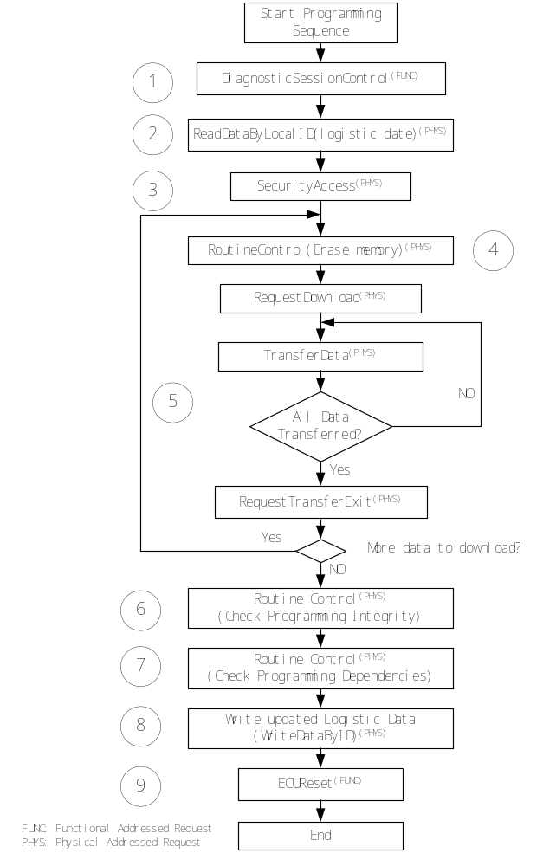
Figure 7-2 Programming process
Step 1:
The programming event is started from a physically/functionally addressed request of the DiagnosticSessionControl ($10) service with sessionType equal to programmingSession. When ECU receives the request message, it shall allocate all necessary resources required for programming.
Step 2:
The tester retrieves the logistic data of ECU, such as VIN, ECU Hardware Number etc.
Step 3:
The tester unlocks the ECU via the SecurityAccess ($27) service to enable the services related to programming. This service shall be mandatory for all programmable ECUs.
Step 4:
The memory of the ECU shall be erased in order to allow the application software / calibration data download. This is achieved via a routine, using the RoutineControl ($31) service to execute the memory erase routine.If ECU can erase the memory of the requested range when has received a valid RequestDownload request message,step4 can ignore.
Step 5:
Each download of a contiguous data block to a non-volatile server memory location shall always follow the general data transfer method using the following service sequence:
No further services other than TesterPresent are permitted during the correct execution of the sequence RequestDownload, TransferData and RequestTransferExit.
If the length of the block exceeds the maximum network layer buffer size, a single data block requires multiple TransferData ($36) request messages to be completely transmitted.
Step 6 :
Once all data block is downloaded completely, the tester shall verify the software integrity by initiating a check routine in the ECU using the RoutineControl (31 hex) service and update SIS parameter. The format of RoutineControl (31 hex) service refer to this refer 8&9
Step 7:
If the result of the software integrity check is true, ECU shall check the programming dependency and update the SCS parameter. The format of RoutineControl (31 hex) service refer to this document 9 Annex E.
Step 8:
Following the download of the application software / application data, the tester shall update the logistic data, such as PIF, ECU Part Number etc.
Step 9:
ECU need hardreset in order to enable the downloaded application software / application data. When ECU exits the programming session the SVF shall be updated.

Fault Detection

General Condition
xxxxxxxxxxxxxxxxxxxxxxxxxxxxxxxxxxxxxxxxxxxxxxxxxxx

Supported DTC

Table 8-80: Supported DTCs table
DTC Code | Failure Type | Description | Fault Lamp (On/Off) | Project
0xC07300 | 00 | Bus OFF | off | SV51-03/04/H/B1
0xC10100 | 00 | 接收TCU_1F5h的报文丢失 | off | SV51-03/04/H/B1
0xC12100 | 00 | 接收GSM_2F5h的报文丢失 | off | SV51-03/04/H/B1
0xC12200 | 00 | 接收TCU_0C7h的报文丢失 | off | SV51-03/H
0xC12300 | 00 | 接收EMS_0C9h的报文丢失 | off | SV51-03/H
0xC12400 | 00 | 接收GW_BCM_46Ah的报文丢失 | off | SV51-03/04/H/B1
0xC12500 | 00 | 接收SRS_163h的报文丢失 | off | SV51-03/04/H/B1
0xC12600 | 00 | 接收GW_ESC_23Ch的报文丢失 | off | SV51-03/04/H/B1
0xC12700 | 00 | 接收GW_BCM_1F1h的报文丢失 | off | SV51-03/04/H/B1
0xC12800 | 00 | 接收GW_IPK_1F2h的报文丢失 | off | SV51-03/04/H/B1
0xC12900 | 00 | 接收GW_BCM_0F1h的报文丢失 | off | SV51-03/04/H/B1
0xC12A00 | 00 | 接收GW_FICM_541h的报文丢失 | off | SV51-03/04/H/B1
0xC12B00 | 00 | 接收GW_IPK_540h的报文丢失 | off | SV51-03/04/H/B1
0xC12C00 | 00 | 接收ESC_348h的报文丢失 | off | SV51-03/04/H/B1
0xC12D00 | 00 | 接收ESC_34Ah的报文丢失 | off | SV51-03/04/H/B1
0x911717 | 17 | 电池电压过高 | off | SV51-03/04/H/B1
0x911716 | 16 | 电池电压过低 | off | SV51-03/04/H/B1
0x1C101C | 1C | GBA传感器1供电电压故障 | off | SV51-03/04/H
0x1C111C | 1C | GBA传感器2供电电压故障 | off | SV51-03/04/H
0x1C121C | 1C | GBA传感器1故障 | off | SV51-03/04/H
0x1C131C | 1C | GBA传感器2故障 | off | SV51-03/04/H
0x1C1413 | 13 | GBA电机开路 | off | SV51-03/04/H
0x1C1511 | 11 | GBA电机对地短路 | off | SV51-03/04/H
0x1C1612 | 12 | GBA电机对电源短路 | off | SV51-03/04/H
0x1C171C | 1C | GBA环境温度正常范围外 | off | SV51-03/04/H
0x1C181C | 1C | 芯片工作供电电压故障 | off | SV51-03/04/H/B1
0x1C191C | 1C | P 档硬性输出模块故障 | off | SV51-03/04/H/B1
0xC13000 | 00 | 接收EPB_22Ah的报文丢失 | off | SV51-03/04/H/B1
0xC13100 | 00 | SCU发生轻微故障 | off | SV51-03/04/H/B1
0xC13200 | 00 | 接收TCU_0F9h的报文丢失 | off | SV51-03/04/H
0xC12E00 | 00 | 接收IECU_201h的报文丢失 | off | SV51-H
0xC12F00 | 00 | 接收IECU_204h的报文丢失 | off | SV51-H
0xC13300 | 00 | SCU发生一般故障 | off | SV51-03/04/H/B1
0xC13400 | 00 | SCU发生严重故障 | off | SV51-03/04/H/B1
\

Supported Global Snapshot Data
Refer to reference document for use.
Table 8-81: Global Snapshot Data
Data Name | Start Byte | Unit | Scaling | offset | Min. | Max.
Supply voltage | 1 | V/bit | 0.1 | 0 | 0 | 25
Odometer reading | 2 | km/bit | 1 | 0 | 0 | 2²⁴-1
Ignition status | 5 | - | - | - | - | -

Table 8-82 Global snapshot information

Snapshot data | Supply voltage |  |  | Odometer reading |  |  |  |  | Ignition status |  |  | Data&Time
Cvt | M |  |  | M |  |  |  |  | M |  |  | U
Definition | ID |  | Data | ID |  | Data |  |  | ID |  | Data | ID |  | Data
Definition | 2 Bytes |  | 1 Byte | 2 Bytes |  | 3 Byte |  |  | 2 Bytes |  | 1 Byte | 2 Bytes |  | 6 Bytes
Byte sequence | 1 | 2 | 3 | 4 | 5 | 6 | 7 | 8 | 9 | 10 | 11 | 12 | 13 | 14-19
HEX value | 01 | 12 | xx | E1 | 01 | xx | xx | Xx | D0 | 01 | xx | 01 | 0B | xx

Table 8-83 Ignition status byte bit mask definitions
ID | Name | # of bytes | Bit | Bit Description | 0 | 1
D001 | Ignition status | 1 | 0 | System KL.R status | Off | On
D001 | Ignition status | 1 | 1 | System KL.15 status | Off | On
D001 | Ignition status | 1 | 2 | System engine running status | Off | On
D001 | Ignition status | 1 | 3 | System KL.50 status | Off | On
D001 | Ignition status | 1 | 4 | Global KL.R status | Off | On
D001 | Ignition status | 1 | 5 | Global KL.15 status | Off | On
D001 | Ignition status | 1 | 6 | Global engine running status | Off | On
D001 | Ignition status | 1 | 7 | Global KL.50 status | Off | On

Table 8-84 Global snapshot data identifier definition
ID | Name | # of bytes | Description | Resolution | Offset | Min | Max
0112 | Supply voltage | 1 | System supply voltage | 0.1 V/bit | 0 V | 0 V | 25.5 V
E101 | Odometer  reading | 3 | Global odometer  reading | 1 km/bit | 0 km | 0 km | (2²⁴-1) km
010B | Date&Time | 6(Byte1) | Year:(0x0-0xFF) | 1 | 2000 | 2000 | 2255
010B | Date&Time | Byte2 | Month  C: December  B: November  A: October  9: September  8: August  7: July  6: June  5: May  4: April  3: March  2: February  1: January  0: Unknown | 1 | 0 | 0 | 12
010B | Date&Time | Byte3 | day (0x0 - 0x1F) | 1 | 0 | 0 | 31
010B | Date&Time | Byte4 | Hour(0x0-0x17) | 1 | 0 | 0 | 23
010B | Date&Time | Byte5 | Minute(0x0 - 0x3B) | 1 | 0 | 0 | 59
010B | Date&Time | Byte6 | Second(0x0 - 0x3B) | 1 | 0 | 0 | 59

Supported Local Snapshot Data
Table 8-85 Local snapshot data identifier definition
执行器相关的DID对于SV51-B1项目，其值均为0；
ID | Name | # of bytes | Description | Resolution | Offset | Min | Max
BDF0 | 执行器传感器1物理位置 | 2 | 执行器传感器1物理位置 | 1/128 | 0 | 0 | 100
BDF1 | 执行器传感器2物理位置 | 2 | 执行器传感器2物理位置 | 1/128 | 0 | 0 | 100
BDF2 | 执行器传感器1供电电源 | 1 | 执行器传感器1供电电源 | 1/10 | 0 | 0 | 25
BDF3 | 执行器传感器2供电电源 | 1 | 执行器传感器2供电电源 | 1/10 | 0 | 0 | 25
BDF4 | 当前档位 | 1 | 0：P  1：R  2：N  3：D  4-15：ERROR | 1 | 0 | 0 | 15
BDF5 | GSM换挡杆位置信息 | 1 | 0x0: A+2  0x1:A+1  0x2:A0  0x3:A-1  0x4:A-2  0x5:M+1  0x6:S  0x7:M-1  0x8:Invalid | 1 | 0 | 0 | 15
BDF6 | 执行机构档位信号 | 1 | 0x0：Reserve  0x1：Position Detected Park  0x2：Position Detected Reverse  0x3：Position Detected Neutral  0x4：Position Detected Drive  0x5：Position Detected Between P&R  0x6：Position Detected Between R&N  0x7：Position Detected Between N&D  0x8：Position Detected Out of Bounds  0x9：Position Detected Release | 1 | 0 | 0 | 15
BDF7 | SCU请求档位 | 1 | 0x0:P  0x1:R  0x2:N  0x3:D  0x4:S  0x5:M  0x6:M-  0x7:M+  0x8-0xF:ERROR | 1 | 0 | 0 | 15
BDF8 | 接收的车速 | 2 | 车速值 | 0.015625 | 0 | 0 | 512
BDF9 | 接收的转速 | 2 | 转速 | 0.25 | 0 | 0 | 16383
BDE0 | 档位判断的信号 | 1 | 详见上述bitmap id | 1 | 0 | 0 | 15
BDE1 | 告警拒绝提示信息 | 1 | 详见上述bitmap id | 1 | 0 | 0 | 15
BDF2 | SCU故障详细状态 | 9 | Byte0:故障号  Byte1-9:故障号对应的上下文 | 1 | 0 | 0 | X

Supported Extended Data

Table 8-7 Global snapshot information
Extended data | Fault occurrence counter | Fault pending counter | Aged counter | Ageing counter
Cvt | M | M | M | M
Definition | 1 Byte | 1 Byte | 1 Byte | 1 Byte
Byte sequence | 1 | 2 | 3 | 4
HEX value | xx | xx | xx | xx

