Anh-Kiet Ngo

Ayman Abdo

Smart Ringer

## Problem and solution overview

In this modern environment, nearly everyone is equipped with a cell phone. It is a great technology in that it keeps us all connected to the ones we love. Or in the cases of emergencies, it allows us to get help regardless if we are stranded on a highway or losing our keys after a heavy night of binge drinking. Naturally, all of these conveniences mean that the cell phone is constantly by our side. This inevitably leads to the allowance of interruptions during important meetings or gatherings. The ringing of a cell phone in today's world is an annoyance that many people are plagued with. The odd thing is that the ability to control the ring of our devices is quite primitive and limited.

Most people tend to ignore the functionality of a ringer all together. They put their phones on a silent mode inevitably and just rely on the phone’s vibration alerts. This will lead to missed calls and important notifications especially when the users are not in direct contact with the phone. This usually happens during the evening after the phone user is back home from work without realizing that his or her phone’s ringer is still off. They might leave the phone by the door when they enter their house or apartment and forget about it for a while. During that time important phone calls and notifications could be missed.

There are third party apps that attempt to alleviate this problem, but many are simply a calendaring system for us to indicate when and when not to ring. More advanced apps even allow us to set the ring by proximity to locations. However, these solutions do not take into account the dynamic nature of a person's schedule. For example, being in class is a situation where we do not want the phone to ring, but a meetup after class does not necessarily warrant the silencing of the ringer. Something as important as the ringer of a mobile phone cannot rely on one dimension of configurability alone.

By combining multiple configuration options, we believe that we can achieve something more useful and flexible than what is currently available to consumers. For example, by combining both the calendaring system and the GPS location, we can come up with a set of much clearer constraints for when the ringer should be silenced. We also propose a few new ways to interact with the device that could further enhance the experience of the consumer, such as the direct control of the ringer by using a device's orientation or proximity to an external device.

By giving the users more flexibility to set their phone’s ringing settings, it will allow them to get the most out of the feature without having to deal with the inconveniences or the social awkwardness of an uninvited phone ring.

Paper prototype

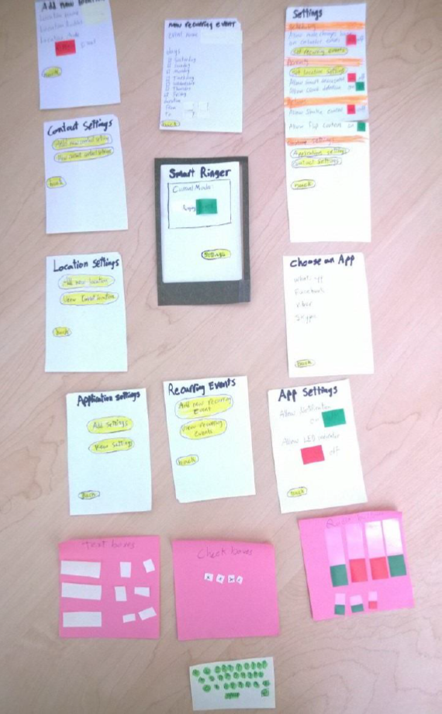

The paper prototype shown in the photo above has all the screens required for the interface except for the settings page of “adding new contact settings.” We decided that this feature was similar to other features and there will be no need to test it if we are testing the other ones. The prototype comprises of a dark green frame that simulates a smart phone. The phone screens are displayed through that frame. Green and red bookmarks were used to simulate radio buttons. Cut sticky notes were used as text boxes and check boxes. Buttons are highlighted in yellow while section titles are highlighted in orange. We created a small keyboard with a sticky note for data entry simulation.

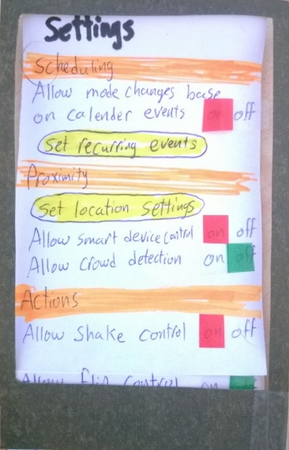The follow screen on the right shows the main settings screen. This screen contains all the settings for the app. It starts with the scheduling settings where you can set a recurring event. There is also the option to let your smart ringer app integrate with the phone’s calendar and decide the ringer’s mode depending on the calendar’s status. Next, there are the proximity settings. In this section you can set a certain location and give it some defaults. So that every time you are geographically located in that place your phone will follow the settings you have specified. Next, there is a section for the actions settings. Like the shake to silent actions or the flip to silent. The prototype shows the dark green frame as the current screen view. The page beneath it is moveable and its movement up and down simulates the scrolling on a mobile phone.

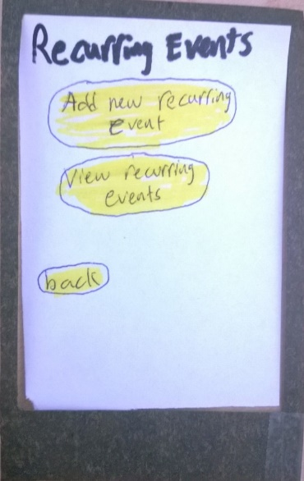The next screen is an example for an intermediate setting screen. Through this screen you can show the events you have already set and add some more. If you choose to add a new event. You will be navigated to the next screen.

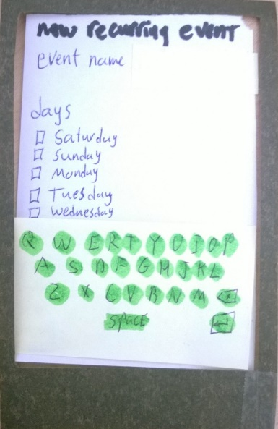The next screen shows the adding of a new recurring event. To add a recurring event you’ll need to choose an event name. The onscreen keyboard will pop up to allow you to enter the name. Afterwards, you’ll need to choose the days and times on which this event will occur.

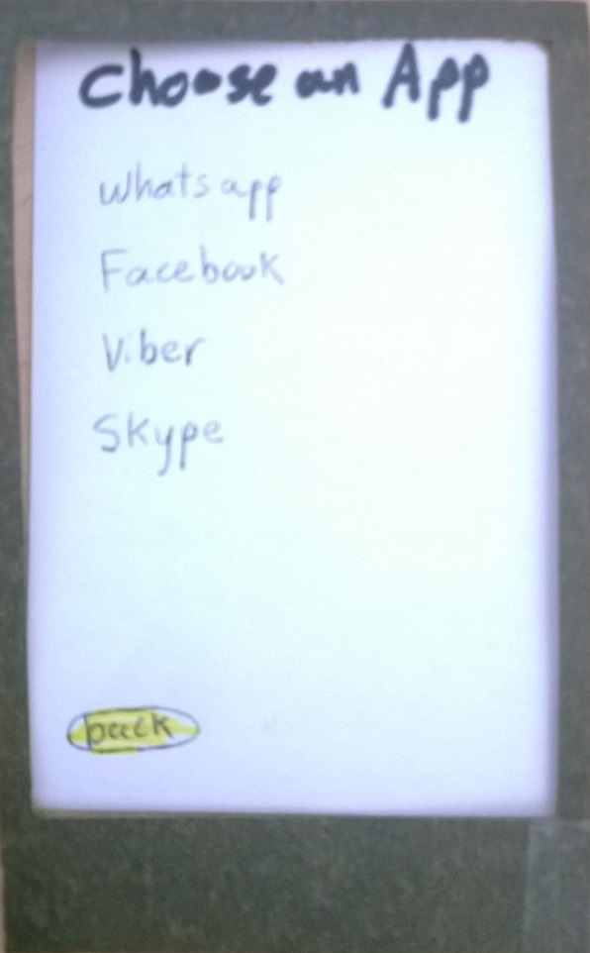

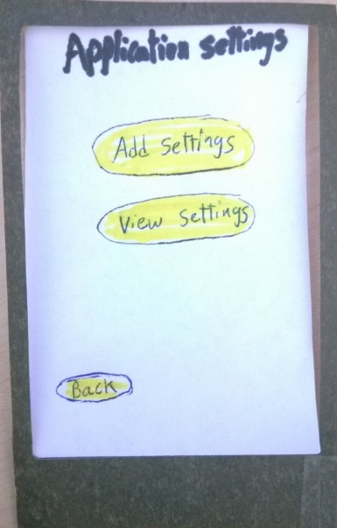Another functionality that was testing in the paper prototype was changing the setting for a certain application. The user can navigate to this screen from the main settings screen. The user next chooses if he would like to view the settings that he has already added before or add a new one. If the user chooses to add a new setting he will be navigated to the next screen.

This screen is very simple way to view all the applications on the phone that are registered to send notifications. The user can scroll through the list and choose an application. When the user does so he will be taken to the next screen.

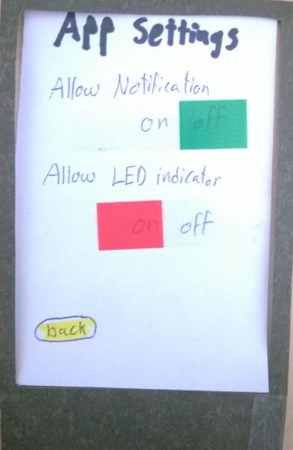The final screen to for this functionality is shown on the right. After the user has chosen an application, he will be allowed to choose the settings he want by clicking the slide buttons to activate or deactivate sounds and notification light for the application.

Testing method

For the testing phase, there were 3 volunteers who agreed to test the interface through the prototype design. They supplied valuable feedback on the design and the functionality. The first volunteer is a student. He uses his phone to text his friends and call his family. He is a tech savvy and knows how to use smart phones well. The next volunteer is a software developer. He works mainly in database and storage solutions. He is also very good with smart phones. He mentioned that he receives a lot of phone calls from friends and some notifications from applications like whatsapp and skype. The last volunteer is a nurse. She has a smartphone but she does not use most of its functionalities. She says her husband and kids call her a lot at work especially when she is doing night shifts.

The testing environment was a room with a large desk. The volunteers were seated and the interviewer was located next to them taking notes. On the other side of the desk, the helper was acting as the smart phone navigating the screens, adding text and responding to the volunteer’s clicks and other actions. The paper prototype was set on the desk on the main screen. Notes were being taken as the testing proceeded. The paper prototype has all the screens required for the interface except for the settings page of “adding new contact settings.” The prototype comprises of a dark green frame that simulates a smart phone. The phone screens are displayed through that frame. Green and red bookmarks were used to simulate radio buttons. Cut sticky notes were used as text boxes and check boxes. Buttons are highlighted in yellow while section titles are highlighted in orange. We created a small keyboard with a sticky note for data entry simulation.

Those following tasks were executed:

**Scheduled events**

*Existing task*: Knowing that there will be a meeting in 10 minutes because of the reminder, the user then goes into the phone's settings and turn off the ringer. Most modern phones will also allow you to do this by using the volume key. After the meeting is done, the user has to remember to turn the ringer back on.

*New task*: Since the device is already integrated with the calendar, it will check to see if the calendar status indicates a ringer status. If not, it will prompt the user if they want to silence the phone during the meeting. After the meeting is over, it automatically enables the ringer.

**Unscheduled events**

*Existing task*: Remember that your phone is not silent. If it is not, then actively turn it off. Once the meeting is over, remember to turn it back on again.

*New task*: Leave the phone on the table, facing down to indicate that it needs to be silent.

**Recurring reading with location**

*Existing task*: Default device functionality. Remember to silence the device before the discussion meeting and remembering to enable it afterward.

*Existing task*: Third party app with calendar integration. The device is now aware of the meeting so it disables and enables the ringer automatically. In the case that the event was canceled, the user needs to remember to remove the calendar event for the ringer to be turned back on.

*Existing task*: Third party app with location integration. It detects that you are at the meeting location, and thus disables the ringer. The moment it detects that you are away, it turns it back on. In the case that it's a friend's house, if you are over to visit, you'll have to remember to turn the ringer on because it's not for the book discussion.

*New task*: With calendar and location integration, both requirements need to be satisfied before the silencing effect of the app kicks in. If either of those conditions fail, the app will keep the ringer on.

During the beginning on each interview. The Volunteers were told about the application, its purpose and goals. We also explained to them about the paper prototype and the purpose of the test we were conducting. They were briefed on how to use the paper prototype. We encouraged them to think out loud and explain everything they are doing. We then began to explain about the tasks. We explained how each one had a purpose. We explained that the testing was not done to test their ability or their understanding of the application. It was a test of the design and they were welcome to comment on any aspect of the design, positive or negative. Each volunteer proceeded to perform all three tasks. The tasks were instructed to them as they began to interact with the paper prototype. Notes were being taken as the interview continues. The volunteers sometimes had some trouble expressing what they were thinking. But for the most part they were clear on what they were doing and what they needed to do next. After all three tasks were performed, we thanked the volunteers for their help and we skimmed through the notes to see if the volunteer wanted to elaborate on any comments or problems they have faced.

Testing results

The interviews we have held to test the paper prototype gave us very valuable feedback about the design. We have used the feedback to better enhance our design. The first volunteer is a student. He started doing the first task but she had some trouble navigating through the screens. He kept asking what he should do next. He said that the titles of the sections on the settings screen are vague and he suggested different naming. He was done with the task relatively fast. He began the second task and he knew right away what he should click as he had already noticed the option while doing the first task. For the third task, he did not think the location settings were clear. He said she was confused by the radius text field as the unit of measurement was not specified.

The second volunteer is a software developer. He said that he likes the idea of the app and that he thinks it would be very useful for him. The first task went smoothly although he stopped the interview to ask about how he would enter data if he needed to and we showed him the keyboard post-it note. The user thought he will need to go to the phone calendar first to set meetings and asked how to do so. We explained that he can assume the events are already on the calendar. For the second task the user activated the shake to silence feature instead of the flip to silence one. It appeared the user was confused about the difference between the two features. For the last task the user asked why we don’t have a map view on which he can pin point location or search for it. The user also commented on the radius’ unit was not clear.

The last volunteer is a nurse. She seemed to have some trouble with understanding the features. She said that the design looked crammed and that it was filled with things she did not understand. After revising all the note we decided to make some changes to the design to integrate the feedback we got into the system. We decided to change the way the user interact with the location oriented settings. It was apparent that the users preferred a more graphical way of entering a location instead of relying on the GPS detection from the background. We’ve also decided to remove the home screen as to simplify the navigation. We thought that the lesser screens the user had to go through to achieve the task is better.

Interface revision sketches

a) We simplified the ability to see existing locations by skipping an extra step. The reason for this was the complaint that users wanted to see if they had already added a location. By seeing a list of all the locations, they can easily make the determination if they can add a new one or not. By reducing one click, this made for a quicker flow in the location setup process.

**Before**

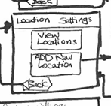

**After**

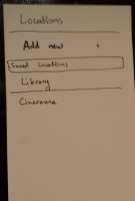

b) Removal of a home screen. After a while, it made little sense to have a home screen to indicate the current mode of the ringer. It made more sense for this to be an "advanced setting" so the user can see why the ringer is on/off, but it does not make sense to have this all the time. Most of the time, the user only cares about if the ringer is on or off, and that is already readily available in the top bar for both Android and iOS. The removal of this screen:

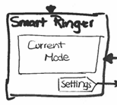

c) Changing the way we did the radius as it was hard and unintuitive. Since users complained about the fact that it was hard to visualize the distance, using a radius was not good in general. Most people have much easier time with maps as that is what they are used to:

**Before**

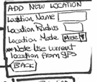

**After**

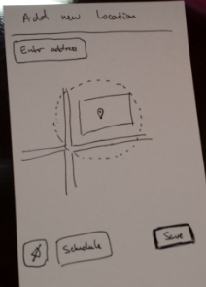

Interactive prototype overview

The interactive prototype was written in HTML(5), CSS3, and JavaScript as a simple single-page application. Due to the time constraint, the implementation was only implemented on Chrome and not other browsers, so there will be cross-browser bugs. The implementation took a stock photo of a Galaxy S4 phone and replaced the contents of the screen with dynamically generated content/settings. With the help of Photoshop, we were able to do the following transform:

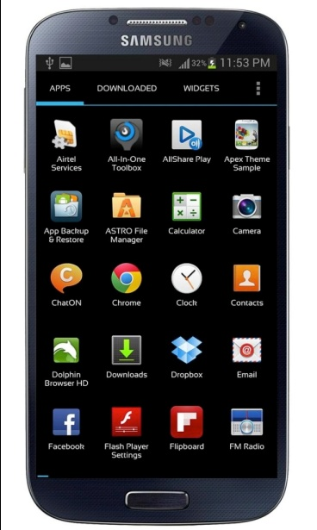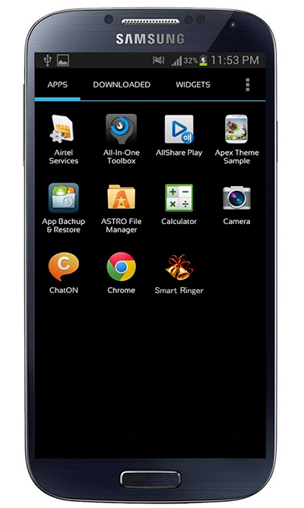

Before After

Essentially all we did was add a little icon for our app onto the screen. We chose to do this part via image editing was so that we could get a better match with the existing styles of icons and text. Sadly, we were still not able to match it up completely.

To make a base to start off every new screen for our app, we create an HTML element to overlay the inside of this image. Since it is pure black, it makes it easy for us to add other things on top of it

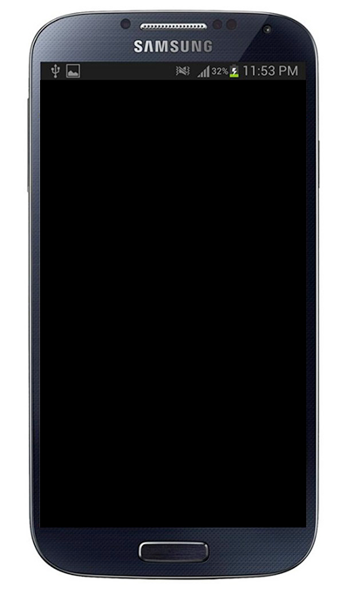

To simulate some of the functionality of a physical device, we decided to implement additional these features as an external button to the actual interactive prototype. For example, to be able to simulate the phone ringing, we have a button called "call" on the screen that when clicked, some audio of a ringer will sound. To make this easier while testing, we have added a shortcut key "c" onto the page. So that when we want to cause the phone to ring, simply pressing "c" on the keyboard will cause the ringing to happen.

Since we are implementing some "tactile" feedback as well, there are two additional buttons for this for the user to use. The first is to flip the phone, the second is to shake the phone. Due to our lack of understand of CSS3, we were not able to cause the phone to do a flip animation. So we had to fade out the phone and fade back in the image of the back of the phone. The shaking functionality is a lot simpler to manage by using CSS3's animation and keyframe. This allows for a very smooth shaking functionality.

**Scenarios**

Since it is hard to implement and test some of the complex stuff like scheduling and calendar integration, we have opted for different scenarios for the interactive prototype. We felt that with just these functionalities alone would make for a strong argument to use this application.

*Scenario 1* - A phone call occurs during a meeting where the user has enabled "flip to silence." Since the user already has the phone faced down on the table, the phone call never makes it through.

User goes to setting screen

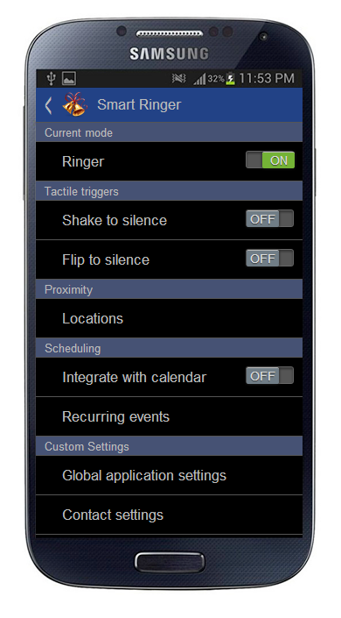

User enables "flip to silence"

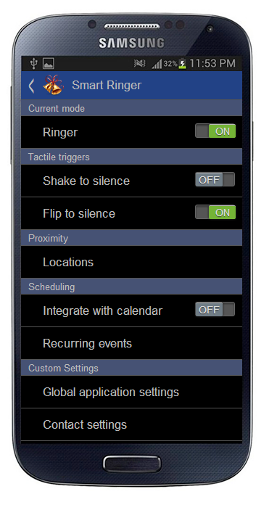

User flips the phone to prevent calls

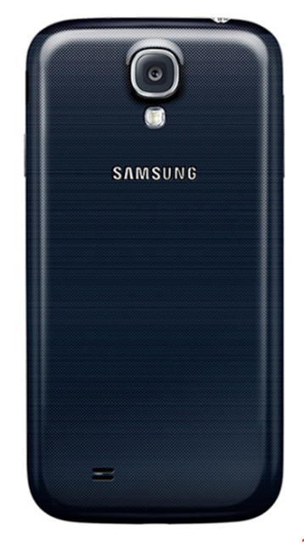

Scenario 2 - The user has enabled "shake to silent" and had kept the phone in the purse. This functionality allows for the user to silence the phone without having direct access to it.

User goes to setting screen



User enables "shake to silence"

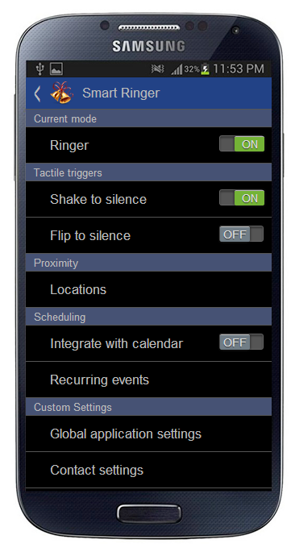

Scenario 3 - Allow a user to input a location via GPS to enable or disable the ringer. This gives them the ability to control the ringer via GPS location.

User goes to setting screen



User goes to the Locations setting

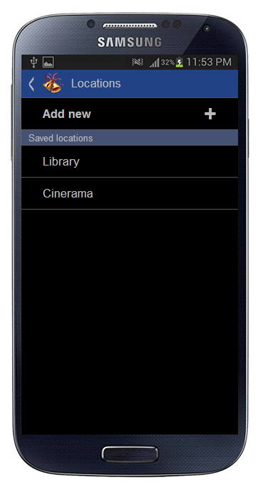

Add a new location or look at an existing entry

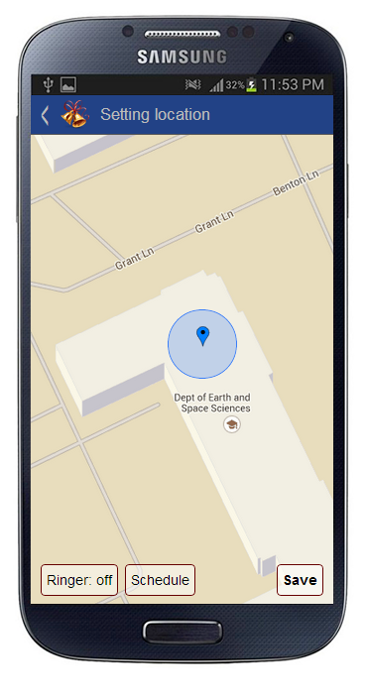

Change the location and radius

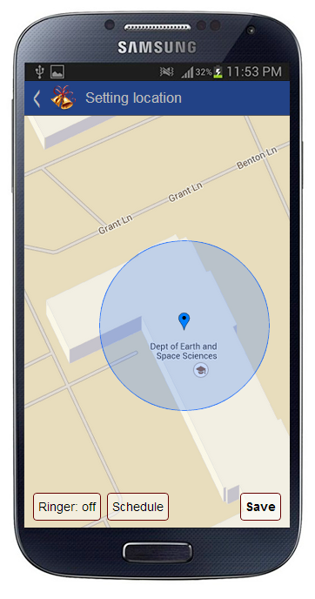

For our interactive prototyped, we implemented it with the help of Bootstrap, Backbone.js with a touch of CSS3 here and there. Most of the implementation was actually done from scratch, that is all the screens and transitions are written with the focus of using CSS3. The reason for this was to learn something new.

The use of Backbone.js helped us greatly as it gave us a great way to implement event binding and model/data binding. This allowed us to implement some of the more complex interactions, such as allowing for the phone to ring or shake to silence. Without using a more complex framework, we are able to get started minimally without high cost of ramping up or understanding a complicated widget lifecycle. In this instance, being able to quickly do things was great because we were able to quickly incorporate user feedback.

There were many small features that were left out of the final interactive prototype. Since some of these functionalities are quite complex and have multiple layers, it could take a very long time to implement them all.

Saving of location - this was left out because the core of the functionality was to be able to set the location and a radius. Saving and entering a name is not quite as important as getting the the feature done. Here's the missing screen:

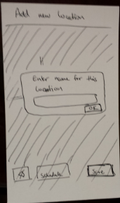

Scheduling for location - the interaction here is quite complex and has a lot of intricate parts. To fully implement this functionality, it would have taken a lot of time so we opted not to do it.

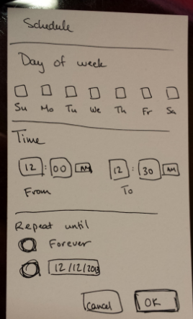

Summary discussion of project and lessons learned

Smart ringer is a smart phone application that helps users to have better control of their phone’s settings. It allows the users to customize when, where and how their phones should ring. It introduced a lot of cool new features that will allow the user to get the most out of his phone in a flexible and easy manner. There are third party apps that already to solve the issue, but none of them went the extra mile to give the users more control over the phone. Moreover, we proposed a few new ways to interact with the device that could further enhance the experience of the consumer, such as the direct control of the ringer by using a device's orientation or proximity to an external device. By allowing the user to combine many dimensions of settings such as time, location and proximity, the user will be allowed to create a unique configuration that works for his schedule. A configuration that he could depend on and not have to worry about his phone’s status.

When we started working on the project. We were not expecting the interaction with the users to would bring us such valuable insight about the design phase of software. From the early stages of the project, users were involved. We conducted interviews to gather information about the needs of the users. We have gained valuable knowledge by stepping in their shoes. We understood how our application can be a part of their daily lives. Moreover, we developed our application’s concept around the desires and capabilities of the users. Then, we have used their feedback to further enhance the design.

We have learned that there is always room for improvement. The defaults that the phones have might not be the best option. The more options we give the users to shape the way their phones act the more productive the users get. However, there is a limit after which more flexibility only becomes overwhelming for the user. It is important to maintain this balance between offering the user more freedom while still being able to offer a simple straightforward solution.

Appendices

First design

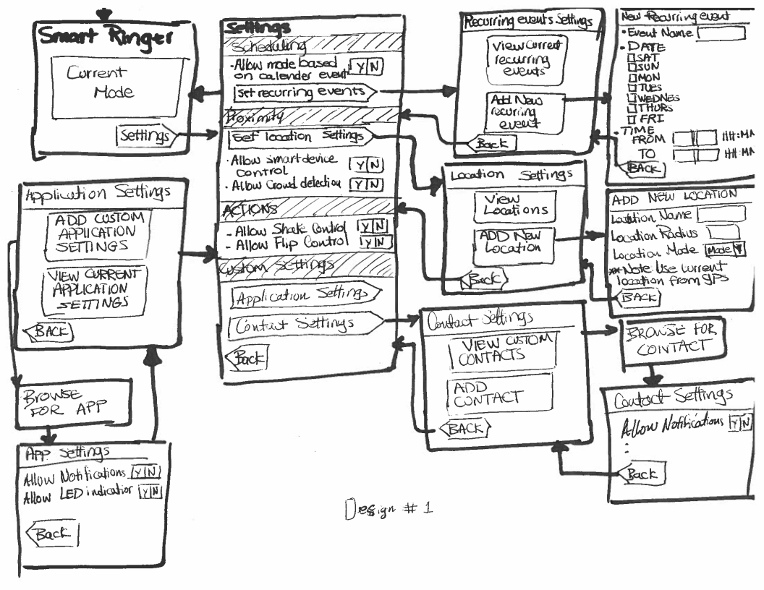

Sample interview notes

