* Title Candidates
  + Pernicious effects of long incubation periods on speed and synchrony of epidemic disease spread.
  + The Small Worlds of Slow-Course Epidemic Diseases
  + The impact of illness-induced changes in mobility on the speed and synchrony of epidemics.
* Introduction
  + Diseases, information, or anything else that spreads through a strictly proximity-based network is expected to propagate as a continuous and constantly growing wave front. Indeed, in historical outbreaks of Black Death such as 1347-1350, a wave front crept at a rather constant speed through a European continent that had weak long-distance connections at the time [Marvel 2013]. In the highly connected world of the 21st century, however, epidemic fronts can be globally discontinuous, as seen with the recent pandemic of SARS.
    - See also swear word adoption in feudal Japan
  + The factors driving these different pandemic patterns have been the topic of much research. Foremost among the explanations suggest that the increase in long-distance domestic and intercontinental travel has effectively rendered the human contact network a *small world*: as the global population swelled in recent centuries, the number of links needed to connect any two people grew more slowly or even decreased.
  + However, all diseases have not responded to the increase in global connectedness in the same way. The spread of vector-borne diseases such as malaria and yellow fever are limited by the need for a competent vector to sustain transmission even after the disease is introduced to new regions. Diseases that transmit from person-to-person, sometimes through a medium such as air or water, more directly depend on human mobility, but also on regional vulnerabilities and pathogen characteristics.
  + Recent back-to-back epidemics of cholera (2012-3) and Ebola (2014-5) in Sierra Leone present a unique opportunity to compare epidemic spread patterns in essentially the same population with respect to connectivity, vulnerability, and immunological backgrounds essentially naïve to both diseases.
  + These diseases share important similarities (eg, dramatic diarrheal symptoms with highly contagious effluent and acquired immunity at least through the epidemic season) and differences (eg, the ability for cholera to transmit via water and Ebola by blood and other bodily fluids). However, we hypothesize that differences in just one characteristic, the incubation period, is sufficient to reproduce much of the observed differences in dynamics in a population with a tendency to decrease travel while ill.
  + The study of changes in mobility during periods of illness is a surprisingly neglected topic despite the fundamental importance of changes in human behavior, self-initiated [Funk 2010] or institutional interventions [Bell 2004, Hatchett 2007] during epidemics.
    - Recent empirical studies have generated cross-cultural support for the expectation that a person decreases their travel and contact patterns while experiencing illness.
    - Febrile residents of an Amazonian city found reported significantly more time at home than afebrile residents and when they did travel, it was closer to home and to fewer locations [Perkins 2016].
    - English persons interviewed during the 2009 influenza pandemic reported four-fold more social contacts, particularly outside the home, while experiencing influenza-like illness as compared while healthy two weeks later [Kerckhove 2013]. Also, the contacts that remained were of a shorter duration.
  + In this paper, we demonstrate that reductions in human mobility in response to illness can generate an interrupted diffusion process whereby disease dispersion is primarily driven by travel of pre-symptomatic individuals. We use network theory and simulations of disease spread to show that long incubation periods can increase epidemic wave front velocity and global synchrony.
* Methods
  + In our model, agents are distributed in 250 equidistant villages of size 1,000 on a lattice and can progress through a traditional SEIR compartmental transmission framework. The time elapsed in the (E) compartment is defined as the latent period and our initial models assume the incubation period, from infection to symptom onset, is the same duration of each agent.
    - We can loosen this assumption by having the change in travel occur X days after moving to the “I” compartment. Therefore, infectiousness emerges while individuals carry on their normal behavior since they are symptom-free.
  + Also, some diseases may be infectious beyond symptoms (e.g., Dengue), so consider ending the travel reduction before leaving the I compartment
  + Direct calculations of how spark probability increases with incubation period
    - Prob(starting an outbreak at a distance X from the wave extent)
      * Probability of sustaining transmission given introduction
        + If all travel is during incubation period, then only depends on R0. Otherwise, also depends on infectious duration
      * Daily probability of making a jump of at least distance X
        + Consider a cone. If the jump is perpendicular to the wave front, then X can be shorter. But, angles are possible too if the jump is longer. Perhaps consider one dimension, since the others should be proportional?
        + This will not depend on the disease
      * Expected number of incubation days
        + This depends on the disease
    - If long jumps are super rare, then neither diesease will have sparks. If the long jumps are very common, then both diseases will have the sparks and the population is functionally well-mixed.
      * In-between, the probability of a sparking event increases as a function of the incubation period duration
    - Assumes that only those at the edge of the wave will generate the spark. But, there will be more infectious people further inside the wave, so the edge may not be largest contributor to the sparking. It depends on the density of infective and their distance to the wave front edge.
  + Measurements
    - Spread velocity
      * Vel(t) = Cumulative proportion of villages that have had at least 1 case by time t
        + Alternatively, consider increasing to 10 cases or some other metric (Mollison 1977)
      * Vel(t) = slope of the log(distance from origin) vs log(time) plot
        + Select some cardinal directions and sample the max from each.
    - Synchrony of local outbreaks
      * Peak timing of local outbreaks
        + Variance in the Peak(i) distribution, where Peak(i) = time of max “I” load in village “i”
        + Cross-correlation function of each pair, weighted by the product of the total case count in each or something to create a summary statistic
        + standard deviation of the Mean Confirmation Time index (mean time of infection for an individual over course of outbreak in that area) (He 2015)
      * Synchrony of global epidemic
        + Peak number of infectious individuals globally
* Results
  + Network Theory
  + Simulations
  + Case Study
    - Similarities between the diseases
      * The reproductive number estimated from both epidemics was on a similar order
    - Differences
      * The Reproductive number of cholera was closely correlated with rainfall. Therefore, there was a close correlation between heavy rainfall and the higher number of cases X days latter, accounting for the generation interval.
        + Rainfall can be an important driver of epidemic synchrony though, in areas that already had introduction. By the beginning of the rainy season (ie the first day with ____), X% of chiefdoms had already detected cholera, demonstrating that a large degree of the spatial dispersion was prior to rainfall.
      * Transmission route
        + Note that for cholera though, the disease did not follow the river flow directional network nor did the transmission intensity correlate with indicators of water or hygiene quality (indeed, Ebola proved more highly correlated than cholera did)
    - Spread measurements
      * Check in the case study if cholera or Ebola were more synchronized in onset and in peak.
    - Simulations using SL characteristics and each disease
      * Show how well the incubation period difference reproduces the observed epidemics
* Discussion
  + In a population of individuals who decrease mobility when ill, travel during the incubation period is the key driver of geographic disease dispersion.
    - Consequently, diseases with longer incubation periods will tend to have more long-distance “sparking” events. This results in faster epidemic dispersion and more globally synchronized epidemics (i.e., the diameter of the disease contact network decreases and the “world” becomes “smaller”)
  + We recognize that many other factors will influence wave speed, continuity, and epidemic synchrony, but in our simulations starting with the simplest dynamical description, very small changes in incubation period can powerfully influence epidemic dynamics of spread and synchrony.
  + The incubation period has already been recognized as an important component for understanding epidemics and control, but here we demonstrate a mechanism challenging the conventional wisdom that suggests that long incubation periods are desirable for disease control efforts.
    - The essence of that argument observes that longer incubation periods lead to longer generation intervals and therefore more time for responders to scale-up interventions.
    - We show here how a long incubation period, generally a regarded as a godsend, can render containment more challenging by increasing geographic dispersion, unpredictability in spread, and global synchrony.
    - *measure time as days and also number of generations in order to emphasize that the generation interval is important for slowing down spread, but overwhelmed by the incubation period*
  + Despite (or perhaps because of) a much longer incubation period, the epidemic of Ebola spread more quickly through Sierra Leone than the epidemic of cholera
    - While we recognize that despite the similarities, there are meaningful differences between these diseases and characterizing disease spread will necessarily be multi-factorial. However we show that differences in incubation period alone is a powerful driver of geographic dispersion when human mobility decreases due to immobilizing diseases.
    - How much of the difference in wavefront velocity can be explained by differences in disease dynamics?
      * Without needing to model nuances in transmission route, etc.
  + Usual consensus is that a longer incubation period will aid control efforts, because more time is allotted for interventions such as contact tracing and the epidemic growth rate, which is inversely related to the generation interval, will tend to slow, which gifts responders with more time to scale-up containment.
    - However, we propose a mechanism whereby a longer incubation period may hinder a response by increasing the geographic scope of an outbreak, the number of affected populations, and synchronizing an outbreak such that limited resources (e.g., ventilators or hospital beds) can be stretched even more thinly at an epidemic peak.
  + There is a need to better understand the travel behaviors of individuals who are ill. Novel methods for long-term monitoring of human mobility are now available, and should be leveraged to better quantify how travel may change during illness. Our results suggest that such changes can powerfully influence the dynamics of disease spread and merit further study.
  + Conventional wisdom suggests that a long incubation period is advantageous for our control efforts [SARS]. However, longer incubation periods are known to have perverse consequences by increasing time needed to quarantine or monitor suspected contacts [Ebola], etc. Here, we show how the incubation also can influence disease synchrony and spread, both of which can amplify the strain placed on epidemic control measures that must be increased in quantity [Influenza] and distributed more widely.
    - We identify counteracting forces: long incubation periods can slow outbreaks within populations but can increase the time allowed for pre-symptomatic individuals to travel and disperse the pathogen.
  + Interaction between the reduction in probability of travel (ϕ) and the duration of infectiousness. Diseases with long infectious periods can still have a chance of traveling while infectious
* Supplemental Information
  + More on Case Study results
    - Due to their unfortunate frequency, the global health community has identified patterns in epidemic spread. One factor commonly cited is that epidemics follow vulnerability fault lines. However, we show here that the profile of epidemic spread can be strongly influenced by epidemiological dynamics, and particularly the incubation period.
    - These case studies show that within a rather poor country, we didn’t just see the most poor affected, nor did we see a disease with water-borne transmission follow river or water networks.
    - In a country where neither disease caused recent outbreaks, cholera, notorious for its quick onset, spread more slowly than Ebola, which can incubate undetected in a healthy person for up to three weeks.
* Other Notes
  + Analogies
    - Generation interval is like the size between the steps. Assuming a diffusive process, a longer time between steps can lead to longer sparking events
    - An interrupted diffusion process is like a game of red-light green-light. An individual has a green-light to disperse until symptoms emerge and cause the red-light to slow or prevent further movement. People can move further if the green-light time (the incubation period) is longer.
    - In the popular game Plague Inc., new users quickly converge on a strategy for global viral domination. That strategy is to suppress symptom development as long as possible so that the diffusion process can continue unimpeded by “red-lights” such as travel restrictions or vaccine development. When evolution plays this game in nature, pressure is placed on the incubation period
  + Previous work
    - Previous work by Mollison (1972) through Marvel (2013) have demonstrated the importance of long-range connectivity in determining whether a continuous wave front is sustainable or if spread is punctuated by “great leaps forward” followed by converging ripples. In their work, long-range connectivity was defined by distance kernel functions determining the decay in transmission intensity as a function of distance between an S-I pair. Such kernel functions would depend on transportation infrastructure, commerce patterns, and other characteristics specific to a population. However, as seen in the example of cholera and Ebola in Sierra Leone, we posit that disease characteristics can also influence the probability of generating “great leaps forward”, which we show here could have strong implications on disease spread and synchrony.
* Table 1

|  |  |  |  |
| --- | --- | --- | --- |
|  | Cholera | Ebola | Ratio  [Ebola/Cholera] |
| Median Incubation Period | 1.5 days | 7.9 days | 5.3 |
| Median Duration of Infectiousness |  |  |  |
| Median Generation Interval | 2.3 days | 13.4 days | 5.8 |

* Technical Appendix
  + Create a simple grid with nV villages of nP residents per village
  + Create an SEIR disease process
    - Assume that the incubation period and latent period are equal, so symptom onset and infectiousness onset coincide.
    - Extension: Allow infectiousness to precede symptom onset by some length by allowing travel to continue at the normal rate until X days after entrance into the “I” category.
  + Generate a binary rook’s contiguity adjacency matrix **A** for the nV villages
  + Assign a home village Hi for each individual
  + Define a probability α of an (S,E,R) individual leaving their current location
    - If an individual is chosen to move during this time step, they select a village according to adjacency matrix **A**
      * To account for homeward-bound travel, supplement the destination candidates from adjacency matrix **A**with the home village Hi. To increase the weight of homeward bound travel, additional Hi destinations can be added.
      * Initially, this number can be set to zero and thereby generate a pure diffusion process with no home memory.
    - If an individual is infectious (ie, compartment I), their probability of travel α* = min(max(ϕ α, 0), 1).
      * Note, infectiousness does not affect travel if ϕ = 1, infectiousness increases travel if ϕ > 1, infectiousness decreases travel if 0 < ϕ < 1, and infectiousness halts travel if ϕ = 0.
      * ϕ = 0 is like a set of travel restrictions that prevent movement completely when individuals are symptomatic
    - Consider settings where travel can still occur, but is decreased in probability (i.e., 0 < ϕ < 1). Under this circumstance, the duration of infectiousness also matters, because if you’re only infectious for a day or two, you still are unlikely to travel far. Since cholera has a shorter duration of infectiousness, this is consistent with our case study too. Even if people still travel while infectious, they aren’t likely to go far.
      * So, the duration of the incubation period is essential if travel halts upon symptoms. It is still important if travel occurs after symptom onset, but the duration of infectiousness is increasingly influential if symptoms are less likely to reduce travel.
      * Therefore, pre-symptomatic infectiousness is highly influential as well, since it can spread the disease to each location visited and would not be reduced by interventions or changes in human behavior during illness.
    - A negative control is to increase travel among sick people. Show that this increases dispersion and has opposite effects? Note in discussion how this could occur if individuals travel to far-away hospitals or possibly move to avoid detection if the disease is stigmatized or illegal.
  + Define P(j|dij) as the probability a traveler chooses village j given the distance of dij between villages i and j
    - eg, P(j|dij) = dij/ Σjdij
  + Define ω(dij) as the rate of returning home given distance dij
    - eg, ω(dij) = k/dij where k is a constant scalar
  + Assume visitors and residents are well-mixed within a village
  + Assume disease follows SEIR process where illness and infectiousness are both fully contained in compartment “I”
  + Simulate SEIR epidemics
    - Variables: Incubation period, duration of infectiousness, R0
  + Measure speed of epidemic spread
    - Survival analysis, origin-to-wavefront distance (Pybus 2012)
  + Measure outbreak synchrony
    - Spatial phase coherency functions (Grenfell 2001)
* Methods (Extensions)
  + Instead of simple grid
    - Village locations can be placed via a cumulative advantage generative network model
    - Village locations can emulate Sierra Leone
  + Ill individuals travel to health facilities (eg ETUs) for care
  + Record the events of disease export and import
    - Export: Incubating traveler brings disease to destination
    - Import: Traveler brings home a disease acquired abroad
  + Create a map that shows the timing of the peak, holding the time unit to days
    - 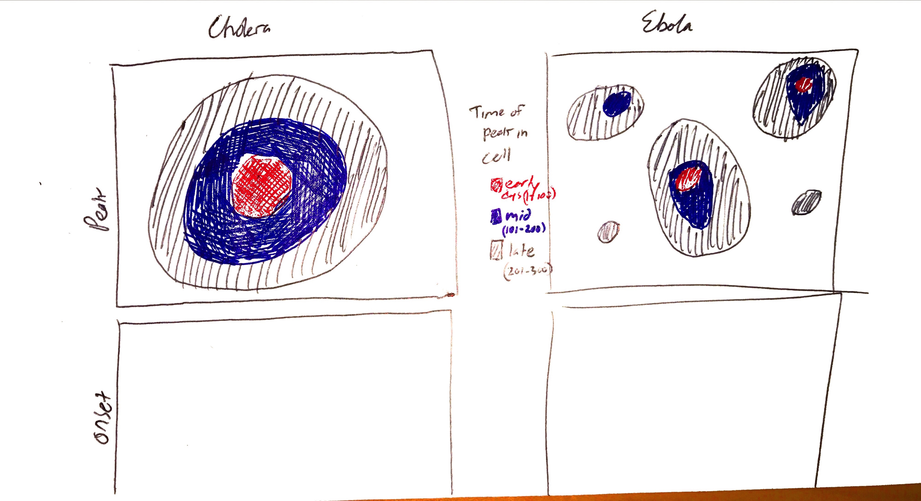
    - Consider also having time unit as Generation #
    - Consider also showing time of onset
  + Create a map that shows the effective edges that we simulated. So, a map with very long edges suggests that individuals were able to travel long distances with the disease.
    - Color code by time (red for very early, blue for late in the simulation).
      * A cholera-like disease may have very short edge lengths, but lots of them radiating outward in each time step.
      * An Ebola-like disease may have longer edge lengths
    - 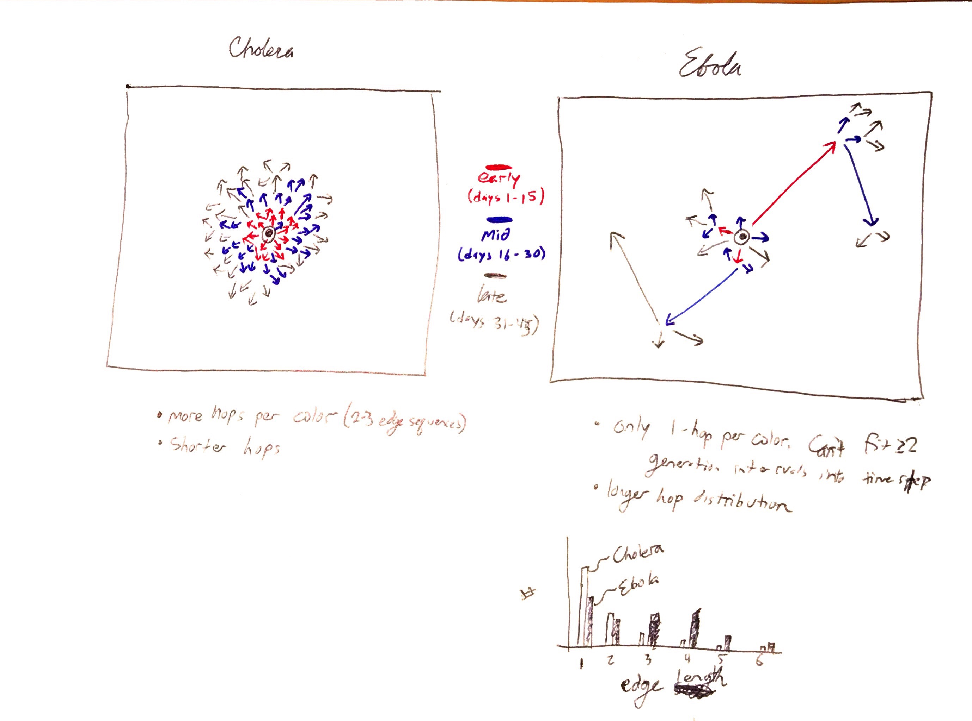
    - Calculate distribution of edge lengths. Show how the mean edge length increases with the incubation period.
      * 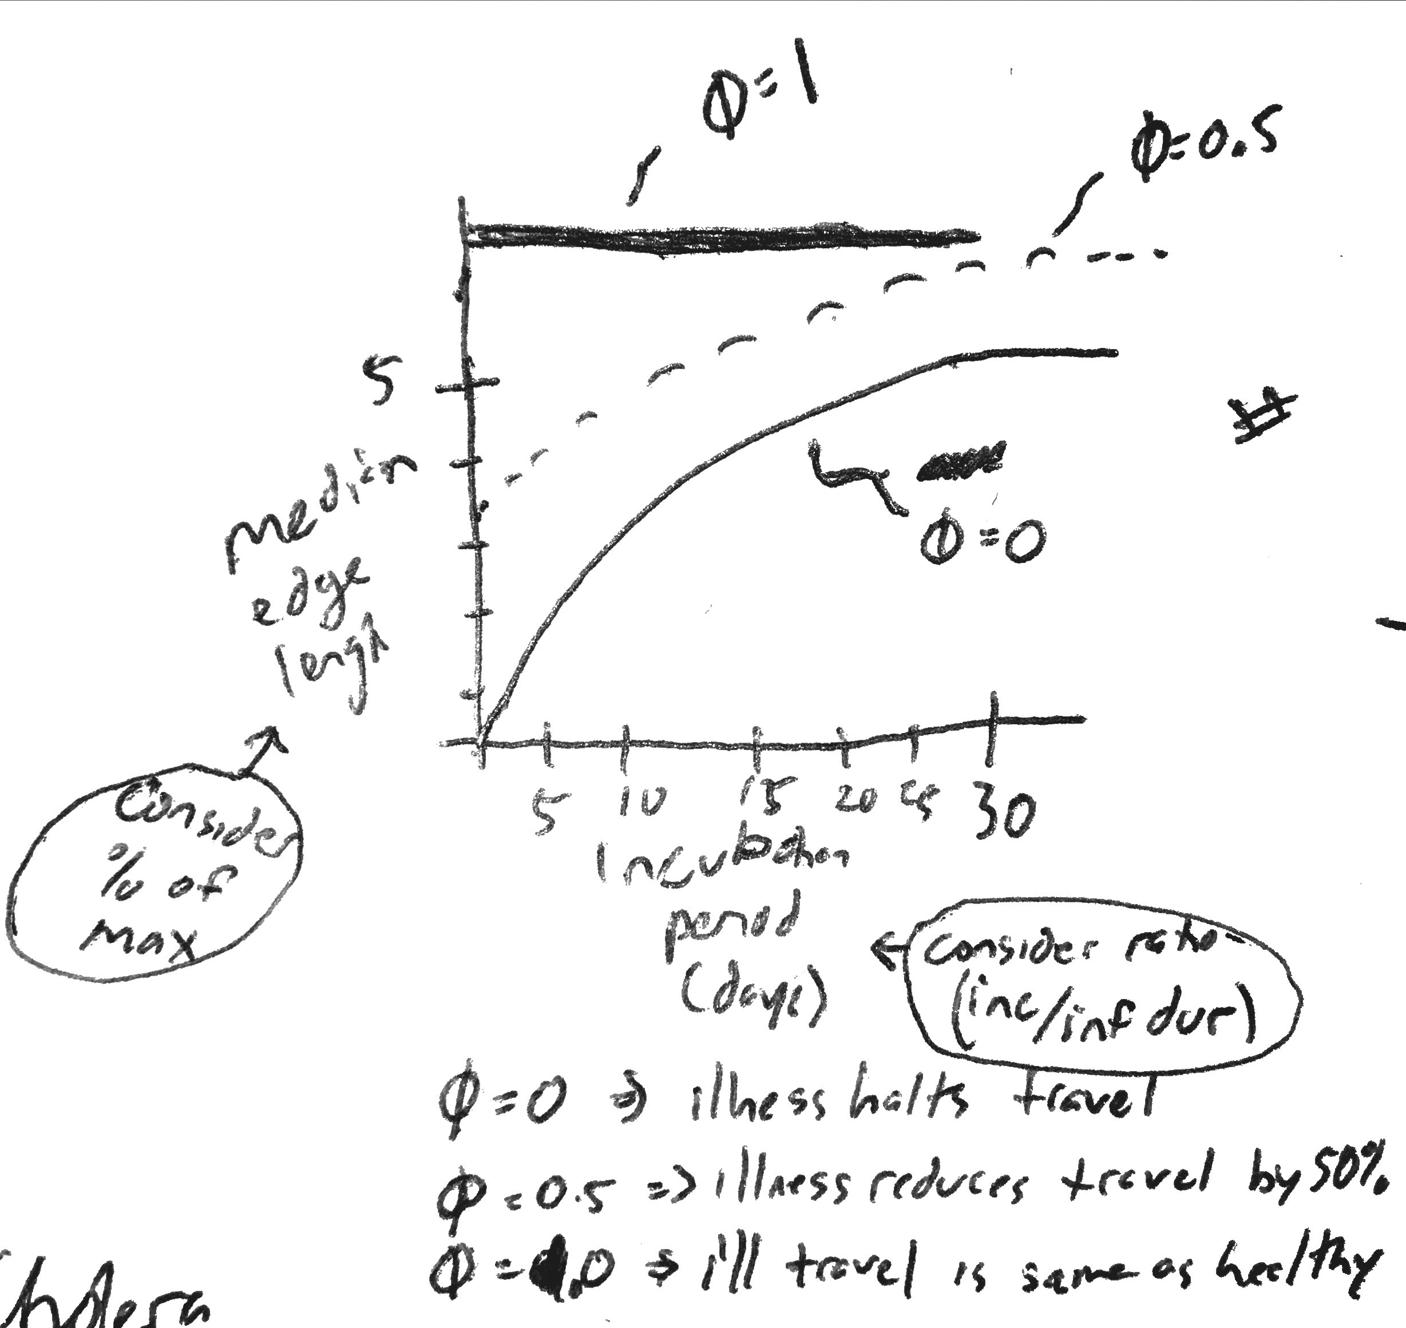
* Parallel concepts
  + Is effectiveness of travel restriction for reducing disease spread altered by incubation period? Are some diseases more suitable?
  + Evolutionary tension between reaching new niches and unexposed populations against the drive to be the first pathogen to escape the current host and reproduce in another. Assumes immunizing and virulent infection. Strong motivation for asymptomatic but infectious clinical presentation. Optimal result may be some hosts with short incubation, some with long, and some with asymptomatic yet infectious.
  + Would be interesting to test with many epidemics of different diseases
    - X-axis is incubation period or generation interval
    - Y-axis is speed of geographic spread in Kilometers per day
* References
  + [Riley 2015 Epidemics].
    - Five challenges. Regular lattice reference (mollison and kuulasmaa 1985) and random geometric graphs reference (Penrose 2003)
  + [Riley 2007]
    - Ref that movement of hosts is important feature of sparkly explicit ID models
  + [Riley Ferguson 2006]
    - Consider keeping a lattice and then individuals move according to a kernel. Then I don't need a network defined, but a single probability function for how far they might go
  + [Kramer 2016 Royal Society Open Science]
    - Example of networks weighting the fully-connected graph.
  + [Marvel 2013]
    - Wave front continuity example with Smallpox in Europe
  + [Viboud 2006 Science]
    - Proposes a measure of synchrony based on the inverse of the variance of onset date.
    - Synchrony increases with R0.
    - Synchrony and probability of an outbreak increase with a more highly-connected origin
  + [Zinszer 2015 Lancet]
    - Ebola spread velocity