Sub-task 1 - Update web application
- Update your web application to include the following functions:
  - download an image by name
  - show metadata for the existing image by name
  - show metadata for a random image
  - upload an image
  - delete an image by name
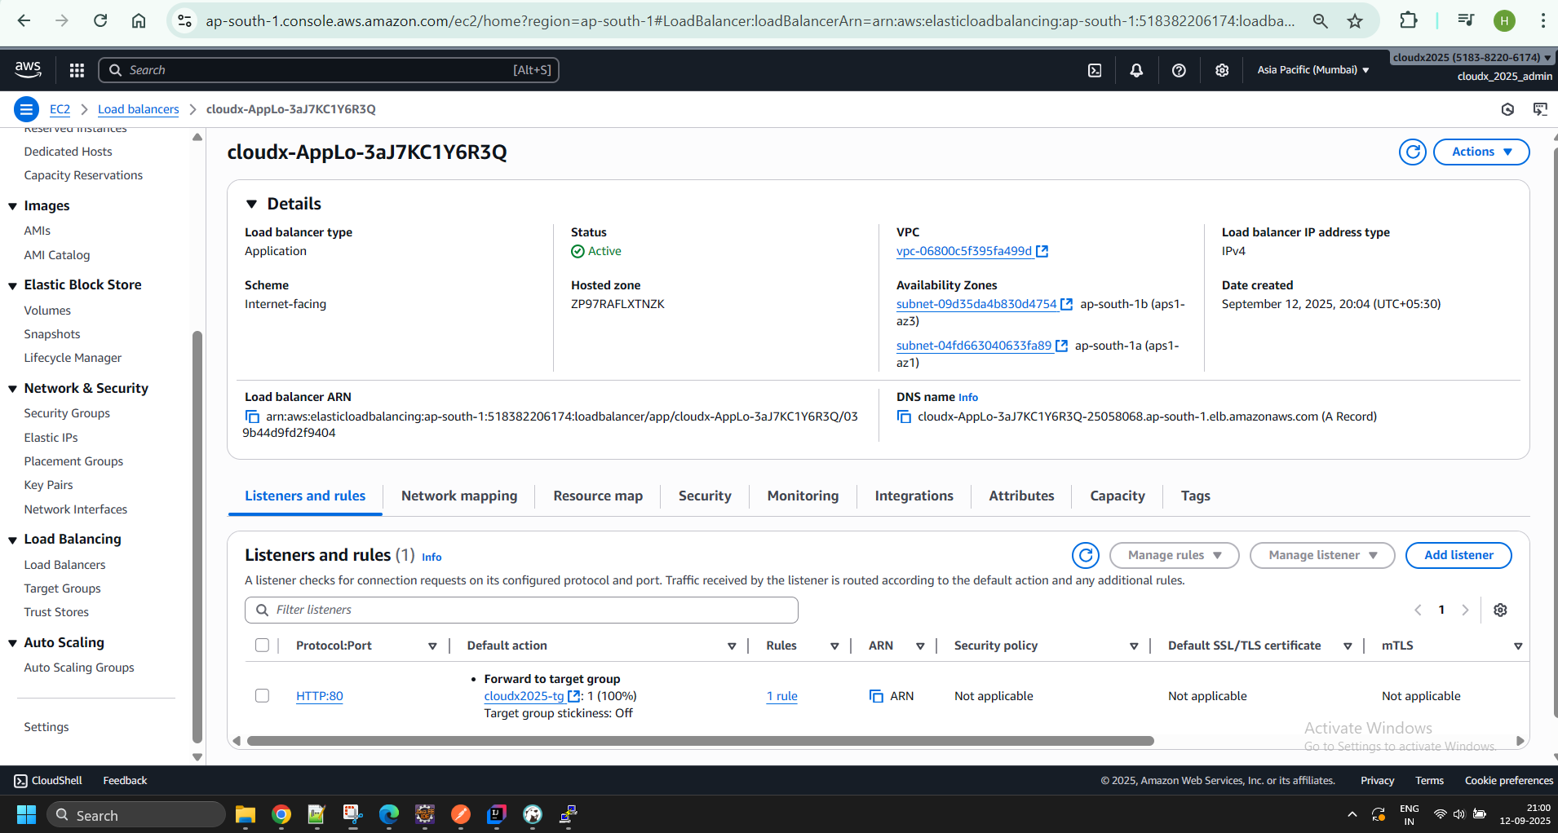
Note. The image metadata should include: last update date, name, size(in bytes), and file extension.

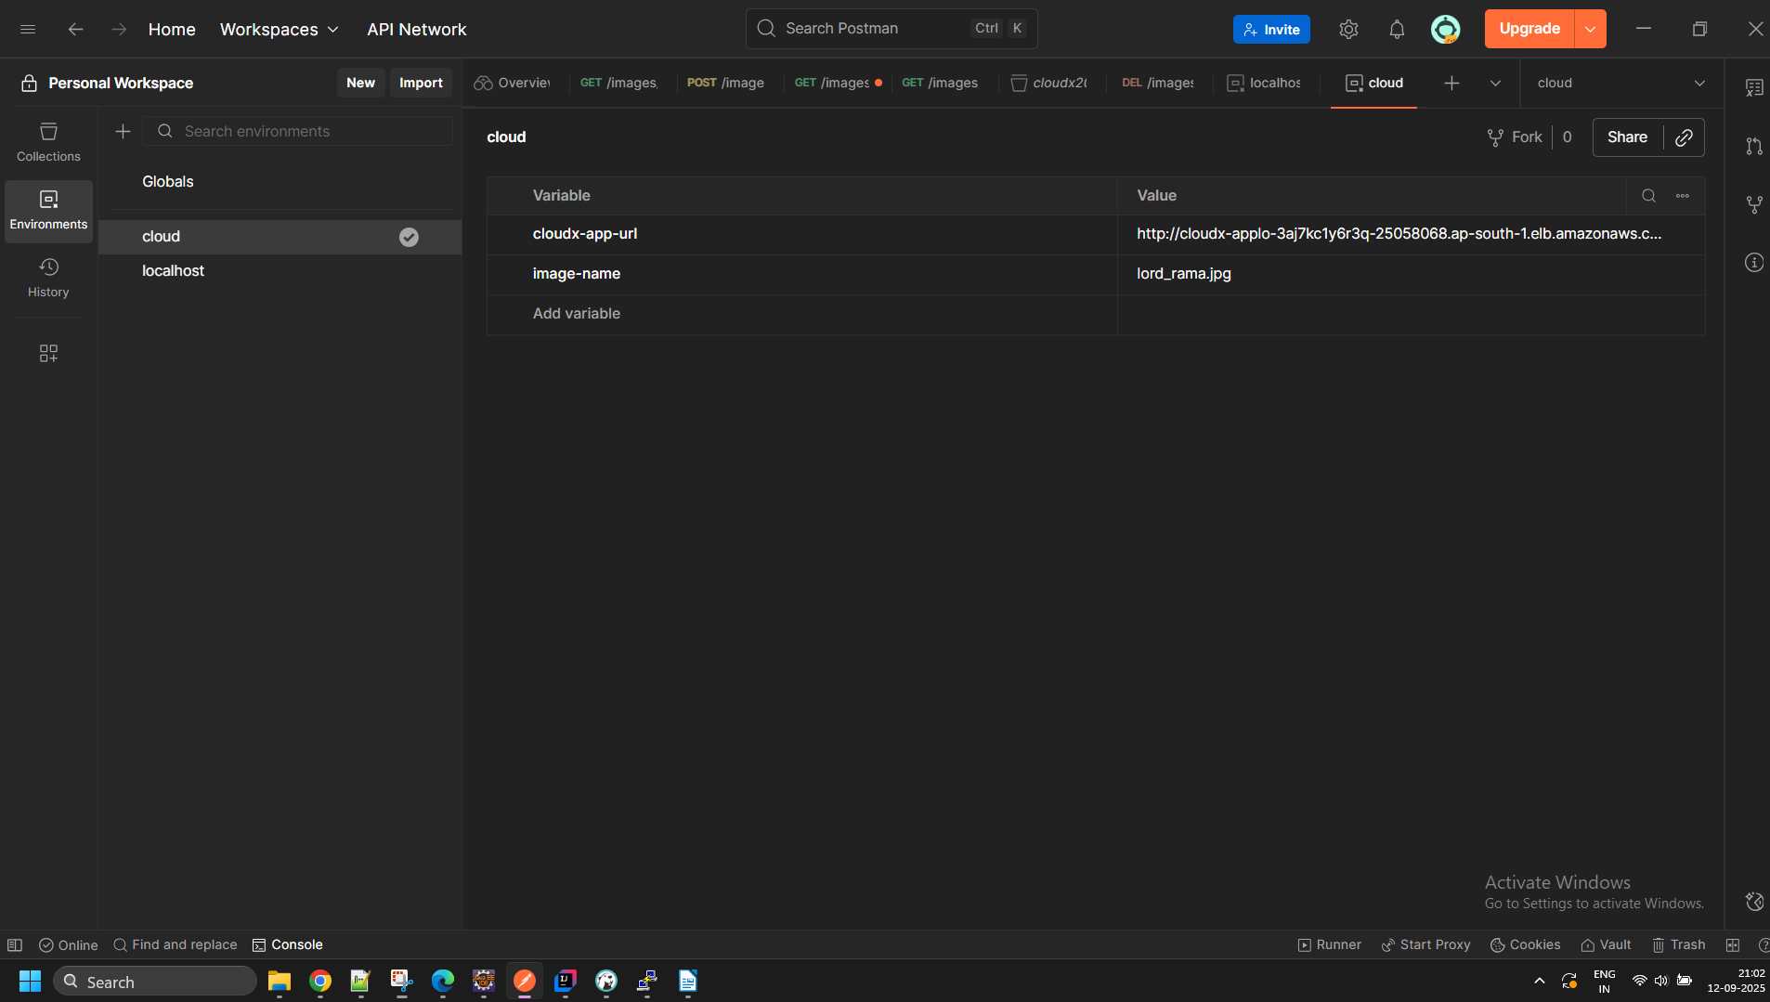

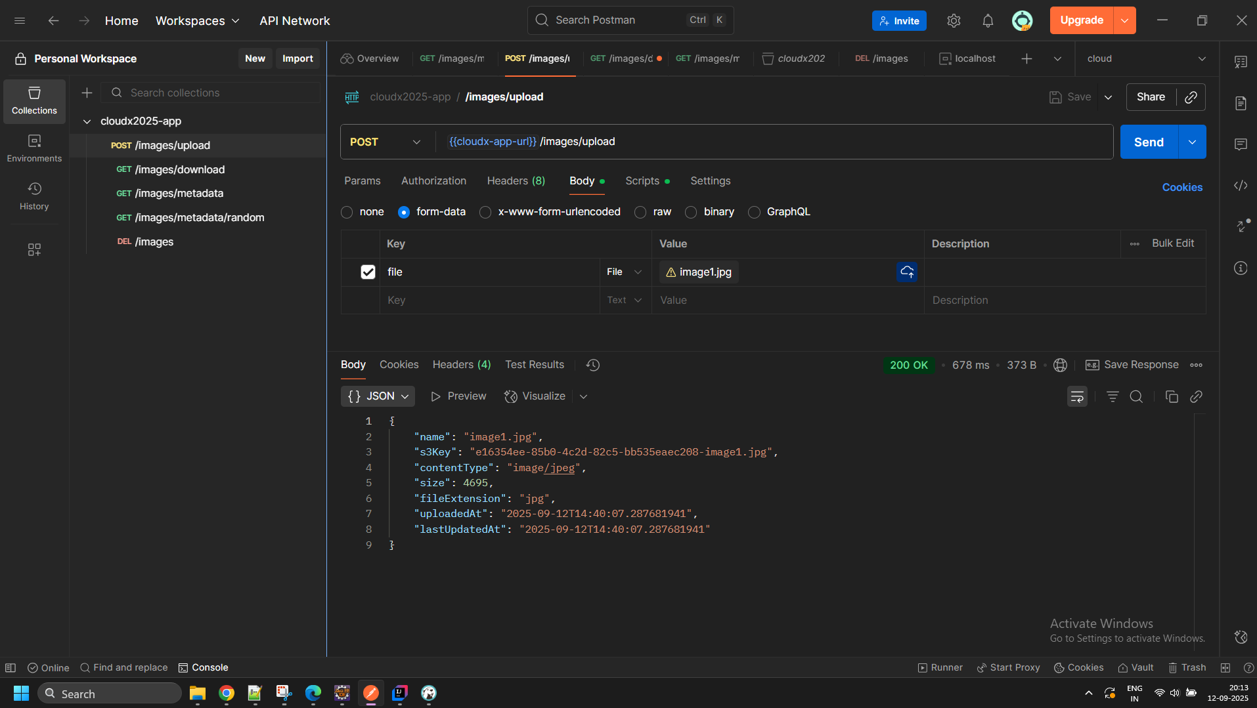
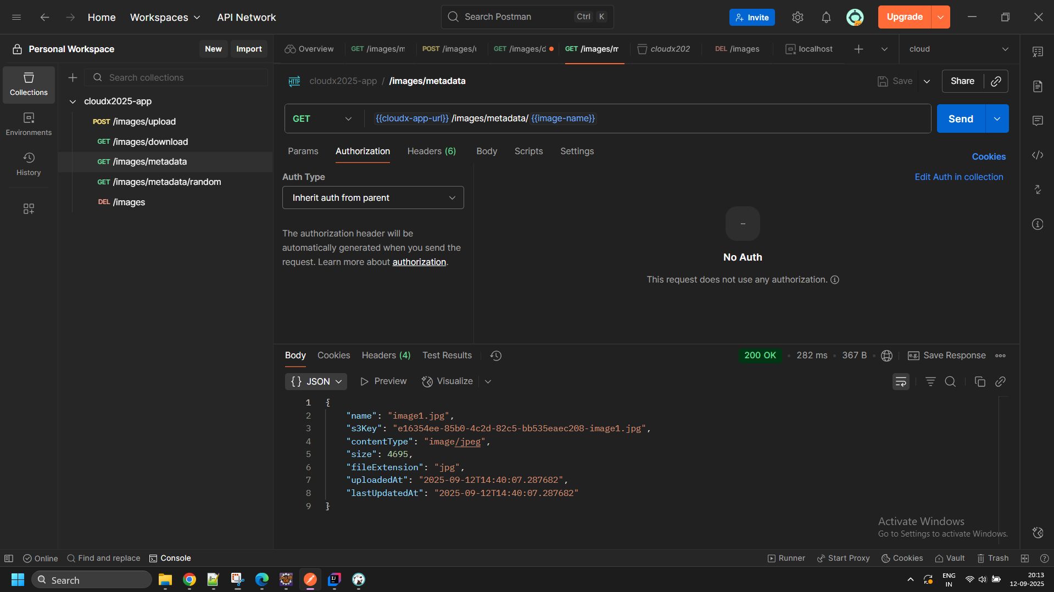
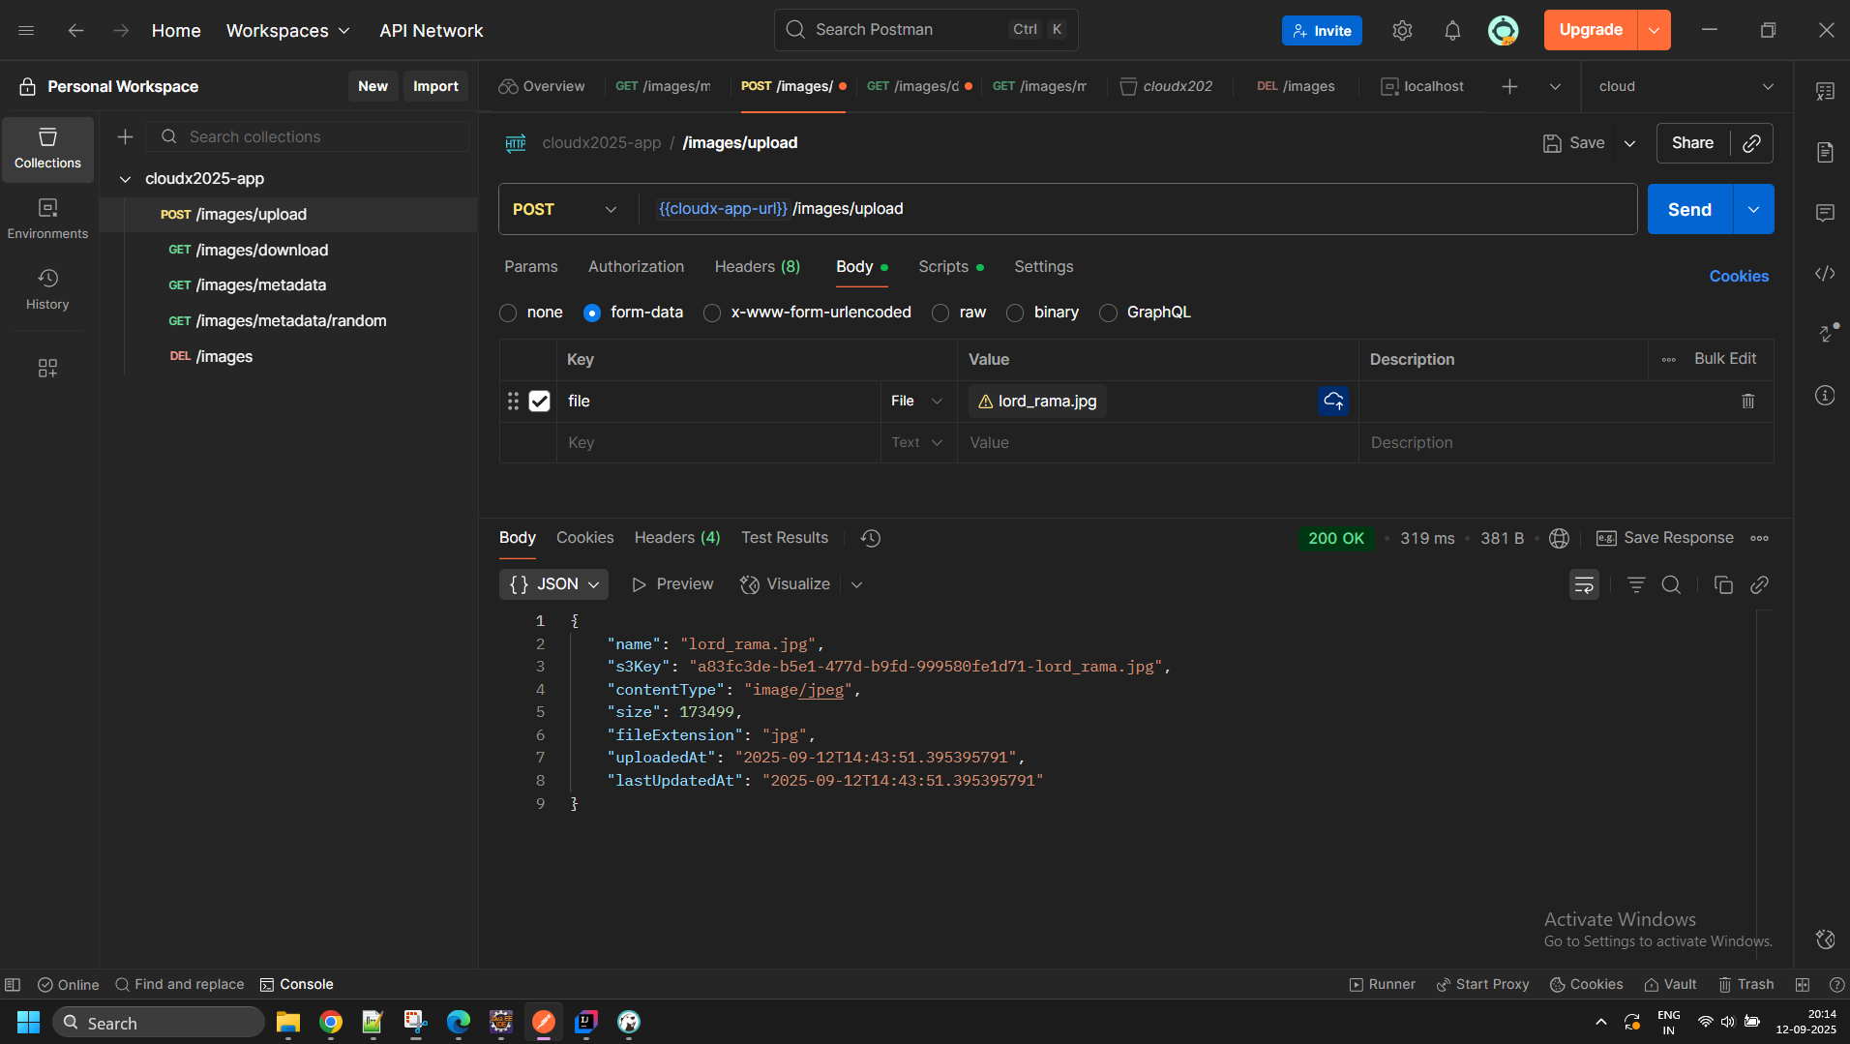

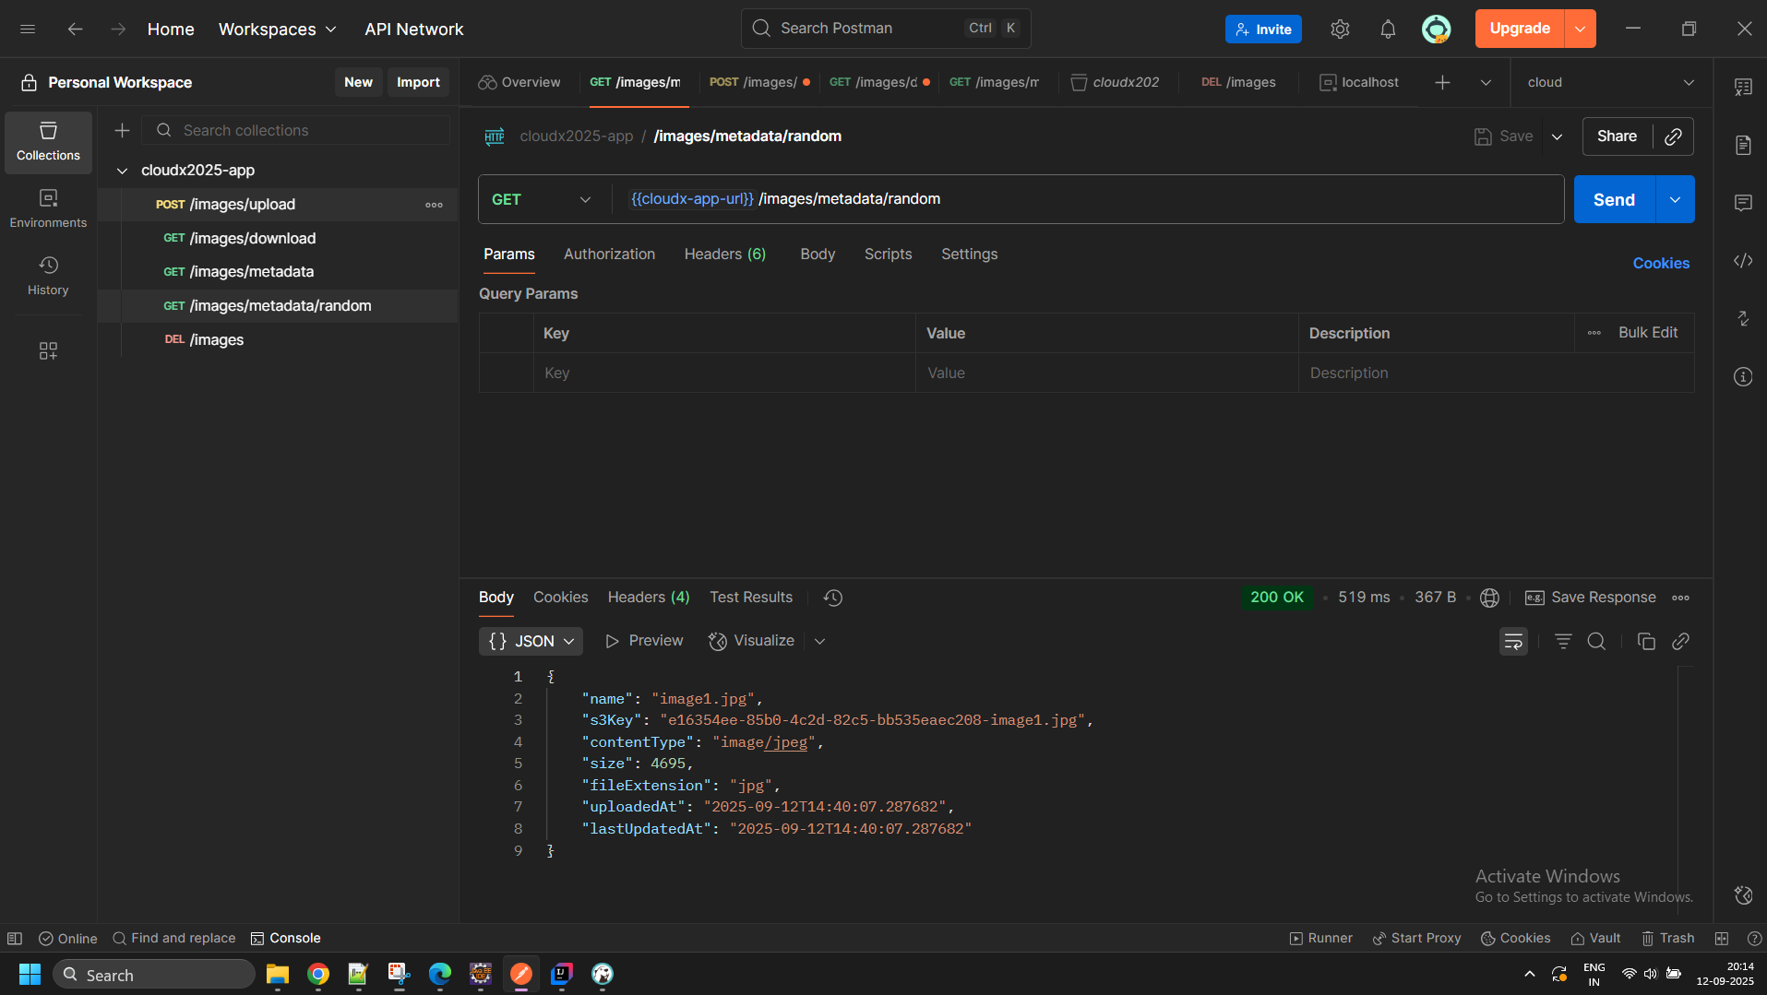
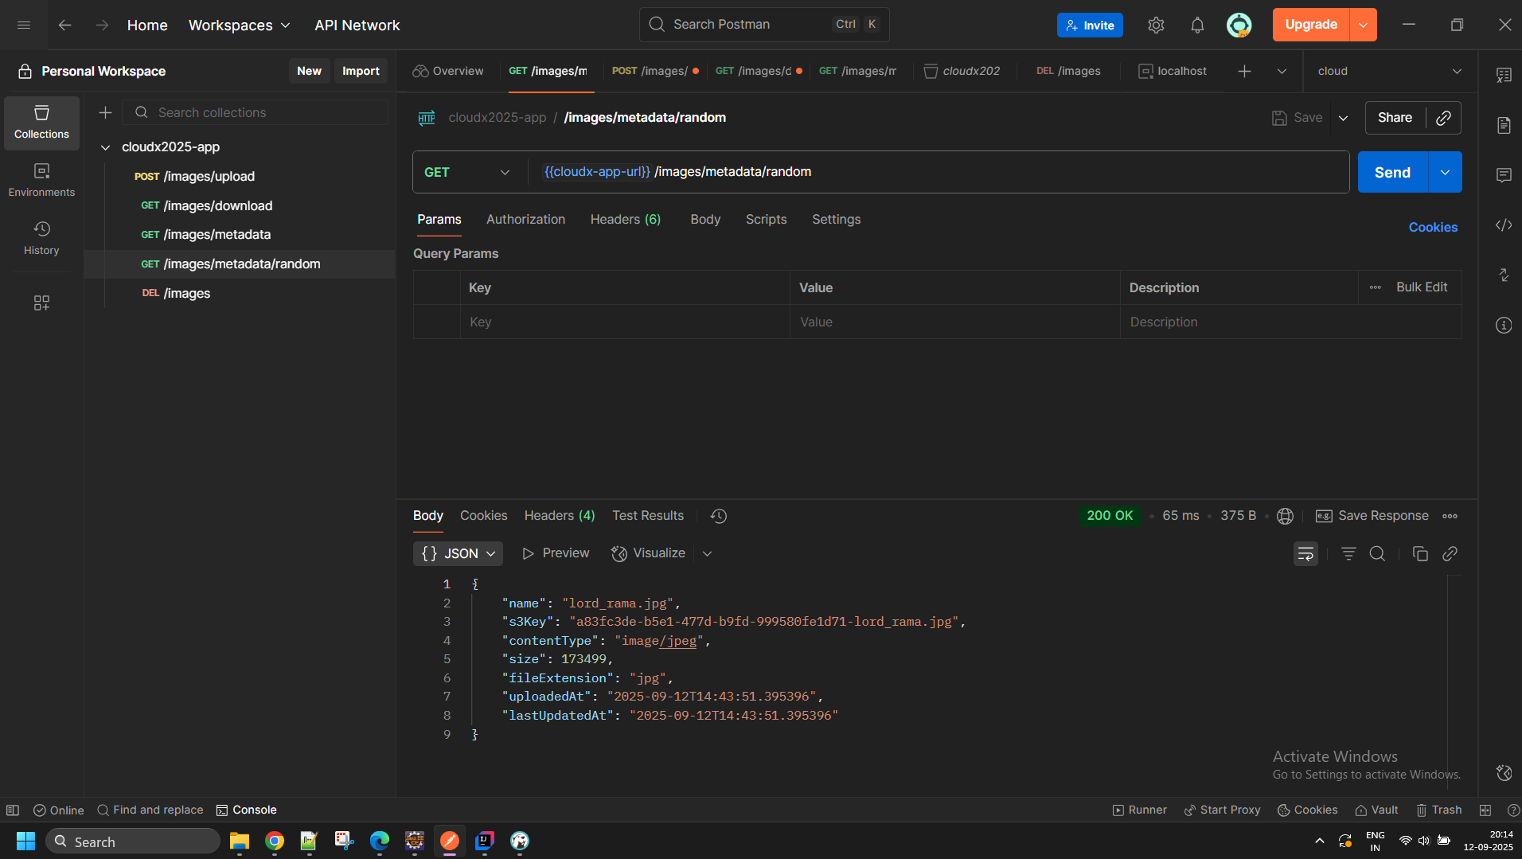

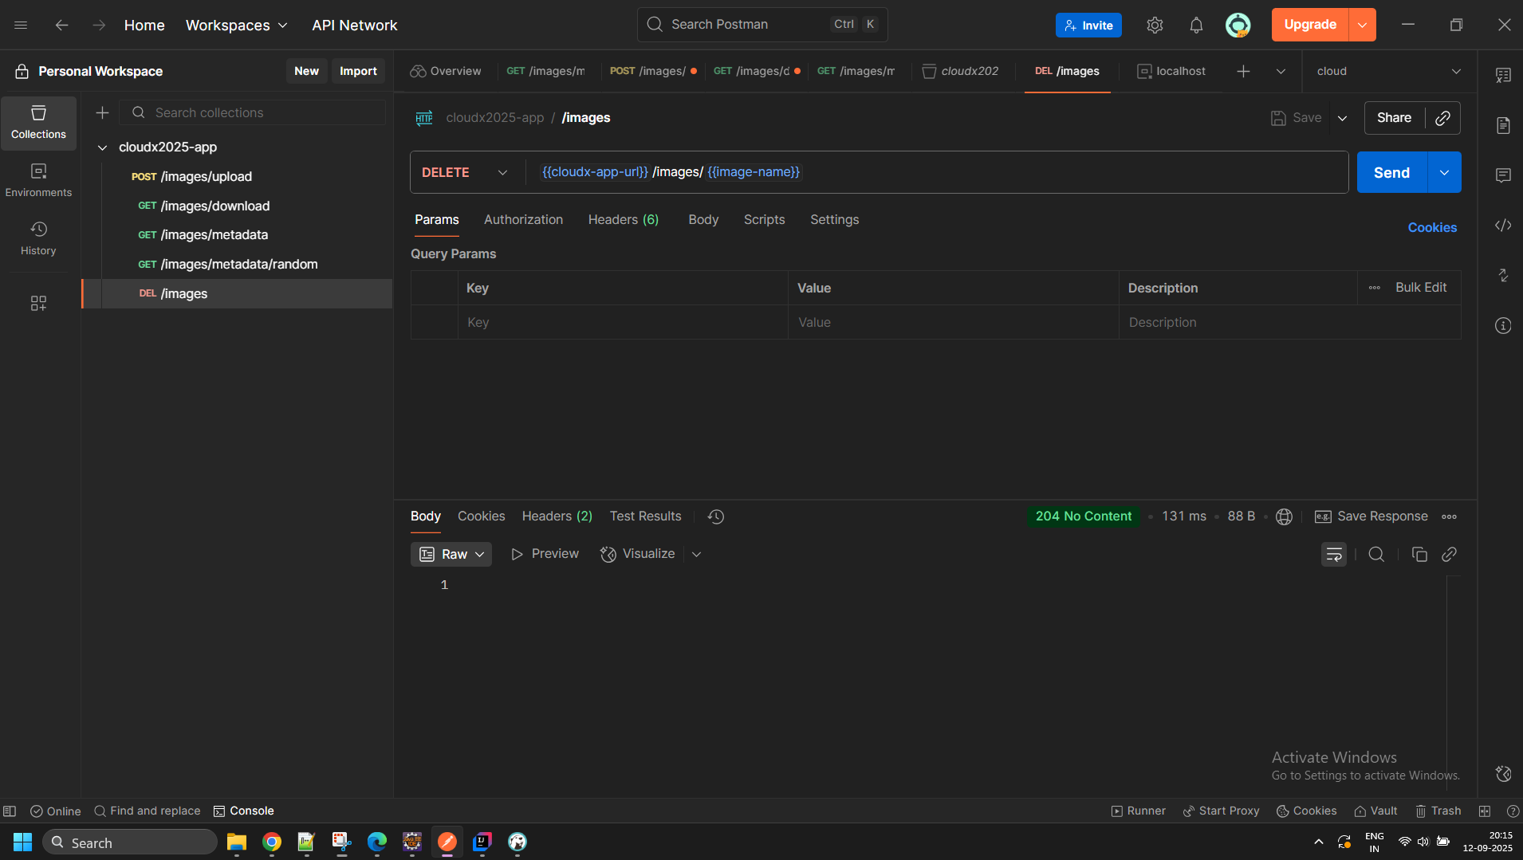

Sub-task 2 - Add DB instance to store metadata
Note. The screenshots are made in us-east-1 (N.Virginia) region. If you use another region, the UI may be different.
- Create an RDS instance in one of the DB subnets (Private Subnets) of your VPC. Choose creation method and engine type. WARNING: Select a free-tier template.
Cloud Formation template 1
======================
This just creates the network stack
Parameters:
ProjectName:
Type: String
BucketSuffix:
Type: String
Description: "Suffix for the S3 bucket name"
DBUsername:
Type: String
NoEcho: true
Description: "Master username for RDS"
DBPassword:
Type: String
NoEcho: true
Description: "Master password for RDS"
DBName:
Type: String
Default: cloudx2025
Description: "Name of the database to create"
Resources:
S3Bucket:
Type: AWS::S3::Bucket
Properties:
BucketName: !Sub "cloudx2025-${BucketSuffix}"
VPC:
Type: AWS::EC2::VPC
Properties:
CidrBlock: 10.0.0.0/16
EnableDnsHostnames: true
EnableDnsSupport: true
Tags:
- Key: Name
Value: !Sub "${ProjectName}-VPC"
InternetGateway:
Type: AWS::EC2::InternetGateway
Properties:
Tags:
- Key: Name
Value: !Sub "${ProjectName}-IGW"
AttachGateway:
Type: AWS::EC2::VPCGatewayAttachment
Properties:
VpcId: !Ref VPC
InternetGatewayId: !Ref InternetGateway
PublicSubnetA:
Type: AWS::EC2::Subnet
Properties:
VpcId: !Ref VPC
CidrBlock: 10.0.1.0/24
AvailabilityZone: !Select [0, !GetAZs '']
MapPublicIpOnLaunch: true
Tags:
- Key: Name
Value: !Sub "${ProjectName}-PublicSubnet-A"
PublicSubnetB:
Type: AWS::EC2::Subnet
Properties:
VpcId: !Ref VPC
CidrBlock: 10.0.2.0/24
AvailabilityZone: !Select [1, !GetAZs '']
MapPublicIpOnLaunch: true
Tags:
- Key: Name
Value: !Sub "${ProjectName}-PublicSubnet-B"
PrivateSubnetA:
Type: AWS::EC2::Subnet
Properties:
VpcId: !Ref VPC
CidrBlock: 10.0.3.0/24
AvailabilityZone: !Select [0, !GetAZs '']
MapPublicIpOnLaunch: false
Tags:
- Key: Name
Value: !Sub "${ProjectName}-PrivateSubnetA"
PrivateSubnetB:
Type: AWS::EC2::Subnet
Properties:
VpcId: !Ref VPC
CidrBlock: 10.0.4.0/24
AvailabilityZone: !Select [1, !GetAZs '']
MapPublicIpOnLaunch: false
Tags:
- Key: Name
Value: !Sub "${ProjectName}-PrivateSubnetB"
PublicRouteTable:
Type: AWS::EC2::RouteTable
Properties:
VpcId: !Ref VPC
Tags:
- Key: Name
Value: !Sub "${ProjectName}-PublicRT"
PublicRoute:
Type: AWS::EC2::Route
DependsOn: AttachGateway
Properties:
RouteTableId: !Ref PublicRouteTable
DestinationCidrBlock: 0.0.0.0/0
GatewayId: !Ref InternetGateway
PublicSubnetARouteTableAssociation:
Type: AWS::EC2::SubnetRouteTableAssociation
Properties:
SubnetId: !Ref PublicSubnetA
RouteTableId: !Ref PublicRouteTable
PublicSubnetBRouteTableAssociation:
Type: AWS::EC2::SubnetRouteTableAssociation
Properties:
SubnetId: !Ref PublicSubnetB
RouteTableId: !Ref PublicRouteTable
DBSubnetGroup:
Type: AWS::RDS::DBSubnetGroup
Properties:
DBSubnetGroupDescription: !Sub "${ProjectName} RDS subnet group"
SubnetIds:
- !Ref PrivateSubnetA
- !Ref PrivateSubnetB
DBSubnetGroupName: !Sub "${ProjectName}-db-subnet"
AppSecurityGroup:
Type: AWS::EC2::SecurityGroup
Properties:
GroupDescription: "Allow app traffic from ALB and SSH access"
VpcId: !Ref VPC
SecurityGroupIngress:
- IpProtocol: tcp
FromPort: 22
ToPort: 22
CidrIp: 202.14.120.130/32
Tags:
- Key: Name
Value: !Sub "${ProjectName}-AppSecurityGroup"
RdsSecurityGroup:
Type: AWS::EC2::SecurityGroup
Properties:
GroupDescription: "Allow MySQL from app"
VpcId: !Ref VPC
SecurityGroupIngress:
- IpProtocol: tcp
FromPort: 3306
ToPort: 3306
SourceSecurityGroupId: !Ref AppSecurityGroup
MyDB:
Type: AWS::RDS::DBInstance
Properties:
Engine: mysql
DBInstanceClass: db.t3.micro
AllocatedStorage: 20
DBName: !Ref DBName
MasterUsername: !Ref DBUsername
MasterUserPassword: !Ref DBPassword
PubliclyAccessible: false
MultiAZ: true
BackupRetentionPeriod: 0
VPCSecurityGroups:
- !Ref RdsSecurityGroup
DBSubnetGroupName: !Ref DBSubnetGroup
DeletionProtection: false
Outputs:
VpcId:
Value: !Ref VPC
Export:
Name: !Sub "${ProjectName}-VpcId"
PublicSubnetAId:
Value: !Ref PublicSubnetA
Export:
Name: !Sub "${ProjectName}-PublicSubnetAId"
PublicSubnetBId:
Value: !Ref PublicSubnetB
Export:
Name: !Sub "${ProjectName}-PublicSubnetBId"
PrivateSubnetAId:
Value: !Ref PrivateSubnetA
Export:
Name: !Sub "${ProjectName}-PrivateSubnetAId"
PrivateSubnetBId:
Value: !Ref PrivateSubnetB
Export:
Name: !Sub "${ProjectName}-PrivateSubnetBId"
S3BucketName:
Value: !Ref S3Bucket
Export:
Name: !Sub "${ProjectName}-S3BucketName"
RDSEndpoint:
Value: !GetAtt MyDB.Endpoint.Address
Export:
Name: !Sub "${ProjectName}-RDSEndpoint"
RDSInstanceId:
Value: !Ref MyDB
Export:
Name: !Sub "${ProjectName}-RDSInstanceId"
RDSUsername:
Value: !Ref DBUsername
Export:
Name: !Sub "${ProjectName}-RDSUsername"
AppSecurityGroupId:
Value: !Ref AppSecurityGroup
Export:
Name: !Sub "${ProjectName}-AppSecurityGroupId"
RDSDBName:
Value: !Ref DBName
Export:
Name: !Sub "${ProjectName}-RDSDBName"

Cloud Formation Template 2
======================
This creates the App stack once the network stack is ready
Parameters:
ProjectName:
Type: String
AppJarBucket:
Type: String
Description: "S3 bucket name containing the application JAR"
AppJarKey:
Type: String
Description: "S3 key for the application JAR file"
RDSHost:
Type: String
Description: "RDS endpoint from network stack"
DBUsername:
Type: String
Description: "Database username"
NoEcho: true
DBPassword:
Type: String
Description: "Database password"
NoEcho: true
S3BucketName:
Type: String
Description: "S3 bucket name from network stack"
DBName:
Type: String
Description: "Database name from network stack"
Resources:
AppSecurityGroupIngress:
Type: AWS::EC2::SecurityGroupIngress
Properties:
GroupId:
Fn::ImportValue: !Sub "${ProjectName}-AppSecurityGroupId"
IpProtocol: tcp
FromPort: 8080
ToPort: 8080
SourceSecurityGroupId: !Ref AlbSecurityGroup
AlbSecurityGroup:
Type: AWS::EC2::SecurityGroup
Properties:
GroupDescription: "Security group for ALB"
VpcId:
Fn::ImportValue: !Sub "${ProjectName}-VpcId"
SecurityGroupIngress:
- IpProtocol: tcp
FromPort: 80
ToPort: 80
CidrIp: 0.0.0.0/0
Tags:
- Key: Name
Value: !Sub "${ProjectName}-ALBSecurityGroup"
AppLaunchTemplate:
Type: AWS::EC2::LaunchTemplate
Properties:
LaunchTemplateData:
ImageId: ami-0b982602dbb32c5bd
InstanceType: t3.micro
KeyName: cloudx_ec2_keypair
IamInstanceProfile:
Name: cloudx2025_FullAccessRoleS3
SecurityGroupIds:
- Fn::ImportValue: !Sub "${ProjectName}-AppSecurityGroupId"
UserData:
Fn::Base64: !Sub |
#!/bin/bash
yum install -y aws-cli
# Install Java 17
amazon-linux-extras enable java-17-amazon-corretto
yum clean metadata
yum install -y java-17-amazon-corretto
# Download and start the application
aws s3 cp s3://${AppJarBucket}/${AppJarKey} /home/ec2-user/cloudx2025-app.jar
# Create application service file with properly escaped environment variables
cat << EOF > /etc/systemd/system/cloudx-app.service
[Unit]
Description=CloudX Application
After=network.target
[Service]
User=ec2-user
WorkingDirectory=/home/ec2-user
Environment=DB_HOST=${RDSHost}
Environment=DB_USER=${DBUsername}
Environment=DB_PASS=${DBPassword}
Environment=DB_NAME=${DBName}
Environment=S3_BUCKET=${S3BucketName}
Environment=SERVER_PORT=8080
ExecStart=/usr/bin/java -jar cloudx2025-app.jar
SuccessExitStatus=143
TimeoutStopSec=10
Restart=on-failure
RestartSec=5
[Install]
WantedBy=multi-user.target
EOF
# Log the environment variables for debugging
echo "Environment variables being used:" > /home/ec2-user/env.log
echo "DB_HOST=${RDSHost}" >> /home/ec2-user/env.log
echo "DB_USER=${DBUsername}" >> /home/ec2-user/env.log
echo "DB_NAME=${DBName}" >> /home/ec2-user/env.log
echo "S3_BUCKET=${S3BucketName}" >> /home/ec2-user/env.log
echo "SERVER_PORT=8080" >> /home/ec2-user/env.log
# Set permissions and start service
chmod 644 /etc/systemd/system/cloudx-app.service
systemctl daemon-reload
systemctl enable cloudx-app
systemctl start cloudx-app
# Save logs to persistent location
ln -sf /var/log/messages /home/ec2-user/system.log
touch /home/ec2-user/app.log
chown ec2-user:ec2-user /home/ec2-user/app.log
journalctl -u cloudx-app -f > /home/ec2-user/app.log &
AppAutoScalingGroup:
Type: AWS::AutoScaling::AutoScalingGroup
Properties:
VPCZoneIdentifier:
- Fn::ImportValue: !Sub "${ProjectName}-PublicSubnetAId"
- Fn::ImportValue: !Sub "${ProjectName}-PublicSubnetBId"
LaunchTemplate:
LaunchTemplateId: !Ref AppLaunchTemplate
Version: !GetAtt AppLaunchTemplate.LatestVersionNumber
MinSize: "1"
MaxSize: "3"
DesiredCapacity: "1"
TargetGroupARNs:
- !Ref AppTargetGroup
Tags:
- Key: Name
Value: !Sub "${ProjectName}-AppInstance"
PropagateAtLaunch: true
AppTargetGroup:
Type: AWS::ElasticLoadBalancingV2::TargetGroup
Properties:
VpcId:
Fn::ImportValue: !Sub "${ProjectName}-VpcId"
Port: 8080
Protocol: HTTP
TargetType: instance
HealthCheckProtocol: HTTP
HealthCheckPort: "8080"
HealthCheckPath: "/"
HealthCheckIntervalSeconds: 15
HealthCheckTimeoutSeconds: 5
HealthyThresholdCount: 2
UnhealthyThresholdCount: 5
Matcher:
HttpCode: 200
Name: !Sub "${ProjectName}-tg"
AppLoadBalancer:
Type: AWS::ElasticLoadBalancingV2::LoadBalancer
Properties:
Subnets:
- Fn::ImportValue: !Sub "${ProjectName}-PublicSubnetAId"
- Fn::ImportValue: !Sub "${ProjectName}-PublicSubnetBId"
SecurityGroups:
- !Ref AlbSecurityGroup
Tags:
- Key: Name
Value: !Sub "${ProjectName}-LoadBalancer"
AppListener:
Type: AWS::ElasticLoadBalancingV2::Listener
Properties:
DefaultActions:
- Type: forward
TargetGroupArn: !Ref AppTargetGroup
LoadBalancerArn: !Ref AppLoadBalancer
Port: 80
Protocol: HTTP
Outputs:
AppAutoScalingGroupName:
Value: !Ref AppAutoScalingGroup
Export:
Name: !Sub "${ProjectName}-AppAutoScalingGroupName"
AppLoadBalancerDNS:
Value: !GetAtt AppLoadBalancer.DNSName
Export:
Name: !Sub "${ProjectName}-AppLoadBalancerDNS"

- Be careful during configuring storage for your RDS instance. Choose min allocated storage value to save money.
- After uploading some images, make some SQL queries to the RDS instance bypassing the web application – for example, from the EC2 instances over SSH.
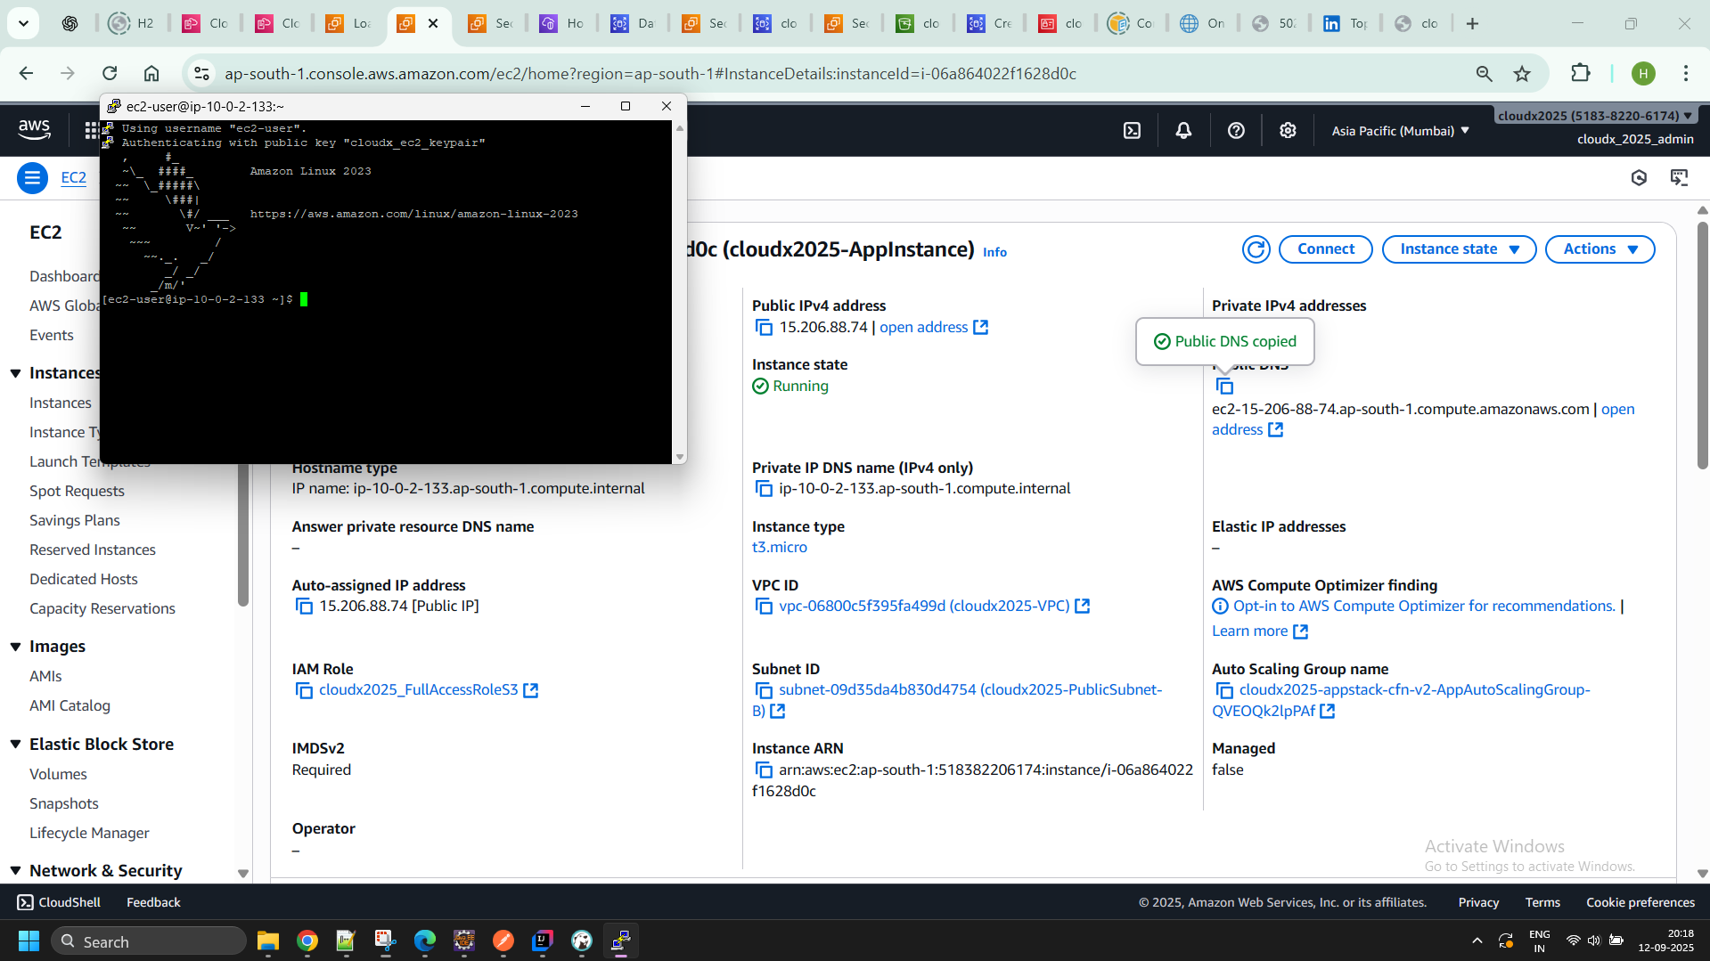
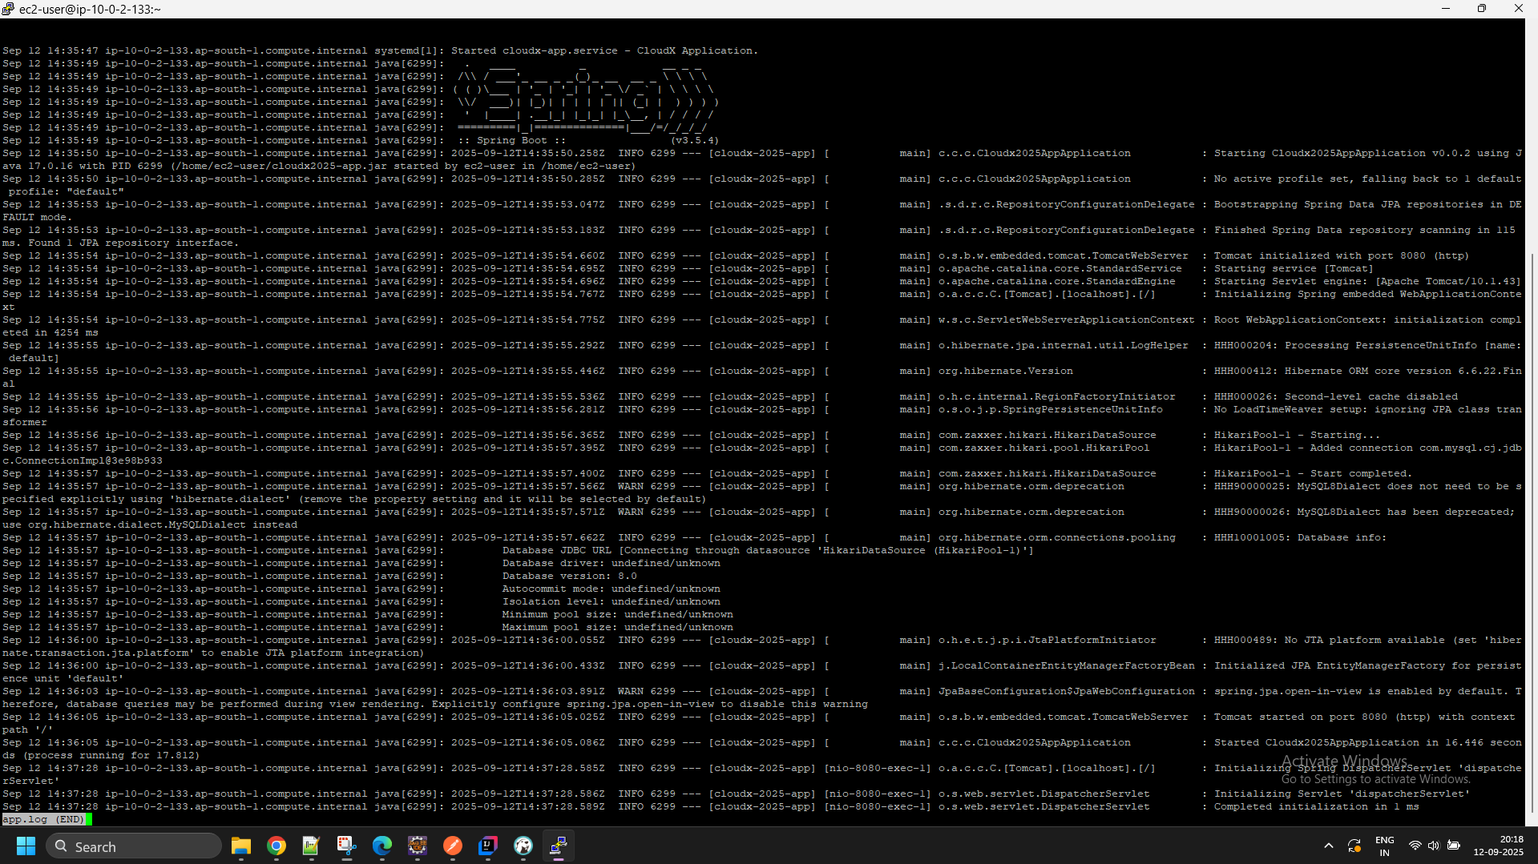

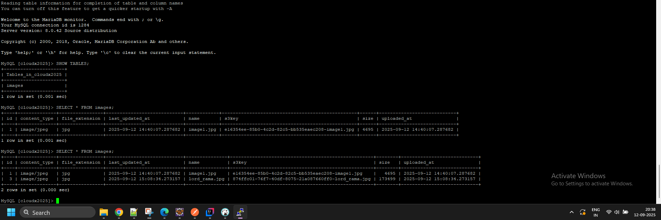
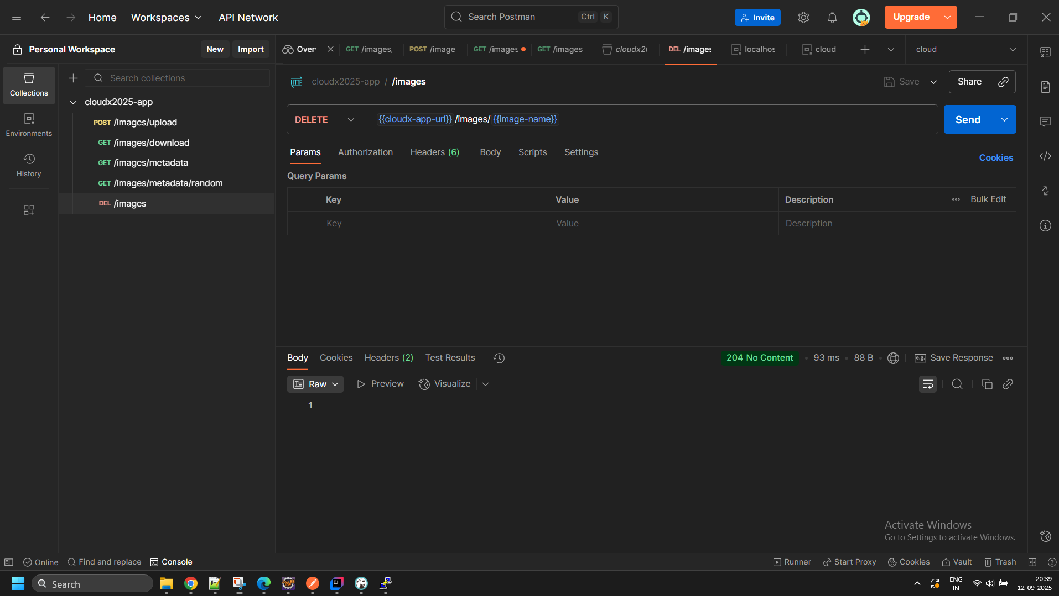
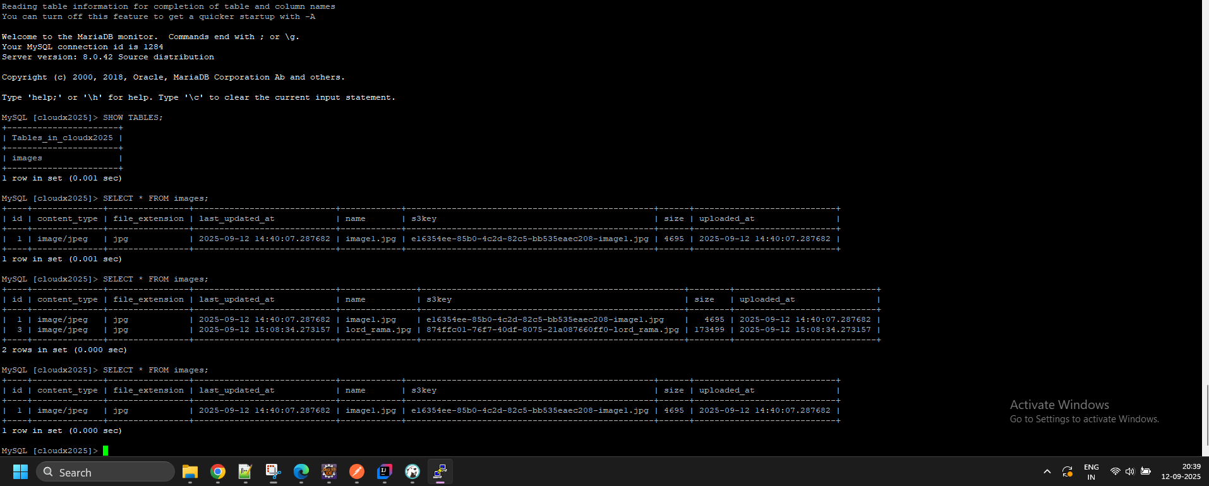
- Ensure the following non-functional criteria are met:
  - the EC2 instance should use IAM roles to access S3
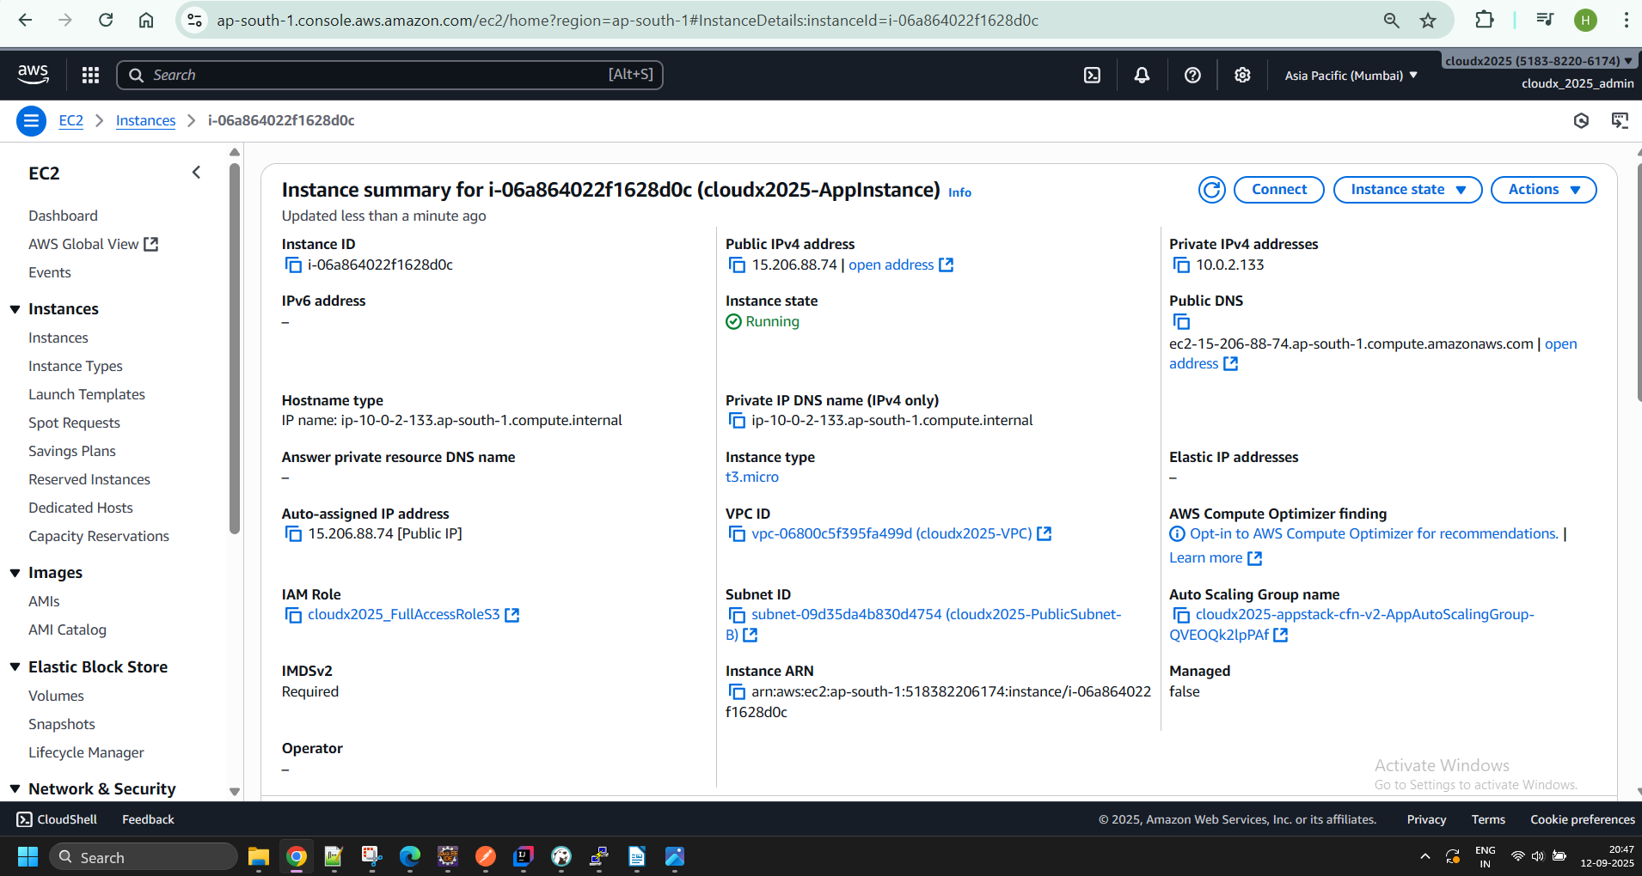
  - the EC2 instance is able to connect to RDS instance (RDS instance can be reached only through your EC2 instance)
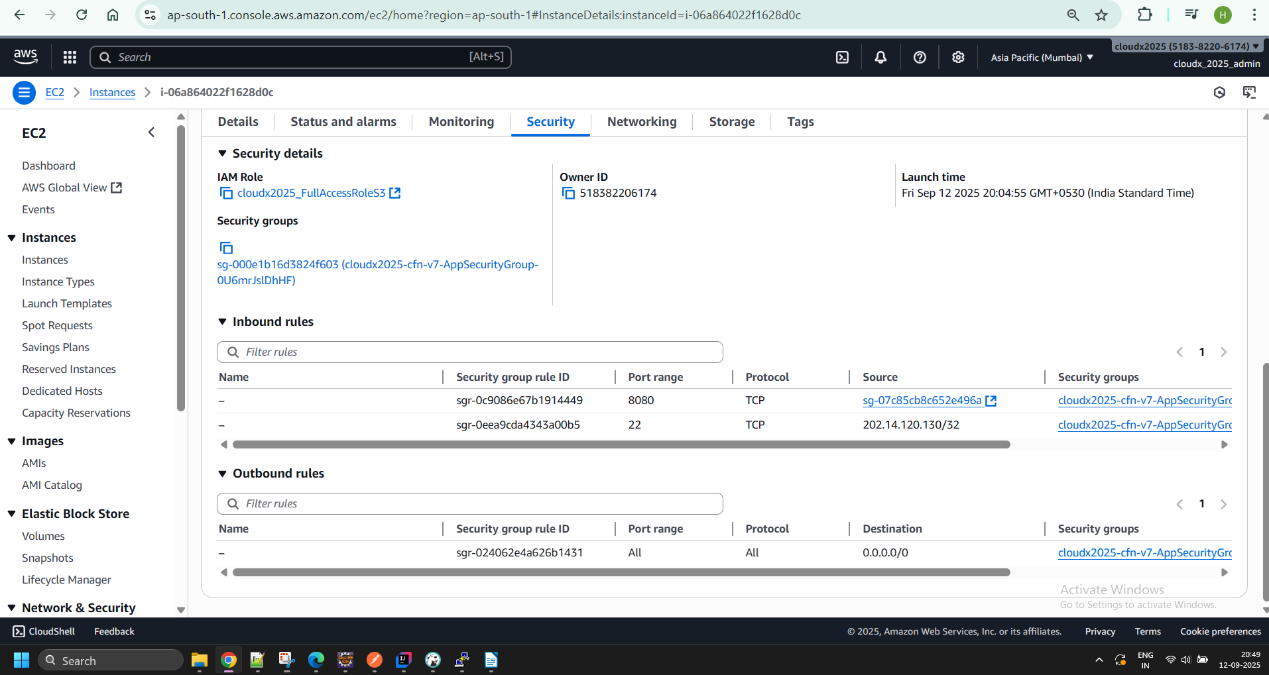

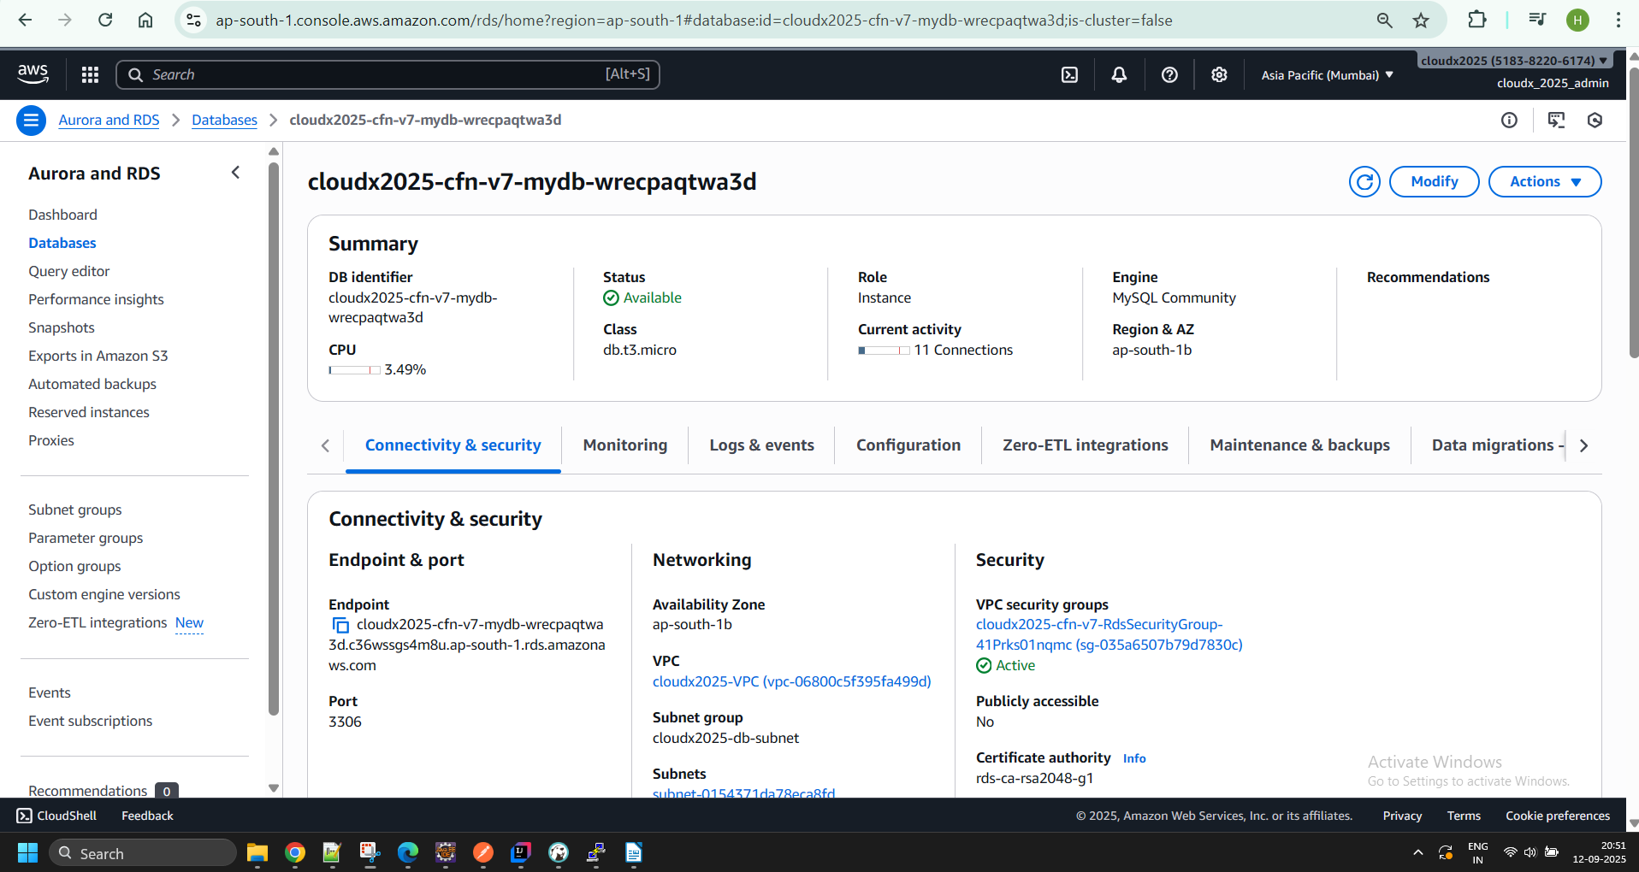
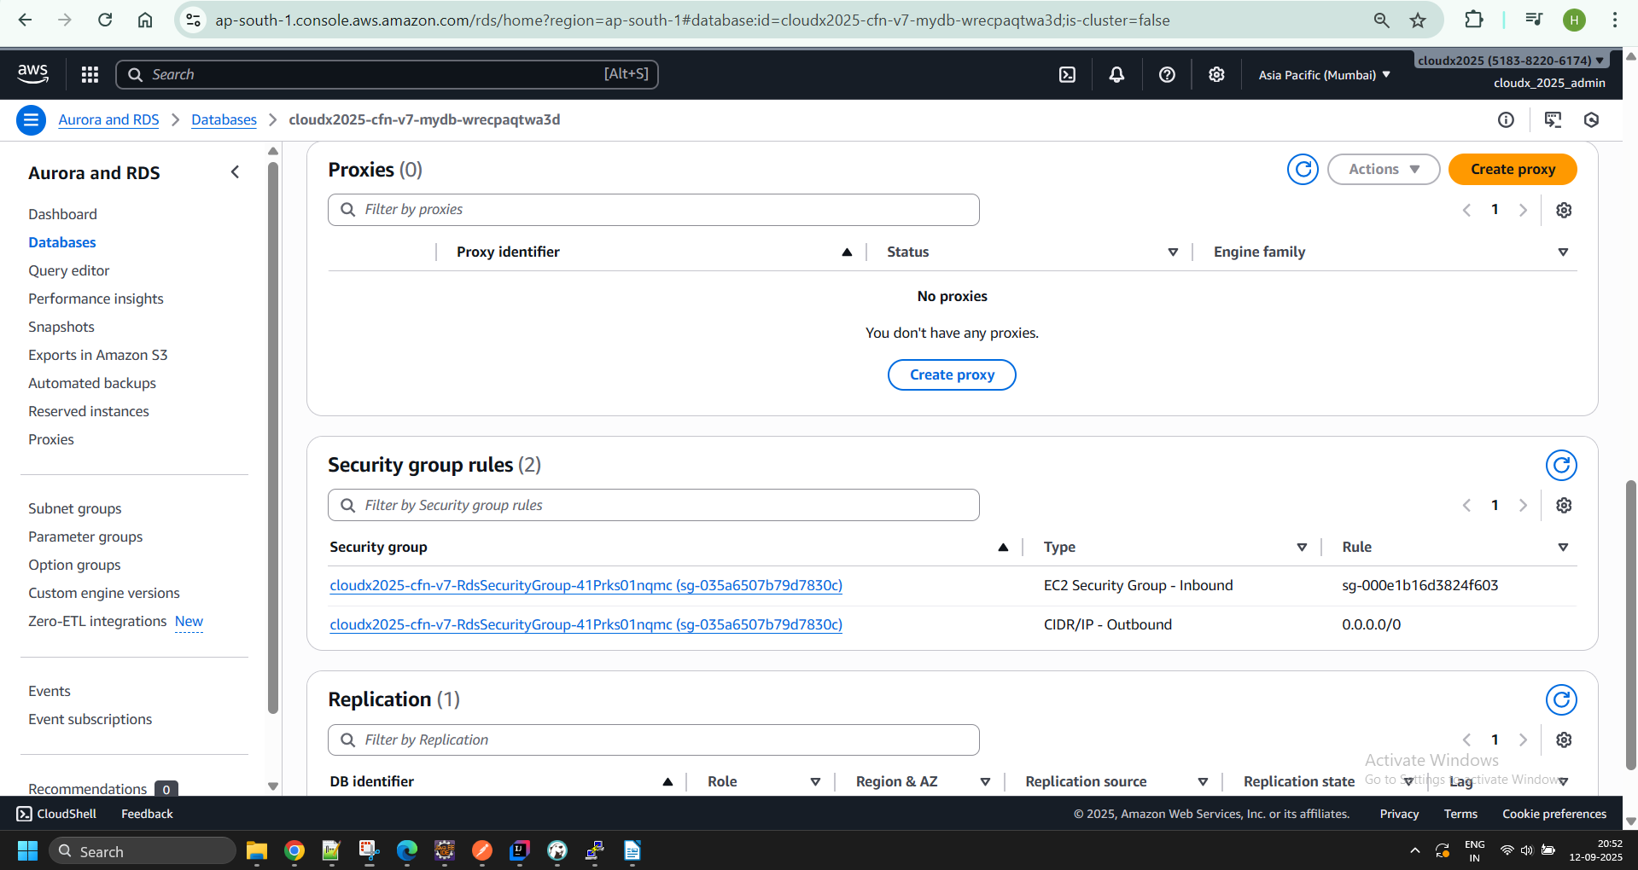

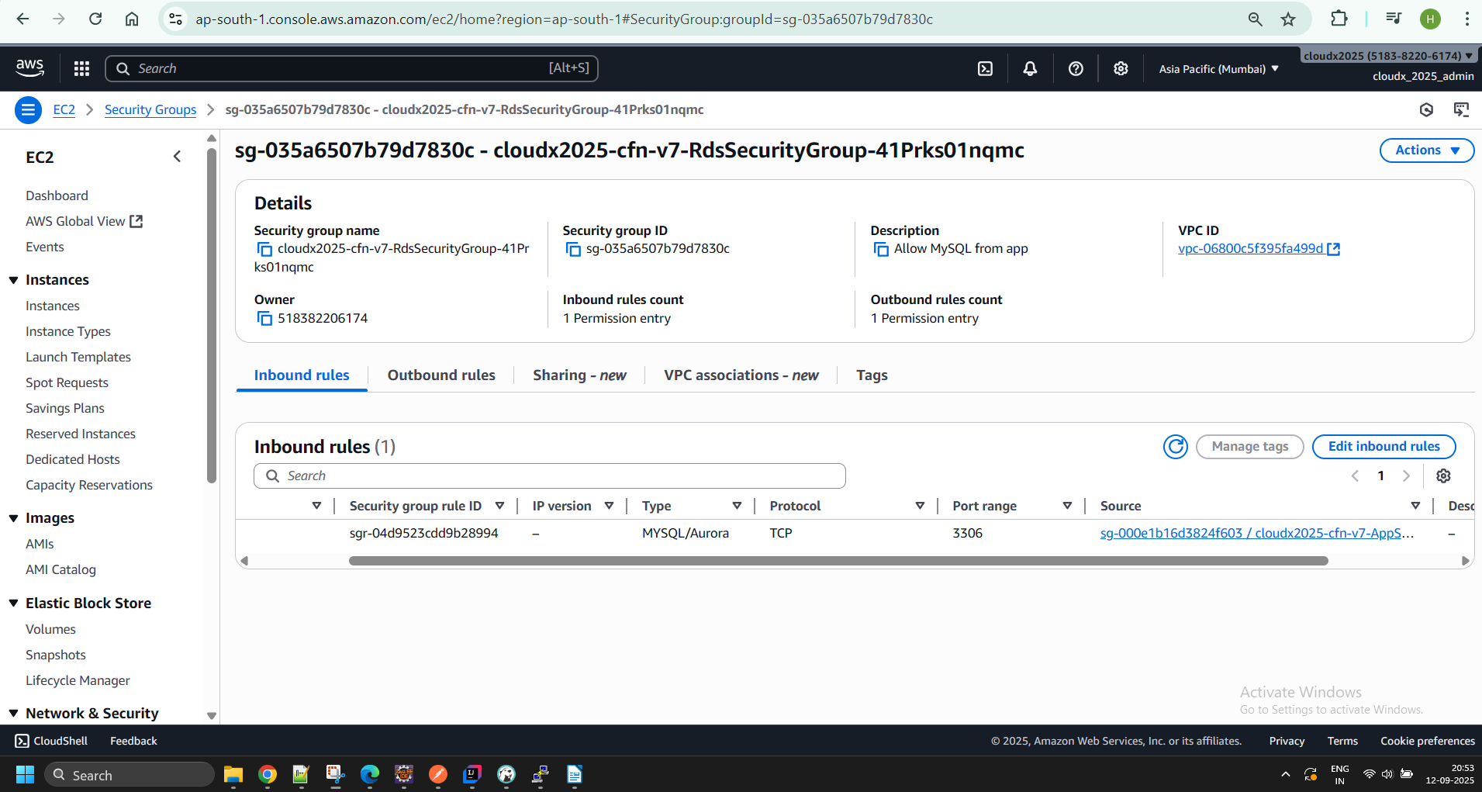

  - the EC2 instance should claim the role using the AWS credentials provider chain

- Optional: use AWS Identity and Access Management (IAM) database authentication to connect your application to the DB instance.
  - AWS Documentation with examples can be found here - Connecting to your DB instance using IAM authentication
  - AWS RDS + Spring Boot example - RDS IAM Authentication with Spring Boot
Note. If you use MySQL, then you need to create user AND grant privileges on your DB table (Granting privileges is not shown in tutorial but is required when using MySQL DB). A script example for MySQL:
mysql -h ${RDS_HOST} -P ${RDS_PORT} -u {USERNAME} -p {PASSWORD} -D {TABLE_NAME} -e "CREATE USER IF NOT EXISTS '{NEW_USERNAME}' IDENTIFIED WITH AWSAuthenticationPlugin AS 'RDS'; GRANT ALL PRIVILEGES ON {TABLE_NAME}.* TO '{NEW_USERNAME}'@'%';"
- Optional Task is not mandatory for completion this module but highly recommended, if you don’t have a time to complete it - just skip it

What should I remember?
- Once you create AWS Account -> Setup Multi-factor Authentication
- Do NOT share your account
- Do NOT commit your account Credentials into the Git
- Terminate/Remove all created resources/services once you finish Module
- Please Do not forget to delete NAT Gateway if you used it.
- Do NOT keep instance running if you don’t use it
- Carefully keep track of billing and working instances so you don't exceed limits

