Sub-task 1 – Implement a subscription feature in your web application
- Create a standard SQS queue named <ProjectName>-UploadsNotificationQueue.
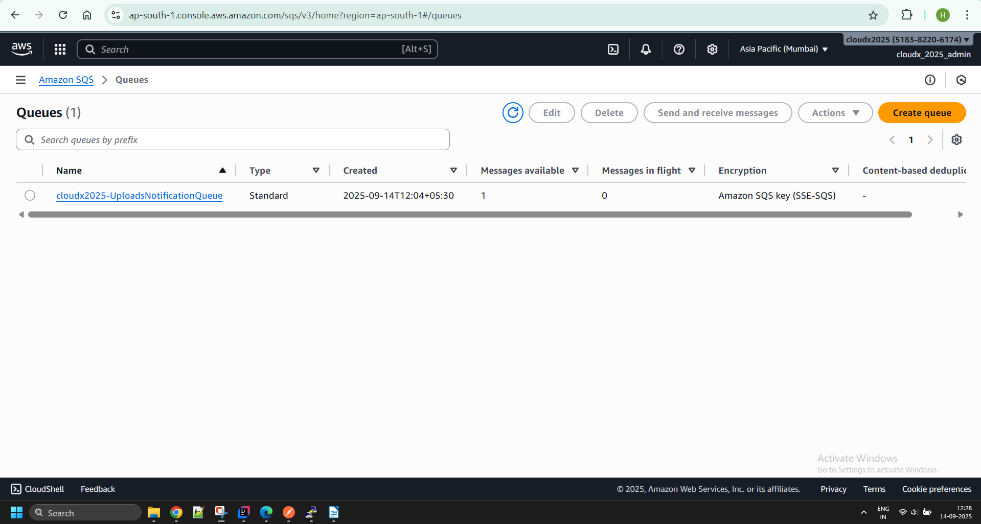
- Create an SNS topic named <ProjectName>-UploadsNotificationTopic.
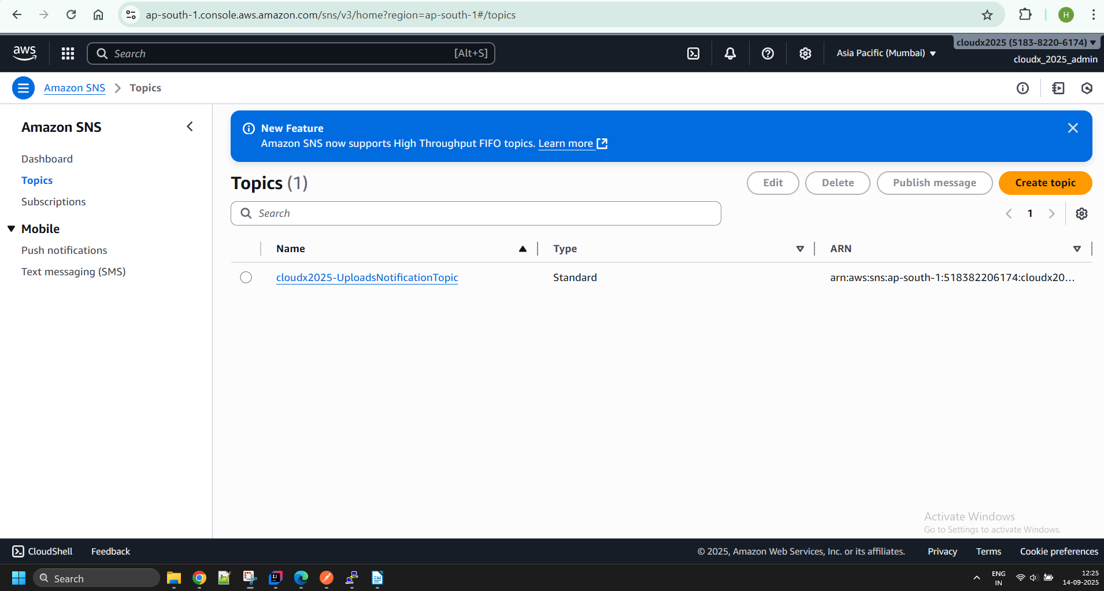

- Add two new endpoints in your web-applications :
  - subscribe an email for notifications
  - unsubscribe an email from notifications
- After a user visits the subscription endpoint, the specified email should receive a confirmation message.
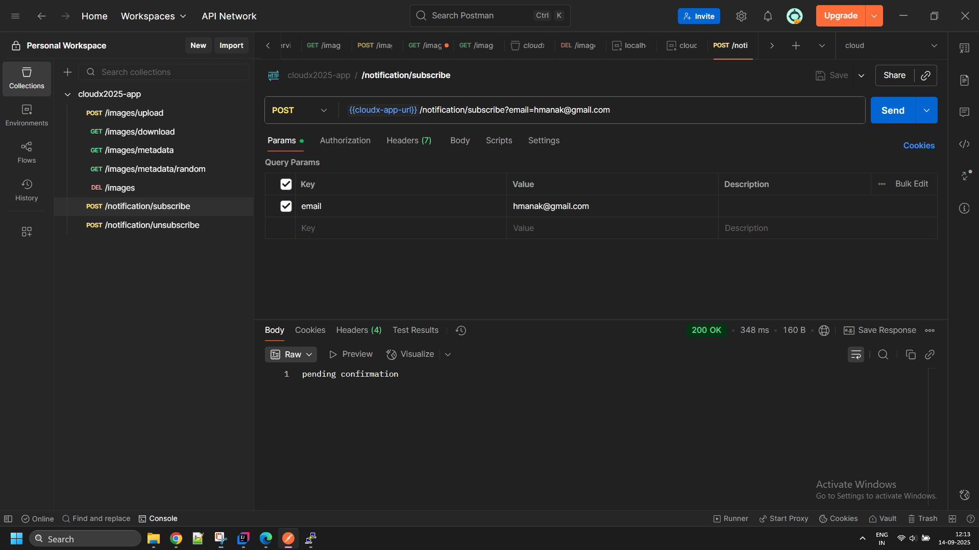

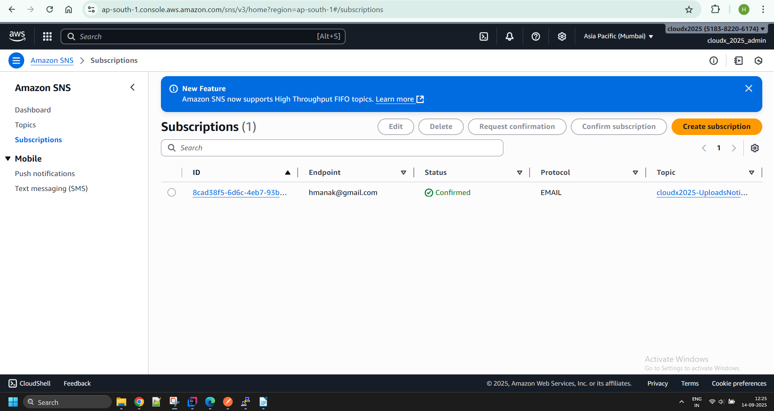

- Whenever a user visits the unsubscription endpoint, AWS should stop sending notifications to the specified email.

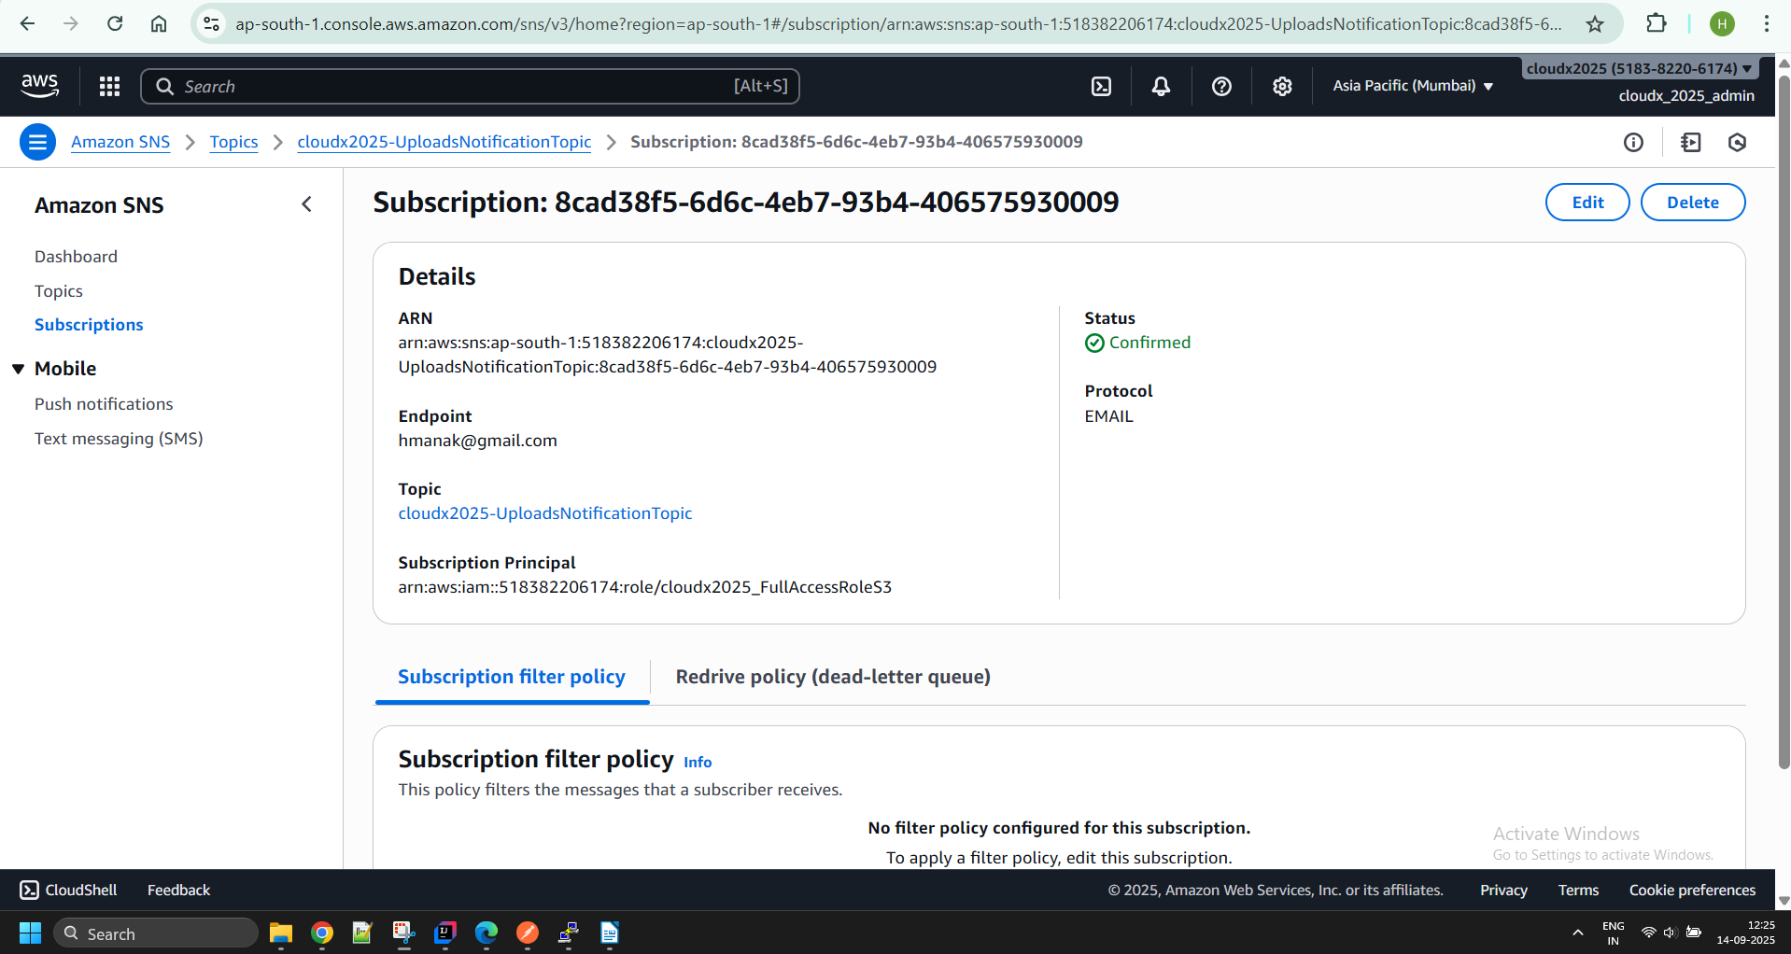

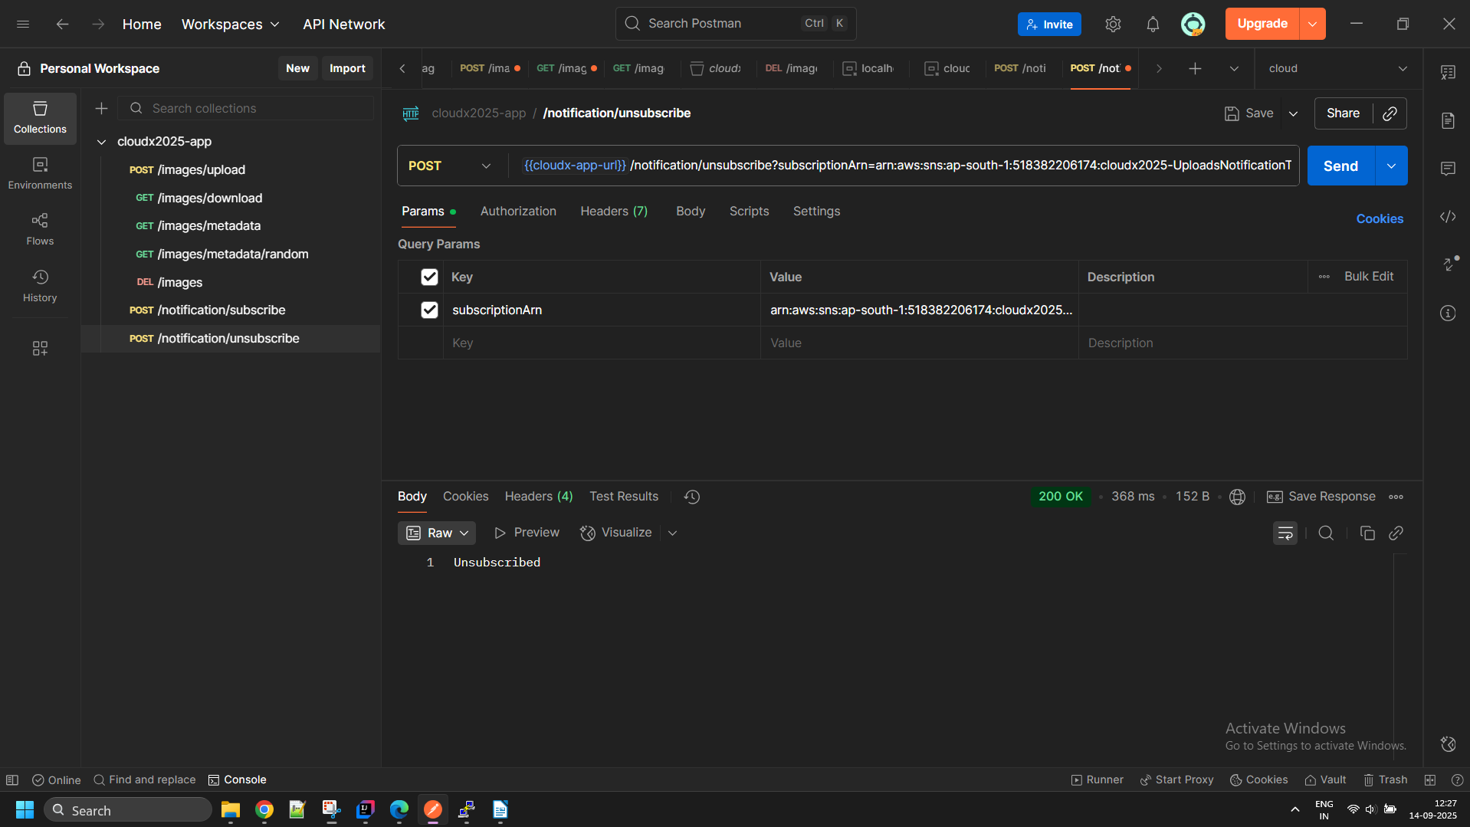

6. Whenever an image is uploaded using your web application, a new message describing the event should be published to the SQS queue.
7. Update your web-application to run a scheduled background process which extracts the SQS messages in batch and sends them to the SNS topic.
8. The SNS notifications should be in plain text which includes:
  - an explanation that an image has been uploaded
  - the image metadata (size, name, extension)
  - a link to the web application endpoint for downloading the image
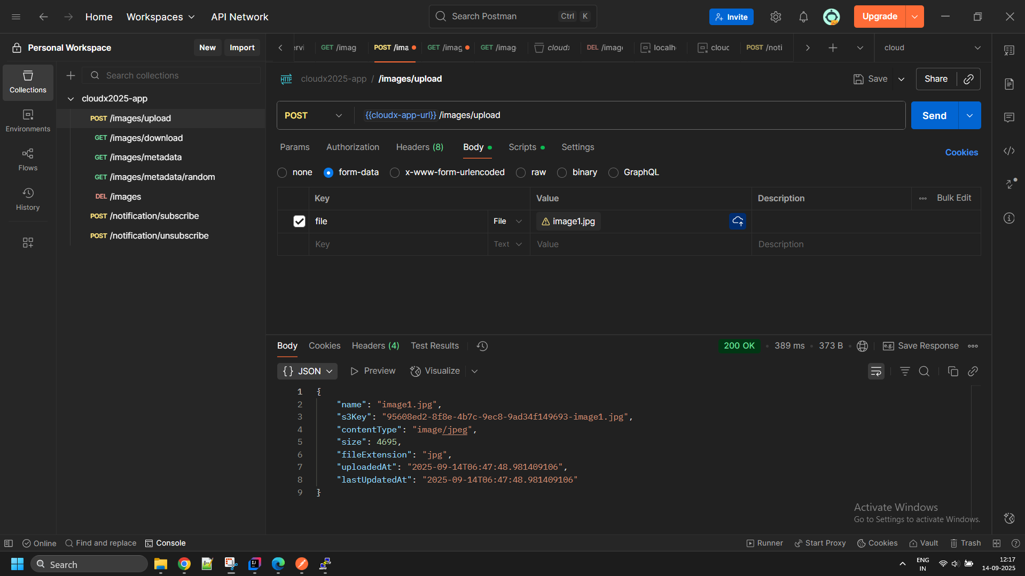
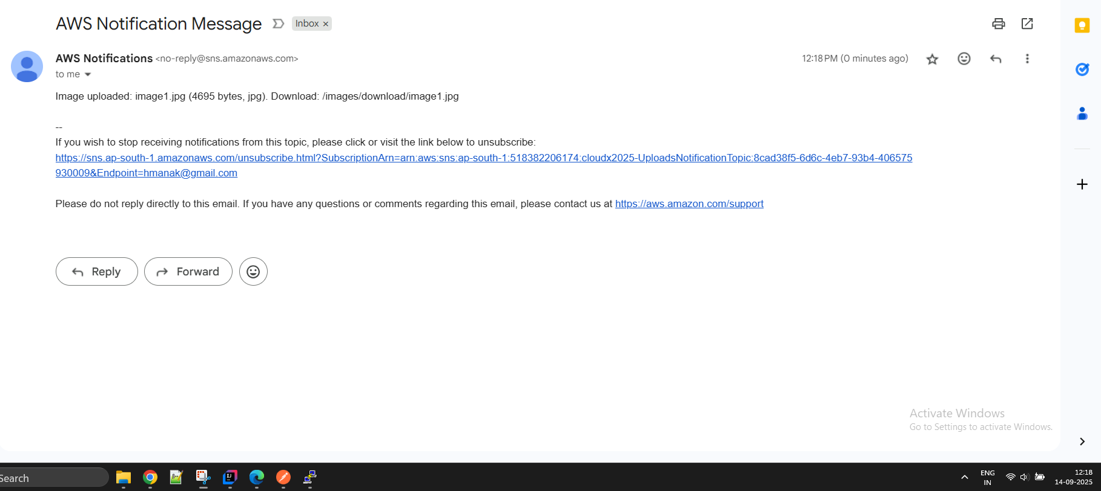
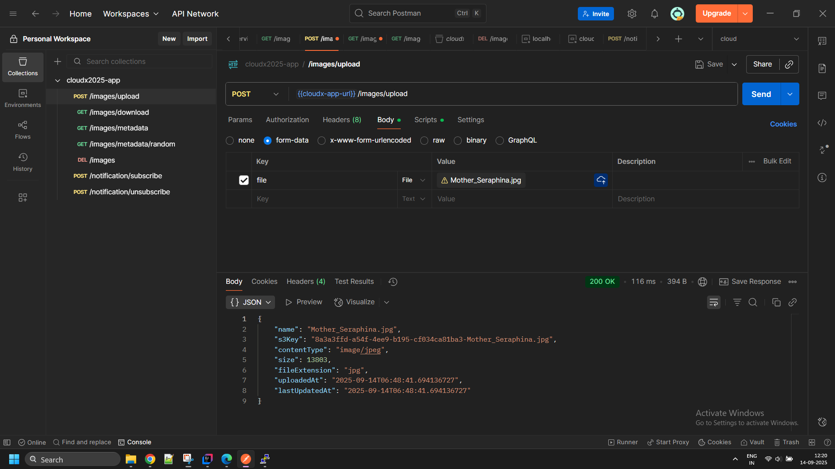
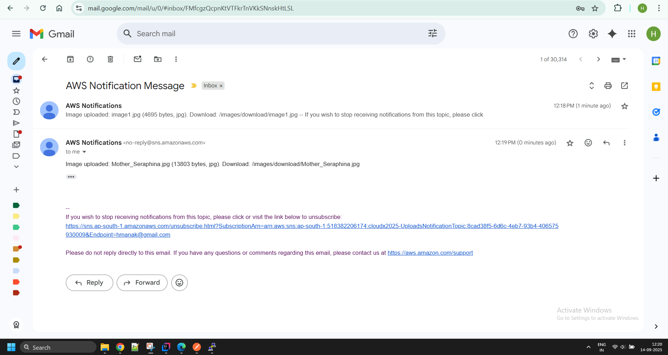

9. Optional: Add an attribute to the message your app will send to the SNS topic (such as an image extension) and configure the filtering policy for subscriptions to accept messages with a specific attribute value (such as .png).
10. Think what are the other ways of receiving SNS notifications for the image uploads (not necessarily in a human-readable form).
> SNS can invoke a Lambda function when a message arrives
> SNS can push JSON messages to your API endpoint.

Attaching the CloudFormation scripts updated for this Task:
1. Network stack.yml
===============
Parameters:
ProjectName:
Type: String
BucketSuffix:
Type: String
Description: "Suffix for the S3 bucket name"
DBUsername:
Type: String
NoEcho: true
Description: "Master username for RDS"
DBPassword:
Type: String
NoEcho: true
Description: "Master password for RDS"
DBName:
Type: String
Default: cloudx2025
Description: "Name of the database to create"
Resources:
S3Bucket:
Type: AWS::S3::Bucket
Properties:
BucketName: !Sub "cloudx2025-${BucketSuffix}"
VPC:
Type: AWS::EC2::VPC
Properties:
CidrBlock: 10.0.0.0/16
EnableDnsHostnames: true
EnableDnsSupport: true
Tags:
- Key: Name
Value: !Sub "${ProjectName}-VPC"
InternetGateway:
Type: AWS::EC2::InternetGateway
Properties:
Tags:
- Key: Name
Value: !Sub "${ProjectName}-IGW"
AttachGateway:
Type: AWS::EC2::VPCGatewayAttachment
Properties:
VpcId: !Ref VPC
InternetGatewayId: !Ref InternetGateway
PublicSubnetA:
Type: AWS::EC2::Subnet
Properties:
VpcId: !Ref VPC
CidrBlock: 10.0.1.0/24
AvailabilityZone: !Select [0, !GetAZs '']
MapPublicIpOnLaunch: true
Tags:
- Key: Name
Value: !Sub "${ProjectName}-PublicSubnet-A"
PublicSubnetB:
Type: AWS::EC2::Subnet
Properties:
VpcId: !Ref VPC
CidrBlock: 10.0.2.0/24
AvailabilityZone: !Select [1, !GetAZs '']
MapPublicIpOnLaunch: true
Tags:
- Key: Name
Value: !Sub "${ProjectName}-PublicSubnet-B"
PrivateSubnetA:
Type: AWS::EC2::Subnet
Properties:
VpcId: !Ref VPC
CidrBlock: 10.0.3.0/24
AvailabilityZone: !Select [0, !GetAZs ''] # This will be ap-south-1a
MapPublicIpOnLaunch: false
Tags:
- Key: Name
Value: !Sub "${ProjectName}-PrivateSubnetA"
PrivateSubnetB:
Type: AWS::EC2::Subnet
Properties:
VpcId: !Ref VPC
CidrBlock: 10.0.4.0/24
AvailabilityZone: !Select [1, !GetAZs ''] # Changed to index 1 for ap-south-1b
MapPublicIpOnLaunch: false
Tags:
- Key: Name
Value: !Sub "${ProjectName}-PrivateSubnetB"
PublicRouteTable:
Type: AWS::EC2::RouteTable
Properties:
VpcId: !Ref VPC
Tags:
- Key: Name
Value: !Sub "${ProjectName}-PublicRT"
PublicRoute:
Type: AWS::EC2::Route
DependsOn: AttachGateway
Properties:
RouteTableId: !Ref PublicRouteTable
DestinationCidrBlock: 0.0.0.0/0
GatewayId: !Ref InternetGateway
PublicSubnetARouteTableAssociation:
Type: AWS::EC2::SubnetRouteTableAssociation
Properties:
SubnetId: !Ref PublicSubnetA
RouteTableId: !Ref PublicRouteTable
PublicSubnetBRouteTableAssociation:
Type: AWS::EC2::SubnetRouteTableAssociation
Properties:
SubnetId: !Ref PublicSubnetB
RouteTableId: !Ref PublicRouteTable
DBSubnetGroup:
Type: AWS::RDS::DBSubnetGroup
Properties:
DBSubnetGroupDescription: !Sub "${ProjectName} RDS subnet group"
SubnetIds:
- !Ref PrivateSubnetA
- !Ref PrivateSubnetB
DBSubnetGroupName: !Sub "${ProjectName}-db-subnet"
AppSecurityGroup:
Type: AWS::EC2::SecurityGroup
Properties:
GroupDescription: "Allow app traffic from ALB and SSH access"
VpcId: !Ref VPC
SecurityGroupIngress:
- IpProtocol: tcp
FromPort: 22
ToPort: 22
CidrIp: 103.41.39.253/32
Tags:
- Key: Name
Value: !Sub "${ProjectName}-AppSecurityGroup"
RdsSecurityGroup:
Type: AWS::EC2::SecurityGroup
Properties:
GroupDescription: "Allow MySQL from app"
VpcId: !Ref VPC
SecurityGroupIngress:
- IpProtocol: tcp
FromPort: 3306
ToPort: 3306
SourceSecurityGroupId: !Ref AppSecurityGroup
MyDB:
Type: AWS::RDS::DBInstance
Properties:
Engine: mysql
DBInstanceClass: db.t3.micro
AllocatedStorage: 20
DBName: !Ref DBName
MasterUsername: !Ref DBUsername
MasterUserPassword: !Ref DBPassword
PubliclyAccessible: false
MultiAZ: true
BackupRetentionPeriod: 0 # Disable automated backups
VPCSecurityGroups:
- !Ref RdsSecurityGroup
DBSubnetGroupName: !Ref DBSubnetGroup
DeletionProtection: false
Outputs:
VpcId:
Value: !Ref VPC
Export:
Name: !Sub "${ProjectName}-VpcId"
PublicSubnetAId:
Value: !Ref PublicSubnetA
Export:
Name: !Sub "${ProjectName}-PublicSubnetAId"
PublicSubnetBId:
Value: !Ref PublicSubnetB
Export:
Name: !Sub "${ProjectName}-PublicSubnetBId"
PrivateSubnetAId:
Value: !Ref PrivateSubnetA
Export:
Name: !Sub "${ProjectName}-PrivateSubnetAId"
PrivateSubnetBId:
Value: !Ref PrivateSubnetB
Export:
Name: !Sub "${ProjectName}-PrivateSubnetBId"
S3BucketName:
Value: !Ref S3Bucket
Export:
Name: !Sub "${ProjectName}-S3BucketName"
RDSEndpoint:
Value: !GetAtt MyDB.Endpoint.Address
Export:
Name: !Sub "${ProjectName}-RDSEndpoint"
RDSInstanceId:
Value: !Ref MyDB
Export:
Name: !Sub "${ProjectName}-RDSInstanceId"
RDSUsername:
Value: !Ref DBUsername
Export:
Name: !Sub "${ProjectName}-RDSUsername"
AppSecurityGroupId:
Value: !Ref AppSecurityGroup
Export:
Name: !Sub "${ProjectName}-AppSecurityGroupId"
RDSDBName:
Value: !Ref DBName
Export:
Name: !Sub "${ProjectName}-RDSDBName"
2. Appstack yml
===========
Parameters:
ProjectName:
Type: String
AppJarBucket:
Type: String
Description: "S3 bucket name containing the application JAR"
AppJarKey:
Type: String
Description: "S3 key for the application JAR file"
RDSHost:
Type: String
Description: "RDS endpoint from network stack"
DBUsername:
Type: String
Description: "Database username"
NoEcho: true
DBPassword:
Type: String
Description: "Database password"
NoEcho: true
S3BucketName:
Type: String
Description: "S3 bucket name from network stack"
DBName:
Type: String
Description: "Database name from network stack"
Resources:
AppSecurityGroupIngress:
Type: AWS::EC2::SecurityGroupIngress
Properties:
GroupId:
Fn::ImportValue: !Sub "${ProjectName}-AppSecurityGroupId"
IpProtocol: tcp
FromPort: 8080
ToPort: 8080
SourceSecurityGroupId: !Ref AlbSecurityGroup
AlbSecurityGroup:
Type: AWS::EC2::SecurityGroup
Properties:
GroupDescription: "Security group for ALB"
VpcId:
Fn::ImportValue: !Sub "${ProjectName}-VpcId"
SecurityGroupIngress:
- IpProtocol: tcp
FromPort: 80
ToPort: 80
CidrIp: 0.0.0.0/0
Tags:
- Key: Name
Value: !Sub "${ProjectName}-ALBSecurityGroup"
AppLaunchTemplate:
Type: AWS::EC2::LaunchTemplate
Properties:
LaunchTemplateData:
ImageId: ami-0b982602dbb32c5bd
InstanceType: t3.micro
KeyName: cloudx_ec2_keypair
IamInstanceProfile:
Name: cloudx2025_FullAccessRoleS3
SecurityGroupIds:
- Fn::ImportValue: !Sub "${ProjectName}-AppSecurityGroupId"
UserData:
Fn::Base64: !Sub |
#!/bin/bash
yum install -y aws-cli
# Install Java 17
amazon-linux-extras enable java-17-amazon-corretto
yum clean metadata
yum install -y java-17-amazon-corretto
# Download and start the application
aws s3 cp s3://${AppJarBucket}/${AppJarKey} /home/ec2-user/cloudx2025-app.jar
# Create application service file with properly escaped environment variables
cat << EOF > /etc/systemd/system/cloudx-app.service
[Unit]
Description=CloudX Application
After=network.target
[Service]
User=ec2-user
WorkingDirectory=/home/ec2-user
Environment=DB_HOST=${RDSHost}
Environment=DB_USER=${DBUsername}
Environment=DB_PASS=${DBPassword}
Environment=DB_NAME=${DBName}
Environment=S3_BUCKET=${S3BucketName}
Environment=SERVER_PORT=8080
Environment=UPLOADS_NOTIFICATION_QUEUE_URL=${UploadsNotificationQueue}
Environment=UPLOADS_NOTIFICATION_QUEUE_ARN=${UploadsNotificationQueue.Arn}
Environment=UPLOADS_NOTIFICATION_TOPIC_ARN=${UploadsNotificationTopic}
ExecStart=/usr/bin/java -jar cloudx2025-app.jar
SuccessExitStatus=143
TimeoutStopSec=10
Restart=on-failure
RestartSec=5
[Install]
WantedBy=multi-user.target
EOF
# Log the environment variables for debugging
echo "Environment variables being used:" > /home/ec2-user/env.log
echo "DB_HOST=${RDSHost}" >> /home/ec2-user/env.log
echo "DB_USER=${DBUsername}" >> /home/ec2-user/env.log
echo "DB_NAME=${DBName}" >> /home/ec2-user/env.log
echo "S3_BUCKET=${S3BucketName}" >> /home/ec2-user/env.log
echo "SERVER_PORT=8080" >> /home/ec2-user/env.log
# Set permissions and start service
chmod 644 /etc/systemd/system/cloudx-app.service
systemctl daemon-reload
systemctl enable cloudx-app
systemctl start cloudx-app
# Save logs to persistent location
ln -sf /var/log/messages /home/ec2-user/system.log
touch /home/ec2-user/app.log
chown ec2-user:ec2-user /home/ec2-user/app.log
journalctl -u cloudx-app -f > /home/ec2-user/app.log &
AppAutoScalingGroup:
Type: AWS::AutoScaling::AutoScalingGroup
Properties:
VPCZoneIdentifier:
- Fn::ImportValue: !Sub "${ProjectName}-PublicSubnetAId"
- Fn::ImportValue: !Sub "${ProjectName}-PublicSubnetBId"
LaunchTemplate:
LaunchTemplateId: !Ref AppLaunchTemplate
Version: !GetAtt AppLaunchTemplate.LatestVersionNumber
MinSize: "1"
MaxSize: "3"
DesiredCapacity: "1"
TargetGroupARNs:
- !Ref AppTargetGroup
Tags:
- Key: Name
Value: !Sub "${ProjectName}-AppInstance"
PropagateAtLaunch: true
AppTargetGroup:
Type: AWS::ElasticLoadBalancingV2::TargetGroup
Properties:
VpcId:
Fn::ImportValue: !Sub "${ProjectName}-VpcId"
Port: 8080
Protocol: HTTP
TargetType: instance
HealthCheckProtocol: HTTP
HealthCheckPort: "8080"
HealthCheckPath: "/"
HealthCheckIntervalSeconds: 15
HealthCheckTimeoutSeconds: 5
HealthyThresholdCount: 2
UnhealthyThresholdCount: 5
Matcher:
HttpCode: 200
Name: !Sub "${ProjectName}-tg"
AppLoadBalancer:
Type: AWS::ElasticLoadBalancingV2::LoadBalancer
Properties:
Subnets:
- Fn::ImportValue: !Sub "${ProjectName}-PublicSubnetAId"
- Fn::ImportValue: !Sub "${ProjectName}-PublicSubnetBId"
SecurityGroups:
- !Ref AlbSecurityGroup
Tags:
- Key: Name
Value: !Sub "${ProjectName}-LoadBalancer"
AppListener:
Type: AWS::ElasticLoadBalancingV2::Listener
Properties:
DefaultActions:
- Type: forward
TargetGroupArn: !Ref AppTargetGroup
LoadBalancerArn: !Ref AppLoadBalancer
Port: 80
Protocol: HTTP
UploadsNotificationQueue:
Type: AWS::SQS::Queue
Properties:
QueueName: !Sub "${ProjectName}-UploadsNotificationQueue"
UploadsNotificationTopic:
Type: AWS::SNS::Topic
Properties:
TopicName: !Sub "${ProjectName}-UploadsNotificationTopic"
Outputs:
AppAutoScalingGroupName:
Value: !Ref AppAutoScalingGroup
Export:
Name: !Sub "${ProjectName}-AppAutoScalingGroupName"
AppLoadBalancerDNS:
Value: !GetAtt AppLoadBalancer.DNSName
Export:
Name: !Sub "${ProjectName}-AppLoadBalancerDNS"
UploadsNotificationQueueArn:
Description: "ARN of the uploads notification SQS queue"
Value: !GetAtt UploadsNotificationQueue.Arn
Export:
Name: !Sub "${ProjectName}-UploadsNotificationQueueArn"
UploadsNotificationTopicArn:
Description: "ARN of the uploads notification SNS topic"
Value: !Ref UploadsNotificationTopic
Export:
Name: !Sub "${ProjectName}-UploadsNotificationTopicArn"
UploadsNotificationQueueUrl:
Description: "URL of the uploads notification SQS queue"
Value: !Ref UploadsNotificationQueue
Export:
Name: !Sub "${ProjectName}-UploadsNotificationQueueUrl"

