**Law Office Management Information System in Bootstrap and PHP Script**

**Landing Page -** [**https://bibric.jadurhari.com/**](https://bibric.jadurhari.com/)

**Login Form**

**Admin Dashboard**

* Number of Law Office Firm
* Number of Attorney
* Number of Services
* Number of Appointment
* Schedule of Calendar

**Law Office Firm Information - crud**

* Firm name
* Complete Address
* Contact
* Email Address
* Firm History
* View Members button – List of Attorney

**Attorney Information - crud**

* Law Office
* Complete Name
* Address
* Email Address
* Contact Numbers
* Fax
* Profile Picture
* Education
* Professional and Legal Experience
* Username
* Password

**Services - crud**

* Attorney Name
* Service Name
* Description
* Rate

**Appointment – view only**

* Reference Number
* Customer Name
* Contact Number
* Email
* Service name
* Attorney
* Remarks
* Status – pending, approved, cancelled, completed

**Testimonial and Feedback**

* Customer name
* Message
* Feedback on – attorney name
* Rate – 1 star to 5 star
* Status – published, unpublished

**Bad Words Collection**

* Word

**Email and SMS Settings**

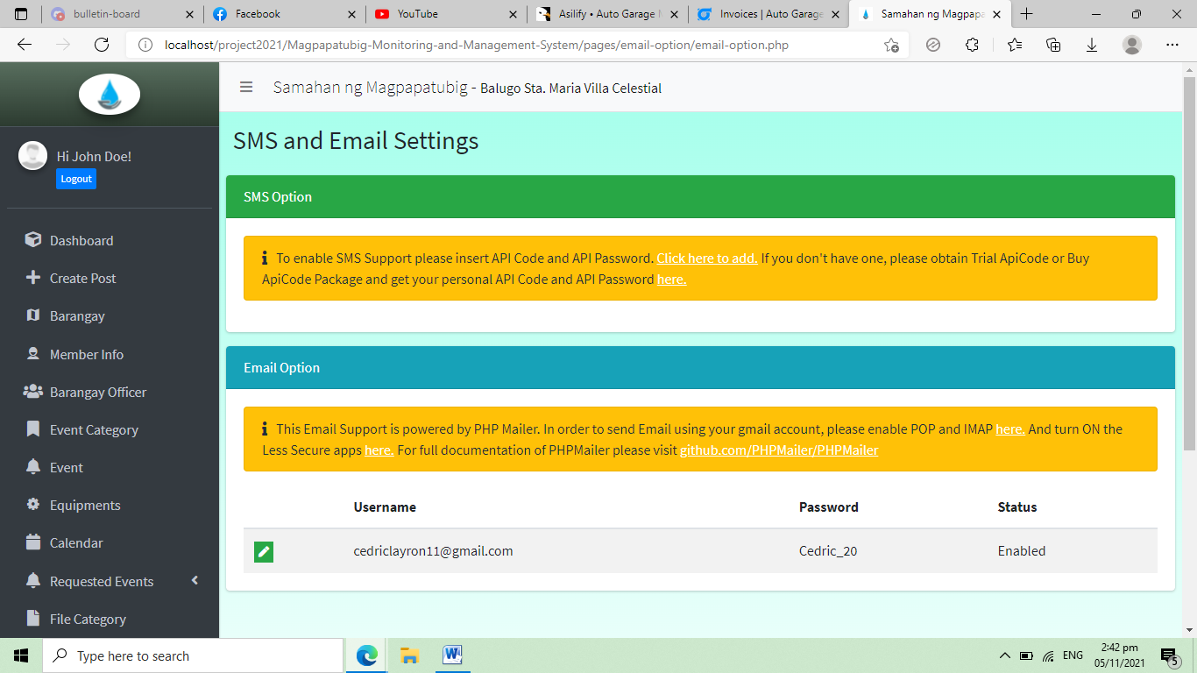

**Appointment Report**

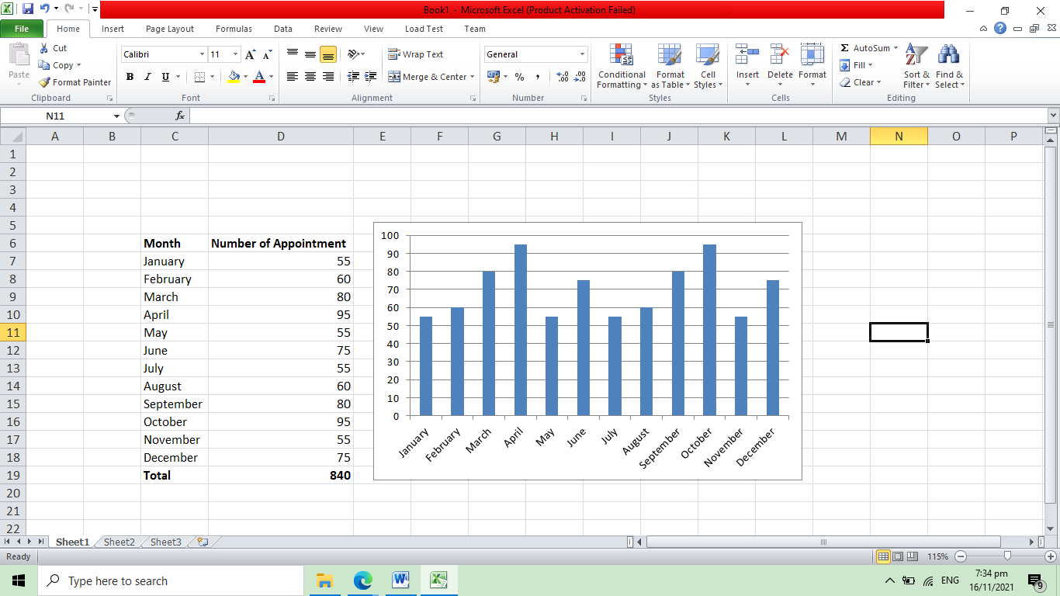

**Admin Accounts**

**Complete name**

**Email Number**

**Account Type – admin, staff**

**Username**

**Password**

**Attorney Account**

**Dashboard**

* Number of Appointments
* Number of Services
* Number of Active Cases

**List of Appointment**

* Reference Number
* Customer Name
* Contact Number
* Email
* Service name
* Remarks
* Status – pending, approved, cancelled, completed

**Services - crud**

* Attorney Name
* Service Name
* Description
* Rate

**Testimonial and Feedback – view only**

* Service name
* Message
* Rate – 1 star to 5 star

**Profile**

* Complete Name
* Address
* Email Address
* Contact Numbers
* Fax
* Profile Picture
* Education
* Professional and Legal Experience
* Username
* Password