Bellabeat Smart Device Usage Analysis
Final Capstone Report with Tableau Public Visualizations
Tools Used: SQL & Tableau Public

Executive Summary
This project analyzes smart device usage trends using a public Fitbit dataset. SQL was used for data cleaning and aggregation, while Tableau Public was used to develop visual dashboards illustrating behavioral patterns. The objective was to identify usage trends and recommend data-driven marketing strategies for Bellabeat.

Key Insights from Tableau Analysis
• Users demonstrate higher activity levels mid-week, with Wednesday showing the highest average steps.
• A strong positive relationship exists between total steps and calories burned.
• Most users fall within the moderate activity category (5,000–10,000 steps daily).
• Activity levels are generally lower during weekends.

Dashboard 1: Smart Device Usage Trends & Marketing Insights
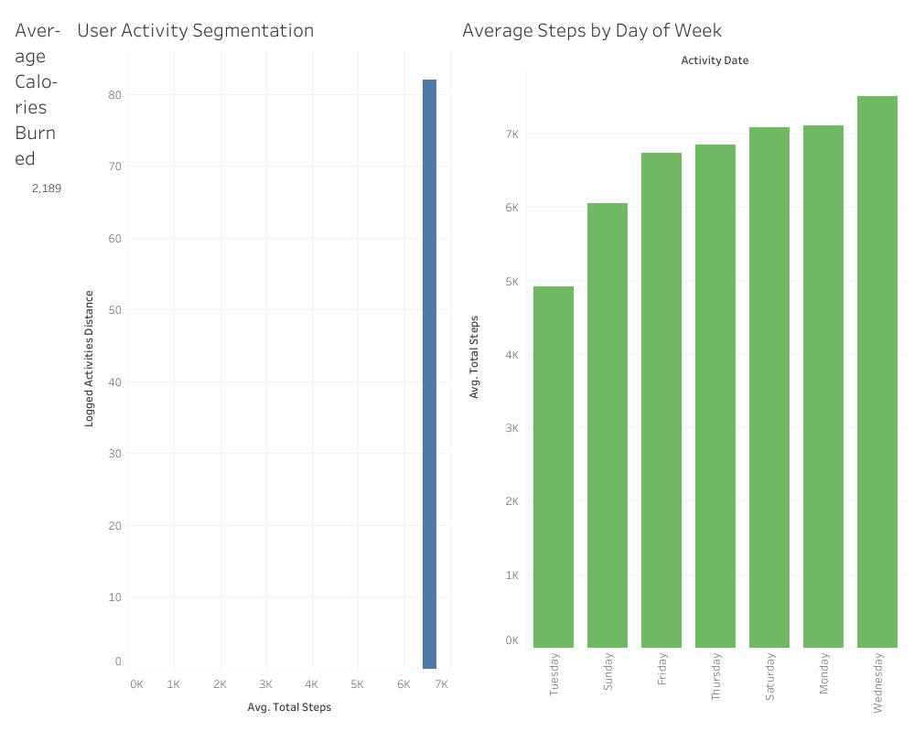
This dashboard presents user activity segmentation and average steps by day of week. The visual clearly shows structured weekday routines, providing insights for targeted engagement campaigns.

Dashboard 2: Relationship Between Steps and Calories Burned
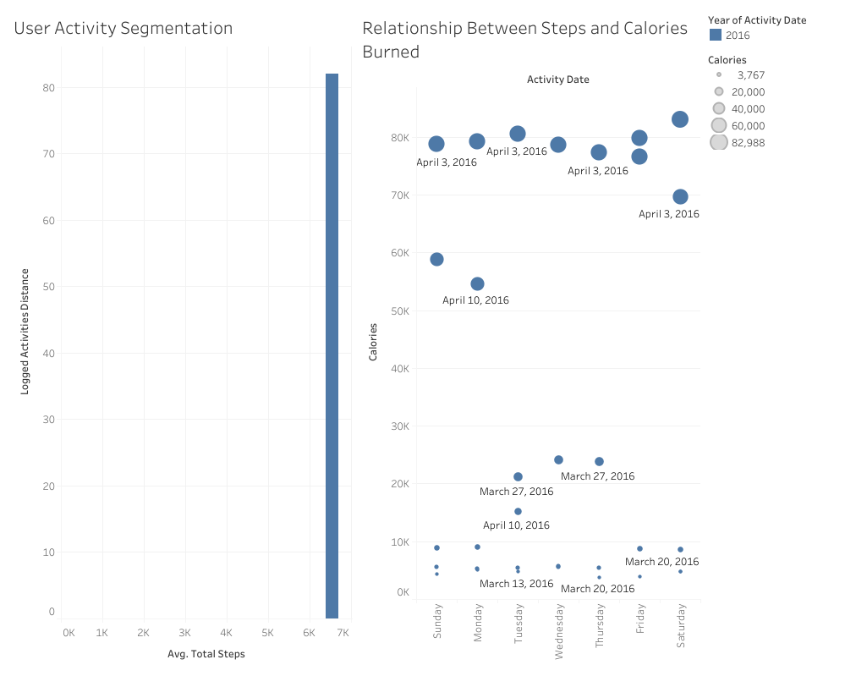
The scatter plot demonstrates a strong positive correlation between daily steps and calories burned. This relationship supports goal-based marketing strategies focused on incremental physical activity improvements.

Marketing Strategy Recommendations
• Implement goal progression campaigns encouraging gradual improvement.
• Launch weekday-focused wellness challenges.
• Use personalized engagement notifications based on activity behavior.
• Highlight measurable health outcomes within the Bellabeat app.

Conclusion
The Tableau visualizations provide clear, data-driven evidence of structured user behavior and moderate activity levels. These insights create strong opportunities for Bellabeat to enhance marketing strategy, increase engagement, and improve retention through personalization.

