Section 1: Case Summary

Scenario Title: | Bronchiolitis and Respiratory Failure
Keywords: | Pediatric, intubation, respiratory failure, RSV, bronchiolitis
Brief Description of Case: | Pediatric Respiratory Failure

Goals and Objectives
Educational Goal: | To demonstrate the management of a critically ill patient with bronchiolitis.
Objectives:  (Medical and CRM) | Medical:  - Identify respiratory distress in an infant  - Review the diagnosis of bronchiolitis, including evidence and non-evidence-based therapies, and distinguish it from asthma  - Initiate supportive care with supplemental oxygen and fluids  - Recognize treatment failure and intubate an infant  CRM:  - Use appropriate resources to check medication doses and equipment sizes  - Demonstrate effective teamwork and communication skills in a pediatric resuscitation  - Demonstrate graded assertiveness to identify a change in patient status
EPAs Assessed: | D1, F1, C1, C3

Learners, Setting and Personnel
Target Learners: | ☒ Junior Learners |  | ☒ Senior Learners |  |  | ☐ Staff
 | ☒ Physicians | ☐ Nurses |  | ☐ RTs | ☐ Inter-professional
 | ☐ Other Learners:
Location: | ☒ Sim Lab |  | ☐ In Situ |  |  | ☐ Other:
Recommended Number of Facilitators: | Instructors: 1
 | Sim Actors: 0
 | Sim Techs: 1

Scenario Development
Date of Development: | September 23, 2022
Scenario Developer(s): | Qadeem Salehmohamed
Affiliations/Institutions(s): | University of British Columbia, Department of Emergency Medicine, Interior Site
Contact E-mail: | Qadeem@alumni.ubc.ca
Last Revision Date: | October 1, 2022
Revised By: | Qadeem Salehmohamed
Version Number: | 5

Section 2A: Initial Patient Information

- Patient Chart
Patient Name: Zarah |  |  |  | Age: 6 months | Gender: F | Weight: 7.5 kg
Presenting complaint: Noisy breathing sent in by 811 (nursing hotline)
Temp: 38.4C | HR: 180 | BP: 86/52 |  | RR: 60 | SpO2 88% R/A
Cap glucose: 6.2 mmol/L |  |  |  | GCS: 15 (E4 V5 M6 )
Triage note:
Recent viral illness. This AM, breathing sounded “noisy,” so parents called 811 (telehealth nurse assessment service). Sent to the ED.

Allergies: None
Past Medical History:  - Uncomplicated spontaneous vaginal delivery at term  - No previous admissions to hospital  - Up to date with vaccinations  - No family history of asthma/atopy |  |  | Current Medications: None

Section 2B: Extra Patient Information

A. Further History
Four days ago, an older sibling who recently started pre-school had a cold. The next day, 6-month-old Zarah fell sick. She has had a runny nose and cough but seemed to be doing fine until yesterday when she did not eat or drink very much. This morning, she had some noisy breathing, and her chest looked funny while she was breathing. When it did not go away after a couple of hours, Zarah’s parents called 811 for advice. They were directed to go to the emergency department.

Zarah has not urinated today. Her last bowel movement was yesterday evening, and it was normal. She is otherwise healthy and fully up to date with her vaccines.

B. Physical Exam
List any pertinent positive and negative findings
Cardio: Tachycardia. Capillary refill 4-5 seconds centrally, 6 seconds peripherally. | Neuro: Alert
Resp: Nasal flaring, grunting, suprasternal, intercostal, and subcostal indrawing are present. Crackles and wheezes on auscultation. | Head & Neck: Mouth appears dry
Abdo: Soft, unremarkable. | MSK/skin: Unremarkable

Section 3: Technical Requirements/Room Vision

A. Patient
☒ Mannequin: Infant
☐ Standardized Patient
☐ Task Trainer
☐ Hybrid
B. Special Equipment Required
- Intubation equipment
- Oxygen delivery equipment and tubing
- Equipment for a crystalloid bolus with the push-pull method (3 way stop-cock and syringe)
- MDI +/- spacer or nebulizer
- NIPPV and/or High flow nasal cannula

C. Required Medications
- Normal Saline
- Salbutamol for inhalation
- Epinephrine for inhalation
- Acetaminophen
- Ketamine
- Rocuronium

D. Moulage
None

E. Monitors at Case Onset
☐ Patient on monitor with vitals displayed
☒ Patient not yet on monitor
F. Patient Reactions and Exam
Increased work of breathing
Crackles and wheezes on auscultation. (Crackles may need to be more prominent than wheezes to replicate auscultation of a bronchiolitic patient more accurately.)

If acetaminophen is given, decrease the temperature to 37.5 degrees.
If IV fluids are given, the heart rate will drop to 140.
If an epinephrine nebule is given, increase the heart rate by 10-15 bpm, do not change respiratory rate or oxygen saturation.
If salbutamol is administered, increase the heart rate by 10-15 bpm, do not change respiratory rate or oxygen saturation.
When the patient is started on oxygen, saturations increase to greater than 90%.

In stage two, after oxygen has been started, the patient will become apneic and exhibit central cyanosis. Oxygen saturation will decrease to 70%.
Once intubated, the cyanosis will resolve, and the oxygen saturation will improve to 95%.

Section 4: Sim Actor and Standardized Patients

Sim Actor and Standardized Patient Roles and Scripts
Role | Description of role, expected behaviour, and key moments to intervene/prompt learners. Include any script required (including conveying patient information if patient is unable)
N/A
N/A

Section 5: Scenario Progression

Scenario States, Modifiers and Triggers
Patient State/Vitals | Patient Status | Learner Actions, Modifiers & Triggers to Move to Next State |  | Facilitator Notes
1. Baseline State  Rhythm: Sinus tachycardia  HR: 180  BP: 86/52  RR: 60  O₂SAT: 88%  T: 38.4 °C  GCS: 15  Lungs: Diffuse crackles and wheezes | The patient has severely increased work of breathing. The patient is coughing and has a runny nose. | Expected Learner Actions  Start oxygen  Suction (copious amounts)  Achieve IV access  Give fluid bolus  Check a bedside glucose  Administer acetaminophen  Consult respiratory therapy for hi-flow oxygen / NIPPV | Modifiers  - Oxygen will improve saturation to greater than 90%  - Fluid will decrease heart rate to 140  - Salbutamol or epinephrine will increase the heart rate by 10-15 points but will not change the work of breathing  - Ipratropium will have no effect  - Acetaminophen will reduce temperature to 37.5 degrees  - Bedside glucose is 6.2 mmol/L  Triggers  - The patient has been started on oxygen, and all other expected actions have been satisfied.  - The patient has been started on oxygen, and participants show no signs of giving fluid or acetaminophen. | Participants will likely try salbutamol, ipratropium, or epinephrine during this phase of the simulation. They will be ineffective. If participants attempt further interventions to treat asthma (magnesium), the facilitator may need to emphasize the lack of effect.
2. Apnea and Intubation  Rhythm: Sinus tachycardia  HR: 140 if fluids given  BP: 86/52  RR: 0  O₂SAT: 70%  T: 37.5 °C if fever treated | Patient has an apneic episode requiring escalation to mechanical ventilation. | Expected Learner Actions  Identify apnea  Call for help  Select appropriate intubation equipment and medications  Intubate patient | Modifiers  - Apnea will cause oxygen saturation to drop to 70%, and central cyanosis will appear on the mannequin  Triggers  - Patient has been intubated | The difficulties of a pediatric airway are not the focus of this case.
3. Improvement following mechanical ventilation  Rhythm: Sinus tachycardia  HR: 140 if fluids given  BP: 86/52  RR: 20 (or bagging rate/ventilator rate)  O₂SAT: 94%  T: 37.5 °C if fever treated | The patient stabilizes following invasive ventilation | Expected Learner Actions  Initiate post-intubation sedation  Call PICU at the pediatric referral centre | Modifiers  - Intubation will improve oxygen saturation to 95%, and cyanosis will resolve  Triggers  - Case ends when PICU has been called | Ventilation settings are not the focus of this case.

Appendix A: Laboratory Results

CBC
WBC 6.0
Hgb 130 g/L
Plt 350

Lytes
Na 135 mmol/L
K 4.0 mmol/L
Cl 99 mmol/L
HCO₃ 26 mEq/L
AG 10
Urea 4.0 mmol/L
Cr 30 umol/L
Glucose 6.2 mmol/L

Extended Lytes
Ca 2.3 mmol/L
Mg 0.7 mmol/L
PO₄ 2.0 mmol/L

VBG
pH 7.4
pCO₂ 45 mmHg
HCO₃ 26 mEq/L
Lactate 1.6 mmol/L

Appendix B: ECGs, X-rays, Ultrasounds and Pictures

https://www.bmj.com/content/375/bmj-2021-064132
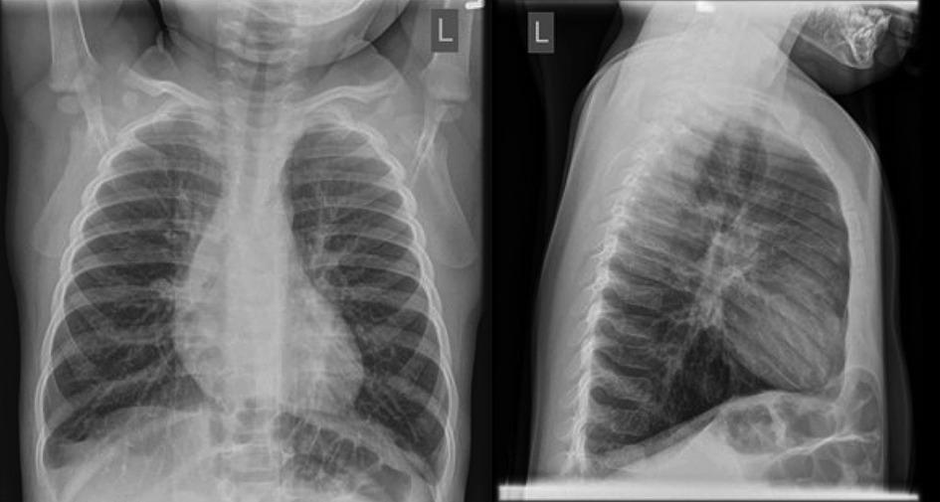

Appendix C: Facilitator Cheat Sheet & Debriefing Tips

Include key errors to watch for and common challenges with the case. List issues expected to be part of the debriefing discussion. Supplemental information regarding any relevant pathophysiology, guidelines, or management information that may be reviewed during debriefing should be provided for facilitators to have as a reference.

Compare and contrast respiratory failure with a more typical presentation of bronchiolitis.

Laboratory work and chest imaging are very reasonable investigations in this case. However, in straightforward bronchiolitis, they are unnecessary.

Review which treatments for bronchiolitis are evidenced-based.

Discuss strategies for distinguishing bronchiolitis from asthma.

Ensure participants have methods to select drug doses and equipment sizes safely.

Identify the Canadian Pediatric Society Guidelines as a key resource for bronchiolitis management. (https://cps.ca/en/documents/position/bronchiolitis)

References

1. Friedman J, Rieder M, Walton J. Bronchiolitis: Recommendations for diagnosis, monitoring and management of children one to 24 months of age [Internet]. Canadian Pediatric Society; 2021. Available from: https://cps.ca/en/documents/position/bronchiolitis

