计算机网络作业
作业名称 客户端服务器聊天室
学生姓名 甄洛生
学号 2018054625
专业 计算机科学与技术

- 作业目的
- 掌握socket编程API
- 程序思路
本程序使用C语言编写，服务器不断监听来自客户端的TCP请求，若收到请求，则创建新的线程处理。客户端可向服务端发消息，服务端收到消息打印在公屏上。
- 作业结果
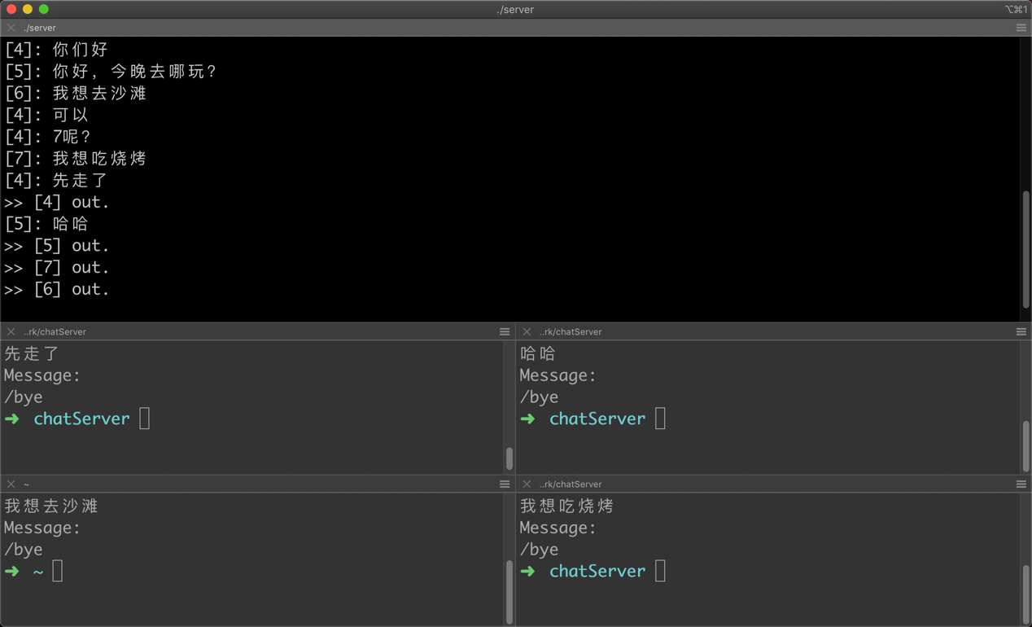
- 附录：源代码
编译：
gcc chat.c client.c -o client
gcc chat.c server.c -o server
chat.h:
- #include <stdio.h>
- #include <stdlib.h>
- #include <string.h>
- #include <unistd.h>

- #include <sys/types.h>
- #include <sys/socket.h>
- #include <arpa/inet.h>

- #include <pthread.h>

- #define SERVER_PORT 6324 // 随便取的
- #define SERVER_IP "127.0.0.1" // 服务端运行在本地
- #define BUFFERSIZE 1024

- int init_connection(); // 初始化客户端与服务器的连接
- int init_server(); // 初始化服务器socket

- void *connection(void *);
chat.c:
- #include "chat.h"

- int
- init_connection()
- {
- int client_fd = socket(AF_INET, SOCK_STREAM, 0);
- int error = 0;

- if (client_fd < 0)
- return client_fd;

- struct sockaddr_in server_socket;

- // 设置服务器socket参数
- server_socket.sin_family = AF_INET;
- server_socket.sin_port = htons(SERVER_PORT);

- // 十进制点表示IP to 二进制表示
- error = inet_pton(AF_INET, SERVER_IP, &server_socket.sin_addr);
- if(error <= 0)
- return error;

- // 与服务器进行链接
- error = connect(client_fd, (struct sockaddr *)&server_socket, sizeof(server_socket));
- if(error < 0)
- return error;

- return client_fd;
- }

- int
- init_server()
- {
- struct sockaddr_in server_socket;

- int server_fd = socket(AF_INET, SOCK_STREAM, 0);
- int error = 0;
- if (server_fd <= 0)
- return server_fd;

- // 将服务器设置为 localhost:SERVER_PORT
- server_socket.sin_family = AF_INET;
- server_socket.sin_addr.s_addr = INADDR_ANY;
- server_socket.sin_port = htons(SERVER_PORT);

- // server_fd 与 socket结构体绑定
- error = bind(server_fd, (struct sockaddr *)&server_socket, sizeof(server_socket));
- if (error < 0)
- return error;

- // socket变成监听套接字
- error = listen(server_fd, 1024);
- if (error < 0)
- return error;

- return server_fd;
- }

- void *
- connection(void *vargp)
- {
- int socket_fd = *(int *)vargp;
- pthread_detach(pthread_self());
- free(vargp);

- printf(">> [%d] join.\n", socket_fd);

- while(1)
- {
- char *buf = (char *)malloc(sizeof(char)*BUFFERSIZE);
- memset(buf, 0, BUFFERSIZE);
- recv(socket_fd, buf, BUFFERSIZE, 0);
- if(!strcmp(buf,"/bye"))
- break;
- printf("[%d]: %s\n", socket_fd, buf);
- free(buf);
- }

- printf(">> [%d] out.\n", socket_fd);
- close(socket_fd);
- return NULL;
- }
client.c:
- #include "chat.h"

- int
- main(int argc, char const *argv[])
- {
- system("clear");
- int connect_fd = init_connection();
- if(connect_fd <= 0)
- {
- perror("init_connection()");
- exit(EXIT_FAILURE);
- }
- puts("You can chat now!\n\"/bye to leave.\"\n");
- while(1)
- {
- char msg[BUFFERSIZE];
- printf("Message:\n");
- scanf("%s", msg);
- send(connect_fd, msg, strlen(msg),0);
- if(!strcmp(msg, "/bye"))
- break;
- strcpy(msg,"");
- system("clear");
- }
- close(connect_fd);
- exit(EXIT_SUCCESS);
- }
server.c:
- #include "chat.h"

- int main(int argc, char const *argv[])
- {
- system("clear");

- // 创建服务器侦听端点
- int server_fd = init_server();
- if(server_fd <= 0)
- {
- perror("init_server()");
- exit(EXIT_FAILURE);
- }
- puts("Server running...");

- // 侦听ing...
- pthread_t tid;
- int *connected_fd;
- struct sockaddr client_socket;
- socklen_t len;
- while(1)
- {
- len = sizeof(struct sockaddr_storage);
- connected_fd = malloc(sizeof(int));
- *connected_fd = accept(server_fd, &client_socket, &len);
- if (connected_fd < 0)
- continue;
- pthread_create(&tid, NULL, connection, (void *)connected_fd);
- }

- close(server_fd);
- exit(EXIT_SUCCESS);
- }

