Implementation of a Web Based Application that Alleviates Congestive Parking
Project Monitoring & Control Report
Hugh Pearce Feeley
B00672792

Table of Contents
Introduction 2
Management 2
Stakeholder Input 3
Commitments 4
Risks 5
Loss of IT 5
Unavailable Resources 5
Timeline Identified Incorrectly 5
Incorrect Requirements 6
Actual Values 7
Review Progress, Performance and Issues 8
Accomplishments 10
Analyse Issues 10
Appendix 11

Introduction
This report will outline the progress of the “Accelerated Parking” web application to date. It will do this by comparing the results of how the project was actually developed with the plan that was initially put forward. Different areas such as management, risks, issues and stakeholder involvement will be outlined in this report and will offer a detailed description to the tasks that were carried out and will also provide more information on what is yet to be carried out in order to meet the initial targets. This report will be of great benefit to the stakeholders as it will allow them to see what targets still need to be met to reach the final aim of the system.

Management
The Modified Waterfall was the methodology that was chosen in the initial stages of the development process. This method is an extension of the Waterfall method. As it was defined in the initial project ‘It uses the same phase process as the Waterfall model but is not subject to sticking to original requirements.’ This meant that if any overlapping needed to be carried out then it could be carried out when necessary. The management of the web applications development has to date ran smoothly and there has been no need for overlapping so far.
It is also crucial to remember that a report is due alongside the web application in a few months so time will also need to be spent on that. As of right now I have structured the report and made notes of the development of the application so far. However meeting this deadline will be more difficult than was initially thought so more time will have to be spent on typing the report so that everything can be handed in on deadline day.
Due to the fact that I have made this project a priority by spending time on it when I get home from work and also taking time at the weekends instead of playing football has proved to be helpful in developing the project. The routine I have gotten into leaves me with very little social time as I want to make sure that the deadline is kept to and with the project looking likely to do so it means that the stakeholders will be pleased with the final results and appreciate all of the hard work put in for their system. The only thing to do now is to make sure the report is on schedule alongside the code. To do this I have informed the people at my football club about my need to get this assignment finished so I have taken a step back from football and only go to training every so often. This is because I can only commit myself to a few nights a month as I want to spend most of my time working in developing the project so that I have it finished on time. The people at the club are very understanding when it comes to these circumstances but some of them can relate because they’ve had to go through final year in university before and others realise how important it is. I have told them that when the project is completed and that I will return at the end of April.

Stakeholder Input
Throughout this projects development it has been essential that it’s created to the stakeholder’s standards. As a result of this regular tests were carried out by a number of different users to make sure everything that has been developed so far is usable by the public. This will be carried out more frequently closer to the deadline but for now the user testing has gone well. It was planned that a meeting with the stakeholder would be held at least once a week which could have been a face to face conversation or even a conversation over Skype. Unfortunately, due to my very busy schedule with work it has been difficult for me to hold these conversations and show the stakeholder the progress of web application. To date only one meeting has taken place between myself and the stakeholder, while admittedly this is not enough interaction to track how the project is progressing. Therefore closer to the deadline more of an effort will be made to keep in contact with the stakeholder just so that it is guaranteed the project is meeting its initial aim and is on the right track.
After presenting the project proposal it was easily identifiable that the main functionality of the project was to have a booking system for a car parking space. The idea behind it was to prevent the time wasted by customers when they’re trying to find a parking space so that it would get them to their final destinations as quickly as possible. The majority of this functionality has been set up and only a few other user input fields need to be added to allow the user to book their space. The stakeholder also wanted the ability to have an administrative section that would allow the admin user the ability to see how many users have booked parking between specific dates, how often user’s book on specific days etc. This feature has yet to be implemented but it is planned to be completed by the 28th February as that is when I plan to have all of the source code in place.
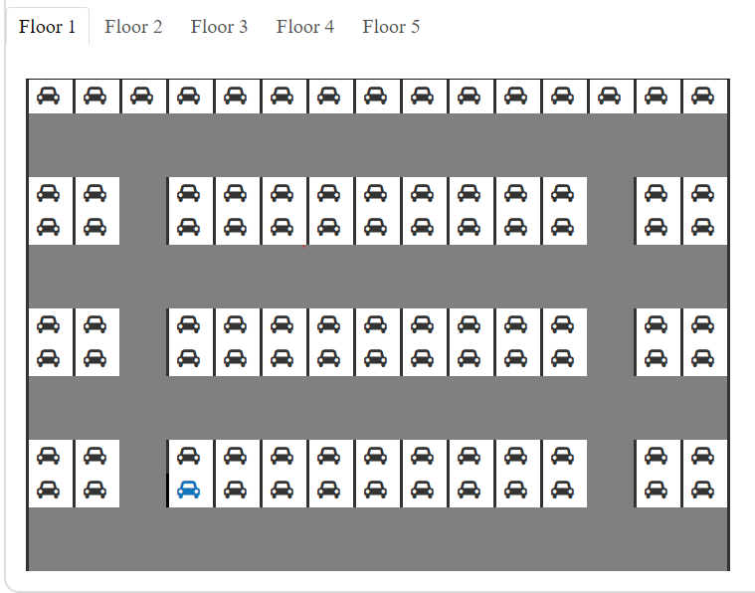
The stakeholders have been shown the web application’s current state and they are pleased with the progress that has been made. Some suggestions were put forward in regards to the date functionality on the booking of the car parking space and it was decided that a time feature would also have to be included so that system would record the specific time in which a parking space would be free so that it would be made available for other users to book as well. The feature that they were most pleased with was the ability to easily select the specific parking space. A screenshot of the parking space feature on the application has been provided below. It shows all available car parking spaces in Black and the users highlighted space that they are going to select in Blue. When the user has booked their space the information will be stored in the database and therefore make the parking space unavailable to other users that want that space at that same time. The car icon will be highlighted in red to show this.
During the stakeholder meetings it became apparent that the parking feature would need to appeal to a wide variety of people. Therefore it was discussed that the parking spaces should be identified as either a normal parking space, a parking space for a disabled person or a parking space for a family. This ability will be implemented at a later date because as of right now it is most important that a parking space can be booked. Other features were discussed with the stakeholders and it was decided that a communication feature would be needed for those that had any queries for them. It was decided that a “Contact Us” section was to be included into the project allowing the user to easily ask a question with a simple email. The admin users of the application would receive an email from the user that they could answer immediatley.
The stakeholder’s role throughout this project has mainly been during the project proposal stage where they decided on the requirements that would be needed for the project. Other than that I have developed the project and have been getting feedback from those likely to use the site. This has enabled me to identify what appeals to users registering to the system and also the things that they do not like with the application so far. The results have been promising with most people being pleased with the user experience.

Commitments
I have carried out a performance check with the stakeholder and have presented them with the current state of the application. The stakeholder was pleased with the progress but it was decided that information would be stored using SQL and not NoSQL as previously suggested. This meant that the requirements specification had to be changed slightly since it was first proposed. This didn’t cause any problems as I have more experience in using SQL with programs such as SQL Server Management Studio.
My experience as a junior software developer has made the creation of this web application easier. This is because I can take the skills that I have gained while working and use them in this project. I spend a lot of personal time on the project on a regular basis after I come home from work. I have got into the routine of starting at 7.00pm and work to around 11pm with minor breaks in between. I’ll also do this most weekends. The stakeholder understands that I work full-time and have other commitments to my Football team, Rock Athletic FC, as a committee member where I hold multiple roles as the club treasurer and also as a Player Representative who relays any issues that the team has back to the committee.
The initial aim of this project was ‘to create a web based application that will include a system that allows users to book and pay for parking in Belfast City Centre.’ The aim still stands and with a couple of months left on the deadline means that the project is on track as the current ‘Develop Prototype’ phase is nearing its end. The development of the application is currently in a good state with everything sticking to the schedule.

Risks
Assessing the risks was an important step in being prepared for potential problems during the development of the project. Some risks could possibly cause the project to fail if they are not dealt with in the right way this is why I carried out a risk assessment. The assessment process required a list of risks that could possibly happen which were then graded on how detrimental the consequences would be if the problem was to occur. The consequences ranged from most severe consequence to least: Major, Moderate, Minor, Rare and Insignificant.
These 4 risks were identified in the initial report:
- Loss of IT
- Unavailable Resources
- Timeline Identified Incorrectly
- Incorrect Requirements

Loss of IT
The first risk is the possibility of losing any work. The loss of IT could happen in a number of ways so a lot of thought was put into counteracting any problems that may occur. The loss of user data, hardware failures, database corruption and even natural disasters are just some examples of the possibilities. None of these things happened during the creation of the project but to counteract these problems I frequently save copies of the work on a pen drive and also upload files to repositories using GitHub. That way if anything were to go wrong at least the code would be safe on the cloud with multiple versions available allowing me to go back to any point in the projects state and make changes. I have got into the routine of pushing code to the cloud at the end of every session working on the web app. As a result of this the current version of the project is 1.9 and will probably be completed around the 2.6 mark.

Unavailable Resources
The price of the software that could be used to develop the web application could be too difficult or costly to get. Thankfully being a student at the Ulster University has allowed me to download any necessary programs for free on DreamSpark that I may have needed. To make sure that I would not have to be out of pocket I used open frameworks to develop the project. PHPMyAdmin was used to store the data which is developed and distributed for free by Apache Friends. I used Sublime text to code the project as it is also free of charge. I had already had installed sublime text on my computer as I use it on a daily basis however, there was a couple of issues with the installation of XAMPP as changes had to be made to its route documents. Port numbers had to be changed in order to get the application to run smoothly. The cost ended up not being a problem as was initially feared and with only minor installation issues the resources were not a problem at all.

Timeline Identified Incorrectly
The risk of the timeline being set incorrectly could leave you under a lot of pressure to get something done in a short amount of time possibly causing things to be unfinished. Sticking to the deadline is an important part of the project so being late on delivering the final version to the stakeholder could be costly to them and then to you. So far this has not been the case for me and the project looks to be on course to meet the initial deadline of April 23rd. It is planned that for the rest of the schedule I will continue to work on further developing the code while typing the final report of the project. Doing this will leave me with no doubt that the deadline will be met.

Incorrect Requirements
Another risk that had to be taken into consideration was the possibility of the initial requirements being wrong. If they were incorrect from the beginning then this could cause major problems in the future as many things could possibly have to be changed or worse removed. Thankfully it is looking like this will not be the case and the requirements have not changed from they were initially put forward. With only a few things needing to be complete it shows that the requirements were not gathered incorrectly leading to a quick and easy development of a system.

Actual Values
In order to track how well the project is moving forward a comparison must be made between the modified waterfall approach that I submitted in October in the form of a Gantt chart and the current status of the project. The Gantt chart has been included and is named ‘appendix1’. Any comparisons that are used will be made against this. The original project plan has changed slightly since it was initially put forward however things such as the projects purpose, scope along with aims and objectives have stayed the same.

The web application is moving along swiftly and is running to schedule. This is because the finish date for the project is 23rd April 2018 and right now it is looking likely that there will be no problem with meeting this deadline. Prior to the hand in of the initial report a great deal of research was carried out on the Planning of the project and the Project Analysis. I had to develop a project proposal and present it to the stakeholder. After the project was given the go ahead I started gathering the requirements along with the creating the design of how the system will look. I designed the project using Moqups which is an intuitive web app that helped me to create the wireframes and prototype ideas that I had at the start.

The requirements gathering stage has ended and went according to plan. In my initial Gantt chart I did not specify how long this stage would take but in total this aspect took around 8 days. I feel this was a reasonable timeframe as it allowed me a lot of time to find out which features needed to go into the project while also leaving more than enough time to develop the project. The design stage has also been completed and the project is currently in the “Develop Prototype” stage. As of right now a number of different features have been included into the web application. Things such as: Most of the design that was drew up with Moqups has been implemented. Along with the ability to register as a new user and log in. The back end database has been created to allow the user the ability to do this.
Initially it was planned that I would use Firebase to store the data of the project, however after carrying out a little more research into this it proved to be not worthwhile. It was realised that using PHPMyAdmin to store data made more sense as I have more experience in using SQL rather than NoSQL. This saved a great amount of time in the development of the web application as I wasn’t required to learn a new language and could jump straight into setting up the data quickly and easily.
Below is an example screenshot of the user registering to Accelerated Parking one of the main features of the web application.
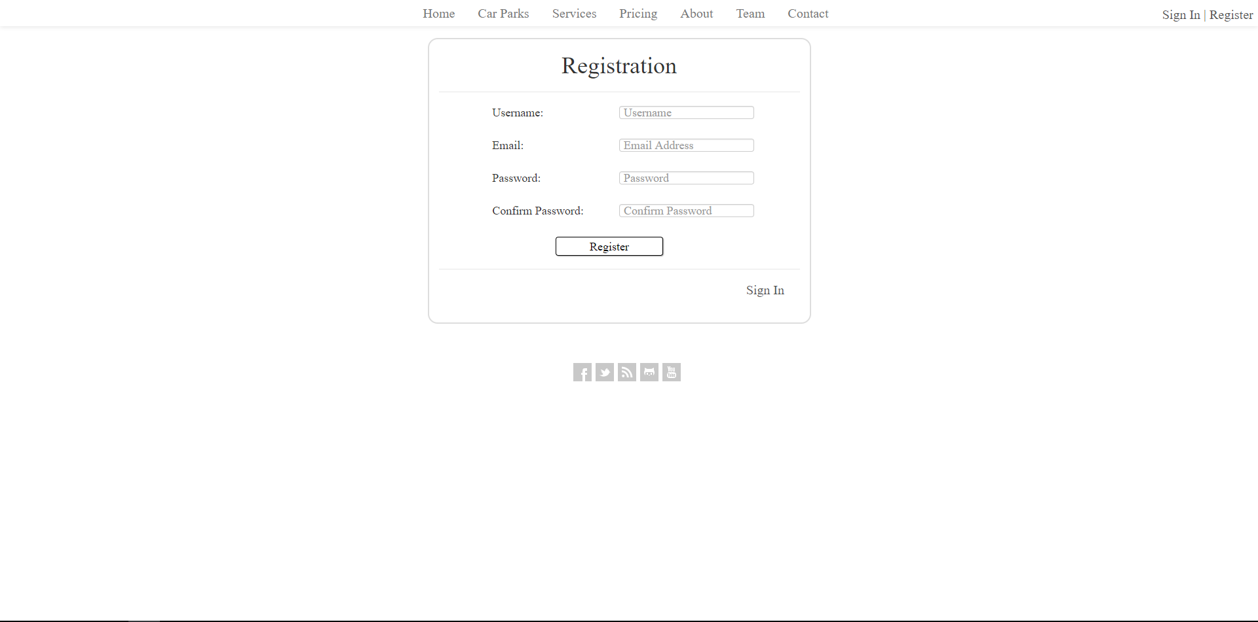
The user registers by using a unique username, their email address and a password that needs to be validated in order to proceed. The user’s details are submitted in a form to the database and the information is included into the necessary tables.
I have set myself a deadline of the 28th February to finish the tasks that need to be done on the coding end. This includes the ability to book your parking space along with the different abilities for admin users, such as, being able to create a new car park facility and include it into the web application. The deadline is hopeful and seems achievable as there is code already in place that can just be reused.

Review Progress, Performance and Issues
As previously mentioned, the stakeholders are pleased with the current version of the project. The project is progressing well under the current routine that is used in order to complete it and the deadline in April is looking likely to be made. However, initially there were difficulties with the system. As I have only began to grow my knowledge of PHP I am still no expert. This led to some problems at the beginning as I was constantly having errors in the code. Eventually with help from some materials online I was able to build my knowledge on PHP and create a system that can so far allow people to register to the system, Login to the system, select their parking space and can also allow admin users to see specific data in their own private section.
Another issue that was encountered was how the data would be stored. It was initially decided that the data would be stored using a NoSQL database that would store JSON objects where you can store whatever data you want inside. The objects can be built out differently from one another allowing for more information to be stored on a particular section than others. While all of this sounded promising at the start it became apparent that it would be too hard to implement. This is because I have limited experience in storing data as JSON object and with there being a tight schedule to meet the deadline so it was decided that a SQL database would be used. This decision has led to a more rapid development as no time needed to be used in learning a new way to store data. This could be changed further down the line after the project has been completed but extensive work would need to be carried out in order to switch the data from an SQL format to a JSON object.
Users have the ability to create a personal account on the system. They can register by providing a Username, Email Address and a Password that also needs to be confirmed. When they create their account they are brought to their own personal page where they can view their parking history, i.e. when they parked previously and the specific space they chose. The user will have the ability to add more information about themselves such as their name, their Car model and Car registration. These things are necessary when booking a parking space so the user needs to ensure that they have these filled out in the first place. Validation has been put in place that makes sure the user never has this problem and they’ll know that they have to fill in this information if they wish to make a parking reservation.
The web application uses a feature that checks to see whether a user is logged in or not. It does this by checking the session value that is stored and if it contains any user information. If the session is null then that means the user is not logged in and they will not be able to use the system so they will only be able to see the login screen. This means that users must register in order to get access to the system. This is done to stop any fake reservations being made so that more parking spaces will be available to those that actually need them.
Other areas of the application have already been complete as they only took a brief amount of time to set up. Pages like: “Services” and “About” were easy to create as it was only a matter of filling in information on what the system is actually for and what it provides. A page titled “Team” is an area of the application that gives details on the developers of the project. It provides an image of the developer and a brief description about them. This has been done to give credit to the people behind the creation of the project.
The performance of the application is as expected and it is looking likely that no problems will arise. Should difficulties come to light however I feel that the application will be fine as many risk assessment steps have been took to counteract any issues that may present themselves. The only problem that may arise is a mismanagement of time and whether the project will be finished. While this is unlikely it must still be monitored so that the development runs as expected.

Accomplishments
Milestones can be used to ensure that key deliverables are being achieved. The milestones that have been outlined in the initial Gantt chart can be used to measure the accomplishments of the project. A total of 4 milestones were included in the chart:
- Approve Project Proposal
- Approve Prototype
- Approve Final Version
- Roll-out Final Version
So far only one of these milestones have been met. The web application is still in the “Develop Prototype” stage so the prototype has yet to be approved. I am not worried about this however because the project is nearing its final stages, meaning that when it gets approved that only a few minor adjustments will have to be implemented to enhance the project even more.

Analyse Issues
It is always important to prevent any issues from arising during the development of any project. It is not always impossible to stop issues from happening however so that is why it is important to have certain measures in place. With data being backed up on a regular basis it means that the system is always safe because it is stored on multiple locations. This stops the source code from ever experiencing any issues as there is a history of versions also.
While there is still more to be implemented it is possible that more issues may become apparent. No major issues have been encountered so far thankfully and hopefully it remains that way until the projects end. The only issue that can be thought of right now is that during the final demonstration of the project whether the system will work on the University’s systems or not. To counteract this I will try to store everything onto my user account at the university and transfer my files using FTP server. This means that I can test that the final version of the system is working before the deadline meaning that a fully functioning system is presentable to end users and the stakeholders come late April.
A major issue that was encountered was that of the initial Gantt chart itself. This is because no dates were outlined on it. With there being no dates it made it a bit more difficult to keep to a schedule because there was no clear indication on when a particular feature should be implemented, only the order in which it should be implemented was provided. Although this is an issue it has proven to not have a major effect on the project’s development. It is looking likely to meet the deadline because of the time and effort spent in the development stage. This limits time wastage and allows problems to be dealt with immediately before the next feature is designed and created.

Appendix
