Table of Contents
ABSTRACT 4
1. Introduction 4
1.1 Background 4
1.2 Project Aim 4
1.3 Project Objectives 4
1.4 Outline Dissertation 4
2. Requirements 5
2.1 Requirements Gathering Methods 5
2.2 Requirements Evaluation 5
2.3 Final Requirements 5
3. System Design 6
3.1 Approach to Design 6
3.2 Interface Design 6
3.2.1 Material Design 6
3.2.2 HCI Considerations 6
3.2.3 Mock Screens 6
3.3 Data Support Design 6
3.3.1 Consideration for Security and Data Validation 6
3.3.2 SQL Database Design 6
3.3.3 Relationships 8
3.4 User Interaction Design 8
3.4.1 Use Case Modelling 8
3.4.2 Activity Diagrams 8
4. Implementation 9
4.1 Evidence of use of version control 9
4.3 Summary of the Volume of Code Produced 9
4.4 System Walkthrough 9
4.5 Security Implementation 10
4.5.1 Sign In 10
4.5.2 Register 11
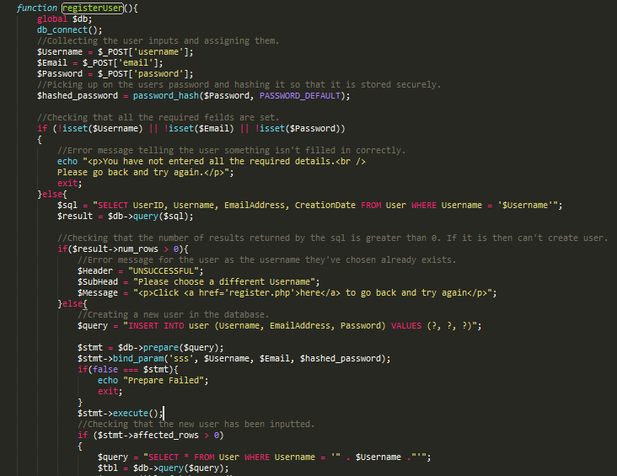5. System Testing and Verification 11
5.1 Testing Strategy 12
5.2 System Verification 12
6. System Validation 13
6.1 Rationale for User Evaluation and Acceptance Testing 13
6.2 User Evaluation Results 13
6.3 Requirements Evaluation & Results 13
6.4 Consideration for Future Work 13
6.4.1 Future Improvements 13
6.4.2 Additional Features 13
7. Conclusion 14
7.1 Critical Appraisal of the Project 14
7.2 Reflection on Project Plan 14
7.2.1 Methodology 14
7.2.2 Technologies 14
7.3 Reflection on Time Estimation 14
8. References 15

ABSTRACT

1. Introduction

Background
Project Plan – 1.1 & Project Plan 1.2

1.2 Project Aim
Project Plan – 2.1 Project Aims

1.3 Project Objectives
Project Plan – 2.4 Project Objectives

1.4 Outline Dissertation
This dissertation is made up of the chapters listed below.
- This chapter contains a background of the projects along with the Aims and Objectives.
- Gives an overview of the methods used for gathering requirements, an evaluation of the requirements and the final requirements of the project.
- The Interface, Data Support and User Interaction Designs are broken down in this chapter providing detail of the entire System design.
- Covers how the project was implemented. A summary of code is provided along with the evidence of version control. A walkthrough is also provided within this chapter which demonstrates how the web app is used.
- Gives a detailed description of System Testing and Verification. This chapter discusses the testing strategy and verification.
- Provides detailed information about System Validation. An evaluation is also provided along with considerations for any future work that may be carried out.
- This chapter is the conclusion to the report. Reflection is given on the project plan and time estimations.

2. Requirements

2.1 Requirements Gathering Methods
Requirements for this project were gathered using different techniques involving the identified stakeholders: Unstructured interviews were carried out with the mentor and a company (Boots) who has developed an initial interest in the project. Also questionnaires were distributed among the 20 potential users identified.

2.2 Requirements Evaluation
As the software methodology chose, modified waterfall, does not allow for requirements change, the final list of requirements is the same as the initial list.

2.3 Final Requirements

3. System Design

3.1 Approach to Design
This chapter includes information on the interface design showing the layout of the web-app using mock screens. Data support and user interaction designs are also covered discussing security and data validation, database table breakdowns, database relationships and activity diagrams.

3.2 Interface Design

3.2.1 Material Design

3.2.2 HCI Considerations
It is a priority that HCI guidelines are adhered to when designing the user interface. This project has used Schneiderman’s 8 Golden Rules. Using these rules has allowed for a user friendly system. The table below shows how each rule was followed.
Principle | Consideration | Complete
1.) Strive for consistency |  | ✔
2.) Enable frequent users to use shortcuts. |  | ✔
3.) Offer informative feedback |  | ✔
4.) Design dialog to yield closure. |  | ✔
5.) Offer simple error handling. |  | ✔
6.) Permit easy reversal of actions. |  | ✔
7.) Support internal locus of control |  | ✔
8.) Reduce short-term memory load. |  | ✔

3.2.3 Mock Screens
MOQUPS TO SHOW DIFFERENT SCREEN DESIGNS

3.3 Data Support Design

3.3.1 Consideration for Security and Data Validation
“Stripe software allows individuals and businesses to receive payments over the Internet. Stripe provides the technical, fraud prevention, and banking infrastructure required to operate on-line payment systems.” (Levi, A. 2015) The user does not need to store their payment information into the projects database as Stripe handles their details. This allows the ability to pay for their parking reservations in a secure way in which their card details are never stored.
The image below shows the dashboard used to monitor payments. From this system prices, dates and references can all be viewed. No personal information of the user is stored so there is no need to worry about data protection within this section of the project.
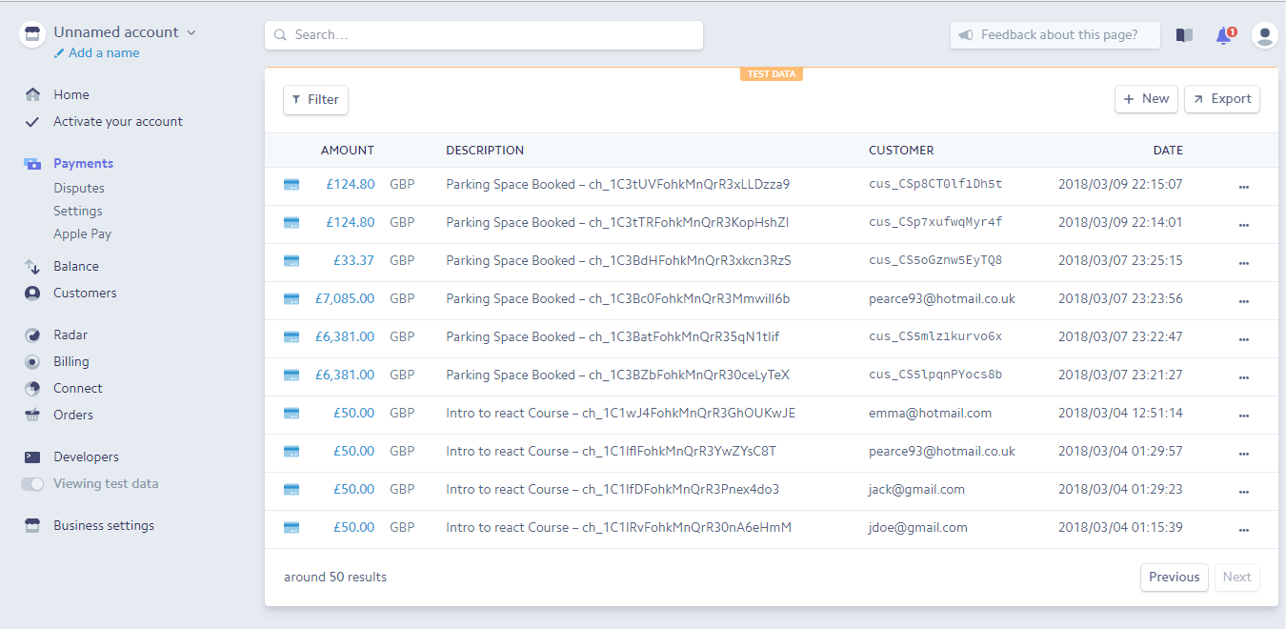

3.3.2 SQL Database Design
PHPMyAdmin is a PHP tool that handles MySQL over the internet. It is the database that was used to store the data of the project. It was decided that MySQL was the best way to store data because the structure of the database

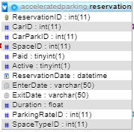
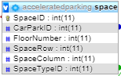
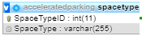
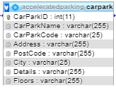
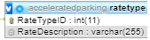
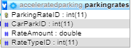
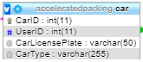
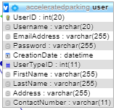
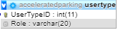
****ADD TO THIS****

Reservation Table
This table is used to store information on reservations. It is made up of a unique ID so that each individual reservation can be identified. It also stores information on the car that is parking in a particular space during a period of time. Details of the car park and price of reservation are also stored in this table.
Space Table
The space table stores information on each individual space in a car park. The car park is identified using a CarParkID which links it to the CarPark table. SpaceRow is an identifier for the spaces that run horizontally in the car park. SpaceColumn is the vertical identifier. A space type is also stored so that a space can be marked as available, unavailable, road, disabled or a family space.
SpaceType Table
This table has 2 fields. One is the SpaceTypeID which will offer a unique identifier while a description is also stored.
ParkingRates Table
This stores information about the costs of the car park. A unique ID is stored for each parking rate. The table is linked to the car table by the CarParkID.
RateType Table
The rate type table stores details of the rates. It is stored this way to allow for different prices on different days for each car park.
Car Table
This table stores information about a user’s car. The model and license plate of the car are stored so that it can be used as identification when checking if a car is parked in the correct space. A user ID is stored so that the car can be linked to the driver.
CarPark Table
Details of the car parks are stored in this table. The name of the car park, its address and postcode, the city its located and the amount of floors it has are different fields that are saved to distinguish car parks from one another.
User Table
Information such as the unique username, a user’s first and last name, their email address and a contacted number are stored in this table. Each user is assigned their own ID to identif y them.
UserType Table
The user type table stores the roles of the user. For example an admin user needs to be separated from a standard user so that they have access to authorised features.

3.3.3 Relationships
Below is an Entity Relationship Diagram (ERD). It is used to track data relations in the database. It shows how each table is connected to at least one other. Some tables have more relationships to other tables than others. For example the reservations table connects to 3 other tables: car, parking rates and space. The diagram shows that these then have further connections with even more tables. There are a total of 8 different relationships between tables and the database has the ability to grow even larger and develop more relationships if further development was needed in the web app which required more information to be stored.
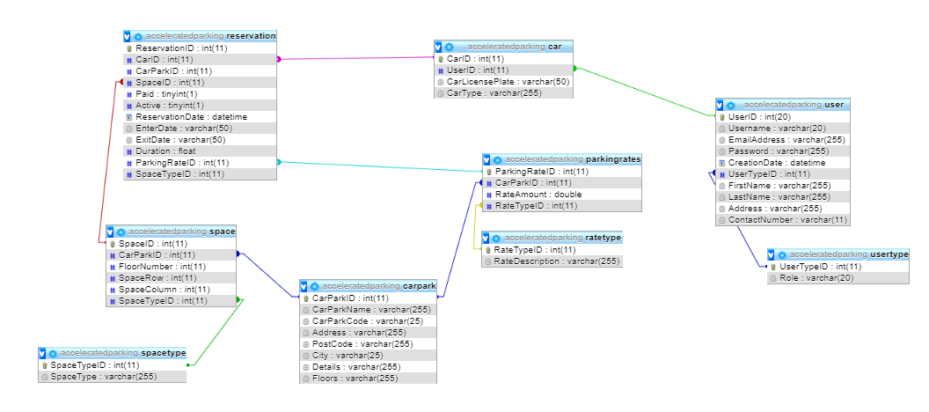

3.4 User Interaction Design

3.4.1 Use Case Modelling

3.4.2 Activity Diagrams

4. Implementation
This section will highlight the main features of the web app and go into more detail on how the layout of the screens was implemented. It will also show issues that were encountered in the creation of the web app and what how it was addressed.

****OLD DESIGN****
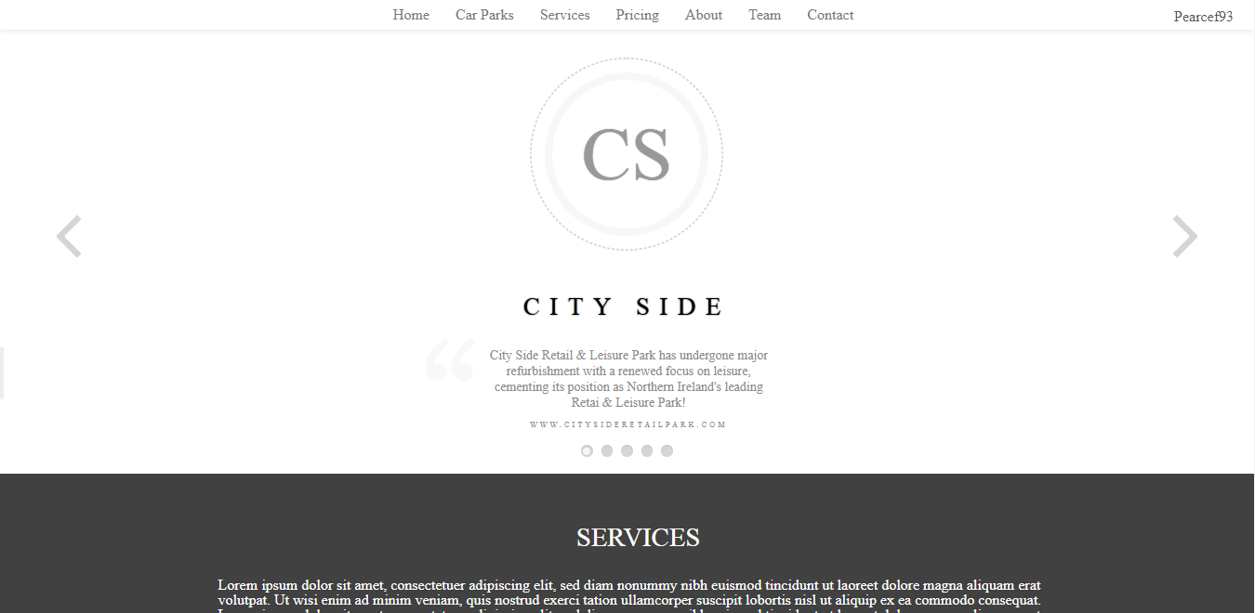
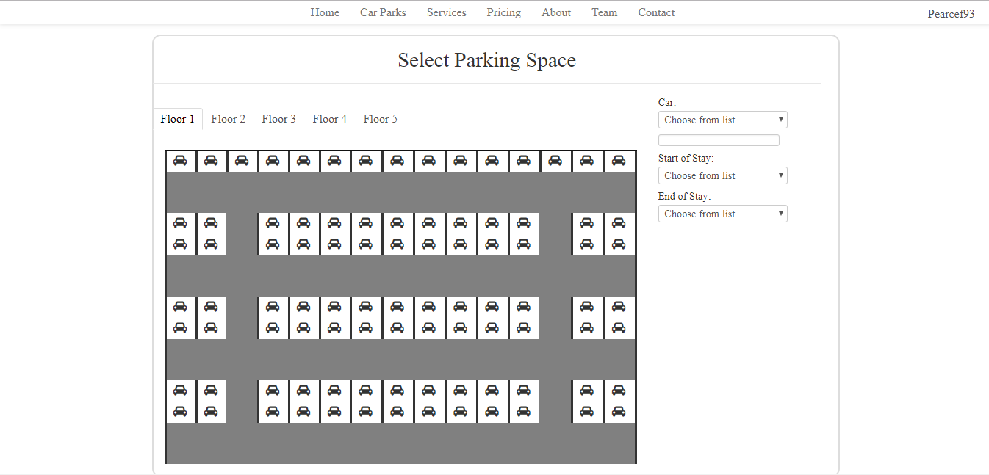

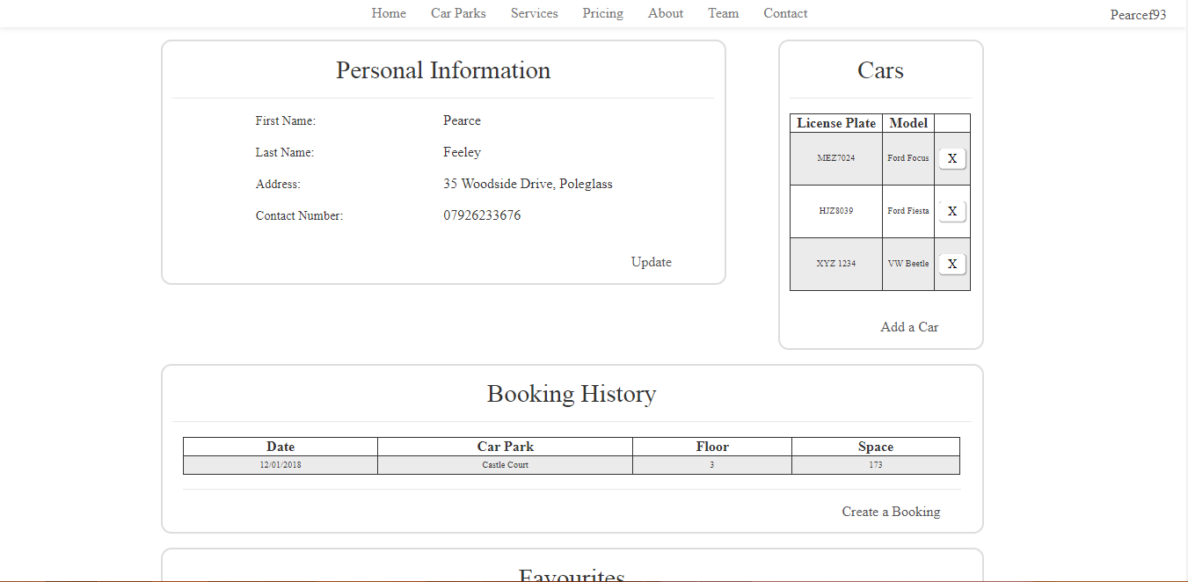
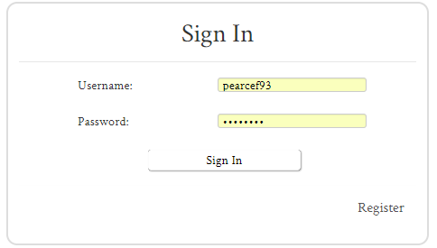
****NEW DESIGN****

****BOOK SPACE REGISTERED****
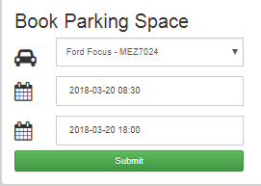
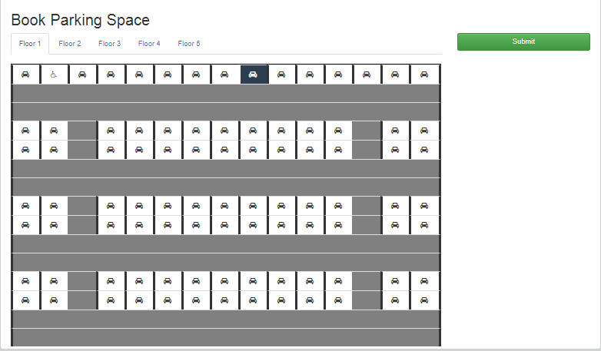
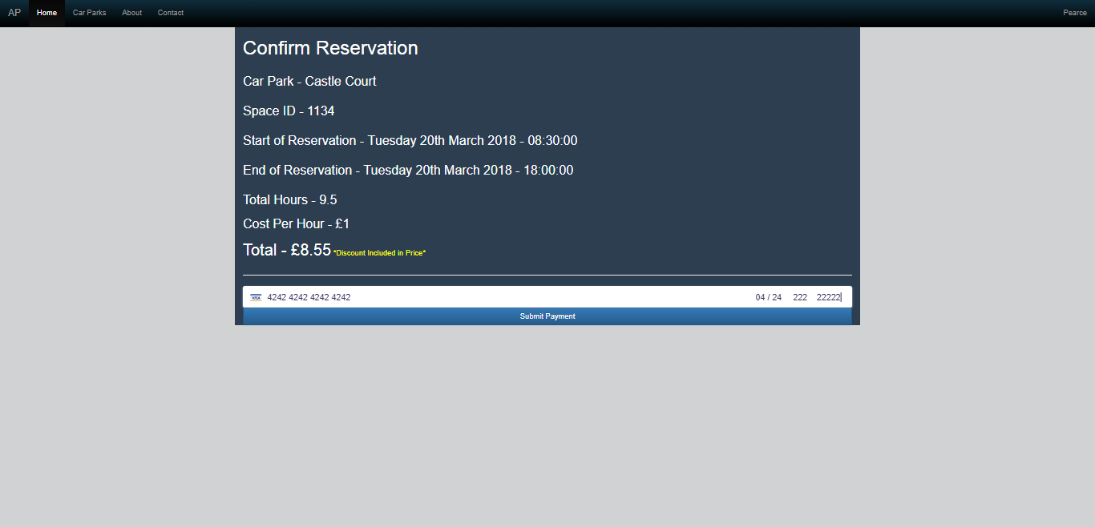


****BOOK SPACE UNREGISTERED****
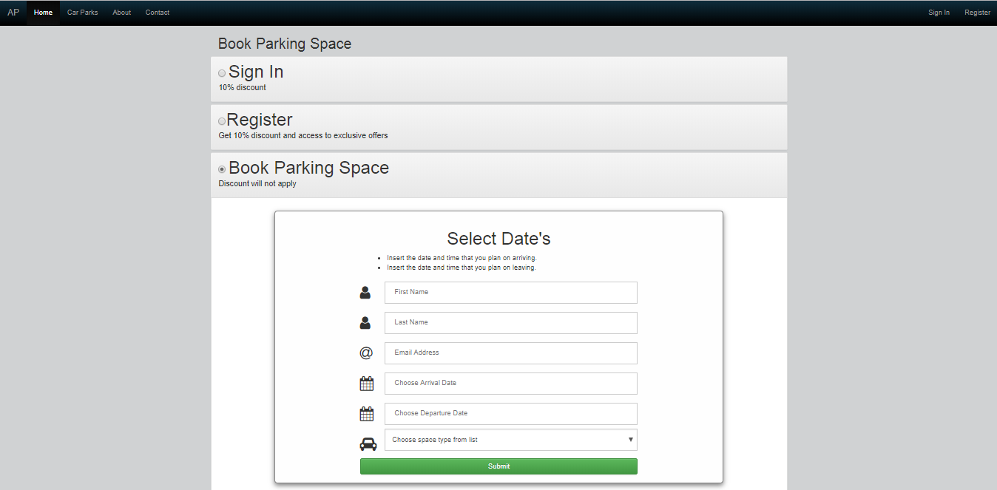

****CREATE CAR PARK****
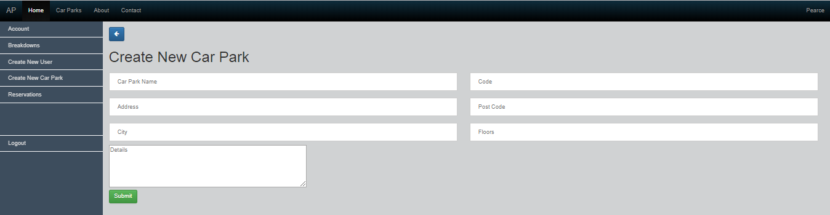

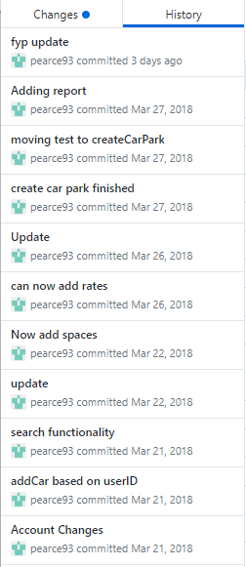
****LIBRARIES****

4.1 Evidence of use of version control
Whenever new code was created the project would be committed to a repository on GitHub, a web-based hosting service, where it could be stored in a safe location. Each individual push to the repository is stored meaning that the project could be picked up from any previous save in the past. This was a useful tool and allowed the ability of accessing a previous version at any given time.
As **FIGURE** shows, there is a range of different versions that can be reverted back to. Using version control ensured that the project always had a recoverable copy if it was needed.

4.3 Summary of the Volume of Code Produced
The DRY (Don’t Repeat Yourself) principle was used in the project. This meant that code was kept to a minimum where possible. To keep code from repeating a PHP file, “AP_functions.php”, was created to store functions that would be used on different PHP pages. These functions only need to be called on other pages so that the functionality could be accessed meaning that unnecessary lines of code weren’t created.

4.4 System Walkthrough
****What the user should click on etc to get to things*****

4.5 Security Implementation

4.5.1 Sign In
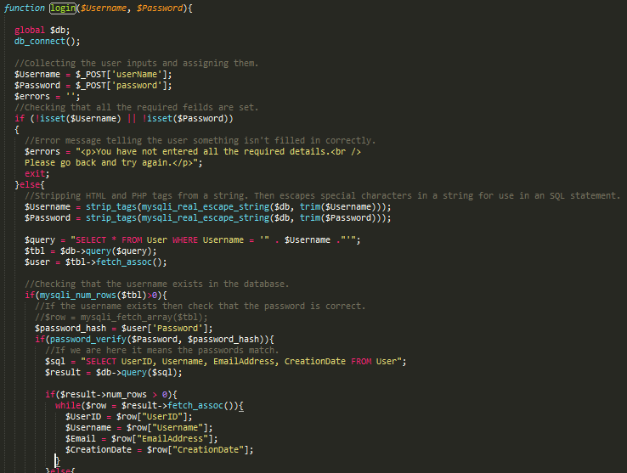
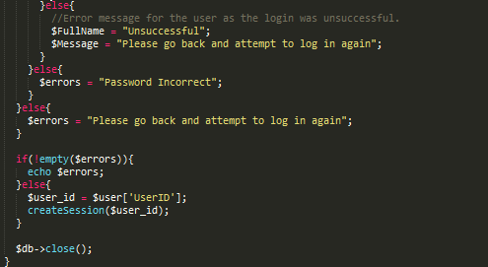

4.5.2 Register

5. System Testing and Verification

5.1 Testing Strategy
Testing is a crucial yet somewhat neglected aspect of building a software product. Testing was necessary to ensure the Findation Application was reliable, robust and could run independently. Therefore, it is important to have a rigorous test driven strategy in place which outlines this projects testing approach. As the developer was using the Revised Waterfall method, testing was carried out after implementation was complete. However, as the Revised Waterfall method has a more flexible structure, implementation could have been revised if necessary after the test phase was complete. It was decided to have a test/feedback step for each feature and phase of implementation. The majority of the testing carried out for this project is white box testing. This approach is used to generate test cases that cover the adequacy criterion for all code elements identified by the approach. White box testing is applicable to lower levels of testing: Unit Testing and Integration Testing. These testing methods are described in the next section.
****BLACK BOX TESTING***
Unit testing is used to ensure that small component functionality is consistent with the requirements. As a result, it helps to improve the overall software quality. (Jamro, 2015) In Android development either local test units or instrumented unit tests can be carried out. Local unit tests avoid the need for the application to be ran on an emulated or physical device as they make use of the JVM instead. This ensures a faster execution time which can quickly provide results for specific tests. Mockito is a framework which enables the mocking of simple Android dependencies and as a result was integrated into the project to aid unit testing. A unit test called testLoginUser() was created to test on a small login component. After unit testing is concluded, the individual code components that have been tested are collated and validated using another set of test drivers. This is referred to as Integration Testing. Its objective is to ensure that, “all components interact and interface correctly with each other, that is, have no interface mismatches.” (Hartmann J., Imoberdorf C., Meisinger M., 2000)

5.2 System Verification
****SHOW TEST TABLE AND RESULT****
Based on the Verification tests results presented in table 4, it can be concluded that the systems has passed all the tests.

6. System Validation

6.1 Rationale for User Evaluation and Acceptance Testing

6.2 User Evaluation Results

6.3 Requirements Evaluation & Results

6.4 Consideration for Future Work

6.4.1 Future Improvements

6.4.2 Additional Features

7. Conclusion

7.1 Critical Appraisal of the Project

7.2 Reflection on Project Plan

7.2.1 Methodology

7.2.2 Technologies

7.3 Reflection on Time Estimation

8. References
Levy, A. (Thu, 7 May 2015) Stripe expands into Asia, Latin America, Available at: https://www.cnbc.com/2015/05/07/stripe-expands-into-asia-latin-america.html(Accessed: 21st March 2018).

