Financial Econometrics Coursework Report: Forecasting Oil Term Structure
By Nakul Pillai, Samuel Soon, and Pierson Chu

Abstract
Our team forecasts next month’s change in the WTI calendar spread, $\frac{CL2-CL1}{CL1}$, the position a calendar-spread trader holds. We leverage a LASSO regression on monthly macroeconomic and industry predictors, re-estimated each month on past data only, with a random-walk benchmark as a comparison. The results indicate that the LASSO beats the benchmark (modest at out-of-sample R² [X]%, direction correct in [X]% of months), though it is largely attributed to March-May 2020. We also establish a trading rule based on our model that follows the sign of the forecast, which earns $[X] per barrel before costs.

Introduction
Our model is catered towards a calendar-spread trader, who asks the question: will the front of the futures curve steepen or flatten? We make use of a set of candidate macroeconomic and industry predictors to forecast the next month’s move to see whether we are able to forecast the spread well enough to inform a trade.

Defining the Dependent Variable
The target variable is defined as the monthly change in the normalized calendar spread or a one-step-ahead forecast:

$$ΔY_{t+1}=\frac{CL2_{t+1}-CL1_{t+1}}{CL1_{t+1}}-\frac{CL2_{t}-CL1_{t}}{CL1_{t}}$$

Each observation is a forecast made at the end of month t: predictors are known at that date, and the target is the change in the spread from t to t+1.

We rejected two of the brief’s candidates:
- The CL1 price has a unit root (ADF p = 0.34, autocorrelation 0.99), so regressions on it risk being spurious.
- CL1 returns are stationary but behave close to noise and are a directional bet on oil.

Therefore, we chose the normalised calendar spread, due to its clear interpretability. The spread measures the slope of the front of the futures curve, where positive values and negative values indicate contango and backwardation in the market respectively.

The spread is hedged against moves in the oil price, and storage and financing costs keep it bounded, so it tends to revert to normal levels, giving it a predictable component.

We forecast its one-month change rather than its level, as t spread position earns the change and the change is clearly stationary (ADF p < 0.01, KPSS p = 0.10; Appendix Table A1) while compared to the level. Additionally, normalised spread makes it comparable across 1995–2024, when oil traded between $11 and $140.

Economic Rationale over Data Mining
Candidate predictors were chosen for a plausible link to the spread rather than by searching for correlations, echoing Peter E. Kennedy’s famous “Ten Commandments of Applied Econometrics”, where empirical research should use both common sense and economic theory. The candidates cover factors related to supply, demand, cost of carry and macro, risk sentiment, hedger positioning, and today’s spread. Ultimately, we use 16 series plus today’s spread. Appendix Table B1 lists each series with its transformation, publication lag and economic link.

Data Architecture & Feature Alignment
Sampling Frequency
Our chosen sampling frequency is monthly, as it doesn’t require us to alter the predictors’ data by forward-filling, while still giving us a sufficiently big data set to train on (355 rows, Dec 1994–Jun 2024). Daily data gives the most observations but includes major noise, and most macro series data is announced monthly (which would require us to forward fill). Weekly data may have less noise but has the same forward-filling issue. Naturally, the cost is fewer observations and slower reaction to shocks.

The target at a glance
The spread usually stays within a few percent of zero and reverts after shocks, but it has shown shifting behaviour over time. The average spread moved from backwardation (−0.85%, 1995–2004) to contango (+0.90%, 2005–2014), and the 2020 pandemic produced a super-contango of 19.7% as storage filled and front-month WTI briefly traded below zero (Figure 1).
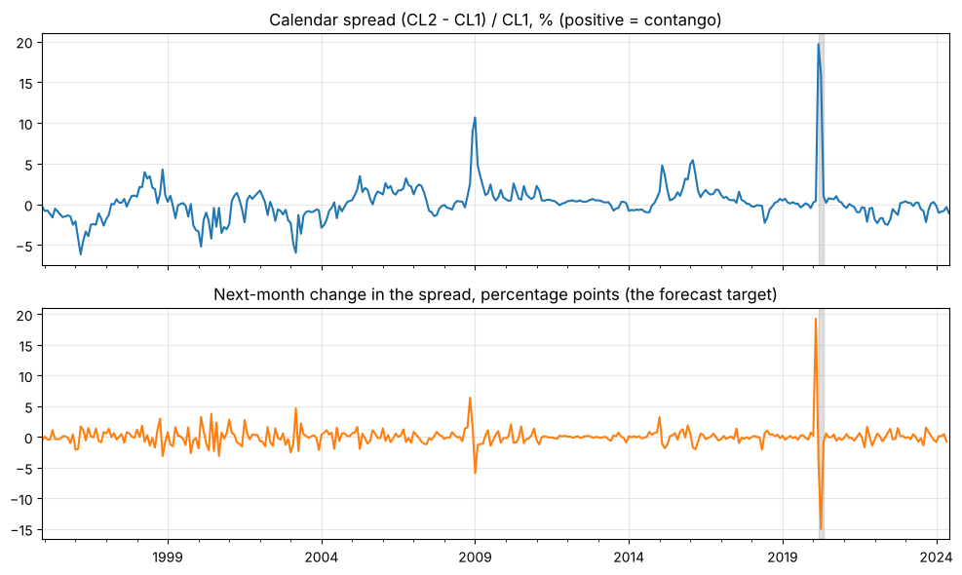
Figure 1: WTI calendar spread (CL2 − CL1)/CL1 (top) and its one-month change, the forecast target (bottom), 1995–2024. Shaded: March–May 2020.

Exclusions of certain data series
Overlapping predictors make regression coefficients unstable and hard to interpret, therefore we identified such overlapping predictors and removed them. Individual oil-company stocks move closely with the Dow Jones Oil & Gas index (monthly return correlations 0.70–0.87), and Shell is missing 127 months, which would shorten the sample. Additionally, Total Open Interest is exactly Commercial Long plus Commercial Short, so it adds nothing. Brent tracks CL1 almost one-for-one (correlation 0.95) and was flagged for a data issue.

Transforming the Predictors
To avoid spurious relationships when regressing on upward trending series, we conducted the following changes:
- Monthly log changes (≈ percentage changes) for prices and quantities
- Simple changes for rates and VIX
We left already-stationary series (dollar returns, today’s spread) as is. We test that these changes were successful in our diagnostics section.

Timing and Publication delays
Each forecast uses only information available at the end of month t: all predictors are measured at t and the target is the change to t+1. For CPI and industrial production, we use their values from t−1 to avoid look-ahead bias.

Methodology & Model Architecture (OLS vs. LASSO)
Training and Test Samples
The first 239 monthly observations (Feb 1995–Dec 2014) are used only for training, while the last 113 (Jan 2015–May 2024, forecasting Feb 2015–Jun 2024) form the test sample. The test sample spans the 2015–16 glut, the 2020 pandemic and the 2022 energy shock. All reported scores are out of sample, as we only re-estimate on earlier data at every test month.
Naive Benchmark: Random Walk
Our naive benchmark assumes next month’s spread equals today’s, so the forecast change is zero. This is what market efficiency implies for a traded price, as a predictable move would have been actioned on and removed. A model must beat this benchmark out of sample to be useful.

OLS Limits
OLS chooses the coefficients that minimise squared forecast errors and is easy to interpret. However, with 17 predictors that are mostly weak and a small data set, OLS assigned non-zero weights to all variables due to fitting noise as well as any relevant signal. It forecasts poorly out of sample, and acts purely as a comparator to LASSO.

LASSO
By adding a penalty $λ·Σ|βⱼ|$ to the OLS objective, it shrinks the coefficients towards zero and sets weak predictors exactly at zero, whereas ridge only shrinks. This makes the model shorter and allows traders to interpret it with more ease. Predictors are standardised within each training window so the penalty treats them equally, and a fully shrunk model forecasts zero change, the random walk.

Choosing the Penalty
λ is chosen by time-ordered cross-validation, where each training window is split into six consecutive blocks, each of the last five is forecast using only the blocks before it, and the λ (from 60 candidates) with the lowest average error is used. We avoid ordinary K-fold cross-validation to avoid looking ahead. λ is re-tuned at every forecast origin, so the test months never influence it.

Expanding vs Rolling Windows
At each test month we refitted either on all data since 1995 (expanding: 239 months at the first forecast, 351 at the last) or on the latest 120 months only (rolling). Testing both methods, expanding gives steadier estimates, while rolling adapts faster if the market has changed. Both are scored on the same 113 out-of-sample months, and the expanding window scored lower out-of-sample RMSE.

Econometric Diagnostics
Area | Test | What it checks | Result
Stationarity | ADF | Unit root in each series (null: unit root) | Target stationary; 2 of 17 predictors unclear
Stationarity | KPSS | Stationarity of each series (null: stationary) | (read together with ADF)
Autocorrelation | Breusch-Godfrey | Serial correlation in in-sample residuals (post-LASSO OLS) | [to fill]
Autocorrelation | Ljung-Box | Serial correlation in out-of-sample forecast errors | [to fill]
Heteroskedasticity | Breusch-Pagan | Whether error size depends on the predictors | [to fill]
Heteroskedasticity | ARCH-LM | Volatility clustering: large errors follow large errors | [to fill]
Parameter stability | Chow test | Coefficient break at Jan 2005 and Jan 2015 | [to fill]
Parameter stability | Rolling coefficients (chart) | Drift in coefficients over time | [to fill]
Supporting: multicollinearity | VIF | Overlap among the predictors LASSO keeps | [to fill]
Table 1: Diagnostic tests. p-values below 0.05 flag a problem. Results are filled in from the notebook (Steps 5 and 11).

Stationarity (ADF and KPSS)
We test every series for whether they drift without returning to an average (to flag possible spurious regression relationships) with two complementary tests: ADF assumes a unit root, KPSS assumes stationarity. Agreement gives a confident verdict and disagreement is flagged “unclear” (Appendix Table C1).

On the training years, 11 of the 16 raw series have a unit root. After transformation, the target and every predictor are stationary except daily production and today’s spread, which is highly persistent (autocorrelation 0.81) but strongly rejects a unit root (ADF p < 0.01). However, we keep the spread in levels because its distance from normal is the mean-reversion signal.

Autocorrelation (Breusch-Godfrey and Ljung-Box)

  - Project Application: Checking in-sample OLS residuals and out-of-sample forecast errors for linear serial dependence.

Heteroskedasticity (Breusch-Pagan and ARCH-LM)

  - Project Application: Verifying whether error variance is constant across time and testing for autoregressive conditional volatility clustering.

Parameter Stability (Chow Test and Rolling Coefficients)

  - Project Application: Testing whether model coefficients shift across major market regimes (e.g., pre- and post-2008 Financial Crisis) and visually tracking parameter drift.

Multicollinearity (VIF)

  - Project Application: Evaluating collinearity across the 16 candidate predictors to ensure standard errors are not artificially inflated.

Results, Out-of-Sample Performance & Robustness
Evaluation
All metrics use out-of-sample forecasts only:
- RMSE is the typical size of a miss in percentage points and weights large misses heavily
- MAE is the average miss and is less driven by extreme months
- Out-of-sample R² is one minus the model’s squared errors over the random walk’s (positive indicates the model beats the benchmark. )
- Hit rate is the share of months with the right direction, which is what a spread trade depends on.
- MAPE is not used, as it divides by changes that are often near zero.

Forecast Performance
Expanding-window LASSO is the best model on every measure (Table 2): out-of-sample R² of 9.0% against the random walk, a lower MAE, and the right direction in 60% of months, about two standard errors above a coin flip. OLS beats the benchmark on RMSE but not on MAE, and both rolling models do worse, so more data helps.

Window | Model | RMSE (pp) | MAE (pp) | Out-of-sample R² | Hit rate
— | Random walk | 2.449 | 0.865 | 0 | n/a
Expanding | OLS | 2.364 | 0.945 | 6.8% | 60.2%
Expanding | LASSO | 2.336 | 0.818 | 9.0% | 60.2%
Rolling | OLS | 2.687 | 1.173 | −20.4% | 54.9%
Rolling | LASSO | 2.371 | 0.904 | 6.3% | 46.9%
Table 2: Out-of-sample forecast performance, Jan 2015–May 2024 (113 months). RMSE and MAE in percentage points of the spread. Out-of-sample R² is measured against the random walk. Best model in bold.

However, the gain is concentrated: 94% of LASSO’s advantage comes from March–May 2020, when it called the direction correctly but far too small (Figure 2). In practice, the model trims errors but cannot anticipate spikes.
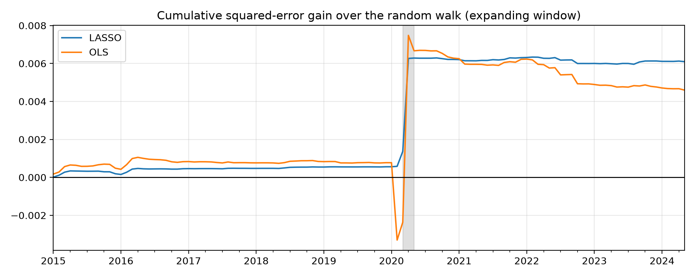
Figure 2: Cumulative squared-error gain over the random walk, expanding window. A rising line means the model is ahead. Shaded: March–May 2020.

In-Sample Fit vs. Out-of-Sample Performance
In sample, OLS on all 17 predictors has the higher R² (0.261 vs 0.241 for the six predictors LASSO keeps at the final origin) but the lower adjusted R² (0.223 vs 0.228), and it forecasts worse out of sample. The two R² figures are not comparable: in-sample R² is measured against the sample mean on data already seen, out-of-sample R² against the random walk on unseen months.

Robustness: Without the COVID Shock
March–May 2020 account for 90% of the random walk’s squared error, so we test whether our result depends on them as well. We exclude them in two ways (Table 3): from the scoring only, and from both training and scoring, re-running the model as if the shock never happened. After this testing, expanding LASSO still beats the random walk: 5.7% scored without the months and 10.1% when re-run. Training on the crash therefore hurts ordinary months, and without it LASSO relies almost entirely on today’s spread and gasoline. Without the shock the rolling window does best (13.7%), so the window choice partly reflects 2020. However, it is important that we keep 2020 in the headline results, because a forecaster could not have skipped it.
Window | Months excluded | LASSO, scoring only | LASSO, re-run | OLS, scoring only | OLS, re-run
Expanding | Mar–May 2020 (110 left) | 5.7% | 10.1% | −31.2% | 4.0%
Expanding | All of 2020 (101 left) | 6.6% | 9.7% | −15.1% | 7.9%
Rolling | Mar–May 2020 (110 left) | −22.5% | 13.7% | −223.1% | −28.2%
Rolling | All of 2020 (101 left) | −9.0% | 11.2% | −216.5% | −3.8%
Table 3: Out-of-sample R² against the random walk with COVID months excluded. With all months (Table 2): expanding LASSO 9.0%, OLS 6.8%; rolling LASSO 6.3%, OLS −20.4%. Random-walk RMSE falls from 2.45 to 0.78 pp without March–May 2020.

Trading Strategy, Economic Interpretation & Limitations
- Economic Interpretation of Survived Predictors:

  - Project Application: Evaluating the signs and magnitudes of variables retained by LASSO to ensure they align with commercial market mechanics.

  - Slide Citation: "Our Objective: To build a statistically adequate empirical model which... has the right 'shape' - i.e. all signs on coefficients are 'correct', all sizes of coefficients are 'correct'"

  - Pre-post covid, looking at the results of the notebook there was a difference between the lasso selected periods with and without covid included. For instance, 3-month yields was included way more often (interpretation: Oil prices acted as the primary inflation catalyst that forced the 3-month Treasury yield out of its post-COVID 0% floor, while the subsequent surge in yields eventually cooled oil demand and brought crude prices back down)

  - How do we think this links with the Iran war?

- Executing the Calendar Spread Trading Rule:

  - Project Application: Translating forecast signs into a long $CL2$/short $CL1$ position (if $\Delta \hat{Y}_{t+1} > 0$) or short $CL2$/long $CL1$ position (if $\Delta \hat{Y}_{t+1} < 0$), evaluating performance via cumulative PnL curves.

- Acknowledging Real-World Model & Market Limitations:

  - Project Application: Transparently reporting practical desk risks (transaction friction, contract roll dynamics, structural regime shifts) and presenting honest statistical conclusions if out-of-sample gains are insignificant.
Conclusion
Appendix
Table A1: Candidate target variables
Candidate target | ADF p-value | KPSS p-value | Verdict | Lag-1 autocorrelation | Std. dev. per month
CL1 price level | 0.338 | 0.010 | Unit root | 0.99 | $32.37
CL1 monthly log return | 0.000 | 0.100 | Stationary | 0.12 | 9.25%
Spread level | 0.000 | 0.036 | Unclear | 0.81 | 1.96 pp
Spread one-month change | 0.000 | 0.100 | Stationary | -0.14 | 1.22 pp
Training sample 1995–2014. A p-value below 0.05 rejects the null (ADF: unit root; KPSS: stationary). Source: notebook Appendix A.
Table B1: Predictors
Predictor | Transformation | Extra lag (months) | Economic link
Spread level (today) | level | 0 | Contango and backwardation are bounded by storage and financing costs, so a wide spread tends to close: mean reversion
3-2-1 crack spread | log diff | 0 | Refining margin; strong margins mean strong demand for crude
Baltic Dry Index | log diff | 0 | Shipping cost, a proxy for global demand
Daily production | log diff | 0 | Supply
Inventories | log diff | 0 | Storage: high stocks favour contango, low stocks backwardation
Rig count | log diff | 0 | Drilling activity, a leading indicator of future supply
Commercial long / short | log diff | 0 | Hedgers' positioning in the futures market
CPI (year on year) | diff | 1 | Inflation and macro conditions
3-month yield | diff | 0 | Cost of financing stored oil (cost of carry)
10-year yield | diff | 0 | Longer-term rates and growth expectations
Industrial production | log diff | 1 | Real activity, a GDP proxy for oil demand
S&P 500 | log diff | 0 | Risk appetite and growth
Dollar index return | level | 0 | Oil is priced in dollars; a stronger dollar tends to weigh on prices
VIX | diff | 0 | Market stress
Gasoline price | log diff | 0 | End-product price, a read on prompt demand
Dow Jones US Oil & Gas Index | log diff | 0 | The equity market's view of the oil sector
Table C1: Stationarity before and after transformation
Series | Raw series | After transformation
Target: change in spread | n/a | Stationary (ADF 0.000, KPSS 0.10)
Spread level (today) | Unclear (ADF 0.000, KPSS 0.036) | Unclear (kept in levels)
3-2-1 crack spread | Unit root | Stationary
Baltic Dry Index | Unclear | Stationary
Daily production | Unclear | Unclear (KPSS 0.014)
Inventories | Unit root | Stationary
Rig count | Unit root | Stationary
Commercial long | Unit root | Stationary
Commercial short | Unit root | Stationary
CPI (year on year) | Stationary | Stationary
3-month yield | Unit root | Stationary
10-year yield | Unit root | Stationary
Industrial production | Unit root | Stationary
S&P 500 | Unit root | Stationary
Dollar index return | Already a return | Stationary
VIX | Stationary | Stationary
Gasoline price | Unit root | Stationary
Dow Jones US Oil & Gas Index | Unit root | Stationary
Training sample 1995–2014. Verdicts combine ADF and KPSS at the 5% level: both agree = stationary or unit root; they disagree = unclear.

