
GEOSCAN
ATTENDANCE PRO
Software Development Project Report
A developer-oriented report documenting the submitted repository, intended system, design decisions, implementation status, and recommended next steps.
Group Members
Pearl Masinga • Lehutso Maahlo • Ntombikayise Msitini • Siphuxolo Nocuze • Lizalise Manyakavu
October 2026

Document Control
Item | Details
Project | GeoScan Attendance Pro
Document type | Software Development and Implementation Report
Version | 1.0
Date | 12 October 2026
Evidence reviewed | Submitted React frontend ZIP, Django backend/repository ZIP, and project documentation included in the repository
Status statement | This report distinguishes implemented code from planned features. Features are not described as working unless supported by the submitted source.

Purpose. This report is intended to provide a clear, traceable account of the project's objectives, development approach, architecture, current implementation, constraints, and next steps. It is written for academic review and for developers who may continue the project.

Contents
1. Project Title and Team
2. Introduction
3. Problem Statement
4. Aim
5. Objectives
6. Motivation
7. Significance
8. Methodology
9. Design
10. Architecture and Technology Stack
11. Implementation
12. Challenges and Resolutions
13. Limitations Against Objectives
14. Recommendations
15. Future Work
16. Conclusion
17. References

1. Project Title and Team

Project title
GeoScan Attendance Pro: A QR-Code and Geolocation-Based Attendance Management System.

Group members and roles
Member | Role | Primary responsibility
Pearl Masinga | Project Manager / Product Owner | Coordinates planning, prioritises requirements, tracks delivery, and aligns the product with user needs.
Lehutso Maahlo | Backend Developer (recorded in project plan) | Works on server-side logic and API integration. The submitted backend currently contains user registration and login endpoints.
Ntombikayise Msitini | Researcher (kickoff plan); Kayise is listed as backend/API developer in Agile plan | Researches requirements and technology options. The project documents use both Ntombikayise and Kayise; the team should standardise this name in future records.
Siphuxolo Nocuze | Tester / QA and Documentation | Plans testing, identifies defects, and maintains technical documentation.
Lizalise Manyakavu | UI/UX Designer; Scrum Master in Agile plan | Designs user experience and supports team coordination and Agile ceremonies.

Role traceability note: the kickoff minutes and Agile plan assign some responsibilities differently. This report preserves the roles stated in the repository rather than assuming that one document is definitive.

2. Introduction
GeoScan Attendance Pro is a web-based attendance system concept intended for higher-education environments. It is designed to replace paper-based registers with a workflow in which a lecturer presents a session-specific QR code, a student scans the code, and the system verifies that the student is at the authorised teaching location before recording attendance.
The proposed solution combines a browser-based interface, server-side application logic, a relational database, QR-code validation, and geolocation checks. These controls are intended to reduce proxy attendance, reduce administrative effort, and improve the quality of attendance records.
The submitted codebase is an early implementation. The React frontend currently provides login and registration interface states. The Django backend defines a custom user model with role values and API endpoints for registering and authenticating users. The submitted code does not yet demonstrate an integrated, end-to-end QR attendance workflow, GPS validation, session expiry, attendance history, or reporting. This distinction is maintained throughout the report.

3. Problem Statement
Manual attendance recording is time-consuming and interrupts teaching. Paper registers can be completed incorrectly, records may be difficult to consolidate, and one student may sign on behalf of another student who is absent. These weaknesses reduce confidence in attendance data and create additional work for lecturers and administrators.
GeoScan Attendance Pro addresses this problem through a proposed digital workflow that combines a session-specific QR code with location verification. The system should accept attendance only when the submitted code is valid for the current class session and the student's device reports a location within the permitted area. The current prototype establishes initial user-management foundations but does not yet implement the complete workflow.

4. Aim
The aim is to design and develop a maintainable web-based attendance management system that improves the speed, accuracy, and trustworthiness of class attendance records through QR-code check-in and geolocation verification.

5. Objectives
- Provide a user interface through which students, lecturers, and administrators can access the system according to their roles.
- Implement secure account registration and authentication using a server-side user model.
- Generate a unique QR code for each class session and reject invalid, expired, or reused codes.
- Capture and validate student location against a defined classroom or venue radius before accepting attendance.
- Record each student's attendance at most once per class session and provide clear success or failure feedback.
- Allow lecturers to monitor session attendance and retrieve records for review.
- Provide a modular architecture that supports testing, maintenance, and future reporting features.
- Use version control and structured project documentation to improve collaboration, clarity, and traceability.

6. Motivation
The project is motivated by the limitations of paper registers and the need for faster, more reliable attendance processes in busy lecture environments. QR scanning can reduce the time required to identify students, while location checks can make remote proxy check-ins more difficult. A centralised digital record can also simplify later review and reporting.

7. Significance
- Students: receive a straightforward way to submit attendance and, in a future complete implementation, verify that their attendance was recorded.
- Lecturers: reduce time spent circulating registers and gain access to structured session records.
- University administrators: gain a foundation for consistent attendance summaries and academic planning.
- Developers and maintainers: benefit from documented modules, explicit implementation status, and a layered design that can be extended incrementally.
- Institution: potentially improves the reliability and auditability of attendance records, provided location and attendance data are handled securely.

8. Methodology

8.1 Software development model
The project documentation selects Scrum, an Agile development framework. The Agile plan describes two-week sprints, three planned sprints, daily asynchronous check-ins, and weekly Microsoft Teams meetings. GitHub is identified for source control and task tracking; WhatsApp and Google Docs support coordination and shared notes.

8.2 Justification
Scrum is appropriate for a student project with several distinct features and evolving requirements. Work can be divided into manageable backlog items, demonstrated at the end of each sprint, and reprioritised after feedback. This supports early delivery of the user-management foundation before the more complex QR, GPS, and attendance functions are integrated.

8.3 Processes and phases
Phase | Activities | Expected outputs / evidence
Requirements and product vision | Identify users, define the problem, create user stories and prioritise features. | Product vision, feature list, user stories, requirements mapping.
Sprint planning and design | Break work into tasks, agree acceptance criteria, design UI and architecture. | Sprint backlog, wireframes, architecture and UML diagrams.
Implementation | Build React UI, Django API, data model, and later QR/location/attendance modules. | Version-controlled source code and working increments.
Integration | Connect frontend API requests to backend endpoints and database operations. | End-to-end workflows with consistent request/response contracts.
Verification | Test validation rules, role access, duplicate check-ins, expiry, error cases, and UI responsiveness. | Test cases, results, defect list, and fixes.
Review and retrospective | Demonstrate completed work, discuss issues, refine the backlog, and record lessons. | Sprint review outcomes and retrospective action items.

The repository includes a Sprint 1 retrospective. It records successful progress on QR scanning and location validation as project-level retrospective notes, along with GPS accuracy issues and frontend/backend integration delays. However, the submitted source code reviewed for this report does not contain those QR/GPS workflows. Therefore, the retrospective is treated as a record of reported project activity, not as independent verification that these features are present in the current code snapshot.

9. Design

9.1 Design principles
- Separation of concerns: presentation, application logic, and data persistence should remain distinct.
- Least privilege: each role should access only the functions and records required for its duties.
- Validation at the server: client-side fields improve usability, but the backend must enforce security and business rules.
- Traceability: each feature should link to a requirement, implementation module, and test case.
- Maintainability: small modules, meaningful names, consistent API contracts, and documented configuration should make future changes safer.
- Privacy by design: location should be requested only for attendance verification, with access and retention controlled.

9.2 Features, users and roles
Feature | Primary user(s) | Current status in submitted code
Registration UI | Student, lecturer, administrator | Frontend form exists; it currently shows a browser alert rather than submitting to the API.
Login UI | Student, lecturer, administrator | Frontend form exists; it currently shows a browser alert rather than authenticating against the API.
Role field in user model | All roles | Implemented as STUDENT, LECTURER, ADMIN choices in Django user model.
Registration API | All roles | Implemented in Django; requires username and password and creates a user.
Login API | All roles | Implemented in Django using Django authentication; returns username and role on success.
Dynamic QR generation and scanning | Lecturer / student | Specified in requirements; not evidenced in submitted implementation.
GPS location verification | Student | Specified in requirements; not evidenced in submitted implementation.
Attendance records and duplicate prevention | Student / lecturer | Specified in requirements; no attendance model or endpoint was found in the submitted backend files inspected.
Session expiry and reports | Lecturer / administrator | Planned features; not evidenced in the submitted implementation.

9.3 Use-case relationships
At the intended system level, a student authenticates, selects or joins a class session, scans the session QR code, grants location access, and submits a check-in. The application validates the code and location, checks for an existing attendance record, and records attendance if all checks pass. A lecturer creates or opens a session and monitors attendance. An administrator manages user accounts and reviews institution-level summaries.
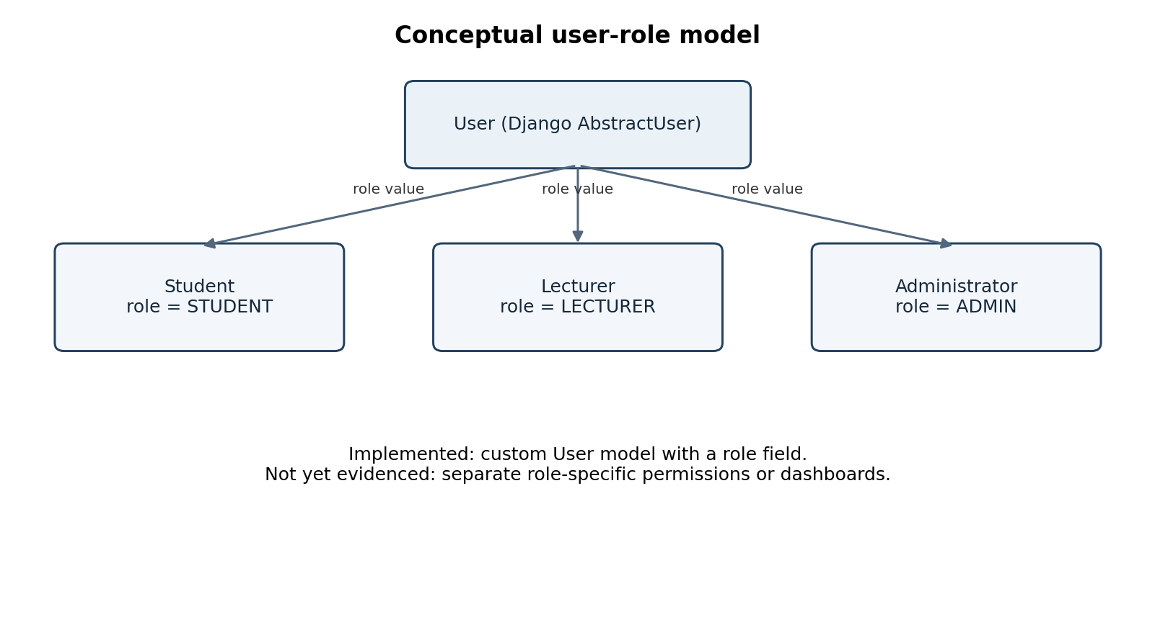
Figure 1. Conceptual role model derived from the custom Django User model. It shows role categories, not a complete use-case diagram.

9.4 Relevant UML relationships
The submitted documentation includes a UML component-diagram description. For implementation traceability, the key component relationships are: React UI → HTTP API → Django views and authentication → Django ORM → PostgreSQL. Planned services for QR verification, geolocation, attendance management, and reporting should be added as separate components when implemented.

10. Architecture and Technology Stack

10.1 Architecture and components
The intended architecture is layered and client-server based. The presentation layer handles the browser interface; the application layer enforces authentication and attendance rules; and the data layer persists users, sessions, and attendance records. This separation supports clarity and maintainability and makes individual components easier to test.
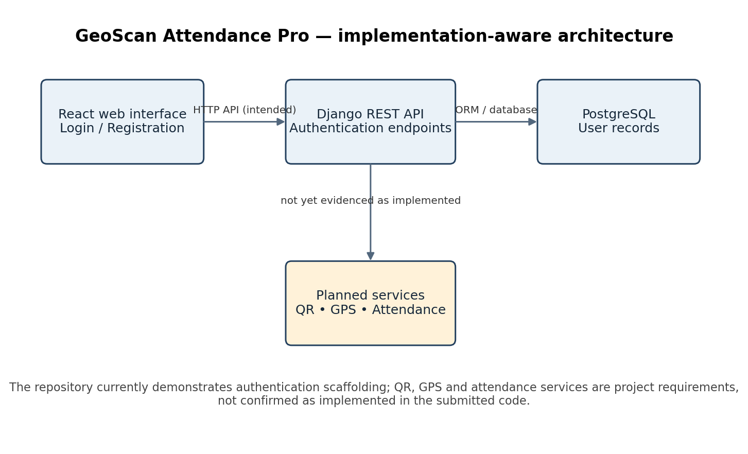
Figure 2. Architecture mapped to the submitted code. The QR, GPS and attendance services are planned components and are not represented as completed.
Component | Responsibility | Evidence / current position
React presentation layer | Render login and registration forms and manage interface state. | Implemented in src/App.jsx with CSS in src/App.css.
Django REST endpoints | Accept registration/login requests and return JSON responses. | Implemented in backend/users/views.py and users/urls.py.
Custom user model | Extend Django authentication user with a role field. | Implemented in backend/users/models.py.
PostgreSQL | Persist user and future attendance data. | Configured in backend/config/settings.py; successful live database operation was not verified from the source archive.
QR service | Generate and validate short-lived class-session codes. | Planned; no implementation verified in submitted source.
Geolocation service | Check that device coordinates fall within the authorised venue radius. | Planned; no implementation verified in submitted source.
Attendance service | Prevent duplicate check-ins and store session attendance. | Planned; no attendance model or endpoint verified in inspected backend files.
Reporting/analytics | Produce session and institution-level summaries. | Planned.

10.2 Technology stack and justification
Technology | Use | Justification and implementation note
React 19 | Frontend UI | Component-based UI and state management support a responsive, maintainable interface. Current code uses React state to switch between login and registration views.
Vite | Frontend development/build tooling | Provides a lightweight development server and production build pipeline.
HTML and CSS | Structure and styling | Defines form fields, layout, buttons, spacing, and basic visual hierarchy.
Python and Django | Backend application | Django provides user management, password hashing, authentication utilities, routing, and database ORM support.
Django REST Framework | JSON API | The backend views use API decorators and Response objects to provide HTTP API endpoints.
PostgreSQL | Relational data storage | Suitable for structured user, class-session, and attendance records with constraints and transactional operations.
Git / GitHub | Version control and collaboration | Supports shared code, change history, review, and task traceability.

Deployment: the project documentation mentions Heroku for development/staging and AWS for production. No deployment configuration or live deployment evidence was verified in the submitted files. Hosting should therefore be treated as a proposed option rather than a completed deployment.

11. Implementation

11.1 Frontend: login interface

Figure 3. Login interface representation reconstructed from the submitted React JSX and CSS. It is a source-based illustration, not a runtime screenshot.
The login view presents the product name, a role selector, username and password fields, a Login button, and a Register navigation button. React state controls whether the login or registration view is displayed. The current form prevents the browser's default submission and displays an alert; it does not call the Django login endpoint.

Business-logic snippet — current login submission
onSubmit={(event) => {
event.preventDefault();
alert("Login form submitted!");
}}
This snippet confirms that the current frontend demonstrates the interaction but not end-to-end authentication. The next implementation step is to validate inputs, send a POST request to the backend login endpoint, handle HTTP responses, and store authentication state securely.

11.2 Frontend: registration interface

Figure 4. Registration interface representation reconstructed from the submitted React JSX and CSS. It is a source-based illustration, not a runtime screenshot.
The registration view includes full name, username, email, role, and password fields, a Create Account button, and navigation back to login. The current form displays a confirmation alert only. It does not send the form data to the registration API, and the current input elements do not all have explicit required validation.

Business-logic snippet — view switching
const [showRegister, setShowRegister] = useState(false);
if (showRegister) {
return (/* registration view */);
}
// Otherwise render the login view.
The state variable determines which form is rendered. The Register button sets the state to true; Back to Login sets it to false. This is appropriate for a small prototype, although separate components would become easier to maintain as the interface grows.

11.3 Backend: custom user model
The Django User model extends AbstractUser and introduces a role field with three supported values. This reuses Django's existing authentication fields and password-handling mechanisms rather than creating a password system from scratch.
class User(AbstractUser):
class Role(models.TextChoices):
STUDENT = "STUDENT", "Student"
LECTURER = "LECTURER", "Lecturer"
ADMIN = "ADMIN", "Administrator"
role = models.CharField(
max_length=20,
choices=Role.choices,
default=Role.STUDENT,
)
The role field records the user's category, but a role value alone does not enforce role-based access. Permission checks and protected endpoints must be added before the system can safely provide different capabilities to students, lecturers, and administrators.

11.4 Backend: registration endpoint
The registration endpoint reads username and password from the request, checks that both are present, rejects an already-used username, creates the user through Django's create_user method, and returns a success response with HTTP 201. Django's create_user method hashes the password before storage.
if not username or not password:
return Response(
{'error': 'Username and password are required.'},
status=status.HTTP_400_BAD_REQUEST
)
if User.objects.filter(username=username).exists():
return Response(
{'error': 'Username already exists.'},
status=status.HTTP_400_BAD_REQUEST
)
user = User.objects.create_user(
username=username,
password=password,
first_name=first_name,
email=email,
role=role
)
Further hardening should validate the role against the allowed choices, validate email format and uniqueness where required, apply rate limiting, and ensure the endpoint cannot be abused to create administrator accounts. Registration should not trust a client-selected role for privileged accounts.

11.5 Backend: login endpoint
The login endpoint checks for missing credentials and uses Django's authenticate function. Invalid credentials return HTTP 401; successful authentication returns HTTP 200 with the username and role.
user = authenticate(username=username, password=password)
if user is None:
return Response(
{'error': 'Invalid username or password.'},
status=status.HTTP_401_UNAUTHORIZED
)
return Response({
'message': 'Login successful.',
'username': user.username,
'role': user.role
}, status=status.HTTP_200_OK)
The current endpoint does not issue a token or establish a documented persistent session for the React client. A production implementation should select and configure an authentication strategy, protect API routes, implement logout/session expiry, and avoid exposing sensitive data in responses.

11.6 QR generation, GPS validation and attendance
These features are central to the product vision and are documented in the requirements, but they were not found in the submitted frontend or backend source reviewed for this report. No code snippet is presented as if it were implemented. The recommended implementation sequence is:
- Create a class-session model with course, venue coordinates, allowed radius, start/end time, QR token hash, expiry time, and status.
- Generate cryptographically unpredictable session tokens and encode only the token or a signed payload in the QR code.
- Implement a scan/check-in API that verifies token validity, session status, server-side expiry, user authentication, and location radius.
- Use a geodesic distance calculation between the authorised venue coordinates and submitted device coordinates; reject missing or implausibly inaccurate readings according to documented rules.
- Create an Attendance model with foreign keys to user and session and a database uniqueness constraint on (user, session) to prevent duplicate check-ins.
- Return clear success and failure responses and record audit metadata without retaining precise location longer than necessary.
- Add tests for expired tokens, reused tokens, duplicate attendance, outside-radius locations, denied location permission, malformed requests, and concurrent requests.

11.7 Feature-to-requirement traceability
Requirement / objective | Source or module | Current evidence | Verification needed
Account registration | React App.jsx; Django users/views.py | Registration form and API endpoint exist but are not integrated. | POST valid/invalid data; duplicate username; password hashing; invalid role.
Login and role identification | React App.jsx; Django login_user; User model | Login UI and API exist; frontend currently uses alert only. | Valid/invalid login; API integration; role-based access tests.
Dynamic QR per session | Product vision and feature requirements | No implementation verified. | Unique token, expiry, replay and tampering tests.
GPS venue restriction | Requirements mapping | No implementation verified. | Inside/outside radius, permission denied, accuracy and spoofing tests.
Attendance logged once | Requirements mapping | No attendance model/endpoint verified. | Database uniqueness and concurrent duplicate check-in tests.
Lecturer monitoring and reports | Feature list/user stories | No implementation verified. | Session record query, totals, export and access control tests.
Maintainable collaborative delivery | Agile plan and Git repository | Project documentation and version-control repository exist. | Use pull-request review, issue links, test evidence and release notes.

12. Challenges During the Project Lifecycle
Challenge | Impact | Resolution / action
Frontend/backend integration delays | The interface and API can exist separately without a complete user workflow. | Define API contracts early, integrate one endpoint at a time, and test using sample requests before connecting the UI.
GPS accuracy variation | A legitimate student may be incorrectly rejected, or an imprecise reading may weaken validation. | Use a configurable radius, inspect reported accuracy, allow a short retry window, test indoors at different venues, and consider Wi-Fi/beacon support where appropriate.
QR sharing or replay risk | A static or reusable code could allow proxy attendance. | Use short-lived session tokens, server-side expiry, one-time or session-bound validation, and duplicate prevention at the database level.
Scope and time constraints | The requirements include more features than the submitted code currently demonstrates. | Prioritise authentication integration, then a vertical slice of QR + GPS + attendance before analytics and optional features.
Inconsistent role assignments across project documents | Unclear ownership can cause duplicated or missed work. | Maintain one team roster and role register and update it whenever responsibilities change.
Configuration and deployment risk | Development settings may be unsafe or incomplete for production. | Move secrets to environment variables, disable DEBUG, configure allowed hosts, enforce HTTPS, and document database/deployment setup.

12.1 Resolutions recorded in the project retrospective
The Sprint 1 retrospective recommends improving location handling, dividing tasks into smaller units, starting integration testing earlier, and scheduling mid-sprint check-ins. These actions are appropriate and should be converted into assigned backlog items with owners, due dates, and acceptance criteria.

13. Limitations of the Implemented System in Relation to the Objectives
- The current frontend is a login/registration prototype; form submissions display alerts and do not call the backend.
- The backend has registration and login endpoints, but frontend-to-backend integration is not demonstrated.
- The login endpoint returns a response but does not implement a complete client authentication lifecycle or documented token/session handling.
- The user model records a role, but role-based authorisation and separate role dashboards are not implemented in the inspected source.
- QR generation, QR scanning, token expiry, GPS verification, attendance records, duplicate prevention, reporting, and notifications are not evidenced in the submitted implementation.
- PostgreSQL is configured in Django settings, but the archive alone does not establish that migrations have been applied or that the application runs successfully against a live database.
- The Django settings include DEBUG enabled, an insecure development secret key, and an empty ALLOWED_HOSTS list. These are development settings and must not be used as-is in production.
- The UI illustrations in this report are reconstructed from the submitted JSX/CSS; actual runtime screenshots were not included in the uploaded files.
- Automated test coverage and measured performance results were not available in the inspected source snapshot.

14. Recommendations
- Connect the React forms to the existing Django REST endpoints and handle loading, success, validation, and server-error states.
- Introduce a documented API contract with request schemas, response examples, status codes, and authentication requirements.
- Implement server-enforced permissions for each role. Do not rely on the role selector in the frontend to authorise privileged actions.
- Complete the attendance data model before implementing reporting. Enforce uniqueness for each user/session pair at database level.
- Implement QR expiry and location validation on the server; client-side checks alone are not trustworthy.
- Add automated tests for models, API endpoints, permissions, QR expiry, geolocation boundaries, duplicate requests, and error handling.
- Secure configuration: load SECRET_KEY and database credentials from environment variables, disable DEBUG in production, configure ALLOWED_HOSTS, use HTTPS, and apply Django's deployment checklist.
- Add input validation and rate limiting to authentication endpoints; review whether self-registration should allow users to select their own role.
- Record each requirement against a code location and test case so reviewers can trace what has been delivered.
- Use consistent naming in documents, particularly the team member referenced as Ntombikayise/Kayise.

15. Future Work
- Implement class, course, venue, and session management.
- Build dynamic QR generation and a mobile-friendly QR scanner.
- Add geolocation permission handling, distance calculation, accuracy thresholds, and anti-spoofing risk controls.
- Persist attendance with transaction-safe duplicate prevention and an auditable event history.
- Create student attendance history and lecturer live session monitoring.
- Build administrator analytics and exportable CSV/PDF reports.
- Add notifications and missed-class summaries after core attendance logic is reliable.
- Evaluate offline or intermittent-connectivity handling with safe delayed synchronisation.
- Conduct usability testing with students and lecturers and measure check-in time, rejection rates, and false acceptance/rejection rates.
- Deploy to a controlled staging environment, configure monitoring and backups, and complete security review before production use.

16. Conclusion
GeoScan Attendance Pro proposes a relevant solution to weaknesses in manual attendance management by combining session-specific QR codes with location verification. The project documentation establishes the product vision, user groups, feature requirements, Scrum approach, and a layered client-server architecture. The submitted source provides an initial React login/registration interface and a Django user-management foundation with role values and registration/login endpoints.
The current repository should be regarded as an early prototype rather than a complete attendance system. The most important next milestone is to integrate the frontend with the API, establish secure authentication and role-based permissions, and then deliver one complete attendance workflow from session creation through QR validation, GPS checking, duplicate prevention, and stored attendance. Consistent testing and requirement-to-code traceability will help the team demonstrate that the final system meets its stated objectives.

17. References
- GeoScan Attendance Pro project repository. README.md and source files: frontend/src/App.jsx; frontend/src/App.css; backend/users/models.py; backend/users/views.py; backend/users/urls.py; backend/config/settings.py. Submitted project archive, accessed 12 October 2026.
- GeoScan Attendance Pro project documentation. product_vision.md; software_management_plan.md; docs/agile/agile_plan.md; docs/agile/retrospective.md; docs/features/features_list.md; docs/features/user_stories.md; docs/features/requirements_mapping.md; docs/architecture/architecture_overview.md; docs/architecture/tech_stack.md; docs/architecture/system_decomposition.md. Submitted project archive, accessed 12 October 2026.
- Django Software Foundation. Django documentation: User authentication and custom user models. https://docs.djangoproject.com/
- Django REST framework. API views and responses documentation. https://www.django-rest-framework.org/
- React. React documentation. https://react.dev/
- PostgreSQL Global Development Group. PostgreSQL documentation. https://www.postgresql.org/docs/
- Schwaber, K. and Sutherland, J. The Scrum Guide. https://scrumguides.org/

