Application Paper

**VaxTrax - Vaccine Tracking Web App for Healthcare Providers**

Pearle Shah1, Rahul Barla1, Anusha Shinde1

1 School of Biomedical Engineering, Drexel University, USA

Course: Bmes550 Advanced Bio-computational Languages

Instructor: Ahmet Sacan

Date: 2022-12-05

**ABSTRACT**

Keeping track of personal medical information can be difficult for the average patient, especially if this involves changes in healthcare providers for the patient or different immunization locations for vaccines.This can be more burdensome for vaccine records because the patient may not recall their entire specific vaccine history, which makes it harder for the healthcare professional to have fully accurate information, creating a gap between healthcare providers and patients. The goal of our project is to mitigate this process. Our web application, VaxTrax, allows a healthcare provider to enter information for a specific patient. The information entered will pertain to a vaccine that a patient will be receiving, which includes the location and date of administration, vaccine's lot number and name, vaccine expiration date, and the vaccine administrator's name - which will be stored in a database. The database will also enable a doctor to view information about a patient's previous vaccine history by filtering the database via the patient's name (will populate a table that shows the vaccine history for the patient). All in all, VaxTrax will allow for an easy way to keep track and update patient immunization records.

**1 INTRODUCTION**

Oftentimes there is a disconnect between patients and their doctors, especially after changes in healthcare providers and hospitals. Patients are asked to provide their information every time they switch locations and this can be exhausting for the patient and can make monitoring the patient’s needs harder for the doctor.

This is particularly inconvenient for vaccine records as the patient may not fully remember their vaccine history which includes information such as vaccine dose, date of each dose, lot number, etc. Errors in medical records are very common and can result in significant harm. In a recent study with 22,889 participants, researchers found that more than 21% of the patients’ records reported errors and 42.3% of those errors proved to be serious [1]. This is why it is important for medical professionals to ensure records are maintained accurately since these errors can lead to worse problems down the line.

**Goals:**

Our goal is to bridge the gap between various healthcare providers and patients by having a way to track the vaccine records of patients, especially so that healthcare providers and doctors have access to a universal healthcare database system updated with a patient's vaccine history to avoid confusion with whether or not a patient has received a particular vaccine or not. VaxTrax, which was created using the web environment (HTML, CSS, SQL, and PHP, allows a healthcare provider to log in to a database and enter information for a specific patient. The information that is entered will pertain to the vaccine that the patient will be receiving - the location administration, date, vaccine's lot number, and name, the reason for vaccination, and the vaccine administrator's name - will be stored in a database. The database will also enable a doctor to view information about a patient's previous vaccine history by filtering the database via the patient's name (will populate a table that shows the vaccine history for the patient).

**Related Work:**

The CDC has a Vaccine Tracking System (VTrckS) [3] which is a web-based information technology system that incorporates the publicly-funded vaccine supply chain, from purchasing and ordering to distribution to participating state, local, and territorial health departments and health care providers. The Inca clinic [4] also has a complete patient vaccine tracking and management application that runs on the internet. It focuses on vaccine scheduling, online bookings, complete health questionnaires, managing stocks, prescribing medication and more. Most hospitals also have their own internal programs for medical record keeping, but our solution not only keeps vaccine information organized, it makes it available across healthcare providers by being a universal tool.

**2 DATASET**

The data we used in this study to help develop the webpage were pulled from various sources. All the vaccinations that are required for pediatric patients up until the age of eighteen years old came from the CDC as they had a list of what age and when the vaccine needs to be administered [2]. The rest of the data for our website is inputted by the user (healthcare professionals) which is stored in a database that the code automatically creates for each patient. The database stores critical vaccine information for each patient in table format which can then be called upon when the healthcare worker looks up the patient’s first and last name along with their date of birth. The database is also used to display a pie chart based on gender percentages for each available vaccine in the system.

**3 METHODS AND IMPLEMENTATION**

Our website allows healthcare professionals to input patient and vaccine information into a database, look up stored vaccine history information by inputting patient information (first name, last name, and date of birth), and display male vs. female percentage pie charts for each specific vaccine. Our program uses the web interface which includes SQL, HTML, CSS, and PHP.

The CSS (styles.css) page encompasses all of the general styling needed throughout the webpages. It is the main file that helps to maintain the consistent look of the application as a user navigates through the webpages.

Our code works by starting with the index (home) page made in PHP, prompting the user to fill out a form with the patient's first name, last name, and date of birth. The form will not allow the user to continue or submit the form until all fields are filled in. Once the user successfully fills in all fields and clicks submit, the page will take the user to the vaxhistory page which is also made in PHP.

The vaxhistory page displays all prevalent vaccine history information such as address, vaccine type, date administered, etc. If there are no records for a particular patient an error message will pop up notifying the user that there is no data in the database. All data from the database is pulled from the init script which is written in PHP. The init script is what is used to create a connection between the SQL database and our webpage. This script also contains some functions for the vaccine history to be displayed in table format in conjunction with the vaxhistory.php script. Further information regarding the schema of the database in SQL can be found in Figure 1 below.

Next, the add record page (also made with PHP) is a form that has all the necessary information a healthcare worker would need to input when the patient is getting a vaccine administered, if all fields are not filled in, the page will prompt the user to fill in the missing sections. The code will ensure that no duplicate data will be added to the database. Once all data is filled in and the user clicks submit, a message in green text will inform the user of a successful addition to the database.

Finally, the statistics page asks the user to submit a vaccine type which then obtains a pie chart of the percentage of males vs females who have received a particular vaccine from the database. If no patient has ever gotten the vaccine, an error message will pop up accordingly.

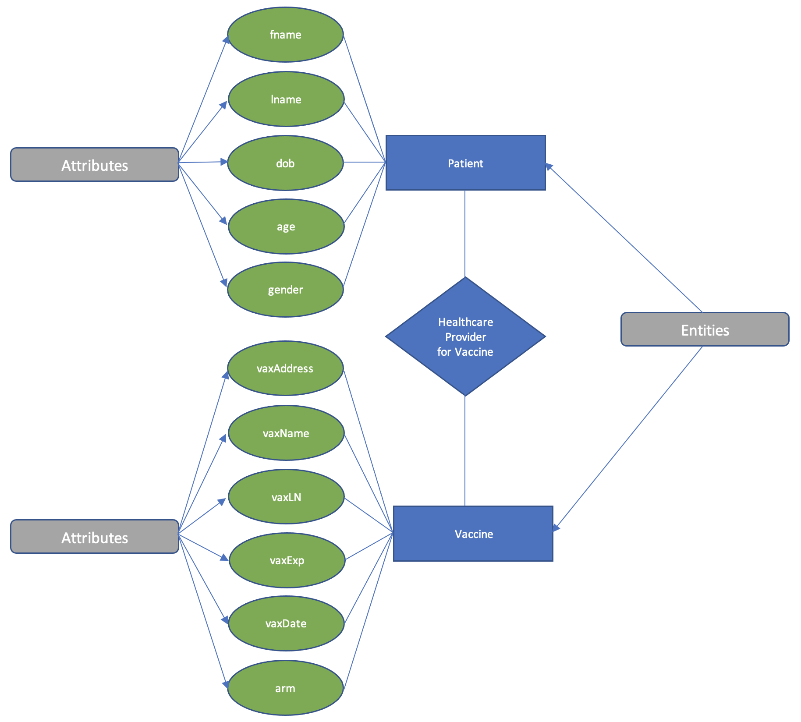

***Figure 1: ER Diagram.*** This diagram discusses the general database schema for the SQL database (vaccinerecordsdb.sqlite). The two major entities involved in this are the patients and the vaccines, which are connected via a healthcare provider for the vaccine (who would be an example user of VaxTrax). The major attributes for both the patient and vaccine are listed in the green ovals in this figure, which cover the major pieces of information needed to update the database table with the immunization record.

**4 EXPERIMENTS AND RESULTS**

The software design that we have produced has various use cases that help healthcare workers in having a better understanding of which vaccines the patient has already received or which vaccines are needed in the future.

***Figure 2: Snapshot of Index Page.*** Prompts the healthcare professionals to input the patient’s first and last name as well as their date of birth.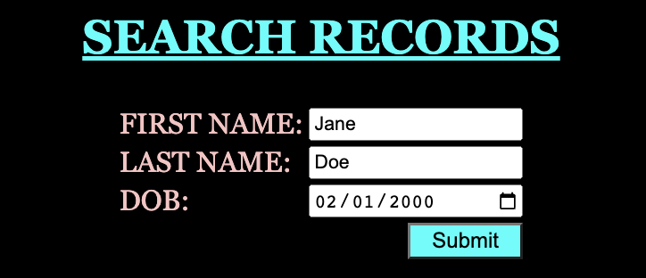

When initially opening our web design, the nurse or doctor treating the patient will be asked to input three parameters: firstname, lastname, and date of birth. This is to ensure that those with the same names can have a unique differentiator which would be their date of birth. Once the user fills out the needed information and clicks submit on the index page, it redirects them to the Vaccine Record page.

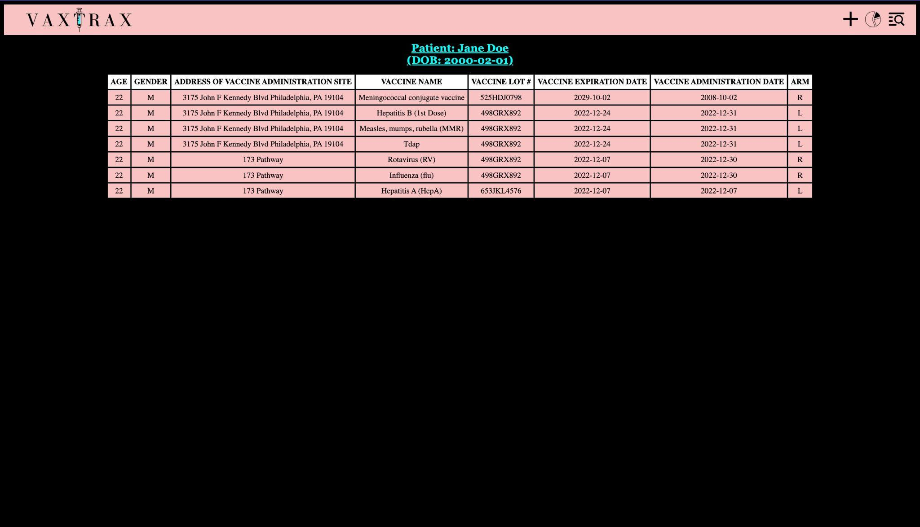

***Figure 3: Snapshot of the Patient Vaccine Record Table.*** The Vaccine Record page displays the patient’s information along with past and present administered vaccine information.

This page is designed for the user to quickly check their patient’s immunization records and any crucial information that is needed for all vaccines up until 18 years of age. The main goal of this page is for healthcare providers to universally access and update patient records securely when a patient receives an immunization. This allows doctors to alert the patient of any missed vaccines in the past or help the patient schedule future vaccines that are needed. This page can also be essential for diagnostic purposes. For example, when a patient comes in with symptoms of a certain disease, the doctor can quickly cross-check the page to see if the patient has gotten the vaccine for the disease.

***Figure 4: Snapshot of Patient/Vaccine Entry Input Information Page.*** The Patient/Vaccine Entry page prompts healthcare professionals to enter the information of the current vaccine that is being administered for the patient. 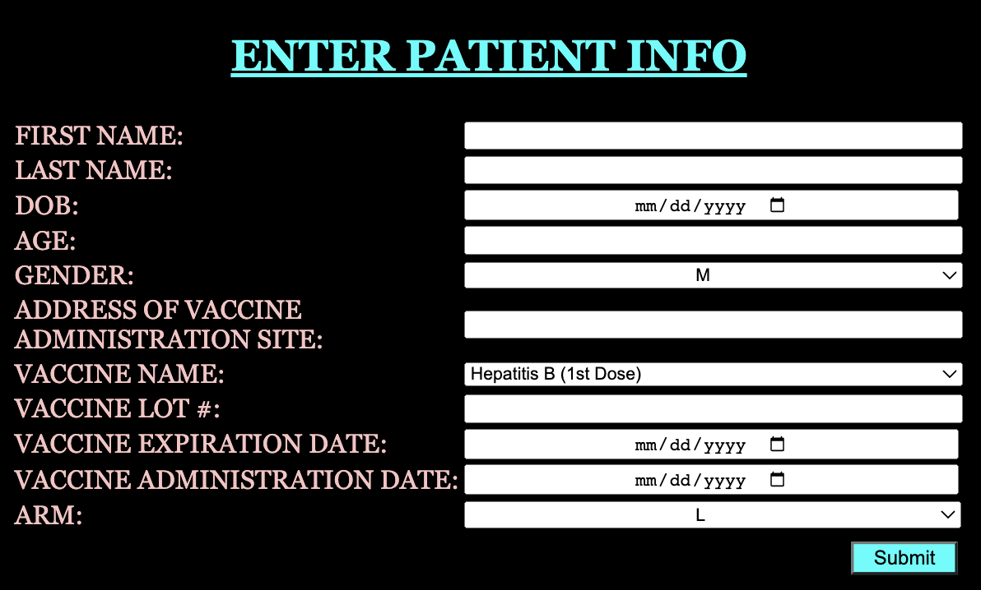

Once a patient comes into the clinic to get a vaccine/immunization, the healthcare worker will be prompted to enter these parameters into the database. Once the worker enters all the information pertinent to the vaccine information is then stored in a database where all other vaccines that the patient has gotten are stored. This allows the patient and their doctors to have universal access to the patient’s vaccine records at all times.

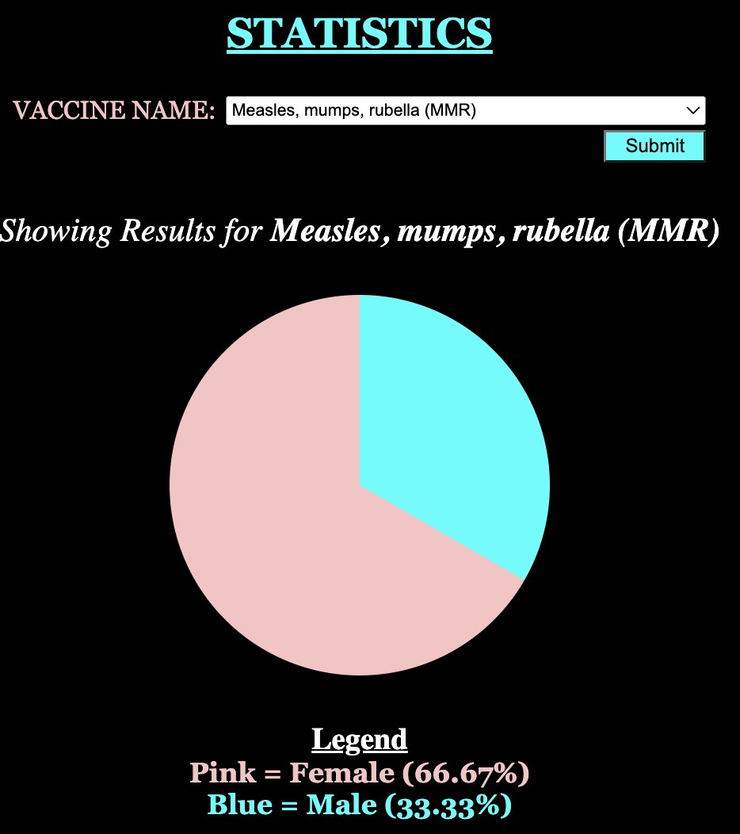

***Figure 5: Snapshot of Statistic Page.***

The Statistics page allows healthcare professionals to understand the male vs female ratios for each vaccine, allowing healthcare professionals to guide research and answer questions regarding vaccines and gender.

Doctors and nurses can get a better understanding of which populations, in general, are not getting their vaccinations administered within the given timeframe of eighteen years. Inherently, certain vaccines will be more male-dominanted and others will be more female-dominated, but it will give a brief overview of the insightful proportions.

**5 DISCUSSION**

Our web application, VaxTrax, has three main interactive sections which include the index page, the vaccine record page, the add-record page, and the statistics page. Our index page searches the records where the healthcare worker will input a patient’s first name, last name, and date of birth, which then takes the healthcare provider to the vaccine record page. The vaccine record page displays all the necessary information needed for an administered vaccine (vaccine name, address, lot#, expiration date, which arm, and the administered date) in table format. This allows doctors and nurses to understand which vaccines the patient has gotten and will need in the future. Next, is the add-record page where the healthcare provider is prompted to add vital information of the vaccine that is being administered to the patient which is all stored in a database for healthcare workers to be able to access at any given time. Finally, we have a statistics page that displays a pie chart comparing the percentage of males vs females of each vaccine that is required until the age of eighteen years. This helps doctors analyze gender-based statistics for each vaccine.

Existing limitations to our webpage include the fact that there are only three main unique patient identifiers (first name, last name, and date of birth). This is an issue if two patients have identical values for all three because the database would have issues extracting the correct data records for both patients leading to HIPAA and data privacy violations. A solution for this limitation would be to provide each patient with a unique ID/QR code that would be completely personalized for that certain patient so when the ID/QR code is inputted, the database will only output that patient’s vaccine records. Future work and improvements can include expanding the webpage to include a patient interface as well. This feature would be programmed around the patient’s needs and would notify patients when they are due for a vaccine or if they have missed a vaccine that is required in addition to many other things. Additionally, a feature that would improve the webpage is implementing a way for the patient to book an appointment directly through the web page for upcoming vaccines.

**6 REFERENCES**

[1] Lawn, Raynes &. “Errors in Medical Records Leading to Medical Malpractice.” *Raynes & Lawn Trial Lawyers*, 26 Sept. 2022, <https://rayneslaw.com/errors-in-medical-records-leading-to-medical-malpractice/>

[2“Recommended Vaccines by Age.” *Centers for Disease Control and Prevention*, Centers for Disease Control and Prevention, 22 Nov. 2016, <https://www.cdc.gov/vaccines/vpd/vaccines-age.html>

[3]“VTrckS: Vaccine Tracking System.” *Centers for Disease Control and Prevention*, Centers for Disease Control and Prevention, 16 May 2022, <https://www.cdc.gov/vaccines/programs/vtrcks/index.html>

[4]“Pharmacy Store J.A. Hogarth Uses Inca Clinic to Accelerate Growth.” *Inca Clinic*, 16 Sept. 2014, <http://www.incaclinic.com/tag/vaccination-software/>