**VaxTrax**

*A Vaccine Tracker Web App for Patients up to 18 Years Old*

*BMES 550: Final Project Design*

Pearle Shah, Anusha Shinde, Rahul Barla

**OVERVIEW OF MAIN WEB PAGES**

**Script: index.php (Primary Author: Pearle)**

* This script (Entry Point) will include a form element that allows a user to interact with our webpage and input a patient’s first and last name, along with their DOB (inputs). The patient will be matched to the appropriate vaccine record based on their first name, last name, and DOB. Once the user hits submit, they will be directed to the next page that shows the vaccine history of a patient (output).

**Script: vaxhistory.php (Primary Author: Pearle)**

* This script will map the searched patient (based on their first name, last name, and DOB inputs from the form’s submission from index.php) and populate a table (output) that shows all of the patient’s vaccine record history. This includes the vaccine name, lot #, vaccine expiration, arm of injection, and address of administration site for each vaccine that is in the patient’s records.

**Script: statistics.php (Primary Author: Anusha)**

* This script will allow the user to select a vaccine based on a dropdown menu (input) and submit it through a form. Based on the vaccine name, a pie chart will populate (output) to show how many vaccines females have taken versus males (as percentages) for the selected vaccine.

**Script: addrecord.php (Primary Author: Rahul)**

* This script will allow the user to enter relevant patient information and vaccine information (as seen in the figure to the right which are the inputs) when a new vaccine is being administered to someone. Once the user submits this form, the data will populate into a database that updates the patient’s vaccine records with the newly administered vaccine that they just received (output).

**OVERVIEW OF INPUT TYPES FOR FORMS ON WEBPAGES**

FIRST NAME: “text”

LAST NAME: “text”

DOB: “date”

VACCINE NAME: “select option” (dropdown menu displaying various vaccine names up to age 18)

FIRST NAME: “text”

LAST NAME: “text”

DOB: “date”

GENDER: “select option” (dropdown of f or m)

ADDRESS OF VACCINE ADMINISTRATION SITE: “text”

VACCINE NAME: “select option” (dropdown menu displaying various vaccine names up to age 18)

VACCINE LOT #: “text”

VACCINE EXPIRATION DATE: “date”

ARM: “select option” (dropdown of l or r)

**s**

**INTERACTING WITH ICONS ON TOP BAR OF WEB PAGES**

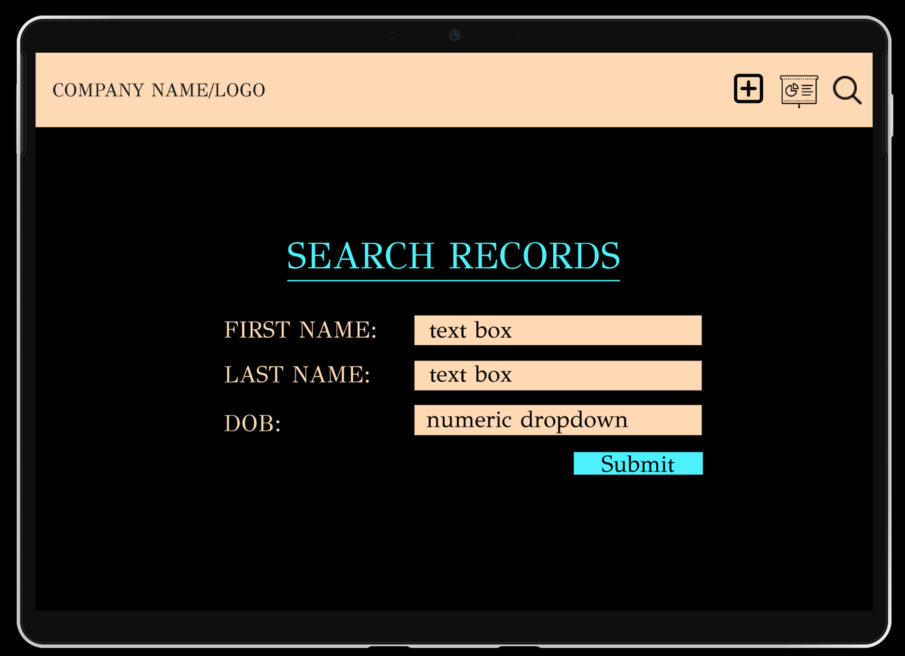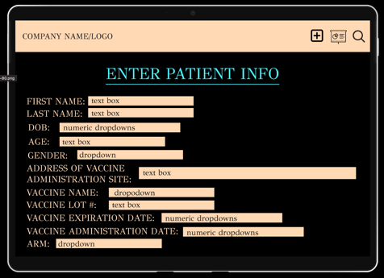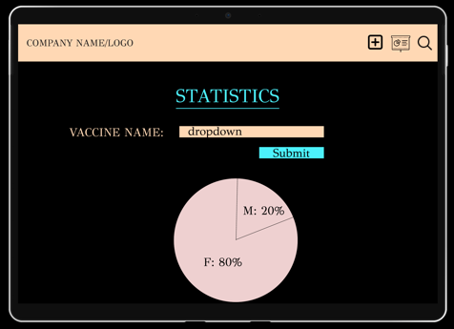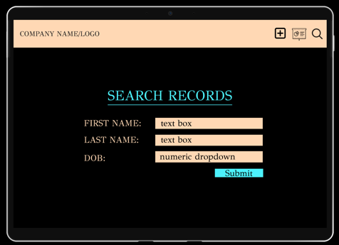

This will allow the user to easily go back to the web page to input new patient data to the database. This will link back to the addrecord.php script.

Add Patient Info Button

Search Records Button

This will allow the user to easily go to the web page that populates a pie chart/statistics based on a vaccine name. This will link back to the statistics.php script.

This will allow the user to easily go to the web page to search patient records. This will link back to the index.php script.

Populate Statistics Button

**DATABASE SCHEMA**

**Database: vaccinerecords.db**

**Table: patientrecords**

*\* gender will have the data type varchar with a length of 1 to decipher male (m) from female (f) with a single letter*

*\* arm will have the data type varchar with a length of 1 to decipher the left (l) and right (r) arms with a single letter*

This database and table will be used to retrieve information about the patient and his/her respective vaccine record history based on the patient’s first name, last name, and DOB (DOB will be unique if there are two patients with the same first and last name to help decipher patients from one another in the database).

This will help with searching patient records and outputting a table of vaccine history, creating a statistical graph (pie chart), and inputting new vaccine information for patients (as described in the scripts’ descriptions earlier in this document)

This database will be created with a script in MATLAB (createdb.m) with an SQL query.

**ADDITIONAL FILES**

**\*** *A CSS file will also be created to maintain the consistency of our web app as the user navigates through different web pages while interacting with the application (linked to our scripts)*

*\* A README file will also be provided to discuss any assumptions or information needed in the development of this web application.*