**TECHNICAL PROJECT REPORT**

# ***Title of Invention/Project:-***

***CLAP SWITCH HOME AUTOMATION PROJECT***

# ***Team Members / Inventors***:-

|  |  |  |  |  |  |
| --- | --- | --- | --- | --- | --- |
| **S. No.** | **Name** | **Department** | **Designation** | **Mobile** | **E-Mail** |
| ***1.*** | ***PEARL YADAV*** | ***CSE(IOT)*** | STUDENT | ***7976107971*** | ***yadavpearl2001@gmail.com*** |
| ***2.*** | ***MANSI*** | ***CSE(IOT)*** | STUDENT | ***6239971140*** | ***mansi143c@gmail.com*** |
| ***3.*** | ***HARSHITA SAXENA*** | ***CSE(IOT)*** | STUDENT | ***6284012455*** | ***harshitasaxenafeb05@gmail.com*** |
| ***4.*** | ***KHUSHAL THAKUR*** | ***ECE*** | MENTOR | ***9646030764*** | ***khushal.thakur@cumail.in*** |
| ***5.*** | ***ANSHUL SHARMA*** | ***ECE*** | MENTOR | ***9478697475*** | ***anshulsharma.ece@cumail.in*** |
| ***6.*** | ***KIRAN JOT SINGH*** | ***ECE*** | MENTOR | ***9463909689*** | ***kiranjotsingh.ece@cumal.in*** |
| ***7.*** | ***DIVNEET SINGH KAPOOR*** | ***ECE*** | MENTOR | ***9878422653*** | [***divneet.ece@cumail.in***](mailto:divneet.ece@cumail.in) |

Section – 1

* ***Problem your project is solving***

***We usually have to get to the switch board to turn on/off the electrical appliances. A clap switch allows us to control most of the electronics of our home from a large distance also.***

* ***How are you solving that (solution)?***

***Most of the time we have a hectic schedule and we usually don’t turn off the appliances and in such a hurry we usually takes some time to also find the switch boards, so this will not only cut-off your electricity bills but you can just clap from anywhere in the house to turn on/off your appliances. This is a one-time investment and a smart solution to high Bills. Home Automation is all about the management of your home and daily life. You can control lights, turning off the appliances when not in use.***

* ***Additional modifications that can cater to improved solution***

***Now, as we have connected the condenser mic to the circuit and it works when you clap as it only works on the sound having same pitch as input. It can be any sound having same pitch as the sound of a clap. We can use this as a remote controller after some modifications. We can increase its range by using a better mic***

# ***Existing state-of-the-art and Drawbacks in existing state-of-the-art:-***

|  |  |  |
| --- | --- | --- |
| ***S. No.*** | ***Existing state of art*** | ***Drawbacks in existing state of art*** |
| ***1.*** | ***Clap-Switch (On/Off)*** | ***We have to clap again to turn off the switch.*** |

# ***PATENT INFORMATION EXTRACTED:-***

***This product was patented by*** ***Carlile R. Stevens,*****Dale E. Reamer *haviing the patent number* US5493618A.**

**For more reference :** [*https://patents.google*](https://patents.google.com/patent/US5493618A/en)*.com/patent/US5493618A/en*

# ***Novel/Additional modifications that you can propose to improve upon drawbacks:-***

* ***Feature 1:***

***So we can increase or decrease the time after which we want to turn off the switch. It basically depends upon the need where you are placing the circuit.***

* ***Feature 2:***

***So here a condenser mic is used. It can be of greater use when it will be having a greater range and that is only possible when we are having a good quality mic***

* ***Feature 3:***

***We can modify the circuit and can use any component such as a fan or a door (using a relay) for more comfort.***

# ***Advantages:-***

***1) Convenience: Iot devices can be very helpful. As we know, it is easier to clap rather than to stand and walk to the switch board.***

***2) Save Money:  This is the biggest advantage of home automation.  With the ability to control the appliances, turning on/off on specific time will saves the owner a great amount of money.***

***3) Easy to use: The ability to control everything with your fingertips is very convenient.  You never leave the house without your wallet, keys and your smart phone.  With our smart phone always with us, we can easily monitor our home and control everything with just touch of a finger.***

***4) Saves Time: Since we all are having a hectic scheduled life, we don’t even have time to worry about our home. With home automation, we can save time going back to our home and make sure everything is order, like if the kids close the door from school or turn on the lights when you get home.***

***5) Cheaper Product : By using 555 Timer IC instead of Arduino, we have saved a lot in production cost hence results in Reduction of Total Cost and we have used soldering machine and paper PCB rather than breadboard to minimalize the cost.***

# ***Block Diagram:***

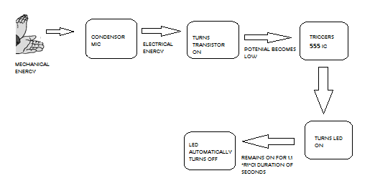

Section – 2

***MATERIALS:-***

* ***555 Timer IC – 1.***
* ***Transistor BC547 - 1***
* ***Condenser Mic - 1***
* ***Battery (5-9V) - 1***
* ***Printed Circuit Board (Paper PCB) - 1***
* ***Capacitor (10µF) - 1***
* ***RESISTORS (220Ω, 1KΩ, 47KΩ, 100KΩ) – 1(for each)***
* ***LED.***

***CIRCUIT DIAGRAM:-***

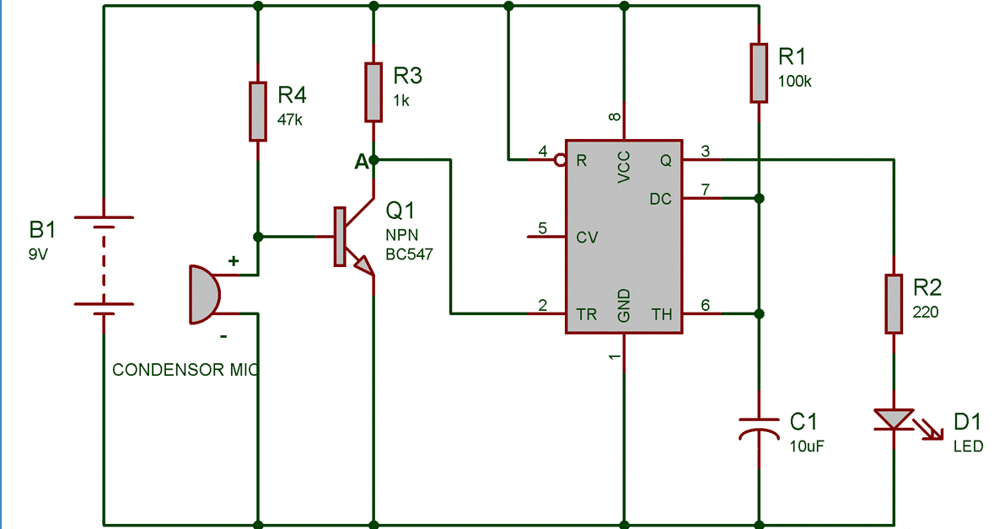

***STEPS OF CIRCUIT COMPLETION:-***

1. Firstly, we connected 4 resistors and a 555 Timer IC Parallel to a 9V battery.
2. After that we Connected Condenser Mic, Transistor and Capacitor in series with the 47K***Ω***, 1K***Ω***, 100K***Ω*** Resistors respectively.
3. Then we connected 220 Resistor and an LED in parallel to the capacitor and in series with the IC.
4. Then we soldered all the components and assembled them in a proper way.
5. ***PROGRAM CODE: -*** Link to file:

*https://github.com/pearlyadav/Clap-Switch-Home-Automation*

***Images***

