**I. Pen-and-paper**

1. 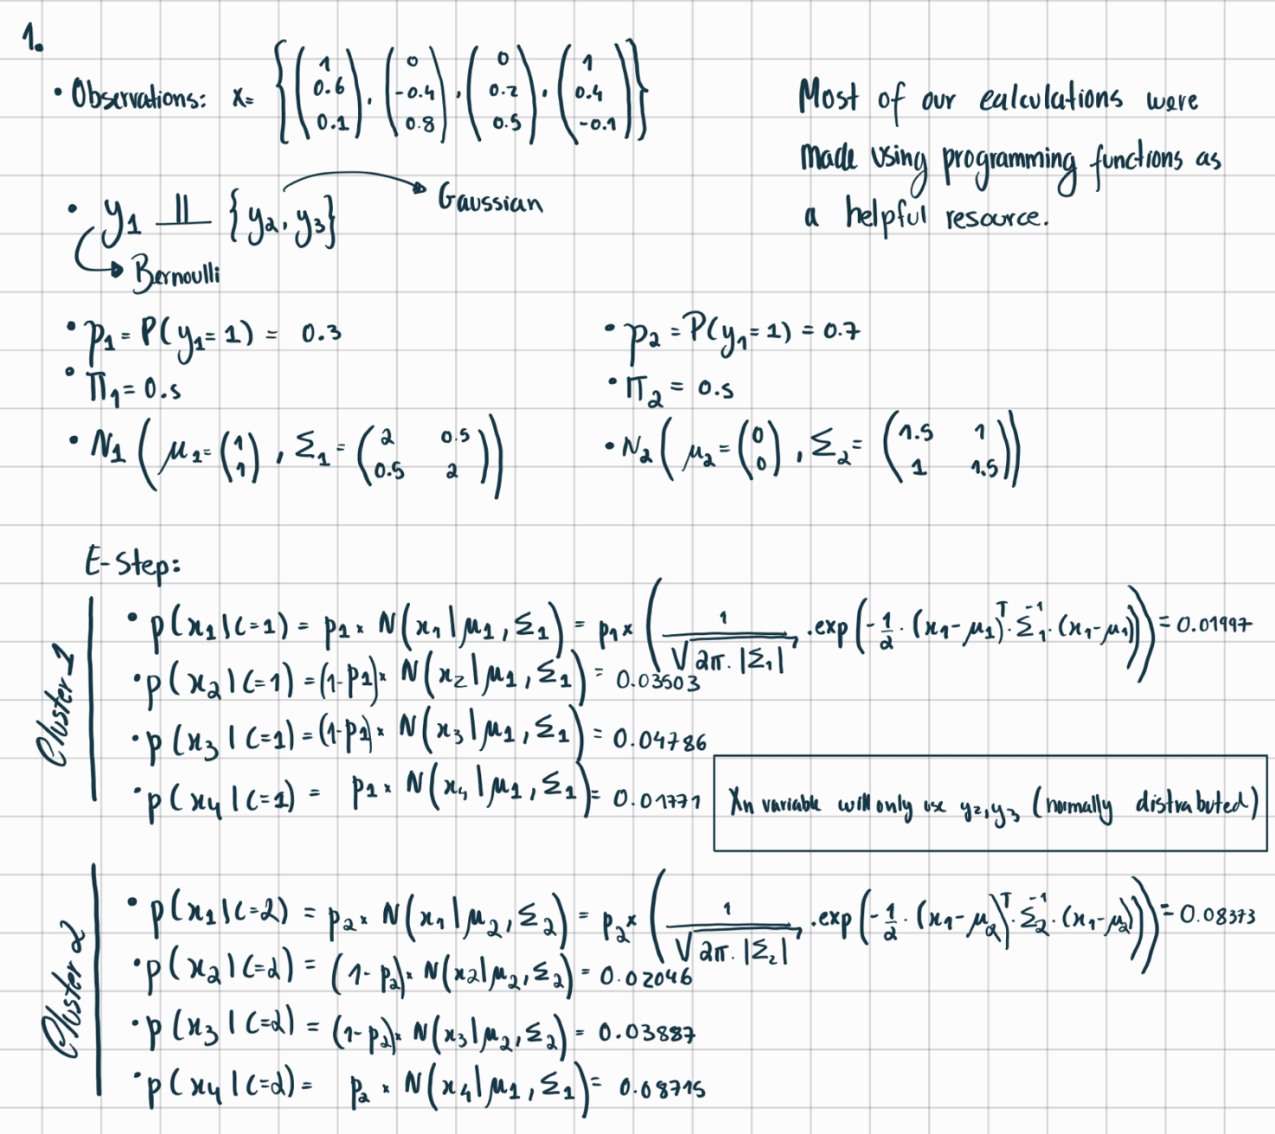

**II. Programming and critical analysis**

1)

2)

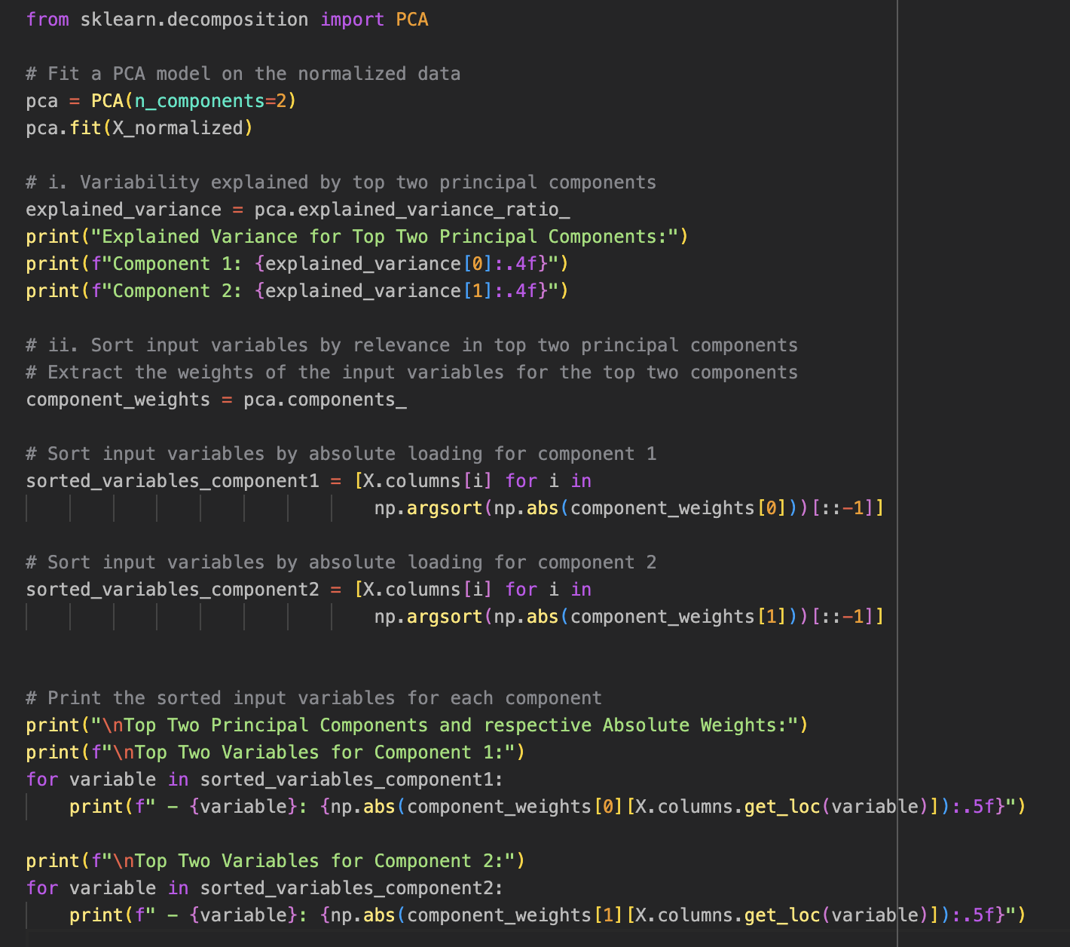

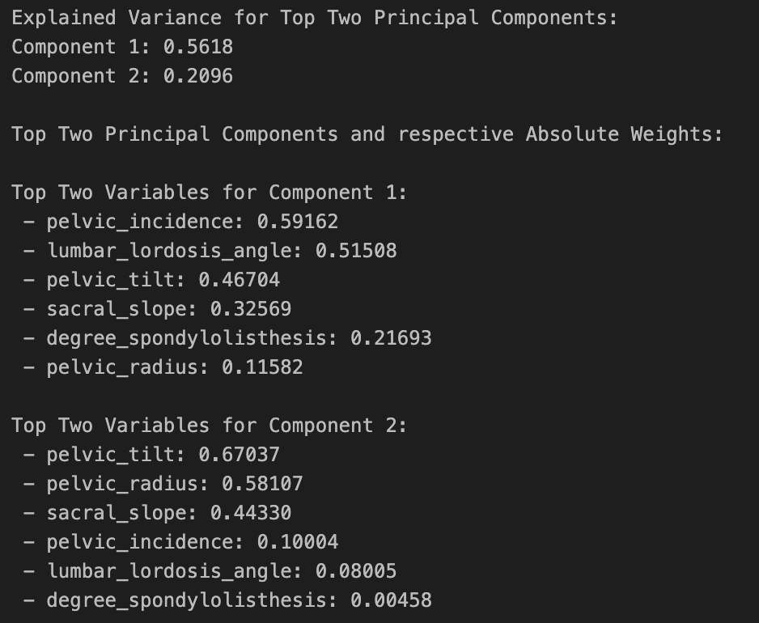

3)

4)

**END**