Mazeygamey

In this game you are tasked with escaping a maze with twists and turns with many dead ends. to add tension there is also a guard chasing you throughout the maze looking to track you down. the game contains two mazes one of which can only be accessed once the first level has been cleared. when the player clears a level they get a point. the objective of the game is to obtain as many points as possible before losing all three lives.

# MENU

When the game starts the player will be brought to the main screen, from here the player will be given the option of changing the difficulty Via the track bar and starting the game.

# DIFFICULTY

The trackbar determines the difficulty of the game. the difficulty of the game is defined as the distance between the player and the guard the guard has to be to enter smart mode.

# CONTROLS

Mazeygamey has basic movement controls using the W, A, S, D Keys to move the player character.

↑W

←A ↓S →D Fig.1 Player Controls. C:\Users\Pearse\Desktop\28th\MazeGame\MazeGame\Resources\PlayerUp.pngFig.2 Player Character

Using these controls you will navigate through the maze moving around walls and the guard to make it to the finish.

# SPECIAL SQUARES.

there is a goal at the end of each level that will add a point and will take you to the next level. the finish point is shown below.

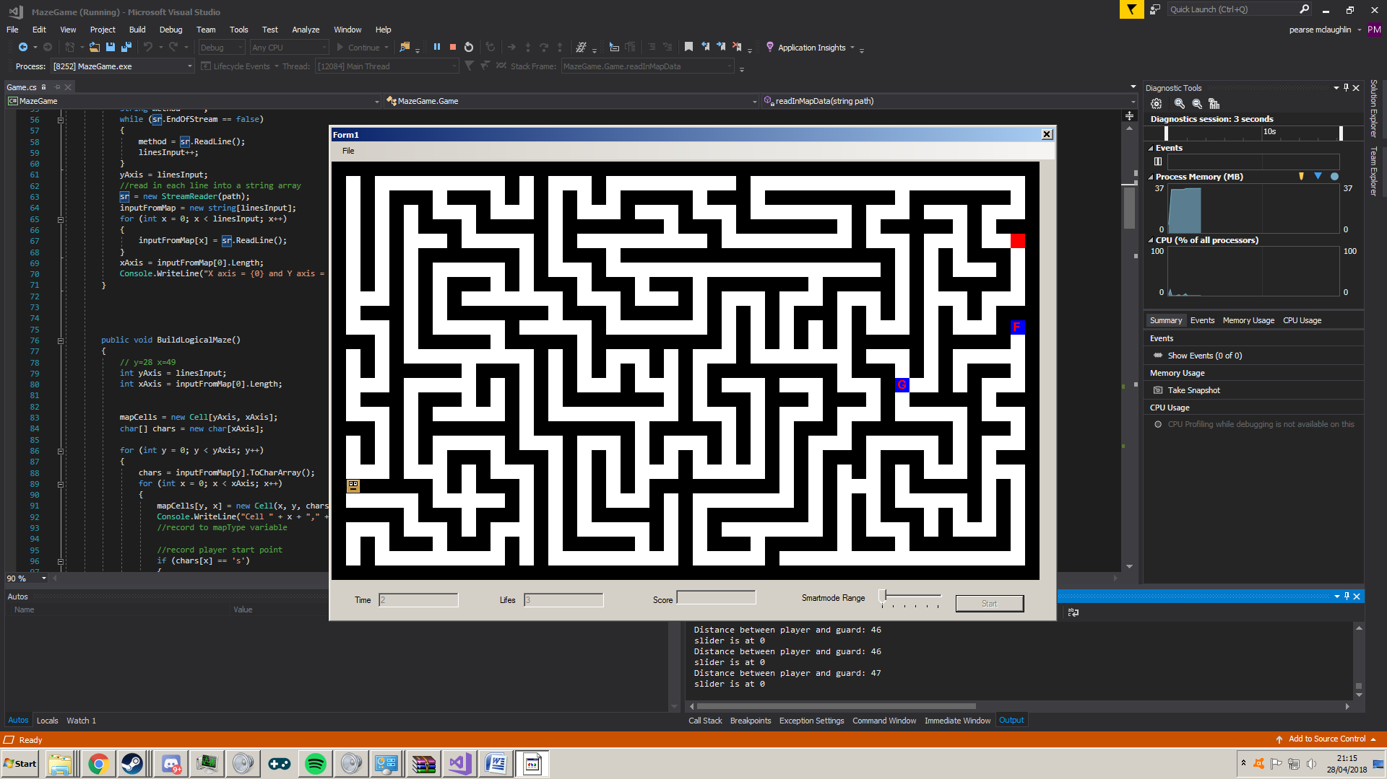Fig.3 Finish point

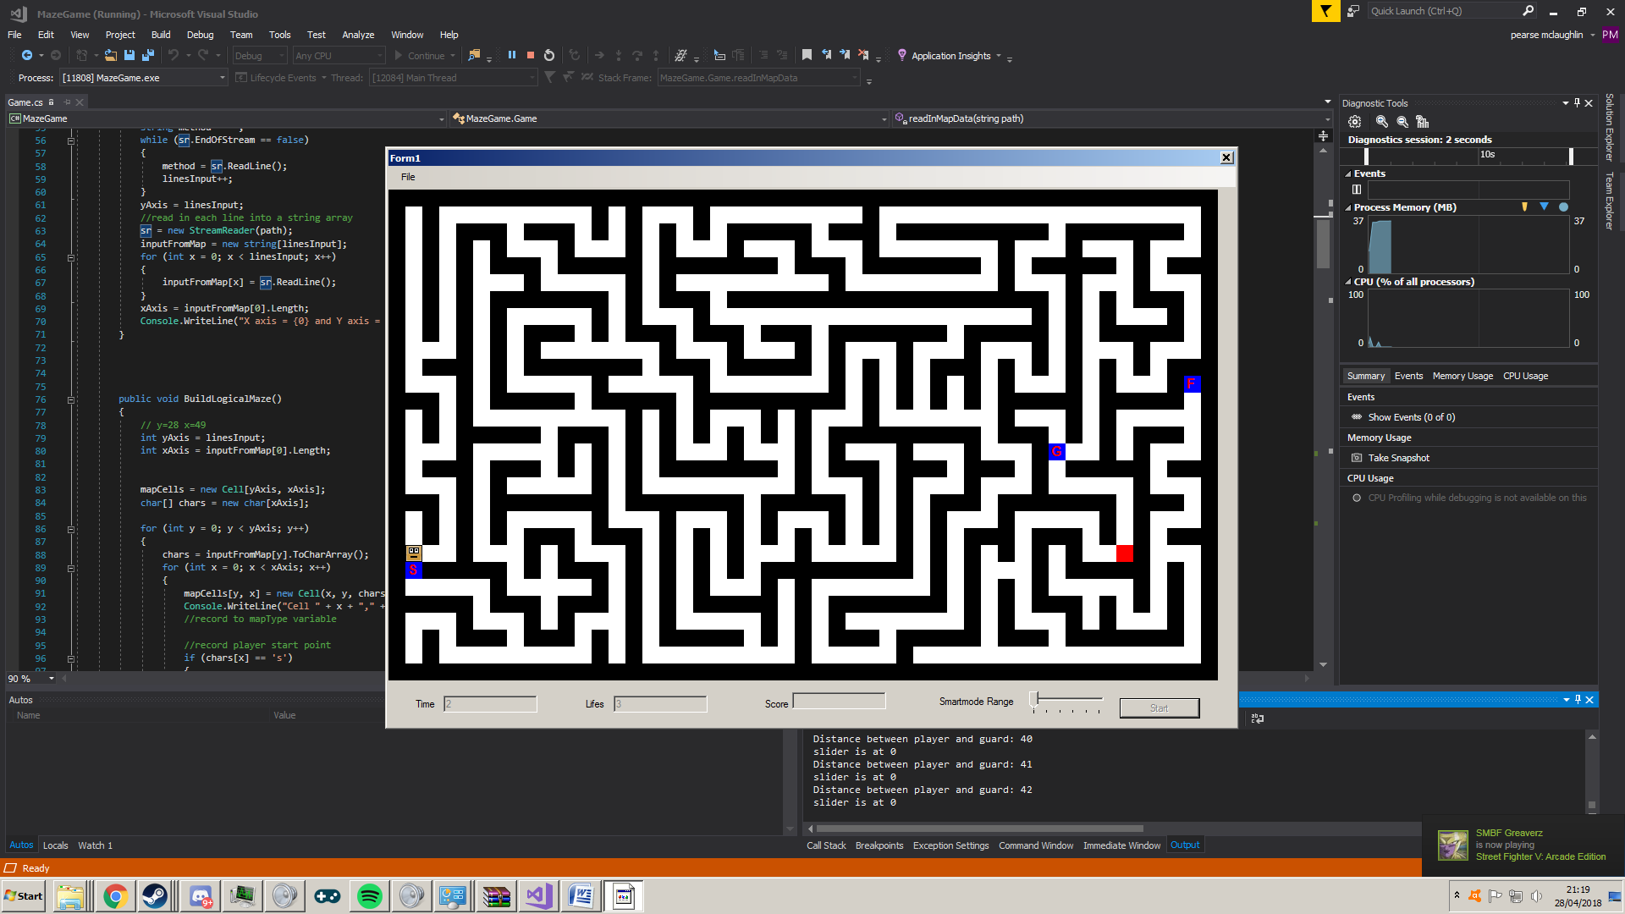the player and the guard start at separate locations given by the S and G Points shown below

Fig.4 Start Point Fig.5 Guard Start Point.

# GUARD.

The guard is the main opposition stopping the player from reaching the finish line. the guard has two types of movement and when these modes occur is dependent on the difficulty selected by the player.



# RANDOM MOVEMENT

when outside of the range specified by the difficulty track bar the guard will move randomly around the maze. on the lowest setting/difficulty the guard will only move randomly and not enter smart mode. on other difficulties when the guard is within the specified range it will enter smart mode.

# SMART MODE.

when inside the specified range. the guard will use pathfinding AI to find the player and take the shortest possible path to the player. this of course makes the game much more challenging but as the guard is actively chasing the player. upon leaving the specified range the guard will go back to random AI. at the highest difficulty/setting the guard will always be in smartmode.

# GAME OVER.

When the player loses all their lives the game is over. The program will need to be run again to start over.

# LEVELS

the two levels in the game is shown below

