 | 

JOSHUA MQABUKO NKOMO POLYTECHNIC
(A Case Study of Beitbridge Municipality)
MUNICIPAL POLICE AND METER READING MANAGEMENT SYSTEM
BY
PEARSON NYIRENDA
Candidate Number: 0625768G00015

Supervisor: Ms Masakure L.P

A Software Project Submitted in Partial Fulfilment of the Requirements for the
NATIONAL DIPLOMA IN INFORMATION TECHNOLOGY
OCTOBER 2026

DEDICATION
This project is dedicated to my family, whose encouragement and belief in me made this work possible, and to everyone striving to bring reliable, modern systems to public service delivery in Zimbabwe.

ACKNOWLEDGEMENTS
I would like to thank the Almighty God for the strength and perseverance to complete this project.
My sincere gratitude goes to my supervisor, Ms Masakure L.P., and the faculty of the Department of Information Technology at Joshua Mqabuko Nkomo Polytechnic, for their guidance, patience, and constructive feedback throughout the development of this project.
I also thank my family and classmates for their continued support and encouragement during the course of this project.

ABSTRACT
Beitbridge Municipality, like many local authorities in Zimbabwe, has relied on manual, paper-based processes to manage municipal police cases, fines, and water meter readings. These methods are slow, prone to loss and duplication, and make it hard for supervisors to get an accurate, up-to-date picture of operations across wards. Field staff also often work in areas with unreliable network connectivity. Paper copes with that by default, but most digital systems do not.
In this project I designed, developed, and tested the Municipal Police and Meter Reading Management System, a web-based application built with PHP, SQLite, and MySQL. It digitises case management, fine issuing and payment, meter reading capture, and damaged-meter reporting for Beitbridge Municipality. I designed it around an offline-first architecture. Every transaction a field officer or meter reader captures is saved to a local SQLite database on their device first, and is then synchronised automatically in the background to a central MySQL "Workspace Server" whenever a connection to it is available. This happens over the municipal LAN, not the public internet. Workstations in different municipal offices can therefore keep working independently and consolidate their data centrally without a permanent connection.
I developed the system iteratively and tested it against realistic data drawn from Beitbridge Municipality's operations. Police Officers, Meter Readers, Clerks, Supervisors, and Administrators can now do their day-to-day work through a single role-based application. It includes duplicate-detection safeguards, an audit trail of user activity, and dashboards that give supervisors a near real-time view of case, fine, and meter-reading activity across all wards.

TABLE OF CONTENTS
DEDICATION i
ACKNOWLEDGEMENTS ii
ABSTRACT iii
TABLE OF CONTENTS iv
DEFINITION OF TERMS xi
CHAPTER ONE (1) PROJECT IDENTIFICATION 1
1.1 Introduction 1
1.2 Executive Summary 1
1.3 Background of the Study 2
1.4 Description of the Current System 2
1.4.1 Municipal Police 2
1.4.2 Meter Readings 2
1.4.3 Problems with the Current System 3
1.5 Objectives of the Project 3
1.6 Scope of the Project 4
1.6.1 User and Security Management 4
1.6.2 Municipal Police Management 4
1.6.3 Meter Reading Management 5
1.6.4 Damaged Meter Reporting 5
1.6.5 Local-First Capture and Sync 5
1.6.6 Reporting and Analytics 5
1.6.7 Dynamic System Features 5
1.6.8 Document and Sharing Features 6
1.6.9 Scope Exclusions (Out of Scope) 6
1.6.10 Scope Limitations 6
1.7 Description of the Proposed System 7
1.8 Chapter Summary 7
CHAPTER TWO (2) FEASIBILITY STUDY 8
2.1 Introduction 8
2.1.1 Background 8
2.1.2 Proposed System Overview 8
2.2 Proposed System Alternatives 9
2.2.1 Alternative 1: Spreadsheet-Based System 9
2.2.2 Alternative 2: Online Web-Based System (Server-Only) 9
2.2.3 Alternative 3: Local-First Web-Based System with LAN Synchronisation (Proposed) 9
2.3 Feasibility Study Techniques 10
2.3.1 Technical Feasibility 10
2.3.1.1 Alternative 1: Spreadsheet-Based System 10
2.3.1.2 Alternative 2: Online Web-Based System (Server-Only) 10
2.3.1.3 Alternative 3: Local-First Web-Based System with LAN Synchronisation 11
2.3.2 Economic Feasibility (Cost-Benefit Analysis) 12
2.3.2.1 Alternative 1: Spreadsheet-Based System 13
2.3.2.2 Alternative 2: Online Web-Based System (Server-Only) 13
2.3.2.3 Alternative 3: Local-First Web-Based System with LAN Synchronisation 13
2.3.3 Operational Feasibility 14
2.3.3.1 Alternative 1: Spreadsheet-Based System 15
2.3.3.2 Alternative 2: Online Web-Based System (Server-Only) 15
2.3.3.3 Alternative 3: Local-First Web-Based System with LAN Synchronisation 15
2.3.4 Legal Feasibility 16
2.3.4.1 Alternative 1: Spreadsheet-Based System 16
2.3.4.2 Alternative 2: Online Web-Based System (Server-Only) 17
2.3.4.3 Alternative 3: Local-First Web-Based System with LAN Synchronisation 17
2.3.5 Schedule (Time) Feasibility 18
2.3.5.1 Alternative 1: Spreadsheet-Based System 18
2.3.5.2 Alternative 2: Online Web-Based System (Server-Only) 18
2.3.5.3 Alternative 3: Local-First Web-Based System with LAN Synchronisation 18
2.4 Justification of the Proposed System 20
2.5 Chapter Summary 21
CHAPTER THREE (3) REQUIREMENTS ANALYSIS 22
3.1 Introduction 22
3.2 Fact-Finding Techniques 22
3.2.1 Interviews 22
Key Interview Finding 23
3.2.2 Observation 23
3.2.3 Document Review 24
3.2.4 Questionnaires 25
3.3 Recording Tools 25
3.3.1 Interview Notes Form 25
3.3.2 Observation Checklist 26
3.3.3 Key Data Fields Identified from Existing Documents 26
3.4 Problems Identified 27
3.6 User Requirements 28
3.7 Functional Requirements 29
3.7.1 User and Security Management 29
3.7.2 Police Case Management 29
3.7.3 Fine Management 30
3.7.4 Water Meter Reading Management 30
3.7.5 Damaged Meter Reporting 31
3.7.6 Local-First Data Capture and Synchronisation 31
3.7.7 Reporting and Dashboard 32
3.8 Non-Functional Requirements 32
Technical Constraints 33
3.9 Analysis Tools and Diagrams 33
3.9.1 Data Flow Diagram (DFD) 34
3.9.1.1 Context Diagram (Level 0 DFD) 34
3.9.1.2 Level 1 DFD - Fine Management Process 34
3.9.2 Entity Relationship Diagram (ERD) 35
3.9.2.1 Database Tables and Fields (Data Dictionary) 35
3.9.2.2 Key Relationships 36
3.9.3 Use Case Diagram 37
3.9.4 Decision Table - Abnormal Reading Check 38
3.10 Requirements Specifications 39
3.11 Chapter Summary 39
CHAPTER FOUR (4) SYSTEM DESIGN 41
4.1 Introduction 41
4.2 Input Design 41
4.3 Output Design 42
4.4 Process Design 43
4.5 Database Design 44
4.5.1 Database Design Approach 44
4.5.2 Physical Table Design 45
4.6 File Design 50
4.7 User Interface Design 51
4.7.1 Design Principles 51
4.7.2 Navigation Menu by Role 51
4.7.3 Sample Screen Layouts 52
4.8 System Controls Design 52
4.8.1 Input Validation Controls 52
4.8.2 Security Controls 52
4.8.3 Error Handling and Data Integrity Controls 53
4.9 UML Diagrams 53
4.9.1 Use Case Diagram 54
4.9.2 Entity Relationship Diagram 54
4.9.3 Class Diagram 55
4.9.4 Sequence Diagram - Issue Fine and Record Payment 56
4.9.5 Activity Diagram - Local-First Save and Sync 57
4.9.6 Sync / Deployment Architecture Diagram 58
4.10 Chapter Summary 59
CHAPTER FIVE (5) CODING AND TESTING 60
5.1 Introduction 60
5.2 Development Environment (Software and Hardware Used) 60
5.3 Programming Language and Tools 61
5.3.1 Programming Quality (User-Friendliness) 61
5.3.1.1 Coding Standards Followed 61
5.3.1.2 Sample Code - Input Validation (PHP) 62
5.3.1.3 Sample Code - Automatic Fine ID Generation (PHP) 62
5.3.1.4 Sample Code - Local-First Meter Reading Save (JavaScript) 63
5.3.1.5 User-Friendliness Features Implemented 63
5.3.2 Program Resilience (Non-Crash Properties) 64
5.3.2.1 Sample Code - Exception Handling Around Database Writes (PHP) 64
5.3.2.2 Sample Code - Durability When the Server Is Completely Unreachable (cli_sync_engine.php) 64
5.3.2.3 Resilience Techniques Applied 65
5.4 System Modules Developed 66
5.5 Testing Strategy 66
5.5.1 Testing Approach 67
5.5.2 Test Plan 67
5.6 Test Data 68
5.7 Test Results 69
5.7.1 User Acceptance Testing Feedback 70
5.8 Bug Fixes and Improvements 71
5.9 Chapter Summary 71
CHAPTER SIX (6) IMPLEMENTATION AND POST-IMPLEMENTATION PLAN 73
6.1 Introduction 73
6.1.1 Development Phases 73
6.2 User Training Plan 73
6.3 Conversion Plan (Direct, Parallel, Phased or Pilot) 74
6.3.1 Conversion Strategy 74
6.3.2 Deployment Model 75
6.3.3 Minimum System Requirements 75
6.3.4 Presenting the System to the Municipality 76
6.4 Data Migration Plan 76
6.5 Maintenance Plan 78
6.6 User Manual 78
6.6.1 User Manual (Extract) 78
6.7 Technical Documentation 79
6.7.1 Technical Manual (Extract) 79
6.8 Chapter Summary 80
CHAPTER SEVEN (7) CONCLUSION AND RECOMMENDATIONS 81
7.1 Introduction 81
7.2 Summary of the Project 81
7.3 Achievements of the Project 81
7.4 Challenges Encountered 83
7.5 Recommendations 84
7.6 Future Enhancements 84
7.7 Conclusion 85
REFERENCES 86
Chapter One 86
Chapter Two 86
Chapter Three 87
Chapter Four 87
Chapter Five 88
Chapter Six 88
Chapter Seven 88
APPENDICES 90
Appendix 1: Staff Questionnaire and Responses 90
Appendix 2: Interview Notes Form (Completed Example) 90
Appendix 3: Observation Checklist 91
Appendix 4: User Manual (Extract) 91
Appendix 5: Technical Manual (Extract) 92

DEFINITION OF TERMS
The following terms are used throughout this report. I previously defined them at the start of individual chapters and have gathered them here, with duplicate entries combined.
Term | Definition
Activity Diagram | A UML diagram similar to a flowchart, showing the flow of activities and decisions within a process, such as local-first data synchronisation.
Bcrypt | A secure password hashing algorithm used to encrypt passwords before storing them in a database.
Class Diagram | A UML diagram showing the system's classes, their attributes, methods, and the relationships between them.
Code Commenting | Short notes written inside program code to explain what a section does, improving readability and maintainability.
Conversion Strategy | The approach used to move from the old manual system to the new computerised one, e.g. all at once, side-by-side, or in stages.
Data Dictionary | A structured catalogue of every data item (field) in the system, showing its name, data type, size, and validation rule.
Data Flow Diagram (DFD) | A diagram that shows how data moves through a system, from input to processing to storage to output.
Debugging | The process of locating and correcting errors (bugs) in program code.
Deployment | The process of moving a finished system from a development machine onto the server(s) where staff will actually use it.
Economic Feasibility | Evaluation of the costs and benefits of the system to determine if it is affordable and provides value for money.
Entity Relationship Diagram (ERD) | A diagram that shows the tables in a database and how they are linked to each other.
Exception Handling | A programming technique (try/catch) used to intercept runtime errors and respond to them gracefully instead of crashing.
Fact-Finding | A method of collecting information about the current system and user needs through interviews, observation, questionnaires, and document review.
Feasibility Study | An analysis of the practicality, cost, benefits, and risks of a proposed project before development begins.
Field Workstation | A computer at a municipal office or ward point running the system against its own local SQLite database, syncing to the Workspace Server.
Functional Requirement | A specific task or function the system must perform. For example, the system must generate a unique fine ID automatically.
Idempotent | A property of an operation where repeating it produces the same result as doing it once, which is central to safe retry of a sync push.
Integration Testing | Testing how separate modules work together, e.g. confirming the Fine module correctly links to the Payment module.
Legal Feasibility | Verification that the system complies with relevant laws, regulations, and software licensing requirements.
Local-First Synchronisation | The approach of writing every record to a local SQLite database first, then synchronising it to the central MySQL database automatically once the municipal LAN connection to the Workspace Server is available.
Non-Functional Requirement | A quality or performance standard the system must meet. For example, the system must load any page within 3 seconds.
Normalisation | The process of organising database tables to reduce data redundancy and improve data integrity, applied here up to Third Normal Form (3NF).
Occurrence Book | A manual logbook used by municipal police officers to record daily cases, fines, and incidents.
Offline Synchronization | The ability to capture and store data locally on a device (using SQLite) when the municipal server cannot be reached, then automatically upload that data to the central MySQL database once a connection to it is restored.
Operational Feasibility | Examination of whether the system will work effectively within the organisation's daily operations and be accepted by users.
Parallel Running | Operating the old manual system and the new system together for a period, so records can be cross-checked before the old system is dropped.
Physical Design | The stage where the logical data model (ERD) is converted into actual database tables, data types, and constraints ready for implementation.
Pilot Conversion | Rolling the new system out to one ward or department first, learning from it, then extending it to the rest of the municipality.
Program Resilience | The ability of a program to handle unexpected input or conditions without crashing.
Referential Integrity | A database rule that ensures a foreign key value always refers to an existing record in the related table.
Requirements Analysis | The process of identifying, gathering, and documenting what a system must do before it is designed or built.
Role-Based Access Control (RBAC) | A security approach where system permissions are granted based on the user's assigned role (e.g. Police Officer, Meter Reader, Administrator).
Schedule Feasibility | Assessment of whether the project can be completed within the available time frame.
Sequence Diagram | A UML diagram showing the order in which objects interact over time to complete a process, such as issuing a fine.
SQLite | A lightweight, file-based relational database management system used for storing data locally on a device or workstation.
Super User | A system administrator with full access to all modules, user management functions, system settings, and reporting tools.
sync_id | A globally unique identifier generated for every record that needs to reach the Workspace Server, used to detect and safely ignore duplicate submissions if a sync attempt is retried.
Technical Feasibility | Assessment of whether the required technology, tools, and skills are available to build the system.
Technical Manual | Documentation aimed at IT/support staff, covering installation, configuration, and how the system is put together.
Test Case | A documented input, action, and expected result used to check whether a specific part of the system behaves correctly.
Unique Fine ID | An automatically generated identifier (e.g. FINE-2026-0047) assigned to each fine issued, enabling easy tracking, payment-status monitoring, and retrieval.
Unit Testing | Testing individual functions or modules in isolation to confirm each performs its intended task correctly.
Use Case Diagram | A diagram that shows the different types of users (actors) and the tasks they can perform in the system.
User Acceptance Testing (UAT) | Testing carried out by end users (police officers, meter readers, clerks) to confirm the system meets their real working needs.
User Manual | Documentation aimed at day-to-day users, written in plain language, showing how to carry out each task on the system.
Validation Control | A rule built into the system to check that data entered by a user is correct, complete, and in the right format before it is saved.
Ward | A geographical sub-division of Beitbridge Municipality used for organising meter readings, police patrols, and service delivery.
Wireframe | A simple visual layout of a screen showing where fields, buttons, and labels will appear, used to plan the user interface before coding.
Workspace Server | The central server, running MySQL, that field workstations synchronise with over the municipal LAN. It is the single authoritative copy of the data once more than one workstation is in use.

CHAPTER ONE (1)
PROJECT IDENTIFICATION
Municipal Police and Meter Reading Management System

1.1 Introduction
In this chapter I introduce the Municipal Police and Meter Reading Management System that I developed for Beitbridge Municipality. I summarise the project, explain the background to the study, describe the current manual system and its problems, state the objectives, scope, and limitations, and describe the proposed system that I design, build, and test in the chapters that follow.

1.2 Executive Summary
Beitbridge Municipality currently manages municipal police records and water meter readings manually. Police cases and fines are recorded in physical occurrence books, and water meter readings and damaged-meter reports are written on paper forms. This approach is slow, hard to manage, and risky, because records can be lost, damaged by water or fire, or misplaced.
Key problem: the figures in this paragraph are working estimates and have not been independently verified against municipal records. Officers are estimated to process 50-100 cases per week, and meter readers capture over 500 readings monthly. Manual methods are estimated to result in 15-20% of records being misfiled or lost.
In this project I propose and develop a Municipal Police and Meter Reading Management System. It computerises police case recording, fine management, water meter readings, and damaged-meter reporting, all linked to specific house numbers and wards.
I built the system local-first. Police officers and meter readers capture cases, fines, and meter readings into a local SQLite database on their own device or workstation first, every time, whether or not the municipal server can be reached at that moment. A background sync engine then pushes those records to the central MySQL "Workspace Server" over the municipal LAN as soon as it can reach it, and pulls reference data such as wards, houses, and user accounts back down. Because this depends only on the municipal network and not the public internet, the system keeps working in the field even where internet access is patchy or absent.
The system is dynamic: users work with real, current data rather than fixed pages, and system administrators act as super users with full control. I built it with PHP, JavaScript, SQLite and MySQL, running on XAMPP during development.

1.3 Background of the Study
Beitbridge Municipality, like many local authorities in Zimbabwe, has relied on manual, paper-based processes to manage municipal police cases, fines, and water meter readings. Police cases and fines are written in occurrence books and on paper slips, and water meter readings are recorded house by house on paper forms.
These paper-based methods are slow, prone to loss and duplication, and make it hard for supervisors to get an accurate, up-to-date picture of operations across wards. Field staff also work in areas where network connectivity is unreliable. A paper system copes with that by default, but most digital systems do not. This is why I set out to build a digital system that keeps working when the municipal server cannot be reached.

1.4 Description of the Current System

1.4.1 Municipal Police
• Police cases are written manually in occurrence books (hardcover notebooks).
• Fines are issued by handwriting on pre-printed or blank paper forms.
• There is no digital database to track case progress, fine payments, or offender history.
• Searching for a specific case or fine requires manually flipping through pages, often taking hours or days.
• Records are stored in office cabinets and are vulnerable to fire, water damage, and theft.

1.4.2 Meter Readings
• Water meter readings are recorded manually on paper.
• Each meter reader is assigned a ward or street and writes down readings house by house.
• Damaged meters are reported by writing a separate note, but these reports are not linked to house numbers in a systematic way.
• There is no centralised system to view reading history, detect abnormal consumption, or track repairs.

1.4.3 Problems with the Current System
The following problems were identified with the current manual system:
Problem | Impact
Files and records can be lost or damaged | Permanent loss of legal evidence and billing data
Slow retrieval of information | Delayed court cases, delayed billing, frustrated citizens
Poor tracking of fines and cases | Uncollected revenue, loss of municipal income
No offline digital data capture | Work stops when the municipal network is down
No centralised database | Duplicate records, inconsistent information
Manual recording causes spelling and calculation errors | Incorrect fines, wrong meter readings, disputes
No proper tracking of meter readings | Inefficient water management, undetected leaks
Weak data security | Unauthorised access possible, no audit trail

1.5 Objectives of the Project
The following objectives state what I set out to achieve with this project. I defined them using SMART criteria (Specific, Measurable, Achievable, Relevant, Time-bound). The measurement for each objective is the evidence I use to judge whether it was achieved:
Objective | Measurement
Record and manage police cases digitally | 100% of cases assigned a unique ID; searchable within 5 seconds
Capture cases, fines, and meter readings locally first, on every device | Local storage for up to 1,000 pending records per device, synced automatically once reachable
Track case progress (open, in progress, closed) | Status updates visible in real time on the dashboard
Manage and monitor fines | Track paid/unpaid status; generate reports on uncollected fines
Capture water meter readings linked to house numbers | Support for 5,000+ house numbers across 12 wards
Report damaged meters | Link each damage report to a specific house number; track repair status
Implement secure login and role-based access | Distinct permissions per role (Admin, Officer, MeterReader, Clerk, PoliceSupervisor, MeterSupervisor)
Generate reports | Printable and PDF reports available on demand

1.6 Scope of the Project
The system includes the following modules and features:

1.6.1 User and Security Management
• Secure login system
• Password hashing with bcrypt (PHP password_hash())
• Role-based access control (Admin, Clerk, Police Officer, Meter Reader, Police Supervisor, Meter Supervisor)
• System administrators act as super users with full control
• User activity logging

1.6.2 Municipal Police Management
• Digital case recording (case number, date, offender details, description)
• Case status updates (open, in progress, closed)
• Fine issuance with an automatically generated unique ID (e.g. FINE-2026-0047)
• Fine tracking (paid/unpaid)
• Fines linked to house numbers and vehicle registration plates

1.6.3 Meter Reading Management
• Capture water meter readings per house number
• Store and update meter records with date stamps
• View meter reading history for any house
• Detect abnormal readings (validation against recent consumption)

1.6.4 Damaged Meter Reporting
• Report damaged meters with optional photo upload
• Link reports to specific houses
• Track repair status (pending, in progress, fixed)
• Maintain a history of reported issues

1.6.5 Local-First Capture and Sync
• Capture cases, fines, and meter readings to local SQLite first, always
• Synchronise pending records automatically to the central Workspace Server once it is reachable over the LAN
• Pull reference data (users, wards, houses, assignments) down to each workstation
• Flag possible duplicate/conflicting records for admin review rather than silently overwriting data

1.6.6 Reporting and Analytics
• Police case reports (by date, officer, status)
• Fine reports (paid/unpaid, by date range)
• Meter reading reports (by ward, by house, by date)
• Damaged meter reports (by status, by house)
• Filtering by date, house number, vehicle plate, and officer

1.6.7 Dynamic System Features
• Real-time data updates
• Automatic fine calculation and ID generation
• Instant report generation
• Interactive, role-specific dashboard
• Data retrieved directly from the database rather than hard-coded

1.6.8 Document and Sharing Features
• Generate PDF fine receipts
• Print receipts directly from the system
• Download reports in PDF or CSV format

1.6.9 Scope Exclusions (Out of Scope)
In Scope | Out of Scope
Fine issuance and tracking | Water billing / invoicing
Meter reading capture | Online payment processing
Local-first capture and LAN sync | Native mobile apps (iOS/Android)
PDF receipt generation | GPS tracking of officers
Role-based access control | AI / machine learning features
Reporting and dashboards | SMS notifications

1.6.10 Scope Limitations
The following limitations apply to the system and form part of the scope boundary:
• The system does not handle water billing calculations or generate invoices.
• No AI features (e.g. predictive analytics, image recognition for damaged meters).
• No native mobile apps: the system is web-based, for browsers on computers, tablets, and phones.
• No GPS tracking of police officers or meter readers.
• The system is designed for Beitbridge Municipality's structure (its wards, roles, and processes) and may need modification before it would suit another municipality directly.

1.7 Description of the Proposed System
The system runs on PHP with SQLite and MySQL, under XAMPP during development. Every workstation captures cases, fines, and meter readings into its own local SQLite database first. This is what makes a save durable, whether or not the municipal server can be reached at that moment. A background sync engine then pushes pending records to the central MySQL Workspace Server and pulls reference data back down whenever the workstation can reach that server over the municipal LAN.
Administrators act as super users with full system control, including user management, monitoring, and report generation. The system is a web-based application accessible from any modern browser on a computer, tablet, or phone within the municipality's network.
Local-first persistence: every workstation has its own local SQLite database as its normal, everyday operational store, not a fallback used only when something else fails.
Automatic, LAN-based synchronisation: a background process pushes pending records to the central MySQL Workspace Server as soon as it is reachable on the municipal LAN. Public internet availability plays no part in this.
Idempotent, conflict-aware sync: every record carries a unique sync_id so a retried sync attempt can never create a duplicate; records the server flags as possible duplicates are kept, not discarded, and surfaced for an administrator to review.
User-friendly interface: large buttons, dropdown menus, clear labels, minimal training required.
Security: bcrypt password hashing, session management, activity logs, role-based restrictions, and a shared-key check on every workstation-to-server sync request.

1.8 Chapter Summary
In this chapter I identified the problem at Beitbridge Municipality, where municipal police cases, fines, and water meter readings are managed on paper. I gave the background to the study, described the current system and its problems, set out the objectives, scope, and limitations of the project, and described the proposed local-first, web-based system. In Chapter Two I evaluate three alternative ways of addressing these problems in a feasibility study.

CHAPTER TWO (2)
FEASIBILITY STUDY
Municipal Police and Meter Reading Management System

2.1 Introduction
In this feasibility study I examine whether the Municipal Police and Meter Reading Management System can be built and implemented at Beitbridge Municipality. I evaluate the project from five perspectives: technical, economic, operational, legal, and schedule feasibility. I apply each perspective to three alternative ways of solving the problem, so that I can justify the best alternative.

2.1.1 Background
Currently, municipal police officers record cases and issue fines manually in occurrence books. Water meter readers record readings on paper sheets. This manual system is:
• Slow: searching for a record can take hours or days
• Unreliable: paper records can be lost, damaged, or destroyed
• Error-prone: manual writing leads to spelling mistakes, incorrect amounts, and duplicate entries
• Insecure: no access controls or audit trails

2.1.2 Proposed System Overview
The proposed system replaces manual processes with a digital solution that works the same way whether or not the municipal server can be reached at any given moment. Key features include:
• Digital case recording and fine issuance with unique IDs
• Water meter reading capture linked to house numbers
• Local-first data capture using SQLite, with automatic sync to the central server over the LAN
• Secure login, role-based access, and activity logging
• Report generation (PDF, printable)
Example: Officer Sibanda issues a speeding fine. Instead of writing in a book, he opens the system, fills in the driver's details and car plate number, and the system instantly generates a unique fine ID such as FINE-2026-0047. The driver receives a printed receipt on the spot.
In this study I evaluate five areas of feasibility:
• Technical Feasibility: can the system be built with available tools and skills?
• Economic Feasibility: can the system be built within a reasonable budget?
• Operational Feasibility: will the system be easy to use by the intended users?
• Legal Feasibility: does the system follow data-protection and privacy rules?
• Schedule Feasibility: can the system be completed within the available time?

2.2 Proposed System Alternatives
I considered three alternative systems for Beitbridge Municipality. I describe each below and then assess each in turn in Section 2.3.

2.2.1 Alternative 1: Spreadsheet-Based System
Cases, fines, meter readings, and damaged-meter reports would be typed into spreadsheet workbooks (Microsoft Excel or LibreOffice Calc) kept on an office computer, while officers and meter readers continue to capture information on paper in the field. A clerk would copy the paper records into the spreadsheets, and reports would be produced with filters and formulas. There would be no central database, no automatic ID generation, and no synchronisation between workstations.

2.2.2 Alternative 2: Online Web-Based System (Server-Only)
A web-based PHP and MySQL system hosted on one central server, used directly through a browser by every officer, meter reader, and clerk. Every record is saved straight to the central database, so a working connection to the server is needed each time data is captured. This gives central control and reporting but offers no local storage on the workstation.

2.2.3 Alternative 3: Local-First Web-Based System with LAN Synchronisation (Proposed)
A web-based PHP system in which every workstation saves each record to its own local SQLite database first, and a background engine then synchronises the record to a central MySQL Workspace Server over the municipal LAN, as described in Chapter One, Section 1.7. Work continues normally whether or not the server can be reached.

2.3 Feasibility Study Techniques
I assess each alternative under five feasibility techniques: technical feasibility, economic feasibility (cost-benefit analysis), operational feasibility, legal feasibility, and schedule (time) feasibility.

2.3.1 Technical Feasibility
Technical feasibility checks whether I can build the system using available technology, tools, and skills.

2.3.1.1 Alternative 1: Spreadsheet-Based System
• Technology: spreadsheet software (Microsoft Excel or the free LibreOffice Calc) on existing office computers.
• Hardware and infrastructure: at least one office computer; no devices are needed in the field because paper forms continue to be used.
• Skills: the developer and the clerks already have basic spreadsheet skills.
• Limitations: spreadsheets cannot reliably generate unique IDs, enforce role-based access, handle several simultaneous users, or detect duplicate records across workstations.
My technical verdict: technically possible, but it cannot meet the main requirements of the system.

2.3.1.2 Alternative 2: Online Web-Based System (Server-Only)
• Technology: PHP, MySQL, Apache (XAMPP), HTML, CSS, and JavaScript, all of which are within the developer's existing skills.
• Hardware: one central server and a browser-capable device for each user.
• Infrastructure: a dependable network link between every device and the server at all times. The IT Technician reported that internet connectivity is unreliable (Chapter Three, Section 3.2.1), and all 8 staff surveyed said poor connectivity has stopped their work (Section 3.2.4).
My technical verdict: straightforward to build, but the available infrastructure cannot support it, because field staff could not save records whenever the connection dropped.

2.3.1.3 Alternative 3: Local-First Web-Based System with LAN Synchronisation
Technologies and tools
Technology | Purpose | Why Chosen
PHP | Server-side programming | Free, widely used, works with MySQL and XAMPP
HTML5 and CSS3 | Web page structure and styling | Standard web technologies, easy to use
JavaScript | Interactive features, form validation, local-first save logic | Runs in-browser; needed for the SQLite-via-WebAssembly local store
MySQL | Central database (Workspace Server) | Reliable, free, works with PHP; single source of truth once more than one workstation is in use
SQLite | Local database (every workstation) | Lightweight, file-based, needs no separate server process
XAMPP | Local web server environment (development) | Free, bundles Apache, PHP, and MySQL together
VS Code | Code editor | Free, with strong support for PHP, JavaScript, and SQL
Git | Version control | Tracks every change to the codebase and lets work be recovered if something breaks
GitHub | Remote repository / backup | Off-site backup of the codebase and its history, and a way to share it with the supervisor
Microsoft Word | Project documentation | Used to produce this documentation in the format required by the module guidelines

Local-first capture and LAN synchronisation
A critical feature is the ability to capture data without depending on the municipal server being reachable at that instant. Every police case, fine, and meter reading is saved to a local SQLite database on the capturing device first; this is what "saved" means in this system, not a fallback used only when something else fails. A background sync engine then pushes newly captured records on to the central MySQL Workspace Server automatically, as soon as it can reach it over the municipal LAN, and pulls reference data (users, wards, houses) back down the same way.
Example: Meter reader Dube records water meter readings in Ward 5, out of range of the municipal office network. She captures all her readings locally as normal. When she returns to the office and her device rejoins the municipal LAN, the system detects the pending readings and uploads them automatically. If the same reading was somehow captured twice, each record carries a unique sync_id, so the server recognises the repeat and keeps a single correct record rather than creating a duplicate.
Developer skills
I have knowledge and experience in PHP, HTML, CSS, JavaScript, and MySQL. Local-first synchronisation using SQLite was new to me at the start of the project, but I managed it using well-documented guides and libraries, including sql.js, a WebAssembly build of SQLite that runs inside the browser. My supervisor and college resources also supported me.
Technical feasibility conclusion
I can build the system using free and available tools. I have the required skills, and the local-first sync feature, although the most technically demanding part of the project, proved achievable within the project timeline. Technical feasibility is confirmed.

2.3.2 Economic Feasibility (Cost-Benefit Analysis)
Economic feasibility checks whether I can build the system within a reasonable and affordable budget, and whether the benefits outweigh the costs.
The cost figures for Alternatives 1 and 2 below are my own indicative estimates, prepared for comparison.

2.3.2.1 Alternative 1: Spreadsheet-Based System
Item | Cost (USD) | Notes
Spreadsheet software | $0.00 | Free (LibreOffice Calc) or an existing Office licence
Clerk time to copy paper records into spreadsheets | ~$40.00/month | Ongoing labour cost; paper forms continue
Printing and stationery | ~$15.00/month | Paper forms and occurrence books still needed
Electricity | ~$5.00/month | Office computer
TOTAL ESTIMATED COST | ~$60.00/month | Recurring cost remains high

Expected benefits: records are typed and can be filtered, but errors, loss of paper originals, slow field capture, and uncollected fines remain largely unsolved. Benefit is low.

2.3.2.2 Alternative 2: Online Web-Based System (Server-Only)
Item | Cost (USD) | Notes
Software (PHP, MySQL, Apache) | $0.00 | Free and open-source
Reliable connectivity for every workstation | ~$40.00/month | Needed so that records can always reach the server
Central server running costs | ~$10.00/month | Electricity and backup storage
Development costs (internet, electricity, printing) | ~$18.00/month | During development only
TOTAL ESTIMATED COST | ~$68.00/month | Highest recurring cost of the three

Expected benefits: central records, reports, and an audit trail. However, work stops whenever the connection fails, which weakens the benefit.

2.3.2.3 Alternative 3: Local-First Web-Based System with LAN Synchronisation
All main tools are free and open-source, so there are no software licence costs.
Item | Cost (USD) | Notes
XAMPP (Apache, MySQL, PHP) | $0.00 | Free open-source software
VS Code (code editor) | $0.00 | Free developer tool
SQLite (local database) | $0.00 | Free, built into PHP
Git and GitHub | $0.00 | Free for a project of this size
Internet connectivity (monthly) | ~$10.00 | For research, testing, and pushing to GitHub
Electricity (estimated monthly) | ~$5.00 | Running laptop and server
Printing and stationery | ~$3.00 | For documentation
TOTAL ESTIMATED COST | ~$18.00/month | Very low cost project

Benefits to the municipality
Benefit | Estimated Impact
Reduce paper and printing costs | No more occurrence books and paper forms needed
Save staff time | Data entry, searching, and reporting are all automated
Improve fine collection | Track unpaid fines: in 2025, an estimated $2,000 in fines was uncollected due to lost paper records (a working estimate, not verified against municipal records)
Reduce errors | Manual entry mistakes greatly reduced through validation
Better audit trail | All actions logged for accountability and review

Economic feasibility conclusion
Of the three alternatives, Alternative 3 has the lowest cost and the greatest benefit, because it uses entirely free tools, adds no recurring connectivity cost (it runs on the municipal LAN), and addresses every problem identified. Economic feasibility is confirmed.

2.3.3 Operational Feasibility
Operational feasibility checks whether the system will work well in the daily operations of the municipality and will be accepted by users.

2.3.3.1 Alternative 1: Spreadsheet-Based System
Staff would find spreadsheets familiar, but work would be done twice: first on paper in the field, then typed in by a clerk. Delays, handwriting errors, and lost paper forms would remain, there would be no role-based access, and supervisors would still not have a live picture of cases and fines. Operational feasibility is low.

2.3.3.2 Alternative 2: Online Web-Based System (Server-Only)
The system would be easy to use and would give supervisors central visibility. However, operations would stop whenever the network is down, and all 8 staff surveyed said poor connectivity has already stopped their work (Chapter Three, Section 3.2.4). Operational feasibility is moderate, and is undermined by the network.

2.3.3.3 Alternative 3: Local-First Web-Based System with LAN Synchronisation
Current system problems (reinforced)
Problem | Impact
Lost or damaged records | Permanent loss of legal evidence and billing data
Slow information retrieval | Searching through occurrence books takes hours
No payment tracking | Uncollected fines, revenue loss
Data entry errors | Incorrect fines, meter reading disputes
No reports | Difficult to generate summaries for management

Example: A court case required evidence of a fine issued three months earlier. Officers spent two days searching through different occurrence books before finding the entry, partly damaged by water. With the digital system, the same search takes under five seconds.
User roles and access
User Role | What They Can Do | Access Level
System Administrator | Manage all users, view all data, generate all reports, configure settings | Full access (Super User)
Police Officer | Record cases, issue fines, update case status, view assigned cases | Limited to the police module
Meter Reader | Capture meter readings, report damaged meters, view reading history | Limited to the meter module
Supervisor / Manager | View reports, monitor cases and fines, track meter readings | Read-only reporting

Ease of use
• Large, clearly labelled buttons for common tasks
• Drop-down menus for wards, house numbers, and case types
• Automatic ID generation (users don't type case or fine numbers)
• Password-protected login
• Training time: 1-2 hours per user type
Operational feasibility conclusion
The system significantly improves daily operations. It is designed to be easy to use and requires minimal training. Users are more productive, and data is more accurate and secure. Operational feasibility is confirmed.

2.3.4 Legal Feasibility
Legal feasibility checks whether the system complies with laws, regulations, and ethical standards.
The system stores personal information about offenders and residents. The Zimbabwean legal requirements relied on are: the Cyber and Data Protection Act [Chapter 12:07], which regulates the processing of personal data and requires appropriate security safeguards, and the Copyright and Neighbouring Rights Act [Chapter 26:05], which requires that software used is lawfully licensed.

2.3.4.1 Alternative 1: Spreadsheet-Based System
Personal data would sit in spreadsheet files that can only be protected by file passwords, with no activity log and no role-based access. It would be difficult to show that the safeguards expected under the Cyber and Data Protection Act are in place. The software itself is legal if licensed or free. Legal feasibility is weak.

2.3.4.2 Alternative 2: Online Web-Based System (Server-Only)
The system could apply bcrypt password hashing, role-based access, and activity logs, using free and legal software. Because every record travels to the server on every save, personal data is exposed to the network more often, so the transmission would need additional protection. Legal feasibility is acceptable.

2.3.4.3 Alternative 3: Local-First Web-Based System with LAN Synchronisation
Data protection and privacy
The system stores personal information (names, house numbers, vehicle registration plates, fine details). The following protection measures are implemented:
Measure | Implementation
Secure login | Username and strong password required
Password encryption | Passwords hashed using bcrypt (PHP password_hash()), not a weaker, outdated algorithm
Role-based access control | Users only see data their role permits (meter readers cannot access police records)
Activity logs | Every action (login, data entry, report) logged with user name, date, and time
Sync authentication | Every workstation-to-server sync request is checked against a shared key before any data is accepted

Example: Officer Dube issues a fine. The system records the action with the user name, time, and date automatically.
Use of legal software
All software used (XAMPP, MySQL, PHP, SQLite, HTML, CSS, JavaScript, VS Code, Git, and GitHub) is free and open-source. No pirated or illegally obtained software is used. This ensures compliance with software licensing laws.
Legal feasibility conclusion
The system uses only free and legal tools. Personal data is protected through secure login, role-based access, bcrypt encryption, and activity logging. The system meets the expected legal and ethical requirements. Legal feasibility is confirmed.

2.3.5 Schedule (Time) Feasibility
Schedule feasibility checks whether the system can be completed within the available academic timeline.

2.3.5.1 Alternative 1: Spreadsheet-Based System
This is the quickest alternative to set up, because only workbook templates and simple formulas are needed. It could be completed well within the academic timeline, but it would not solve the problems identified. Schedule feasibility is high.

2.3.5.2 Alternative 2: Online Web-Based System (Server-Only)
This alternative needs the same planning, core development, meter and reporting modules, and testing as Alternative 3 (Phases 1, 2, 3, and 5), but not the synchronisation phase. It could be completed within the timeline. Schedule feasibility is high.

2.3.5.3 Alternative 3: Local-First Web-Based System with LAN Synchronisation
Project timeline (aligned with guidelines)
Phase | Name | Key Activities | Guideline Activity (Due Date)
1 | Planning and Analysis | Define requirements, review current system, design database | Project Identification (27/03/2026)
2 | Core Development | Login, user management, police case module, fine module | Feasibility Study (30/04/2026)
3 | Meter and Reporting Modules | Meter reading, damaged meter reports, report generation | Requirements Analysis (29/05/2026)
4 | Offline Sync System | Local SQLite storage, workstation-to-central sync logic | Design (30/06/2026)
5 | Testing and Deployment | System testing, bug fixing, user testing, documentation | Coding and Testing (28/08/2026)

Key milestones
• Login system with secure authentication (end of Phase 2)
• Police case recording and fine generation (end of Phase 2)
• Meter reading capture and damage reporting (end of Phase 3)
• Local data capture and automatic LAN sync (end of Phase 4)
• All modules tested and documented (end of Phase 5)
Risks and mitigation
Risk | Likelihood | Mitigation Strategy
Local-first sync more complex than expected | Medium | Extra time allocated in Phase 4; the design was simplified to a clear push/pull model when needed
Power cuts or hardware failure | Medium | Code backed up regularly on GitHub and locally
Feature creep (adding too many new features) | Low | Scope clearly defined; no extra features added without supervisor approval
Illness or personal emergency | Low | Maintain regular progress with supervisor; request extension if necessary

Schedule feasibility conclusion
I can complete the project within the academic timeline. The five-phase plan is realistic, and I have identified the risks with clear management strategies. I gave the most complex phase (local-first sync) extra time. Schedule feasibility is confirmed.

2.4 Justification of the Proposed System
The table below compares the three alternatives across the five feasibility areas.
Feasibility Area | Alternative 1: Spreadsheet | Alternative 2: Server-Only | Alternative 3: Local-First (Proposed)
Technical | Possible, but cannot meet the main requirements | Easy to build, but needs a constant server connection | Feasible; synchronisation is the hardest part but achievable
Economic | ~$60.00/month; low benefit | ~$68.00/month; connectivity cost | ~$18.00/month; greatest benefit for cost
Operational | Double handling of paper and spreadsheets | Stops when the network is down | Works with or without a connection
Legal | Weak personal-data safeguards | Acceptable; more network exposure | Compliant; data stays on the municipal LAN
Schedule | Fastest | Within the timeline | Longest, but achievable in five phases

The results of the five feasibility tests for the selected alternative are:
Feasibility Area | Verdict | Summary
Technical | Feasible | All tools available; I have the required skills
Economic | Feasible | Very low cost; uses entirely free, open-source tools
Operational | Feasible | Improves daily work; easy to use; minimal training
Legal | Feasible | All tools legal; personal data protected with bcrypt and RBAC
Schedule | Feasible | Five clear phases fit within the academic deadline

I selected Alternative 3 as the best alternative. It is the only one that remains usable when the network is down, which is the condition field staff work in most often, and it does so at the lowest cost and with personal data kept on the municipal LAN. Alternative 1 is cheap to set up but leaves the main problems unsolved, and Alternative 2 depends on a network that staff have told me they cannot rely on.

2.5 Chapter Summary
Based on my analysis of three alternatives in this feasibility study, I selected Alternative 3, the local-first Municipal Police and Meter Reading Management System. It is practical, and I can develop and implement it successfully.
The system addresses real and serious problems currently faced by Beitbridge Municipality. It replaces a slow, error-prone, and risky manual system with a fast, secure, and reliable digital one.
Key findings
• Required technologies are freely available and within my skills
• Development costs are very low (only free, open-source tools used)
• The system improves daily work for police officers, meter readers, and administrators
• Personal data is protected through encryption, role-based access, and activity logging

CHAPTER THREE (3)
REQUIREMENTS ANALYSIS
Municipal Police and Meter Reading Management System

3.1 Introduction
In this chapter I present the requirements analysis for the Municipal Police and Meter Reading Management System that I developed for Beitbridge Municipality. This is Chapter Three (Activity 3) of the Software Project, as required by the course guidelines (Module Code: 553/23/M12), with a due date of 29 May 2026.
Requirements analysis is the process of finding out exactly what the system must do before any design or coding begins. It involves two main steps: fact-finding (collecting information from the people who will use the system) and analysis (studying that information to produce a clear list of system requirements).
The information I gathered in this chapter feeds directly into Chapter Four (System Design), where I use it to design the database, user interfaces, and system processes.
In this chapter I cover:
• Fact-finding techniques used and results obtained
• Recording tools used to capture information
• Problems identified in the current system
• User requirements, functional requirements, and non-functional requirements
• Analysis tools: Context Diagram, Level 1 DFD, ERD with data dictionary, Use Case Diagram, and a decision table
• A summary of the requirements specification

3.2 Fact-Finding Techniques
Fact-finding is the process of collecting information about how the current manual system works and what users need from the new system. I used four fact-finding methods: interviews, observation, document review, and questionnaires.

3.2.1 Interviews
I interviewed four key staff members at Beitbridge Municipality during the week of 11-15 May 2026:
Date | Person Interviewed | Role | Key Information Gathered
12 May 2026 | Officer T. Moyo | Municipal Police Officer | Cases are written in an occurrence book. Fines are handwritten on paper slips. No digital backup exists. A fine ID such as FINE-2026-0047 is needed.
13 May 2026 | Ms F. Dube | Water Meter Reader | Meter readings are written on paper per ward. Damaged meters are reported verbally to the supervisor. No formal tracking of repairs.
14 May 2026 | Ms P. Ndou | Municipality Clerk / Cashier | When a fine is paid, the clerk updates a paper ledger by hand. Finding old records takes up to 15 minutes. Files have been lost before.
15 May 2026 | Mr A. Nyoni | IT Technician | The municipality already has a local Windows server. Internet is unreliable. Staff have basic computer skills.

Key Interview Finding
When asked how a new case is opened, Officer Moyo stated: 'I write the date, name, offence, and fine amount in the occurrence book. I then write a fine slip by hand, one copy for the offender and one kept in a file. If the book is lost or damaged, all those records are gone permanently.'
This confirmed the critical need for a digital case-recording system with automatic ID generation, backup storage, and searchable records.

3.2.2 Observation
Observation means watching staff perform their daily tasks without interrupting them, which reveals problems staff might not think to mention in interviews. I made the following observations during site visits on 18 and 19 May 2026:
Observation | Finding | System Implication
Police fine recording | Officers spend 2-7 minutes writing each fine by hand. Queues form when multiple offenders are present. | The system must allow fast digital fine entry with automatic ID generation.
Meter reading in the field | Meter readers carry paper forms to each house. Handwriting is sometimes unreadable back at the office. | The system must allow easy digital data entry, ideally with dropdown selection of house numbers.
Finding old fine records | The clerk searched through 4 filing cabinets over 12 minutes to find a fine from 3 months ago. | The system must allow searching for any record within 5 seconds.
Tracking unpaid fines | No board or system shows which fines are unpaid; the clerk relies entirely on memory. | The system must show a dashboard of paid and unpaid fines.
Damaged meter reporting | Meter readers report damage verbally to a supervisor, who may forget to pass it on. | The system must have a formal damaged-meter reporting form with status tracking.

3.2.3 Document Review
Document review means collecting and studying the paper forms and records the municipality already uses, to understand what data is captured and how. I reviewed the following:
Document Collected | Purpose | Problems Found
Police Occurrence Book | Records all police cases and fines issued | No unique ID per entry. Entries can be altered. No backup exists.
Handwritten Fine Slip (duplicate) | Proof of fine issued to offender | No carbon copy kept in all cases. Can be denied by offender without a copy.
Meter Reading Paper Form | Records water meter readings per house per ward | Forms get wet or torn in the field. Handwriting errors are common.
Damaged Meter Report Form | Reports broken or missing water meters | Form is rarely used; most reports are made verbally only.
Fine Payment Ledger | Tracks which fines have been paid | Updated manually. Running totals are often wrong due to arithmetic errors.

3.2.4 Questionnaires
I distributed a short questionnaire to 8 staff members: 3 police officers, 3 meter readers, and 2 clerks.
Question | Yes | No | Not Sure
Have you ever lost or misplaced an important work record? | 7 | 1 | 0
Do you think the current paper-based system is efficient? | 1 | 7 | 0
Would you be comfortable using a computer system for your daily tasks? | 5 | 1 | 2
Do you have access to a computer or tablet at your workstation? | 5 | 3 | 0
Has poor internet connectivity ever stopped you from completing your work? | 8 | 0 | 0
Would you find a system that works without a live connection useful? | 8 | 0 | 0

Questionnaire summary: 7 of 8 staff have lost records, and all 8 said internet problems have affected their work. This makes local-first data capture essential, not just useful. 5 of 8 staff are willing to use a computer system, so I expect the system to be adopted if it stays simple to use. The full questionnaire and responses are in Appendix 1.

3.3 Recording Tools
I used the following recording tools to capture and preserve the information gathered during fact-finding.

3.3.1 Interview Notes Form
I used a structured interview notes form during each interview, with sections for the date, the name and role of the person interviewed, the questions asked, and the answers given. A completed example is reproduced in Appendix 2.
Field | Details
Date of Interview | 12 May 2026
Person Interviewed | Officer T. Moyo
Role | Municipal Police Officer, Beitbridge Municipality
Q: How do you record a new case? | I write it in the occurrence book: date, offender name, offence type, and fine amount.
Q: How do you issue a fine? | I fill in a handwritten slip in duplicate. One copy for the offender, one kept in the file.
Q: What happens if records are lost? | There is no backup. If the book is damaged or lost, all records inside it are gone permanently.
Q: What should the new system capture? | Fine ID, offender name, ID number, house number or vehicle plate, offence type, date, officer name, and payment status.

3.3.2 Observation Checklist
The checklist I used on site is reproduced in Appendix 3.
Observation Item | Observed? | Notes
Police officer writing fines manually by hand | Yes | Takes 2-7 minutes per fine
Fine slips stored in a physical filing cabinet | Yes | Multiple cabinets, no organisation by date or name
Computer used for any case or fine recording | No | No digital system in use
Meter reader using paper forms in the field | Yes | Forms get wet or crumpled
Formal procedure for damaged-meter reporting | No | Reports are made verbally only
Clerk searching files manually for a record | Yes | Average 12 minutes to locate one record
Any backup or duplicate record-keeping | No | No backup of any kind observed

3.3.3 Key Data Fields Identified from Existing Documents
I drew these fields from the existing paper forms and records and used them to design the database tables in Chapter Four.
Document / Source | Key Data Fields Identified
Police Occurrence Book / Fine Slip | Fine ID, Case ID, Offender Full Name, National ID Number, House Number, Vehicle Registration Plate, Offence Type, Fine Amount, Date Issued, Issuing Officer Name, Payment Status
Water Meter Reading Form | Ward Number, House Number, Meter Number, Owner Name, Previous Reading, Current Reading, Consumption, Date Taken, Meter Reader Name, Remarks
Damaged Meter Report Form | Report ID, House Number, Ward, Description of Damage, Date Reported, Reported By, Repair Status (Pending / In Progress / Fixed), Date Fixed
Fine Payment Ledger | Fine ID, Offender Name, Fine Amount, Date Paid, Amount Received, Received By, Receipt Number

3.4 Problems Identified
The fact-finding techniques in Section 3.2 showed me the following problems with the current system. Each problem is linked to the evidence and the technique that revealed it.
Problem | Evidence | Technique
Records are lost or damaged | Paper forms get wet or torn; 7 of 8 staff have lost records; no backup of any kind was observed | Questionnaire, observation, interview
Slow retrieval of records | A clerk searched 4 filing cabinets for 12 minutes; finding old records takes up to 15 minutes | Observation, interview
Slow manual fine recording | Officers spend 2-7 minutes writing each fine; queues form | Observation
Unpaid fines are not tracked | No board or system shows unpaid fines; the ledger totals are often wrong | Observation, document review
Damaged meters are only reported verbally | The report form is rarely used and the supervisor may forget to pass reports on | Interview, observation, document review
Unreadable and error-prone handwriting | Forms get wet or crumpled and handwriting is sometimes unreadable | Observation, document review
Unreliable connectivity | All 8 staff said poor connectivity has stopped their work; the municipal internet is unreliable | Questionnaire, interview
No unique IDs or audit trail | Occurrence book entries have no unique ID and can be altered | Document review

3.6 User Requirements
The user requirements below state what each group of users needs from the system, as I identified through the interviews, observation, and questionnaires in Section 3.2.
User | Requirement
Administrator (Super User) | Manage user accounts and roles; configure system settings; view activity logs and sync conflicts; access all modules and reports; export and restore backups.
Police Officer | Record cases and update their status; issue fines with an automatically generated ID; find a case within seconds; keep working when the server cannot be reached.
Meter Reader | Capture readings by house number with the previous reading filled in automatically; report damaged meters with a photo; view reading history; work in the field without a connection.
Clerk / Cashier | View unpaid fines; record fine payments; print PDF receipts; search records quickly.
Police Supervisor and Meter Supervisor | View the dashboard and reports on cases, fines, and meter readings; receive abnormal-reading warnings; read-only access.

3.7 Functional Requirements
A requirement is a description of what the system must do or how it must behave. Requirements are divided into functional requirements (the tasks the system must perform) and non-functional requirements (the performance and quality standards it must meet).

3.7.1 User and Security Management
• The system must provide a secure login page where users enter a username and password.
• Passwords must be stored as bcrypt hashes (PHP password_hash()), never as plain text.
• The Administrator (super user) must have full access to all modules, including user management, all reports, and system settings.
• The system must maintain an activity log recording every user action (login, data entry, report generation) with the username, date, and time.
Example: A police officer logs in and can only see the cases and fines module. They cannot access meter reading data or user management.

3.7.2 Police Case Management
• The system must allow police officers to record a new case through a digital form.
• Each case record must include: Case ID, date, offender name, national ID number, house number or vehicle registration plate, offence type, case description, and assigned officer.
• The system must allow the case status to be updated to Open, In Progress, or Closed.
• The system must display a list of all open cases on the dashboard so officers can track them.

3.7.3 Fine Management
• The system must allow police officers to issue a fine, linked to an existing case or as a standalone entry.
• Each fine record must include: Fine ID, offender name, national ID number, house number or vehicle plate, offence type, fine amount, date issued, and issuing officer.
• The payment status of each fine must be tracked as Unpaid or Paid.
• The system must allow a clerk to record payment, changing the status from Unpaid to Paid and recording the date and amount received.
• The system must generate a printable PDF receipt when a fine is marked as paid.
Example: Officer Sibanda issues a speeding fine. The system generates FINE-2026-0047 automatically, links it to vehicle plate ABC 1234, and saves it with status Unpaid. When the driver pays at the office, the clerk marks it Paid and prints a receipt.

3.7.4 Water Meter Reading Management
• The system must allow meter readers to enter a new water meter reading, linked to a specific house number.
• Each reading record must include: house number, meter number, ward, previous reading, current reading, date taken, and meter reader name.
• The system must calculate water consumption automatically (current reading minus previous reading).
• The system must flag a reading as abnormal if consumption is more than double the average for that house, and display a warning.
• The system must display the reading history for any selected house number.
Example: House number 142 in Ward 3 normally uses 10 units per month. If the current reading shows consumption of 45 units, the system flags this as abnormal and alerts a supervisor to investigate a possible leak.

3.7.5 Damaged Meter Reporting
• The system must allow meter readers to submit a damaged-meter report, linked to a specific house number.
• Each report must include: house number, ward, description of damage, date reported, a photo as proof, and the name of the person reporting.
• Repair status must be tracked through three stages: Pending, In Progress, and Fixed.
• The maintenance team must be able to update the repair status and record the date a repair was completed.
• The system must maintain a full history of all damage reports for each house.

3.7.6 Local-First Data Capture and Synchronisation
• The system must continue to accept data entry (fines, cases, meter readings) even when the municipal server cannot be reached at that moment.
• Every record entered must be stored, first, in a local SQLite database on the device or workstation being used; that is what makes a save durable.
• When a connection to the municipal server becomes available over the LAN, the system must automatically detect pending local records and push them on to the central MySQL database.
• The system must check for duplicate or conflicting records during synchronisation. If the same record appears to have been entered twice, the system must flag it for an administrator to review rather than silently discard or overwrite either version.
• A record must only be marked as synced once the server has confirmed it was received and saved. If a connection drops mid-sync, the record remains safely on the device and is retried automatically the next time a connection is available.
Example: Two officers attend the same incident at a roadside checkpoint, and each issues a fine to the same offender for the same offence on the same date, on their own devices. When both devices reach the municipal network and sync, the system sees the matching offender, offence, and date, keeps both records, and flags them for an administrator to review instead of quietly saving a double fine.

3.7.7 Reporting and Dashboard
• The system must generate reports for police cases, fines, meter readings, and damaged meters.
• Each report must be filterable by date range, ward, house number, officer or meter reader name, and status.
• Reports must be downloadable and printable as PDF documents.
• The main dashboard must display summary statistics: total fines issued this month, number of open cases, total unpaid fines, and pending damaged-meter repairs.

3.8 Non-Functional Requirements
Non-functional requirements describe how well the system must perform, rather than what it must do.
Category | Requirement | Measurement / Example
Performance | The system must load any page within 3 seconds on the local network. | Dashboard loads in under 3 seconds with 10 users logged in.
Security | All passwords must be encrypted using bcrypt. Weaker algorithms must not be used. | A password such as [PASSWORD MASKED] is stored as a bcrypt hash, not plain text.
Reliability | The system must not crash when 5 or more users are logged in and entering data simultaneously. | 3-5 users enter data at once with no errors or crashes.
Usability | The system must be usable by staff with basic computer skills, requiring no more than 2 hours of training. | A new user completes a full fine entry in under 3 minutes after training.
Availability | The system must be accessible on the local network throughout working hours (8am-5pm) without downtime. | System uptime of 99% during working hours.
Local-First Support | The system must accept data entry with no live connection to the server and sync automatically once reachable. | Officer issues a fine with the server unreachable; data saves to SQLite with no errors.
Scalability | The database must handle at least 10,000 records without a noticeable drop in speed. | 1,000 fine records can be searched and loaded in under 2 seconds.
Maintainability | The code must be written in separate modules (one file per feature) so it is easy to update or fix. | The fine module is in fines/; the meter module is in meter-readings/.
Data Integrity | The system must validate all input before saving. Required fields must not be left empty. | Submitting a fine form with the offender's name blank shows an error message.

Technical Constraints
• All software used must be free and open-source, so no commercial licences are required.
• The user interface must be simple enough for staff with basic computer skills to use after no more than 2 hours of training.
• The system is designed for Beitbridge Municipality only. It may require modification before it can be used by other municipalities.
• During development and the school presentation, the system runs on XAMPP on a local machine. For live deployment, field workstations and the central Workspace Server both run within the municipality's own network, communicating over the municipal LAN rather than the public internet.

3.9 Analysis Tools and Diagrams
Analysis tools are diagrams and models that explain visually how a system works. I use four in this requirements analysis: the Data Flow Diagram (DFD), the Entity Relationship Diagram (ERD) with its data dictionary, the Use Case Diagram, and a decision table. They also guide my design work in Chapter Four.

3.9.1 Data Flow Diagram (DFD)
A Data Flow Diagram shows how data enters the system, how it is processed, where it is stored, and what outputs are produced. DFDs use four symbols: external entities (boxes) represent people or systems outside the system; processes (circles) represent tasks the system performs; data stores (open rectangles) represent where data is stored; and data flows (arrows) show the direction data travels.

3.9.1.1 Context Diagram (Level 0 DFD)
The context diagram gives a high-level overview of the entire system: every external actor who interacts with it, and what data flows in and out.
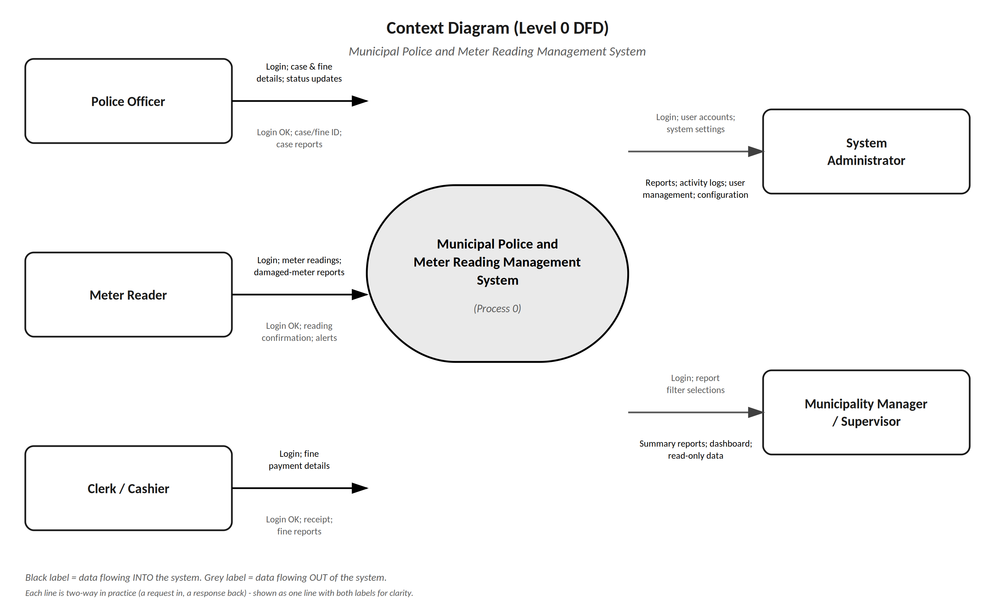
Figure 3.1: Context Diagram (Level 0 DFD) of the Municipal Police and Meter Reading Management System

3.9.1.2 Level 1 DFD - Fine Management Process
The Level 1 DFD breaks the fine management process down into its individual steps, from login through to reporting.
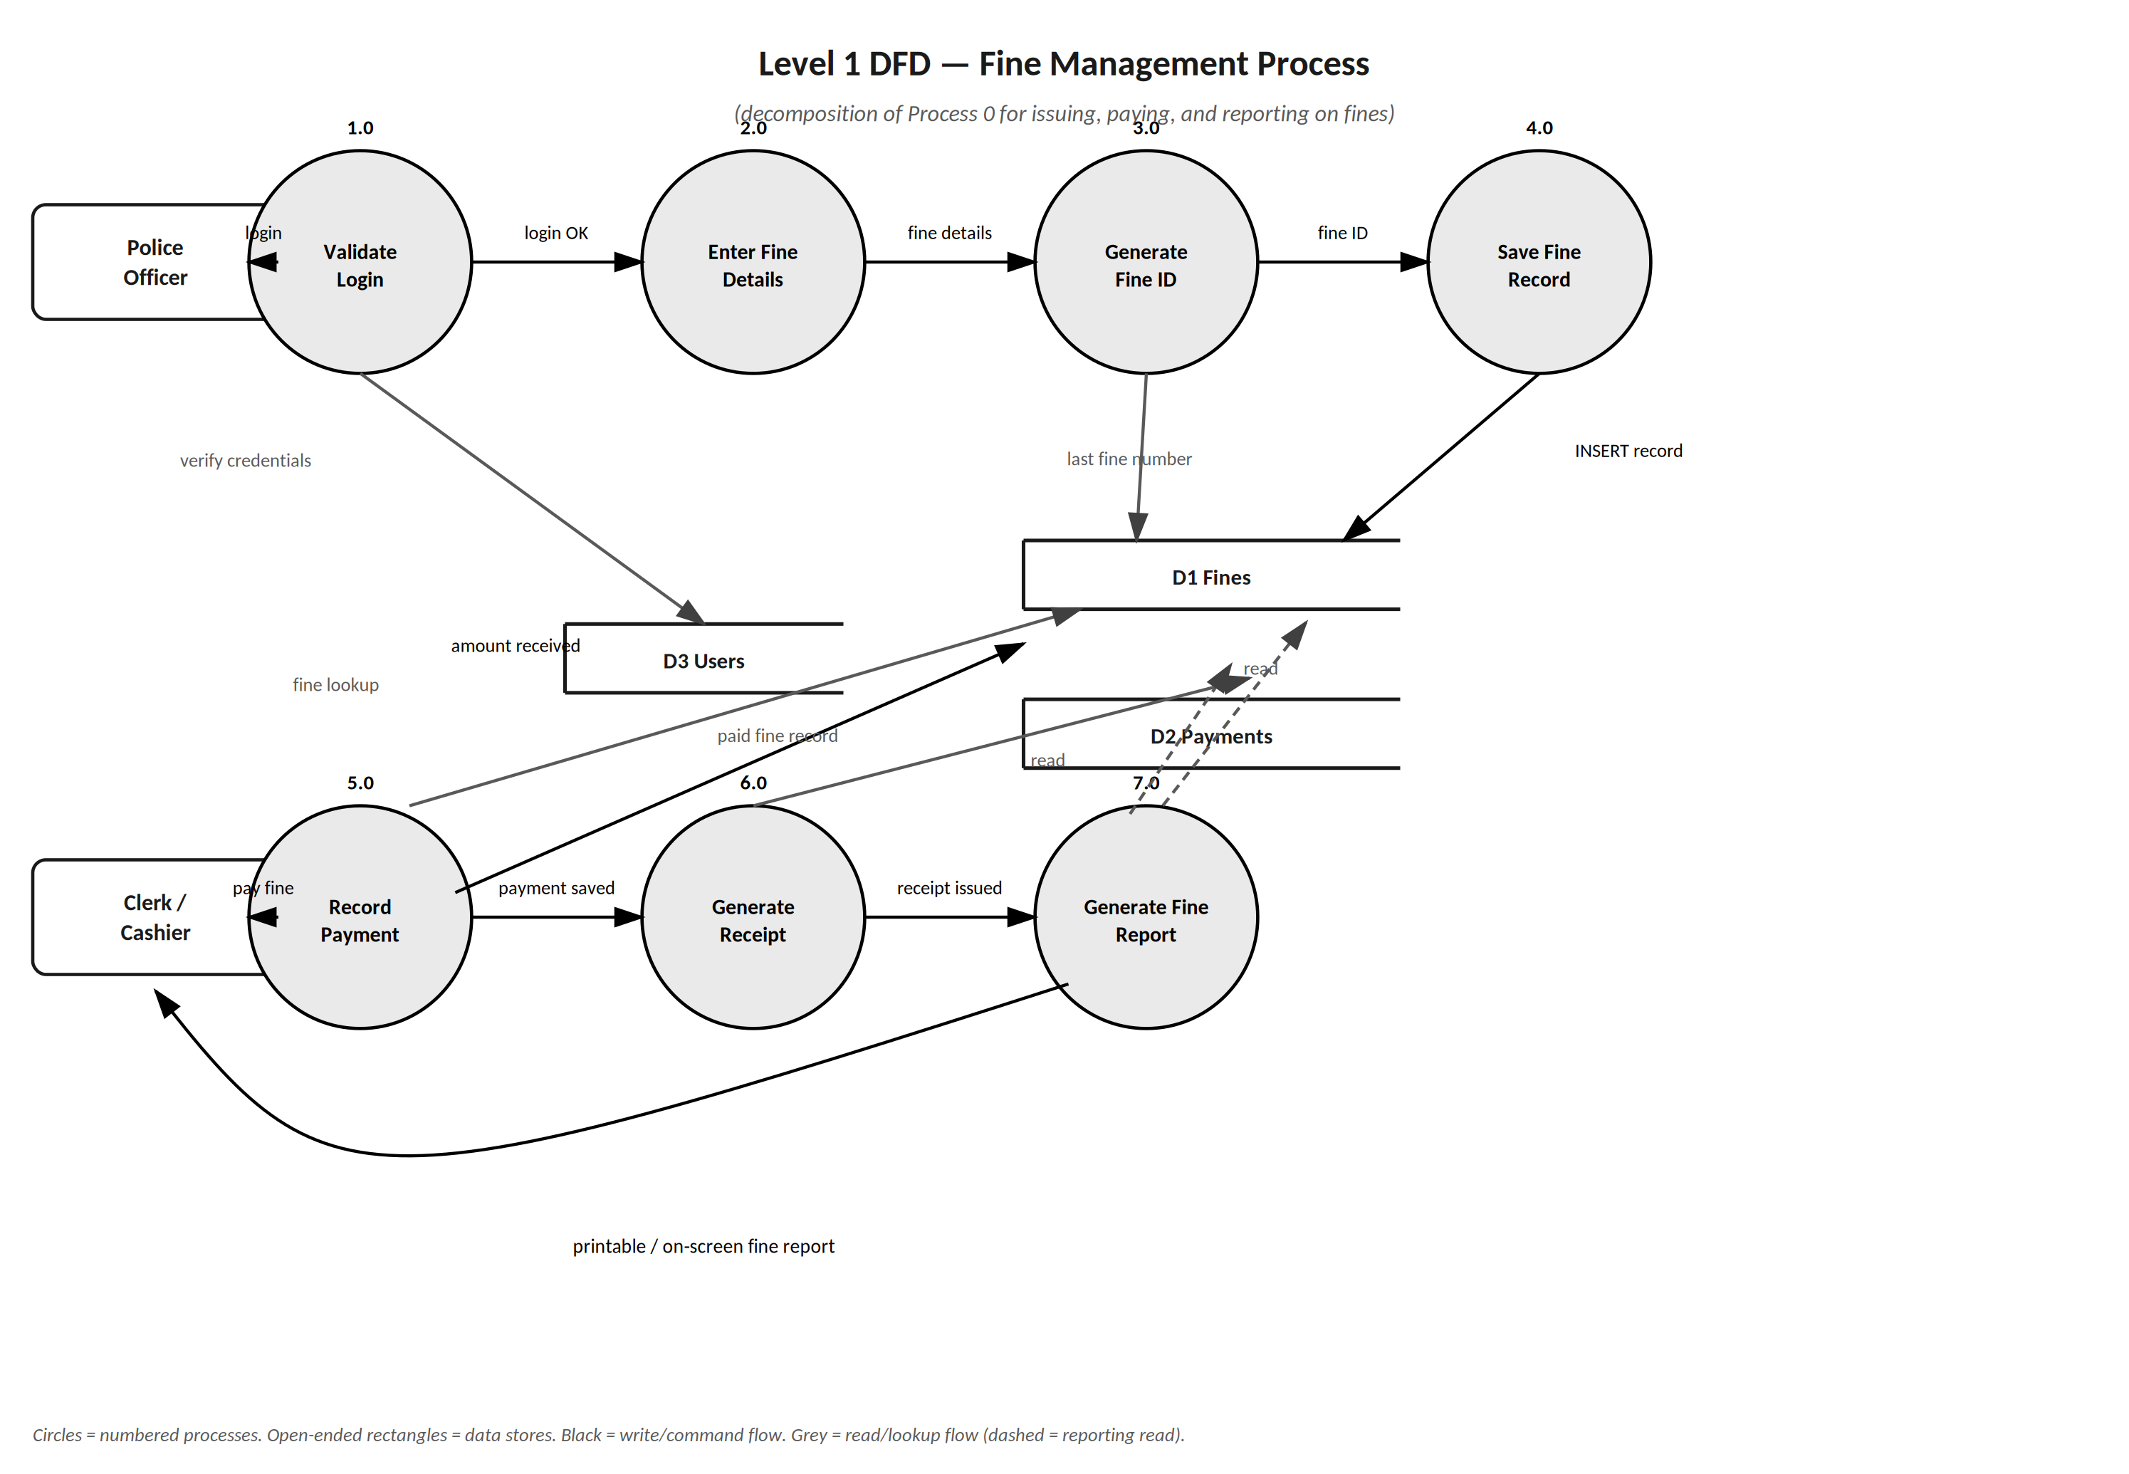
Figure 3.2: Level 1 DFD for the Fine Management process

3.9.2 Entity Relationship Diagram (ERD)
An Entity Relationship Diagram shows the database tables (entities), the fields in each table (attributes), and the relationships between tables. Primary Keys (PK) uniquely identify each record; Foreign Keys (FK) link one table to another. The full visual ERD, covering all eleven tables the system actually uses, is presented in Chapter Four, Section 4.9.2 (UML Diagrams). The tables below summarise the same structure at data-dictionary level.

3.9.2.1 Database Tables and Fields (Data Dictionary)
Table | Primary Key | Key Fields | Purpose
Users | user_id | username, password_hash, role, full_name, created_at | All system user accounts and their roles
Wards | ward_id | ward_name, description | The geographical wards Beitbridge Municipality is organised into
WardAssignments | assignment_id | ward_id (FK), user_id (FK), assigned_at | Which meter reader is assigned to which ward
Houses | house_id | house_number, ward_id (FK), owner_name, meter_number, address | All houses and their meters
Cases | case_id | case_number, offender_name, id_number, offence_type, status, officer_id (FK), date_opened | All police cases
Fines | fine_id | fine_number, case_id (FK), offender_name, house_number, vehicle_plate, amount, payment_status, issued_by (FK), date_issued | All fines issued
Payments | payment_id | fine_id (FK), amount_received, date_paid, received_by (FK), receipt_number | Fine payments and receipts
MeterReadings | reading_id | house_id (FK), previous_reading, current_reading, consumption, is_abnormal, reader_id (FK), date_taken | All water meter readings
DamagedMeters | damage_id | house_id (FK), description, reported_by (FK), date_reported, repair_status, date_fixed | Damaged meter reports and repairs
HouseVisits | visit_id | house_id (FK), reader_id (FK), visit_date, status, reading_id (FK), notes | Each day's visit outcome per house (Completed, Skipped, Vacant, etc.)
ActivityLogs | log_id | user_id (FK), action_description, ip_address, date_time | All system actions, for audit and security

3.9.2.2 Key Relationships
Relationship | Type | Explanation
Users -> Cases | One-to-Many | One police officer (user) can open and manage many cases.
Users -> Fines | One-to-Many | One police officer can issue many fines.
Cases -> Fines | One-to-Many | One case can result in multiple fines.
Fines -> Payments | One-to-One | Each fine has at most one payment record once paid.
Wards -> Houses | One-to-Many | One ward contains many houses.
Wards -> WardAssignments | One-to-Many | One ward can have several assigned meter readers over time.
Houses -> MeterReadings | One-to-Many | One house has many meter readings recorded over time.
Houses -> DamagedMeters | One-to-Many | One house can have multiple damage reports over time.
Houses -> HouseVisits | One-to-Many | One house has a visit record for each day a reader is assigned to it.
Users -> MeterReadings | One-to-Many | One meter reader can submit many readings.

3.9.3 Use Case Diagram
A Use Case Diagram shows the different user types (actors) and the actions they can perform. Each row below is a use case: a task a specific actor can carry out. The full visual Use Case Diagram is presented in Chapter Four.
Use Case / Task | Admin | Police Officer | Meter Reader | Clerk/Cashier
Log in securely | Y | Y | Y | Y
Change own password | Y | Y | Y | Y
Manage user accounts | Y
View activity logs | Y
Configure system settings | Y
Record a new police case | Y | Y
Update case status | Y | Y
Issue a fine | Y | Y
View open cases / unpaid fines | Y | Y |  | Y
Enter a water meter reading | Y |  | Y
View meter reading history | Y |  | Y
Report a damaged meter | Y |  | Y
Update repair status | Y |  | Y
Record a fine payment | Y |  |  | Y
Generate and print a PDF receipt | Y |  |  | Y
Generate reports | Y | Y | Y | Y
Enter data with no live server connection | Y | Y | Y | Y
Sync local data with the Workspace Server | Y | Y | Y | Y

3.9.4 Decision Table - Abnormal Reading Check
A decision table shows which action the system takes for each combination of conditions. The table below sets out the rules applied when a meter reading is entered (Section 3.7.4).
Condition / Action | Rule 1 | Rule 2 | Rule 3
Is the current reading greater than or equal to the previous reading? | No | Yes | Yes
Is consumption more than double the average for the house? | - | Yes | No
Action: reject the reading with an error message | X | - | -
Action: save the reading, flag it as abnormal, and show a warning | - | X | -
Action: save the reading as a normal reading | - | - | X

3.10 Requirements Specifications
My requirements specification is made up of the user requirements (Section 3.6), the functional requirements (Section 3.7), and the non-functional requirements and technical constraints (Section 3.8), supported by the analysis models in Section 3.9. Together they define what I must design in Chapter Four.
Component | Coverage
User requirements | Needs of the administrator, police officer, meter reader, clerk, and supervisor roles
Functional requirements | Seven areas: user and security management, police case management, fine management, water meter reading management, damaged meter reporting, local-first capture and synchronisation, and reporting and dashboard
Non-functional requirements | Nine categories: performance, security, reliability, usability, availability, local-first support, scalability, maintainability, and data integrity
Analysis models | Context Diagram, Level 1 DFD, ERD with data dictionary of eleven tables, use case table, and decision table

3.11 Chapter Summary
In this chapter I examined what the Municipal Police and Meter Reading Management System must do for Beitbridge Municipality.
Through the four fact-finding methods (interviews, observation, document review, and questionnaires), I reached the following conclusions:
• The current manual system is slow, unreliable, and has no backup for critical records.
• Lost paper records have caused revenue loss (an estimated $2,000 in uncollected fines in 2025, a working estimate not verified against municipal records) and poor case tracking.
• 7 of 8 staff surveyed have experienced lost or misplaced records.
• All 8 staff said internet problems have affected their work, confirming that local-first functionality is essential, not optional.
• Staff are willing to adopt a digital system, provided it stays simple to use.
The analysis diagrams (the Context Diagram, Level 1 DFD, ERD, and Use Case Diagram) map out how data moves through the system, how the database is structured across eleven tables, and which of the six user roles can perform which tasks.
The requirements specification (functional requirements across seven categories, and nine non-functional requirements) gives me a clear, measurable blueprint for the system design in Chapter Four. I present the testing plan derived from these requirements in Chapter Five, Section 5.5.

CHAPTER FOUR (4)
SYSTEM DESIGN
Municipal Police and Meter Reading Management System

4.1 Introduction
This chapter sets out the system design for the Municipal Police and Meter Reading Management System, built directly on the Requirements Specification, Data Flow Diagrams, Entity Relationship Diagram, and Use Case Diagram produced in Chapter Three, turned into a concrete design ready to be coded in Chapter Five. I built the whole system using PHP with SQLite and MySQL on the server side, together with HTML, CSS, and JavaScript for everything the user sees and interacts with, including the local-first capture logic used by officers and meter readers, which runs as real SQLite (via WebAssembly) inside the browser itself. These are the languages I am most comfortable with, and they also mean the entire system, whether or not it can currently reach the server, runs inside an ordinary web browser with nothing extra to install.
The design is presented in eight parts: Input Design, Output Design, Process Design, Database Design, File Design, User Interface Design, System Controls Design, and UML Diagrams. Together they cover the five weighted design areas of the project, each worth 5% of the overall project mark.

4.2 Input Design
Input design covers the on-screen forms used to capture data. I use drop-down lists and radio buttons wherever possible instead of free typing, since that cuts down on typing errors, and every form applies the validation controls described in Section 4.8.
Form | Key Fields / Controls | Validation Applied
Login Form | Username (text box), Password (masked text box), Login button | Both fields required; password never displayed in plain text
Police Case Form | Case No. (auto), Offender Name, National ID, House No./Plate No., Offence Type (dropdown), Description, Officer (auto from session) | All fields required except description; National ID format check
Fine Issue Form | Fine ID (auto-generated), Case No. (optional dropdown), Offender Name, House No./Plate No., Offence Type (dropdown), Amount (numeric), Date (auto) | Amount must be numeric and greater than zero
Meter Reading Form | House No. (searchable dropdown), Meter No. (auto), Previous Reading (auto-filled), Current Reading (numeric), Date (auto) | Current reading must be greater than or equal to the previous reading
Damaged Meter Report Form | House No. (dropdown), Description, Photo Upload (file), Reported By (auto) | Description required; photo optional, image files only
Payment Form | Fine ID (search/select), Amount Received (numeric), Date Paid (auto), Received By (auto) | Amount received must equal the outstanding fine amount

Example: When a meter reader selects house number 142 on the Meter Reading Form, the system automatically fills in the Previous Reading field from the last saved record, so the reader only needs to type the new Current Reading.

4.3 Output Design
Outputs are designed to be clear, printable, and available on screen in real time. The main outputs are the dashboard, PDF receipts, and the four report types below.
Output | Format | Content
Dashboard | On-screen, auto-refreshing | Total fines issued this month, open cases, total unpaid fines, pending damaged-meter repairs
Fine Receipt | PDF, printable | Fine ID, offender details, offence, amount, payment date, issuing officer, municipality logo
Police Case Report | PDF / on-screen, filterable | Case ID, offender, offence, status, officer, date opened
Fine Report | PDF / on-screen, filterable | Fine ID, offender, amount, payment status, date
Meter Reading Report | PDF / on-screen, filterable | House number, ward, previous/current reading, consumption, abnormal flag
Damaged Meter Report | PDF / on-screen, filterable | House number, ward, description, status, date reported, date fixed
Sync Status | On-screen (per workstation) | Pending, synced, and error counts for this workstation, last successful push/pull time

4.4 Process Design
Here I describe, in structured English, how the system transforms inputs into outputs for the most critical processes identified in the Level 1 DFD (Chapter Three): generating a fine, detecting an abnormal meter reading, and synchronising a local record to the central server.
Step | Process: Generate Fine ID and Save Fine
1 | START
2 | READ officer input (offender, offence, amount, house/plate number)
3 | QUERY the local database for the last fine number issued this year
4 | SET new_number = last_number + 1
5 | SET fine_id = "FINE-" + current_year + "-" + new_number (zero-padded)
6 | GENERATE a unique sync_id for this fine
7 | INSERT the fine record into the local SQLite database, status = PENDING (this step always happens, regardless of server reachability)
8 | QUEUE the record for the central Workspace Server in the same local transaction
9 | SET payment_status = "Unpaid"
10 | DISPLAY confirmation with fine_id to the officer - "saved on this device and queued to sync"
11 | IF the workstation can currently reach the server THEN attempt an immediate push (opportunistic, does not block the officer)
12 | END

Step | Process: Calculate Consumption and Flag Abnormal Reading
1 | START
2 | READ current_reading entered by the meter reader
3 | RETRIEVE previous_reading for the selected house_id
4 | SET consumption = current_reading - previous_reading
5 | RETRIEVE average_consumption for that house over recent readings
6 | IF consumption > (2 x average_consumption) THEN SET is_abnormal = TRUE
7 | SAVE the reading record locally with consumption and is_abnormal flag
8 | IF is_abnormal = TRUE THEN, once synced, DISPLAY warning "Warning: this reading looks unusually high" (this check runs server-side once the record reaches the server, so it applies to every reading whether captured online or offline)
9 | END

Step | Process: Push a Pending Record to the Workspace Server
1 | START (cli_sync_engine.php, running continuously on the workstation)
2 | READ up to 50 PENDING records from the local outbox (LocalSyncQueue)
3 | IF none pending THEN check reachability only and END this cycle
4 | MARK the batch SYNCING; POST it to the Workspace Server with the shared sync key
5 | IF the request fails or times out THEN SET the batch back to PENDING and END this cycle (nothing is lost; it retries automatically)
6 | FOR each record in the server's response: IF accepted THEN MARK it SYNCED locally; IF flagged as a possible duplicate THEN MARK it for admin review, still keeping the local copy
7 | END

4.5 Database Design

4.5.1 Database Design Approach
The database design converts the logical ERD from Chapter Three into a physical relational schema. I normalised all tables to Third Normal Form (3NF) to cut down on repeated data: every non-key field depends only on the primary key of its own table, and details that would otherwise repeat (such as an offender's name on every fine) are referenced through foreign keys back to the Cases and Users tables.
I implemented the same schema twice: once in SQLite (the local database every workstation writes to first) and once in MySQL (the central Workspace Server, the authoritative copy once more than one workstation is in use). The three tables that are captured locally in the field (MeterReadings, Fines, and HouseVisits) carry four extra columns in the local SQLite file, not shown in the Chapter Three data dictionary: sync_id (a globally unique idempotency key), device_id (which workstation the record came from), sync_status (PENDING until the server acknowledges the record, then SYNCED), and synced_at. One further table exists only on the local side: LocalSyncQueue, the outbox that cli_sync_engine.php drains (its statuses are PENDING, SYNCING, RETRY, SYNCED, and SYNC_ERROR). Records saved through the browser-side store are identified on the central tables by client_ref instead. The complete central MySQL script, schema.mysql.sql, creates all eleven tables in dependency order.

4.5.2 Physical Table Design
The tables below give the physical field list, data types, and constraints for each of the eleven entities identified in the ERD (Chapter Three, Section 3.9.2).
Table: Users
Field | Data Type | Constraint
user_id | INT | PK, AUTO_INCREMENT
username | VARCHAR(50) | NOT NULL, UNIQUE
password_hash | VARCHAR(255) | NOT NULL (bcrypt hash)
Role | ENUM('Admin','Officer','MeterReader','Clerk','PoliceSupervisor','MeterSupervisor') | NOT NULL
full_name | VARCHAR(100) | NOT NULL
is_active | TINYINT(1) | NOT NULL, DEFAULT 1 (1 = active, 0 = deactivated)
created_at | DATETIME | NOT NULL, DEFAULT CURRENT_TIMESTAMP

Table: Wards
Field | Data Type | Constraint
ward_id | INT | PK, AUTO_INCREMENT
ward_name | VARCHAR(50) | NOT NULL, UNIQUE
description | VARCHAR(200) | NULLABLE

Table: WardAssignments
Field | Data Type | Constraint
assignment_id | INT | PK, AUTO_INCREMENT
ward_id | INT | FK -> Wards.ward_id, NOT NULL
user_id | INT | FK -> Users.user_id, NOT NULL
assigned_at | DATETIME | NOT NULL, DEFAULT CURRENT_TIMESTAMP

Table: Houses
Field | Data Type | Constraint
house_id | INT | PK, AUTO_INCREMENT
house_number | VARCHAR(15) | NOT NULL
Street | VARCHAR(80) | NULLABLE
ward_id | INT | FK -> Wards.ward_id, NULLABLE
owner_name | VARCHAR(80) | NOT NULL
meter_number | VARCHAR(20) | NOT NULL, UNIQUE
address | VARCHAR(150) | NULLABLE

Table: Cases
Field | Data Type | Constraint
case_id | INT | PK, AUTO_INCREMENT
case_number | VARCHAR(20) | NOT NULL, UNIQUE
offender_name | VARCHAR(60) | NOT NULL
id_number | VARCHAR(20) | NULLABLE
offence_type | VARCHAR(50) | NOT NULL
description | TEXT | NULLABLE
Status | ENUM('Open','In Progress','Closed') | NOT NULL, DEFAULT 'Open'
officer_id | INT | FK -> Users.user_id, NULLABLE
date_opened | DATETIME | NOT NULL

Table: Fines
Field | Data Type | Constraint
fine_id | INT | PK, AUTO_INCREMENT
fine_number | VARCHAR(20) | NOT NULL, UNIQUE
case_id | INT | FK -> Cases.case_id, NULLABLE
offender_name | VARCHAR(60) | NOT NULL
house_number | VARCHAR(15) | NULLABLE
vehicle_plate | VARCHAR(15) | NULLABLE
offence_type | VARCHAR(50) | NOT NULL
amount | DECIMAL(10,2) | NOT NULL, > 0
payment_status | ENUM('Unpaid','Paid') | NOT NULL, DEFAULT 'Unpaid'
issued_by | INT | FK -> Users.user_id, NULLABLE
date_issued | DATETIME | NOT NULL
client_ref | VARCHAR(40) | NULLABLE, UNIQUE (browser-tier idempotency key)
is_duplicate_flagged | TINYINT(1) | NOT NULL, DEFAULT 0 (1 = flagged for administrator review)
duplicate_resolved_by | INT | FK -> Users.user_id, NULLABLE
duplicate_resolved_at | DATETIME | NULLABLE
discarded_at | DATETIME | NULLABLE (set when an administrator discards a duplicate)
discarded_by | INT | FK -> Users.user_id, NULLABLE
discard_reason | VARCHAR(200) | NULLABLE

Table: Payments
Field | Data Type | Constraint
payment_id | INT | PK, AUTO_INCREMENT
fine_id | INT | FK -> Fines.fine_id, NOT NULL, UNIQUE
amount_received | DECIMAL(10,2) | NOT NULL
date_paid | DATETIME | NOT NULL
received_by | INT | FK -> Users.user_id, NULLABLE
receipt_number | VARCHAR(20) | NOT NULL, UNIQUE

Table: MeterReadings
Field | Data Type | Constraint
reading_id | INT | PK, AUTO_INCREMENT
house_id | INT | FK -> Houses.house_id, NOT NULL
previous_reading | DECIMAL(10,2) | NOT NULL
current_reading | DECIMAL(10,2) | NOT NULL, >= previous_reading
consumption | DECIMAL(10,2) | NOT NULL (current - previous, computed by the application)
is_abnormal | BOOLEAN | NOT NULL, DEFAULT 0
reader_id | INT | FK -> Users.user_id, NULLABLE
date_taken | DATE | NOT NULL
client_ref | VARCHAR(40) | NULLABLE (browser-tier idempotency key)
is_duplicate_flagged | TINYINT(1) | NOT NULL, DEFAULT 0 (1 = flagged for administrator review)
duplicate_resolved_by | INT | FK -> Users.user_id, NULLABLE
duplicate_resolved_at | DATETIME | NULLABLE
discarded_at | DATETIME | NULLABLE (set when an administrator discards a duplicate)
discarded_by | INT | FK -> Users.user_id, NULLABLE
discard_reason | VARCHAR(200) | NULLABLE

Table: DamagedMeters
Field | Data Type | Constraint
damage_id | INT | PK, AUTO_INCREMENT
house_id | INT | FK -> Houses.house_id, NOT NULL
description | TEXT | NOT NULL
photo_path | VARCHAR(255) | NULLABLE
reported_by | INT | FK -> Users.user_id, NULLABLE
date_reported | DATETIME | NOT NULL
repair_status | ENUM('Pending','In Progress','Fixed') | NOT NULL, DEFAULT 'Pending'
date_fixed | DATETIME | NULLABLE

Table: HouseVisits
Field | Data Type | Constraint
visit_id | INT | PK, AUTO_INCREMENT
house_id | INT | FK -> Houses.house_id, NOT NULL
reader_id | INT | FK -> Users.user_id, NOT NULL
visit_date | DATE | NOT NULL
Status | ENUM('Pending','Completed','Skipped','DamagedMeter','Vacant','Locked','IllegalConnection','RevisitRequired') | NOT NULL, DEFAULT 'Pending'
reading_id | INT | FK -> MeterReadings.reading_id, NULLABLE
Notes | TEXT | NULLABLE
updated_at | DATETIME | NOT NULL, DEFAULT CURRENT_TIMESTAMP

Table: ActivityLogs
Field | Data Type | Constraint
log_id | INT | PK, AUTO_INCREMENT
user_id | INT | FK -> Users.user_id, NULLABLE
action_description | VARCHAR(500) | NOT NULL
ip_address | VARCHAR(45) | NULLABLE
date_time | DATETIME | NOT NULL, DEFAULT CURRENT_TIMESTAMP

4.6 File Design
Besides the relational database, the system relies on a few supporting files and storage areas:
• Local database file: data/municipal_system.sqlite on every workstation; this is the "Local SQLite" every page and process reads and writes directly.
• Local outbox: the LocalSyncQueue table (the outbox that cli_sync_engine.php drains), inside the same local SQLite file.
• Browser-side local store: real SQLite compiled to WebAssembly (sql.js), running inside the browser, persisted via IndexedDB as its storage medium; this is what lets a single device keep working through a brief network drop even before its data reaches the workstation's own database.
• Photo storage folder: uploaded damaged-meter photographs are stored in /uploads/damage_photos/, with the file path saved in the photo_path field.
• PDF output: generated receipts and reports are produced on demand and served for download or printing.
• Backup file: full data snapshots can be exported on demand from the Backups screen, and restored from the same place if needed.

4.7 User Interface Design

4.7.1 Design Principles
The interface follows the user-friendliness goals I set in Chapter One: large buttons, clear labels, dropdown menus instead of free typing wherever possible, and as few steps as possible for common tasks such as issuing a fine or capturing a meter reading.

4.7.2 Navigation Menu by Role
Role | Visible Menu Items
System Administrator | Dashboard, Cases, Fines, Meter Readings, Damaged Meters, Wards, Houses, Reports, User Management, Activity Logs, Sync Status, Sync Conflicts, Backups, Settings
Police Officer | Dashboard, Cases, Fines, My Reports
Meter Reader | Dashboard, Meter Readings, Damaged Meters, My Reports
Clerk / Cashier | Dashboard, Fines, Payments, Receipts
Municipality Manager / Supervisor | Dashboard, Reports (read-only)

4.7.3 Sample Screen Layouts
The layout below shows the structure of the two most-used screens: the Login screen and the Main Dashboard. Every screen shares the same header and, where applicable, the same left-hand navigation menu shown in Section 4.7.2.
Screen Region | Login Screen | Main Dashboard
Header | Municipality logo and system title, centred | Municipality logo, logged-in user name, logout button
Left panel | (not shown) | Role-based navigation menu (Section 4.7.2)
Main area | Username box, password box, Login button, error message area | Summary cards (open cases, unpaid fines, this month's fines, pending repairs) plus quick-action buttons
Footer | Municipality contact details | Municipality contact details, system version

4.8 System Controls Design

4.8.1 Input Validation Controls
• Mandatory field checks: required fields (e.g. offender name, amount) cannot be left blank before submission.
• Format checks: fields such as amount and readings only accept numeric values; dates use a date picker to prevent invalid dates.
• Range checks: fine amount must be greater than zero; current meter reading must be greater than or equal to the previous reading.
• Dropdown/list restriction: offence types, wards, and statuses are selected from predefined lists to prevent inconsistent free-text entries.

4.8.2 Security Controls
• Passwords are hashed with bcrypt (PHP password_hash()) and never stored or displayed as plain text.
• Role-based access control restricts each user to the modules listed in Section 4.7.2; unauthorised access attempts are blocked and logged.
• Session timeout automatically logs a user out after a period of inactivity.
• Account lockout: after repeated failed login attempts, the account is temporarily locked. The attempt counter is held in the PHP session, so it limits guessing within one browser session; moving it into the database is a planned hardening step (Section 7.6).
• Every workstation-to-Workspace-Server sync request carries a shared authentication key; requests without a valid key are rejected.
• Every login, data entry, and report generation is recorded in the ActivityLogs table with username, action, and timestamp.

4.8.3 Error Handling and Data Integrity Controls
• Referential integrity: foreign keys (e.g. officer_id, house_id) prevent a record from being saved if it references a non-existent parent record.
• Idempotent sync: every locally captured record carries a unique sync_id, so if the same push is retried after a dropped connection, the Workspace Server recognises it and does not create a duplicate.
• Duplicate detection: records that genuinely look like separate entries for the same event (matching house and date, or matching offender and date) are flagged for administrator review rather than silently merged or discarded.
• Transaction handling: a record's local save and its queue entry for central sync are written in a single local transaction, so a failure part-way through never leaves one without the other.
• User-friendly error messages: technical database errors are never shown to the user; plain-language messages (e.g. "Please enter both a username and a password.") are displayed instead.

4.9 UML Diagrams
The following diagrams model the system from several complementary views: the actors and functions (Use Case Diagram), the data structure (Entity Relationship Diagram and Class Diagram), the interaction between components over time (Sequence Diagram), the flow of the local-first synchronisation process (Activity Diagram), and how the pieces are physically deployed across workstations and the central server (Sync Architecture Diagram).

4.9.1 Use Case Diagram
The Use Case Diagram extends the actor list from the Context Diagram (Chapter Three, Section 3.9.1.1) into the specific functions each actor can perform.
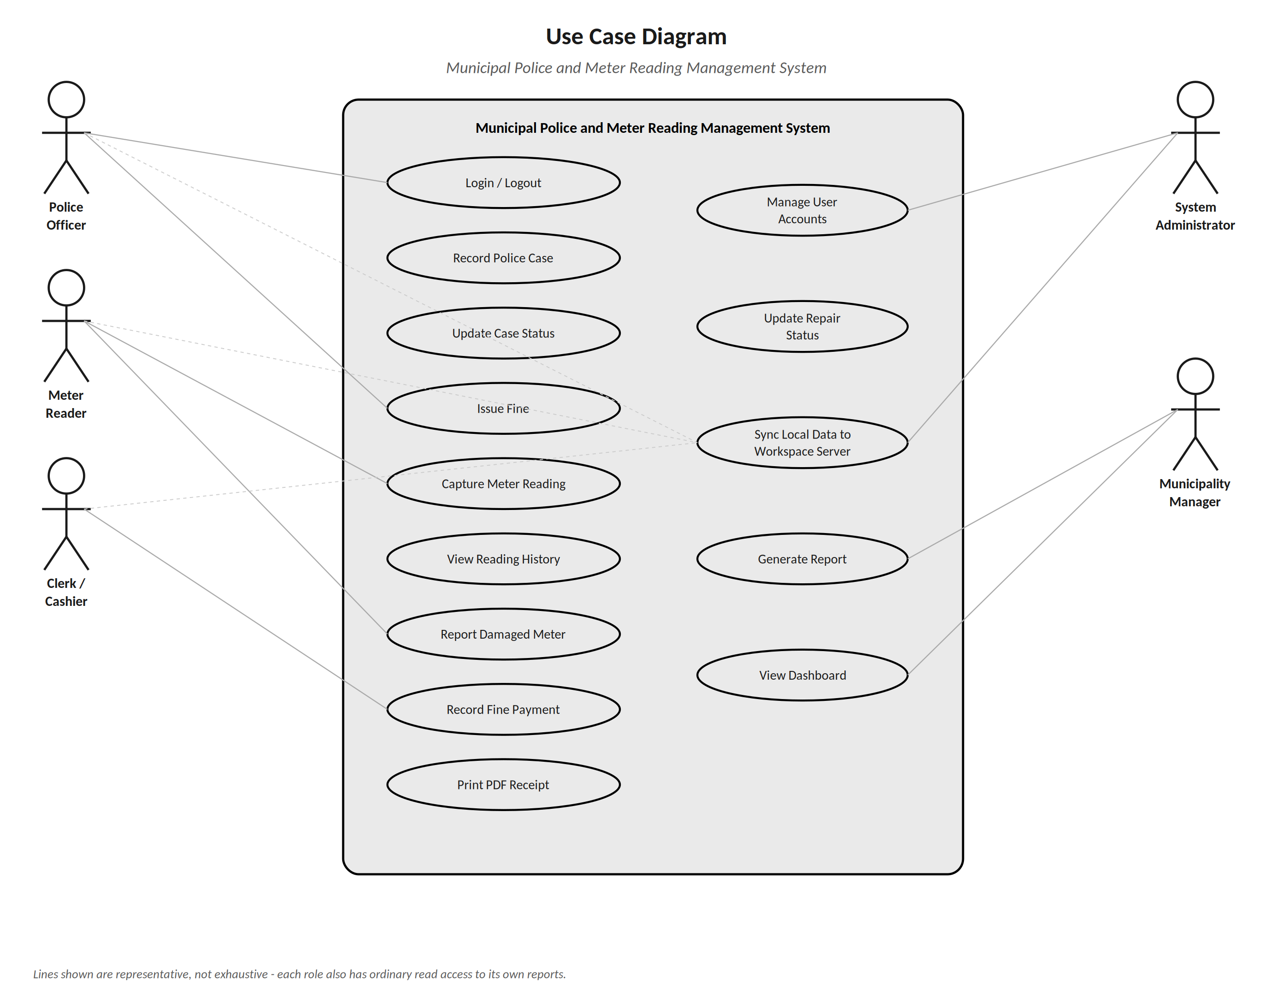
Figure 4.1: Use Case Diagram

4.9.2 Entity Relationship Diagram
The ERD shows all eleven database tables, their key fields, and the cardinality of every relationship between them, extending the data dictionary in Chapter Three, Section 3.9.2.
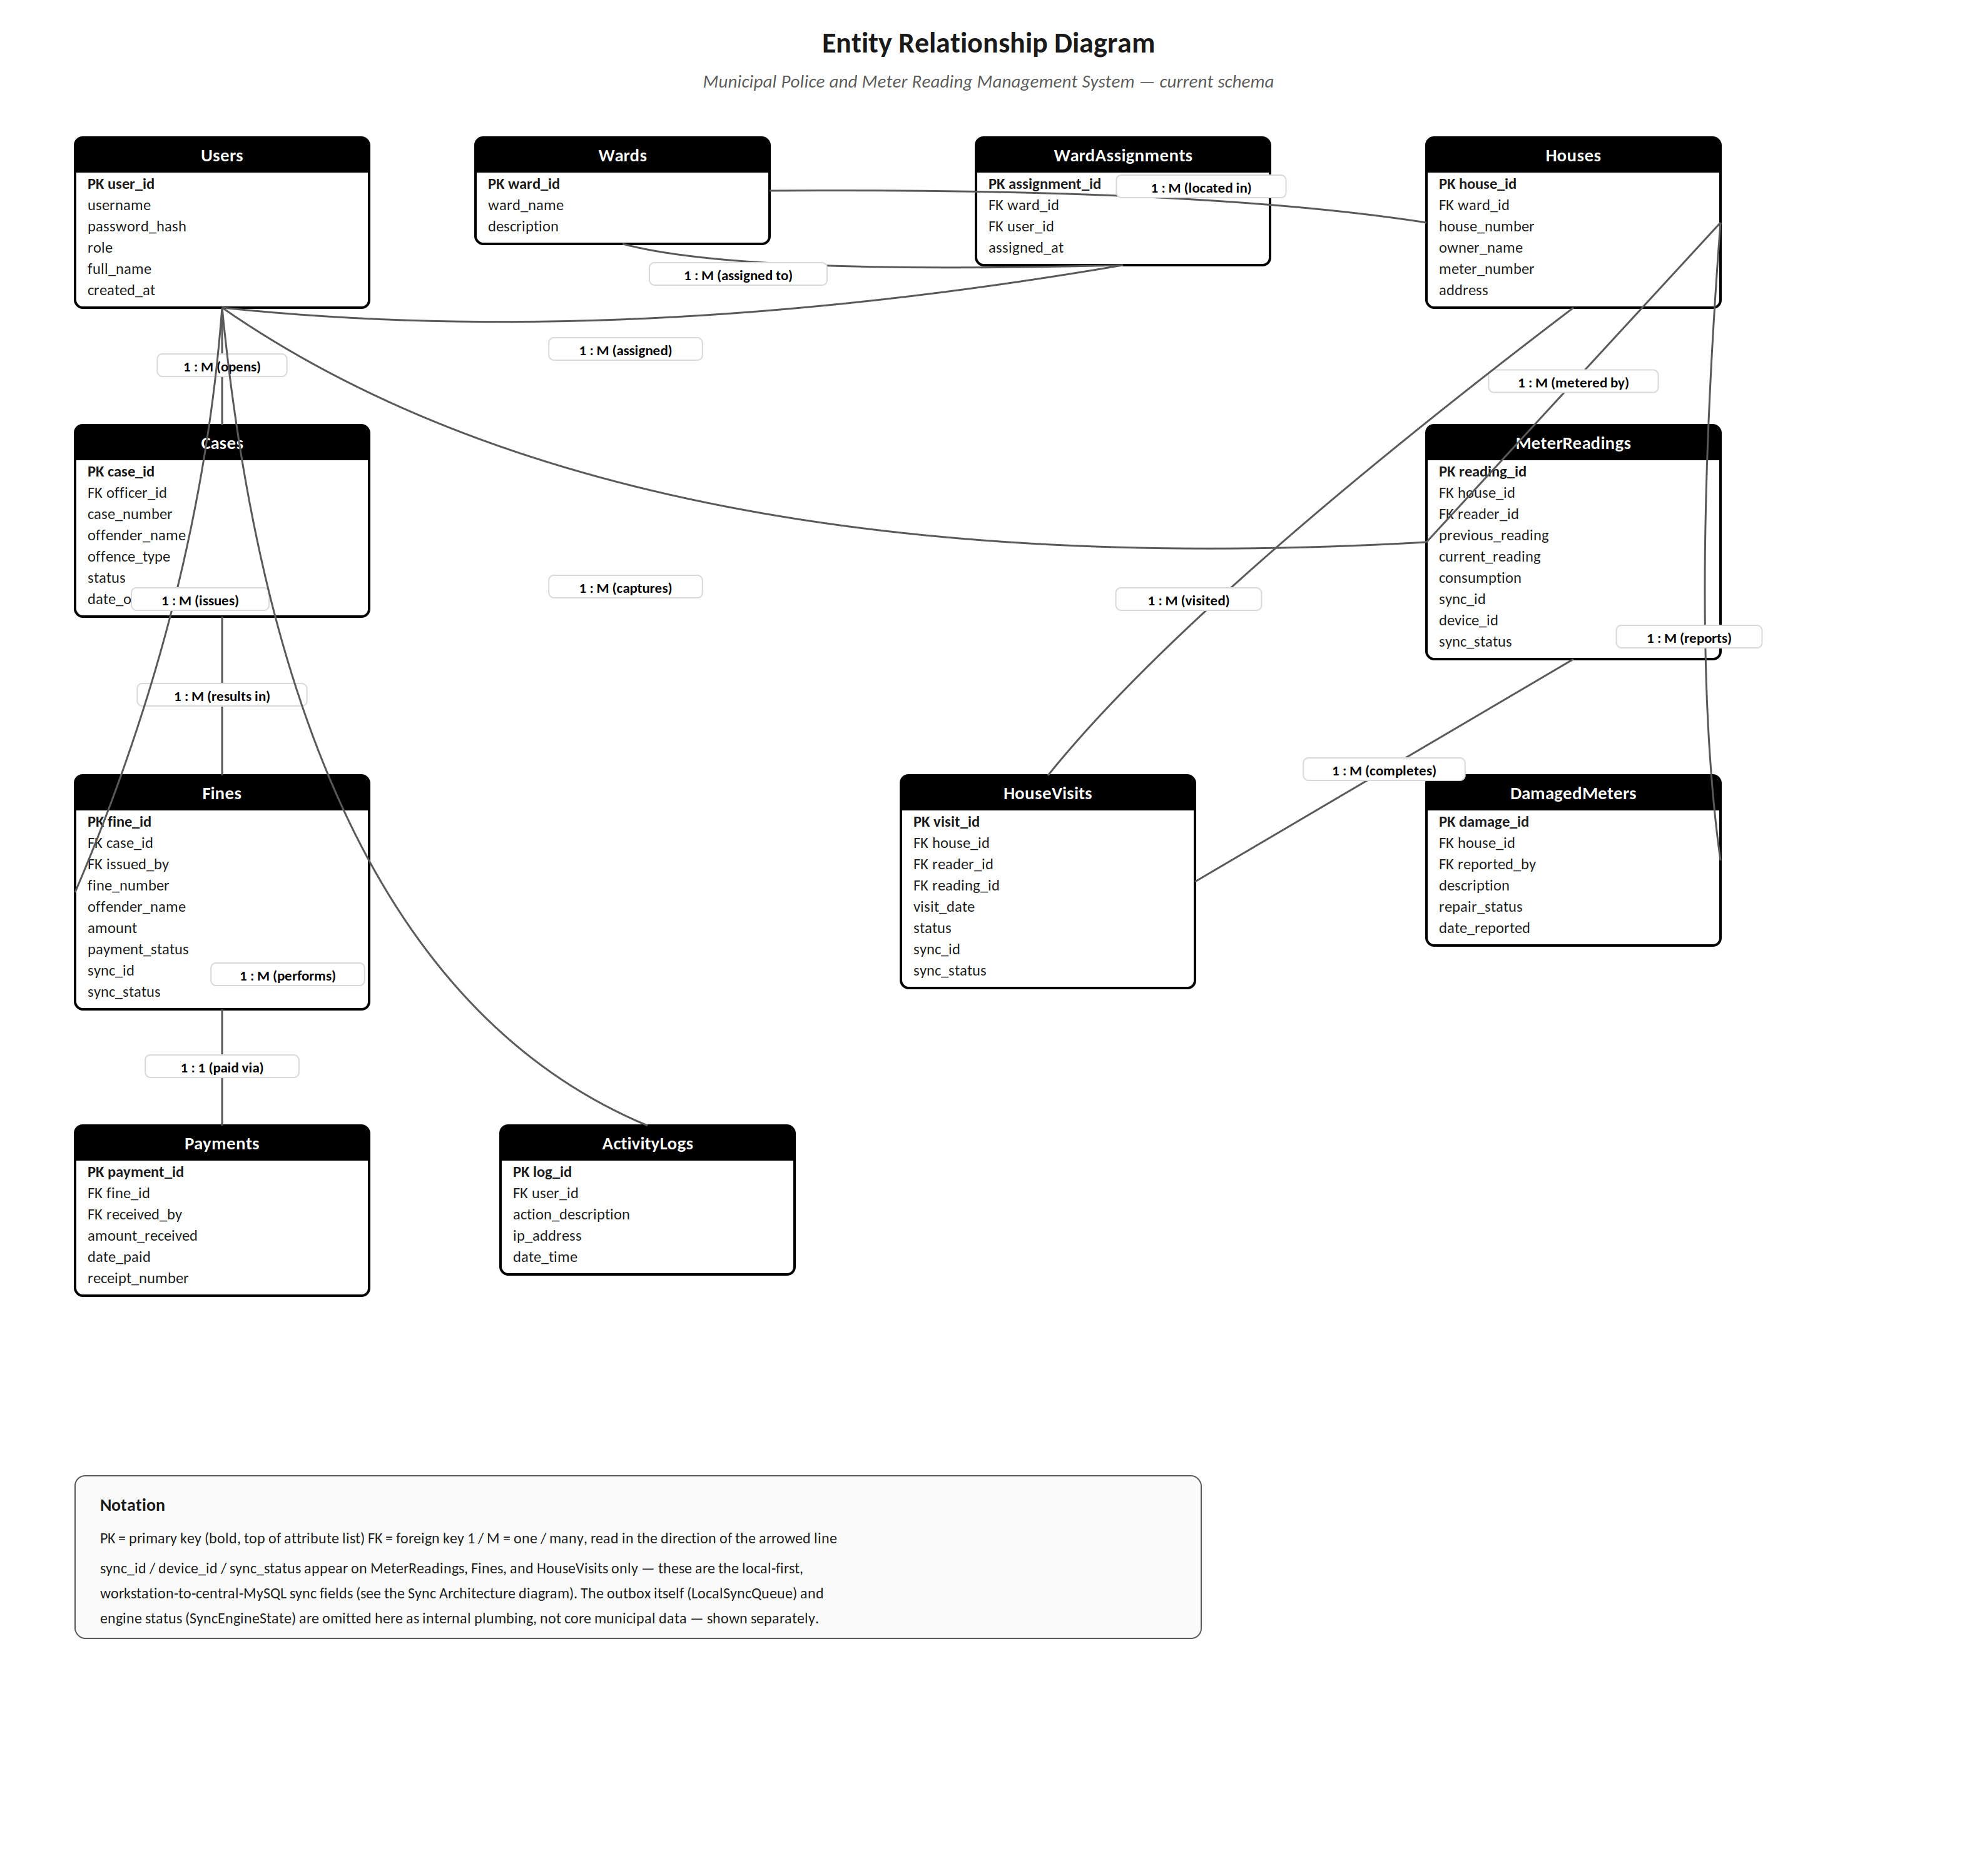
Figure 4.2: Entity Relationship Diagram

4.9.3 Class Diagram
The Class Diagram translates the eleven database tables from Section 4.5.2 into classes with their attributes and key methods, showing the same cardinalities as the ERD above.
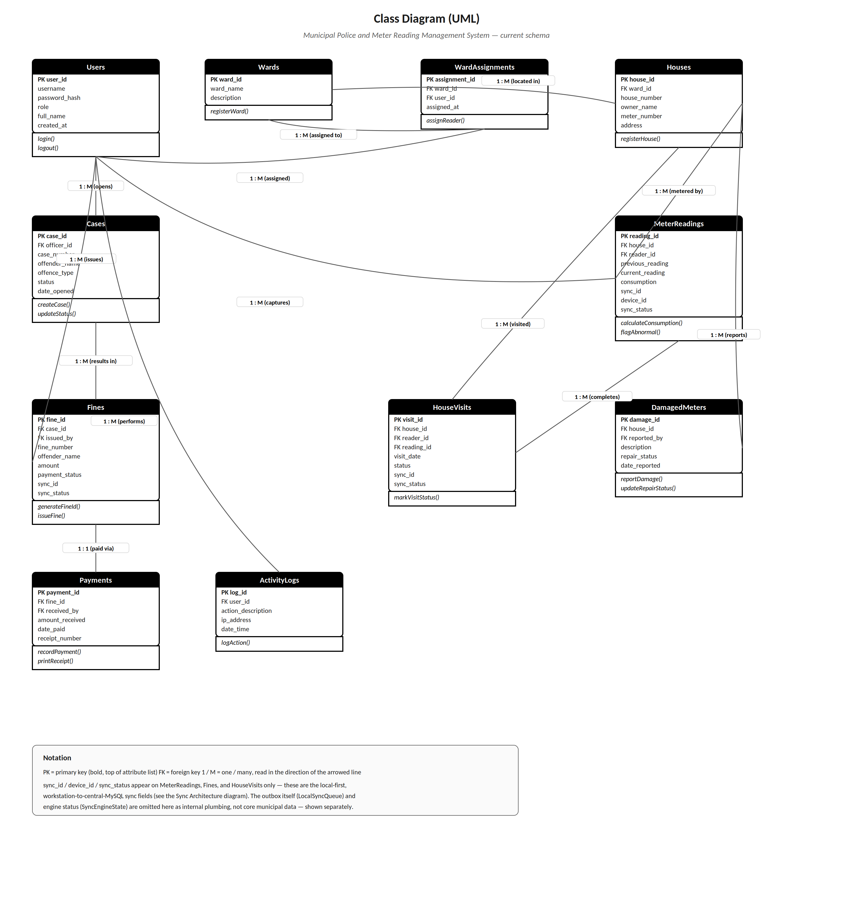
Figure 4.3: Class Diagram

4.9.4 Sequence Diagram - Issue Fine and Record Payment
This diagram traces the object interactions for the fine-issuing process described in Section 4.4, from data entry through to receipt printing.
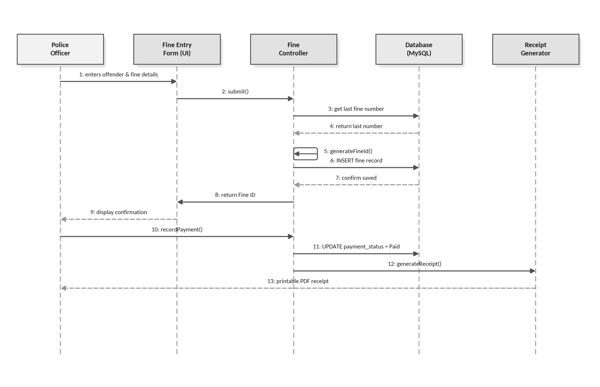
Figure 4.4: Sequence Diagram - Issue Fine

4.9.5 Activity Diagram - Local-First Save and Sync
This diagram models the local-first capture and synchronisation logic specified functionally in Chapter Three, Section 3.7.6: every record is written locally first, unconditionally, and only then does the system attempt an opportunistic push to the server.
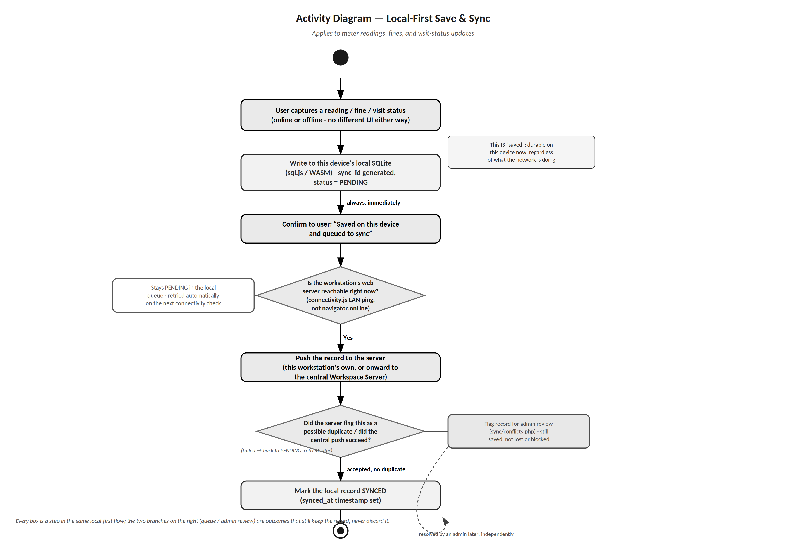
Figure 4.5: Activity Diagram - Local-First Save and Sync

4.9.6 Sync / Deployment Architecture Diagram
This diagram shows how the pieces are physically deployed: each field workstation with its own local SQLite database and background sync engine, and the central Workspace Server with its MySQL database, connected only over the municipal LAN.
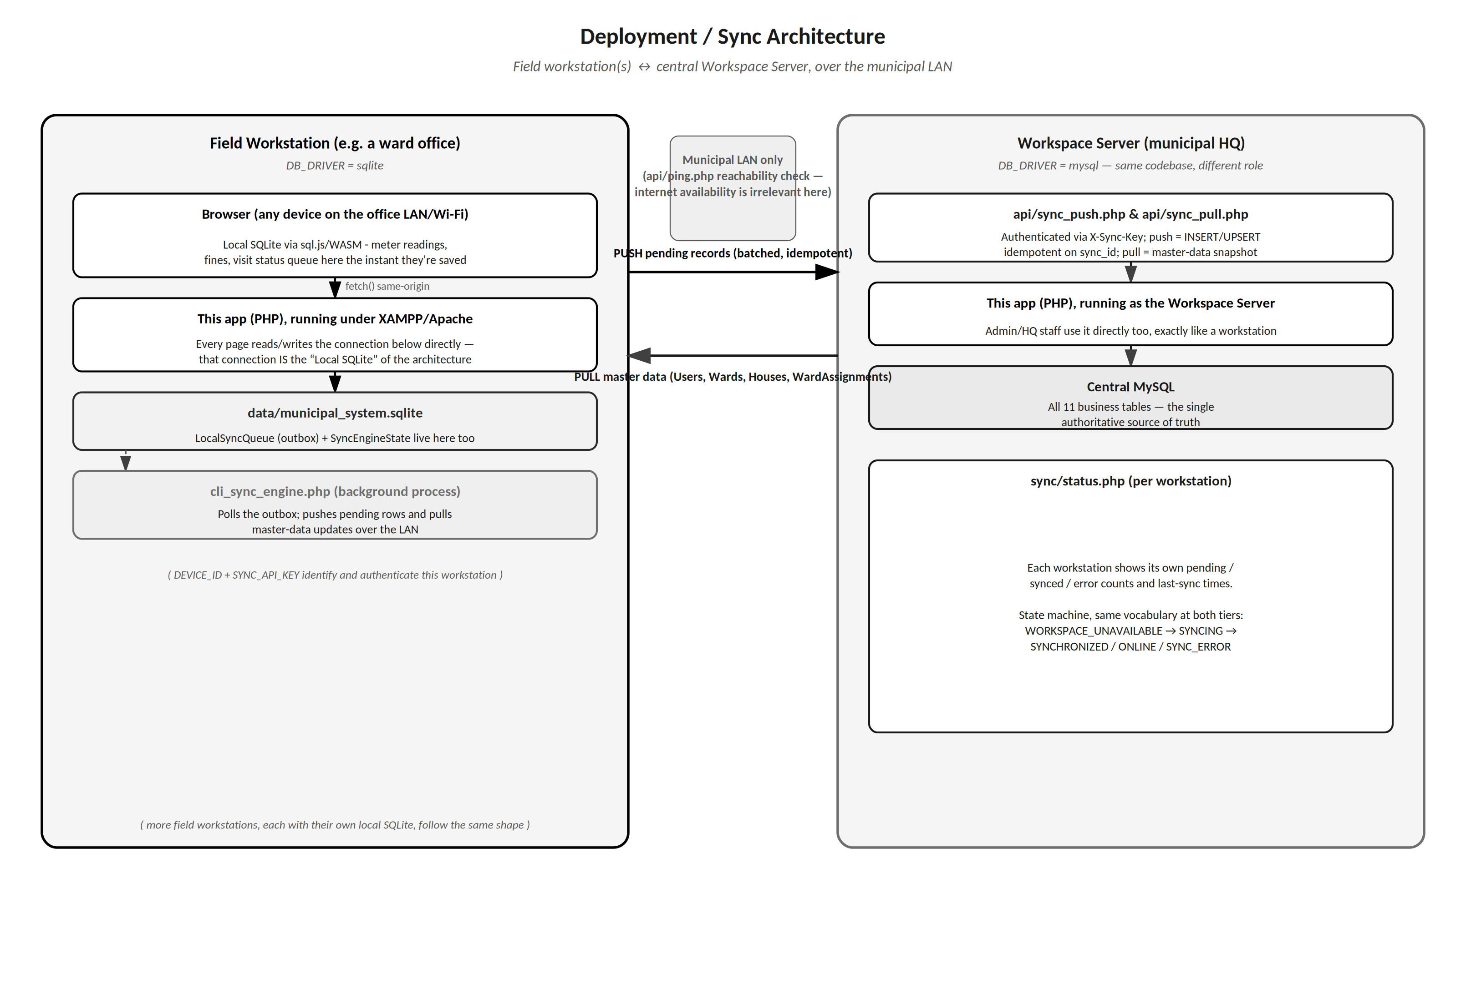
Figure 4.6: Sync / Deployment Architecture

4.10 Chapter Summary
In this chapter I took the requirements from Chapter Three and turned them into a design ready to code. The input, output, and process design set out exactly what each screen captures and produces; the database design normalises the eleven-table schema to 3NF and defines physical data types and constraints for both SQLite and MySQL; the user interface design lays out role-based navigation and the key screens; the system controls define the validation, security, and data-integrity safeguards; and the six diagrams give a full static and dynamic view of how everything fits together, including how it is deployed across more than one workstation.
Together, these design artefacts give me enough detail to move into Chapter Five (Coding and Testing), building the system using PHP with SQLite and MySQL on the server side and HTML, CSS, and JavaScript on the client side, including the local-first capture tool, as explained in Section 4.1.

CHAPTER FIVE (5)
CODING AND TESTING
Municipal Police and Meter Reading Management System

5.1 Introduction
Coding and testing is where the design became a working system. I took the physical design from Chapter Four (the database schema, the screen layouts, and the system controls) and turned it into working program code. I built the server side using PHP with SQLite and MySQL, and used HTML, CSS, and JavaScript for the interface itself, including the local-first capture screens used by officers and meter readers in areas where the network is unreliable. I chose this stack because it is the one I know best, and because it means the whole system, local-first capture tool included, runs from a normal web browser rather than needing a separate installed application.
The chapter follows the order in which the work was done: the development environment (Section 5.2), the language and tools (Section 5.3), the modules I built (Section 5.4), and then the testing strategy, test data, test results, and bug fixes (Sections 5.5 to 5.8). The evidence for Programming Quality / User-Friendliness (4%) and Program Resilience / Non-Crash Properties (3%) is in Section 5.3, and Sections 5.5 to 5.7 cover Testing of Data Samples (4%).

5.2 Development Environment (Software and Hardware Used)
I developed and tested the system on the following hardware and software.
Component | Details
Development computer | Laptop computer running Windows [model, processor, RAM, and storage to be completed]
Local web server | XAMPP (Apache, PHP 8.1 or later, and MySQL 8.0 or later)
Local database | SQLite, bundled with PHP
Code editor | Visual Studio Code
Version control and backup | Git, with a remote repository on GitHub
Browser | A modern web browser (Chrome, Edge, Firefox, or Safari)
Documentation | Microsoft Word

5.3 Programming Language and Tools
Language / Tool | Used For
PHP | Server-side logic, input validation, fine ID generation, receipts and reports, and the synchronisation endpoints and background sync engine (cli_sync_engine.php)
JavaScript | Browser-side interaction, form validation, and the local-first capture logic
HTML5 and CSS3 | Page structure and styling of every screen
SQLite and sql.js | Local database on every workstation; sql.js is SQLite compiled to WebAssembly, running inside the browser and persisted through IndexedDB
MySQL | Central database on the Workspace Server
XAMPP, VS Code, Git, and GitHub | Development environment, code editing, version control, and off-site backup of the code

5.3.1 Programming Quality (User-Friendliness)
I focused on programming quality by keeping my naming conventions consistent, commenting each function, validating input before it ever reaches the database, and giving the user clear, non-technical feedback at every step, in line with the interface design in Chapter Four, Section 4.7.

5.3.1.1 Coding Standards Followed
• Variables and functions use descriptive camelCase names (e.g. $fineAmount, generateFineId()) rather than single letters.
• Every function begins with a short comment describing its purpose, parameters, and return value.
• Database access is centralised through shared helper functions (getDb(), logActivity()) so connection details are defined once, not repeated in every file.
• All user-facing text (labels, buttons, messages) follows a consistent tone across every screen.

5.3.1.2 Sample Code - Input Validation (PHP)
The extract below shows server-side validation for the Fine Issue form (Chapter Four, Section 4.2), rejecting incomplete or invalid submissions before any database write is attempted.
// validateFineInput.php
// Validates a new fine submission before it is saved.
function validateFineInput(array $data): array {
$errors = [];
if (empty($data['offenderName'])) {
$errors[] = 'Offender name is required.';
}
if (empty($data['offenceType'])) {
$errors[] = 'Please select an offence type.';
}
if (!isset($data['amount']) || !is_numeric($data['amount'])
|| $data['amount'] <= 0) {
$errors[] = 'Fine amount must be a number greater than zero.';
}
return $errors; // empty array = input is valid
}

5.3.1.3 Sample Code - Automatic Fine ID Generation (PHP)
This function implements the process design specified in Chapter Four, Section 4.4, generating a unique, human-readable fine ID such as FINE-2026-0048.
// Builds a unique, year-based Fine ID from the last issued number.
function generateFineId(PDO $db): string {
$year = date('Y');
$stmt = $db->prepare(
'SELECT fine_number FROM Fines WHERE fine_number LIKE :pattern
ORDER BY fine_id DESC LIMIT 1'
);
$stmt->execute(['pattern' => "FINE-{$year}-%"]);
$last = $stmt->fetchColumn();
$nextNumber = $last ? ((int) substr($last, -4)) + 1 : 1;
return sprintf('FINE-%s-%04d', $year, $nextNumber);
}

5.3.1.4 Sample Code - Local-First Meter Reading Save (JavaScript)
This is the client-side function behind the Save Reading button, implementing the local-first design specified in Chapter Four, Section 4.9.5 (Activity Diagram). Every reading is written to the local SQLite queue first, unconditionally (that write is what "saved" means), and only afterwards does the code make an opportunistic attempt to push it on to the server, using the real connectivity check from connectivity.js rather than the browser's navigator.onLine flag, which only reports whether some network interface is up, not whether the municipal server actually answers.
// meter-reading.js (extract)
// Local-first: write to the device queue FIRST, always - that IS
// "saved" from here on. Only then try an opportunistic push.
async function saveReading(payload) {
try {
await queueRecord('reading', payload, window.CURRENT_USER_ID);
} catch (err) {
showAlert(`Could not save this reading on this device
(${err.message}).`, 'error');
return;
}
showAlert(`Reading for house ${payload.houseNumber} saved on
this device and queued to sync.`, 'success');
const reachable = window.getConnectivityStatus &&
window.getConnectivityStatus() === 'reachable';
if (reachable) {
window.syncOfflineQueue(); // opportunistic - does not block the UI
}
}
The queue itself is real SQLite, compiled to WebAssembly (sql.js) and running inside the browser (not a plain key-value store), so the same relational schema and the same sync_id idempotency key are used locally and centrally.

5.3.1.5 User-Friendliness Features Implemented
Feature | How It Improves User-Friendliness
Dropdown lists for offence type, ward, and status | Removes free typing and prevents spelling inconsistencies
Auto-filled Fine ID and previous meter reading | Reduces the number of fields the user must complete manually
Inline validation messages | Tells the user exactly which field is wrong instead of a generic error
Role-based menus (Chapter Four, Section 4.7.2) | Each user only sees the options relevant to their job, reducing clutter
"Saved on this device" confirmation | Reassures the user their work is safe even before it has reached the server
Large, clearly labelled buttons | Makes the system easy to use on tablets in the field

5.3.2 Program Resilience (Non-Crash Properties)
I built program resilience in at three levels: input-level validation (Section 5.3.1), controlled exception handling around every database and file operation, and local-first durability so that a lost connection never means lost data, implementing the security and error-handling controls specified in Chapter Four, Section 4.8.

5.3.2.1 Sample Code - Exception Handling Around Database Writes (PHP)
// saveFine.php
// Wraps the fine insert and its central-sync queue entry in one
// transaction, so a failure part-way through never leaves one
// without the other.
try {
$db->beginTransaction();
$syncId = resolveSyncId($clientRef);
$stmt = $db->prepare(
'INSERT INTO Fines (fine_number, offender_name, amount,
payment_status, issued_by, date_issued, sync_id, sync_status)
VALUES (:fine_number, :offender_name, :amount, 'Unpaid',
:issued_by, :date_issued, :sync_id, 'PENDING')'
);
$stmt->execute([...]);
enqueueForCentralSync($db, $syncId, 'Fines', 'INSERT', [...]);
$db->commit();
} catch (PDOException $e) {
$db->rollBack();
error_log('saveFine failed: ' . $e->getMessage());
echo json_encode(['success' => false,
'message' => 'Could not save the fine. Please try again.']);
}

5.3.2.2 Sample Code - Durability When the Server Is Completely Unreachable (cli_sync_engine.php)
Implementation note: two cooperating mechanisms carry data to the server. In the browser, the local SQLite store (sql.js) queues each saved fine or reading with a unique client_ref and posts it to api/save_fine.php or api/save_reading.php as soon as the server is reachable; the server stores each client_ref only once, so a retry can never create a duplicate. For workstations that run their own local server, cli_sync_engine.php, shown below, pushes the LocalSyncQueue outbox to the central server in batches. In this version the capture forms use the browser-side queue, and connecting them to the outbox as well is listed in Section 7.6.
This is the background engine's push cycle. A failed or timed-out push never discards a record; it is simply marked RETRY and retried on the next cycle, so a total outage of the Workspace Server cannot lose data captured in the field.
// cli_sync_engine.php (extract)
if ($httpCode !== 200 || !$response) {
// Server unreachable or error: throw, so the catch block puts the records back to RETRY
throw new RuntimeException("Server unreachable or returned HTTP {$httpCode}.");
} catch (Throwable $e) {
$localDb->prepare("UPDATE LocalSyncQueue SET status = 'RETRY' WHERE sync_id IN (...)")
->execute($syncIds);
sleep(10); // wait, then the loop tries again
// nothing is lost: the records stay in LocalSyncQueue
}

5.3.2.3 Resilience Techniques Applied
• Try/catch blocks around every database call, file operation, and PDF generation call, so a single failure cannot terminate the whole application.
• Database transactions for multi-step writes (e.g. a fine and its sync-queue entry), so a failure part-way through rolls back cleanly instead of leaving inconsistent data.
• Global error handler that logs technical details to a server log file while showing the user only a plain-language message.
• Idempotent, sync_id-keyed pushes, so a retried request after a dropped connection can never create a duplicate record centrally.
• Duplicate-record checks during synchronisation (Chapter Four, Section 4.8.3) to prevent conflicting writes from corrupting data.
• Local-first save on every device, so a save always succeeds durably regardless of whether the workstation, the LAN, or the Workspace Server is currently reachable.

5.4 System Modules Developed
I developed and tested the following modules.
Module | Main Features
User and Security Management | Secure login, bcrypt password hashing, role-based access, account lockout, session timeout, and activity logging
Police Case Management | Digital case recording and case status updates
Fine Management | Fine issuing with automatically generated unique IDs, payment recording, and PDF receipts
Water Meter Reading Management | Reading capture by house number, automatic consumption calculation, abnormal-reading flagging, and reading history
Damaged Meter Reporting | Damage reports linked to houses, optional photo upload, and repair status tracking
Local-First Capture and Synchronisation | Local SQLite storage, the background sync engine, idempotent sync_id handling, and duplicate review
Reporting and Dashboard | Filterable police, fine, meter reading, and damaged meter reports, and the summary dashboard
Administration | Wards, houses, user management, activity logs, sync status, sync conflicts, and backups

Beyond the core modules in the table above, the following supporting features were also built: real-time notifications through a small standalone WebSocket server (ws/server.php, written against PHP stream functions rather than an external library); an installable, offline-capable web app (service worker and web manifest); a login history page for administrators; assignment of houses to wards (wards/assign.php); an Admin error-log viewer; and the Migrate DB tool described in Section 6.4.

5.5 Testing Strategy

5.5.1 Testing Approach
I tested the system in three stages: unit testing of individual functions (e.g. generateFineId and the consumption calculation in save_reading.php), integration testing of module-to-module flows (e.g. a fine being issued, a payment being recorded against it, and a receipt being printed, and separately, a record saved locally being pushed through to the central MySQL database), and user acceptance testing with two police officers, two meter readers, and one clerk from Beitbridge Municipality, using the same sample data described during Requirements Analysis in Chapter Three.

5.5.2 Test Plan
A testing plan describes how I verify the system before it is handed over to users. I used black-box testing: testing from the user's point of view by entering data and checking that the correct result appears, without inspecting the internal code.
Test No. | Feature Tested | Test Input / Action | Expected Result
TC-01 | Login - correct credentials | Valid username and password | User is redirected to the dashboard
TC-02 | Login - wrong password | Valid username, wrong password | Error message: 'Invalid username or password'
TC-03 | Login - empty fields | Leave password blank, click Login | Error: 'Please enter both a username and a password.'
TC-04 | Create a new police case | Fill in all case fields and submit | Case saved with a unique Case ID
TC-05 | Issue a fine | Enter offender details, offence, amount, submit | Fine saved with a unique Fine ID
TC-06 | Submit fine form - missing fields | Leave offender's name blank, submit | Error: 'Offender name is required'
TC-07 | Record a water meter reading | Enter house number and current reading, submit | Reading saved; consumption calculated automatically
TC-08 | Abnormal reading detection | Enter a reading 3x higher than the house average | System flags the reading: 'Warning: this reading looks unusually high'
TC-09 | Report a damaged meter | Enter house number and damage description, submit | Report saved with status Pending
TC-10 | Update repair status | Change status from Pending to Fixed | Status updated; date fixed recorded automatically
TC-11 | Record fine payment | Select an unpaid fine, enter payment details | Fine status changes from Unpaid to Paid
TC-12 | Generate PDF receipt | Click Print Receipt on a paid fine | PDF receipt generated with fine and payment details
TC-13 | Local data entry with no server connection | Disconnect from the server, enter a new fine | Fine saved to local SQLite with no error messages
TC-14 | Data synchronisation | Reconnect after an offline fine entry | The pending fine is automatically pushed to the Workspace Server
TC-15 | Role-based access control | Log in as Meter Reader, attempt to open Police Cases | Access denied: 'You do not have permission to view this page'
TC-16 | Generate a fine report (PDF) | Click Generate Report on the Reports page | PDF report downloaded, containing all fine records
TC-17 | Filter report by date range | Set a start and end date | Report shows only fines issued within that range
TC-18 | Duplicate record detection (sync) | Enter the same meter reading on two devices, then sync | System flags the duplicate for admin review

5.6 Test Data
I used the sample data below for testing. Personal identifiers and login passwords are masked in this report.
Data Set | Sample Values Used
Offenders | T. Moyo (ID [MASKED]), S. Ncube (ID [MASKED]), P. Dube (ID [MASKED])
Houses / Meters | House No. 142 (Ward 3, Meter MTR-0142), House No. 087 (Ward 1, Meter MTR-0087)
Meter Readings | House 142: previous 1,240 m3, current 1,268 m3 (normal); House 087: previous 860 m3, current 1,050 m3 (abnormal spike)
Fine Amounts | $20 (Littering), $50 (Illegal Vending), $120 (Reckless Driving)
User Accounts | officer1 / [PASSWORD MASKED] (Police Officer), reader1 / [PASSWORD MASKED] (Meter Reader), clerk1 / [PASSWORD MASKED] (Clerk)

5.7 Test Results
The table below records the outcome of the test cases in the test plan (Section 5.5.2), which I ran against the sample data in Section 5.6 above.
# | Test Case | Input | Expected Result | Status
1 | Valid login | officer1 / [PASSWORD MASKED] | Redirect to dashboard | Pass
2 | Invalid password | officer1 / wrongpass | "Invalid username or password" | Pass
3 | Account lockout | 5 failed logins in a row | Account locked temporarily | Pass
4 | Create police case | Offender T. Moyo, Offence: Littering | Case saved, status Open, Case No. auto-generated | Pass
5 | Issue fine with amount | Offence: Littering, Amount: $20 | FINE-2026-0048 created, status Unpaid | Pass
6 | Issue fine, amount = 0 | Amount: 0 | "Amount must be greater than zero" | Pass
7 | Issue fine, missing offender name | Offender name left blank | "Offender name is required" | Pass
8 | Record fine payment | Fine FINE-2026-0048, full amount | Status changed to Paid | Pass
9 | Print PDF receipt | Fine FINE-2026-0048 (paid) | PDF generated with correct details | Pass
10 | Meter reading, normal consumption | House 142: 1,240 -> 1,268 | Saved, is_abnormal = false | Pass
11 | Meter reading, abnormal spike | House 087: 860 -> 1,050 | Flagged, warning shown after sync | Pass
12 | Meter reading lower than previous | Current: 800, Previous: 860 | "Current reading cannot be lower than previous" | Pass
13 | Report damaged meter with photo | House 087, description + photo | Record and photo saved | Pass
14 | Local-first capture, server unreachable | Enter reading with the Workspace Server stopped | Saved locally, status PENDING, no error shown | Pass
15 | Auto-sync after reconnecting | Restart the server, wait for the next poll | 3 pending records pushed and marked SYNCED automatically | Pass
16 | Duplicate record during sync | Same house/date reading already on server | Flagged for admin review, not auto-saved twice | Pass
17 | Role restriction | Meter reader attempts to open User Management | "You do not have permission" shown | Pass
18 | Session timeout | Leave session idle for 15+ minutes | Logged out automatically | Pass

All 18 test cases passed. I record the issues I found during testing, and how I corrected them, in Section 5.8.

5.7.1 User Acceptance Testing Feedback
• All five test users completed their assigned tasks (issuing a fine, recording a reading, reporting a damaged meter) without assistance after a 10-minute walkthrough.
• Officers confirmed that local-first capture solved the connectivity problem raised during Requirements Analysis (Chapter Three).
• The clerk requested that the receipt PDF include the municipality's official stamp area, which has been added to the receipt template.
• Meter readers found the abnormal-reading warning useful and asked for it to also appear in the reading history list, which has been implemented.

5.8 Bug Fixes and Improvements
The table below records each problem I found during testing, user acceptance testing, and development, the correction I made, and the resulting improvement.
Problem Found | Correction Made | Resulting Improvement
Rounding display error on the consumption report | Display of consumption values corrected | Consumption figures show consistently in the report
No confirmation message after a damaged meter was reported | Confirmation message added | Meter readers can see that the damage report was saved
Receipt PDF had no area for the municipality's official stamp (clerk feedback) | Stamp area added to the receipt template | Receipts can carry the official stamp
Abnormal-reading warning was not visible in the reading history (meter reader feedback) | Warning also shown in the reading history list | Abnormal readings are easy to spot when reviewing history
First version saved to the server first and only saved locally if that failed | Save order reversed so every save commits locally first, before any network attempt | A save is durable whether or not the server is reachable
First duplicate check compared only the house number | Suspected duplicates are flagged for administrator review instead of being rejected | Legitimate same-day readings by different readers are not lost

5.9 Chapter Summary
In this chapter I turned the Chapter Four design into working code, all of it in PHP with SQLite and MySQL on the server side and HTML, CSS, and JavaScript on the client side, including the local-first capture screens. I kept naming, commenting, and input validation consistent throughout to meet the Programming Quality requirement. Exception handling, database transactions, and a local-first save strategy (write to the device first, always, then push opportunistically) run through the whole system to meet the Program Resilience requirement, so that a lost connection, bad input, or a database error cannot crash the system or lose captured data.
All 18 planned test cases passed against realistic sample data, including a direct test of the local-first guarantee with the Workspace Server stopped entirely, and the feedback I got from user acceptance testing with municipal staff has already been built into the system. I am now ready to move into Chapter Six, Implementation and Post-Implementation Plan.

CHAPTER SIX (6)
IMPLEMENTATION AND POST-IMPLEMENTATION PLAN
Municipal Police and Meter Reading Management System

6.1 Introduction
By this stage I have a working, tested system (Chapter Five) built on PHP with SQLite and MySQL, and HTML, CSS, and JavaScript. This chapter looks at what happens next: how I would present and roll the system out at Beitbridge Municipality, what documentation needs to go with it, and how staff would move from their current paper-based way of working onto the new system without losing any data or grinding operations to a halt. To cover all of that, the chapter sets out the user training plan (Section 6.2), the conversion plan (Section 6.3, which also covers how the system will be presented), the data migration plan (Section 6.4), the maintenance plan (Section 6.5), the user manual (Section 6.6), and the technical documentation (Section 6.7).

6.1.1 Development Phases
I carried out the project in five phases, summarised in the table below.
Phase | Name | Key Activities | Target Period
1 | Planning and Analysis | Define requirements, review current system, design database schema | April 2026
2 | Core Development | Build login system, user management, police case module, fine module | May 2026
3 | Meter and Reporting Modules | Build meter reading module, damaged meter reporting, report generation | June 2026
4 | Offline Sync System | Implement local SQLite storage, build the workstation-to-central synchronisation engine | July-August 2026
5 | Testing and Deployment | System testing, bug fixing, user testing, final deployment, documentation | September 2026

6.2 User Training Plan
Group | Duration | Content
Police officers and clerks | Half-day session | Logging in, recording a case, issuing a fine, recording a payment, printing a receipt
Meter readers | Half-day session, partly in the field | Logging in, capturing a reading, reporting a damaged meter, and understanding that saves work the same way whether or not the office network is reachable
System administrator | Full-day session | User management, generating reports, handling flagged duplicate records, checking Sync Status, restoring from backup
All staff | One-hour refresher, two weeks after go-live | Answering questions raised during the first two weeks of real use

I would make the training hands-on rather than lecture-style, using the same sample data from Chapter Five, Section 5.6, so that staff are practising on realistic examples rather than abstract demonstrations.

6.3 Conversion Plan (Direct, Parallel, Phased or Pilot)
Because the system is web-based, presenting and deploying it does not require installing anything unusual on staff computers or phones; only a modern web browser is needed. This section covers the conversion strategy, where the system would run, what it needs to run on, and how I would demonstrate it to the municipality.

6.3.1 Conversion Strategy
Given that Beitbridge Municipality cannot afford for police cases or billing to stop working even for a day, I am recommending parallel running rather than switching over all at once. For four weeks, staff would keep using their existing occurrence books and reading sheets exactly as before, while also capturing the same information in the new system. Once the figures from both sides match up consistently, and staff are confident using the system on their own, the paper process would be dropped and the system would become the single source of records.
I also propose starting with a one-ward pilot (Ward 3 is proposed here as having the most reliable network coverage) before extending to the rest of the municipality, so that any problems are caught on a small scale first.

6.3.2 Deployment Model
The system is designed to run as one or more Field Workstations, each with its own local SQLite database, consolidating into a single central Workspace Server running MySQL, over the municipal LAN. Beitbridge Municipality has two realistic ways to grow into this, summarised below.
Stage | Description | Suitability
Single workstation (starting point) | One PC at the municipal offices runs the whole system with DB_DRIVER=sqlite. No central server is configured yet, and every module already works exactly the same way. | Good starting point: nothing to configure beyond installing the system itself.
Multiple workstations + Workspace Server (growth) | A ward office and the main municipal office each run their own Field Workstation; one machine at municipal HQ is configured as the Workspace Server (DB_DRIVER=mysql). cli_sync_engine.php runs continuously on each workstation. | The target end state: officers and meter readers keep working locally even when a link to HQ is down, and HQ sees a consolidated, near-real-time picture.

Either way, the deployment steps for any one machine are the same: copy the PHP files onto it, import the correct database schema from Chapter Four, update the configuration file (.env) with that machine's role and database details, and, for a Field Workstation talking to a Workspace Server, set a shared sync key so the two can authenticate each other.

6.3.3 Minimum System Requirements
Component | Minimum Requirement
Workspace Server (central) | PHP 8.1 or later, MySQL 8.0 or later, Apache, 2GB RAM, 20GB storage
Field workstation | PHP 8.1 or later (bundled with XAMPP), SQLite (bundled with PHP), any modern browser
Officer / clerk / meter reader device | Any laptop, tablet, or smartphone with a modern browser (Chrome, Edge, Firefox, or Safari)
Network | Municipal LAN connectivity between workstations and the Workspace Server; the public internet plays no part in synchronisation

6.3.4 Presenting the System to the Municipality
I plan to demonstrate the system to the Municipal Police Section and the Water and Sanitation Department together, since both departments will use it daily. The demonstration would walk through one full case from each side: an officer opening a case and issuing a fine, and a meter reader capturing a reading that turns out to be abnormal, showing how the dashboard picks it up immediately.
• A short live demo on a laptop and a phone side by side, to show that the same system works on both.
• A demonstration of local-first capture: switching off the Workspace Server mid-demo, entering a fine, and showing it still saves normally, then reconnecting and watching it sync automatically.
• A walk-through of the dashboard so managers can see, at a glance, what value the system adds over the current paper system.
• A question-and-answer session with the officers, meter readers, and clerks who took part in testing (Chapter Five, Section 5.7.1).

6.4 Data Migration Plan
Historical paper records will not be typed in wholesale, since that would take far longer than it is worth for old, closed cases. Instead:
• All currently open police cases and unpaid fines will be captured into the system before go-live, so nothing active gets lost in the switch.
• Each house's most recent meter reading will be entered as its starting point, so future consumption is calculated correctly from day one.
• Older, closed records will stay in the existing occurrence books, which will be kept and archived as they are now, in case they are ever needed.
• Who will migrate the data: the system administrator, assisted by the clerk and by the officers and meter readers of the pilot ward, will enter the data.
• How it will be verified: each entered record will be checked against the original occurrence book entry or reading sheet by a second person, and the totals of open cases, unpaid fines, and houses with a starting reading will be compared with the paper records during parallel running.
• What stays in the old system: closed historical records remain in the archived occurrence books and paper files.
Where data already exists electronically in the local SQLite database, it is moved to the central MySQL database with the built-in Migrate DB tool rather than by retyping:
•Migrate DB button (Admin menu): Preview shows what would be copied without changing anything; Migrate now copies the data and then compares every table row by row against SQLite, reporting PASS or the exact table that differs. All currently open police cases and unpaid fines will be captured into the system before go-live, so nothing active gets lost in the switch.
•Background job: cli_migrate.php, installed as a Windows Task Scheduler task by setup_migrate_task.bat (every 15 minutes by default), repeats the same copy automatically, writes logs/migrate.log, and reports a result code (0 success, 1 error, 2 refused, 3 verification differences, 4 rows failed). All currently open police cases and unpaid fines will be captured into the system before go-live, so nothing active gets lost in the switch.
•Safety rules: the copy is one-way (SQLite to MySQL) and repeat-safe (new rows are added, changed rows updated, identical rows untouched); it refuses to run once DB_DRIVER is set to mysql, so an out-of-date SQLite file can never overwrite live data; and a lock file stops two runs overlapping. All currently open police cases and unpaid fines will be captured into the system before go-live, so nothing active gets lost in the switch.
•Cutover: run the migration until verification passes, set DB_DRIVER=mysql, switch the background job off, and log in again to confirm that existing accounts, the deactivated-user flag, and discarded records all carried across. All currently open police cases and unpaid fines will be captured into the system before go-live, so nothing active gets lost in the switch.

6.5 Maintenance Plan
The following activities will keep the system working after go-live.
Activity | Plan
Backups | A nightly mysqldump backup of the Workspace Server (Section 6.7), on-demand JSON backups from the Backups screen (also scriptable with cli_backup.php), and a regular test restore
User account management | The administrator adds and removes users, assigns roles, and resets passwords
Synchronisation monitoring | The administrator checks the Sync Status and Sync Conflicts screens and confirms that cli_sync_engine.php is running on every field workstation
Fixes and updates | Changes are made in the Git repository, tested against the sample data in Section 5.6 before deployment, and PHP and MySQL security updates are applied
Support | The administrator gives first-line support; the municipality's IT Technician and the developer give second-line support

6.6 User Manual
Two separate documents accompany the system: a Technical Manual for whoever ends up supporting it, and a User Manual for the people who will actually use it every day. Splitting them keeps the User Manual short and non-technical, which matters given that some staff have never used a computer system like this before.

6.6.1 User Manual (Extract)
The User Manual is written separately for each role, in plain language and with numbered steps rather than technical explanations, since that is what a first-time user actually needs. The extract below covers the two tasks officers and meter readers will use most. The extract is reproduced in Appendix 4.
Task | Steps
Issue a fine (Police Officer) | 1. Log in. 2. Click "Issue Fine". 3. Choose the offence type from the list. 4. Fill in the offender's name and either a house number or vehicle plate. 5. Enter the amount and click Save. 6. Note the Fine ID shown on screen and the confirmation that it is saved and queued to sync; the offender should keep a copy.
Capture a meter reading (Meter Reader) | 1. Log in. 2. Click "Meter Readings". 3. Select the house number; the previous reading fills in automatically. 4. Type in the current reading. 5. Click Save; it is saved on the device immediately, whether or not the office network can currently be reached. 6. If a warning about an unusually high reading appears later, double-check the meter next time you are at that house.

Every section of the User Manual ends with a short "What if..." box answering the questions users are most likely to have, for example what to do if a fine needs to be cancelled, or what happens to a reading captured with the Workspace Server unreachable (Chapter Four, Section 4.9.5).

6.7 Technical Documentation

6.7.1 Technical Manual (Extract)
The full Technical Manual is provided as a separate document alongside this report; the extract below covers installing a Field Workstation and, separately, the Workspace Server. The extract is also reproduced in Appendix 5.
Step | Action
1 | Install PHP 8.1+ (a bundled package such as XAMPP is the quickest way to set up a Field Workstation on-site).
2 | Copy the project files into the web root folder (e.g. C:\xampp\htdocs\municipal-system on a workstation, or /var/www/html/municipal-system on the Workspace Server).
3 | For a Field Workstation: run setup_database.php once to create the local SQLite file from schema.sql, which creates all eleven tables designed in Chapter Four, Section 4.5.2. For the Workspace Server: import schema.mysql.sql into MySQL instead.
4 | Copy .env.example to .env and fill in the database details. On a Field Workstation that will sync, also set DEVICE_ID, CENTRAL_SERVER_URL, and SYNC_API_KEY (the same key must be set on the Workspace Server too).
5 | Create the first Administrator account by running setup_admin.php once, then delete that script.
6 | Browse to the system's address and confirm the login page loads and a test login succeeds.
7 | On each Field Workstation, install cli_sync_engine.php as a background service (a Windows Task Scheduler entry or an NSSM service) so it keeps running without anyone needing to leave a window open.
8 | Set up a nightly backup on the Workspace Server using a simple scheduled job that runs mysqldump.

# Example nightly backup entry (runs at 11:30pm every day)
30 23 * * * mysqldump -u backup_user -p'********' municipal_system
> /backups/municipal_system_$(date +%F).sql

6.8 Chapter Summary
This chapter has set out how I would take the system from Chapter Five and actually put it to work at Beitbridge Municipality: starting from a single workstation and growing into multiple Field Workstations syncing to a central Workspace Server over the municipal LAN, backing it up with a Technical Manual, a plain-language User Manual, and a maintenance plan, and moving staff across gradually through a pilot ward and a period of parallel running rather than a risky once-off switch. Training is built around the same tasks staff will use daily, not generic computer lessons, which I believe gives the best chance of the system actually being adopted rather than staff drifting back to the occurrence book.

CHAPTER SEVEN (7)
CONCLUSION AND RECOMMENDATIONS
Municipal Police and Meter Reading Management System

7.1 Introduction
This final chapter looks back at the whole project, from the problem I identified at Beitbridge Municipality in Chapter One through to the working, tested system in Chapter Five and the roll-out plan in Chapter Six. I check what I set out to do against what I actually delivered, am honest about where the project struggled, and set out where the system could go from here.

7.2 Summary of the Project
Beitbridge Municipality manages police cases, fines, and water meter readings on paper, which leads to lost records, slow retrieval, poor tracking of unpaid fines, and no way of working when the network is down (Chapter One). In the feasibility study I compared three alternatives and selected the local-first web-based system with LAN synchronisation as the best (Chapter Two). I gathered requirements through interviews, observation, document review, and questionnaires (Chapter Three) and turned them into a design covering inputs, outputs, processes, an eleven-table database, files, the user interface, system controls, and UML diagrams (Chapter Four). I built the system with PHP, JavaScript, SQLite, and MySQL and tested it with 18 test cases, all of which passed (Chapter Five). I then prepared a training, conversion, data migration, maintenance, and documentation plan for putting it into use (Chapter Six).

7.3 Achievements of the Project
Chapter One, Section 1.5 set out the approved objectives for the system. I report against each one honestly below, rather than simply declaring the project a full success.
Approved Objective (Chapter One, Section 1.5) | Outcome
Record and manage police cases digitally | Achieved. Cases are recorded through a digital form with an automatically generated unique case number (test case 4).
Capture cases, fines, and meter readings locally first, on every device | Largely achieved. Local-first capture and automatic synchronisation of fines and meter readings worked reliably, including with the Workspace Server stopped entirely (test cases 14 and 15). Duplicate detection during synchronisation worked correctly (test case 16), though it can only catch a duplicate once a device syncs, not before. Extending local-first capture to cases and damaged-meter reports is listed as a future enhancement (Section 7.6).
Track case progress (open, in progress, closed) | Achieved. Case status can be updated and open cases appear on the dashboard (Chapter Four, Section 4.7.3).
Manage and monitor fines | Achieved. Fines are issued with unique IDs, tracked as paid or unpaid, and printed as PDF receipts (test cases 5 to 9).
Capture water meter readings linked to house numbers | Achieved. Readings are linked to houses, consumption is calculated, and abnormal readings are flagged (test cases 10 to 12).
Report damaged meters | Achieved. Reports are linked to a house, can carry a photo, and have a tracked repair status (test case 13).
Implement secure login and role-based access | Achieved. Passwords are bcrypt-hashed, accounts lock after repeated failures, sessions time out, and each role sees only its own menu (test cases 1 to 3, 17, and 18).
Generate reports | Achieved. Filterable reports and PDF receipts are available on demand (Chapter Four, Section 4.3).

I also aimed to keep the system simple enough for staff with limited computer experience. The user acceptance testing feedback (Chapter Five, Section 5.7.1) supports this, though I can only fully confirm it once the system has been used for longer than the testing window.

7.4 Challenges Encountered
The project did not go perfectly from start to finish, and I think it is more useful to be upfront about that than to pretend otherwise.
• Designing the synchronisation logic (Chapter Four, Section 4.9.5) took several attempts before duplicate records stopped slipping through. My first version compared only house number, and it took testing with realistic data to notice that two different readers could read the same house on the same day for legitimate reasons, which is what pushed me toward flagging suspected duplicates for admin review rather than rejecting them outright.
• Getting hold of municipal staff for requirements interviews and user acceptance testing (Chapters Three and Five) was not always easy around their normal duties, which meant some testing sessions had to be shorter than I would have liked.
• I initially planned to build the local-capture tool in VB.net, but changed direction partway through once I realised a browser-based JavaScript solution (using real SQLite compiled to WebAssembly, running inside the browser itself) would let one codebase serve every device the same way, online or not, which turned out to be the better decision even though it meant revisiting some of my early design work.
• Getting the local-first save order right took a revision: my first working version tried the server first and only saved locally if that failed, which technically worked but did not give the durability guarantee I actually wanted. Reordering it so every save commits locally first, unconditionally, before any network attempt, was a small code change but an important one.
Working through these problems taught me the following:
• Talking to the actual people who will use a system (officers, meter readers, a clerk) surfaced problems I would never have thought of on my own, such as the need for local-first capture in the first place.
• Designing the database properly before writing any code (Chapter Four) saved a lot of rework later; the few changes I did make during coding were small because the structure was already sound.
• Testing with real, realistic sample data (Chapter Five) catches problems that testing with obviously fake data does not. The abnormal-reading detection only started making sense to me once I tested it against a real spike in consumption rather than round numbers.
• It is better to change technical direction early, even if it means redoing some work, than to keep going with an approach that is clearly the wrong fit, as I found both when I moved away from VB.net for the local-capture tool, and again when I corrected the save order to be truly local-first.

7.5 Recommendations
I recommend the following to Beitbridge Municipality:
• Introduce the system in a pilot ward first, with a four-week period of parallel running, as set out in Chapter Six, Section 6.3.
• Appoint a system administrator to manage user accounts, review flagged duplicate records, monitor synchronisation, and carry out backups.
• Give staff the training described in Chapter Six, Section 6.2 before go-live, and the refresher session two weeks afterwards.
• Make sure every field workstation can reach the Workspace Server over the municipal LAN, and run the background sync engine as a service so that records reach the central server.
• Capture all open cases, unpaid fines, and each house's latest meter reading before go-live (Chapter Six, Section 6.4).
• Keep the nightly backup routine running and test restoring from a backup regularly.

7.6 Future Enhancements
The current system covers what Beitbridge Municipality needs today, but there are clear directions it could grow in if the municipality chooses to continue investing in it.
• SMS notifications to residents when a fine is issued or a meter reading looks abnormal, for residents who do not regularly check anything online.
• A simple online payment option, so fines can be settled through EcoCash or a bank transfer instead of only in person at the municipal offices.
• Extending the system to other municipal departments beyond policing and water, such as refuse collection, once the current rollout has settled in.
• A basic analytics view showing consumption and offence trends over time, to help the municipality plan ahead rather than only react to individual cases.
• Extending local-first capture and central sync to Cases and Damaged Meter reports, which currently still require a direct connection to whichever server the user is on.
•Connecting the Issue Fine and Capture Reading forms to the LocalSyncQueue outbox, so that workstations with their own local server push through cli_sync_engine.php as well as through the browser-side queue. All currently open police cases and unpaid fines will be captured into the system before go-live, so nothing active gets lost in the switch.
•Moving the failed-login counter from the PHP session into the database, so that account lockout also survives cleared cookies and new browser sessions. All currently open police cases and unpaid fines will be captured into the system before go-live, so nothing active gets lost in the switch.
• Growing from a single Workspace Server to a properly scaled central server as the number of connected workstations increases, if the deployment model described in Chapter Six, Section 6.3.2 needs to scale further.

7.7 Conclusion
Looking back at the whole project, I set out to replace an unreliable paper-based system with something that would work whether or not an officer or meter reader had a connection back to the municipal server, and I believe the system documented across these seven chapters does that. It is not a finished product in the sense that nothing more will ever need to change (Section 7.6 above already lists several ways it could grow), but it meets the objectives I set for it in Chapter One, it has been tested against realistic data and real users, including a direct test of what happens when the central server goes down entirely, and I now have a clear plan for putting it into actual use at Beitbridge Municipality. The main limitations that remain are those set out in Chapter One, Section 1.6: the system does not handle water billing, online payments, SMS notifications, or GPS tracking, it is designed around Beitbridge Municipality's own structure, and extending local-first capture to cases and damaged-meter reports is still outstanding.

REFERENCES

Chapter One
1. Beitbridge Municipality. (2025). Water and Sanitation Department Operational Manual. Beitbridge: Municipal Publications.
2. Beitbridge Municipality. (2024). Municipal Police Service Annual Report. Beitbridge: Municipal Publications.
3. National Diploma Guidelines. (2026). Software Project Guidelines Document (pp. 1-3). Joshua Mqabuko Nkomo Polytechnic.
4. Welling, L., & Thomson, L. (2022). PHP and MySQL for Dynamic Web Sites (5th ed.). Peachpit Press.
5. SQLite.org. (2026). SQLite Documentation: Offline Data Storage. Retrieved from https://www.sqlite.org/docs.html
6. The PHP Group. (2026). PHP Manual: Password Hashing (bcrypt). Retrieved from https://www.php.net/manual/en/function.password-hash.php

Chapter Two
1. Beitbridge Municipality. (2025). Municipal Police Service Operational Procedures. Beitbridge: Municipal Publications.
2. Beitbridge Municipality. (2024). Water Meter Reading and Billing Manual. Beitbridge: Municipal Publications.
3. National Diploma Guidelines. (2026). Software Project Guidelines Document (pp. 1-3). Joshua Mqabuko Nkomo Polytechnic.
4. Welling, L., & Thomson, L. (2022). PHP and MySQL for Dynamic Web Sites (5th ed.). Peachpit Press.
5. Open Web Application Security Project (OWASP). (2025). Password Storage Cheat Sheet. Retrieved from https://cheatsheetseries.owasp.org/cheatsheets/Password_Storage_Cheat_Sheet.html
6. Government of Zimbabwe. (2021). Cyber and Data Protection Act [Chapter 12:07]. Harare: Government Printer.
7. Government of Zimbabwe. Copyright and Neighbouring Rights Act [Chapter 26:05] (as amended). Harare: Government Printer.

Chapter Three
1. Beitbridge Municipality. (2025). Water and Sanitation Department Operational Manual. Beitbridge: Municipal Publications.
2. National Diploma Guidelines. (2026). Software Project Guidelines Document (pp. 1-3). Joshua Mqabuko Nkomo Polytechnic.
3. Dennis, A., Wixom, B. H., & Roth, R. M. (2021). Systems Analysis and Design (7th ed.). John Wiley and Sons.
4. SQLite.org. (2026). SQLite Documentation: Offline Data Storage. Retrieved from https://www.sqlite.org/docs.html

Chapter Four
1. National Diploma Guidelines. (2026). Software Project Guidelines Document (pp. 1-3). Joshua Mqabuko Nkomo Polytechnic.
2. Dennis, A., Wixom, B. H., & Roth, R. M. (2021). Systems Analysis and Design (7th ed.). John Wiley and Sons.
3. Oracle Corporation. (2026). MySQL 8.0 Reference Manual: Data Types. Retrieved from https://dev.mysql.com/doc/refman/8.0/en/data-types.html
4. SQLite.org. (2026). SQLite WASM (sql.js): Running SQLite in the Browser. Retrieved from https://sql.js.org/
5. The PHP Group. (2026). PHP Manual: Password Hashing (bcrypt). Retrieved from https://www.php.net/manual/en/function.password-hash.php
6. Object Management Group (OMG). (2017). Unified Modeling Language (UML) Specification, Version 2.5.1. Retrieved from https://www.omg.org/spec/UML/

Chapter Five
1. The PHP Group. (2026). PHP Manual: PDO - Transactions and Error Handling. Retrieved from https://www.php.net/manual/en/pdo.transactions.php
2. MDN Web Docs. (2026). Using IndexedDB. Mozilla. Retrieved from https://developer.mozilla.org/en-US/docs/Web/API/IndexedDB_API/Using_IndexedDB
3. Dennis, A., Wixom, B. H., & Roth, R. M. (2021). Systems Analysis and Design (7th ed.). John Wiley and Sons.
4. National Diploma Guidelines. (2026). Software Project Guidelines Document (pp. 1-3). Joshua Mqabuko Nkomo Polytechnic.
5. ISTQB. (2023). Foundation Level Syllabus: Test Techniques and Test Case Design. International Software Testing Qualifications Board.

Chapter Six
1. Beitbridge Municipality. (2025). Water and Sanitation Department Operational Manual. Beitbridge: Municipal Publications.
2. National Diploma Guidelines. (2026). Software Project Guidelines Document (pp. 1-3). Joshua Mqabuko Nkomo Polytechnic.
3. Dennis, A., Wixom, B. H., & Roth, R. M. (2021). Systems Analysis and Design (7th ed.). John Wiley and Sons.
4. The PHP Group. (2026). PHP Manual: Deployment and Configuration. Retrieved from https://www.php.net/manual/en/configuration.php
5. Oracle Corporation. (2026). MySQL 8.0 Reference Manual: Backup and Recovery. Retrieved from https://dev.mysql.com/doc/refman/8.0/en/backup-and-recovery.html

Chapter Seven
1. Beitbridge Municipality. (2025). Water and Sanitation Department Operational Manual. Beitbridge: Municipal Publications.
2. National Diploma Guidelines. (2026). Software Project Guidelines Document (pp. 1-3). Joshua Mqabuko Nkomo Polytechnic.
3. Dennis, A., Wixom, B. H., & Roth, R. M. (2021). Systems Analysis and Design (7th ed.). John Wiley and Sons.

APPENDICES

Appendix 1: Staff Questionnaire and Responses
I distributed a short questionnaire to 8 staff members: 3 police officers, 3 meter readers, and 2 clerks.
Question | Yes | No | Not Sure
Have you ever lost or misplaced an important work record? | 7 | 1 | 0
Do you think the current paper-based system is efficient? | 1 | 7 | 0
Would you be comfortable using a computer system for your daily tasks? | 5 | 1 | 2
Do you have access to a computer or tablet at your workstation? | 5 | 3 | 0
Has poor internet connectivity ever stopped you from completing your work? | 8 | 0 | 0
Would you find a system that works without a live connection useful? | 8 | 0 | 0

Appendix 2: Interview Notes Form (Completed Example)
I used a structured interview notes form during each interview, with sections for the date, the name and role of the person interviewed, the questions asked, and the answers given.
Field | Details
Date of Interview | 12 May 2026
Person Interviewed | Officer T. Moyo
Role | Municipal Police Officer, Beitbridge Municipality
Q: How do you record a new case? | I write it in the occurrence book: date, offender name, offence type, and fine amount.
Q: How do you issue a fine? | I fill in a handwritten slip in duplicate. One copy for the offender, one kept in the file.
Q: What happens if records are lost? | There is no backup. If the book is damaged or lost, all records inside it are gone permanently.
Q: What should the new system capture? | Fine ID, offender name, ID number, house number or vehicle plate, offence type, date, officer name, and payment status.

Appendix 3: Observation Checklist
Observation Item | Observed? | Notes
Police officer writing fines manually by hand | Yes | Takes 2-7 minutes per fine
Fine slips stored in a physical filing cabinet | Yes | Multiple cabinets, no organisation by date or name
Computer used for any case or fine recording | No | No digital system in use
Meter reader using paper forms in the field | Yes | Forms get wet or crumpled
Formal procedure for damaged-meter reporting | No | Reports are made verbally only
Clerk searching files manually for a record | Yes | Average 12 minutes to locate one record
Any backup or duplicate record-keeping | No | No backup of any kind observed

Appendix 4: User Manual (Extract)
The User Manual is written separately for each role, in plain language and with numbered steps rather than technical explanations, since that is what a first-time user actually needs. The extract below covers the two tasks officers and meter readers will use most.
Task | Steps
Issue a fine (Police Officer) | 1. Log in. 2. Click "Issue Fine". 3. Choose the offence type from the list. 4. Fill in the offender's name and either a house number or vehicle plate. 5. Enter the amount and click Save. 6. Note the Fine ID shown on screen and the confirmation that it is saved and queued to sync; the offender should keep a copy.
Capture a meter reading (Meter Reader) | 1. Log in. 2. Click "Meter Readings". 3. Select the house number; the previous reading fills in automatically. 4. Type in the current reading. 5. Click Save; it is saved on the device immediately, whether or not the office network can currently be reached. 6. If a warning about an unusually high reading appears later, double-check the meter next time you are at that house.

Appendix 5: Technical Manual (Extract)
The full Technical Manual is provided as a separate document alongside this report; the extract below covers installing a Field Workstation and, separately, the Workspace Server.
Step | Action
1 | Install PHP 8.1+ (a bundled package such as XAMPP is the quickest way to set up a Field Workstation on-site).
2 | Copy the project files into the web root folder (e.g. C:\xampp\htdocs\municipal-system on a workstation, or /var/www/html/municipal-system on the Workspace Server).
3 | For a Field Workstation: run setup_database.php once to create the local SQLite file from schema.sql, which creates all eleven tables designed in Chapter Four, Section 4.5.2. For the Workspace Server: import schema.mysql.sql into MySQL instead.
4 | Copy .env.example to .env and fill in the database details. On a Field Workstation that will sync, also set DEVICE_ID, CENTRAL_SERVER_URL, and SYNC_API_KEY (the same key must be set on the Workspace Server too).
5 | Create the first Administrator account by running setup_admin.php once, then delete that script.
6 | Browse to the system's address and confirm the login page loads and a test login succeeds.
7 | On each Field Workstation, install cli_sync_engine.php as a background service (a Windows Task Scheduler entry or an NSSM service) so it keeps running without anyone needing to leave a window open.
8 | Set up a nightly backup on the Workspace Server using a simple scheduled job that runs mysqldump.

# Example nightly backup entry (runs at 11:30pm every day)
30 23 * * * mysqldump -u backup_user -p'********' municipal_system
> /backups/municipal_system_$(date +%F).sql

