Deconvolution Library
User Manual

Author: Yuansheng Sun
Contact: yuansheng-sun@uiowa.edu
March, 2007
Department of Biomedical Engineering
University of Iowa
TABLE OF CONTENTS
Introduction to the library 1
CHAPTER
1 Data 2
Row-major order 2
CCube 3
CSlice 6
2 FFt. 8
FFT class for deconvolution 8
FFT functions for your usage 10
3 PSF. 11
3-D PSF 12
2-D RZ PSF 14
4 Deconvolution 17
Common control flags defined for all three types of deconvolution 18
Criterion defined for all three types of deconvolution 18
Pre-conditioning for LW or CG deconvolution 19
Intensity regularization for CG deconvolution 19
Newton acceleration for EM deconvolution 19
Intensity regularization for EM deconvolution 19
Start deconvolution in two steps 20
Export the profile of a deconvolution process 22
Examples of using deconvolution routines 23
REFERENCEs 24
Introduction to the library
Deconvolution, a computationally intensive image processing technique, has become an established procedure for restoring quantitative information from sectioning images acquired by fluorescence microscopy and also for improving images’ resolution and signal-to-noise ratio (SNR) (my reference). The deconvolution library is designed as open-source to provide constrained iterative deconvolution routines for 3-D wide-field fluorescence microscopy imaging and compatible with the GPL (http://www.gnu.org/licenses/gpl.txt). The library is written in C++ and includes classes designed for handling 3-D or 2-D data sets, calculating FFT, generating a 3-D PSF, and deconvolving a 3-D image acquired from a wide-field fluorescence microscope. The purpose of this manual is to introduce how to use the library based on these classes listed in the following table:
Table 1: main classes and files in the deconvolution library
Functionality | Classes | Files
Handle 3-D or  2-D data sets  (Chapter 1) | CCube  CSlice | CCube.h, MYcube.h, MYcube.cc  CSlice.h, MYimage.h,  MYpgm.h, MYpgm.cc
Calculate FFT  (Chapter 2) | FFTW3_FFT | FFTW3fft.h, FFTW3fft.cc,  SHIFTfft.h, SHIFTfft.cc
PSF  (Chapter 3) | FluoPSF  Fluo3DPSF  FluoRZPSF | FluoPSF.h, FluoPSF.cc  Fluo3DPSF.h, Fluo3DPSF.cc  FluoRZPSF.h, FluoRZPSF.cc
Deconvolution  (Chapter 4) | deconvolver  LWCGdeconvolverLWdeconvolver  CGdeconvolver  EMdeconvolver | deconvolver.h, deconvolver.cc  LWCGdeconvolver.h, LWCGdeconvolver.cc  LWdeconvolver.h, LWdeconvolver.h  CGdeconvolver.h, CGdeconvolver.cc  EMdeconvolver.h, EMdeconvolver.cc
Chapter 1 - DATA
Two template classes named as “CCube” and “CSlice” will be introduced in this chapter. The “CCube” template class is designed for handling a 3-D data set (cube) and the “CSlice” template class is applied to handle a 2-D data set (slice). The dimensions of a cube or slice are given as follows:
Table 2: cube’s or slice’s dimensions
Template  Class | Dimensions | Private Members
CCube  for a 3-D data set | DimensionX – length, the fastest varying dimension  DimensionY – width  DimensionZ – height, the slowest varying dimension | _length  _width  _height
CSlice  for a 2-D data set | DimensionX – width, the fast varying dimension  DimensionY – height, the slow varying dimension | _width  _height
Row-major order
In all classes or functions of our deconvolution library, a one-dimensional array is used to store a cubic data set (cube) or a 2-D data set (slice) as a single contiguous block in row-major order (sometimes called “C order”), which is shown below:
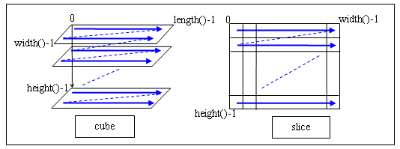
Figure 1 – store a cube or slice data in a one-dimensional array in row-major order
CCube
The public member functions provided by the “CCube” template class are listed in Table 3 and used after including “CCube.h”. Refer to the comments in “CCube.h” for the restrictions of using the member functions.
Table 3: CCube’s public member functions
Purpose | Public Member Functions
Initialize  a cube | CCube ( const CCube& cube )  CCube ( int length = 0, int width = 0, int height = 0, T* data = NULL )  CCube& operator = ( const CCube& cube )  void init ( int length = 0, int width = 0, int height = 0, T* data = NULL )
Compare cubes | bool operator == ( const CCube& cube ) const
Check a cube | bool Valid ( bool throw_if_not = false )
Free a cube | void free ()
Get a cube’s dimensions and data array | int length () const; int width () const; int height () const  int size () const  T* data () const
Get and set  a cube’s voxel | T& operator ( ) ( int x, int y, int z )  void setvoxel ( int x, int y, int z, T value )  void getvoxel ( int x, int y, int z, T& value )
Get and set  a cube’s slice | int getslice ( int slice_index , int slice_plane , CSlice<T>& slice )  int setslice ( int slice_index , int slice_plane , CSlice<T> slice )
Set a cube | void fillcube ( T value )
Draw objects in a cube | int draw_cylinder ( int cx, int cy, int cz, int rx, int ry, int hz, T value )  int draw_ellipse ( int cx, int cy, int cz, int rx, int ry, int rz, T value )
Read and save a cube | int read ( const char * filename )  void write ( const char * filehead )
Crop a cube | int length_crop ( int index0, int index1 )  int width_crop ( int index0, int index1 )  int height_crop ( int index0, int index1 )
Pad a cube | int length_pad ( int num0, int num1, T value )  int width_pad ( int num0, int num1, T value )  int height_pad ( int num0, int num1, T value )
Get a cube’s statistics | double cubemaxval (); double cubeminval ();  double cubemeanval (); double cubevarval (); double cubesumval ()
Shift a cube | int shift ()
Get and set a cube’s voxel: the difference of accessing a cube’s voxel (x, y, z) by the “operator ( )” and “setvoxel/getvoxel” is that the boundary check will be made in “setvoxel/getvoxel” but not in “operator ( )” to see if x is out of the cube’s length, y is out of the cube’s width, and z is out of the cube’s height.
Get and set a cube’s slice indexed at “slice_index” ranging from 0 to length()-1 along the cube’s length for “slice_plane = 1”, or ranging from 0 to width()-1 along the cube’s width for “slice_plane = 2”, or ranging from 0 to height()-1 along the cube’s height for “slice_plane = 3”, using the “CSlice” container.
Read and save a cube from or into two files: a header file whose suffix is “hdr” and a data file whose suffix depends on the cube data, which must be 8-bit unsigned char or 16-bit unsigned integer or 32-bit single floating real or 64-bit double floating real. The header file stores the cube’s dimensions as: “height<newline>width<newline>length”. The data file stores the cube’s data in a row-major order binary stream and its suffix is “u8” if the data is 8-bit unsigned char, “i16” for 16-bit unsigned integer, “f32” for 32-bit single floating real, and “f64” for 64-bit double floating real.
Drawing a cylinder or an ellipse in a cube is shown in the following figure:

Figure 2 – draw a cylinder (left) or an ellipse (right) in a cube
Cropping or padding a cube is shown in the following figure:

Figure 3 – crop (left) or pad (right) a cube
Shifting a cube is dedicated for shifting a 3-D PSF as seen in the following figure:
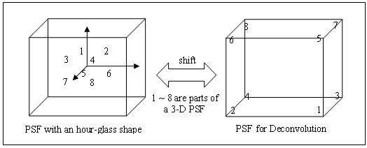
Figure 4 – shift a cube
CSlice
The public member functions provided by the “CSlice” template class are listed in Table 4 and used after including “CSlice.h”. For the restrictions of using other member functions, please refer to the comments in “CSlice.h”.
Table 4: CSlice’s public member functions
Purpose | Public Member Functions
Initialize  a slice | CSlice ( const CSlice& slice )  CSlice ( int width = 0, int height = 0, T* data = NULL )  CSlice& operator = ( const CSlice& slice )  void init ( int width = 0, int height = 0, T* data = NULL )
Compare slices | bool operator == ( const CSlice& slice ) const
Check a slice | bool Valid ( bool throw_if_not = false )
Free a slice | void free()
Get a slice’s dimensions and data array | int width () const; int height () const  int size () const  T* data () const
Get and set  a slice’s pixel | T& operator() ( int x, int y )  void setpixel ( int x, int y, T value )  void getpixel ( int x, int y, T value )
Set a slice | void fillslice( T value )
Read and save a slice | int read ( const char * filename )  void write ( const char * filehead )
Crop or pad  a slice | int crop ( int newx, int newy, int cx = 0, int cy = 0 )  int pad ( int newx, int newy, T value )
Get a slice’s statistics | double slicemaxval(); double sliceminval();  double slicemeanval(); double slicevarval(); double slicesumval()
Get and set a slice’s pixel: the difference of accessing a slice’s pixel (x, y) by the “operator ()” and “setpixel/getpixel” is that the boundary check will be made in “setpixel/getpixel” but not in “operator ()” to see if x is out of the slice’s width or y is out of the slice’s height.
Read and save an image/slice in the 8-bit or 16-bit PGM format given as follows:
Table 5: 8-bit or 16-bit PGM format
Greylevel | Format
8-bit | P5  ImageWidth ImageHeight  Greylevel // no more than 255  unsigned char data in a binary stream
16-bit | P5  ImageWidth ImageHeight  Greylevel //between 255 and 65535  unsigned integer data in a binary stream
Cropping or padding a cube is shown in the following figure:
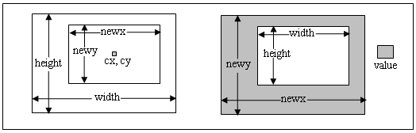
Figure 5 – crop (left) or pad (right) a slice
Chapter 2 - FFT
FFT routines are programmed using the FFTW3 library (www.fftw3.org) and include a class named as “FFTW3_FFT” and FFT functions.
FFT class for deconvolution
The “FFTW3_FFT” class is dedicated for the usage in our deconvolver classes and only supports 3-D real-to-complex/forward or complex-to-real/backward transforms. The public member functions provided by the “FFTW3_FFT” class are listed in Table 6 and used after including “FFTW3fft.h”.
Table 6: FFTW3_FFT’s public member functions
Purpose | Public Member Functions
Initialize  a 3-D FFT plan | FFTW3_FFT ( int DimX, int DimY, int DimZ,  bool IsForward, bool IsDouble, int status )
Execute a 3-D FFT as planed | void execute ( double * buf1, double * buf2, double * buf3 )  void execute ( float * buf1, float * buf2, float * buf3 )
Get FFT’s dimensions | int DimX (); int DimY (); int DimZ ()  int FFTsize ()
Get FFT’s plan information | int status (); bool IsDouble (); bool IsForward ()
Two steps are required for calculating a 3-D FFT using the “FFTW3_FFT “class: first, create a 3-D FFT plan; second, execute the FFT on a given 3-D data set as planned. A 3-D FFT plan is generated using the member function “FFTW3_FFT”, where “DimX” is the fastest varying dimension of the 3-D data set and “DimZ” is its slowest varying dimension; “IsDouble” indicates whether the data is double (true) or float (false); “IsForward” indicates whether the FFT direction is complex-to-real/forward (true) or real-to-complex/backward (false); and “status” indicates requirements for the data arrays by a FFT plan and they are illustrated in the following tables, where buf1, buf2 and buf3 passed to the member function “execute” are all one-dimensional double/float arrays storing the input and output data in row-major order.
Table 7: requirements of data arrays by a forward FFTW3_FFT plan
status | buf1  Input Real | buf2  Output Real | buf3  Output Imaginary | Overlap
1 | Full size | Full size | Full size | NO
2 | Full size | Full size | Full size | Buf1 and buf2
3 | Full size | FFTsize | FFTsize | NO
Table 8: requirements of data arrays by a backward FFTW3_FFT plan
status | buf1  Input Real | buf2  Input Imaginary | buf3  Output real | Overlap
1 | Fullsize | Fullsize | Fullsize | NO
2 | Fullsize | Fullsize | Fullsize | Buf1 and buf3
3 | FFTsize | FFTsize | Full size | NO
“Fullsize” equals to DimX ∙ DimY ∙ DimZ. Taking the advantage of the symmetry of the real-to-complex or complex-to-real transform, only the “FFTsize” space is enough for holding the complex data and it equals to DimX ∙ DimY ∙ (DimZ/2+1) if DimZ is even and DimX ∙ DimY ∙ (DimZ+1)/2 if DimZ is odd. “Overlap” of two arrays means that the input array will be overwritten by the output data. Make sure that you understand how to use the “FFTW3_FFT” class correctly if you want to use it on your purpose.
FFT functions for your usage
If you just want to calculate a single FFT using the library but do not purpose to do it as intensively as in a deconvolution process, it is commended to use the “fft1d/fft2d/fft3d” functions listed in Table 9 to perform a single FFT on your own one-dimensional, two-dimensional, or three-dimensional data set, respectively, after including “FFTW3fft.h”.
Table 9: FFT functions
Dimension | Functions
3D | fft3d ( int DimX, int DimY, int DimZ, bool IsForward, bool IsShift,  double * in_re, double * in_im, double * out_re, double * out_im )  fft3d ( int DimX, int DimY, int DimZ, bool IsForward, bool IsShift,  float * in_re, float * in_im, float * out_re, float * out_im )
2D | fft2d ( int DimX, int DimY, bool IsForward, bool IsShift,  double * in_re, double * in_im, double * out_re, double * out_im )  fft2d ( int DimX, int DimY, bool IsForward, bool IsShift,  float * in_re, float * in_im, float * out_re, float * out_im )
1D | fft1d ( int DimX, bool IsForward, bool IsShift,  double * in_re, double * in_im, double * out_re, double * out_im )  fft1d ( int DimX, bool IsForward, bool IsShift,  float * in_re, float * in_im, float * out_re, float * out_im )
“DimX”, “DimY”, “DimZ”, and “IsForward” have the same meanings as described in the “FFT class for deconvolution” section. “IsShift” indicates whether to shift (true) the DC to the center in the frequency domain or not (false). “in_im”, “out_re”, “out_im”, and “in_re” are one-dimensional arrays storing the input and output data in row-major order and have the same size: “DimX” (fft1d), “DimX ∙ DimY” (fft2d), and “DimX ∙ DimY ∙ DimZ” (fft3d). “in_re” and “out_re” are the input and out real and can be overlapped. “in_im” and “out_im” are the input and output imaginary and can be overlapped, too.
Chapter 3 - PSF
PSF routines are programmed based on a computational PSF model derived by Gibson and her advisor Lanni (Gibson and Lanni, 1989; Gibson and Lanni, 1991; Gibson, 1990; Kontoyannis and Lanni, 1996). Their model is set up based on geometrical- and physical-optics theory and used to predict the image of a point-source object under a variety of optical conditions. There are three classes associated with PSF routines. Both the “Fluo3DPSF” class and the “FluoRZPSF” class are derived from the “FluoPSF” class.
Some physical parameters of a microscope objective are required in PSF routines. An example of reading physical parameters of a microscope objective is given in Figure 6, where 1.40 is the objective’s numerical aperture; 0.17(mm) is the coverslip thickness required by the objective and generally a coverslip is made of glass; oil is the immersion medium required by the objective and its refractive index is normally 1.515; and WD (0.21mm) is the objective’s working distance.
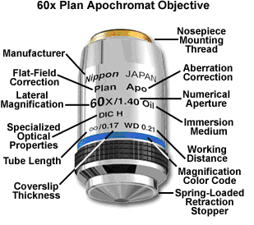
Figure 6 – an example of reading physical parameters of a microscope objective
(courtesy from http://www.micro.magnet.fsu.edu/primer/anatomy/specifications.html)
3-D PSF
A 3-D PSF is calculated in the “Fluo3DPSF” class based on the following equations:
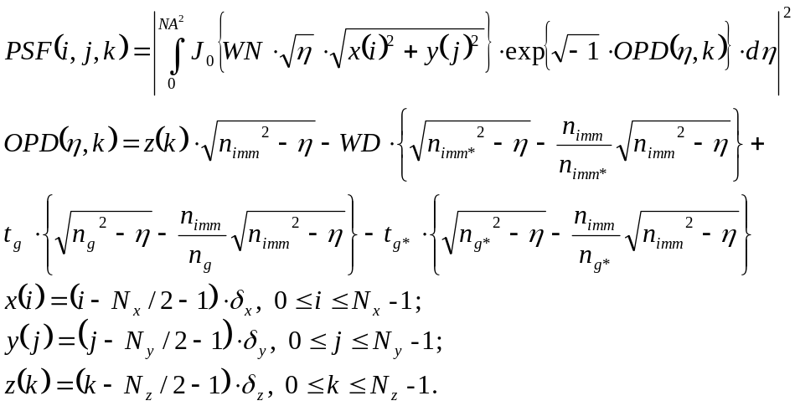 (1)
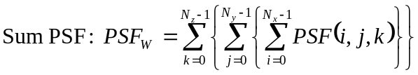 (2)
(3)
(i, j, k) is the index of a PSF voxel. η is the integral variable and derived from the normalized radius of the objective rear pupil.
N_{x}, N_{y} and N_{z} are the PSF’s dimensions along x (the fastest varying dimension), y, z (the slowest varying dimension) and z is consistent with the optical axis.
δ_{x} and δ_{y} are x-, y-calibrations, which are the corresponding lengths (in microns) in the object space to a sectioning image pixel width and height, respectively.
δ_{z} is the sectioning constant, which is the distance (in microns) between two successive sectioning images.
WN = 2π/λ is the wave number.
λ is the wavelength (in microns) of the emission light.
NA is the objective numerical aperture.
WD is the objective working distance.

OPD is the optical path difference function and set up based on real microscope settings such as the improper use of the objective immersion medium (n_{imm} vs. n_{imm*}) and the cover slip/glass (n_{g} vs. n_{g*} and t_{g} vs. t_{g*}).
n_{imm} and n_{imm*} are the refractive indices of the immersion medium actually used for the objective and required by the objective.
n_{g} and t_{g} are the refractive index and thickness of the actually used coverslip/glass.
n_{g*} and t_{g*} are the refractive index and thickness of the coverslip/glass required by the objective.
Initialize a 3-D PSF using Fluo3DPSF’s public member functions:
- Fluo3DPSF ( float NA, float λ, float n_{imm}, float δ_{x}, float δ_{y}, float δ_{z} )
- void init ( float NA, float λ, float n_{imm}, float δ_{x}, float δ_{y}, float δ_{z} )
- void setImmersionMedium_Mismatch ( float n_{imm*}, float n_{imm}, float WD )
- void setCoverSlip_Mismatch ( float n_{g*}, float t_{g*}, float n_{g}, float t_{g} )
Either the constructor “Fluo3DPSF” or the “init” function must be called. Use “setImmersionMedium_Mismatch” if the objective immersion medium is improperly used, otherwise it is not necessary to use this function. Use “setCoverSlip_Mismatch” if the coverslip/glass is improperly used, otherwise it is not necessary to use this function.
Create a 3-D PSF using Fluo3DPSF’s public member functions:
- void create ( int N_{x}, int N_{y}, int N_{z}, float * psf, bool Check = true )
- void create ( int N_{x}, int N_{y}, int N_{z}, double * psf, bool Check = true )
“psf” is a one-dimensional array, whose size is “DimX ∙ DimY ∙ DimZ”, storing the 3-D PSF data in a manner described in Figure4 (right) in row-major order. “Check” is to indicate whether to print (true) the PSF generation progress in the terminal or not (false).
Export a 3-D PSF profile using Fluo3DPSF’s public member function:
- exportProfile ( const char * filename )
2-D RZ PSF
Since a 3-D PSF is cylindrically symmetric, it can be reduced to a 2-D RZ-PSF calculated by the following equation using a cylindrical coordinate system in the “FluoRZPSF” class.
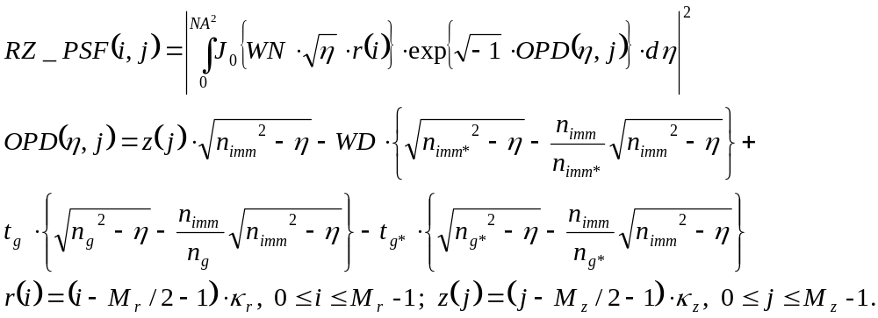 (4)
(i, j) is the index of a 2-D RZ PSF table.
M_{r}, and M_{z} are the RZ PSF’s maximum radial and optical sectioning samples.
κ_{r} and κ_{z} are the RZ PSF’s radial sampling rate and optical sectioning rate.
The other variables have the same meanings as described in the “3-D PSF” section.
Initialize a 2-D PSF using FluoRZPSF’s public member functions:
- FluoRZPSF ( float NA, float λ, float n_{imm}, float κ_{r}, float κ_{z} )
- void init ( float NA, float λ, float n_{imm}, float κ_{r}, float κ_{z} )
- void setImmersionMedium_Mismatch ( float n_{imm*}, float n_{imm}, float WD )
- void setCoverSlip_Mismatch ( float n_{g*}, float t_{g*}, float n_{g}, float t_{g} )
Either the constructor “FluoRZPSF” or the “init” function must be called. Use “setImmersionMedium_Mismatch” if the objective immersion medium is improperly used, otherwise it is not necessary to use this function. Use “setCoverSlip_Mismatch” if the coverslip/glass is improperly used, otherwise it is not necessary to use this function.
Create a 2-D RZ PSF table using FluoRZPSF’s public member function
- void create ( bool Check = true )
The generated RZ PSF data will be stored in an one-dimensional double array, which is a private member of the “FluoRZPSF” class, and the array can be obtained using the member function “double* RZpsfData()”. “Check” is to indicate whether to print (true) the RZ PSF generation progress in the terminal or not (false).
Save and read a 2-D RZ PSF table using FluoRZPSF’s public member function
- void save( const char * filehead )
- void read( const char * filehead )
A RZ PSF table is saved in two files: a header file whose suffix is “rzh” and a data file whose suffix is “rzd”. The header file contains the information on how the RZ PSF is generated such as the physical parameters and its dimensions. The data file stores the 2-D RZ PSF data in a row-major order binary stream.
Create a 3-D PSF from a 2-D RZ-PSF table using FluoRZPSF’s public member functions by performing the table lookups and spline interpolation as follows:
- int get3Dpsf ( int N_{x}, int N_{y}, int N_{z}, float δ_{x}, float δ_{y}, float δ_{z}, float * psf,
const char * file = NULL, int Points2Sum = 5 )
- int get3Dpsf ( int Nx, int Ny, int Nz, float δx, float δy, float δz, double * psf,
const char * file = NULL, int Points2Sum = 5 )
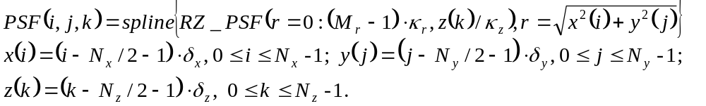 (5)
“N_{x}” must be less than “M_{r}∙κ_{r}/δ_{x}/2”, “N_{y}” must be less than “M_{r}∙κ_{r}/δ_{y}/2”, and “N_{z}” must be less than “M_{z}∙κ_{z}/δ_{z}”. “δ_{x}” must be larger than “κ_{r}∙Points2Sum” and “δ_{y}” must be larger than “κ_{r}∙Points2Sum”, where “Points2Sum” is the compensation parameter and must be an odd integer. “δ_{z}/κ_{z}” must be an integer. If “Points2Sum” is more than 1, for each plane of the 3-D PSF, an expanded plane (N_{x}∙Points2Sum by N_{y}∙Points2Sum) will be first calculated from the RZ PSF, and then the PSF plane (N_{x} by N_{y}) is generated by summing the squared Points2Sum pixels on the expanded plane. If “file” is not NULL, the profile on how the 3-D PSF is generated from the 2-D RZ PSF table will be exported.
Get the maximum dimensions of a 3-D PSF that can be generated from a 2-D RZ-PSF table using FluoRZPSF’s public member functions:
- int maxDimensionX ( float δ_{x} )
- int maxDimensionY ( float δ_{y} )
- int maxSections ( float δ_{z} )
Get the minimum X/Y-calibration (δ_{x} or δ_{y}) of a 3-D PSF that can be generated from a 2-D RZ-PSF table using FluoRZPSF’s public member function:
- float minCalibration( int Points2Sum )
It is recommended to create a 3-D PSF from a 2-D RZ PSF table other than directly using the “Fluo3DPSF” class when the actual sampling rates (δ_{x} and δ_{y}) used to generate a 3-D PSF are larger than the Nyquist sampling rate (λ/NA/4.0) calculated from the objective numerical aperture (NA) and emission light wavelength (λ). In this case, it is better to generate a 2-D RZ PSF table first using a much smaller radial sampling rate (δ_{r}) than the Nyquist sampling rate, then calculate the 3-D PSF for the actual sampling rates from the 2-D RZ PSF table using the function “get3Dpsf “.
The numerical integration and spline routines are implemented by using the 61-point Gauss-Kronrod QAG adaptive integration and cubic spline interpolation in the GNU Scientific Library (GSL, http://www.gnu.org/software/gsl/).
Chapter 4 - Deconvolution
Deconvolution routines are programmed based on three constrained iterative deconvolution algorithms: the Lanweber iterative deconvolution (LWID), the maximum likelihood-conjugate gradient iterative deconvolution (ML-CGID), and the maximum likelihood-expectation maximization iterative deconvolution (ML-EMID) (my reference). There are five classes associated with deconvolution routines: the “LWdeconvolver” class based on the LWID algorithm, the “CGdeconvolver” class based on the ML-CGID algorithm, the “EMdeconvolver” class based on the ML-EMID algorithm and the “LWCGdeconvolver” class are all derived from a base class named “deconvolver”. The “LWCGdeconvolver” class is a base class for both the “LWdeconvolver” and “CGdeconvolver” classes since they use a same conditioning technique.
Common control flags defined for all three types of deconvolution:
- “IsApplyNorm” is to indicate whether to apply (true) normalization on the input image and iteratively estimated object in a deconvolution process or not (false). It is set up when a deconvolution plan is initialized.
- “IsTrackLike” is to indicate whether to track (true) the likelihood value iteratively in a deconvolution process or not (false), and set up when a deconvolution plan is initialized. Be aware that the deconvolution process will be slowed if “IsTrackLike” is set to be true. If the likelihood values are tracked, they can be exported after the deconvolution using
- unsigned int exportLikelihoodTrack ( double * vtrack )
- “IsTrackMax” is to indicate whether to track (true) the max intensity value of an iteratively estimated object in a deconvolution process or not (false), and set up when a deconvolution plan is initialized. Be aware that “IsTrackMax” will be automatically set to be true if “IsApplyNorm” is true. If the max values are tracked, they can be exported after the deconvolution using
- unsigned int exportObjectMaxTrack ( double * vtrack )
- “CheckStatus” is to indicate whether to print (true) the progress of a deconvolution process in the terminal or not (false), and set up when a deconvolution plan is initialized.
Criterion defined for all three types of deconvolution:
- “Criterion” is used to stop a deconvolution process. A deconvolution process will be stopped when the average value of the update between two successive estimated objects over 10 past iterations is less than “Criterion” set up using
- void setCriterion ( double cri = 1.0e-7 )
The update values can be exported after a deconvolution process using
- unsigned int exportUpdateTrack ( double * vtrack )
- “MaxRunIteration” is the number of maximum allowed deconvolved iterations. A deconvolution process will be stopped when “MaxRunIteration” iteraions have been executed in its main loop even if “Criterion” is not be achieved. “MaxRunIteration” can be set up using
- void setMaxRunIteration ( unsigned int iter = 1000 )
Pre-conditioning for LW or CG deconvolution:
- “ConditioningValue” is the conditioning value used for pre-conditioning and set by:
- void setConditioningValue ( double cv = 1.0e-8 )
- “ConditioningIteration” is the number of iterations used in the modified golden searching for “ConditioningValue”. The larger “ConditioningIteration”, the better “ConditioningValue” and the finer pre-conditioning will be, but more time will be taken. If “ConditioningIteration” is more than zero, “ConditioningValue” used for the pre-conditioning will be automatically calculated when running a deconvolution process no matter what “ConditioningValue” is set to be. This is recommended when you first run a deconvolution process on a data set. “ConditioningValue” is set by:
- void setConditioningIteration ( unsigned int iter = 5 )
- “ConditioningTolerance” is the tolerance value used in the modified golden searching for “ConditioningValue”. The smaller “ConditioningTolerance”, the better “ConditioningValue” and the finer pre-conditioning will be, but more time will be taken. “ConditioningTolerance” is set up using:
- void setConditioningTolerance ( double ct = 0.1 )
Intensity regularization for CG deconvolution:
- “IsApplyIR” is to indicate whether to apply (true) intensity regularization on the estimated object iteratively in a CG deconvolution process or not (false). It is set up when a CG deconvolution plan is initialized. If “IsApplyIR” is set to be true, the intensity penalty parameter and will be automatically calculated when running a deconvolution process.
Newton acceleration for EM deconvolution:
- “IsAccelerate” is to indicate whether to apply (true) acceleration using Newton method iteratively in an EM deconvolution process or not (false). It is set up when an EM deconvolution plan is initialized.
Intensity regularization for EM deconvolution:
- “EMIRiteration” is the number of iterations every which intensity regularization is applied in an EM deconvolution process. If it is set to be 0, the intensity regularization will not be applied. “EMIRiteration” is set up using:
- void setEMIRiteration( unsigned int iter = 50 )
- “EMIRpenalty” is the intensity penalty parameter used for the intensity regularization in an EM deconvolution process. “EMIRpenalty” is set up using:
- void setEMIRpenalty( double penalty )
If “EMIRpenalty” is not set or set to be smaller than 0, it will be calculated when running an EM deconvolution process as follows (Conchello and McNally, 1996) :
- the_max_value_in_the_input_PSF / the_max_intensity_in_the_input_image
Start deconvolution in two steps
It is fairly simple to start a deconvolution process using the library: initialize a deconvolution plan first using the “init” and setup functions such as “setCriterion”, “setMaxRunIteration”, “setEMIRiteration”, “setEMIRpenalty”, “setConditioningValue”, “setConditioningIterartion” and “setConditioningTolerance” described above; and then execute the deconvolution process as planned using the “run” function given the input cubic image and 3-D PSF.
- Step 1 - initialize a deconvolution plan.
Initialize an LW deconvolution plan using
- LWdeconvolver() { init() ; }
- void init ( bool IsApplyNorm = false, bool IsTrackLike = false,
bool IsTrackMax = false, bool IsCheckStatus = true )
Initialize a CG deconvolution plan using
- CGdeconvolver() { init() ; }
- void init( bool IsApplyIR = true, bool IsApplyNorm = false,
bool IsTrackLike = false, bool IsTrackMax = false, bool IsCheckStatus = true )
Initialize an EM deconvolution plan using
- EMdeconvolver() { init() ; }
- void init( bool IsAccelerate = false, bool IsApplyNorm = false,
bool IsTrackLike = false, bool IsTrackMax = false, bool IsCheckStatus = true )
“LWdeconvolver”, “CGdeconvolver”, and “EMdeconvolver” are default constructors for LW, CG, and EM deconvolution, respectively. It is always recommended to call the “init” function to initialize an explicit deconvolution plan.
- Step 2 - run a deconvolution process as planned.
Run an LW deconvolution process using
- void run( int DimX, int DimY, int DimZ,
double * image, double * psf, double * object, LWdws & ws,
unsigned char * SpacialSupport = NULL,
unsigned char * FrequencySupport = NULL )
- void run( int DimX, int DimY, int DimZ,
float * image, float * psf, float * object, LWsws & ws,
unsigned char * SpacialSupport = NULL,
unsigned char * FrequencySupport = NULL )
Run a CG deconvolution process using
- void run( int DimX, int DimY, int DimZ,
double * image, double * psf, double * object, CGdws & ws,
unsigned char * SpacialSupport = NULL,
unsigned char * FrequencySupport = NULL )
- void run( int DimX, int DimY, int DimZ,
float * image, float * psf, float * object, CGsws & ws,
unsigned char * SpacialSupport = NULL,
unsigned char * FrequencySupport = NULL )
Run an EM deconvolution process using
- void run( int DimX, int DimY, int DimZ,
double * image, double * psf, double * object, EMdws & ws,
unsigned char * SpacialSupport = NULL,
unsigned char * FrequencySupport = NULL )
- void run( int DimX, int DimY, int DimZ,
float * image, float * psf, float * object, EMsws & ws,
unsigned char * SpacialSupport = NULL,
unsigned char * FrequencySupport = NULL )
The input arguments required by running all three types of deconvolution are same except that each of them has a special working space. “LWdws” or “LWsws” is the LW deconvolution double or float working space, respectively. “CGdws” or “CGsws” is the CG deconvolution double or float working space, respectively. “EMdws” or “EMsws” is the EM deconvolution double or float working space, respectively. The memory required for different working spaces on deconvolving a 128x128x128 image is given as follows:
Table 10: required memory space for deconvolution
Deconvolution Type | LWdws | LWsws | CGdws | CGsws | EMdws | EMsws
Memory Cost (Mbytes) | ~60 | ~30 | ~80 | ~40 | ~70 | ~35
“image” is a one-dimensional array loading the input cubic image in row-major order. The cubic image has the dimensions of “DimX”, “DimY” and “DimZ” where “DimX” is its fastest varying dimension and “DimZ” is its slowest varying dimension. Each dimension must be a power of 2. The input cubic image to be deconvolved must have a black (0) background. “psf” is a one-dimensional array loading the input 3-D PSF data in row-major order. The 3-D PSF must be stored in a manner described in Figure 4 (right) and have the same dimensions as the input image’s. Both the “image” and “psf” arrays will be rewritten in the function “run”.
“object” is a one-dimensional array loading the first estimated object data in row-major order. The first estimated object could be the input cubic image or a previously deconvolved object on the input cubic image. The latter choice is taken when you want to continue a deconvolution process on a cubic image from a previously deconvolved object on it. “object” is also used to return the finally deconvolved object.
Spatial support is not applied by default, but can be applied on the estimated object iteratively by passing a one-dimensional unsigned char array “SpacialSupport”, whose dimensions are same as the input image, to the function “run”. Each value in this array must be (unsigned char) 0 or (unsigned char) 1. Frequency support is not applied by default either, but can be applied on the OTF (the Fourier transform of the input 3-D PSF) by passing a one-dimensional unsigned char array “FrequencySupport”, whose dimensions are same as the PSF, to the function “run”. Each value in this array must be (unsigned char) 0 or (unsigned char) 1.
Export the profile of a deconvolution process
- Export an LW deconvolution profile using
- void exportLW( const char * filename )
- Export a CG deconvolution profile using
- void exportCG( const char * filename )
- Export an EM deconvolution profile using
- void exportEM( const char * filename )
Examples of using deconvolution routines
- Load the input cubic image and 3-D PSF using
CCube<float> image, psf, object ;
image.read ( “deconvolved_image.u8” ) ;
psf.read ( “psf_for_deconvolved_image.f32” ) ;
object = image ;
- An example of starting a default LW deconvolution
LWdeconvolver lw ;
LWsws ws ;
lw.init ( false, false, false, true ) ;
lw.run ( image.length(), image.width(), image.height(), image, psf., object, ws ) ;
lw.exportLW ( “LWdeconvolution” ) ;

- An example of CG deconvolution
CGdeconvolver cg ;
CGsws ws ;
cg.init ( true, false, false, false, true ) ;
cg.setMaxRunIteration ( 500 ) ;
cg.setCriterion ( 1.0E-8 ) ;
cg.setConditioningIteration ( 10 ) ;
cg.run (image.length(), image.width(), image.height(), image, psf., object, ws ) ;
cg.exportCG ( “CGdeconvolution” ) ;
- An example of CG deconvolution
CGdeconvolver em ;
EMsws ws ;
em.init ( false, false, false, false, true ) ;
em.setCriterion ( 1.0E-6 ) ;
em.setEMIRiteration ( 30 ) ;
em.run (image.length(), image.width(), image.height(), image, psf., object, ws ) ;
em.exportEM ( “CGdeconvolution” ) ;

References
My reference
Sarah Frishen Gibson and Frederick Lanni. 1989. Diffraction by a circular aperture as a model for three-dimensional optical microscopy. J. Opt. Soc. Am. A 6 (Septemper): 1357-1367.
Sarah Frishen Gibson and Frederick Lanni. 1991. Experimental test of an analytical model of aberration in an oil-immersion objective lens used in three-dimensional light microscopy. J. Opt. Soc. Am. A 8 (October): 1601-1613.
Sarah Frishen Gibson. 1990. Modeling the 3-D imaging properties of the fluorescence light microscope. Ph.D dissertation. Carnegie Mellon University, Pittsburgh, PA.
Nickos S. Kontoyannis and Frederick Lanni. 1996. Measured and Computed Point Spread Function for Indirect Water Immersion Objective Used in Three-Dimensional Fluorescence Microscopy. Proceedings of SPIE (April): 34-42.
José-Angel Conchello and James G. McNally. 1996. Fast regularization technique for expectation maximization algorithm for optical sectioning microscopy. Proceedings of SPIE 2655 (April): 199-208

