Lab 3: The HTTP protocol

# Learning objectives

* 1. To further understand the http protocol
  2. To use command-line tools to send http requests and view responses
  3. To use browser developer tools to troubleshoot websites

# Procedure

* 1. Install the cURL utility on your Pi as root using apt: sudo apt install -y curl
  2. On your RPi, fire up a command line and type: curl -v https://google.ca -o google.html. This will output the body of the response to a file in your current directory called google.html.
     1. What http verb is used in the request?



* + 1. What user-agent string does the cURL client send to google?



* + 1. What status code does the google server return? Look for the line beginning < HTTP/2.



* + 1. Note the location header that google returns. Now take a look at the file you output, google.html. What do you think the location header signifies?



**It’s the URL of the resource.**

* 1. Now execute the same command using the -L option to follow redirects.
     1. What status code does google return for this request?



* + 1. What is the URL of the page you redirected to? You will need to scroll through the cURL output.

**Redirects you to https://www.google.ca**

* + 1. Open the html file you created in this step. Note all the input elements. What is the value of form action? (You may need to grep the result.)



* + 1. Look for <script> elements. This contains JavaScript for the page. You will notice that is it similar to C code. What do you notice about the variable names? Comment.



**It’s a randomized string for pictographic purposes.**

* 1. In your browser’s address bar, type google.ca.
     1. What is the resulting URL?



* + 1. Open developer mode in your browser. This will differ by browser, but an example using Firefox is shown below:

* + - 1. Navigate the page html hierarchy. Locate the form element and note all the form fields they contain.

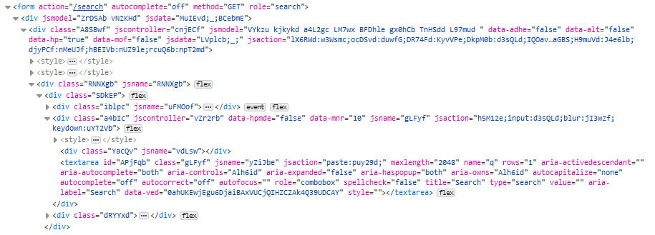

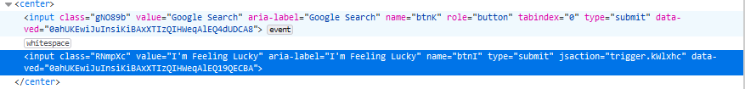

* + - 1. Do they correspond to what you noted in the previous step?

**Yes, It does.**

* + - 1. What do you think they correspond to?

**both are search elements for google.**

* + 1. Use your browser’s developer tools to edit the source html of the current page:
       1. In most browsers, you can right-click a specific page element and select “Inspect” to bring up the html source corresponding to it. An example using Firefox is shown below:

* + - 1. Alter the presentation of the page, e.g. by changing the search button text.

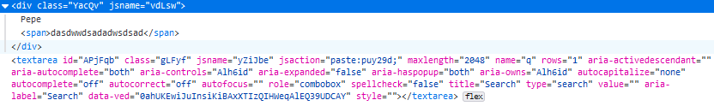

* + - 1. Alter the functionality of the page, e.g. have the form submit to google.ru instead.



* 1. Now google the phrase “hello world”. Note the URL in the address bar:
     1. Note in the query string the query name/value pairs and note the one that corresponds to your search term.



* + 1. What http method does this correspond to?

**Its Get**

* + 1. Execute a curl command to perform a google search on the phrase “goodbye world”. Note the command you used. Was it successful?

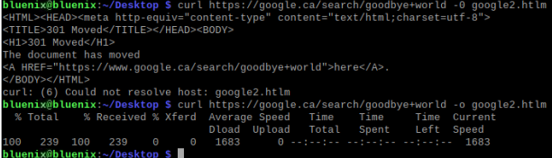

**Yeah it was.**

* 1. Change the user agent string for your request:
     1. Determine the command line option to change the user agent in cURL.
     2. Use the user agent corresponding to a mobile browser, e.g. Safari on iPhone: <https://developer.mozilla.org/en-US/docs/Web/HTTP/Headers/User-Agent>
     3. How does the resulting html page differ? You may need to transfer both versions of the file to your desktop and view them in a browser.
  2. Retrieve only the http header for [www.youtube.com](http://www.youtube.com): curl -IL <https://www.youtube.com> and note the set-cookie headers:
     1. How many cookies were set?
     2. What are their expiry dates?
     3. What are the contents of the cookies?
     4. Use the references in the class notes to determine what the flags secure, samesite=None, and httponly do.

# Questions

Consider the following scenarios:

* 1. A customer calls you to complain the website you have deployed for them does not display properly on their Android mobile phone using the Chrome web browser. Of course, you are an avid iPhone user and do not have an Android phone handy to reproduce the issue. How would you go about trying to reproduce it, using commands we have learnt in this lab?
  2. You have deployed a shopping website for a company that sells surgical masks. The owner calls you to complain that when customers use the back button in their browser, a dialog box appears warning them that they are about to re-submit their order and prompts them to cancel or continue. Describe your response.