David P. Stonehouse

University of Maryland University College

DATA 650 – Big Data Analytics

Fall 2016, Section 9040, Professor Gortcheva

Assignment 2: Analyze Kombucha Twitter Feed

## Introduction/Purpose

The Southside Medical Clinic prides itself on taking a balanced approach concerning advice to patients who are considering new trends in nutrition. Their patients get excited about a new trend that has many followers, but limited clinical studies. In these cases, they seek to understand the patient’s point of view. One new topic is the consumption of kombucha, a fermented drink deemed to have “healthy bacteria”. By studying twitter feeds that relate to kombucha, they hope to be able to more effectively engage and influence patients following the kombucha topic on social media.

## Data Exploration

The data for this project was retrieved from IBM’s Insights for Twitter service. This service allows the user to search for a term used in tweets (in our case, “#kombucha”) and pull back the results into database tables. The source data is a subset (random 10% sample) of the full set of tweets someone could download directly from Twitter. The benefit of using this subset is that IBM enriches the data with insights gained from deep natural language processing (NLP), accomplished with IBM Social Media Analytics. Insights for Twitter attempts to determine the sentiment of the message (positive, negative, etc.) and gender of the sender. The returned data also includes the term used to determine the sentiment. This data (over 8000 tweets) was loaded into IBM’s dashDb database service.

After loading the data, dashDB presents some basic statistics about the tweet set. From Figure 1, it is seen that there has been a steady stream of tweets with #kombucha over the past two years. The monthly tally has not fallen below 500 since the end of 2014 through last month. From Figure 2, many tweets did not indicate the user’s country. For those that did, the majority were from the USA, followed by Canada. The hashtag information from Figure 3 reflect the relationship between kombucha and some other trends. For example, kombucha is part of a family of products that have probiotics (healthy bacteria). Also, some subset of kombucha tweets are also related to words like “vegan”, “organic”, “raw”, and “healthy”. Finally, Figure 4 shows that no sentiment was determined for over half the tweets. For those that had a sentiment polarity value, positive sentiments outweighed negative ones 7-to-1.

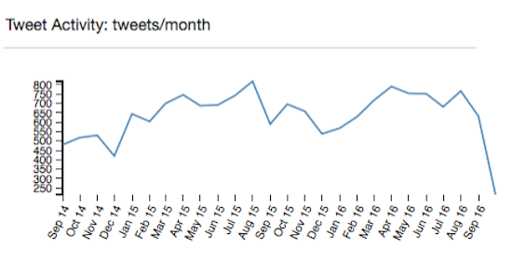

Figure . Kombucha tweets per month in Insights repository.

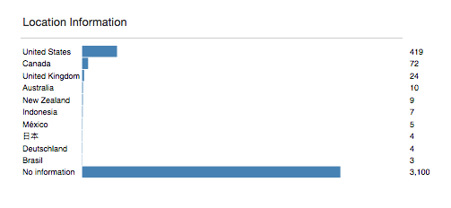

Figure . Locations for senders of kombucha tweets.

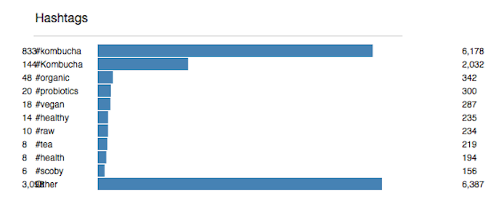

Figure . Hashtags in kombucha tweets

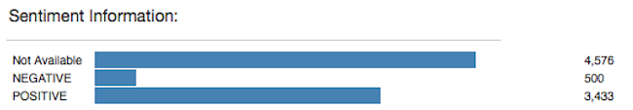

Figure . Sentiments in kombucha tweets.

The loading process produced a series of tables with the base name “KOMBUCHA” (see Table 1).

Table . Insights for Twitter tables

|  |  |
| --- | --- |
| **Table Name** | **Description** |
| KOMBUCHA_TWEETS | Main table: text, URL, |
| KOMBUCHA_HASHTAGS | The hashtags found in the messages, one row per hashtag. |
| KOMBUCHA_LINKS | Expansion of tinyURL links in messages to the full URL. |
| KOMBUCHA_LOCATIONS | Lat/Lon location – user profile, message transmission. |
| KOMBUCHA_MEDIA | Expanded URLs media locations |
| KOMBUCHA_SENTIMENTS | Polarity and text that indicate sentiment |
| KOMBUCHA_USERS | User Id, name and screen name |

All of the tables have the key MESSAGE_ID (e.g., “tag:search.twitter.com, 2005: 600637624315813888”), so that the data from different tables can be joined together as needed.

An example set of tweet texts from the KOMBUCHA_TWEETS table is shown in Table 2.

Table . Example tweet texts.

|  |
| --- |
| **MESSAGE_BODY** |
| RT @craftyleftdee: Slumped brown #Kombucha bottle for spoon rest #ecofriendly #etsymntt CraftyleftDee http://t.co/Qt75VOMuY8 via @Etsy |
| #Kombucha: Thrill Hill, Ginger Berry, Thai Temple (Lemon Grass, Lime Leaf) |
| I'm really enjoying this Ginger #kombucha from @livekombucha - and the cap says "we're betterâ€¦ http://t.co/MEfCKBrNXX |
| Homemade #kombucha first taste. So freaking delicious! This is my fermented beverage for the #GreyCup |
| Burnt cookies, #buchi_kombucha, and #bongojava coffee = good morning! #wakeup #kombucha #paleo #grainfree http://t.co/TPis5SlC8a |
| RT @dbzweier: #kombucha for breakfast, lunch and dinner gets expensive. So I decided to brew my own: http://t.co/GkXbWtC5vy |

Table 3 shows example user information from KOMBACHA_TWEETS. Note again that USER_GENDER is a field generated by IBM Social Media Analytics.

Table . Example rows of user information

|  |  |  |  |
| --- | --- | --- | --- |
| **USER_ GENDER** | **USER_SCREEN_NAME** | **USER_SUMMARY** | **USER_LOCATION_DISPLAY_NAME** |
| female | adams_madeline | An artist in Alabama. |  |
| unknown | AileenMcGraw | A little heart and a whole lotta floral. | Evanston, IL / Elsewhere |
| unknown | amphore_oz | Producer of Sydney's finest Ginger Brew Kombucha & the super-probiotic, dairy-free, sugar-free Coco-Kefir. | Sydney, Australia |
| female | annedooner | minneapolis. athleta. W hotel. travel. fitness. fashion. food. Instagram: lizannedooner | Edina, MN |
| unknown | AquaPamela | Tillbaka till grundlÃ¤ggande | estocolmo |
| Female | bAdLadyVet | #Veteran #Student #Millennial #MotivatingTeenSpirit #Volunteer #Advocate #Feminist does NOT = man haterâœŒï¸ #Videographer #SocialEntrepreneur | California, USA |

Some examples of negative and positive sentiment words that Insights for Twitter detected are shown in Table 4.

Table . Kombucha sentiment information

|  |  |
| --- | --- |
| **SENTIMENT_POLARITY** | **SENTIMENT_TERM** |
| NEGATIVE | nightmares |
| NEGATIVE | problem |
| NEGATIVE | ran out of |
| NEGATIVE | miserable |
| POSITIVE | best |
| POSITIVE | Love |
| POSITIVE | tasty |
| POSITIVE | beneficial |

## SQL Queries

Several SQL queries were run to gain insights into the data. In support of these queries, a view called SENTIMENT was created. The code to create that view is in the appendix.

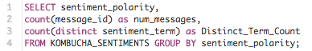

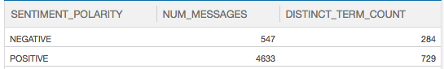In this query found the top terms related to tweets that were analyzed to be negative.

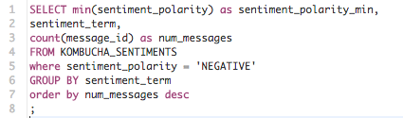

With this result:

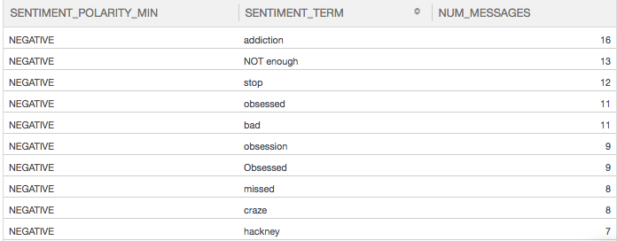

Looking at this deeper, the following query in

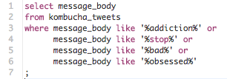

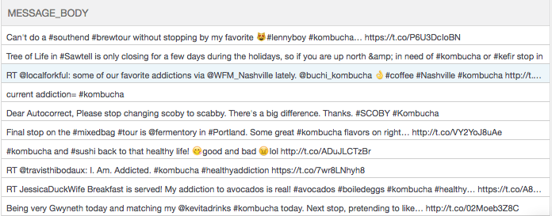

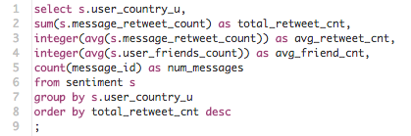

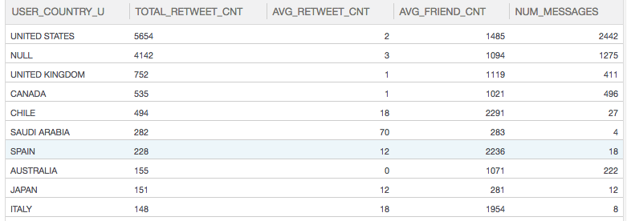

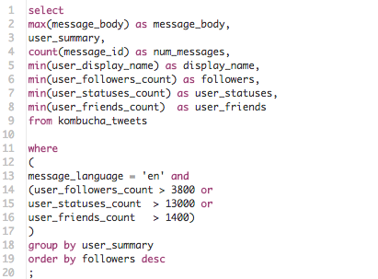

../../Desktop/Screen%20Shot%202016-10-16%20at%204.51.49%20PM.png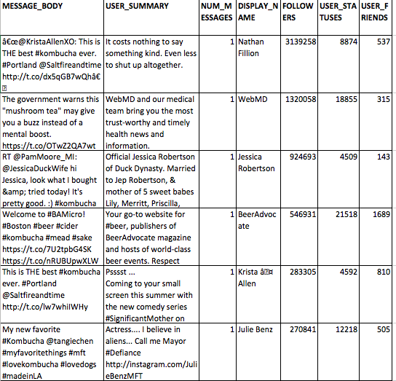

## Analysis with R

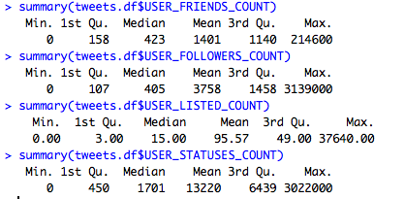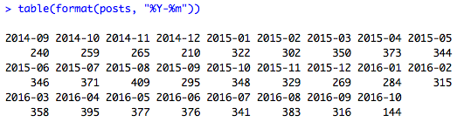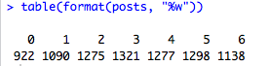../../Desktop/Screen%20Shot%202016-10-16%20at%205.36.25%20PM.png

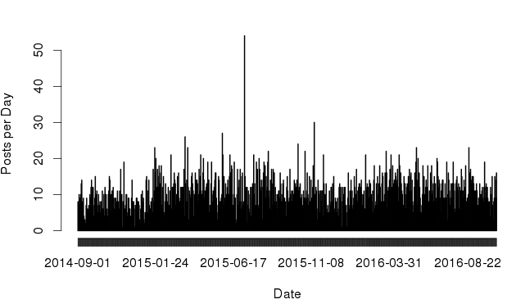

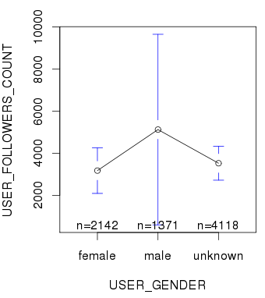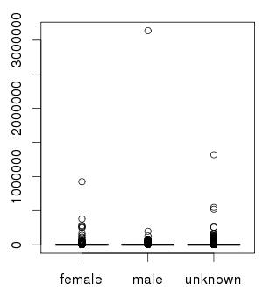

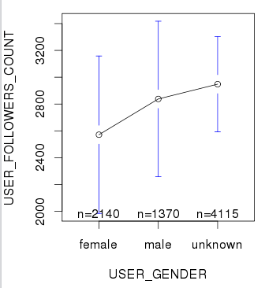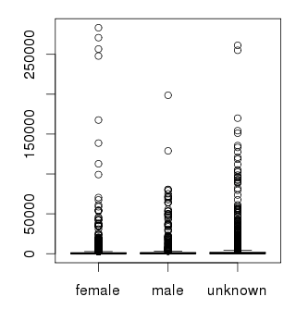

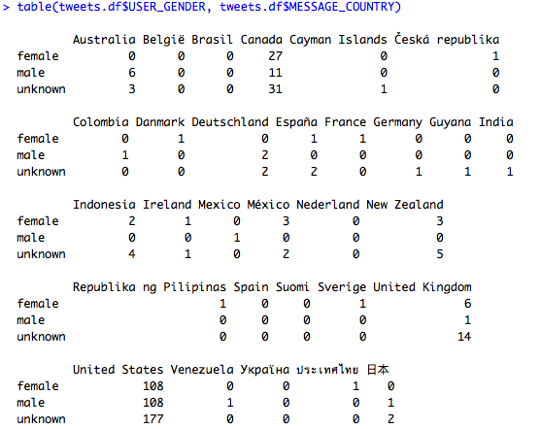

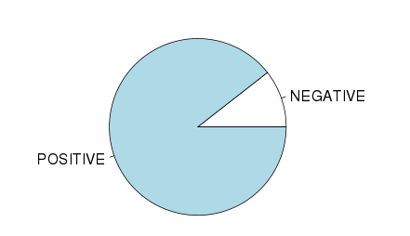

## Limitations and Future Research

.

## Conclusions

## References

IBM, 2016, “About Insights for Twitter”. Retrieved from <https://console.ng.bluemix.net/docs/services/Twitter/twitter_overview.html#about_twitter>

|  |  |  |  |  |  |
| --- | --- | --- | --- | --- | --- |
| **MESSAGE_BODY** | **USER_SUMMARY** | **NUM_MESSAGES** | **FOLLOWERS_COUNT** | **USER_STATUSES_COUNT** | **USER_FRIENDS_COUNT** |
| â€œ@KristaAllenXO: This is THE best #kombucha ever. #Portland @Saltfireandtime http://t.co/dx5qGB7wQhâ€   Agreed! | It costs nothing to say something kind. Even less to shut up altogether. | 1 | 3139258 | 8874 | 537 |
| The government warns this "mushroom tea" may give you a buzz instead of a mental boost. https://t.co/OTwZ2QA7wt #kombucha | WebMD and our medical team bring you the most trust-worthy and timely health news and information. | 1 | 1320058 | 18855 | 315 |
| RT @PamMoore_MI: @JessicaDuckWife hi Jessica, look what I bought &amp; tried today! It's pretty good. :) #kombucha #gettinghealthy https://t.coâ€¦ | Official Jessica Robertson of Duck Dynasty. Married to Jep Robertson, & mother of 5 sweet babes Lily, Merritt, Priscilla, River, & Gus | 1 | 924693 | 4509 | 143 |
| KOMBUCHA ç¾Žå‘³ã—ã„ ãŠæ°—ã«å…¥ã‚Šã£ #kombucha https://t.co/vvnAlSl40S | SKE48ã®æ¾äº•çŽ²å¥ˆã§ã™ â– æ¯Žé€±æœˆæ›œ24:00ã€œãƒ‹ãƒƒãƒãƒ³æ”¾é€ã€ŒãƒŸãƒ¥ã€œã‚³ãƒŸï¼‹ã€å‡ºæ¼” å‡ºæ¼”æƒ…å ±ã¯ã“ã¡ã‚‰ã¸ æ¾äº•çŽ²å¥ˆã‚ªãƒ•ã‚£ã‚·ãƒ£ãƒ«ã‚¤ãƒ³ãƒ•ã‚© @rena_info | 1 | 648862 | 5639 | 171 |
| Welcome to #BAMicro! #Boston #beer #cider #kombucha #mead #sake https://t.co/7U2tpbG4SK https://t.co/nRUBUpwXLW | Your go-to website for #beer, publishers of BeerAdvocate magazine and hosts of world-class beer events. Respect Beer. | 2 | 546931 | 21518 | 1689 |
| Y gracias Andreita @nutristetik por el #kombucha que me regalaste me cayo de perla. ðŸ˜‰ https://t.co/ooYRFp2i9q | Vivo en Guayaquil. Hago Radio y Revista. Tengo dos hijos; amo a mis chikis, a mi trabajo y sobre todo a Dios. | 1 | 378463 | 55094 | 1898 |
| This is THE best #kombucha ever. #Portland @Saltfireandtime http://t.co/lw7whiIWHy | Psssst ... Coming to your small screen this summer with the new comedy series #SignificantMother on The CW Network. Premieres August 3rd @ 9:30 | 1 | 283305 | 4592 | 810 |

UCLA, “How can I subset a data set?”, retrieved from http://www.ats.ucla.edu/stat/r/faq/subset_R.htm

IBM, 2016, “Getting started with dashDB”. Retrieved from https://console.ng.bluemix.net/docs/services/dashDB/dashDB.html

## Appendix: Supporting Information

**SQL code:**

The following code was used to create the sentiment view:

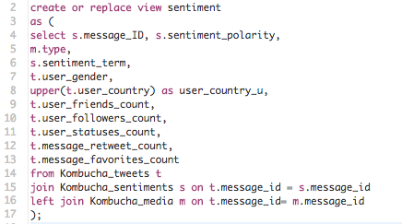

**R source code:**