David P. Stonehouse

University of Maryland University College

DATA 650 – Big Data Analytics

Fall 2016, Section 9040, Professors Gortcheva and Woo

Assignment 4: Spark Analysis of HVAC systems

## HVAC Model Results

The analysis for this question is based on heating, ventilation and air conditioning (HVAC) data. Details of the data are at Mehrotra (2016). The variables in the data are Date, Time, TargetTemp, ActualTemp, System, SystemAge, and BuildingID. The goal of analyzing the data is to develop a model that will predict whether the system will have a temperature reading that is colder or hotter than the target temperature.

Using the IBM Bluemix Spark application, data was read in to a data storage object.

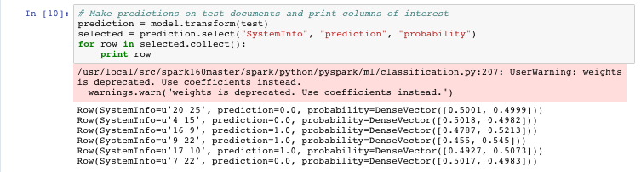

The input data frame for this test had 6 rows. Running the model produced a data frame with 6 rows. The input values to be scored are in the SystemInfo column. Those values are the System and SystemAge, stored together in a string. The SystemInfo values are passed to a Tokenizer to split them into two words. These words are passed to the HashTF function to create hashed values for the input values. These hashed values are then passed to the fitted logistic regression model.

The *prediction* value indicates the prediction from the logistic model, where a value of 1.0 means that the model predicts that the system will be hotter than the target temperature for the system. A value of 0.0 means the system is predicted to be cooler than the target. The *probability* values indicate the probability that the measured value will be cooler or hotter than the target temperature. If the first value in the DenseVector is above .5, then a zero is predicted. If the second value in the DenseVector is above .5, then a one is predicted.

For this set of observations, half of the systems were predicted to be hotter than the target. So, for the first row, the SystemInfo value of “20 25” means the System number is 20 and the SystemAge is 25. The *prediction* is zero, so that system is predicted to be cooler than the target. However, the probability of being cooler is only 50.01%, so really just a coin toss. In contrast, the fourth row, for System 9, 22 years old, is predicted to be hotter with 54.5% probability.

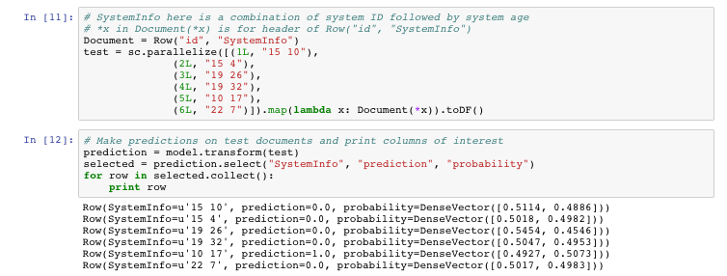

In the second set of results, only one of the observations

From just these two samples, it would seem that the System value has a bigger influence on the prediction. For example, the second set has two pairs of observations for two Systems with a big range of SystemAge values: “15 10”, “15 4”, “19 26” and “19 32”. Also, the first group has two observations with different System values and the same SystemAge value, but the predictions are different: “7 22” and “9 22”.

Logistic regression is suitable for this case. Per Statistics Solutions (2016), logistic regression assumes a number of things. One is that, for binary logistic regression, the target variable is binary. It assumes that P(y=1) is the probability of the event happening. In our case, the target variable is binary, and does represent the label of 1 to mean the event is happening. Only meaningful variables should be included and all meaningful variables should be included. Also, logistic regression requires a large number of samples relative to the number of independent variables. The minimum is 10 cases per independent variable, but often the recommendation is more like 30. The data in this case meets all of these criteria. There are plenty of records (8000) relative to the number of independent variables (2).

An alternative algorithm appropriate for this case is support vector machines (SVMs). The concept of SVM is to divide the observations by a hyperplane, creating the maximum distance between the two groups. SVM can make use of a linear or non-linear (e.g., Gaussian) kernel. SVM with a linear kernel is very similar to logistic regression. Kumar (2015) describes when it is appropriate to use logistic regression, drawing from Andrew Ng’s Machine Learning course. For the HVAC data set, SVM with a Gaussian kernel is appropriate.

## In-memory processing

## Spark, HDFS and Object Storage

**Comparing HDFS and Object Storage**

Both Spark and MapReduce need a way to share data across parallel jobs from one stage to the next. For MapReduce, this is done through HDFS. HDFS suffers because “data sharing is slow in MapReduce due to replication, serialization, and disk IO” (TutorialPoint, 2015). The default mode in HDFS makes two copies of the data. When sending the data, it must be serialized. Serialization means converting from a container (object) to a byte stream. Every time an application needs to share from one stage to next, it involves not only the time to write the block to disk, but also network communication and serialization.

In Spark, sharing from one stage to the next is done through the RDDs and has a lot of flexibility for how it is done. The RDD is configured for sharing through the StorageLevel setting. From the Spark Programming Guide (Apache, 2016),

**Spark and MapReduce**

* Mention things from the “Myths” article – new JVM vs. new thread

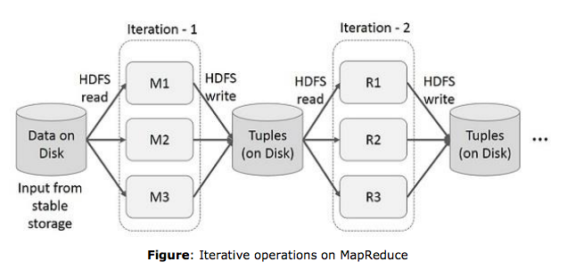

Figure 1. Data sharing between stages - MapReduce

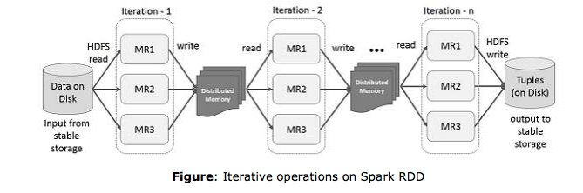

Figure 2. Data sharing between stages - Spark

Spark and HDFS (Tachyon)

## Programming Languages for Spark

A key design goal for the team that supports Spark is that all of the languages be treated as “first class citizens” as far as keeping all of them current with the latest features. Having said that, users should take into consideration some differences between the languages.

**Convenience in coding**

Scala is unique in that it combines function-oriented programming with object oriented programming.

Gangele (2016) mentions a key drawback when using Java to develop with Spark – “Java does not support [a] REPL(Read-Evaluate-Print Loop) interactive shell”.

Pandas – data frames

Code size

**Performance**

Regarding performance, Xin (2015) shared a few results from benchmarks as of the first part of 2015. Regarding Python, Xin says “When it comes to performance, Python programs historically lag behind their JVM counterparts due to the more dynamic nature of the language.” The gap is closing for Python because pyspark can now run on PyPy, which is a faster version of the Python interpreter/compiler. Starting in 1.3, Spark introduced data frames as an alternative to resilient distributed data sets (RDDs) for working with structured data. Figure 1 shows the results of a performance test with RDDs and data frames using Python and Scala. A similar graphic shown in Spark Summit (2016) shows that the performance using data frames across the languages (Scala, Java, R, and Python) was identical.

For performance, the Spark Summit 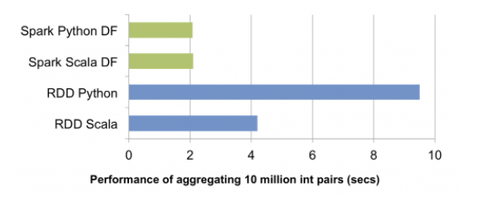

Figure 3. Performance comparison between RDDs and data frames for Python and Scala

.

## References

Alluxio, 2016, “Alluxio Overview”, retrieved from <http://www.alluxio.org/docs/master/en/index.html>

Apache, 2016, Spark Progrramming Guide 2.0.2, retrieved from <http://spark.apache.org/docs/latest/programming-guide.html>

Chambers, B., 2015, “Spark MLLib - Predict Store Sales with ML Pipelines”, retrieved from <http://www.sparktutorials.net/Spark+MLLib+-+Predict+Store+Sales+with+ML+Pipelines>

Damji, J., 2016, “A Tale of Three Apache Spark APIs: RDDs, DataFrames, and Datasets - The Databricks Blog”, retrieved from <https://databricks.com/blog/2016/07/14/a-tale-of-three-apache-spark-apis-rdds-dataframes-and-datasets.html>

Databaseline, 2015, “An Overview of File and Serialization Formats in Hadoop”, retrieved from <https://databaseline.wordpress.com/2015/12/07/an-overview-of-file-and-serialization-formats-in-hadoop/>

Ganesan, K., 2014. “All About Stop Words for Text Mining and Information Retrieval”. Retrieved from <http://text-analytics101.rxnlp.com/2014/10/all-about-stop-words-for-text-mining.html>

Gangele, J., 2016, “Java vs Scala vs python for big data apache spark project”, retrieved from <https://www.linkedin.com/pulse/java-vs-scala-python-big-data-apache-spark-project-jeetendra-gangele>

Kumar, A., 2015, “Machine Learning - When to Use Logistic Regression vs. SVM”, retrieved from <http://vitalflux.com/machine-learning-use-logistic-regression-vs-svm/>

Mehrotra, N., 2016. “Use Apache Spark to build machine learning applications on HDInsight”, retrieved from <https://azure.microsoft.com/en-us/documentation/articles/hdinsight-apache-spark-ipython-notebook-machine-learning/>

Statistics Solutions, 2016, “Assumptions of Logistic Regression”, retrieved from <http://www.statisticssolutions.com/assumptions-of-logistic-regression/>

TutorialsPoint, 2015, retrieved from <https://www.tutorialspoint.com/apache_spark/apache_spark_tutorial.pdf>

Xin, R., 2015, “Recent performance improvements in Apache Spark: SQL, Python, DataFrames, and More”, retrieved from <https://databricks.com/blog/2015/04/24/recent-performance-improvements-in-apache-spark-sql-python-dataframes-and-more.html>

Zotti, R., 2013, “How does a Support Vector Machine (SVM) work?” retrieved from <http://stats.stackexchange.com/questions/23391/how-does-a-support-vector-machine-svm-work>

Spark Summit 2016, "Training Apache Spark Essentials”, retrieved from <https://www.youtube.com/watch?v=OheiUl_uXwo&feature=youtu.be>

## Appendix: Supporting Information

**Selected logs from R code:**

**R source code:**

Now try with tf-idf

kfit <- DoKMeans(m.tf.idf.transpose2,8)