BIEN – WCSP Taxon matching
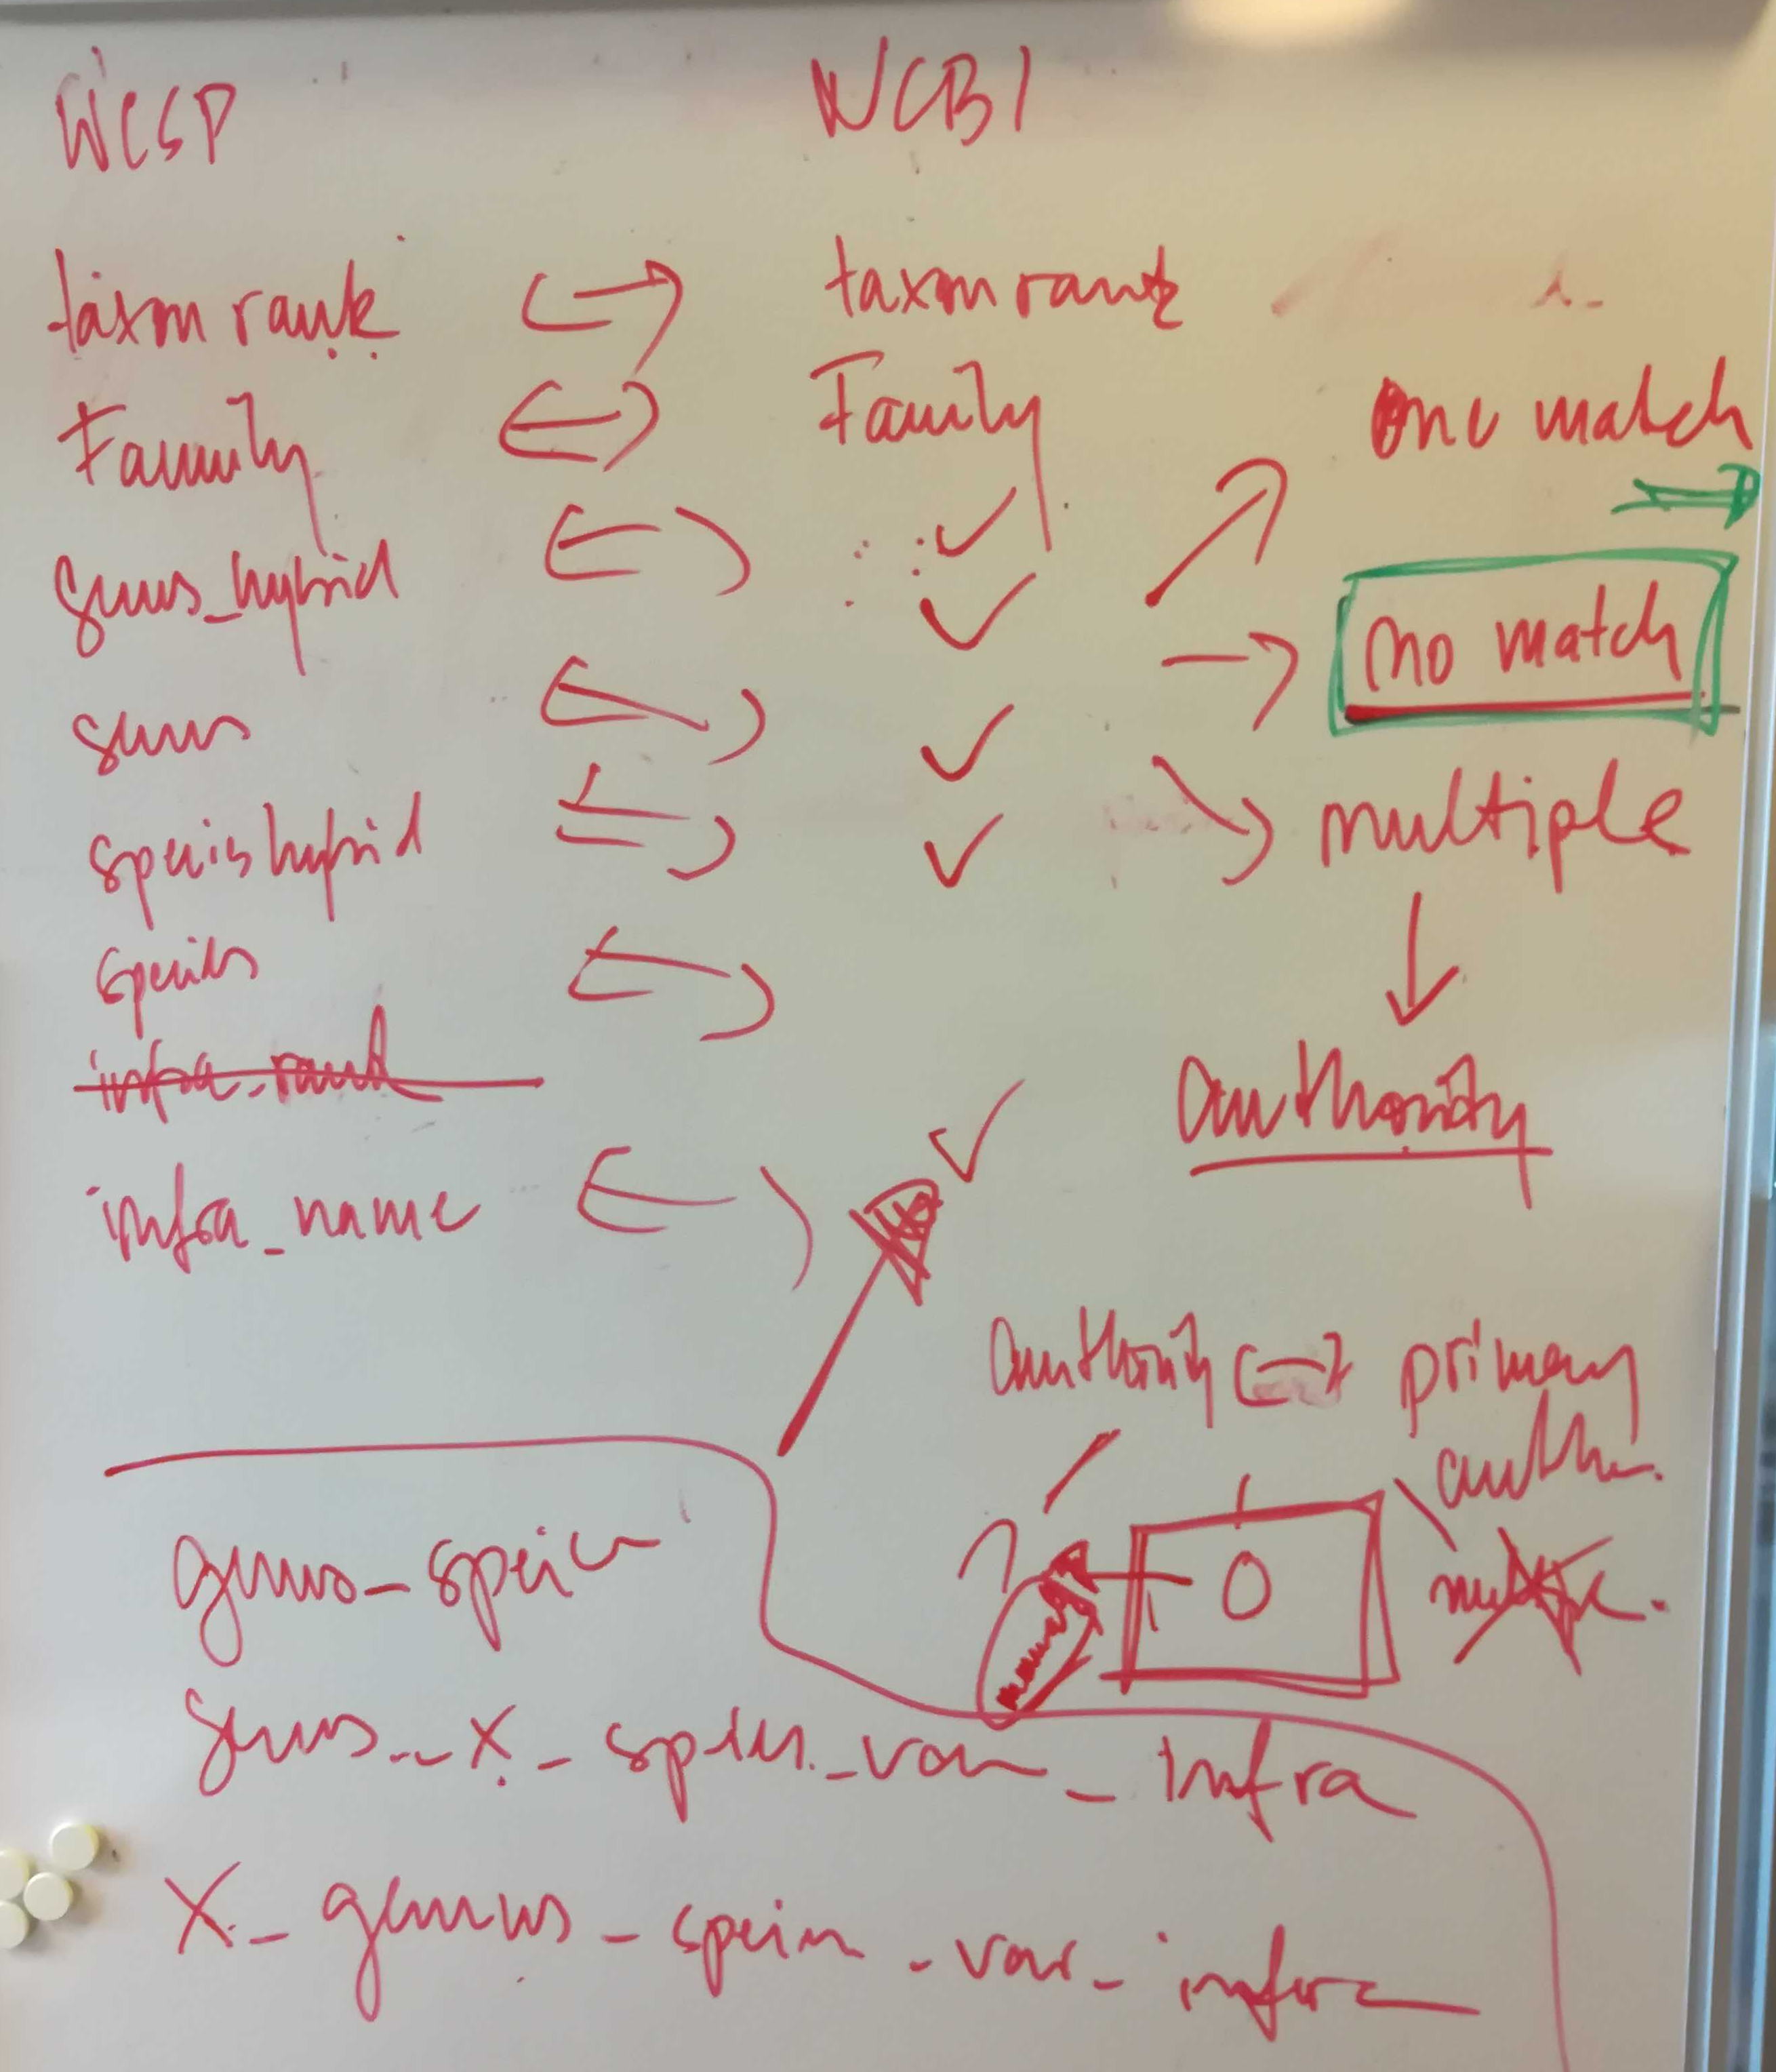
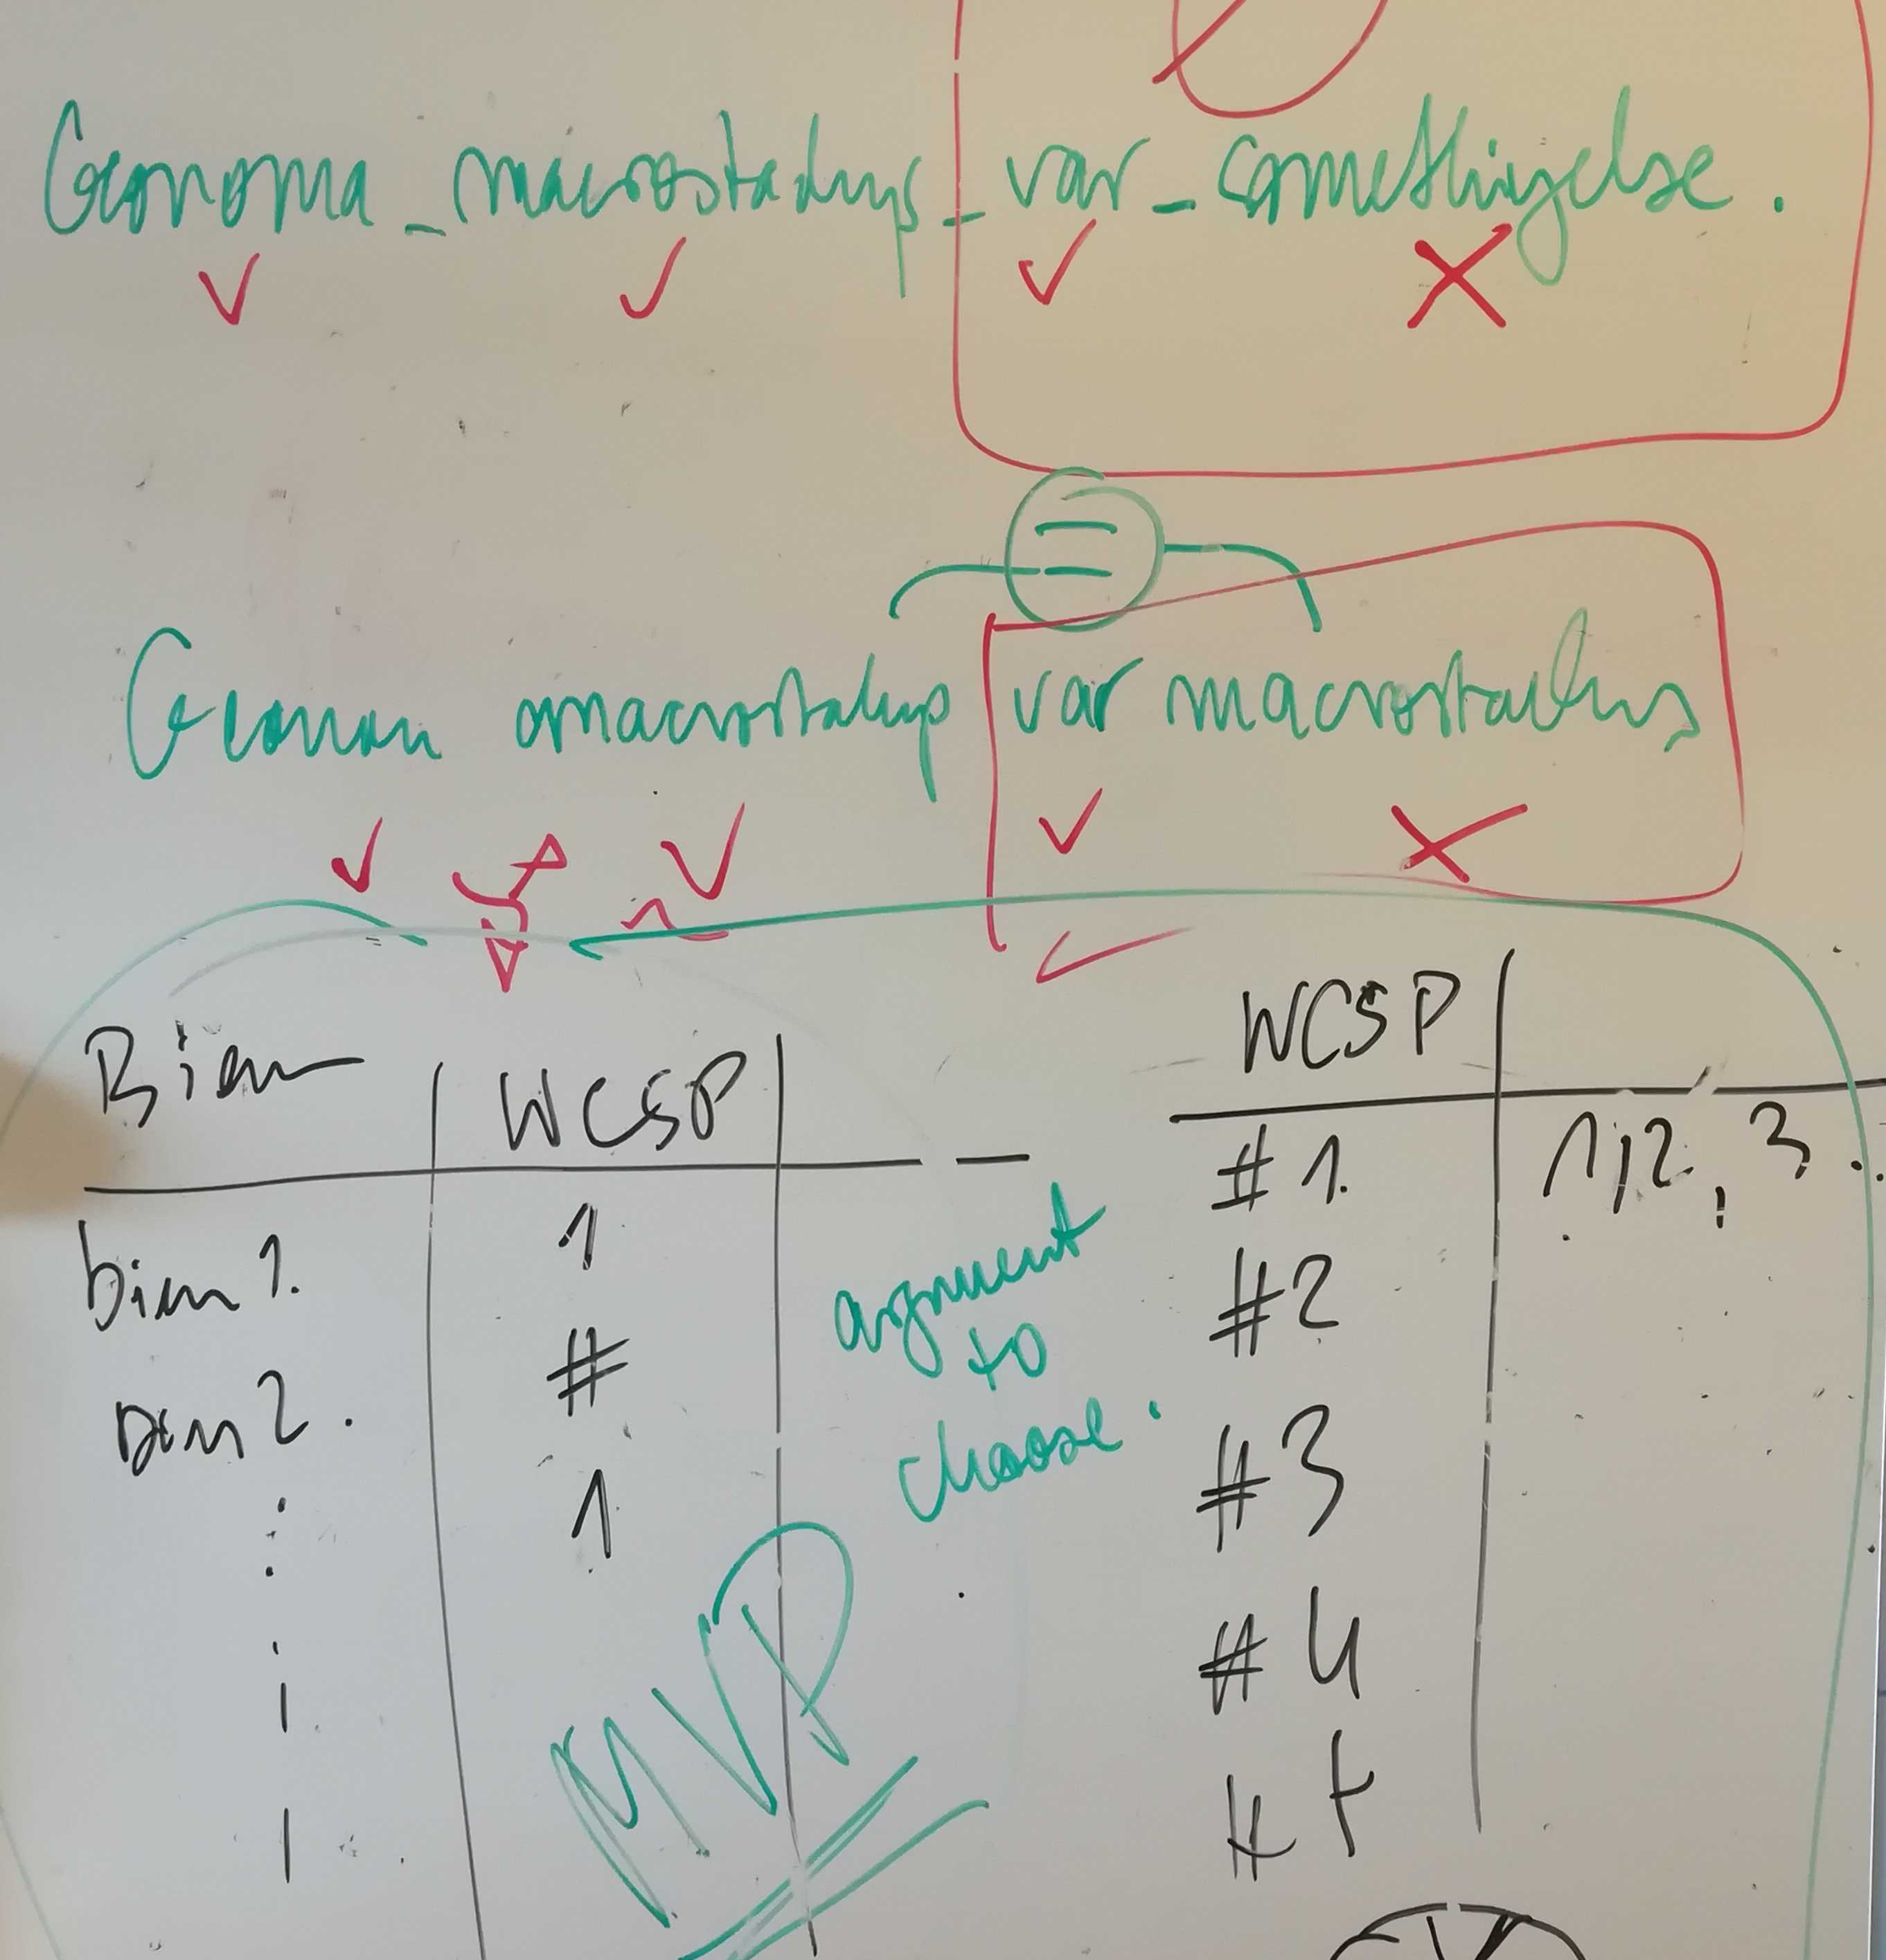

Setting up a matching dataframe that resembles WCSP from BIEN data
common format goal:
 | BIEN | WCSP
Taxon name | name | name
Family | name | name
Genus | name | name
species | name | name
Genus hybrid? | x | +  x
Species hybrid? | x | +  x
Taxon rank | Var. | variety
Taxon rank | Subsp. | subspecies
Taxon rank | fo. | form
Taxon rank | ssp.
Taxon rank | BLANK
Taxon rank | subvar. | subvariety
Taxon rank | unranked
Taxon rank | proles | proles
Taxon rank | race
Taxon rank | nothosubsp.
Taxon rank | convar. | convariety
Taxon rank | cv.
Taxon rank | cv
Taxon rank | subfo. | subform
Taxon rank | Genus | Genus
Taxon rank | species | species
Infra name | name | name
author | As from BIEN | As from WCSP

taxon_rank(BIEN) = infraspecific_rank(WCSP)
infra_name(BIEN) = infraspecies(WCSP)

WORKFLOW
common_format_creator_vectorized.R
runtime: 45min on the linux server

0) merge scrubbed_taxon_name_no_author with author to create a unique taxon identification, unique that data to get a dataframe that includes every name once
1) fill in family and author from BIEN, does not need any editing
2) split scrubbed_taxon_name_no_author by space + fill in common format matrix.

Possible outcomes:
Input | Split | implemented? | Example (number of occurrences) | In WCSP? | rank
Genus | 1 | yes | 41000 / 100.000 | yes | genus
x_Genus | 2 | yes | None | yes | genus
Genus_species | 2 | yes |  | yes | species
Genus_x_species | 3 | yes | A-Z |  | species
x_Genus_species | 3 | yes | x Pucciphippsia vacillans (5 / 100.000) | Yes | species
Genus_x_Genus | 3 | Yes: out | hybrid genus need to go | yes | Genus
Genus_sect._Genus | 3 | yes | Lobelia sect. Hypsela  → match first name |  | Genus
Genus_species_species | 3 | yes | Luzula glabrata desvauxii |  | undefined
X_Genus_x_species | 4 | yes | None | Yes: 1: × Aesculus × carnea | species
Genus_species_BLANK_infra | 4 | yes | Acacia verticillata verticillata  → try matching ignoring rank, skip if multiple |  | undefined
Genus_species_[a-z]_species | 4 | Yes | Zannichellia palustris subvar. polycarpa |  | Depends:  subspecies  variety  subvariety  → position 3
Genus_species_x_species | 4 | incomplete | Rosa rubiginosa x micrantha  → use micrantha as infra name, or match on species level?
Genus_x_species_var_infra | 5 | yes | 2 species / 100.000:  Salvia x sylvestris subsp. tesquicola | Yes: ~100  Carduus × theriotii nothosubsp. cyrneus | variety
Genus_species_var_x_species(?) | 5 | Yes | 3 species  Petasites frigidus var. x vitifolius  Woodsia cystopteroides unranked x phillipsii  Dieffenbachia nitidipetiolada x d. oerstedii |  | variety
Genus_species_ssp_infra_var_infra | 6 | No | Lupinus argenteus ssp. Argenteus var. laxiflorus  → out  24 species, mostly Asteraceae |  | subspecies

Results
stored in bien_input_vectorized2.rds
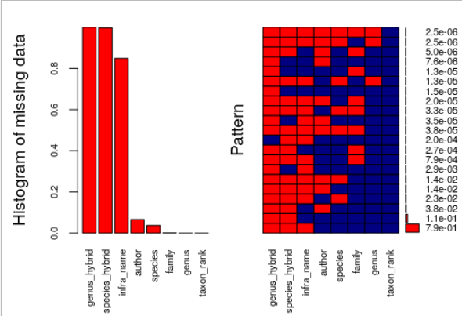
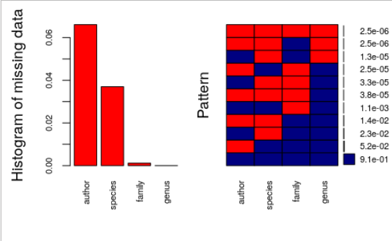

Questions
1) Genus_x_Genus → which Genus? Or ignore because just Genus anyways?
→ out
2) Croton sect. Julocroton
→ If it`s section, match entire thing or based on first part.

3) Vachellia nilotica tomentosa
→ shorthand notation, infraspecific rank try to match entire name without taxon rank, if not possible variety or subsp., else out
4) Genus_species_x_species
→ species = 2
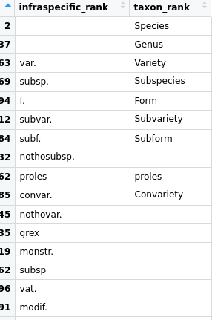
WCSP:
species listed with infraspecific rank == nothosubsp. in WCSP do not carry a taxon rank ------------------------------->
→ combine taxon rank + intraspecific rank into one column

###########################################
STATS common format creator
396.971 unique taxon_name – author combinations
396.944 will be used for the merger script (some excluded due to being e.g. varieties of subspecies

No genus extracted: 7 → out
No species extracted: 14.687 → genera + genus sections
No families extracted: 464
example:
Pertusaria
Jacksonia stellaris
Carex reuteriana subsp. Tartessiana
murorum subsp. subsp. medianiforme
No author extracted: 26,236 (6%) → mostly subspecies, varieties and genera

RENAMING & PREPARING DATA
taxon_matching_new.R
0) remove Bryophyta from BIEN data by family name (source for family names: http://www.theplantlist.org/1.1/browse/B/ )
- excludes 25 547 taxon names (6%)
1) remove all periods and brackets
2) rename BIEN
cv → convar
fo → f
ssp → subsp
unranked → undefined
3) renaming WCSP
combine taxon rank and infra column: species + genus to common column
hybrids: + → x

MATCHING
taxon_matching_new.R
see the flowchart in

1) strict matching, no author
- 84.6% matches using strict match without author (314.340 names)
- 3.8% bien taxon names with multiple accepted WCSP IDs (14.433 names)
- 11.5% with no strict match (42.617 names)

2) multiple matches
reasoning:
- matching author names gives 3 possible outcomes: matching authors, no matching authors, or NA for if authors are missing in one or both cases
→ no matching authors and NA cannot be resolved
→ matching authors, but still differing accepted IDS cannot be resolved as well: those are the real problematic cases in the WCSP (stored in wcp_conflicts: 112 taxa)

action:
- count author matches for each taxon. If match = 1: use that accepted ID
- if match > 1: not possible

RESULT:
- 11.822 more taxon names resolved by author matching for multiple match results
- 2616 taxon names unresolved
- 112 are problematic in the WCSP

3) no strict matches
- 4128 taxon names by matching without family
- 1119 taxon names by matching cases where infraname == species name (species level match)
→ 1300 more matches

  Matching type | proportion
  Strict match | 0.85
  Matching authors | 0.032
  multimatch | 0.007
  No infra match | 0.003
  No family match | 0.01
  NA | 0.10
  match | No match
  331.404 | 39.986

Open questions:
- what is priority: non strict matching without infra name, or without family?
- what to do with no match taxa:
20.000 species names
10.000 varieties
1.700 genera
→ accept them as missing taxa in the wcsp?
→ check where they occur

--> elevate matches species level – DONE
question: are we operating on subspecies level according to the BIEN name, or according to the WCSP name? Latter would make more sense?
1) get wcp accepted plant name ID for BIEN taxon names
2) get their taxon rank
3) for those who are < species: match with species. This step matches wcsp with wcsp data

example:
Cassa abbreviata subsp. Beareana is an accepted subspecies. Gets assigned to Cassa abbreviata (species)

Only 6 multimatch cases, genera Rubus and Solanum

Rubus aurantiacus: appears twice in the world checklist! Both as accepted species, maybe due to author mismatch

Rubus macilentus: same as aurantiacus

→ exclude them

do those 122 multimatch species differ in anything meaningful? Check in the WCSP

Acacia acradenia (611107-az) is invalid → points to 614176-az (Acacia umbellata)
Acacia acradenia (611108-az) is also accepted species

place of publication differs….

deadline for minimum viable product: 19th february.

MVP:
need two formats:
BIEN | WCSP
Name 1 | 157
Name 2 | 157
Name 3 | 134

Switch: input format OR reference format

