2.2 Create a Github Repository

This section will guide you to:

* Create a github repository

This lab has three subsections, namely:

1. Creating a new github repository
2. Editing the README file
3. Uploading a file to the repository

**Please Note**: As you have already done the DevOps Certification Training, you might already have a GitHub account and a repository. If not please refer to the GitHub demo in the DevOps Certification Training to create a GitHub account and follow the steps below to create a repository.

**Step 2.2.1:** Creating a new github repository

* Open the browser in your lab, go to **github.com** and login to your account
* Click on the **+** icon from the upper-right corner of the page and select **New repository** from the drop-down menu

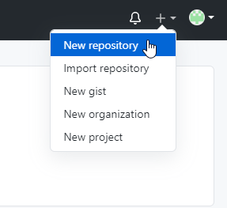

* Enter the **Repository name.** Entering **Description** is optional.
* Choose **Public** for the repository type
* Select **Initialize this repository with a README** to include a README file for the repository
* Click on the **Create Repository** button

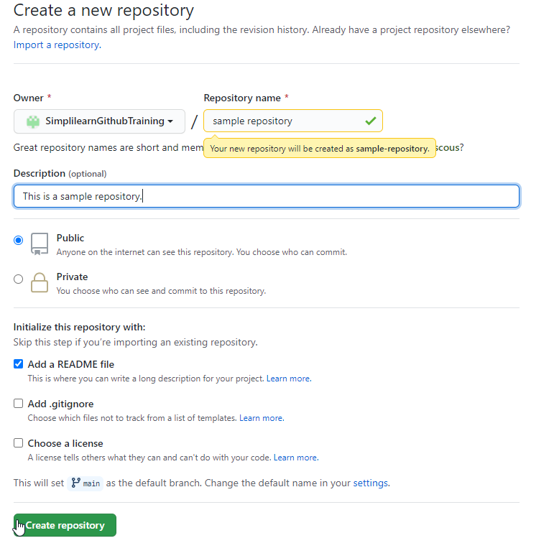

**Step 2.2.2:** Editing the README file

* Click on the **Edit** button to edit the README file

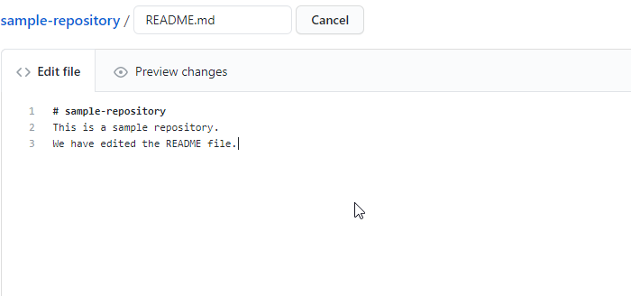

* Type a commit message to describe the changes made in the file (**Example**: First commit: README file update)

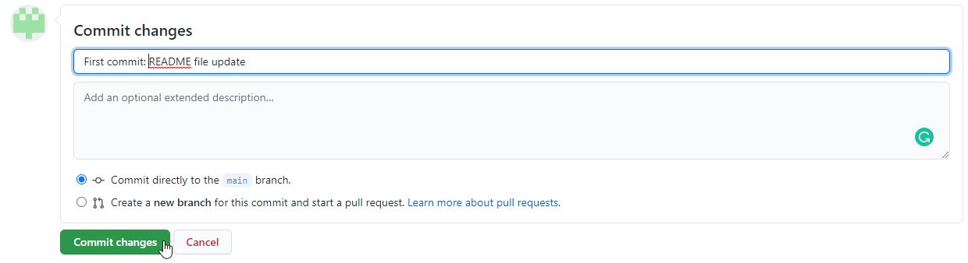

**Step 2.2.3:** Uploading a file to the repository

* Create a new file in your lab inside your home directory similar to **/home*/*<YourUsername>** with the name **GitandGithubCourseFile.txt** by executing the below command in the terminal

**vi GitandGithubCourseFile.txt**

* Add the below line in **GitandGithubCourseFile.txt** file and save it.

*This is a test file*

* Go to your Github repository and to add a file to the repository, click on **Add file**, and then select **Upload files.**

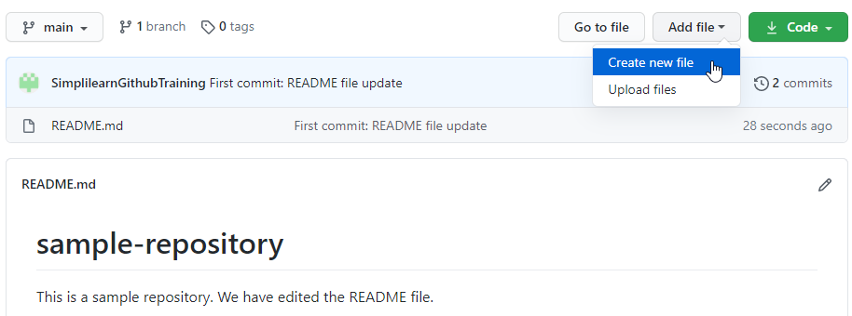

* Select the files from **choose your files**
* Enter a commit message (**Example**: second commit: Added new docx file), and then click on the **Commit changes** button

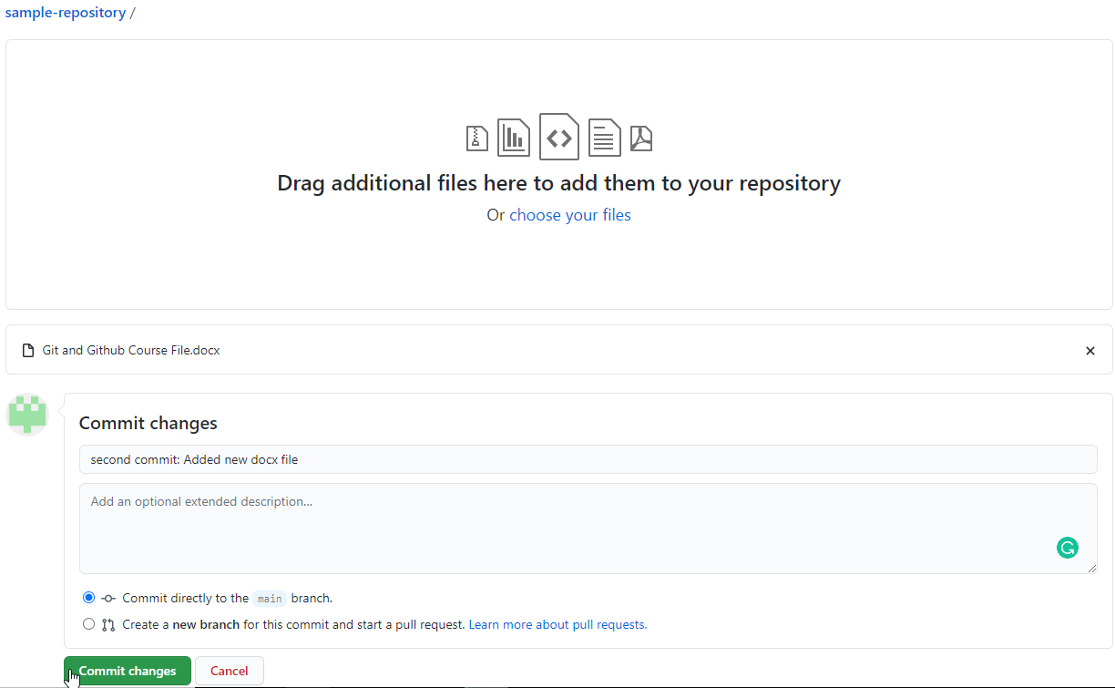

* Check the newly added file with the commit message

