IDF Analysis Report - Bash WPP
Bash WPP
Report period: 2024-12-31 to 2026-08-15 Analysis date: 2026-08-17 Technician: Paulo EC

1. System Availability (Heartbeats)
Daylight-time availability of IDF units, based on heartbeat signals.
idf | offline_mins_total | daylight_mins_total | days_covered | monitoring_period_pct | availability_pct | availability_cat
BSH14-41 | 51,412.65 | 443,819.1 | 593 | 11.6 | 88.4 | 80-90%
BSH12-40 | 33,203.92 | 443,819.1 | 593 | 7.5 | 92.5 | 90-96%
BSH64-04 | 24,795.25 | 443,819.1 | 593 | 5.6 | 94.4 | 90-96%
BSH53-10 | 23,403.42 | 443,819.1 | 593 | 5.3 | 94.7 | 90-96%
BSH52-11 | 22,821.55 | 443,819.1 | 593 | 5.1 | 94.9 | 90-96%
BSH55-09 | 22,230.05 | 443,819.1 | 593 | 5.0 | 95.0 | 90-96%
BSH62-05 | 16,579.67 | 443,819.1 | 593 | 3.7 | 96.3 | >96%
BSH61-06 | 13,679.95 | 443,819.1 | 593 | 3.1 | 96.9 | >96%
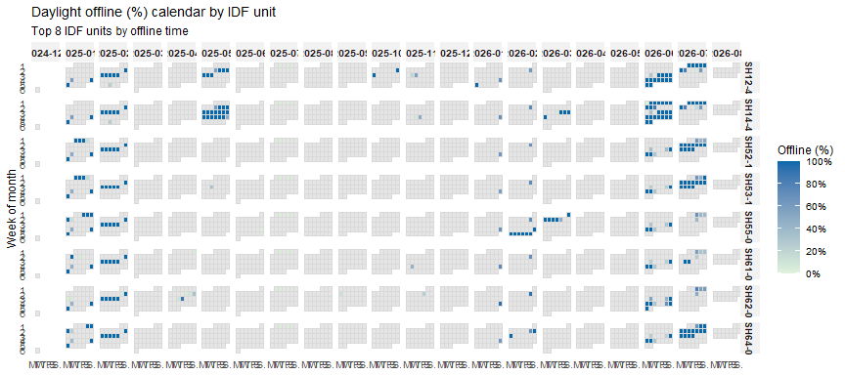
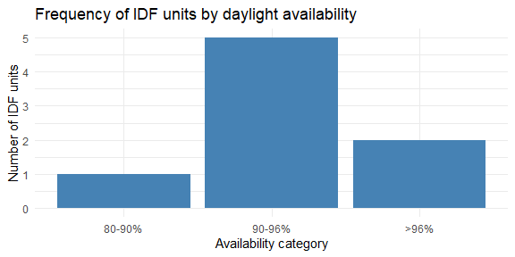

2. Data Coverage
Temporal overlap between Curtailments and SCADA (by turbine), and Heartbeats coverage (by IDF unit). Full download history, not limited to the report period above.
turbine | total_days | days_a | days_b | days_overlap | pct_a_with_overlap | pct_b_with_overlap
BSH1 | 305 | 214 | 0 | 0 | 0.0
BSH10 | 305 | 219 | 0 | 0 | 0.0
BSH11 | 305 | 245 | 0 | 0 | 0.0
BSH13 | 305 | 244 | 0 | 0 | 0.0
BSH15 | 305 | 206 | 0 | 0 | 0.0
BSH16 | 305 | 237 | 0 | 0 | 0.0
BSH17 | 305 | 248 | 0 | 0 | 0.0
BSH18 | 305 | 250 | 0 | 0 | 0.0
BSH19 | 305 | 255 | 0 | 0 | 0.0
BSH2 | 305 | 230 | 0 | 0 | 0.0
BSH20 | 305 | 253 | 0 | 0 | 0.0
BSH21 | 305 | 249 | 0 | 0 | 0.0
BSH22 | 305 | 251 | 0 | 0 | 0.0
BSH23 | 305 | 252 | 0 | 0 | 0.0
BSH24 | 305 | 251 | 0 | 0 | 0.0
BSH25 | 305 | 249 | 0 | 0 | 0.0
BSH26 | 305 | 248 | 0 | 0 | 0.0
BSH27 | 305 | 246 | 0 | 0 | 0.0
BSH28 | 305 | 241 | 0 | 0 | 0.0
BSH29 | 305 | 218 | 0 | 0 | 0.0
BSH31 | 305 | 274 | 0 | 0 | 0.0
BSH32 | 305 | 268 | 0 | 0 | 0.0
BSH35 | 305 | 281 | 0 | 0 | 0.0
BSH37 | 305 | 281 | 0 | 0 | 0.0
BSH38 | 305 | 281 | 0 | 0 | 0.0
BSH39 | 305 | 278 | 0 | 0 | 0.0
BSH4 | 305 | 221 | 0 | 0 | 0.0
BSH41 | 305 | 255 | 0 | 0 | 0.0
BSH42 | 305 | 285 | 0 | 0 | 0.0
BSH43 | 305 | 264 | 0 | 0 | 0.0
BSH44 | 305 | 272 | 0 | 0 | 0.0
BSH45 | 305 | 287 | 0 | 0 | 0.0
BSH46 | 305 | 291 | 0 | 0 | 0.0
BSH47 | 305 | 290 | 0 | 0 | 0.0
BSH48 | 305 | 280 | 0 | 0 | 0.0
BSH5 | 305 | 239 | 0 | 0 | 0.0
BSH51 | 305 | 287 | 0 | 0 | 0.0
BSH52 | 305 | 283 | 0 | 0 | 0.0
BSH53 | 305 | 286 | 0 | 0 | 0.0
BSH56 | 305 | 294 | 0 | 0 | 0.0
BSH58 | 305 | 293 | 0 | 0 | 0.0
BSH59 | 305 | 290 | 0 | 0 | 0.0
BSH6 | 305 | 250 | 0 | 0 | 0.0
BSH60 | 305 | 284 | 0 | 0 | 0.0
BSH61 | 305 | 285 | 0 | 0 | 0.0
BSH63 | 305 | 287 | 0 | 0 | 0.0
BSH64 | 305 | 285 | 0 | 0 | 0.0
BSH65 | 305 | 282 | 0 | 0 | 0.0
BSH66 | 305 | 277 | 0 | 0 | 0.0
BSH67 | 305 | 268 | 0 | 0 | 0.0
BSH7 | 305 | 258 | 0 | 0 | 0.0
BSH70 | 305 | 269 | 0 | 0 | 0.0
BSH71 | 305 | 265 | 0 | 0 | 0.0
BSH72 | 305 | 277 | 0 | 0 | 0.0
BSH73 | 305 | 280 | 0 | 0 | 0.0
BSH74 | 305 | 278 | 0 | 0 | 0.0
BSH75 | 305 | 277 | 0 | 0 | 0.0
BSH76 | 305 | 286 | 0 | 0 | 0.0
BSH77 | 305 | 286 | 0 | 0 | 0.0
BSH78 | 305 | 288 | 0 | 0 | 0.0
BSH79 | 305 | 290 | 0 | 0 | 0.0
BSH8 | 305 | 252 | 0 | 0 | 0.0
BSH9 | 305 | 247 | 0 | 0 | 0.0
BSH14 | 305 | 238 | 26 | 20 | 8.4 | 76.9
BSH12 | 305 | 244 | 29 | 23 | 9.4 | 79.3
BSH3 | 305 | 235 | 29 | 23 | 9.8 | 79.3
BSH49 | 305 | 275 | 29 | 23 | 8.4 | 79.3
BSH33 | 305 | 266 | 29 | 24 | 9.0 | 82.8
BSH30 | 305 | 265 | 29 | 25 | 9.4 | 86.2
BSH34 | 305 | 278 | 29 | 26 | 9.4 | 89.7
BSH36 | 305 | 279 | 29 | 26 | 9.3 | 89.7
BSH40 | 305 | 275 | 29 | 26 | 9.5 | 89.7
BSH50 | 305 | 281 | 29 | 26 | 9.3 | 89.7
BSH68 | 305 | 278 | 29 | 26 | 9.4 | 89.7
BSH55 | 305 | 292 | 29 | 27 | 9.2 | 93.1
BSH80 | 305 | 286 | 29 | 27 | 9.4 | 93.1
BSH57 | 305 | 294 | 29 | 28 | 9.5 | 96.6
BSH62 | 305 | 279 | 213 | 191 | 68.5 | 89.7
BSH54 | 305 | 290 | 244 | 233 | 80.3 | 95.5
idf | start | end | days_with_data | total_days | days_missing | pct_missing
BSH44-20 | 2025-02-14 | 2026-08-15 | 480 | 548 | 68 | 12.4
BSH43-21 | 2025-01-22 | 2026-08-15 | 502 | 571 | 69 | 12.1
BSH04-42 | 2024-12-31 | 2026-08-15 | 537 | 593 | 56 | 9.4
BSH01-43 | 2024-12-31 | 2026-08-15 | 537 | 593 | 56 | 9.4
BSH14-41 | 2024-12-31 | 2026-08-15 | 542 | 593 | 51 | 8.6
BSH28-29 | 2024-12-31 | 2026-08-15 | 545 | 593 | 48 | 8.1
BSH38-24 | 2025-01-15 | 2026-08-15 | 537 | 578 | 41 | 7.1
BSH25-31 | 2024-12-31 | 2026-08-15 | 552 | 593 | 41 | 6.9
BSH22-32 | 2024-12-31 | 2026-08-15 | 558 | 593 | 35 | 5.9
BSH21-33 | 2024-12-31 | 2026-08-15 | 559 | 593 | 34 | 5.7
BSH05-36 | 2024-12-31 | 2026-07-29 | 543 | 576 | 33 | 5.7
BSH19-34 | 2024-12-31 | 2026-08-15 | 560 | 593 | 33 | 5.6
BSH32-28 | 2024-12-31 | 2026-08-15 | 560 | 593 | 33 | 5.6
BSH73-14 | 2024-12-31 | 2026-08-15 | 561 | 593 | 32 | 5.4
BSH41-22 | 2024-12-31 | 2026-08-15 | 561 | 593 | 32 | 5.4
BSH12-40 | 2024-12-31 | 2026-08-15 | 562 | 593 | 31 | 5.2
BSH40-23 | 2025-01-15 | 2026-08-15 | 548 | 578 | 30 | 5.2
BSH17-35 | 2024-12-31 | 2026-08-15 | 563 | 593 | 30 | 5.1
BSH75-15 | 2024-12-31 | 2026-08-15 | 564 | 593 | 29 | 4.9
BSH30-27 | 2024-12-31 | 2026-08-15 | 565 | 593 | 28 | 4.7
BSH26-30 | 2024-12-31 | 2026-08-15 | 565 | 593 | 28 | 4.7
BSH60-07 | 2025-01-06 | 2026-08-15 | 560 | 587 | 27 | 4.6
BSH07-37 | 2024-12-31 | 2026-08-15 | 568 | 593 | 25 | 4.2
BSH72-13 | 2024-12-31 | 2026-08-15 | 568 | 593 | 25 | 4.2
BSH64-04 | 2025-01-03 | 2026-08-15 | 565 | 590 | 25 | 4.2
BSH55-09 | 2024-12-31 | 2026-08-15 | 569 | 593 | 24 | 4.0
BSH53-10 | 2024-12-31 | 2026-08-15 | 570 | 593 | 23 | 3.9
BSH67-03 | 2025-01-03 | 2026-08-15 | 567 | 590 | 23 | 3.9
BSH52-11 | 2024-12-31 | 2026-08-15 | 571 | 593 | 22 | 3.7
BSH46-19 | 2025-02-06 | 2026-08-15 | 537 | 556 | 19 | 3.4
BSH34-26 | 2025-01-29 | 2026-08-15 | 548 | 564 | 16 | 2.8
BSH58-08 | 2025-01-06 | 2026-08-15 | 573 | 587 | 14 | 2.4
BSH48-18 | 2025-01-13 | 2026-08-15 | 566 | 580 | 14 | 2.4
BSH78-16 | 2025-01-02 | 2026-08-15 | 579 | 591 | 12 | 2.0
BSH49-12 | 2024-12-31 | 2026-08-03 | 570 | 581 | 11 | 1.9
BSH09-38 | 2024-12-31 | 2026-05-24 | 501 | 510 | 9 | 1.8
BSH80-17 | 2025-01-03 | 2026-08-15 | 580 | 590 | 10 | 1.7
BSH61-06 | 2025-01-06 | 2026-08-15 | 577 | 587 | 10 | 1.7
BSH62-05 | 2025-01-11 | 2026-08-15 | 572 | 582 | 10 | 1.7
BSH70-02 | 2025-01-11 | 2026-08-15 | 572 | 582 | 10 | 1.7
BSH68-01 | 2025-01-18 | 2026-08-15 | 566 | 575 | 9 | 1.6
BSH10-39 | 2024-12-31 | 2026-05-24 | 503 | 510 | 7 | 1.4
BSH36-25 | 2025-01-28 | 2026-08-15 | 562 | 565 | 3 | 0.5
IDF-BASE | 2024-12-31 | 2026-08-15 | 593 | 593 | 0 | 0.0

3. Curtailment Response Assessment
Whether SCADA-recorded RPM dropped as expected in response to curtailment signals (tight 2s baseline tolerance).
final_status | n | pct | pct_of_valid
no_data | 9,162 | 78.8
full_stop_by_end | 1,336 | 11.5 | 54.2
already_stopped | 689 | 5.9 | 28.0
partial_or_no_stop | 440 | 3.8 | 17.8
turbine | n_curtailments | n_no_immediate_response | n_already_stopped | n_full_stop_by_end | n_partial_or_no_stop | n_no_data | mean_rpm_delta_pct | n_valid_matches | no_immediate_response_pct | missed_pct
BSH14 | 2,736 | 32 | 7 | 17 | 10 | 2,702 | 0.7697532 | 34 | 1.2 | 29.4
BSH54 | 4,430 | 1,146 | 379 | 708 | 236 | 3,107 | -0.8200681 | 1,323 | 25.9 | 17.8
BSH62 | 4,461 | 990 | 303 | 611 | 194 | 3,353 | -0.7537707 | 1,108 | 22.2 | 17.5

4. Shutdown Time
Time from curtailment signal to reaching 2 / 1 / 0 rpm, by turbine.
turbine | threshold | n_curtailments | n_reached | pct_reached | mean_time_sec | median_time_sec | sd_time_sec | min_time_sec | max_time_sec
BSH54 | 0 | 1,222 | 0 | 0.0
BSH62 | 0 | 1,060 | 0 | 0.0
BSH14 | 0 | 33 | 0 | 0.0
BSH14 | 1 | 33 | 20 | 60.6 | 58.5 | 71.2 | 45.1 | 0.156000137 | 111.335
BSH62 | 1 | 1,060 | 830 | 78.3 | 49.0 | 59.4 | 36.3 | 0.008999825 | 238.501
BSH54 | 1 | 1,222 | 927 | 75.9 | 45.4 | 58.4 | 35.6 | 0.010999918 | 119.015
BSH14 | 2 | 33 | 25 | 75.8 | 55.3 | 61.8 | 39.1 | 0.156000137 | 109.348
BSH62 | 2 | 1,060 | 898 | 84.7 | 43.3 | 49.9 | 32.8 | 0.008999825 | 238.501
BSH54 | 2 | 1,222 | 1,037 | 84.9 | 40.7 | 49.5 | 31.7 | 0.010999918 | 109.274
threshold | n_reached | pct_below_cut | pct_above_cut
2 | 1,960 | 40.9 | 49.0
1 | 1,777 | 39.3 | 56.7
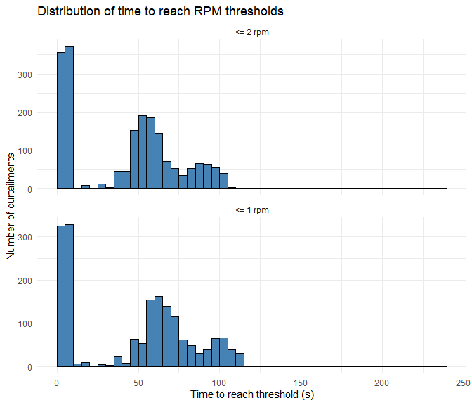

5. 3D Coverage (Topography-corrected)
Coverage of the risk airspace around each turbine, corrected for terrain, based on IDF bird track detections.
wtg_id | n_records | n_valid | n_air_mesh | n_covered | pct_covered | low_sample
BSH1 | 56,255 | 43,168 | 31,141 | 7,648 | 24.6 | true
BSH15 | 124,497 | 111,318 | 31,266 | 9,634 | 30.8 | true
BSH16 | 124,957 | 108,376 | 31,463 | 10,083 | 32.0 | true
BSH30 | 146,262 | 123,116 | 31,230 | 10,080 | 32.3 | true
BSH29 | 109,175 | 89,932 | 31,250 | 10,246 | 32.8 | true
BSH4 | 98,091 | 88,681 | 31,545 | 11,037 | 35.0 | true
BSH33 | 133,115 | 112,107 | 31,384 | 11,191 | 35.7 | true
BSH41 | 95,283 | 83,393 | 31,856 | 11,391 | 35.8 | true
BSH71 | 176,870 | 142,124 | 31,057 | 11,927 | 38.4 | true
BSH2 | 107,981 | 90,547 | 31,005 | 12,008 | 38.7 | true
BSH5 | 168,905 | 137,098 | 31,821 | 12,465 | 39.2 | true
BSH40 | 166,868 | 121,460 | 31,863 | 12,652 | 39.7 | true
BSH67 | 302,005 | 214,427 | 31,710 | 12,650 | 39.9 | true
BSH36 | 167,381 | 131,460 | 31,738 | 12,693 | 40.0 | true
BSH80 | 181,763 | 163,579 | 31,148 | 12,530 | 40.2 | true
BSH37 | 168,893 | 134,005 | 31,321 | 12,782 | 40.8 | true
BSH32 | 176,350 | 159,407 | 31,839 | 13,058 | 41.0 | true
BSH17 | 187,917 | 162,867 | 31,727 | 13,258 | 41.8 | true
BSH39 | 171,840 | 150,633 | 31,697 | 13,264 | 41.8 | true
BSH48 | 212,977 | 177,981 | 31,320 | 13,195 | 42.1 | true
BSH35 | 171,896 | 146,488 | 31,495 | 13,488 | 42.8 | true
BSH14 | 169,259 | 149,634 | 31,226 | 13,479 | 43.2 | true
BSH18 | 216,189 | 175,211 | 31,772 | 13,739 | 43.2 | true
BSH34 | 166,211 | 149,811 | 31,548 | 13,616 | 43.2 | true
BSH3 | 121,696 | 110,280 | 31,523 | 13,673 | 43.4 | true
BSH31 | 179,207 | 165,200 | 31,316 | 13,622 | 43.5 | true
BSH38 | 180,138 | 155,150 | 31,812 | 13,847 | 43.5 | true
BSH77 | 212,272 | 171,359 | 31,329 | 13,903 | 44.4 | true
BSH19 | 209,682 | 173,473 | 31,590 | 14,088 | 44.6 | true
BSH78 | 226,672 | 182,664 | 31,493 | 14,298 | 45.4 | true
BSH49 | 465,473 | 365,957 | 32,102 | 14,594 | 45.5 | true
BSH28 | 152,743 | 132,688 | 31,288 | 14,290 | 45.7 | true
BSH75 | 225,210 | 178,802 | 31,131 | 14,242 | 45.7 | true
BSH13 | 178,956 | 141,709 | 30,993 | 14,273 | 46.1 | true
BSH79 | 231,397 | 203,015 | 31,225 | 14,397 | 46.1 | true
BSH42 | 187,006 | 142,284 | 31,672 | 14,662 | 46.3 | true
BSH12 | 166,736 | 130,060 | 31,646 | 14,678 | 46.4 | true
BSH76 | 211,089 | 175,157 | 31,236 | 14,523 | 46.5 | true
BSH43 | 186,074 | 150,828 | 31,581 | 14,787 | 46.8 | true
BSH74 | 248,496 | 204,065 | 31,849 | 14,949 | 46.9 | true
BSH11 | 165,901 | 132,952 | 31,234 | 14,823 | 47.5 | true
BSH72 | 246,708 | 210,588 | 31,557 | 15,171 | 48.1 | true
BSH10 | 177,140 | 135,619 | 31,252 | 15,090 | 48.3 | true
BSH20 | 217,940 | 180,713 | 31,545 | 15,270 | 48.4 | true
BSH73 | 269,894 | 222,313 | 30,744 | 15,093 | 49.1 | true
BSH44 | 262,849 | 205,215 | 31,716 | 15,989 | 50.4 | true
BSH23 | 213,289 | 171,661 | 31,854 | 16,181 | 50.8 | true
BSH24 | 210,930 | 175,132 | 31,770 | 16,218 | 51.0 | true
BSH22 | 215,112 | 176,099 | 31,704 | 16,187 | 51.1 | true
BSH21 | 214,499 | 169,521 | 31,306 | 16,037 | 51.2 | true
BSH6 | 246,473 | 206,967 | 31,741 | 16,386 | 51.6 | true
BSH27 | 188,301 | 158,989 | 31,268 | 16,124 | 51.6 | true
BSH47 | 279,046 | 242,151 | 31,508 | 16,347 | 51.9 | true
BSH45 | 290,373 | 238,829 | 31,394 | 16,323 | 52.0 | true
BSH25 | 210,482 | 171,176 | 31,606 | 16,459 | 52.1 | true
BSH46 | 315,652 | 268,107 | 31,638 | 16,568 | 52.4 | true
BSH26 | 206,180 | 165,704 | 31,500 | 16,774 | 53.3 | true
BSH7 | 283,096 | 239,375 | 31,788 | 17,090 | 53.8 | true
BSH9 | 258,154 | 215,695 | 31,279 | 17,106 | 54.7 | true
BSH8 | 272,467 | 232,538 | 31,856 | 17,623 | 55.3 | true
BSH66 | 543,404 | 441,385 | 31,781 | 17,738 | 55.8 | false
BSH50 | 661,418 | 544,947 | 32,039 | 18,118 | 56.5 | false
BSH60 | 441,421 | 324,588 | 31,332 | 18,447 | 58.9 | true
BSH68 | 371,301 | 277,302 | 31,675 | 19,007 | 60.0 | true
BSH59 | 351,997 | 277,284 | 31,041 | 18,731 | 60.3 | true
BSH58 | 413,107 | 313,492 | 31,380 | 19,046 | 60.7 | true
BSH51 | 850,804 | 719,935 | 31,644 | 19,820 | 62.6 | false
BSH61 | 664,121 | 533,492 | 31,949 | 20,464 | 64.1 | false
BSH57 | 604,445 | 471,415 | 31,742 | 20,562 | 64.8 | false
BSH53 | 1,079,955 | 913,638 | 31,623 | 20,627 | 65.2 | false
BSH52 | 965,599 | 836,695 | 31,554 | 20,743 | 65.7 | false
BSH62 | 954,590 | 731,717 | 31,925 | 21,115 | 66.1 | false
BSH54 | 1,057,720 | 898,699 | 31,659 | 21,235 | 67.1 | false
BSH56 | 768,036 | 631,033 | 31,816 | 21,428 | 67.3 | false
BSH55 | 915,715 | 775,006 | 31,662 | 21,650 | 68.4 | false
BSH65 | 728,784 | 607,796 | 31,697 | 21,751 | 68.6 | false
BSH63 | 1,114,004 | 902,832 | 31,447 | 23,620 | 75.1 | false
BSH64 | 989,991 | 795,849 | 31,556 | 23,901 | 75.7 | false
BSH70 | 663,373 | 534,092 | 31,881 | 25,354 | 79.5 | false
Note: interactive 3D plots are saved separately as HTML files (folder coverage_3d/) and are not embedded in this document.

