PBR Interpretation based on Frick et al. 2026 (BSH & DGY)
Table of Contents
1. Context 1
2. PBR Threshold Uncertainty 1
2.1. Frick et al. adjusted PBR framework 1
2.2. Sensitivity and elasticity analysis 1
2.3. Evidence base for age at first breeding 1
2.4. Reverse-engineering the imposed thresholds 1
2.5. PBR response surfaces 1
2.6. Monte Carlo simulation outputs 1
2.7. Preliminary interpretation and implications 1

Document history / List of changes.
Version | Changes | Date of changes | Authors
Version 1 | First draft | 2026-05-07 | Paulo Cardoso
Version 2 | Corrected recovery factor (Fr); reverse-engineered and plausibility-checked the local population estimate (Nmin); updated age-at-first-breeding range from a literature review; rebuilt the sensitivity, response-surface and Monte Carlo analyses on consistent, reproducible parameter ranges | 2026-09 | Paulo Cardoso

Context
This technical note reviews the Potential Biological Removal (PBR) framework proposed by Frick et al. (2026) for bats at wind-energy facilities, and applies it to the Parti-coloured bat (Vespertilio murinus) fatality thresholds currently imposed at BSH & DGY (144 bats/year at BSH; 120 bats/year at DGY). No documented derivation of these threshold values is available, and no independent local population estimate for the species in this region exists or can realistically be obtained. The note therefore works backwards from the imposed thresholds to identify a parsimonious, checkable set of assumptions consistent with them, and then tests how sensitive those thresholds are to reasonable demographic uncertainty, rather than to the single fixed parameter values the framework uses by default.

PBR Threshold Uncertainty

Frick et al. adjusted PBR framework
The PBR framework presented by Frick and colleagues (Frick et al. 2026, herein referred to as Frick) adapts the classical Potential Biological Removal concept to bat mortality at wind-energy facilities. It retains the precautionary structure of the original PBR formulation while addressing known limitations of applying marine-mammal-derived PBR methods to volant terrestrial taxa, particularly long-lived bat species characterised by low fecundity, delayed maturity, and strong sensitivity to adult survival.
Under the adjusted framework, PBR is expressed as:
$$PBR=\frac{1}{2}R_{max}⋅F_{r}⋅N_{min}$$
where $R_{max}=λ_{max}-1$ is the maximum annual population growth rate, $F_{r}$ is a recovery factor linked to IUCN conservation status, and $N_{min}$ is a conservative lower-bound estimate of local abundance.
A key conceptual shift in the Frick proposal is the move from broad regional or continental population framing towards a project-scale local population proxy. Local abundance bounds ($N_{L}$ and $N_{U}$) are derived from the interaction area surrounding the wind facility combined with plausible density estimates, and a lognormal formulation is then used to derive the geometric mean abundance estimate ($\hat{N}$), its coefficient of variation ($CV_{\hat{N}}$), and ultimately $N_{min}$. Uncertainty is therefore incorporated explicitly into the abundance term: poorly constrained abundance estimates are penalised with lower, more precautionary PBR values.
$λ_{max}$ is standardised using the Niel & Lebreton (2005) demographic-invariant approximation, from adult survival ($s$) and age at first breeding ($α$):
$$λ_{max}≈\frac{(sα-s+α+1)+\sqrt{(s-sα-α-1)^{2}-4sα^{2}}}{2α}$$
Frick et al. propose precautionary fixed $λ_{max}$ values (1.24 for most bats, 1.20 for families with later age at first breeding such as Pteropodidae) to reduce sensitivity to poorly constrained demographic inputs. The framework remains structurally dependent on several uncertain ecological assumptions, including the definition of the local interacting population, density estimation, recovery-factor selection, and the demographic assumptions underlying the fixed $λ_{max}$ values. Accordingly, PBR thresholds are best interpreted as precautionary decision bands rather than deterministic operational limits, particularly where they are used to calibrate mitigation measures such as curtailment.

Sensitivity and elasticity analysis
Sensitivity and elasticity analyses were undertaken to evaluate how uncertainty in the two demographic parameters used by the Niel & Lebreton approximation, adult survival ($s$) and age at first breeding ($α$), propagates into $λ_{max}$ and consequently into PBR. Parameter ranges were set at $s∈$ [0.7, 0.95] and $α∈$ [1.5, 3.5] years, the latter following the literature review below. For each combination, $λ_{max}$ was recalculated and local sensitivity estimated numerically using finite differences. Elasticity is a dimensionless proportional sensitivity metric: the expected percentage variation in $λ_{max}$ resulting from a 1% variation in a demographic parameter.
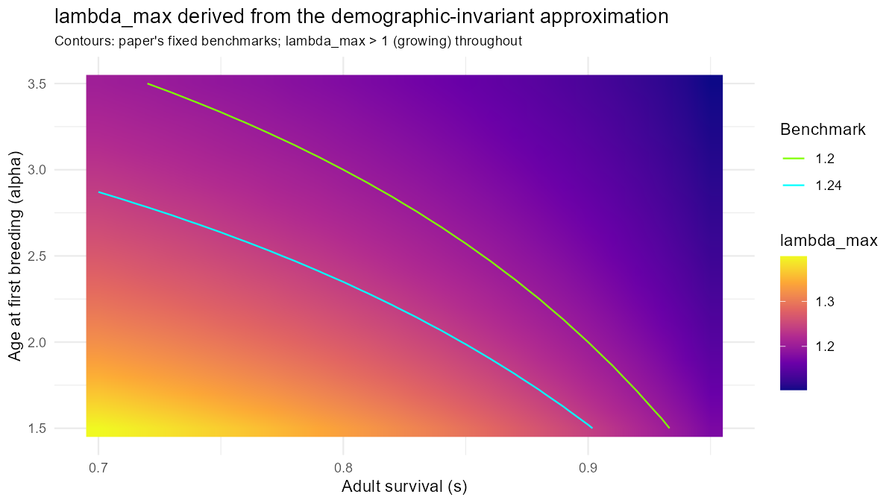
Within the explored range, $λ_{max}$ decreases as adult survival or age at first breeding increase – a counterintuitive relationship documented by Niel & Lebreton (2005) and noted by Frick et al. themselves, arising from the life-history trade-off between survival and fecundity built into the demographic-invariant approximation. This is a decrease in absolute terms, not a sign change: for any survival probability in (0, 1), this formula’s $λ_{max}$ only approaches 1 (a stable population) in the limit as age at first breeding tends to infinity, and never actually reaches it for a realistic age at first breeding – the population is growing ($λ_{max}>1$) throughout the entire range explored here and well beyond it. The elasticity values below should be read with that in mind: a negative elasticity means $λ_{max}$ falls (while remaining well above 1) as the parameter increases, not that $λ_{max}$ itself becomes small or negative.
Elasticity of lambda_max to each demographic parameter.
Parameter | min | max | median
Adult survival (s) | -1.347 | -0.130 | -0.356
Age at first breeding (alpha) | -0.222 | -0.059 | -0.129
$λ_{max}$ is substantially more sensitive to uncertainty in adult survival than to uncertainty in age at first breeding across the explored demographic space: a 1% variation in adult survival produces roughly 1.35-0.13% variation in $λ_{max}$, versus 0.22-0.06% for an equivalent variation in age at first breeding. Sensitivity is not spatially uniform: combinations of relatively high adult survival and earlier reproductive maturity produce the largest elastic responses, which is particularly relevant because adult survival is also among the least well-constrained demographic parameters for most bat species.
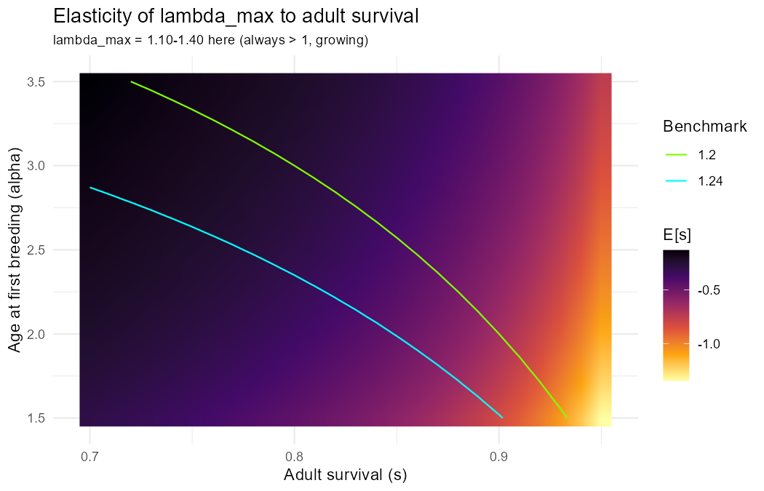
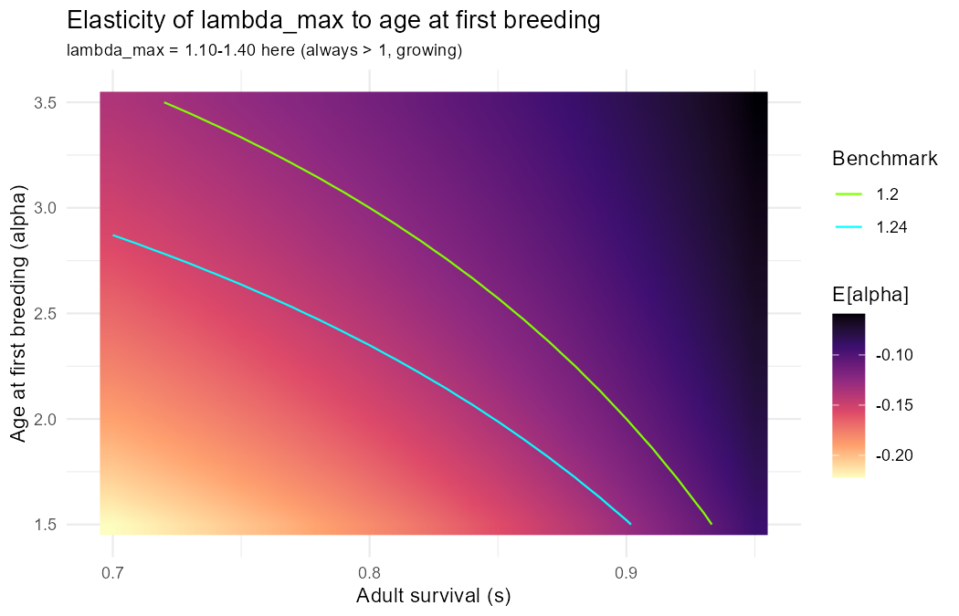
These results support the central rationale of the Frick adjusted framework: uncertainty in demographic parameterisation can materially influence resulting PBR values, and precautionary fixed-$λ_{max}$ assumptions reduce excessive sensitivity to uncertain demographic inputs. However, substantial uncertainty remains even under a fixed-$λ_{max}$ approach, through the interaction of demographic assumptions, local abundance estimation, and recovery-factor selection – the remainder of this note works through that interaction for the Parti-coloured bat at BSH & DGY specifically.

Evidence base for age at first breeding
For PBR, $α$ should represent effective age at first reproduction – the age at which a female actually recruits offspring into the population – not merely physiological sexual maturity. A literature review for Vespertilio murinus was undertaken on this basis.
Sources reviewed for age at first breeding in the Parti-coloured bat.
Source | Species / group | Relevant information | Implication for alpha
AnAge database | Vespertilio murinus | Female and male sexual maturity listed at 730 days (~2 years); litter size 2; one litter per year. | Supports alpha ~= 2 as a defensible value.
Haensel 2010, Nyctalus | Vespertilio murinus | Some females raise young in their first year of life; the author’s own data suggest most or all females may reach sexual maturity in the year of birth and raise young as one-year-olds, stated cautiously. | Suggests alpha = 1-2 may be plausible; alpha = 2 is not an optimistic assumption.
Ratpenats species account | Vespertilio murinus | Many females mate in their first autumn. | Supports early sexual maturity, but mating is not the same as confirmed breeding.
Racey & Entwistle synthesis, cited in Frick et al.’s own discussion | Bats broadly | The general view for most bats is that age at first breeding is around 1 year, though first-year breeding probability can be lower; Frick et al. use alpha = 1.5 as a general benchmark and suggest alpha = 2 for some families. | Supports alpha = 1.5-2 as plausible for many bat species.
Cryan et al. 2012 | Migratory tree bats killed at wind turbines | Ovarian development indicating sexual maturity even in first-year females for several migratory tree-roosting species. | Useful analogue: some wind-vulnerable migratory bats mature very early.
Komar et al. 2020 | Male Vespertilio murinus | Food restriction delayed seasonal sexual maturation in males; well-fed males matured earlier. | Maturation timing is condition-dependent; male data are less directly useful for PBR (which uses female recruitment).

$α=2$ is a defensible, reasonably conservative central value for PBR purposes under the effective-recruitment reading of $α$, and is directly supported by the AnAge sexual-maturity estimate. $α=1.5$ (the paper’s own general bat benchmark) is a plausible lower bound, though it rests on thinner, more cautiously stated species-specific evidence. $α=3-4$ has no direct empirical support for V. murinus in the sources reviewed; it remains a useful precautionary sensitivity scenario for ecological constraints on effective recruitment (migration costs, poor juvenile survival, low first-year breeding probability), but is not the best-supported biological estimate. This review supports using $α∈$ [1.5, 3.5] years as the working range throughout this note, in place of a single fixed value.

Reverse-engineering the imposed thresholds
BSH & DGY were given a fixed annual fatality threshold for the Parti-coloured bat – 144 bats/year at BSH and 120 bats/year at DGY – without a documented derivation. Since no independent local population estimate for the species exists for this region, plausibility is assessed by working backwards from the imposed thresholds under the Frick PBR equation.
Local population size (Nmin) required to reproduce each imposed threshold, under Fr = 0.3 (Near Threatened) and the paper’s fixed lambda_max benchmarks.
Facility | Threshold (bats/yr) | Fixed lambda_max | Required Nmin
BSH | 144 | 1.24 | 4000
BSH | 144 | 1.20 | 4800
DGY | 120 | 1.24 | 3333
DGY | 120 | 1.20 | 4000

This is the most parsimonious explanation available for how the imposed thresholds were obtained: local populations of ~4,000 individuals near each facility, combined with the paper’s $λ_{max}$ benchmarks applied per facility. BSH & DGY are approximately 100 km apart, so this is better read as two similarly sized local populations rather than a single population shared between them (see below).
Whether ~4,000 individuals is a plausible local population can be assessed against the real, known project geography, by asking what average bat density it would imply, rather than backing out a hypothetical area from a hypothetical density.
Density that Nmin = 4,000 would imply, under the two real area readings, holding the density ratio fixed at the default proxy’s (5.5-18.2 bats/km²).
Area scenario | Area (km²) | Implied density low (bats/km²) | Implied density high (bats/km²)
Single project footprint (370 km2) | 370 | 5.88 | 19.46
Combined region, both projects (7000 km2) | 7000 | 0.31 | 1.03

The single-project-footprint reading (370 km$​^{2}$) implies a density of 5.9-19.5 bats/km$​^{2}$ – closely matching the paper’s own default density proxy (5.5-18.2 bats/km$​^{2}$, based on Pipistrellus pipistrellus, used in the absence of species-specific density data) for a common bat species. Treating $N_{min}≈4,000$ as the local population near each facility individually, rather than shared across both, is therefore consistent with typical bat density and with Frick et al.’s own project-scale definition of local population.
By contrast, treating $N_{min}=4,000$ as a single population spread across the combined region spanning both projects (7000 km$​^{2}$) implies a density of only 0.31-1.03 bats/km$​^{2}$ – roughly an order of magnitude below the default proxy, an assumption that would need independent supporting evidence (e.g. that regional density for Parti-coloured bat here is genuinely that sparse) before being considered reasonable.
The project-footprint reading is therefore both the more defensible order of magnitude and the one that matches Frick et al.’s own project-scale local-population concept. The working assumption throughout the rest of this note is accordingly that $N_{min}≈4,000$ applies to each facility’s own local population, not to a single population shared across the 100 km separating BSH and DGY.
$F_{r}=0.3$ corresponds to a Near Threatened status. The Parti-coloured bat is not a threatened category, so the defensible recovery factor is $F_{r}=0.5$ (Least Concern). Holding $N_{min}$ at 4,000 and correcting only $F_{r}$:
PBR at Nmin = 4,000, Fr = 0.5.
Fixed lambda_max | PBR (bats/yr)
1.24 | 240
1.20 | 200
The recovery-factor correction alone shifts PBR upward at every fixed $λ_{max}$ benchmark, before any change to $λ_{max}$ itself is considered.

PBR response surfaces
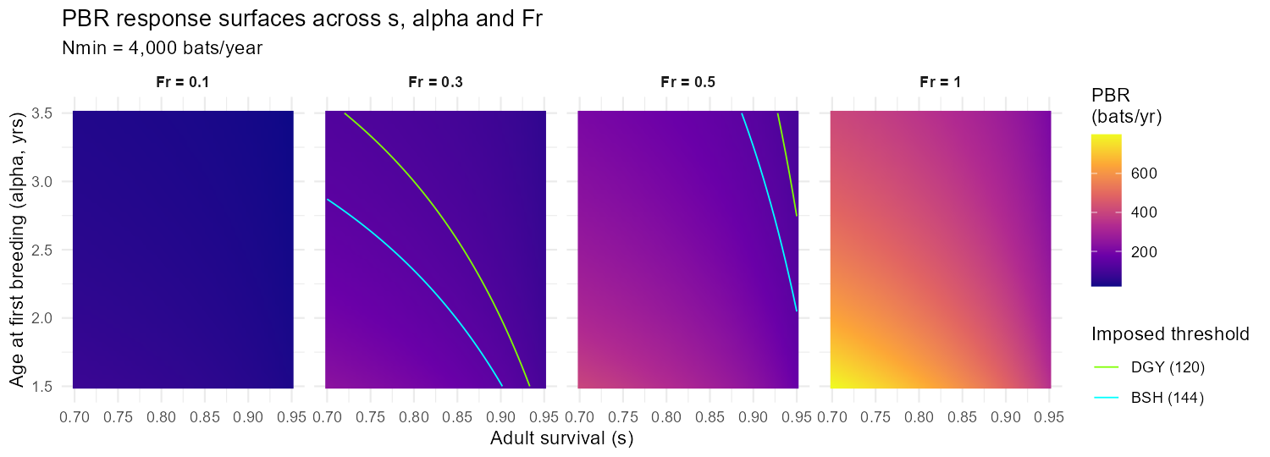
Across the plausible demographic range, the imposed-threshold contours only appear for a narrow combination of relatively high adult survival and low age at first breeding – outside that narrow band, PBR departs from the imposed thresholds even before changing $F_{r}$.

Monte Carlo simulation outputs
Uncertainty in adult survival and age at first breeding was propagated into $λ_{max}$ and PBR by simulation, holding $N_{min}=4,000$ and $F_{r}=0.5$ fixed, with $s∼U(0.7,0.95)$ and $α∼U(1.5,3.5)$ (20,000 draws).
Simulated PBR distribution quantiles.
Quantile | PBR (bats/yr)
5% | 134.0
25% | 177.0
50% | 211.3
75% | 255.0
95% | 327.3

Where the imposed thresholds fall within the simulated PBR distribution.
Facility | Threshold (bats/yr) | Percentile rank in simulated PBR | Median ratio | P95 ratio
BSH | 144 | 8.43 | 1.47 | 2.27
DGY | 120 | 1.75 | 1.76 | 2.73

The imposed thresholds sit on the low, conservative side of the simulated distribution, not the permissive side: median simulated PBR is 1.47-1.76x the imposed thresholds, reaching 2.27-2.73x at the 95th percentile.
Effect of the alpha range on the simulated PBR distribution (Fr = 0.5, Nmin = 4,000).
Alpha range | Q05 | Median | Q95 | % below 144 (BSH) | % below 120 (DGY)
2 - 4 (prior) | 120.5 | 185.6 | 270.3 | 16.8 | 4.9
1.5 - 3.5 (updated) | 134.0 | 211.3 | 327.3 | 8.4 | 1.8

Moving from the wider, less literature-grounded alpha range (2-4) to the range the evidence review supports (1.5-3.5) shifts the simulated PBR distribution further up, not down: the literature review therefore reinforces, rather than weakens, the conclusion below.
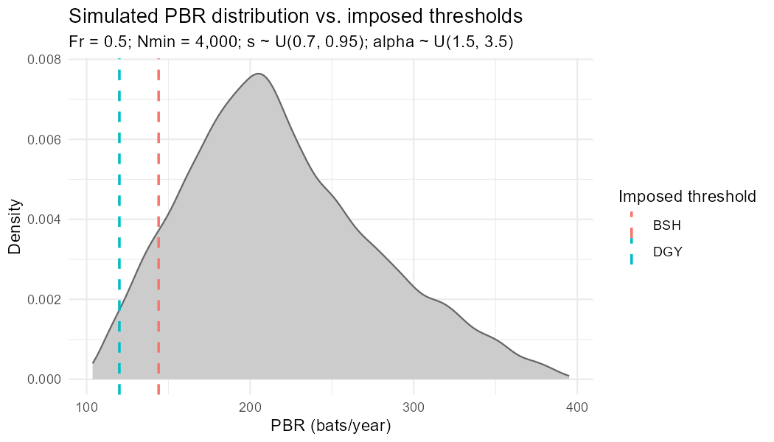

Preliminary interpretation and implications
Under a defensible, non-optimistic parametrisation – recovery factor corrected to the species’ actual (non-threatened) status, and demographic parameters treated as a literature-supported range rather than a single fixed point – the currently imposed thresholds sit near the conservative end of the resulting PBR distribution rather than at its centre. This indicates the current thresholds are not unreasonably permissive; if anything, a flexible parametrisation would support materially higher values, approaching double the current figures at the upper end of the plausible range.
These results reinforce that any operational threshold derived from PBR should be accompanied by transparent documentation of the underlying calculations, demographic assumptions, local population estimates, and uncertainty analysis. A nominal threshold can still serve as a precautionary reference point, but mitigation decisions should additionally consider:
- the plausible uncertainty interval surrounding the threshold;
- temporal trends in fatality estimates;
- uncertainty associated with PCFM-derived mortality estimates;
- the conservation relevance and demographic sensitivity of the affected species;
- the spatial concentration and recurrence of fatalities;
- the expected effectiveness and proportionality of mitigation measures;
- and the broader adaptive-management context in which the threshold is applied.
Presenting PBR as a range rather than a single fixed number provides a more robust and defensible basis for adaptive management decisions where demographic parameters, local population structure, and abundance estimates remain incompletely resolved – as is the case for the Parti-coloured bat in this region.

