VisionCheck AI
Technical Report for Devpost Submission — v6
Interactive Image Quality Assessment for Researchers and Photographers

1. Problem and motivation
Images used in research, photography, field documentation, and everyday communication can lose value because of blur, poor brightness, low contrast, clipped exposure, or insufficient resolution. VisionCheck AI provides transparent, fast, interactive quality screening before an image is accepted into a dataset, report, editing workflow, or sharing pipeline.

2. Intended users and impact
Researchers can screen dataset and documentation images before annotation or analysis. Photographers can perform a quick technical quality check before editing or sharing. Field and agricultural users can identify capture problems caused by motion or difficult lighting. General users receive plain-language feedback rather than a hidden score. VisionCheck AI is decision support, not a replacement for scientific validity checks or artistic judgment.

3. System overview
The desktop application is implemented in Python with OpenCV 5, NumPy, Tkinter, and Pillow. A user selects an image, OpenCV-derived metrics are computed, each metric is converted into a normalized score, the scores are combined into an overall VisionCheck score, and a descriptive status is produced. A custom five-point spider-web control lets the user adjust thresholds in real time and immediately re-run the decision logic.

4. Mathematical image-quality metrics
The image-quality measurements are mathematically defined. The decision thresholds are practical empirical defaults and are not universal constants.
Metric | Mathematical basis | Scoring rule | Default decision value
Sharpness | V = Var(Laplacian(Igray)) | S = 100·clip((V−25)/(300−25), 0, 1) | 45
Brightness | μ = (1/N) Σ Ii | 100 in the 75–190 band; decreases outside that band | Dark: μ < 55; Bright: μ > 210
Contrast | σ = sqrt[(1/N) Σ(Ii−μ)^2] | C = 100·clip((σ−15)/(65−15), 0, 1) | 45
Exposure | pclip = 100·[N(I<20)+N(I>235)]/N | E = max(0, 100−3·pclip) | 50
Resolution | MP = W·H / 10^6 | R = 100 if ≥2 MP; 80 if ≥1; 60 if ≥0.5; else 40 | R < 60 → Low Resolution
Overall VisionCheck score: Q = 0.30S + 0.20B + 0.20C + 0.20E + 0.10R.
Important justification: the formulas define the measurements, while the starting thresholds (45, 55, 210, 45, 50) are empirical engineering defaults selected for a usable first prototype. The labeled 120-image evaluation should be used to calibrate and validate these defaults before performance claims are made.

5. Interactive Quality Control Web
The five-point web exposes Sharpness, Bright Level, Dark Level, Contrast, and Exposure thresholds. Dragging a node changes the threshold and automatically re-evaluates the current image. This supports different cameras, lighting conditions, visual domains, and user goals. Reset Defaults restores the starting values. Because the user can inspect and change the thresholds, the system preserves human control and avoids presenting the decision as an immutable black box.

6. Dataset and evaluation plan
The prototype dataset contains 120 labeled images in three categories: Human, Flora and Fauna, and Scenery. Each category has 20 good-quality and 20 poor-quality images, for 60 good and 60 poor images overall. The batch evaluation should report accuracy, precision, recall, F1 score, confusion matrix, and representative failure cases. Any final numeric results must come from the actual batch evaluation; placeholders should not be presented as measured performance.

7. OpenCV 5 implementation
OpenCV is used for grayscale conversion, Laplacian-based sharpness analysis, image resizing, and pixel-level image calculations. NumPy supports mean, standard deviation, and pixel-count operations. Pillow is used for GUI display. The application provides CLEAR, BLURRED, TOO DARK, TOO BRIGHT, LOW CONTRAST, POOR EXPOSURE, and LOW RESOLUTION statuses with a plain-language recommendation.

8. AWS deployment architecture
The submission package includes an AWS deployment scaffold. The intended path is API Gateway → AWS Lambda container with OpenCV 5 → optional S3 storage and CloudWatch logs. This provides a reproducible cloud execution path while preserving the local desktop application for interactive use. The endpoint must be deployed and verified before it is claimed as working in the final submission.
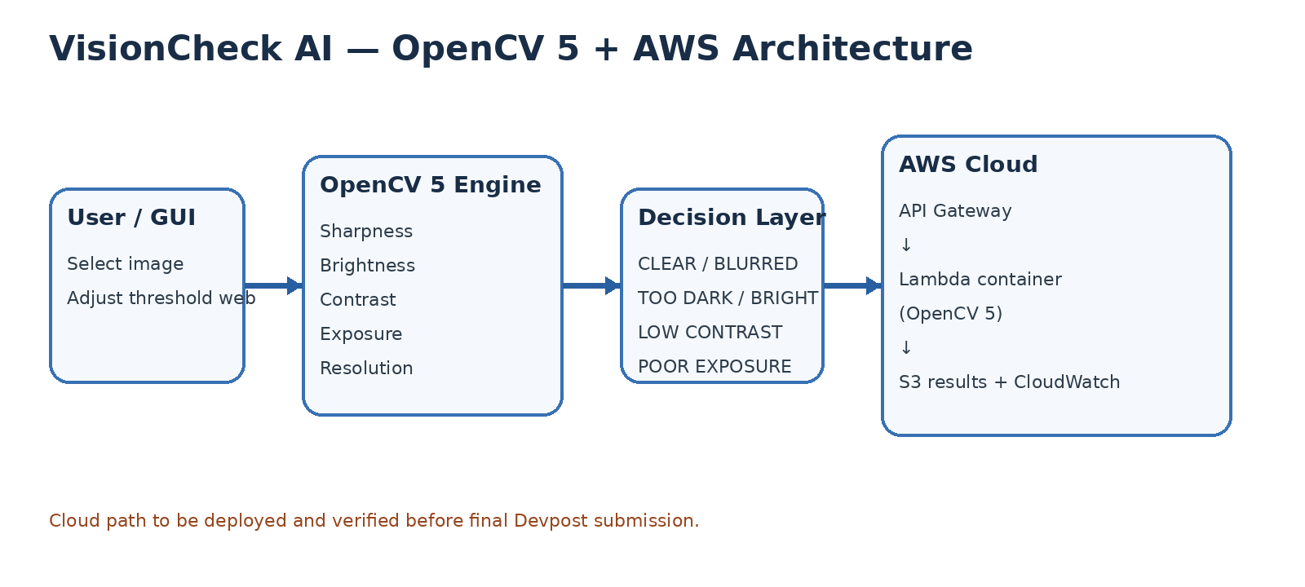

9. Limitations and responsible use
Image quality is context-dependent. A sunset may naturally contain bright regions; a scientific specimen image may prioritize sharpness; a photographer may intentionally use low contrast. The tool therefore supports adjustable thresholds and should be treated as decision support. It does not establish scientific validity, aesthetic quality, authenticity, or suitability for every professional use. False positives and false negatives should be documented in the final evaluation evidence.

10. Reproducibility and testing
The package includes pinned dependencies, the desktop source code, batch evaluation code, AWS deployment files, build/testing instructions, an architecture diagram, and the presentation/demo script. Judges should be given access to the repository or archive and either a working endpoint or an arranged live screen-share demonstration, along with the public or unlisted video required by the competition.

