# CS 255 System Design Document Template

## UML Diagrams

### UML Use Case Diagram

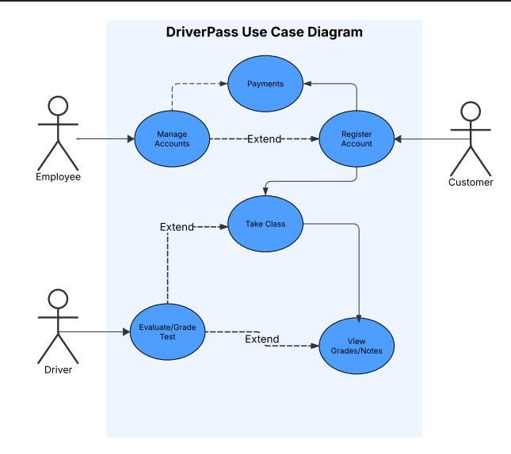

### UML Activity Diagrams

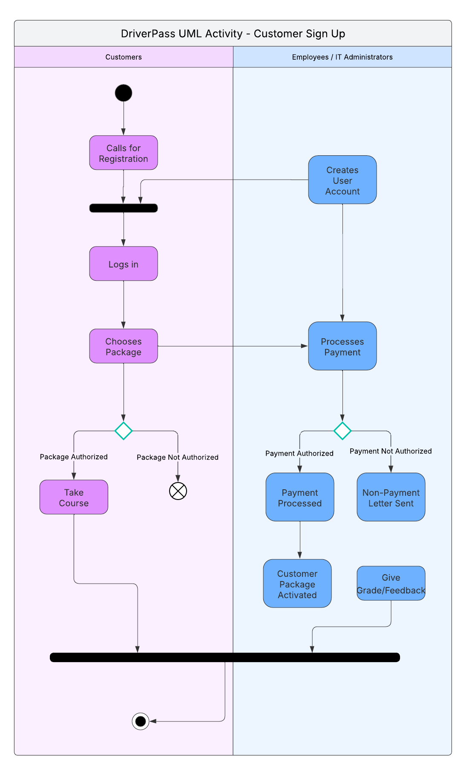

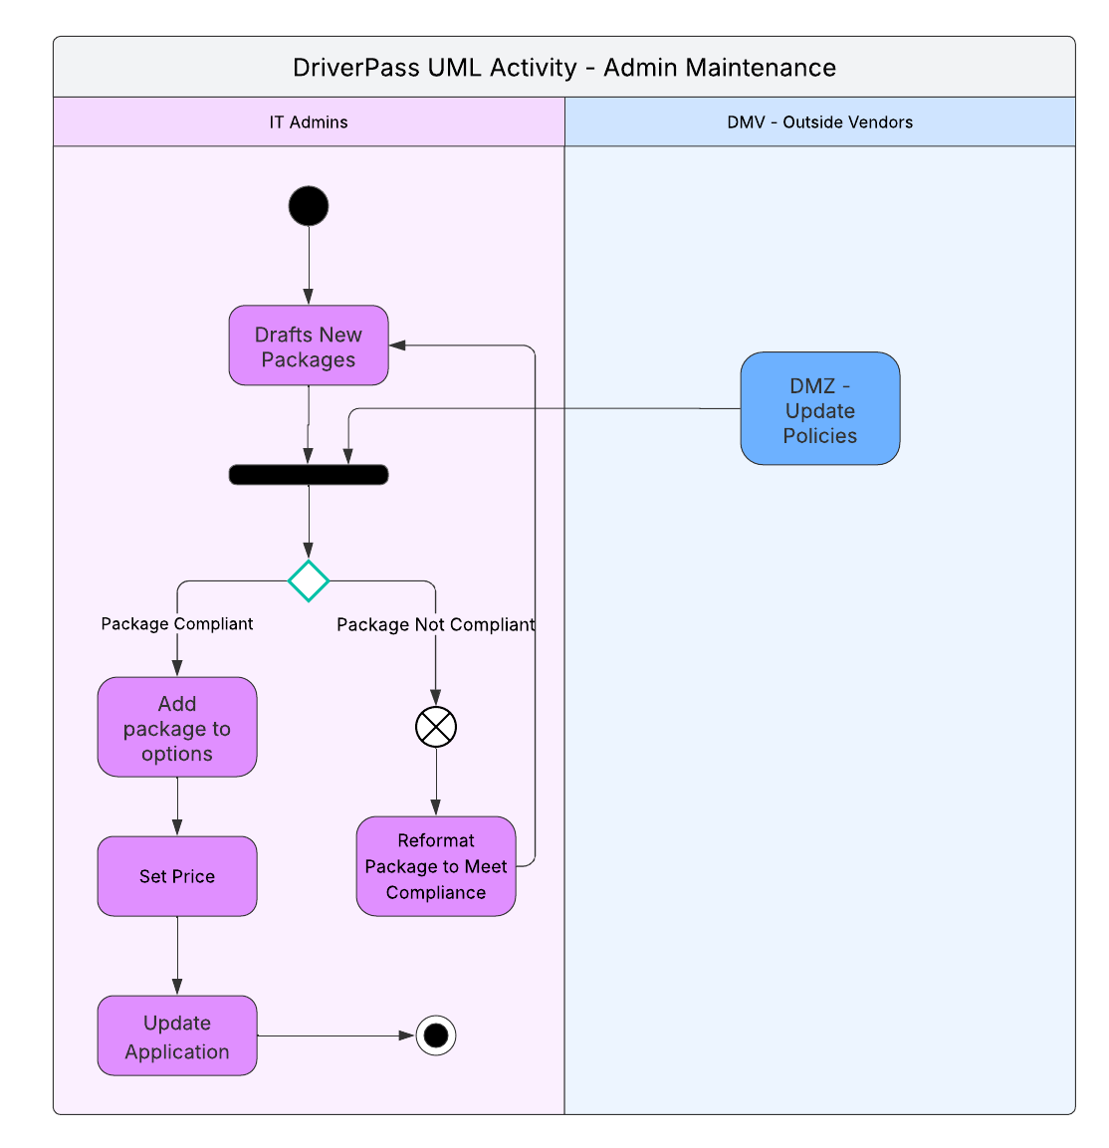

### UML Sequence Diagram

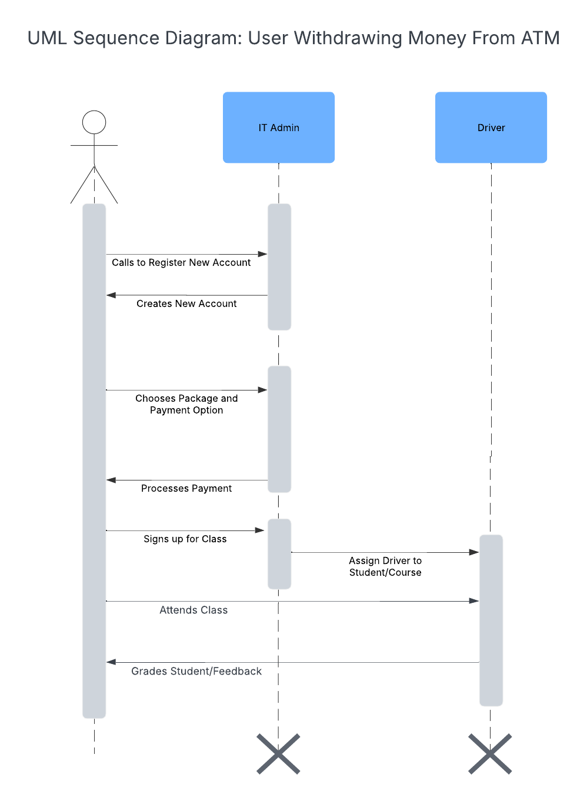

### UML Class Diagram

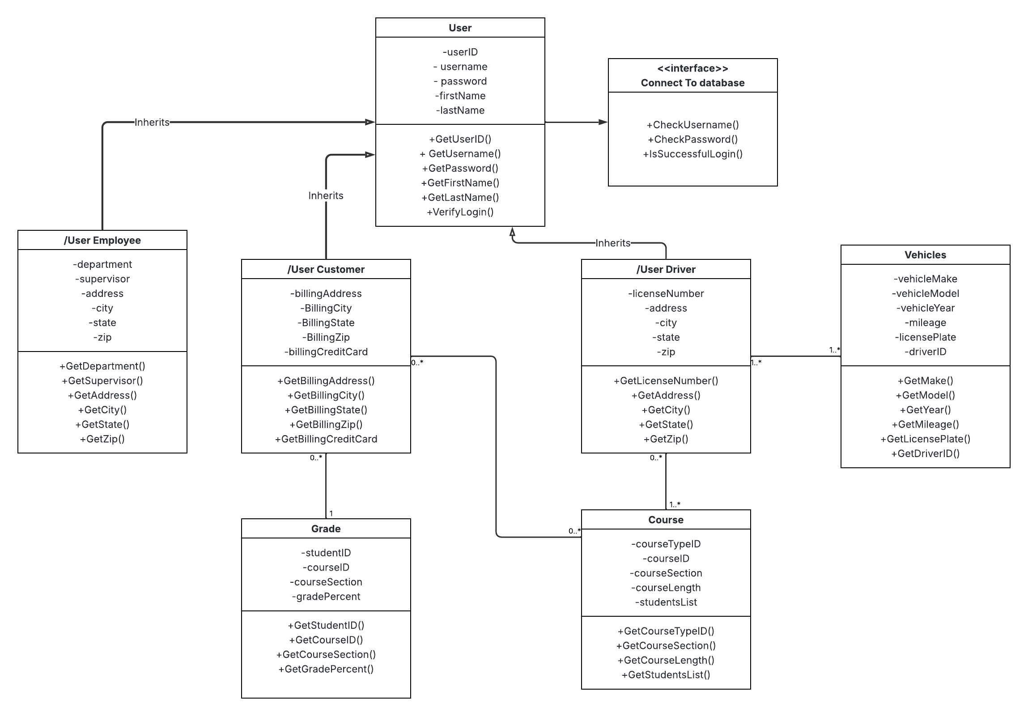

## Technical Requirements

* Application must be hosted on cloud-based server with High-Availability
* Application must be visible on Mobile Devices (phones, tablets) and most Web-based browsers
* Application must authentication software to ensure proper logins
* Application must have a relational database to store and retrieve information with high-level encryption to protect information
* Follow the Principle of Least Privilege so information is given to those with high enough clearance (i.e., IT Administrators)
* Vehicles must be in good condition, regularly maintained, cleaned daily, and sanitized for use.
* Driving instructors must maintain valid driver’s licenses per state law (i.e., no suspended licenses)