GRAZIOSO SALVARE

About the Project/Project Title
Grazioso Salvare is seeking a software application that can work with existing data from the animal shelters to identify and categorize available dogs. Global Rain has contracted for a full stack development of this application, including a database and a client-facing web application dashboard through which users at Grazioso Salvare will access the database.

Motivation
As part of its work, Grazioso Salvare identifies dogs that are good candidates for search-and-rescue training. When trained, these dogs are able to find and help rescue humans or other animals, often in life-threatening conditions. To help identify dogs for training, Grazioso Salvare has reached an agreement with a non-profit agency that operates five animal shelters in the region around Austin, Texas. This non-profit agency will provide Grazioso Salvare with data from their shelters.

Getting Started
To get started with this application, you will need to design your web application page, and a python script like the following so your web application can access and communicate with the MongoDB database. Your python script will need to have all CRUD capabilities so it can properly communicate with the database. Be advised, the CRUD functions are not present in this image. Just the initialization variables.

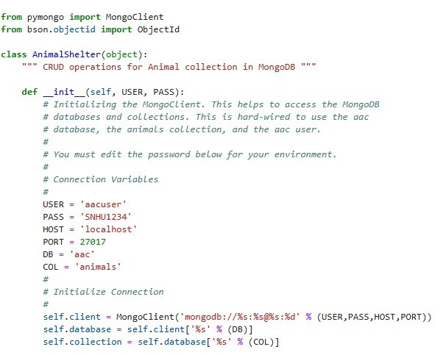
If you haven’t already, you should also create an administrator account for your MongoDB account that is different from your root account, because you should never use that for day-to-day administration operations. Use the following code snippet to create this user account within your mongosh shell:
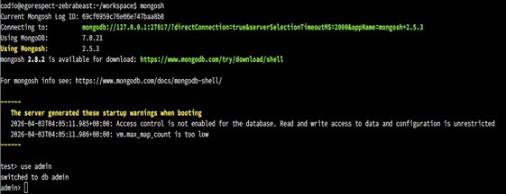
Once you are in the admin database, we use the db.createUser function to create the user, the roles associated, and which databases they will have access to. This user will be the account that will be used to communicate with the web application so be sure to remember the username and password for when you are ready to implement this script.
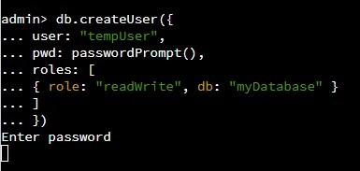
Now when you execute those in the mongosh terminal, your user account will now have access to the database based on the role(s) you chose. Common roles include read, readWrite, dbAdmin, userAdminAnyDatabase, or root. Only enable the lowest role needed for each user.

Installation
To use this tool, you will need to:
- Install and create a MongoDB database (MongoDB)
- Install Python (Python 3.6)
- Install PyMongo to access MongoClient with Python (PyMongo)
- An IDE to develop Python scripts (Visual Studio Code or PyCharm)
- Create a user account that can read and write to your database in lieu of a root user account (which you should never use for day-to-day operations)

Usage
Using this animal lookup system is all done within the web application that was designed alongside the CRUD module with python working behind the scenes. The web application is as user-friendly as possible, accounting for most often “filtered” results and more can be added as needs may arise. Below is a default view of what the web application would appear like.

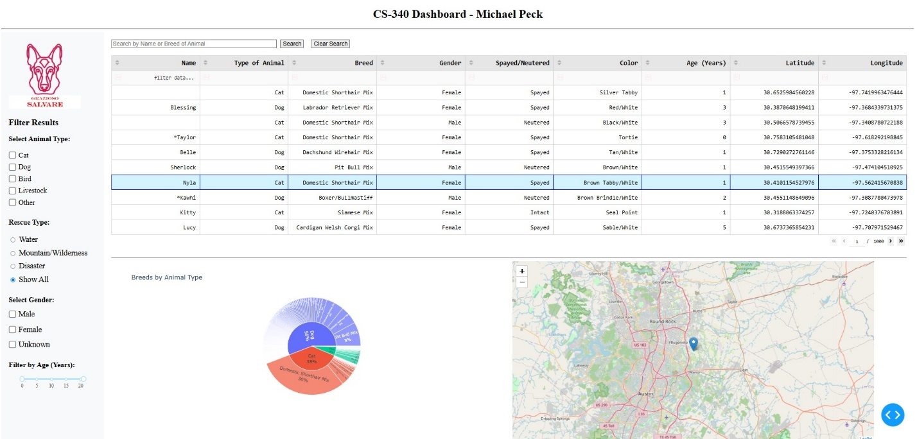
Figure 1 - Default Web View
As you can see from the default view, the left “sidebar” view handles all filter options, such as the type of animal that you are searching for, like cats, dog, birds, livestock or other animals. If you are looking for a animal that has been designated as a suitable animal for various types of rescue(s), there are premade filters that will search for all animals that meet very specific criteria. Other filter options given and tested are gender-specific, and age range specific. There are many others that may be included in a later version but will not be included in the launch version unless specified during discussions.

Also added in the web application are a sunburst style pie graph that will display first the number of filtered (or unfiltered) animals based on the type of animal, then the expanded section separates the results further into the breed of the animals in that category. When you have selected various filter options, the pie graph will update accordingly. Furthermore, when you select an animal (by clicking on a row that contains animal data (any row except the header row), a map will pop up in the lower right-hand corner of the web page giving you detailed information about where the animal is located, based on latitude and longitude coordinates.

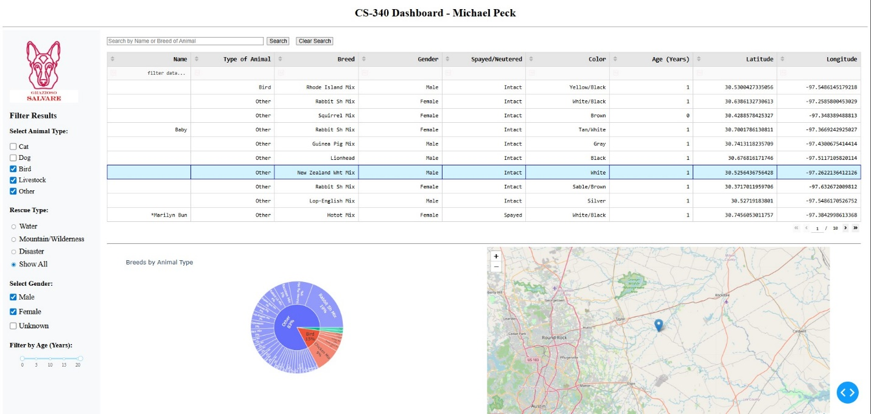
Figure 2 - Web View with Filters Active

Code Example
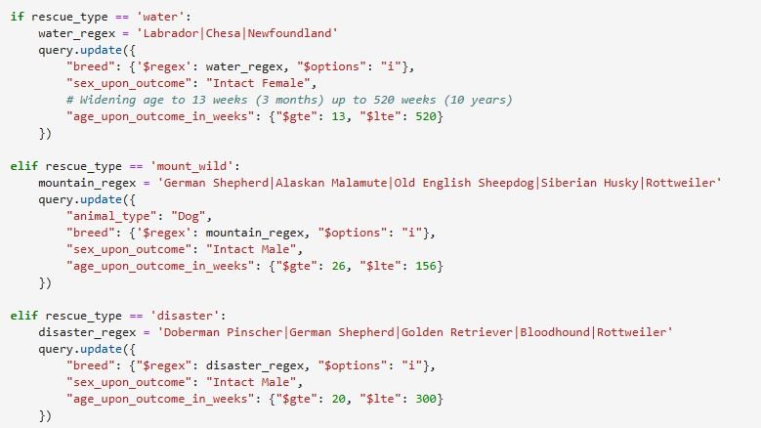
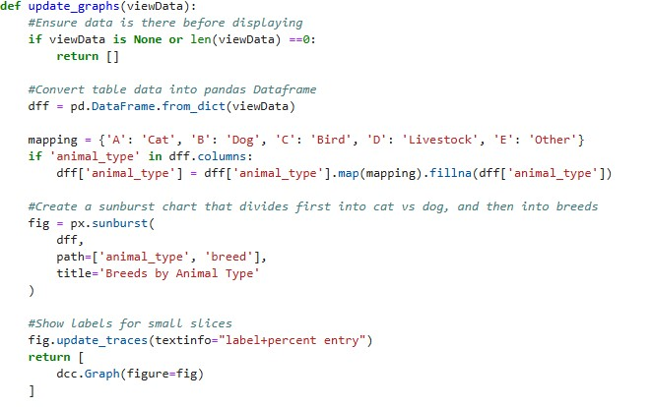
Figure 3 - Example of the code for current rescue filters along with requirements for each.
Figure 4 - Example of the code used to create the sunburst style pie graph

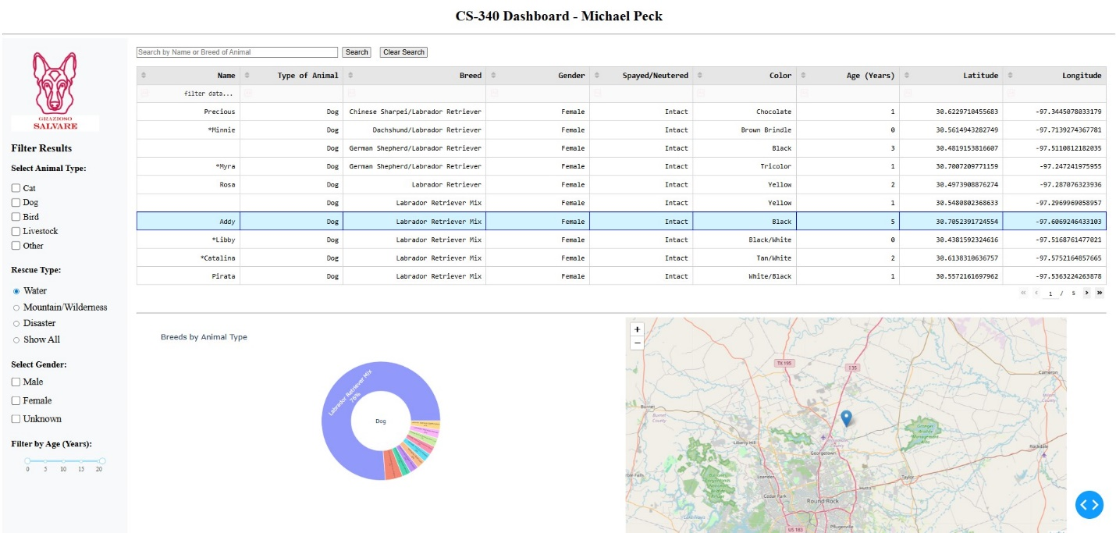
Tests / Screenshots
Figure 3 - Example of using the Water Rescue filter for dogs only.
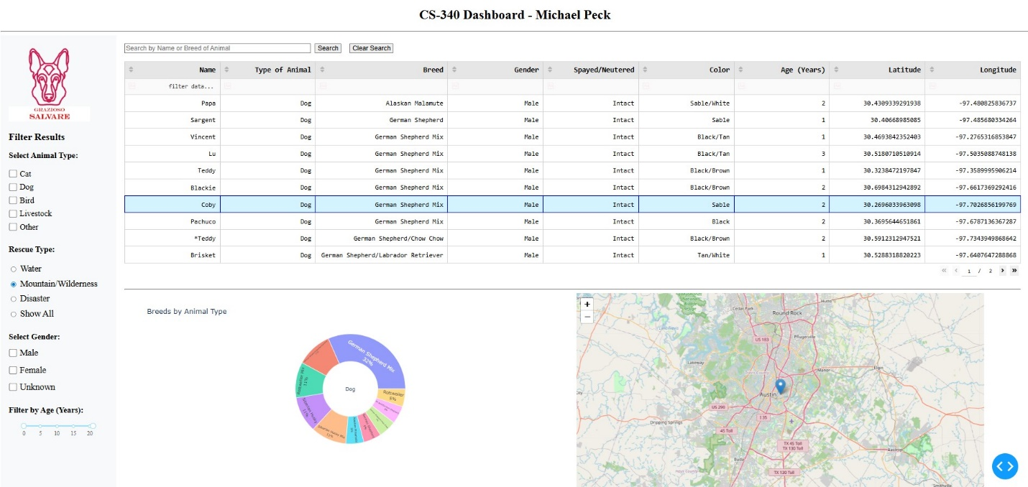
Figure 4 - Example of using the Mountain Rescue filter for dogs only.

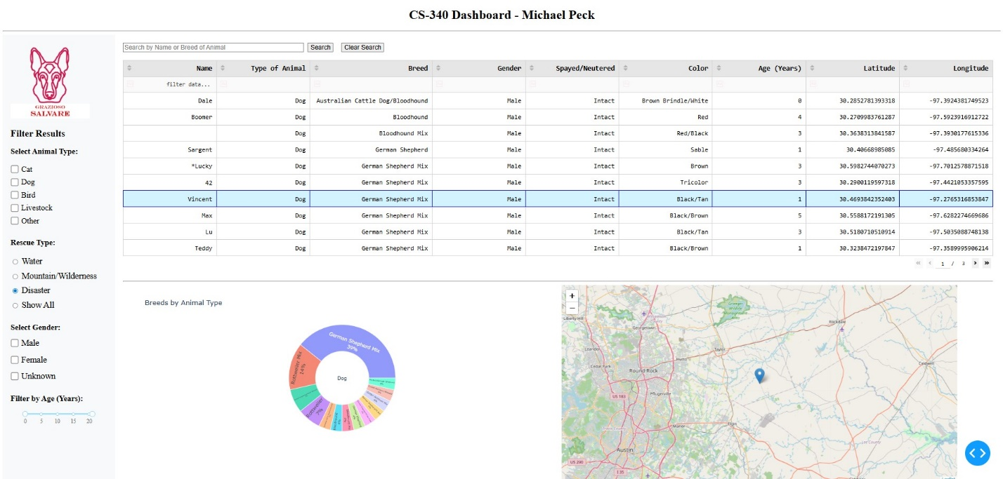
Figure 5 - Example of using the Disaster Rescue for dogs only.

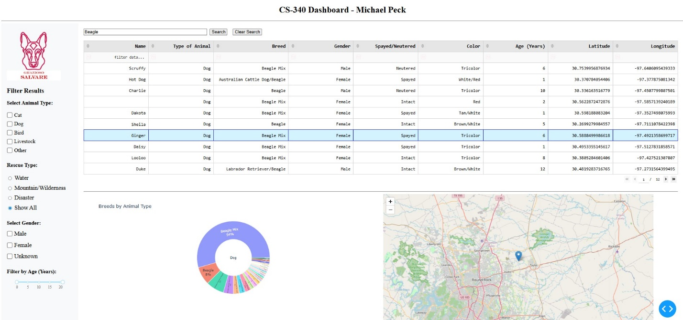
Figure 6 - Example using the Search Bar, filtering options for "Beagle"

Roadmap/Features (Optional)
☐ Add filter options for Spayed/Neutered/Intact animals
☐ Add adaptive filter options for other animals based on database entries

Contact
Your name: Michael Peck Jr

