Michael R Peck Jr
Southern New Hampshire University
CS 405 – Secure Coding
Module Five Assignment – Encryption / Decryption

Summary of Process
So, this assignment’s comments had me confused at times, because some of the comments needed to be read multiple times to make sense. Starting at the encrypt and decrypt function, I changed the if block that changes the output string to the source so that when it changes the index of the char string, it performs a logical or operation so that it chooses the opposite value of what it was. So, given a key, and a string, it will invert the string based on the key. Moving on to the reading of the file, I used a standard ifstream class and passed the file name that was passed as a parameter, then I did a valid checksum to see if the file could be opened. If the file could not be open, which could be caused by any number of reasons, it would immediately return from that function after an error message. If it did not return, meaning a successful file open, it would dump all the text into a bugger and then that buffer would pass along its string value to a temp string and that would then get returned. The next part is to save these files as separate files, and so instead of an ifstream, we open an ostream class and we did another checksum to make sure the file does open and if not, do another return out of the function. Then when that checksum passes, we go line by line adding what data we need, such as the name, a time stamp that is formatted from the local time using the std::time and the tm class and break down the time to get the format of yyyy-mm-dd as requested. Beyond that was the main function and nothing was required for this segment.

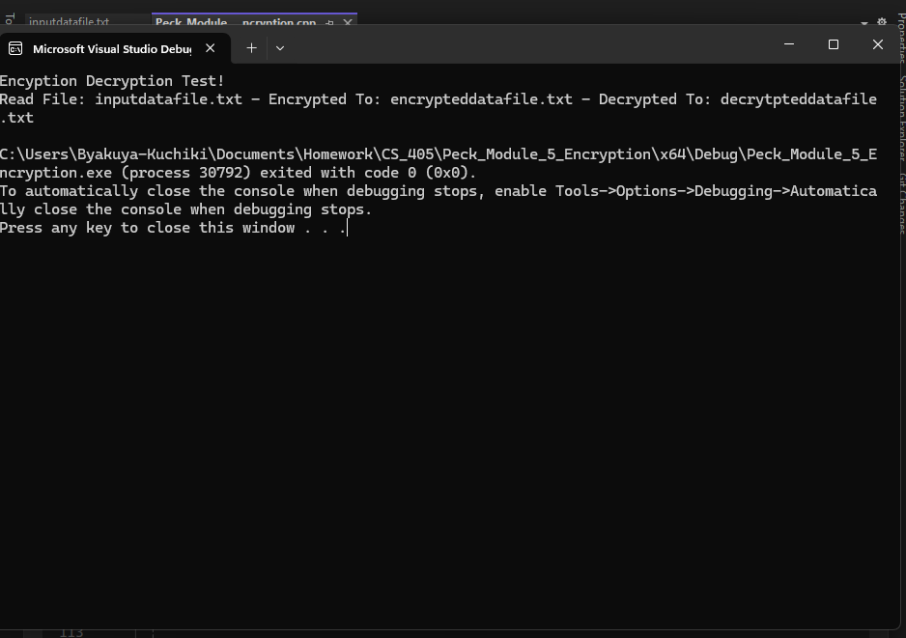
Figure 1 - Console running successful.
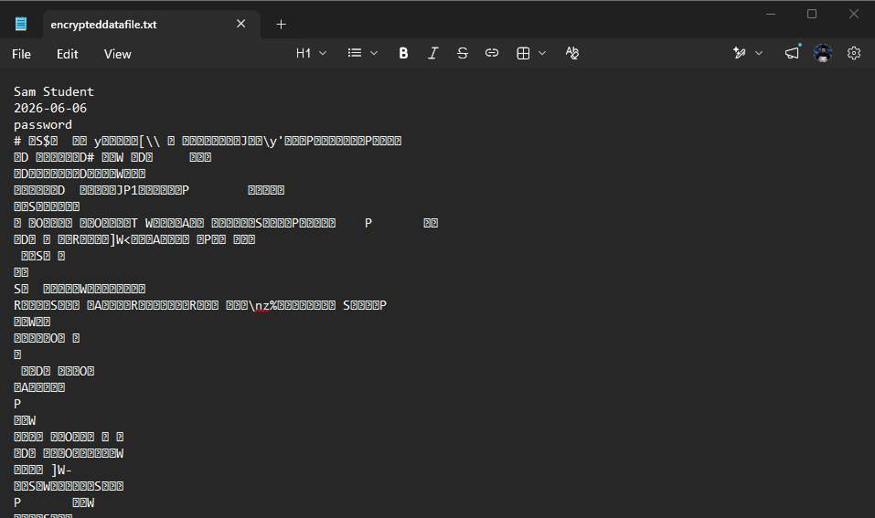
Figure 2 - Encrypted text sample.

