Michael R Peck Jr
Southern New Hampshire University
CS 405 – Secure Coding
Module Five Assignment – Static Code Analysis

Summary of Process
When we compare Visual Studio’s error list against the Cppcheck program it is obvious that Visual Studio is losing strictly in a numbers game. Cppcheck had found 28 errors and warnings where Visual Studio only found 11. Below is a table outlining each of the errors, warning and messages that are not within both system checks and identifying the risks. Keep in mind that VS means the error is only in Visual Studio, whereas CPP is only in Cppcheck
Message | Risk /  Not Risk | VS | CPP | Description
Address of local auto-variable assigned to a function parameter. [autoVariables] | Risk | CPP | This line in questions assigns a function level variable to a global pointer. However, once the function is out of scope, the pointer that was passed as a variable is now a null pointer, so it is a dangling pointer.
Using iterator to local container 'items' that may be invalid. [invalidContainer] | Risk | CPP | This segment of code tries to iterate over a list or collection, but there’s a potential that the iterator may miss an item in its collection. There is a better way to iterate through a list or collection.
Include file: <cassert> not found. Please note: Standard library headers do not need to be provided to get proper results. | Not Risk | CPP | This error states that the file is missing a header file. This is not a risk, solely because it would prevent the application from compiling and thus would not be included in a package.
Include file: <iostream> not found. Please note: Standard library headers do not need to be provided to get proper results. | Not Risk | CPP
Include file: <numeric> not found. Please note: Standard library headers do not need to be provided to get proper results. | Not Risk | CPP
Include file: <set> not found. Please note: Standard library headers do not need to be provided to get proper results. | Not Risk | CPP
Include file: <vector> not found. Please note: Standard library headers do not need to be provided to get proper results. | Not Risk | CPP
The member function 'Token::next' can be static. | Not Risk | CPP | This message is just saying that this piece of code could have been given a modifier of static, or unchangeable. This is not a risk in most cases, but it can be best practices to use static modifiers whenever possible to remove ways to change variables.
Variable 'tok' is assigned a value that is never used. | Not Risk | CPP | This message is just saying that there is a variable that is not being used and is superlative. Removing this and all other unused variables is best practice.
Variable 'x' is assigned a value that is never used. | Not Risk | CPP
Variable 'y' is assigned a value that is never used. | Not Risk | CPP
Local variable 'x' shadows outer variable | Not Risk | CPP | This message is saying that this function level variable was already created and initialized, before being modified. This is saying it’s preferred to declare the variable and then if you had planned later to initialize, then do not initialize at declaration.
Local variable 'y' shadows outer variable | Not Risk | CPP
Local variable 'z' shadows outer variable | Not Risk | CPP
The member function 'MySpecialType::DontThrow' can be static. | Not Risk | CPP | This message is saying that this function could have been made static. Static in this case, because it does not interact with any member variables and therefore there is no issue.
The scope of the variable 'buf' can be reduced. | Not Risk | CPP | This message is just stating that this variable can be placed one level down from where it is. It can be nested one level down without causing any issues.
Variable 'buf[count]' is assigned a value that is never used. | Not Risk | CPP | This message is saying that the code assigns a value to a variable, but the variable or the value is never used.
Non-boolean value returned from function returning bool | Risk | CPP | This section of code returns a char when it is expecting a Boolean value. While this will compile in C++ because of C rules, it will cause a runtime exception error and open a vulnerability.
Assignment of function parameter has no effect outside the function. Did you forget dereferencing it? | Risk | CPP | This is saying there is a piece of code where the parameter that is passed in, is meant to be used elsewhere, but is not. The parameter should have been a regular parameter and not a pointer or address.
Either the condition 'tok' is redundant or there is possible null pointer dereference: tok. | Risk | CPP | In this same section of code as the previous message, there is a redundant loop with the tok variable and after it, there is a change for a null pointer reference. Very high risk for runtime errors.
Variable 'z' is modified inside assert statement. | Risk | CPP | Inside the Assert function, z is being assigned a value of 2. However, when the application is packaged and shipped, all asserts are removed, and if this application depends on the z being equal to 2, then it will create issues.
Variable 'z' is modified inside assert statement. | Risk | CPP | Inside this assert statement, much like the same one previously, when the application is compiled and ready to ship, all asserts are removed and this statement will never execute. Normally, doing an assert on a function that compares a value won’t necessarily cause issues, in this case, because this function specifically alters a global level variable, it will cause an issue.
Comparison of a boolean expression with an integer other than 0 or 1. | Risk | CPP | This is the same assert statement as the previous two, but this error is because the function that is inside the assert statement returns a bool, which is either true, false, or a 0 or 1, and this assert assesses this function returning a value of 3.
class member 'A::x' is never used. | Not Risk | CPP | This is a global level variable inside the A class, that is declared but is never used. This is an extra variable that takes up space in memory, but is otherwise safe to remove or keep.
Either the condition 'count==1000' is redundant or the array 'buf[10]' is accessed at index 1000, which is out of bounds. | Risk | CPP | This is a catastrophic error that is caused by an out of bounds error with the count == 1000 when the max was supposed to be 10.
Function 'foo' can be made static | Not Risk | VS | This message just states that the function in question does no mutation to any variable and thus can be made static. There is no risk to this being here, but as it does nothing functional, can and should probably be removed.
Function 'work_with_arrays' can be made static | Risk | VS | Similar to the message above, this function does not mutate any variables. However, it does cause an error with a buffer out of index, and should either be removed entirely or re-written so the buffer does not throw an exception.
Function 'do_something_useless' can be made static | Not risk | VS | This message reports that this function could be made static since it does not mutate any variable. However, it does absolutely nothing but counts and accumulates a value, so it should be removed to save memory.
Function 'vector_test' can be made static | Risk | VS | This message reports that this function could be made static as it does not mutate any variable outside of its scope or returns any value. This function can however, cause a null exception with its iterator loop. This iterator can be written different to ensure that there is a value in the iterator before erasing an item in the collection.
Function 'my_function' can be made static | Risk | VS | This function is listed as a bool, but it returns an int. Normally that would not be an issue, so long as the value is either 0, or 1. This function however returns a value of 3, so unless it’s modded by 2, it can cause a runtime error.
Function 'foo' can be made static | Risk | VS | This function, which has been declared twice, and overloaded will cause an error if ran over the other one. The while loop here will execute until there is no value for tok, and then the next line is to assign it to the next, which is a null reference pointer. This function needs to remove the (;) from after the while loop, to first check that top->next is available.

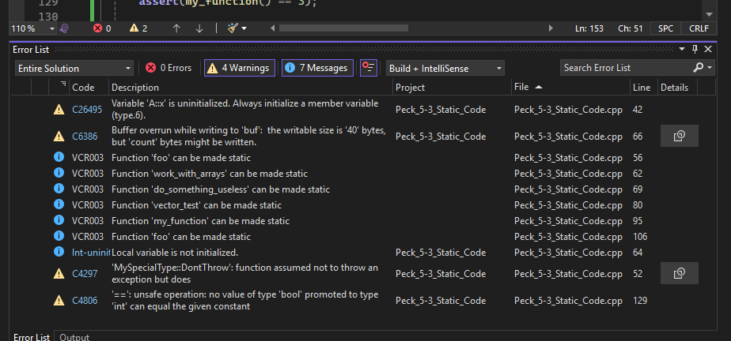
Figure 1 - Error list on Visual Studio
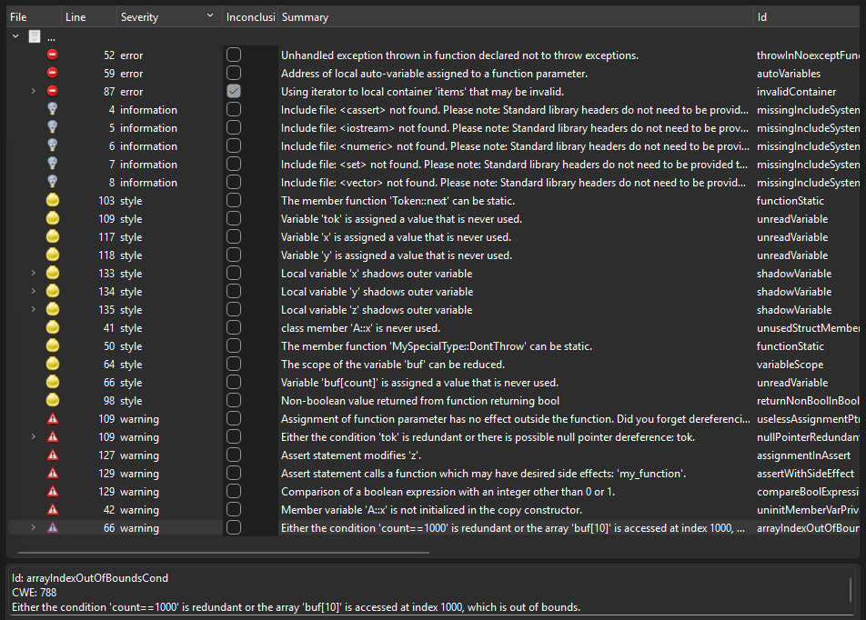
Figure 2 - Cppcheck Error list

