Michael R Peck Jr
Southern New Hampshire University
CS 405 – Secure Coding
Module 2 Assignment –Buffer Overflow
After reading this week’s reading resources, and before working on this assignment, I had ideas on what I would do that would not work with the instructions within the code’s comments. One of those changes was to use string classes instead of using char arrays, since the string variable conforms to the size that is needed (to some extent I’m sure) which would clearly fulfill the buffer overflow requirement, but it would be too easy.
However, when evaluating the code, I noticed that we are using char arrays and we could not change the variable, so based off of that, we had a length of 20 to work with (well 19, if we consider that we need a null-terminating character at the end). So, I figured the best way to start is to first set the width of the std::cin to the maximum length of the variable for user input. This should force the cin input to be a maximum of 20 characters or whatever the length of the char array designated for the user input variable. However, I can still enter more than 20 characters, but it seems to only “save” the first 20 characters from the buffer, and the rest are sitting there in the buffer. So, we managed to save the first 19 characters, plus the null character with the set width function. What we did next was check to see if the user did enter 19 characters or 20 characters, since entering 20 characters would trigger the overflow as the max is 1 less than the variable size. So we called a std::cin.peek() to get the next immediate character from the buffer, then did an if/else check, and the parameter was that if the peeked character was not a null character, or a new line, or even an end-of-file indicator, then it would indicate that the user did enter more characters than was allowed, so a print message was printed indicating that this buffer overflow would have triggered. If this event was triggered, I also added a std::cin.ignore to wipe out the rest of the buffer, attempting to get in the habit of managing memory, and I set the ignore size to the maximum allowed for a stream size.
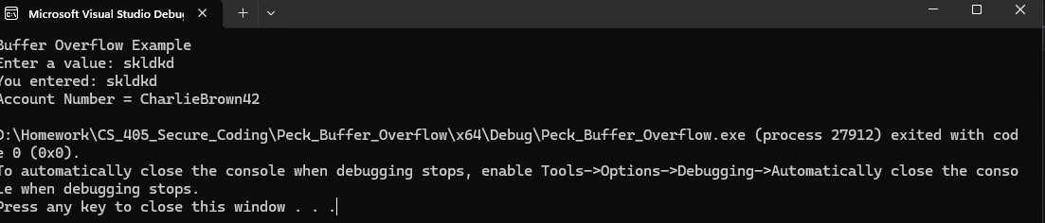
Figure 1 - Entering data whose length does not exceed the variable size

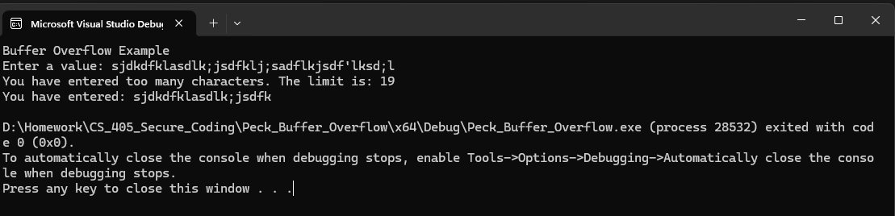
Figure 2 - Entering data whose length far exceeds the variable size, showing the buffer overflow alert, and shows the maximum length string allowed.

