Michael R Peck Jr
Southern New Hampshire University
CS 405 – Secure Coding
Module 2 Assignment –SQL Inection
Before working on this assignment, I completed this week’s reading assignment, but could not recall anything about SQL injections, what they are or how to prevent them. So after the readings and before starting this assignment, I had to do a little Google research on what SQL injections are, and then how to prevent them. What I found was that when a query is passed through, sometimes an attacker will add a token to the query that will bypass other tokens, usually in the WHERE clause. So, taking a look into the code that was given to me, I realized that without hard coding every single response that was added into the query just before returning results was not going to be sufficient in a real-world scenario, and then it came down to string manipulation.
Since we are limited to altering the run_query and the main functions, it became clear that the other functions needed to be read and understood how they operate. One of the functions had a clue on where to break strings into substrings, the run_query_injection. Inside this function, the sql is copied to a local variable, converted to lower case because the string find functions are case sensitive, and lowering cases will solve any potential issues with comparisons. So I did the same beginning steps, I created a local variable holding the sql query string, converted to lower case, and then I noticed that each of the injection additions added an “or” at the end forcing a true on every record. So, if we used that as a stepping stone, we could do a find for the sequence of “ or “, adding the spaces in there so we can ensure it’s the full keyword and not a partial sequence inside a valid word. Storing that position in another variable helps us then to create substrings using that position as a starting point to analyze additional sql tokens. However, before we can actually compare strings, and after we confirm that there is an instance of “ or “, we eliminate any trailing spaces and semi-colons, and then that final substring is the addition to the sql, or the injection.
Now that we have the injection part of the assignment, now we have to confirm if it is indeed an injection that forces a true value in all records. It does this by evaluating two statements to the same (i.e. 1=1 or ‘1’ = ‘1’) for all records, and since SQL does not disallow this, it is still run inside its query. Normally adding an “OR” in SQL is legitimate but it does not evaluate 1=1 or such but uses column names against a literal of some kind or another column in a table. So, once we have that injection segment, we need to then check if it is comparing two identical tokens rather than comparing a token against a record. Once again, we needed to do substrings on the already existing substring, this time into left and right segments based solely on where the ‘=’ was. All values to the left of the = sign was regarded as the left side, and the values to the right were regarded as the right side. Now while this next part was not affecting this particular assignment, I added it in as a safeguard for the professional level, and that was eliminating and previous or trailing spaces on the left and right side. After the left and right substrings are made and adjusted, then they are compared. If they are the same, then the SQL injection fails and the false Boolean flag is returned and the statement ends. The records do not display if there is an injection, however in this case, all values with the random generator all return some appending to create an injection.
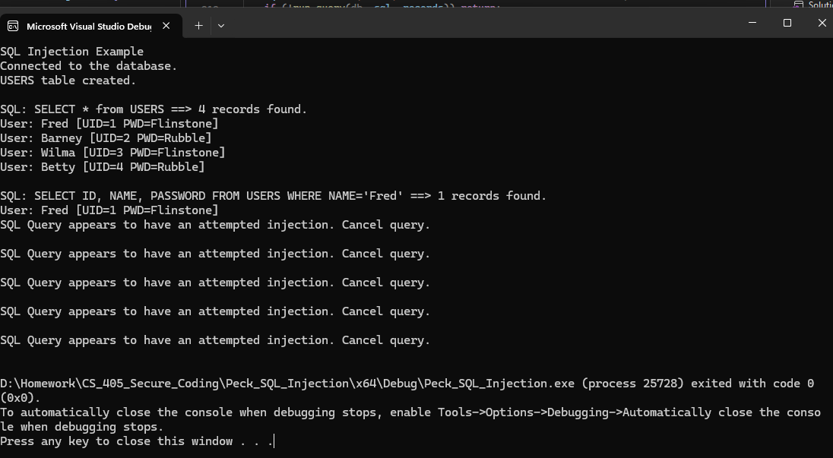
Figure 1 - SQL Injections detected and SQL Query failed to return rows.

