Michael R Peck Jr
Southern New Hampshire University
CS 405 – Secure Coding
Module One Assignment: Numeric Overflow Coding

Screenshots of underflow/overflow console messages
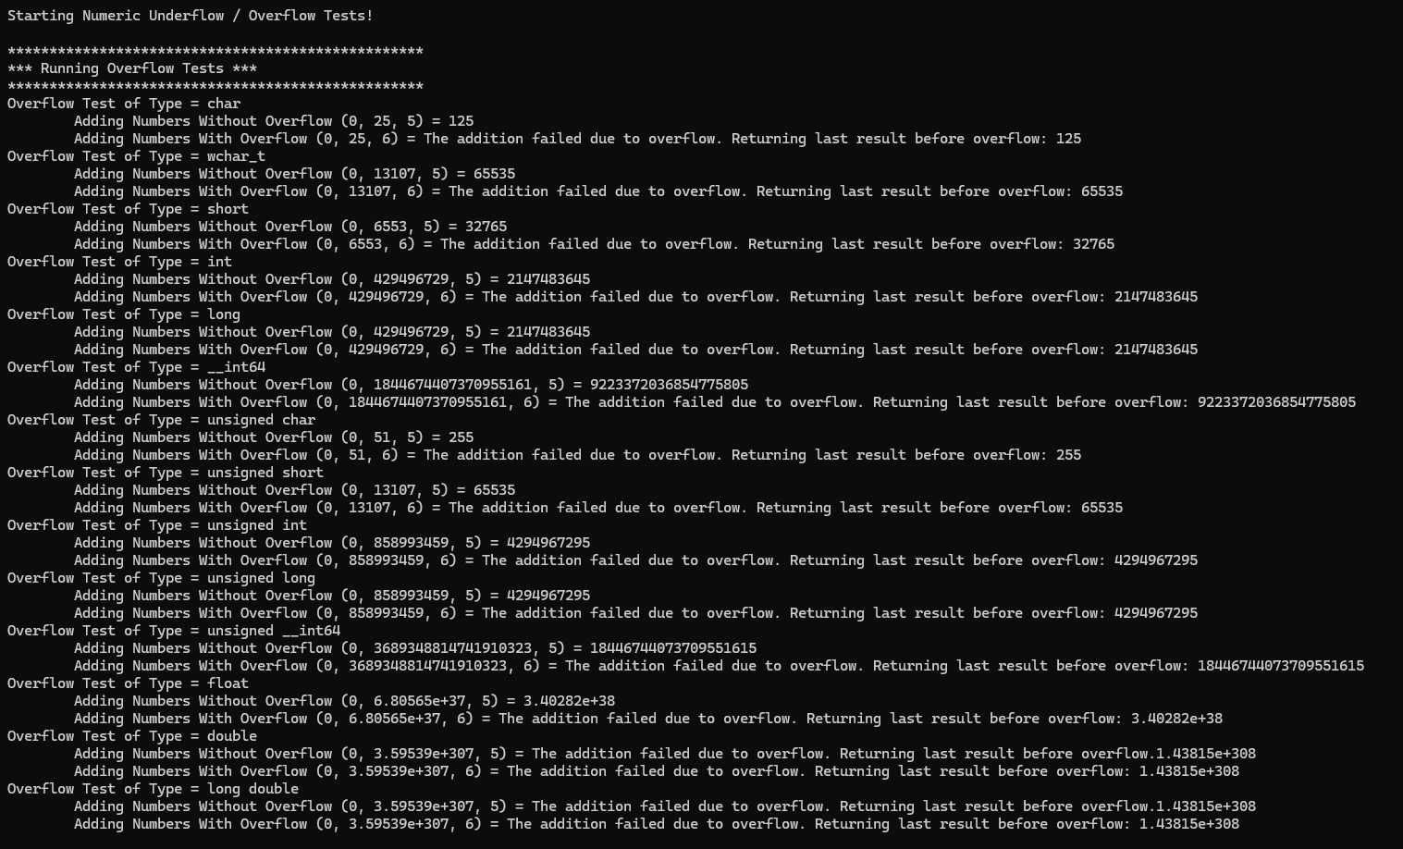
Figure 1 - Overflow Testing Messages
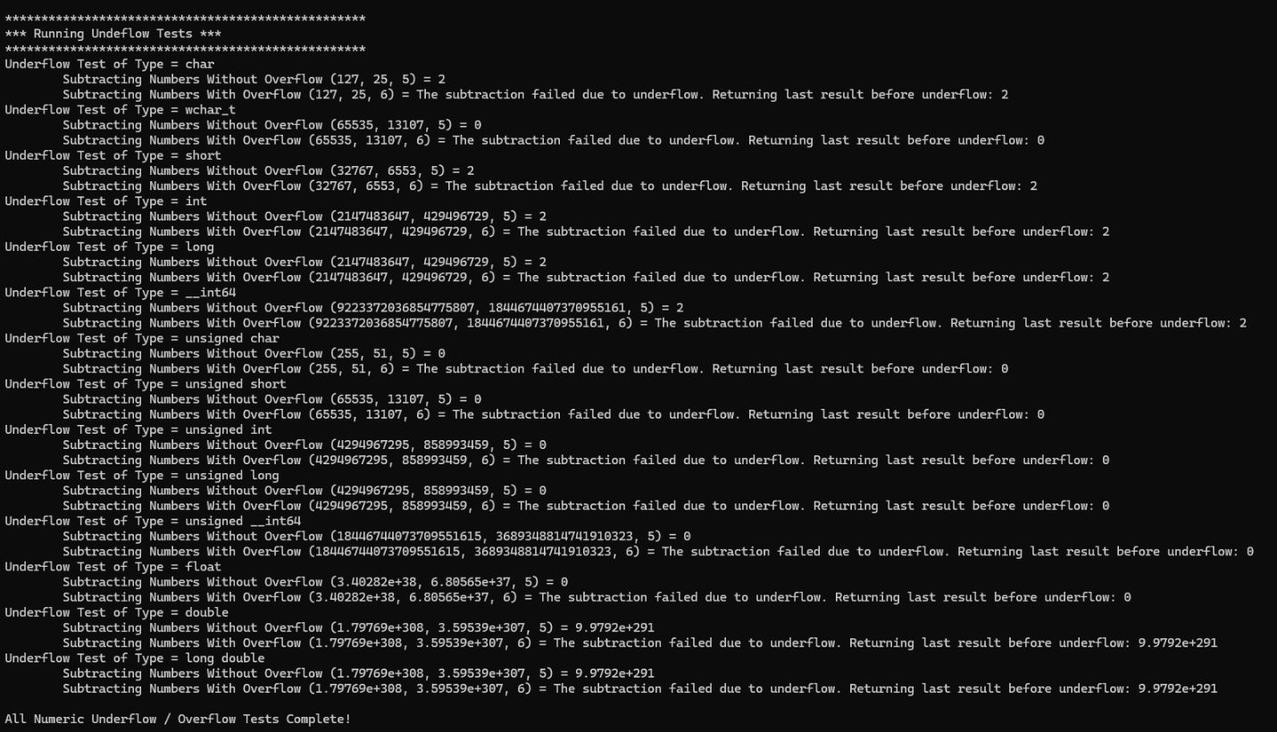
Figure 2 - Underflow Test Messages
Brief summary of changes made:
I made a change to both the definitions of the add_number and subtract_numbers, while keeping it as a template. I added a Boolean as a parameter that gets passed a Boolean that determines if an overflow does happen and then spits out a message based on that flag. If it did overflow during the test sequence, it returns a message that it caused an overflow or underflow, and it returns the last value before the overflow/underflow occurred.
Then inside the add and subtract number’s function, I created a Boolean that again gets passed in from the test sequence, but the value changes when an overflow happens. For instance, with the addition function, I do an if/else check where if the increment step is greater than the template type’s max value minus the result, it causes an overflow and immediately returns the current value. If the if/else fails on the if statement, it proceeds to add the increment to the result.
On the subtract function, inside the if/else statement, we instead check if the decrement is greater than the result, which because we are dealing with unsigned values, means the value would be negative, and we don’t want that, as that would be an underflow (although some would argue it’s still an overflow in the negative direction).

