**ER Diagram**

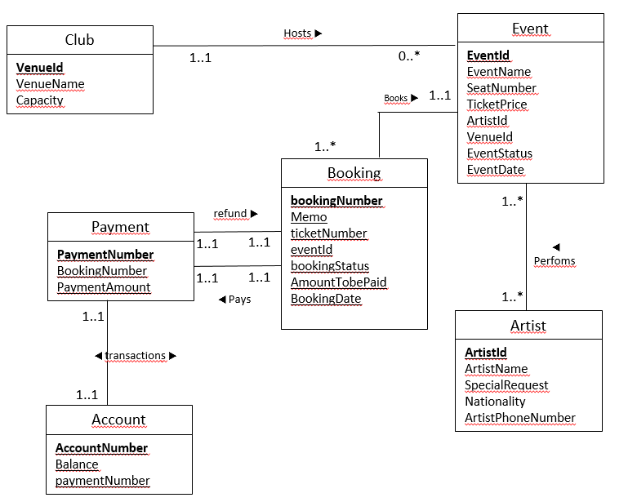

**Relational Schema**

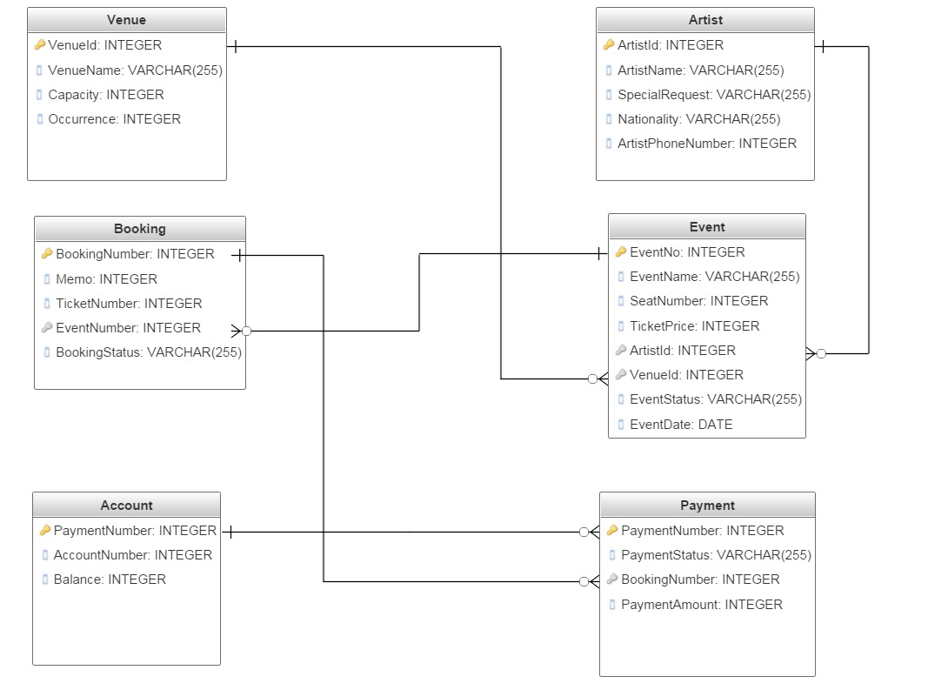

**Database Diagram**

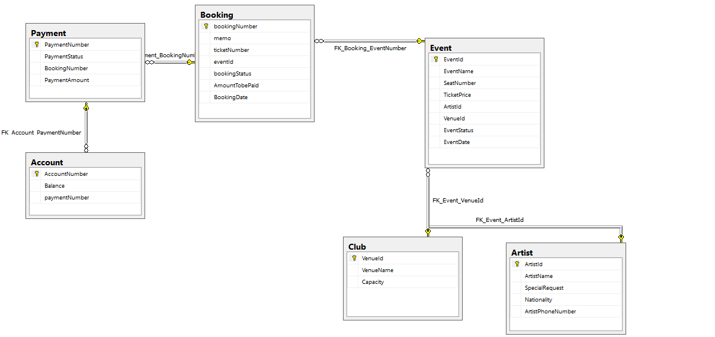

**REPOSITORY**

**ENTITY TYPE DESCRIPTIONS**

|  |  |  |  |
| --- | --- | --- | --- |
| **ENTITY TYPE** | **Description** | **Synonyms, aliases** | **Occurrence** |
| **Club** | The venue that host all the events in this club | Club, venue ,stage ,set | Used every time there is an event |
| **Artist** | An artist who is going to be performing for Kuru | artist, performer, singer, | Multiple occurrences, can be used in many events |
| **Event** | Different types of performances | concert, solo, dance, theatre, cultural events | Occasional occurrences, one for each event. |

**ATTRIBUTE TYPE DESCRIPTIONS**

**Artist**

|  |  |  |  |  |  |
| --- | --- | --- | --- | --- | --- |
| **Attribute** | **Description** | **Data type** | **Value**  **required** | **Keys** | **Special domain** |
| ArtistName | Unique name of the artist | VARCHAR (50) | Yes | ALTERNATE KEY (UNIQUE) | - |
| SpecialRequest | Memo to specify any type of special request | VARCHAR (50) | No | - | - |
| Nationality | Specifies where the artist is from | VARCHAR (50) | Yes | - | - |
| ArtistPhoneNumber | Phone number of artists | INTEGER | YES | - | - |

**Event**

|  |  |  |  |  |  |
| --- | --- | --- | --- | --- | --- |
| **Attribute** | **Description** | **Data type** | **Value required** | **Keys** | **Special domain** |
| EventName | Name of the event | VARCHAR(50) | Yes | ALTERNATE KEY (UNIQUE) |  |
| SeatNumber | Specifies the number of seats for the event | INTEGER | Yes | - | - |
| TicketPrice | price of each ticket to the event | INTEGER | Yes | - |  |
| ArtistId | Unique set of numbers used as an identifier | INTEGER | Yes | FK |  |
| VenueId | Unique set of numbers used as an identifier | INTEGER | Yes | FK |  |
| EventStatus | Status of the event | VARCHAR (50) | YES | - | Cancelled-past-active |
| EventDate | the date of the event | DATE | Yes | - | dd/mm/yyyy |

**TABLE DESCRIPTIONS**

**Club**

|  |  |  |  |  |  |
| --- | --- | --- | --- | --- | --- |
| **Attribute** | **Description** | **Data type** | **Value required** | **Keys** | **Special domain** |
| VenueId | Unique set of numbers used as an identifier | INTEGER | Yes | PK | - |
| VenueName | Name of the event | VARCHAR(50) | Yes | ALTERNATE KEY (UNIQUE) |  |
| Capacity | The max amount the venue can hold | INTEGER | Yes | - | - |

**Event**

|  |  |  |  |  |  |
| --- | --- | --- | --- | --- | --- |
| **Column** | **Description** | **Data type** | **Value required** | **Keys** | **Special domain** |
| EventId | Unique set of numbers used as an identifier | INTEGER | Yes | PK | - |
| EventName | Name of the event | VARCHAR(50) | Yes | ALTERNATE KEY (UNIQUE) |  |
| SeatNumber | Specifies the number of seats for the event | INTEGER | Yes | - | - |
| TicketPrice | price of each ticket to the event | INTEGER | Yes | - |  |
| ArtistId | Unique set of numbers used as an identifier | INTEGER | Yes | FK |  |
| VenueId | Unique set of numbers used as an identifier | INTEGER | Yes | FK |  |
| EventStatus | Status of the event | VARCHAR (50) | YES | - | Cancelled-past-active |
| EventDate | the date of the event | DATE | Yes | - | dd/mm/yyyy |

**Artist**

|  |  |  |  |  |  |
| --- | --- | --- | --- | --- | --- |
| **Column** | **Description** | **Data type** | **Value**  **required** | **Keys** | **Special domain** |
| ArtistId | Unique set of numbers used as an identifier | INTEGER | Yes | PK |  |
| ArtistName | Unique name of the artist | VARCHAR (50) | Yes | ALTERNATE KEY (UNIQUE) | - |
| SpecialRequest | Memo to specify any type of special request | VARCHAR (50) | No | - | - |
| Nationality | Specifies where the artist is from | VARCHAR (50) | Yes | - | - |
| ArtistPhoneNumber | Phone number of artists | INTEGER | YES | - | - |

**Booking**

|  |  |  |  |  |  |
| --- | --- | --- | --- | --- | --- |
| **Attribute** | **Description** | **Data type** | **Value required** | **Keys** | **Special domain** |
| bookingNumber | Unique set of numbers used as an identifier | INTEGER | Yes | PK | - |
| Memo | Can be used to put phone number | VARCHAR(50) | Yes | ALTERNATE KEY (UNIQUE) |  |
| ticketNumber | Number of tickets booked for the event | INTEGER | Yes | - | - |
| eventId | Unique set of numbers used as an identifier | INTEGER | Yes | FK | - |
| bookingStatus | Shows the status of the booking | VARCHAR(50) | Yes | - | Cancelled-active-sold |
| AmountTobePaid | Total amount to be payed for each booking | INTEGER | Yes | - | - |
| BookingDate | Date the booking was created | DATE | Yes | - | - |

**Payment**

|  |  |  |  |  |  |
| --- | --- | --- | --- | --- | --- |
| **Column** | **Description** | **Data type** | **Value required** | **Keys** | **Special domain** |
| Account Number | Unique set of numbers used as an identifier | INTEGER | Yes | PK | - |
| BookingNumber | Unique set of numbers used as an identifier | INTEGER | Yes | FK | - |
| PaymentAmount | the amount payed | INTEGER | Yes | - | - |

**Account**

|  |  |  |  |  |  |
| --- | --- | --- | --- | --- | --- |
| **Attribute type** | **Description** | **Data type** | **Value**  **required** | **Identity attribute**  **or part of it** | **Special domain** |
| AccountNumber | Account number | INTEGER | Yes | PK |  |
| Balance | balance of the account | INTEGER | Yes |  |  |
| paymentNumber | Unique set of numbers used as an identifier | INTEGER | Yes | FK | - |