Title: Development and Temporal External Validation of a Parsimonious, Interpretable Machine Learning Model for Predicting 6-Month Mortality in Long-Term Care Facilities: A Retrospective Cohort Study

Abstract
Background:
Early mortality after long-term care facility (LTCF) admission is common, yet prognostic tools are often derived from Western minimum data-set-based cohorts or require hospital electronic health record linkages that are unavailable at intake in many LTCFs. There is also limited evidence on explainable, admission-feasible machine learning -based prognostication in Asian LTCF settings.
Objective: To develop and temporally externally validate an interpretable machine learning model for predicting 6-month all-cause mortality among older adults newly admitted to LTCFs in Taiwan using routinely collected admission data.
Methods
: We conducted a retrospective cohort study using the JUBO Long-Term Care Database, a nationwide private administrative registry covering 636 LTCFs (37.43% of the long-term care facilities in Taiwan). We included residents aged ≥65 years with first-time LTCF admission and prespecified nonoverlapping cohorts for temporal validation: development (January 1, 2020–December 31, 2023; n = 23,901) and external validation (January 1–December 31, 2024; n = 6216). The outcome measure was death within 180 days of admission. We compared a nonlinear ensemble model (HybridXGBRF) with seven other algorithms, including tree-based and linear benchmarks. Discrimination (AUROC), classification metrics (accuracy, precision, recall, and F1), and calibration (Brier score and calibration plots) were assessed. Model interpretability was examined using Shapley Additive Explanations (SHAP).
Results:
In the development cohort, 5272/23,901 (22.1%) residents died within six months; in the 2024 validation cohort, 1781/6,=216 (28.7%) died. In internal cross-validation, the HybridXGBRF model achieved the highest AUROC (0.875, 95% CI 0.862–0.889) and the lowest Brier score (0.109). In the temporal external validation, the HybridXGBRF model maintained strong discrimination (AUROC 0.878, 95% CI 0.866–0.889), with an accuracy of 0.851 and an F1 score of 0.572. Calibration plots indicated a close agreement between the predicted and observed risks across most probability ranges in both cohorts, with a mild divergence at higher predicted risks. The SHAP analysis identified frequent hospitalizations within six months, activities of daily living impairment, and weight loss as the most influential predictors. The model showed stable AUROC across sex and age strata (0.88–0.89), and maintained high discrimination in the subgroup of residents with improving activities of daily living scores (AUROC: 0.90), a population where mortality risk is often underestimated by conventional clinical assessments.
Conclusions:
An interpretable machine learning model using routinely collected admission data provide accurate mortality predictions without requiring hospital-based electronic health record data linkages, and generalized well under temporal validation in Taiwan. This practical tool can serve as a decision-support system to prompt early palliative care discussions and enhance person-centered care planning in LTCF settings.

Keywords: long-term care facilities; mortality prediction; machine learning; artificial intelligence; Taiwan
Introduction
The accelerating population aging at a global scale has established long-term care facilities (LTCFs) as a cornerstone of geriatric healthcare systems [1,2]. For many older adults, LTCF transition is a major event in in their health trajectory, often marked by precipitous functional decline and limited life expectancy [1,3]. This renders paramount accurate prognostic assessment at the time of admission, not only to align clinical care with patient goals but also facilitate timely advance care planning (ACP), optimize resource allocation, and ensure equitable access to palliative services [4,5]. Substantial early mortality has been reported after first-time LTCF admission, with approximately one in five residents dying within the first months of placement and mortality rates markedly exceeding those in age-matched community populations [2,3]. Therefore, there is importance in promoting the early identification of residents at high risk in the short-term.

Several prognostic tools have been developed to estimate mortality risk among LTCF residents, mostly in the United States of America and predominantly using a minimum dataset (MDS) or related assessment instruments [5-10]. Examples include the Advanced Dementia Prognostic Tool, designed for residents with advanced dementia [7,9], and the MDS Mortality Risk Index for six-month risk stratification [5,6,8]. Although several of these models have undergone prospective validation [6,7], most were developed more than a decade ago and may not reflect contemporary care practices, evolving resident acuity, or shifts in LTCF populations following post-acute care policy changes.

Recent initiatives have attempted to address these limitations, achieving mixed success. The Hospice Eligibility Prediction Index incorporates various clinical indicators of hospital admission history [11], while Jorissen et al. developed a comprehensive 51-variable model with individual-, medication-, system-, and healthcare-related factors known at entry into an LTCF [12]. However, their clinical utility remains hindered by excessive complexity and a lack of external validation in a greater number of populations.

In such contexts, machine learning methods offer potential advantages for risk prediction, including the ability to model nonlinear associations and higher-order interactions within correlated clinical domains [13]. There have been recent reports describing improved discrimination when using machine learning models that incorporate demographic characteristics, comorbidities, and prior healthcare utilization [14,15]. Despite the potential, many of the extant machine learning models for mortality prediction remain dependent on acute-care hospitalization data, which are often inaccessible or significantly delayed during the LTCF intake process. Furthermore, evidence of AI-driven prognosis in Asian LTCF contexts remains sparse, leaving a critical gap in health equity and geographical generalizability [16].

To address these gaps, this study aimed to, first, develop an interpretable machine learning survival model to predict six-month mortality among older adults newly admitted to LTCFs in Taiwan, using variables that are routinely collected at the time of admission or shortly thereafter. Second, prospectively validate this model using real-world data.

Methods
Reporting Guideline
This study was reported in accordance with the Transparent Reporting of a multivariable prediction model for Individual Prognosis Or Diagnosis-Artificial Intelligence (TRIPOD-AI) statement (Multimedia Appendix 1) [17].

Ethical Approval
This study was approved by the Institutional Review Board of National Cheng Kung University Hospital (B-ER-112-466). All data were anonymized prior to the analysis, and the use of AI models was aligned with the ethical principles of transparency, clinical utility, and human oversight.

Study Design and Data Source
We conducted a retrospective cohort study to develop and validate a machine learning model for predicting six-month all-cause mortality among older adults newly admitted to LTCFs in Taiwan. This study utilized de-identified administrative and clinical assessment data routinely collected at the time of LTCF admission. Data were extracted from the JUBO Long-Term Care Database, a nationwide private administrative registry that captures structured admission, discharge, and clinical assessment data from LTCFs in Taiwan. The JUBO LTCFs system is significant for Taiwan’s long-term care market, with its services being used by 37.43% of all long-term care facilities nationwide (i.e., a total of 636 institutions). Most (67.7%) of the facilities were in the south, 20% were in the central region, 11% were in the north, and a small number were in the east.

Study Population
The study sample comprised all residents aged ≥65 years with a first-time LTCF admission recorded in the JUBO database between January 1, 2020, and December 31, 2024. First-time admission was defined as the first LTCF admission recorded for a resident in the JUBO database during the study period. To enable temporal external validation, we prespecified two nonoverlapping cohorts by admission date, as follows: a model development cohort including admissions from January 1, 2020, to December 31, 2023 (n = 23,901); a temporal external validation cohort including admissions from January 1, 2024, to December 31, 2024 (n = 6216).

Residents were excluded if they had (1) missing or indeterminate information on vital status within 6 months after admission, (2) implausible admission dates or duplicate records that could not be reconciled, (3) incomplete activities of daily living (ADL) assessments (i.e., required for feature construction). As the outcome was defined as death within 6 months of admission, residents without sufficient follow-up information to ascertain the 6-month outcome (e.g., discharge/loss to follow-up before 6 months without subsequent status data) were also excluded. The cohort selection process, exclusions, and event counts are reported in Multimedia Appendix 2.

Outcome Definition
The primary outcome of this study was all-cause mortality within 180 days (six months) after LTCF admission. Mortality status and date of death were ascertained from the discharge/case-closure disposition fields in the JUBO Long-Term Care Database, which contains the recorded reason for case closure (including death) as documented by facility staff at the time of case closure. The outcome was operationalized as a binary indicator of death occurring within 6 months after LTCF admission (yes/no).

Candidate Predictors
We prespecified 16 candidate predictors based on (1) clinical plausibility and prior evidence of short-term mortality risk in LTCF or nursing home populations, (2) routine availability within LTCF admission or early stay workflows, and (3) feasibility of implementation without reliance on hospital-based electronic health record linkage (Multimedia Appendix 3). To inform candidate selection, we conducted a targeted review of published prognostic models and identified repeatedly reported domains, as described herein: demographics, functional status, comorbidity burden, recent acute-care service utilization, nutritional risk, psychosocial status, and care-related factors. Candidate predictors were defined a priori to reflect clinically meaningful domains, rather than being derived solely through automated feature selection. Although prior models have incorporated hospital-derived laboratory measures, such information is not consistently available at the time of LTCF admission; we did not include laboratory variables in this study to prioritize real-world applicability.

The candidate predictor set included age, sex, number of hospitalizations, level of consciousness (Glasgow Coma Scale) [18], ADL score [19], Geriatric Depression Scale 15 score [20], Study of Osteoporotic Fracture score [21], Mini Nutritional Assessment–Short Form [22], Cumulative Illness Rating Scale for Geriatrics score [23], do-not-resuscitate documentation, number of medications, body weight, fall count, denture use, tube feeding, and use of respiratory aids. These variables are routinely documented in the LTCF assessment system and can be extracted without cross-setting data integration.

Predictor Measurement and Preprocessing
Predictors were extracted from structured fields recorded at admission and from the first routine assessment completed within seven days after admission (i.e., prior to outcome ascertainment). Continuous variables were retained on their original scales, where appropriate, and categorical variables were encoded using standard binary or categorical representations. To balance data quality with feasibility and interpretability, candidate predictors with high missingness (> 30 %) were excluded from the model development cohort. The remaining missing values were handled using the prespecified imputation strategy described below (Multimedia Appendix 4).

Missing Data Handling
Guided by the clinical documentation patterns of the source database [24-26], we applied a pragmatic rule-based imputation strategy to handle missing values,. For binary or count variables typically documented only when present in routine LTCF workflows (e.g., do-not-resuscitate documentation, number of hospitalizations within the previous 6 months, falls, use of respiratory assistive devices, tube feeding, and denture use), missing entries were treated as indicating absence (coded as 0). This assumption reflects the prevailing documentation practice, in which the event is actively recorded when it occurs, although we acknowledge that under-documentation in some settings may lead to misclassification.

For continuous measures and scale scores, we standardized each variable using z-score normalization with the mean and standard deviation estimated from the model development cohort only. Then, we imputed missing standardized values as 0 (i.e., the cohort mean on the original scale). This approach places missing values at a neutral reference point in the distribution and avoids imputation of implausible extremes [27]. All preprocessing parameters estimated in the development cohort were applied unchanged to the external validation cohort to prevent information leakage and mirror real-world deployment.

Model Development
To investigate the prognostic advantage of advanced computational techniques over traditional statistical methods, we compared 8 classification algorithms to predict 6-month mortality (Multimedia Appendix 5). The candidates were categorized into 2 groups, which are explored hereinafter.

- Tree-based Ensemble Learners: This group included an XGBoost Classifier (Gradient Boosting) [28], a Random Forest Classifier (Bagging) [29], and our proposed HybridXGBRF approach. Ensemble models were selected because of their ability to capture intricate nonlinear feature interactions and robustness against noisy clinical data. The HybridXGBRF model is an ensemble architecture that integrates the predictive strengths of Gradient Boosting and Bagging using a weighted probability blending (soft-voting) mechanism. For each prediction, the model computes a final probability $PHybrid$, which is as described below:
$$PHybrid=α∙PXGB+\left(1 - α\right)∙PRF, α∈\left[0\right., \left.1\right]$$
where $PXGB$ and $PRF$ are the predicted probabilities from the base learners, and α controls their relative contribution. The blending weight (α) was tuned via an exhaustive search over a prespecified range ($α∈\left[0\right., \left.1\right]$) in the development cohort. For each candidate α, the Hybrid probability was evaluated under the same cross-validation framework. The α yielding the best cross-validated performance (primary criterion: area under the receiver operating characteristic curve, AUROC) was selected and then fixed for refitting on the full development cohort, as well as evaluation in the external validation cohort.

- Linear Statistical Benchmarks: 5 linear models were constructed as performance baselines, including standard logistic regression and regularized versions (i.e., Ridge, L2 [30]; Lasso, L1 [31]; Elastic Net [32])to address potential multicollinearity among clinical predictors.

Model Evaluation
An internal model evaluation was conducted in the development cohort using 5-fold stratified cross-validation, preserving the event proportion in each fold. Within each fold, all preprocessing steps, including feature screening rules, imputation, standardization (when applicable), and model fitting, were performed using only the training partition and then applied to the corresponding validation partition. This fold-specific pipeline was used to minimize information leakage.

For each model and fold, we calculated the discrimination and classification performance metrics: AUROC, accuracy, precision, recall (sensitivity), F1 score, and confusion matrix. The Multimedia Appendix 6 presents the definitions of the evaluation metrics. When the accuracy was summarized across folds, we reported the mean (SD), while probability accuracy was assessed using the Brier score whenever applicable. We prioritized the AUROC as the primary metric for model comparison because it is threshold-independent and less sensitive to class imbalance. Meanwhile, threshold-dependent metrics (precision/recall/F1) were reported at the classification threshold used across models for comparability.

Calibration was evaluated using reliability diagrams (calibration plots). For each model, the predicted 6-month mortality risks were grouped into deciles of predicted risk (10 bins) based on the distribution of the predicted probabilities. Within each bin, we computed the mean predicted probability and observed event rate (i.e., the fraction of residents who died within 6 months). These pairs were plotted against the 45-degree line representing perfect calibration. For internal evaluation and to reduce optimism, calibration curves were generated using out-of-fold predictions from the cross-validation procedure; for temporal external validation, calibration curves were computed using predictions from the final model applied to the 2024 cohort.

External Validation and Subgroup Analyses
To assess generalizability under a temporal dataset shift, we performed temporal external validation in the 2024 cohort (admissions in 2024), which was not used for model development, feature engineering decisions, or cross-validation. The final models were refitted to the full development cohort using the same predictors and preprocessing rules, and then evaluated in the external validation cohort.

All preprocessing parameters estimated in the development cohort (e.g., scaling parameters for continuous variables) were applied to the external validation cohort. Model performance in the external validation was quantified using the same set of metrics as in the internal evaluation (Multimedia Appendix 6).

To examine performance stability, we additionally evaluated discrimination across sex, age (≥85 y/o and ˂85 y/o), and ADL decline (yes/no), reporting subgroup AUROC values using the same prediction pipeline.

Model Interpretability
We quantified feature contributions using Shapley Additive Explanations (SHAP) [33,34] to enhance clinical interpretability. The SHAP values were computed for the final selected tree-based model using the TreeExplainer algorithm, with a background dataset drawn from the model development cohort [33]. Global interpretability was visualized using SHAP beeswarm and forest plots to rank feature importance across the entire population. Local interpretability for individual-level risk explanations was demonstrated using SHAP force plots, illustrating how specific clinical features shift the predicted probability from the baseline.

Statistical Analysis
The descriptive characteristics of the residents in the development cohort were summarized overall and by outcome status. Group differences were quantified using standardized mean differences as key predictors, describing the magnitude of the imbalance between residents who died within six months and those who did not.

Model performance metrics were computed for internal and external validation, as aforementioned. Where confidence intervals were required for AUROC, we estimated 95% confidence intervals (CIs) using the bootstrap resampling of the evaluation set (with the resampling procedure applied at the individual level), and reported point estimates and 95% CIs accordingly. Statistical significance was set at a p-value < 0.05. Database management and extraction were conducted using the PostgreSQL server, and all statistical analyses were performed using Python (version 3.12.7).

Results
Model Development Cohort Characteristics
Between 2020 and 2023, 57,697 newly admitted nursing home residents were identified. A total of 11,449 residents were excluded for the following reasons: severe or incorrect data records (n = 2,591), insufficient follow-up information to ascertain the 6-month outcome (n = 19,756), and missing ADL assessment data (n = 11,449). A comparison of the characteristics between the training cohort and those excluded owing to missing ADL data is presented in Multimedia Appendix 7.

After excluding individuals who did not meet the inclusion criteria, 23,901 residents from 497 long-term care facilities were included in the model development cohort, of which 5,272 died within six months of admission (the participant flowchart is presented in Multimedia Appendix 2, while the characteristics of the model development cohort are summarized in Table 1). The mean age of the cohort was 79.3 ± 11.8 years. There were standardized mean differences (> 0.1) [35] between the 6-month mortality and non-mortality groups in the Cumulative Illness Rating Scale for Geriatrics, ADL, body weight, and number of hospitalizations, as well as in the distributions of sex, do-not-resuscitate status, denture use, tube feeding, oxygen use, and institutional region.

Table 1 Characteristics of development cohort (N = 23,901)
Characteristic |  |  | Total  N = 23,901 | % | Death group  (n = 5272) | % | Survivor group  (n = 18,629 ) | % | SMD
Age, mean ± SD |  |  | 79.3±11.8 |  | 80.2±11.5 |  | 79.1±11.9 |  | 0.09
Age group
 | 65–69 |  | 1926 | 8.06% | 430 | 8.16% | 1496 | 8.03%
 | 70–74 |  | 2794 | 11.69% | 549 | 10.41% | 2245 | 12.05%
 | 75–79 |  | 3112 | 13.02% | 623 | 11.82% | 2489 | 13.36%
 | 80–84 |  | 4345 | 18.18% | 1001 | 18.99% | 3344 | 17.95%
 | 85–89 |  | 4734 | 19.81% | 1075 | 20.39% | 3659 | 19.64%
 | 90+ |  | 4448 | 18.61% | 1073 | 20.35% | 3375 | 18.12%
Sex |  |  |  |  |  |  |  |  | 0.23
 | Male |  | 11,746 | 49.14% | 3069 | 58.21% | 8677 | 46.58%
 | Female |  | 12,155 | 50.86% | 2203 | 41.79% | 9952 | 53.42%
CIRS-G, mean ± SDª |  |  | 1.74±0.59 |  | 1.72±0.59 |  | 1.82±0.58 |  | -0.58
DNR Notes (+) |  |  | 9777 | 40.91% | 2472 | 46.89% | 7305 | 39.21% | 0.15
ADL
 | First score, mean ± SD |  | 28.56 ± 31.74 |  | 15.14 ± 22.94 |  | 32.28 ± 32.8 |  | -0.61
 | Max score in 6 months, mean ± SD |  | 31.03 ± 32.75 |  | 15.44 ± 23.30 |  | 35.44 ± 33.67 |  | -0.69
 | Last score, mean ± SD |  | 28.46 ± 31.77 |  | 13.28 ± 21.73 |  | 30.52 ± 32.35 |  | -0.63
GCS (EVM), mean ± SD^{b} |  |  | 7.66 ± 5.31 |  | 7.00 ± 4.94 |  | 7.85 ± 5.39 |  | 0.07
Dentures |  |  | 3918 | 16.39% | 720 | 13.66% | 3198 | 17.17% | -0.13
Tube feeding |  |  | 2081 | 8.71% | 758 | 14.38% | 1323 | 7.10% | 0.26
Respiratory support |  |  | 848 | 3.55% | 410 | 7.78% | 438 | 2.35% | 0.26
History of falls |  |  | 1197 | 5.01% | 294 | 5.58% | 903 | 4.85% | 0.03
BW, mean ± SD |  |  | 51.43 ± 12.05 |  | 49.14 ± 13.79 |  | 51.98 ± 11.52 |  | -0.22
Number of admissions in 6 months, mean ± SD |  |  | 0.53 ± 1.01 |  | 1.08 ± 1.08 |  | 0.65 ± 1.06 |  | 0.53
Institutional regions |  |  |  |  |  |  |  |  | 0.14
 |  | North | 2245 | 9.39% | 378 | 7.17% | 1867 | 10.02%
 |  | Central | 4754 | 19.89% | 1122 | 21.28% | 3632 | 19.50%
 |  | South | 16,603 | 69.46% | 3745 | 70.98% | 12,861 | 69.04%
 |  | East | 299 | 1.25% | 30 | 0.57% | 269 | 1.44%
ªAbbreviations: ADL = activities of daily living; BW = body weight; CIRS-G, modified cumulative illness rating scale for geriatric patients; DNR = do not resuscitate; GCS = Glasgow Coma Scale; SD = standard deviation; SMD = standardized mean difference.
^{b}GCS scores between 3 and 15. It comprises three parameters: best eye response (E), best verbal response (V), and best motor response (M).

Temporal External Validation Cohort
A cohort of 20,390 residents newly admitted to nursing homes was initially identified in 2024. Following the application of predefined exclusion criteria, 6,216 residents across 548 distinct long-term care facilities were enrolled for model development. Within this cohort, 1,781 deaths occurred within the 6-month follow-up period (Multimedia Appendix 2 for the flowchart). The participants’ average age was 78.6 (SD = 11.7) years (detailed baseline profiles provided in Table 2).

Table 2 Characteristics of external validation cohort (N = 6216)
Characteristic |  | Total  N = 6216 | % | Death group  (n = 1781) | % | Survivor group  (n = 4435) | %
Age, mean ± SD |  | 78.6±11.7 |  | 79.5±11.4 |  | 78.2±11.9
Age group
 | 65–69 | 531 | 8.54% | 143 | 8.03% | 388 | 8.75%
 | 70–74 | 786 | 12.64% | 230 | 12.91% | 556 | 12.54%
 | 75–79 | 864 | 13.90% | 212 | 11.90% | 652 | 14.70%
 | 80–84 | 1116 | 17.95% | 325 | 18.25% | 791 | 17.84%
 | 85–89 | 1388 | 22.33% | 415 | 23.30% | 973 | 21.94%
 | 90+ | 820 | 13.19% | 273 | 15.33% | 547 | 12.33%
Sex
Male |  | 3173 | 51.05% | 1067 | 59.91% | 2106 | 47.49%
Female |  | 3043 | 48.95% | 714 | 40.09% | 2329 | 52.51%
DNR notes (+)ª |  | 2832 | 45.56% | 946 | 53.12% | 1886 | 42.53%
ADL
 | First score, mean ± SD | 26.28 ± 30.05 |  | 15.03 ± 23.18 |  | 30.72 ± 31.27
 | Max score in 6 months, mean ± SD | 28.91 ± 31.18 |  | 15.29 ± 23.48 |  | 34.37 ± 32.20
 | Last score, mean ± SD | 29.08 ± 30.66 |  | 12.17 ± 21.03 |  | 30.52 ± 32.35
GCS (EVM), mean ± SD^{b} |  | 7.86 ± 5.36 |  | 6.96 ± 4.97 |  | 8.22 ± 5.46
Dentures |  | 783 | 12.60% | 151 | 8.48% | 632 | 14.25%
Tube feeding |  | 888 | 14.29% | 378 | 21.22% | 510 | 11.50%
Respiratory support |  | 427 | 6.87% | 249 | 13.98% | 178 | 4.01%
History of falls |  | 618 | 9.94% | 191 | 10.72% | 427 | 9.63%
BW, mean ± SD |  | 52.70 ± 11.82 |  | 50.52 ± 11.95 |  | 53.45 ± 11.68
Number of admissions in 6 months, mean ± SD |  | 0.71 ± 1.09 |  | 1.04 ± 1.08 |  | 0.58 ± 1.06
Institutional regions
 | North | 462 | 7.43% | 138 | 7.75% | 324 | 7.31%
 | Central | 1328 | 21.36% | 407 | 22.85% | 921 | 20.77%
 | South | 4333 | 69.71% | 1217 | 68.33% | 3116 | 70.26%
 | East | 93 | 1.50% | 19 | 1.07% | 74 | 1.67%
ªADL = activities of daily living; BW = body weight; DNR = do not resuscitate; GCS = Glasgow Coma Scale; SD = standard deviation.
^{b}GCS scores between 3 and 15. It comprises three parameters: best eye response (E), best verbal response (V), and best motor response (M).

Model Performance
This study evaluated the performances of eight classification algorithms (results are summarized in Table 3 and Figure 1). Among all algorithms, the tree-based models (Model¹–Model³) consistently outperformed the linear-based models (Model⁴–Model⁸). Notably, the HybridXGBRF model achieved superior predictive performance, yielding the highest average AUROC of 0.875 (95% CI: 0.862–0.889) and the lowest Brier Score (0.109). In contrast, the linear models (Model⁴–Model⁸) demonstrated a significantly limited predictive capacity across all metrics, characterized by low sensitivities ranging from 0.202 to 0.211 and F1 scores of approximately 0.30.

Table 3. Performance of the different predictive models
Model  metrics | Model^{1a} | Model^{2b} | Model^{3c} | Model^{4d} | Model^{5e} | Model^{6f} | Model^{7g} | Model^{8h}
AUROC (95%CI) | 0.88  (0.86–0.89) | 0.87  (0.86–0.89) | 0.86  (0.84–0.88) | 0.80  (0.78–0.81) | 0.80  (0.78–0.81) | 0.80  (0.78–0.81) | 0.80  (0.78–0.81) | 0.80  (0.78–0.81)
Precision | 0.77 | 0.79 | 0.73 | 0.58 | 0.58 | 0.58 | 0.58 | 0.58
Recall | 0.45 | 0.46 | 0.49 | 0.21 | 0.20 | 0.20 | 0.20 | 0.21
Sensitivity | 0.45 | 0.46 | 0.49 | 0.21 | 0.20 | 0.20 | 0.20 | 0.21
Specificity | 0.96 | 0.97 | 0.95 | 0.96 | 0.96 | 0.96 | 0.96 | 0.96
F₁ Score | 0.57 | 0.58 | 0.58 | 0.30 | 0.30 | 0.30 | 0.30 | 0.31
Accuracy, Mean (SD) | 0.85  (0.005) | 0.85  (0.003) | 0.85  (0.005) | 0.79  (0.005) | 0.79  (0.005) | 0.79  (0.005) | 0.79  (0.004) | 0.79  (0.003)
Brier Score | 0.11 | 0.11 | 0.11 | 0.14 | 0.14 | 0.14 | 0.14 | 0.14

ªHybridXGBRF(proposed approach).
^{b}XGB Classifier.
^{c}Random Forest Classifier.
^{d}Logistic Regression (max_iter=1000).
^{e}Ridge.
^{f}Elastic.
^{g}Lasso.
^{h}Logistic Regression(max_iter=200).

Figure 2 shows the confusion matrices, offering a detailed view of the performance of individual models. Based on these confusion matrices, the overall accuracy of the HybridXGBRF model was 85.0%, whereas that of the XGBClassifier model was 85.3%. Although the absolute difference in accuracy was small, the XGBClassifier model displayed slightly fewer misclassifications, resulting in marginal improvements across multiple performance metrics.

In the temporal external validation cohort, the machine learning models demonstrated robust generalization capabilities and maintained high discriminative performance despite the potential for temporal distributional shifts. A comparative analysis revealed that the nonlinear machine learning models consistently outperformed the linear baseline (Table 4).

Table 4. Performance metrics of classification algorithms in the external validation dataset
Model  metrics | Model^{1a} | Model^{2b} | Model^{3c} | Model^{4d} | Model^{5e} | Model^{6f} | Model^{7g} | Model^{8h}
AUROC (95%CI) | 0.88  (0.87–0.89) | 0.88  (0.86–0.89) | 0.86  (0.85–0.87) | 0.81  (0.79–0.82) | 0.81  (0.79–0.82) | 0.81  (0.79–0.82) | 0.81  (0.79–0.82) | 0.80  (0.79–0.82)
Precision | 0.79 | 0.79 | 0.73 | 0.55 | 0.54 | 0.54 | 0.54 | 0.55
Recall | 0.45 | 0.45 | 0.50 | 0.20 | 0.19 | 0.19 | 0.19 | 0.21
F₁ Score | 0.57 | 0.57 | 0.59 | 0.29 | 0.28 | 0.29 | 0.29 | 0.31
Accuracy, Mean (SD) | 0.85  (0.004) | 0.85  (0.004) | 0.85  (0.004) | 0.79  (0.004) | 0.79  (0.004) | 0.79  (0.004) | 0.79  (0.004) | 0.79  (0.004)
ªHybridXGBRF(proposed approach).
^{b}XGB Classifier.
^{c}Random Forest Classifier.
^{d}Logistic Regression (max_iter=1000).
^{e}Ridge.
^{f}Elastic.
^{g}Lasso.
^{h}Logistic Regression (max_iter=200).

Subgroup Analysis
Subgroup analyses demonstrated that the HybridXGBRF model maintained high and consistent discriminative power across demographic strata, with its AUROC ranging from 0.88 to 0.89 for the sex and age subgroups. Notably, the model achieved the best performance among residents with ADL improvement (AUROC: 0.90). In contrast, residents with ADL decline presented a greater predictive challenge, yielding a lower AUROC (0.73) and significantly reduced sensitivity (recall, 0.08), reflecting higher clinical heterogeneity in this specific subpopulation (Table 5).

Table 5 Subgroup performance of the HybridXGBRF model
Subgroup | Accuracy | Precision | Recall | F1 | ROC AUC | Support (n) | Positives (n)
ADL improvement | 0.83 | 0.86 | 0.53 | 0.65 | 0.90 | 5524 | 1658
ADL decline | 0.83 | 0.67 | 0.08 | 0.14 | 0.73 | 692 | 123
Female | 0.85 | 0.83 | 0.47 | 0.61 | 0.89 | 3043 | 714
Age $≤$85 | 0.83 | 0.84 | 0.49 | 0.62 | 0.88 | 4292 | 1181
Age > 85 | 0.83 | 0.88 | 0.52 | 0.65 | 0.89 | 1924 | 600
Male | 0.81 | 0.86 | 0.51 | 0.64 | 0.88 | 3173 | 1067

Internal Calibration
The HybridXGBRF model demonstrated good internal calibration, with predicted probabilities closely following the reference 45-degree line across the low-to-moderate risk range (<0.6) (Figure 3). A small degree of underestimation was observed in the highest predicted-risk bin (>0.7). The model achieved the best internal Brier score (0.128), outperforming all comparators. Tree-based models generally exhibited a stable calibration, whereas linear models demonstrated noticeable deviations from the reference line.

External Calibration
External validation showed that HybridXGBRF maintained the strongest calibration among all the models, yielding the lowest Brier score (0.122; Figure 4). The calibration curve closely matched the reference line across most probability ranges, with only a mild divergence at higher predicted risks. Again, the tree-based models demonstrated better alignment than the linear models, which consistently overestimated the mid-range probabilities. Overall, HybridXGBRF provided the most reliable probability estimates across datasets.

Model Global Interpretability
Figure 5 presents a SHAP beeswarm plot illustrating the distribution of individual SHAP values, and Figure 6 summarizes the mean absolute SHAP values with 95% confidence intervals in a forest plot. Across both visualizations, recent hospitalizations within the past 6 months demonstrated the largest overall contribution to predicted mortality, consistently shifting model outputs toward the higher risk.

Functional status emerged as a key determinant: lower most recent ADL scores, declines in ADL performance, and greater variability across ADL measurements (ADL SD) were all associated with increased predicted risk, as reflected by the predominantly positive SHAP values. Conversely, higher maximum total ADL scores exerted a modest protective effect by lowering the predicted probability of death.

Nutritional indicators were similarly influential, such that sequential declines in body weight and lower recent body weight shifted SHAP values upward, indicating a heightened risk of nutritional deterioration. Sex contributed as well, with male patients tending to have an increased predicted mortality probability.

Therefore, Figures 5 and 6 combinedly show that the HybridXGBRF model captures a clinically coherent pattern of acute-care utilization, functional reserve, functional instability, and nutritional changes to generate individualized 6-month mortality risk predictions.

Local Interpretability for Individual-level Risk
Figure 7 illustrates the SHAP force plots for two representative residents. For the positively predicted case (Panel A), multiple high-risk features collectively shifted the prediction from the baseline mortality probability (~0.21) to a substantially higher estimated risk (0.68). The contributing factors included impaired functional status, recent functional decline, lower or decreasing body weight, male sex, and recent hospitalization, all of which pushed the prediction toward a higher risk.

In contrast, the negatively predicted case (Panel B) showed minimal deviation from the baseline probability (~0.14), with predominantly protective features (e.g., preserved functional ability, stable body weight, and the absence of recent acute-care utilization) driving the SHAP values toward a lower predicted risk. These examples highlight the manner in which the HybridXGBRF model integrates functional, nutritional, and clinical history features to generate patient-specific risk estimates.

Discussion
Principal Findings
This study developed and externally validated an explainable machine learning model that can accurately predict 6-month all-cause mortality among newly admitted LTCF residents using only routinely collected admission data. In the external validation, the HybridXGBRF model achieved an AUROC of 0.878, demonstrating robust discriminative performance without requiring integration with hospital electronic health records or additional data collection beyond standard admission assessments. The most influential predictors, according to the SHAP analysis, were frequent hospitalizations within 6 months, ADL impairment, and weight loss, providing clinically interpretable risk attributions at the individual level. Notably, the model maintained stable performance across the sex and age subgroups, with exceptional accuracy (90%) among residents with ADL improvement—and this was despite this being a clinically challenging subgroup in which traditional prognostic judgment may underestimate short-term mortality risk. Accordingly, there are indications that a parsimonious set of admission-available features, when analyzed through an interpretable machine learning framework, can deliver accurate and actionable mortality predictions to support early goals-of-care discussions and resource allocation in Taiwanese long-term care settings.

Interpretation in Context of Existing Literature
The performance of our model compares favorably with that of established prognostic tools for LTCF populations. The MDS Mortality Risk Index is a validated prognostic tool designed to estimate the risk of 6-month mortality in nursing home residents using routinely collected clinical and demographic data from the Minimum Data Set assessment [5,6,8]. The original MDS Mortality Risk Index and its revised versions (MMRI-R and MMRI-v3) have demonstrated good discrimination for predicting 6-month mortality (AUROC: 0.75–0.81), and have been adapted for use in various settings, including nursing homes and community-based care [5,6,8]. Moreover, the Advanced Dementia Prognostic Tool score, specifically designed for residents with advanced dementia, reported an AUROC of 0.67 (95% CI 0.62–0.72) [7,9]. More recent approaches include the Hospice Eligibility Prediction Index using hospital diagnoses and age (AUROC: 0.838) [11] and Jorissen's comprehensive model utilizing 51 variables (AUROC: 0.82), including individual-level factors, LTCF-level factors, medication history, and health (hospital and medical practitioner) service utilization [12]. A 2022 study by Chandra et al. reported an AUROC of 0.84 for predicting mortality among hospitalized patients discharged to LTCFs, albeit this model also required extensive hospitalization data (e.g., laboratory results and imaging findings) [14]. Importantly, models that depend on detailed hospital-derived diagnoses, medication histories, or longitudinal health service utilization may not be consistently available nor readily linkable at LTCF admission, potentially constraining their scalability and routine implementation in many care settings.

In contrast to these preceding models, our model attains comparable or superior discrimination using a smaller set of predictors routinely documented in standard LTCF admission or early-stay assessments. This parsimony is a deliberate design choice that prioritizes real-world actionability; by avoiding reliance on hospital-derived diagnoses, medication histories, or granular utilization data, the model can be executed at, or shortly after, LTCF entry, a point at which timely prognostic awareness may highly meaningfully support ACP and goal-concordant care. This positioning is conceptually aligned with the established Changes in Health, End-Stage Disease, and Signs and Symptoms scale, which utilizes MDS- or interRAI-derived clinical indicators to predict short-term mortality and offers substantial improvement in prognostic precision [36]. While the Changes in Health, End-Stage Disease, and Signs and Symptoms 3.0 [37] scale exhibits moderate discrimination for short-term death (AUROC of 0.716–0.759 for 30- to 60-day periods), our model achieved a superior AUROC of 0.878 for 6-month mortality in external validation. What this entails is that by leveraging machine learning to analyze functional trajectories and acute care history (i.e., rather than relying primarily on symptomatic clusters), we can still provide a resilient and accurate predictive signal supportive of longitudinal care coordination and resource allocation.

Reliance on machine learning models (vs. traditional logistic regression) reflects a deliberate trade-off between interpretability and predictive power. Although logistic regression offers a straightforward coefficient interpretation, it assumes linear relationships and cannot capture complex interactions among predictors without an explicit specification [38]. To address the interpretability challenge inherent in ensemble methods, we used SHAP analysis, which decomposes individual predictions into additive feature contributions grounded in cooperative game theory [33,34]. SHAP analysis revealed that frequent hospitalizations within 6 months, ADL impairment, and weight loss were the most influential predictors, findings strongly aligned with established geriatric prognostic frameworks [3,39]. Functional decline (as measured by ADL scores) is a consistent and robust mortality predictor across diverse care settings [3,39]. Weight loss, particularly unintentional loss exceeding 5% of the body weight, serves as a clinical marker of frailty, malnutrition, and underlying systemic illnesses [40]. The concordance between the SHAP-identified features and clinically validated risk factors enhances the model’s credibility, which may facilitate acceptance among care teams that may otherwise be skeptical of algorithm-driven recommendations.

Additionally, our model was developed and validated exclusively in Taiwanese LTCF residents—that is, an Asian population. Meanwhile, most existing mortality prediction tools have been derived from Western cohorts, primarily using U.S. MDS registries [5-8,11,14]. Worthy of note is that the ethnic and geographic differences in disease prevalence, healthcare utilization patterns, cultural attitudes toward end-of-life care, and nutritional status may limit the generalizability of Western-derived models to Asian contexts [16]. By developing a prediction model grounded in Taiwanese long-term care data, this study contributes region-specific evidence, emphasizing that interpretable machine learning approaches can achieve strong performance using locally relevant variables.

Subgroup Performance and Algorithmic Fairness
A particularly noteworthy finding was the exceptional performance of the model (accuracy = 90%) among residents who demonstrated ADL improvement after LTCF admission. Clinically, functional improvement is typically interpreted as a positive prognostic indicator and used as a quality metric in institutional care [41,42]. However, our results suggest that a meaningful subset of residents with improving functional status may still face an elevated short-term mortality risk, a pattern that may be difficult to identify using conventional clinical assessments alone.

Several mechanisms can explain this paradoxical association. First, some residents may experience transient functional recovery or “terminal lucidity,” referring to brief improvements in cognitive or physical function shortly before death, a phenomenon documented in the palliative care literature [43,44]. Second, residents with very low baseline ADL may show relative improvement from institutional rehabilitation while still harboring severe underlying comorbidities/physiological frailty, which in turn may not be fully captured by functional measures alone [45,46]. Similarly, selection effects may operate such that residents admitted to LTCFs in acute decompensation states show functional “improvement” simply by returning toward their prior baseline, yet remain at a high mortality risk due to the severity of the precipitating illness/frailty [45,47].

From an algorithmic fairness perspective, this subgroup represents cases in which human clinical judgment is most likely to underestimate risk, referring to situations sometimes termed “false reassurance” scenarios. The ability of the model to identify elevated mortality risk even in the presence of functional improvement has significant implications for ACP. This enables timely goals-of-care conversations and referrals to palliative services for residents whose improving ADL trajectories could otherwise delay such discussions. The potential complementary role of algorithmic decision support is also emphasized here, showing that it does not replace clinical expertise but brings to the surface risk patterns that may be counterintuitive or masked by seemingly positive clinical indicators.

Subgroup analyses further demonstrated the model’s stable performance across sex and age strata with minimal variation in discrimination (AUROC range: 0.88–0.89). This consistency suggests that the model does not systematically disadvantage specific demographic groups. This is key if we consider the ongoing concerns regarding algorithmic bias in healthcare AI [48]. Overall, the evidence from subgroups underlines the model’s robustness across key demographic strata, as well as the necessity of a prospective evaluation of whether risk signals in seemingly improving residents translate into better-timed, goal-concordant care when embedded in routine LTCF workflows.

Potential Clinical and Operational Applications
A primary goal of short-term mortality prediction in LTCFs is not to “label” residents, but to deliver timely support, proportionate care planning, and resource allocation. In practice, a well-calibrated risk estimate can be used to trigger structured needs assessments (e.g., symptom burden reviews, ACP discussions, medication reviews, family meetings, or palliative care consultations), enabling the prioritization of residents most likely to benefit from earlier engagement [4]. Because machine learning models provide predicted probabilities and demonstrate good calibration across most of the risk spectrum, they can be supportive of threshold-based decision rules tailored to local capacities and values [13]. For example, facilities might adopt a lower threshold to prompt ACP education and preference elicitation while reserving higher thresholds for triggering specialist palliative reviews or intensified interdisciplinary care planning.

Beyond individual-level care, the model may support operational planning such as case-mix adjustment for quality improvement initiatives, proactive staffing strategies, or targeted supportive services for residents at the highest levels of risk. The availability of interpretable feature contributions, rather than representing an opaque score, may facilitate communication, allowing teams to contextualize risk estimates using tangible domains (function, acute instability, and nutritional decline). It is paramount that any deployment explicitly frames the model as a decision-support tool rather than a care eligibility determinant, securing that the intended use is to augment clinical judgment and equitable access to person-centered planning.

Furthermore, the identification of key modifiable risk factors, such as weight loss and frequent hospitalization, is a critical clinical trigger for care quality reviews [49,50]. Rather than viewing these as inevitable mortality precursors, LTCF interdisciplinary teams should utilize these signals to evaluate underlying risk reversibility, such as through nutritional optimization or more robust chronic disease management, to stabilize the resident’s trajectory. Looking forward, the transition from a static admission-based assessment to a real-time longitudinal risk monitoring will enable a more dynamic care model. We envision that such an ongoing monitoring system would allow care teams to observe, in real-time, whether targeted adjustments to a care plan effectively mitigate or can even reverse predicted mortality risk. This “closed-loop” approach transforms predictive AI from a simple prognostic indicator into a proactive tool for producing continuous quality improvement and personalized clinical intervention.

Importantly, the simplicity and portability of the model render it accessible even to smaller resource-limited facilities that may lack a sophisticated IT infrastructure. Such a lightweight web-based interface or mobile application could allow staff to input admission assessment data and receive immediate risk predictions, thus democratizing access to advanced prognostic tools beyond large academic or hospital-affiliated institutions.

Limitations
This study had several limitations. First, as this was a retrospective analysis of the JUBO database, the findings were subject to documentation heterogeneity across facilities.

Second, while we prioritized data availability, several potentially high-impact variables (e.g., frailty scores or specific comorbidities) were excluded owing to missingness exceeding 30%, potentially restraining the granularity of the model.

Third, the current study utilized a binary outcome (death within 6 months), to which we suggest future researches to transition toward “Time-to-Event” modeling, which might provide a more dynamic spectrum of risk.

Fourth, although the dataset covers a significant portion of Taiwan’s long-term care market, further validation is required to ensure the model’s generalizability to public institutions or international healthcare systems.

Finally, the ethical dimension of mortality prediction requires continued vigilance. Even well-calibrated models carry risks of misuse, including the possibility that such predictions might be weaponized to justify limiting care, pressure families toward unwanted care transitions, or create self-fulfilling prophecies wherein high-risk residents receive less aggressive treatment and consequently experience worse outcomes. The key takeaway is that the model should be positioned as a tool to enhance, not replace, human judgment and facilitate conversations and options, not foreclose them.

Future Directions
Future research should move beyond predictive accuracy to evaluate clinical impacts. Prospective implementation studies could help determine whether model-guided workflows improve patient- and family centered outcomes (e.g., earlier ACP engagement, reduced burdensome transitions, better symptom control, or alignment of care with preferences). Such studies should explicitly specify intended use, thresholds, and action pathways, and measure potential unintended consequences (e.g., clinician overreliance, inequitable resource allocation, or documentation behavior changes). Model updating strategies should be prespecified, including monitoring dataset shifts and triggers for recalibration or refitting. Additionally, incorporating trajectory-aware features (e.g., distinguishing rehabilitation from progressive decline) and integrating resident-reported outcomes or symptom burden measures may improve both interpretability and clinical relevance.

Conclusion
This study demonstrates that an explainable machine learning model built upon a parsimonious set of features can achieve accurate and generalizable predictions of 6-month mortality in long-term care facility residents. The model’s robust predictive capabilities, paired with its independence from complex electronic health record systems, establish it as a feasible solution for real-time prognostication during LTCF admission. The identified predictors map closely to geriatric prognostic domains, functional dependency and instability, age-related vulnerability, and nutritional decline, supporting face validity and potential acceptability for clinical decision support. Future research should focus on prospective implementation studies, temporal refinement through survival modeling, and cross-institutional validation to enable the model’s broader adoption and maximize its clinical impact across diverse long-term care settings.

Acknowledgments
We thank Jubo Health Technologies, Inc. for their technical support. A portion of the grant funding (NSTC 114-2321-B-006-013) was utilized to commission the assistance services of Jubo Health Technologies, Inc. for model programming and data processing tasks. The intellectual property of the developed models remains with the research team and the funding agency.

Funding Statement
This study was supported by the National Science and Technology Council of Taiwan (Grant number: NSTC 114-2321-B-006-013).

Conflicts of Interest
Tsai YC serves as a paid consultant for Jubo Health Technologies, Inc.; however, this role is independent of the current study's funding. Chen YW is a full-time employee of Jubo Health Technologies, Inc. The machine learning models evaluated in this study were developed by the research team, while the technical implementation and data extraction services were contracted to Jubo Health Technologies, Inc., using research grant funds. Jubo Health Technologies, Inc. had no role in the study design, analysis, interpretation of data, or decision to publish the results.

Data Availability
The datasets generated and analyzed during the current study are not publicly available because of patient privacy regulations and commercial restrictions from Jubo Health Technologies, Inc., but are available from the corresponding author upon reasonable request.

Authors’ Contributions
Conceptualization: LYT, WYL, Yu YC
Methodology: LYT, WYL, TYC
Software: TYC, CYW (Jubo Health Technologies)
Validation: TYC, CYW (Dept of Nursing)
Formal Analysis: TYC, WYL, CYW (Jubo Health Technologies)
Investigation: WYL, CYW (Dept of Nursing), Yu YC
Resources: Yang YC, CYW (Jubo Health Technologies)
Data Curation: WYL, Yu YC, CYW (Jubo Health Technologies)
Writing – Original Draft: LYT
Writing-Review and Editing: Yang YC, WYL, TYC, Yu YC, and CYW (Department of Nursing)
Visualization: TYC, WYL
Supervision: Yang YC
Project Administration: LYT, WYL

Abbreviations

LTCF: long-term care facility

JUBO: Jubo Health Technologies, Inc.

ADL: activities of daily living

AUROC: area under the receiver operating characteristic curve.

SD: standard deviation.

References
1. Ferrah N, Ibrahim JE, Kipsaina C, Bugeja L. Death following recent admission into nursing home from community living: a systematic review into the transition process. J Aging Health. 2018;30(4):584-604. doi:10.1177/0898264316686575
2. Morris JN, Howard EP, Schachter E, Pešić V, Laytham AK, Burney SN. Risk of death among nursing home residents: a cross-national perspective. J Am Med Dir Assoc. 2024;25(9):105142. doi:10.1016/j.jamda.2024.105142
3. Yourman LC, Lee SJ, Schonberg MA, Widera EW, Smith AK. Prognostic indices for older adults: a systematic review. JAMA. 2012;307(2):182-192. doi:10.1001/jama.2011.1966
4. Boyd C, Smith CD, Masoudi FA, et al. Decision making for older adults with multiple chronic conditions: executive summary for the American Geriatrics Society guiding principles on the care of older adults with multimorbidity. J Am Geriatr Soc. 2019;67(4):665-673. doi:10.1111/jgs.15809
5. Niznik JD, Zhang S, Mor MK, et al. Adaptation and initial validation of minimum data Set (MDS) mortality risk index to MDS version 3.0. J Am Geriatr Soc. 2018;66(12):2353-2359. doi:10.1111/jgs.15579
6. Porock D, Parker-Oliver D, Petroski GF, Rantz M. The MDS Mortality Risk Index: the evolution of a method for predicting 6-month mortality in nursing home residents. BMC Res Notes. 2010;3:200. doi:10.1186/1756-0500-3-200
7. Mitchell SL, Miller SC, Teno JM, Kiely DK, Davis RB, Shaffer ML. Prediction of 6-month survival of nursing home residents with advanced dementia using ADEPT vs hospice eligibility guidelines. JAMA. 2010;304(17):1929-1935. doi:10.1001/jama.2010.1572
8. Porock D, Oliver DP, Zweig S, et al. Predicting death in the nursing home: development and validation of the 6-month Minimum Data Set mortality risk index. J Gerontol A Biol Sci Med Sci. 2005;60(4):491-498. doi:10.1093/gerona/60.4.491
9. Mitchell SL, Kiely DK, Hamel MB, Park PS, Morris JN, Fries BE. Estimating prognosis for nursing home residents with advanced dementia. JAMA. 2004;291(22):2734-2740. doi:10.1001/jama.291.22.2734
10. Flacker JM, Kiely DK. Mortality-related factors and 1-year survival in nursing home residents. J Am Geriatr Soc. 2003;51(2):213-221. doi:10.1046/j.1532-5415.2003.51060.x
11. Levy C, Kheirbek R, Alemi F, et al. Predictors of six-month mortality among nursing home residents: diagnoses may be more predictive than functional disability. J Palliat Med. 2015;18(2):100-106. doi:10.1089/jpm.2014.0130
12. Jorissen RN, Wesselingh SL, Whitehead C, et al. Predictors of mortality shortly after entering a long-term care facility. Age Ageing. 2024;53(5):afae098. doi:10.1093/ageing/afae098
13. Lee S-K, Ahn J, Shin JH, Lee JY. Application of machine learning methods in nursing home research. Int J Environ Res Public Health. 2020;17(17):6234. doi:10.3390/ijerph17176234
14. Chandra A, Takahashi PY, McCoy RG, et al. Risk prediction model for 6-month mortality for patients discharged to skilled nursing facilities. J Am Med Dir Assoc. 2022;23(8):1403-1408. doi:10.1016/j.jamda.2022.01.069
15. Susnjak T, Griffin E. Towards clinical prediction with transparency: an explainable AI approach to survival modelling in residential aged care. Comput Methods Programs Biomed. 2025;263:108653. doi:10.1016/j.cmpb.2025.108653
16. Zhang S, Zhang K, Chen Y, Wu C. Prediction models of all-cause mortality among older adults in nursing home setting: a systematic review and meta-analysis. Health Sci Rep. 2023;6(6):e1309. doi:10.1002/hsr2.1309
17. Collins GS, Moons KGM, Dhiman P, et al. TRIPOD+AI statement: updated guidance for reporting clinical prediction models that use regression or machine learning methods. BMJ. 2024;385:e078378. doi:10.1136/bmj-2023-078378
18. Teasdale G, Maas A, Lecky F, Manley G, Stocchetti N, Murray G. The Glasgow Coma Scale at 40 years: standing the test of time. Lancet Neurol. 2014;13(8):844-854. doi:10.1016/S1474-4422(14)70120-6
19. Mahoney FI, Barthel DW. Functional evaluation: the Barthel index. Md State Med J. 1965;14:61-65.
20. Park S-H, Kwak M-J. Performance of the geriatric depression Scale-15 with older adults aged over 65 years: an updated review 2000-2019. Clin Gerontol. 2021;44(2):83-96. doi:10.1080/07317115.2020.1839992
21. Ensrud KE, Ewing SK, Taylor BC, et al. Comparison of 2 frailty indexes for prediction of falls, disability, fractures, and death in older women. Arch Intern Med. 2008;168(4):382-389. doi:10.1001/archinternmed.2007.113
22. Kaiser MJ, Bauer JM, Ramsch C, et al. Validation of the Mini Nutritional Assessment short-form (MNA-SF): a practical tool for identification of nutritional status. J Nutr Health Aging. 2009;13(9):782-788. doi:10.1007/s12603-009-0214-7
23. Salvi F, Miller MD, Grilli A, et al. A manual of guidelines to score the modified cumulative illness rating scale and its validation in acute hospitalized elderly patients. J Am Geriatr Soc. 2008;56(10):1926-1931. doi:10.1111/j.1532-5415.2008.01935.x
24. Digitale J, Franzon D, Pletcher MJ, McCulloch CE, Gennatas ED. Methods for addressing missingness in electronic health record data for clinical prediction models: comparative evaluation. JMIR Med Inform. 2025;13:e79307. doi:10.2196/79307
25. Wells BJ, Chagin KM, Nowacki AS, Kattan MW. Strategies for handling missing data in electronic health record derived data. EGEMs (Wash DC). 2013;1(3):1035. doi:10.13063/2327-9214.1035
26. Wu K, Dahlem D, Hane C, Halperin E, Zou J. Collecting data when missingness is unknown: a method for improving model performance given under-reporting in patient populations. Proceedings of the Conference on Health, Inference, and Learning; 2023 Jun 22-24; Cambridge, Massachusetts, USA. Seattle, D.C., USA; Association for Health Learning and Inference; 2023: 229-242.
27. Cabello-Solorzano K, de Araujo IO, Peña M, Correia L, Tallón-Ballesteros AJ. The impact of data normalization on the accuracy of machine learning algorithms: a comparative analysis. 18th International Conference on Soft Computing Models in Industrial and Environmental Applications (SOCO 2023); 2023 Sept 5-7; Salamanca, Spain. Switzerland: Springer Nature Switzerland; 2023:344-353.
28. Chen T, Guestrin C. XGBoost: A scalable tree boosting system. KDD '16: Proceedings of the 22nd ACM SIGKDD International Conference on Knowledge Discovery and Data Mining; 2016 Aug 13-17; San Francisco, California, USA. New York, NY, USA: ACM; 2016:785-794. doi:10.1145/2939672.2939785
29. Breiman L. Random forests. Mach Learn. 2001;45(1):5-32. doi:10.1023/A:1010933404324
30. Hoerl AE, Kennard RW. Ridge regression: biased estimation for nonorthogonal problems. Technometrics. 1970;12(1):55-67. doi:10.1080/00401706.1970.10488634
31. Tibshirani R. Regression shrinkage and selection via the lasso. J R Stat Soc B. 1996;58(1):267-288. doi:10.1111/j.2517-6161.1996.tb02080.x
32. Zou H, Hastie T. Regularization and variable selection via the elastic net. J R Stat Soc B. 2005;67(2):301-320. doi:10.1111/j.1467-9868.2005.00503.x
33. Lundberg SM, Erion G, Chen H, et al. From local explanations to global understanding with explainable AI for trees. Nat Mach Intell. 2020;2(1):56-67. doi:10.1038/s42256-019-0138-9
34. Lundberg SM, Lee S-I. A unified approach to interpreting model predictions. NIPS'17: Proceedings of the 31st International Conference on Neural Information Processing Systems; Long Beach, California, USA; 2017 Dec 4-9. New York, NY, USA: ACM; 2017;30.
35. Park E-G, Hahn S. An approach to exploring patterns of imbalance and potential missingness in reports of the randomized baseline values for primary outcomes measurable at baseline in randomized controlled trials for meta-analyses. BMC Med Res Methodol. 2022;22(1):154. doi:10.1186/s12874-022-01620-x
36. Hirdes JP, Frijters DH, Teare GF. The MDS-CHESS scale: a new measure to predict mortality in institutionalized older people. J Am Geriatr Soc. 2003;51(1):96-100. doi:10.1034/j.1601-5215.2002.51017.x
37. Ogarek JA, McCreedy EM, Thomas KS, Teno JM, Gozalo PL. Minimum data Set changes in health, end-stage disease and symptoms and signs scale: A revised measure to predict mortality in nursing home residents. J Am Geriatr Soc. 2018;66(5):976-981. doi:10.1111/jgs.15305
38. Stoltzfus JC. Logistic regression: a brief primer. Acad Emerg Med. 2011;18(10):1099-1104. doi:10.1111/j.1553-2712.2011.01185.x
39. Soh CH, Lim WK, Maier AB. Predictors for the transitions of poor clinical outcomes among geriatric rehabilitation inpatients. J Am Med Dir Assoc. 2022;23(11):1800-1806. doi:10.1016/j.jamda.2022.05.019
40. Gaddey HL, Holder KK. Unintentional weight loss in older adults. Am Fam Physician. 2021;104(1):34-40.
41. Downer B, Pritchard K, Thomas KS, Ottenbacher K. Improvement in activities of daily living during a nursing home stay and one-year mortality among older adults with sepsis. J Am Geriatr Soc. 2021;69(4):938-945. doi:10.1111/jgs.16915
42. Wysocki A, Thomas KS, Mor V. Functional improvement among short-stay nursing home residents in the MDS 3.0. J Am Med Dir Assoc. 2015;16(6):470-474. doi:10.1016/j.jamda.2014.11.018
43. Nahm M, Greyson B, Kelly EW, Haraldsson E. Terminal lucidity: a review and a case collection. Arch Gerontol Geriatr. 2012;55(1):138-142. doi:10.1016/j.archger.2011.06.031
44. Silva TO, Levy K, Kerr CW. End-of-life experiences in patients: a scoping review of types, characteristics, and implications for the mind-brain relationship. Int Rev Psychiatry. 2025;37(2):142-156. doi:10.1080/09540261.2025.2503726
45. Carrasco-Ribelles LA, Roso-Llorach A, Cabrera-Bean M, et al. Dynamics of multimorbidity and frailty, and their contribution to mortality, nursing home and home care need: a primary care cohort of 1 456 052 ageing people. EClinicalmedicine. 2022;52:101610. doi:10.1016/j.eclinm.2022.101610
46. Vetrano DL, Damiano C, Tazzeo C, et al. Multimorbidity patterns and 5-year mortality in institutionalized older adults. J Am Med Dir Assoc. 2022;23(8):1389-1395.e4. doi:10.1016/j.jamda.2022.01.067
47. Matusik P, Tomaszewski K, Chmielowska K, et al. Severe frailty and cognitive impairment are related to higher mortality in 12-month follow-up of nursing home residents. Arch Gerontol Geriatr. 2012;55(1):22-24. doi:10.1016/j.archger.2011.06.034
48. Ferryman K, Mackintosh M, Ghassemi M. Considering biased data as informative artifacts in AI-assisted health care. N Engl J Med. 2023;389(9):833-838. doi:10.1056/NEJMra2214964
49. Tamura BK, Bell CL, Masaki KH, Amella EJ. Factors associated with weight loss, low BMI, and malnutrition among nursing home patients: a systematic review of the literature. J Am Med Dir Assoc. 2013;14(9):649-655. doi:10.1016/j.jamda.2013.02.022
50. Spector WD, Limcangco R, Williams C, Rhodes W, Hurd D. Potentially avoidable hospitalizations for elderly long-stay residents in nursing homes. Med Care. 2013;51(8):673-681. doi:10.1097/MLR.0b013e3182984bff

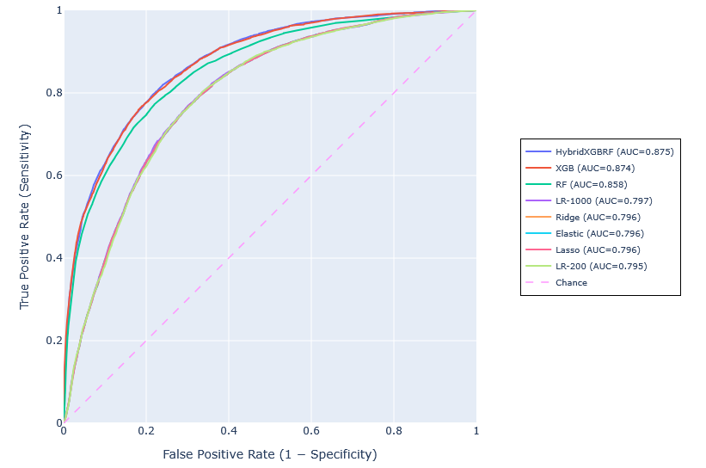
Figure 1 Receiver operating characteristic curve comparison

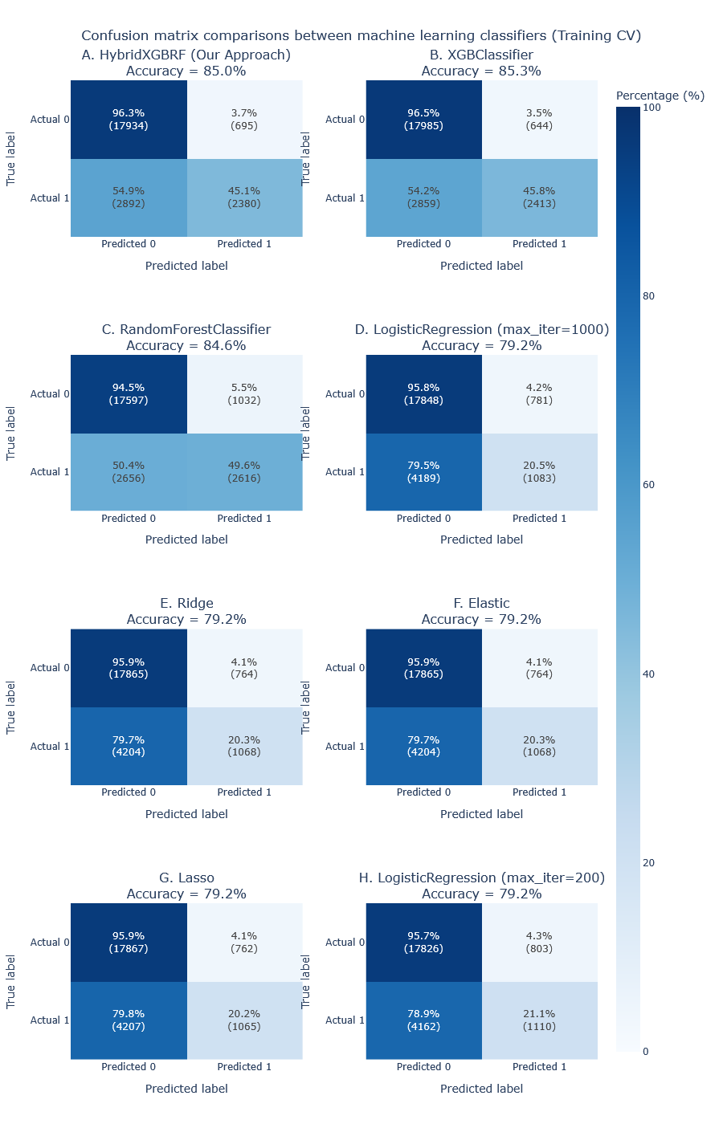
Figure 2 Confusion matrix comparisons between machine learning classifiers

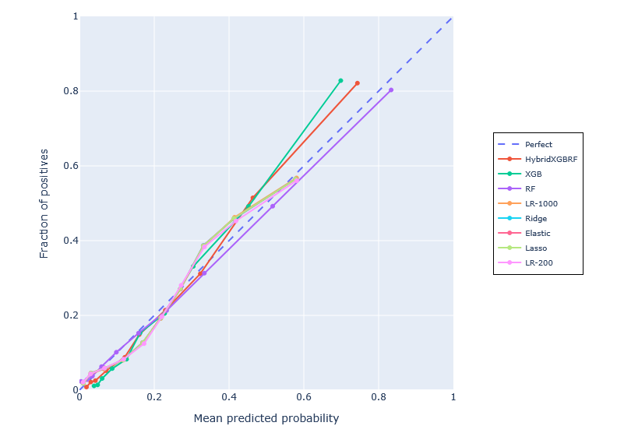
Figure 3 Calibration plots of the machine learning models in the development cohort

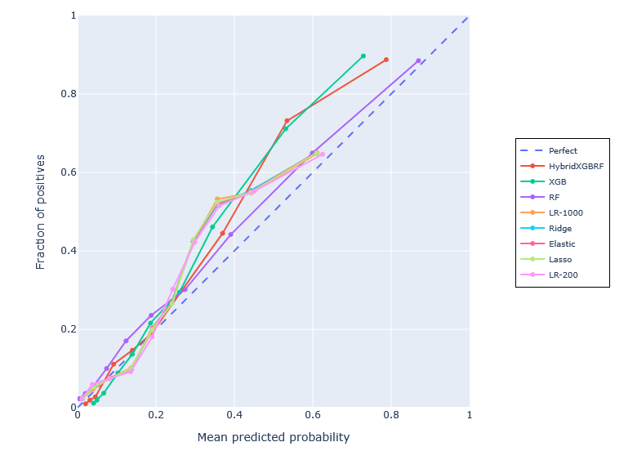
Figure 4 Calibration plots of the machine learning models in the external validation cohort

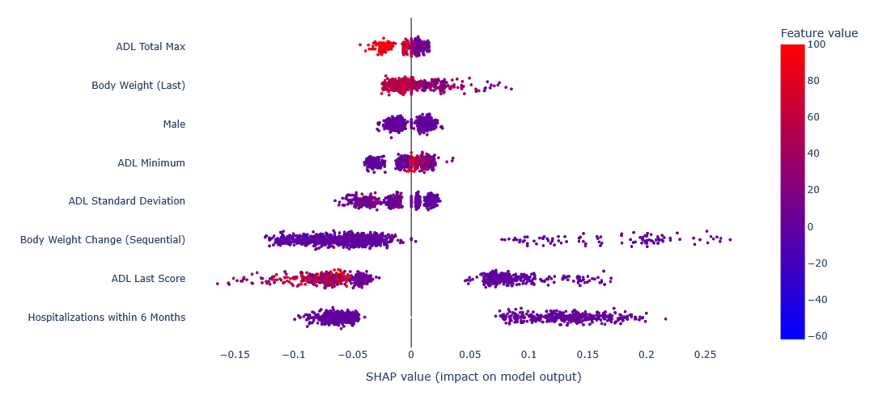
Figure 5 SHAP beeswarm plot of HybridXGBRF model

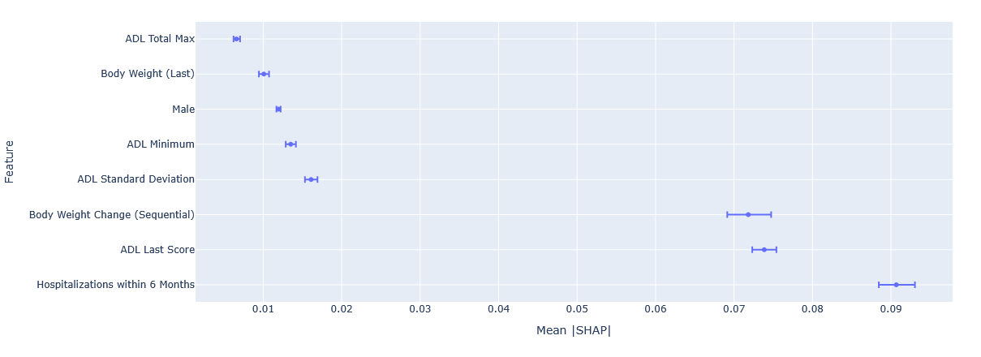
Figure 6 SHAP forest plot of HybridXGBRF model

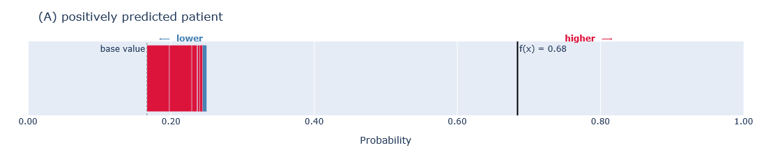
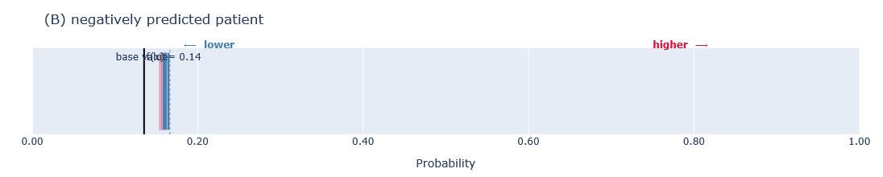
Figure 7 SHAP force plots for two representative residents

