Half Field Offense

In this experiment I used a hand-made goalkeeper (behavior explained bellow).

1. Game parameters:
- Number of teammates: 0;
- Number of opponents: 1; (Dumb Goalie)
- Number of episodes: 4000;

2. Q-Learning Agent

2.1. Q learning parameters:
- Learning rate: 0.10;
- Epsilon: 1.0; Epsilon decrescent: 0.996; Epsilon end: 0.01;
- Discount factor: 0.99;
- Q learning table dim: 192 states = environment features * number of actions;

2.2. State Features
- Position – int [0, 6], subdivided the field in 6 regions, each integer signalizes one of these regions;
- Direction – int [0,3]. 0=East, 1=North, 2=West, 3 == South.
- Has Ball – int (0,1). 1 if agent can kick, else 0.
- Should Shoot – int (0,1). Agent’s goal opening angle > 20%;
- Opponent is close – int (0,1). Opponent is close;

2.3. Actions
- Move - Re-positions the agent according to the strategy given by Agent2D. The Move command works only when the agent does not have the ball. If the agent has the ball, another command such as Dribble, Shoot, or Pass should be used.
- Dribble - Advances the ball towards the goal using a combination of short kicks and moves.
- Shoot - Executes the best available shot. This command only works when the agent has the ball.

2.4. Rewards
- - 500 – the game ends without scoring goal;
- + 1000 – score goal;
- - -1 – for each time-step, the idea was to motivate the agent to goal as fastest as possible;

3. Goalkeeper Agent
The agent presents 2 simple behavior:
If ball is on the upper side of the field:
the goalkeeper moves to the goal top corner;
Else:
the goalkeeper moves to the goal bottom corner;

4. Results:

4.1. Learning plot:
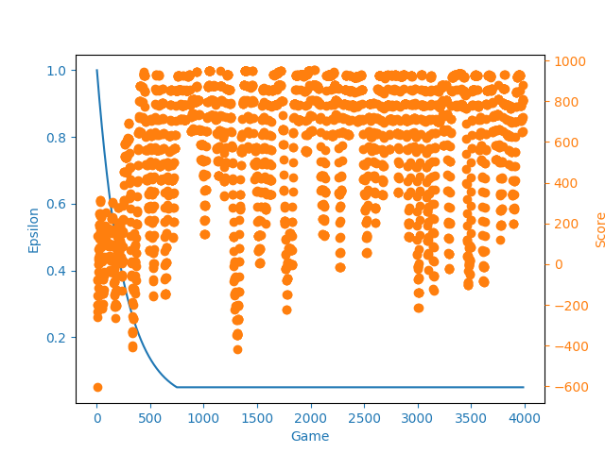

4.2. Results Discussion:
After 4000 games, the agent learns to go around the goalkeeper and then shoot, as we can see in the video.

