## Working with Arduino

The Arduino is a very popular small microcontroller. Thanks to its simple but powerful IDE (integrated development environment), many libraries and low price, it’s become perhaps the most common hobbyist microcontroller. You can find more information at <https://www.arduino.cc/>

Many Arduino devices are connected via a Bluetooth Rfcomm (also known as SPP, Serial Port Protocol) mini-board. Many are available from different vendors.

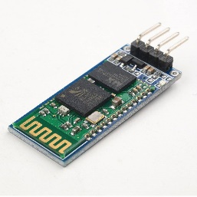To communicate with an Arduino using a Bluetooth serial interface, follow the instructions in Rfcomm (Serial-port) Bluetooth. There are methods like PickDevicesRfcommName (“*”) to let your end-user pick a Bluetooth device to connect to and to send and receive data.

There isn’t a single Bluetooth protocol for these connections. Many devices (like the Slant Robotics LittleBot and Infineon DPS310) have their own mini-protocol. Other boards use “standard” protocols like the Ardudroid.

If there’s some protocol you would like supported, please contact [shipwrecksoftware@live.com](mailto:shipwrecksoftware@live.com) and let us know what protocol and what you’re building!

### Slider (x1, y1, x2, y2, text, function)

Creates a slider control on the graphics screen at the given position. The slider’s text will be the text, and when the value changes, the function will be called.

You can set the slider Min and Max value; if you don’t set them, the default values are 0 and 255 (because that corresponds to byte values)

## Release Notes (3.11, November 2017)

Added g.Button and g.Slider, both of which return an object. Each has an Change method, a Text value. Slider also includes Min and Max.

String.Parse (“csv”, array), if given an array-of-arrays, will create a correct 2-D table.

You can create pretty-print output from a package in Markdown format (MD) now. Markdown is an increasingly popular file format for writing computer documentation. Note that not all apps implement the same markdown. In particular, the markdown generated by Best Calculator marks source code with block:

CORRECTION: MID(str, index) is the same as MID (str, index, rest-of-string). The documentation used to say that the default was “1”, not “the rest of the string”.